
APPENDIX GA36c

LEVEL 6 ASSESSMENT SPECIFICATION

Student name: |  | Jake Mason | Student ID number:
Programme:
Module: |  | Data Warehousing and Data Mining
Module code: |  | ACCA6026 | Contribution to Overall Module Assessment (%): | 50%
Lecturer: |  | John Williams | Internal Verifier: | Bev Holland
Assignment Title: |  | Data Warehousing | Word count (or equivalent): | 3000
Submission deadline: |  | 28th November 2021 | Return date of provisional marks & written feedback: | 25th December 2021
Submission method: |  | All written assessments, where practical and possible, must be submitted via Turnitin unless otherwise instructed by the Lecturer. (Please DO NOT put this assessment specification into Turnitin or it will match many similarities with other students’ submissions.)  Alternative submission method (if applicable):  Late submission of the assessment will result in a late penalty mark. Penalties for late submission: Up to one week late, maximum mark of 40%. Over one week late, 0%. Only the Extenuating Circumstances Panel may approve a change to submission dates.
Academic honesty / referencing: |  | Academic honesty is required. In the main body of your submission you must give credit to authors on whose research and ideas your work is based. Append to your submission a reference list that indicates the books, articles, etc. that you have used, cited or quoted in order to complete this assessment.
 | Module Learning Outcomes (from module syllabus)
Upon the successful completion of this module, the student should be able to:
- Analyse critically the structure, capabilities and role of a data warehouse within a modern business environment.
- Select and perform appropriate data analysis and reporting on data within a data warehouse environment and critically evaluate the results
- Provide business intelligence through the creative application of appropriate data mining processes and the critical evaluation of their results.

TASK DESCRIPTION

Case Study: Recovery Radio

‘Recovery Radio Ltd.’ is an independent company that provides hospital radio services to a number of smaller hospitals across north Wales and north-west England. These services are aimed specifically at local hospitals that do not have the capability to run their own in-house hospital radio stations. The company was formed in 1997 by the amalgamation of several smaller hospital radio companies, with shares split between a number of individuals and hospitals. Annual revenues are around £3.6 million, which is raised through a combination of radio-based advertising and charitable donations, while annual profits are in the £0.6 million region.
With the recent societal move towards streamed music Recovery Radio needs to rationalise its operations to improve its profits, and its senior officers are smart enough to recognise that this will include a major review of its IT systems. They would like to be able to expand into online broadcasting as well as on-site broadcasting in order to sell their services to hospitals in the UK and abroad. Your job is to carry out this review and to present a report to the CEO and the board on the data capture, storage, analysis and presentation of the data necessary to run a multi-site radio station. This will allow them to make better strategic decision relating to the future growth of the company.
Recovery Radio provides four different types of radio programme to its partner hospitals. Hospitals may take one or more of these programme types in any combination. All programmes are 4 hours long, and different hospitals may be playing different programmes at any point in time.
- No-presenter pre-recorded programmes. These consist of a pre-defined playlist that provides 50 minutes of music each hour, 8 minutes of adverts, and 2 minutes for a news bulletin bought in from an external provider. Hospitals often buy these programmes to play overnight, when there are relatively few listeners.
- Centralised pre-recorded programmes. These have a human presenter introducing the tracks, and are often bought to play in the evening. Each hour of the programme contains 42 minutes of music, 8 minutes of adverts, 2 minutes for a news bulletin, and 8 minutes of presenter time.
- Centralised live programmes. These have a live presenter based in Recovery Radio’s head office in Carnforth, Lancashire, who introduces the music and provides interaction with listeners countrywide through SMS, email, and messages left on the website. Each hour of the programme contains 35 minutes of music, 8 minutes of adverts, 2 minutes for a news bulletin, and 15 minutes of presenter time. Unlike the pre-recorded programmes, the playlists for these programmes are generated ‘on the fly’ as people contact the station with their requests.
- Local live programmes. These involve taking a presenter and a mobile studio to a hospital and generally involve much more spoken word material as the presenter will include interviews with staff and patients. Each hour of the programme contains 25 minutes of music, 8 minutes of adverts, 2 minutes for a news bulletin, and 25 minutes of presenter time. As with the centralised live programmes, the playlists for these programmes are generated ‘on the fly’ as people contact the station with their requests. Listeners may make requests via SMS, email, messages left on the website, or on forms handed to Recovery Radio staff or placed into the “RR Postbox” in the hospital’s main entrance lobby. The mobile studio normally changes its location every week, so hospitals can expect to host a live programme every couple of months.
As a radio station, Recovery Radio must pay public performance fees for all music that it plays. These are paid at rates agreed with the Performing Rights Society (PRS) who, in turn, distribute them to the artists whose music was played. It is therefore essential that a complete record is kept of what music has been played, including the track name, artist, track length, International Standard Recording Code (the ISRC is a unique code that identifies a performance of a song, so each recording of a particular track will have a different code), which Recovery Radio programme it was played in and at what time it was played. Each Recovery Radio programme will have a related playlist consisting of a set of these records, which can be used for the calculation of performance fees.
The rates agreed with the PRS depend upon the time of day at which the song was played. These are calculated on a per-hour basis, so a programme that includes 45 minutes of music would be charged 0.75 times the hourly rate. The current rates are:
- 23:00-07:00: £1.63 per hour
- 07:00-14:00: £2.49 per hour
- 14:00-19:00: £2.17 per hour
- 19:00-23:00: £1.98 per hour.
Pre-recorded programmes are created automatically on a computer by an programme compiler who enters the length of the programme, the number and position of adverts, and some parameters relating to the genres or periods of music to include. This will then output a working playlist that can be uploaded to the broadcasting software. Where a programme has a presenter, the working playlist is generated and then the presenter will record the track introductions (known as ‘continuity tracks’) as separate files. These files are then added to the working playlist as voice tracks between the music tracks. When the programme is played the broadcasting software writes a record of each track as it is played to the day’s primary playlist. Details of any continuity tracks are not saved to the primary playlist.
Live programmes have the working playlist for the first hour compiled before the start of the programme by a music compiler based upon requests that were not played in the previous programme. As more requests come in they update the working playlist with further tracks and, in parallel, add notes that will appear on the presenter’s screen so that they can see what the next few tracks will be, who has requested them, and who the track is being dedicated to. As each track is broadcast, the track details, but not the request details) are written to the day’s primary playlist.
On Monday, all of the preceding week’s playlists will be processed to provide a report that lists the tracks played throughout the week and the cost per track (based upon the appropriate rate for the time at which it was played). The primary playlist is then uploaded to the playlist history database where it can be accessed for further analysis. The playlist history database contains a record of every track played on Recovery Radio since its formation in 1997.
Every month the company’s programme compilers will extract the data for requests from the playlist history database to see which artists, genres and individual tracks are popular that month, and they will use this information to tweak the parameters used to generate the working playlists for the pre-recorded programmes. The playlist history database is also accessed by the music department of a local university, who are using it as part of an ongoing project to look at how popular music has changed over the past twenty years.
Recovery Radio funds some of its operating costs by selling advertising on its programmes. The cost to advertisers is banded in the same way that royalty fees are, where the station charges a fixed amount for each 30-second advert according to the timing of the programme when the advert is played:
- 23:00-07:00: £341 per advert
- 07:00-14:00: £589 per advert
- 14:00-19:00: £552 per advert
- 19:00-23:00: £407 per advert.
Some advertising slots are sold directly to companies, while others are sold through media advertising agencies. Advertisers are becoming interested in whether the music played around the adverts has any effect on the power of the advert, so the timing of each advert needs to be stored both for calculating the advert cost and for further analysis. Reports on advertising revenue are generated every week, while the music/advert interaction analysis may occur at any time and require a great deal of processing power.
Using the above scenario, you should write a report that addresses the tasks provided below. This should be appropriately referenced and contain such diagrams as are necessary to each section. You should frame your answer based upon the case study company and their specific needs. Some background information is required in places but try to keep your focus on the case study rather than giving a general answer.

Task 1 (50%)
Imagine that you are a data warehousing consultant who has been asked to provide a report to the chief executive and board of directors of the above company on the following technical issues. The CEO and the directors are not computing specialists, but have been advised that a data warehouse might be suitable for their organisation.

Discuss the difference between an online transaction processing (OLTP) database and a data warehouse. The company already has a working OLTP system and the CEO needs to learn the benefits that investing in a data warehouse system will bring to their company.
(10 marks)

Explain, with the aid of appropriate diagrams, the architecture of a data warehouse and its source systems. Show how the different internal and external sources of data can be used to populate a data warehouse. The CEO has heard the term ‘ETL’ but does not understand it, so they will need to be convinced that this will not affect the data-to-day operations of the company.
(20 marks)

The managing director, finance director, and the sales and marketing director have their own specific needs in terms of seeing relevant data to allow them to make well-founded management decisions. Explain how data marts may be used to provide targeted information for these managers and their departments.
(10 marks)

The IT director knows a lot about OLTP systems but little about data warehousing. Explain to them the difference between the ‘normalised’ structure of an OLTP system and the ‘dimensional’ structure of a data warehouse. Use a suitable diagram to explain how facts and dimensions can be used to develop a suitable star schema for their system. N.b. As this is a management report you do not need to develop the entire schema at this state, but should instead use examples related to the company’s data to illustrate the concepts involved.
(10 marks)

Task 2 (50%)
The CEO and the board have been convinced that a data warehouse is the way forward for their company and you have been employed as a contractor to support the company in its development of the new data warehouse solution. You should now produce a report that develops and describes a suitable star schema for the company’s new data warehouse. This should include the following elements:

- Identification of internal and external source systems
(5 marks)
- An appropriate star schema (which may include multiple stars) for the system which includes and clearly shows tables for master data, metadata and aggregate data.
(25 marks)
- Identification of appropriate data marts, and the schema for data that would be extracted to each data mart
  - marks)
- A simplified ETL plan that describes where the data for each table will be sourced and what, if any, transformations need to be applied to that data before it can be loaded into the data warehouse.
  - marks)
All design decisions should be explained and justified

GUIDANCE FOR STUDENTS IN THE COMPLETION OF TASKS

NOTE: The guidance offered below is linked to the five generic assessment criteria overleaf.

1. Engagement with Literature Skills
Your work must be informed and supported by scholarly material that is relevant to and focused on the task(s) set; you should make use of scholarly reviews and primary sources, where appropriate (for example, refereed research articles and/or original materials appropriate to the discipline). You should provide evidence that you have accessed a wide range of sources, which may be academic, governmental and industrial; these sources may include academic journal articles, textbooks, current news articles, organisational documents, and websites. You should consider the credibility of your sources; academic journals are normally highly credible sources while websites require careful consideration/selection and should be used sparingly. Any sources you use should be current and up-to-date, mostly published within the last five years or so, though seminal/important works in the field may be older. You must provide evidence of your research/own reading throughout your work, using a suitable referencing system, including in-text citations in the main body of your work and a reference list at the end of your work.

Guidance specific to this assessment: You should be able to justify your design decisions with relevant references to the literature.

2. Knowledge and Understanding Skills
At level 6, you should be able to demonstrate coherent and detailed knowledge and a systematic understanding of the subject area, at least some of which is informed by the latest research and/or advanced scholarship within the discipline. You should be aware of the uncertainty, ambiguity and limits of knowledge. Your work must demonstrate the growing extent of your knowledge and systematic understanding of concepts and underlying principles associated with the subject area. Knowledge relates to the facts, information and skills you have acquired through your learning. You demonstrate your understanding by interpreting the meaning of the facts and information (knowledge). This means that you need to select and include in your work the concepts, techniques, models, theories, etc. appropriate to the task(s) set. You should be able to explain the theories, concepts, etc. meaningfully to show your understanding. Your mark/grade will also depend upon the extent to which you demonstrate your knowledge and understanding; ideally each should be complete and detailed, with comprehensive coverage.

Guidance specific to this assessment: Think about the processes described in the case study and how these map to the elements of data warehouse structure and the ETL process.

3. Cognitive and Intellectual Skills
You should be able to: critically evaluate evidence, arguments, assumptions, abstract concepts and data some of which are at the forefront of a discipline (and that may be incomplete) to devise and sustain arguments, to make judgements and/or solve problems; describe and comment upon particular aspects of current research, or equivalent advanced scholarship, in the discipline Your work must contain evidence of logical, analytical thinking, evaluation and synthesis. For example, to examine and break information down into parts, make inferences, compile, compare and contrast information. This means not just describing what! But also justifying: Why? How? When? Who? Where? At what cost? At all times, you must provide justification for your arguments and judgements. Evidence that you have reflected upon the ideas of others within the subject area is crucial to you providing a reasoned and informed debate within your work. Furthermore, you should provide evidence that you are able to make sound judgements and convincing arguments using data and concepts. Sound, valid conclusions are necessary and must be derived from the content of your work. Where relevant, alternative solutions and recommendations may be proposed.

Guidance specific to this assessment: Remember to identify your source systems and your user groups, and use these to inform the design of your system.

4. Practical Skills
At level 6, you should be able to apply the methods and techniques that you have learned to review, consolidate, extend and apply your knowledge and understanding, and to initiate and carry out projects. You will deploy accurately established techniques of analysis and enquiry relevant to the discipline, and apply them in complex and unpredictable contexts, to devise and sustain arguments and/or to solve problems. You should be able to frame appropriate questions to achieve a solution - or identify a range of solutions. You should be able to demonstrate how the subject-related concepts and ideas relate to real world situations and/or a particular context. How do they work in practice? You will deploy models, methods, techniques, and/or theories, in that context or circumstances, to assess current situations, perhaps to formulate plans or solutions to solve problems, or to create artefacts, some of which may be innovative and creative. This is likely to involve, for instance, the use of real world artefacts, examples and cases, the application of a model within an organisation and/or benchmarking one theory or organisation against others based on stated criteria. You should show awareness of the limitations of concepts and theories when applied in particular contexts.

Guidance specific to this assessment: As you’re building a data warehouse remember that you should be using dimensional modelling and star schemas rather than a normalised database.

5. Transferable Skills for Life and Professional Practice
Your work must provide evidence of the qualities and transferable skills necessary for graduate-level employment requiring the exercise of initiative and personal responsibility and decision-making in complex and unpredictable circumstances. This includes demonstrating: the learning ability for professional development to advance existing skills and acquire new competences of a professional nature that will enable you to assume significant responsibility within organisations; that you can initiate and complete tasks and procedures, whether individually and/or collaboratively; that you can use appropriate media to effectively communicate information, arguments and analysis in a variety of forms to specialist and non-specialist audiences; fluency of expression; clarity and effectiveness in presentation and organisation. Work should be coherent and well-structured in presentation and organisation.

Guidance specific to this assessment: The report should be aimed at readers who understand database basics but do not have specific knowledge of data warehousing. Phrase your explanations accordingly.

STUDENT FEEDBACK FORM

This section details the extent to which the assessment criteria are demonstrated by you, which in turn determines your mark. The marks available for each category of skill are shown. Lecturers will use the space provided to comment on the achievement of the task(s), including those areas in which you have performed well and areas that would benefit from development/improvement.

Generic Assessment Criteria | Marks  available | Marks  awarded
1. Engagement with Literature Skills
.
Engagement with an appropriate range of research informed literature, including sources retrieved independently. Some over-reliance on texts. Very good use of referencing, with no/very few inaccuracies or inconsistencies | 20 | 13
2. Knowledge and Understanding Skills

Knowledge is reasonably detailed, accurate with a good systematic understanding of the field of study and to some extent, current research and scholarship. | 20 | 12
3. Cognitive and Intellectual Skills

An emerging awareness of different stances and ability to use evidence (that may be incomplete) to support the argument. Mostly valid arguments and  logical judgements | 10 | 5
4. Practical Application Skills

Clear appreciation of the context of the application. Mainly consistent, accurate and logical application of theory to practice, making appropriate links between the two. Can identify problems and propose mostly appropriate solutions in complex and unpredictable contexts. | 40 | 20
5. Transferable Skills for Life and Professional Practice

Demonstrates the skills required in graduate employment, with some areas of strength and some of minor weakness | 10 | 5

Assessment Mark (Assessment marks are subject to ratification at the Exam Board. These comments and marks are to give feedback on module work and are for guidance only until they are confirmed. ) | Late Submission Penalties (tick if appropriate) |  | 58%
 | Up to 1 week late (40% Max) |  | 58%
 | Over 1 week late (0%) |  | 58%

GENERIC ASSESSMENT CRITERIA
Level 6
In accordance with the Framework for Higher Education Qualifications, at the end of Level 6 students should have coherent and detailed knowledge and a systematic understanding of their subject area, at least some of which is informed by the latest research and/or advanced scholarship within the discipline. They will be able to accurately deploy established techniques of analysis and enquiry within a discipline, using their conceptual understanding to devise and sustain arguments and/or to solve problems. They should be aware of the uncertainty, ambiguity and limits of knowledge. They should be able to critically evaluate evidence, arguments, assumptions, abstract concepts and data (that may be incomplete), to make judgements, and to frame appropriate questions to achieve a solution - or identify a range of solutions. They will apply the methods and techniques that they have learned to review, consolidate, extend and apply their knowledge and understanding, and to initiate and carry out projects. They will have the ability to manage their own learning, and to make use of scholarly reviews and primary sources (for example, refereed research articles and/or original materials appropriate to the discipline). They will demonstrate the qualities and transferable skills necessary for employment requiring: the exercise of initiative and personal responsibility; decision-making in complex and unpredictable contexts; the learning ability needed to undertake appropriate further training of a professional or equivalent nature.

Level 6 | FAIL | MARGINAL FAIL | SATISFACTORY  (3rd / Pass) | GOOD  (2.2 / Pass) | VERY GOOD  (2.1 / Merit) | EXCELLENT  (1st / Distinction) | EXCEPTIONAL  (1st / Distinction)
Category | 0-29% | 30-39% | 40-49% | 50-59% | 60-69% | 70-84% | 85-100%
Engagement  with literature  (including reading,  referencing, academic conventions and academic honesty) | Little or no evidence of reading and/or reliance on inappropriate sources. Views and findings mostly unsupported and nonauthoritative. Referencing conventions used incoherently or largely absent. | Poor engagement  with essential reading. No evidence of wider reading. Reliance on inappropriate sources, and/or indiscriminate use of sources. Heavily reliant on information gained through class contact. Inconsistent and weak use of referencing. | Engagement with a limited range of mostly relevant and credible sources. Some omissions and minor errors.  Referencing conventions evident though not always applied accurately or consistently. | Engagement with an appropriate range of researchinformed  literature, including sources retrieved independently. Some over-  reliance on texts. Referencing may show minor inaccuracies or inconsistencies. | Engagement with a wide range of researchinformed  literature, including sources retrieved independently. Selection of relevant and credible sources. Very good use of referencing, with no/very few inaccuracies or inconsistencies. | Engagement with an extensive range of relevant and credible  literature, informed by the latest research. Consistently accurate application of referencing. | Exceptional engagement with an extensive range of relevant and credible  literature, informed by the latest research. High-level referencing skills consistently and professionally applied.
Knowledge and understanding  (Coherent and detailed | Major gaps in knowledge and systematic understanding of the subject | Gaps in knowledge, with only superficial systematic understanding. | Limited knowledge and systematic understanding of the relevant | Knowledge is reasonably detailed, accurate with a good systematic | Knowledge is reasonably extensive coherent and detailed. | Excellent coherent and detailed knowledge and systematic | Exceptionally coherent and detailed knowledge and systematic

Level 6 | FAIL | MARGINAL FAIL | SATISFACTORY  (3rd / Pass) | GOOD  (2.2 / Pass) | VERY GOOD  (2.1 / Merit) | EXCELLENT  (1st / Distinction) | EXCEPTIONAL  (1st / Distinction)
Category | 0-29% | 30-39% | 40-49% | 50-59% | 60-69% | 70-84% | 85-100%
knowledge and systematic understanding of the subject area, at least some of which is informed by the latest research and/or advanced scholarship within the discipline.) | matter. Substantial inaccuracies. No awareness of knowledge of the latest research and/or advanced scholarship within the discipline. | Some significant inaccuracies and/or irrelevant material. No awareness of knowledge of the latest research and/or advanced scholarship within the discipline. | concepts and principles within the subject area which to some  limited extent, is informed by current research and scholarship. | understanding of  the field of study and to some extent, current research and scholarship. | Exhibits very good understanding of the breadth and depth of established views, and the work is, at least in part, wellinformed by current research and scholarship. | understanding of the principles and theories of current research and scholarship. Clear awareness of challenges to established views and the limitations of the knowledge base. | understanding of the principles and theories of the subject, wellinformed by current research and scholarship. A critical, sophisticated and nuanced awareness of the ambiguities and limitations of knowledge.
Cognitive and intellectual skills  (Conceptual and  critical thinking, analysis, synthesis and evaluation of research, assumptions, abstract concepts  and data (that  may be  incomplete); logic, argument and judgement.) | Wholly or almost wholly descriptive work. Little or no analysis, synthesis or evaluation. Failure to develop arguments, leading to illogical or invalid judgements. Unsubstantiated generalisations, made without use of any credible evidence. | Largely descriptive work, with superficial use of critical evaluation.  Weak development of arguments and judgements. Information accepted uncritically, uses generalised statements made with scant evidence and unsubstantiated opinions. Ideas  sometimes  illogical and contradictory. | Limited attempt  at critical thinking, analysis, synthesis and evaluation, tending towards description.  Some evidence to support emerging arguments and judgements but these may be  underdeveloped  or with a little inconsistency / misinterpretation. Asserts rather than argues a case. | Some critical thinking, analysis, synthesis and evaluation. Can analyse new and/or abstract concepts and data without guidance. An emerging awareness of different stances and ability to use evidence (that may be incomplete) to support the argument. Mostly valid arguments and  logical judgements. Some tendency to assert/state opinion rather than argue on | Sound critical thinking, analysis, synthesis and evaluation demonstrating critical thinking. Ability to devise and sustain persuasive arguments, and  to review the  reliability, validity and significance  of evidence (that may be incomplete) to make mostly appropriate and valid judgements. | Excellent critical thinking, analysis, synthesis and evaluation. Ability to investigate contradictory or incomplete information and make strong, persuasive, arguments and sophisticated judgements. Some evidence of independent thought and  ability to ‘see beyond the question’, suggesting a grasp of the broader field and wider concepts. | Exceptional  critical thinking, analysis, synthesis and evaluation based on judiciously selected evidence. Ability to investigate contradictory or incomplete information and make strong, persuasive, arguments and sophisticated, nuanced, judgements. Evidence of independent thought and  ability to ‘see beyond the question’, suggesting an outstanding

Level 6 | FAIL | MARGINAL FAIL | SATISFACTORY  (3rd / Pass) | GOOD  (2.2 / Pass) | VERY GOOD  (2.1 / Merit) | EXCELLENT  (1st / Distinction) | EXCEPTIONAL  (1st / Distinction)
Category | 0-29% | 30-39% | 40-49% | 50-59% | 60-69% | 70-84% | 85-100%
 |  |  |  | the basis of reason and evidence. |  |  | grasp of the broader field and wider concepts.
Practical skills  (Apply/deploy accurately established tools and techniques; initiate and carry out projects; formulate solutions to solve problems in complex and unpredictable contexts.) | Limited or no use of methods, materials, tools and/or techniques. Little or no appreciation of the context of the application. Limited understanding of the application of theory to practice or making appropriate links between the two. Very weak problem-solving skills in complex and unpredictable contexts. | Rudimentary application of methods, materials, tools  and/or techniques but without consideration and competence. Flawed appreciation of the context of the application.  Weak  understanding of the application of theory to practice, with only occasional evidence of making appropriate links between the two. Weak problem-solving skills in complex and unpredictable contexts. | An adequate awareness and mostly appropriate application of well-established methods, materials, tools and/or techniques. Basic appreciation of the context of the application. Theoretical knowledge and understanding applied in practice, but not always making  logical links between the two. Can identify problems and propose basic solutions in complex and unpredictable contexts without fully appreciating the complexity. | A good and appropriate application of standard methods, materials, tools and/or techniques. Clear appreciation of the context of the application. Mainly consistent, accurate and logical application of theory to practice, making appropriate links between the two Can identify problems and propose mostly appropriate solutions in complex and unpredictable contexts. | A very good application of a range of methods, materials, tools and/or techniques. Very good consideration of the context of the application, with perceptive insights. Can identify problems and propose appropriate solutions in complex and unpredictable contexts. Evidence of some innovation and creativity. | An advanced  application of a range of methods, materials, tools and/or techniques. The context of the application is well considered, and insightful. Application and deployment extend beyond established conventions. Can identify complex problems and propose excellent solutions. Innovation and creativity evident. | Exceptional levels of application and  deployment  skills in unpredictable, practical contexts, drawing skilfully on the latest research within the discipline. Can identify complex problems and propose sophisticated solutions. Assimilation and development of cutting edge processes and techniques.
Transferable  skills for life and professional practice (Exercise of initiative and | Communication medium is inappropriate or misapplied. Work is poorly structured, disorganised | Communication medium is poorly designed and/or not suitable for the audience. Work is poorly presented in a | Can communicate in a suitable medium but with some room for improvement. | Can communicate  effectively in a suitable format, but may have minor errors. | Can communicate  well, confidently and consistently in a suitable format. | Can communicate  professionally confidently and consistently in a suitable format. | Can communicate with an exceptionally high level of professionalism.

Level 6 | FAIL | MARGINAL FAIL | SATISFACTORY  (3rd / Pass) | GOOD  (2.2 / Pass) | VERY GOOD  (2.1 / Merit) | EXCELLENT  (1st / Distinction) | EXCEPTIONAL  (1st / Distinction)
Category | 0-29% | 30-39% | 40-49% | 50-59% | 60-69% | 70-84% | 85-100%
personal responsibility; professional development; initiate and complete tasks and procedures: individually and/or collaboratively; use appropriate media to communicate  effectively; fluency of expression; clarity and effectiveness in presentation and organisation.) | and/or confusingly expressed. Very weak use of language and/or very inappropriate  style. Little or no evidence of autonomy (or collaboration, where relevant) in the completion of tasks. Little or  no evidence of the skills required in graduate employment. | disjointed manner. It is loosely, and at times incoherently, structured, with information and ideas often poorly expressed. Weak use of language and/or inappropriate style. Weak independent  initiative (or collaboration, if relevant). Limited evidence of the skills required in graduate employment. | Mostly ordered presentation and structure in which relevant ideas / concepts are reasonably expressed. Work may lack coherence in places. Can work as part of a team, but with  limited involvement in group activities. Demonstrates  the basic skills required in graduate employment, with some areas  of minor weakness. | Mostly coherent, organised work, in a suitable structure and is for the most part clearly expressed. Can work effectively independently and/or as part of a team, with clear contribution to group activities. Demonstrates  the skills required in graduate employment, with some areas of strength and some of minor weakness. | Work is coherent, fluent, well-structured and organised. Can work very well autonomously and/or as part of a team, with very good  contribution to group activities. Demonstrates very good graduate employment  skills, with just occasional minor weakness. | Work is coherent, very  fluent and is presented professionally. Can work autonomously with initiative. Where relevant can work professionally within a team,  showing  leadership skills  as appropriate, managing  conflict and meeting obligations.  Demonstrates excellent graduate employment skills and an appetite for further development. | Work is exceptionally coherent, very fluent and is presented professionally. Can work exceptionally well and professionally within a team, showing advanced leadership skills. Demonstrates exceptional graduate  employment skills and an appetite for further development.

THIS DOCUMENT IS ALSO AVAILABLE IN WELSH

Task 1
Data Warehouse and Online Transaction Processing
Online Transaction Processing (OLTP)
An OLTP is an information system used to manage transaction-based applications [1]. Transactions are recorded and made secure so information regarding them can be accessed anytime for accounting purposes. Speed and recoverability are the main goals of an OLTP [2]. OLTPs make dealing with finances simpler for organisations because of their accuracy.
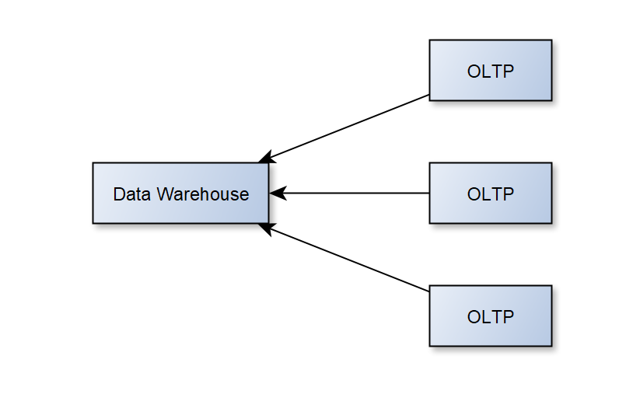
Data Warehouse
A data warehouse is a system used for recording data and performing data analysis [3]. Data warehouses are repositories of data from both internal and external sources, keeping current and past data in the same place. The primary method to building a data warehouse system is extract, transform, load (ETL) [3]. Facts are a value kept in a data warehouse representing a truth about an entity. The dimensional approach to a data warehouse uses a star schema [4], and partitions data into ‘facts’. 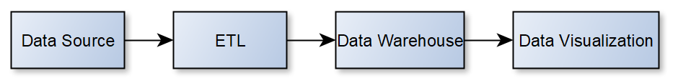
Differences
The data in a data warehouse is not typically in the third form of normalisation (3NF), while this form of data is common in OLTP systems [6]. OLTPs are more commonly used for websites used for trade and resource planning software [2][7]. Data warehouse databases are larger in size, generally 100GB-2TB [7], while an OLTP is generally 10MB-100GB, this is because data warehouses are meant for storing current and historical data [3][8], while an OLTP is intended to only hold current data [8].
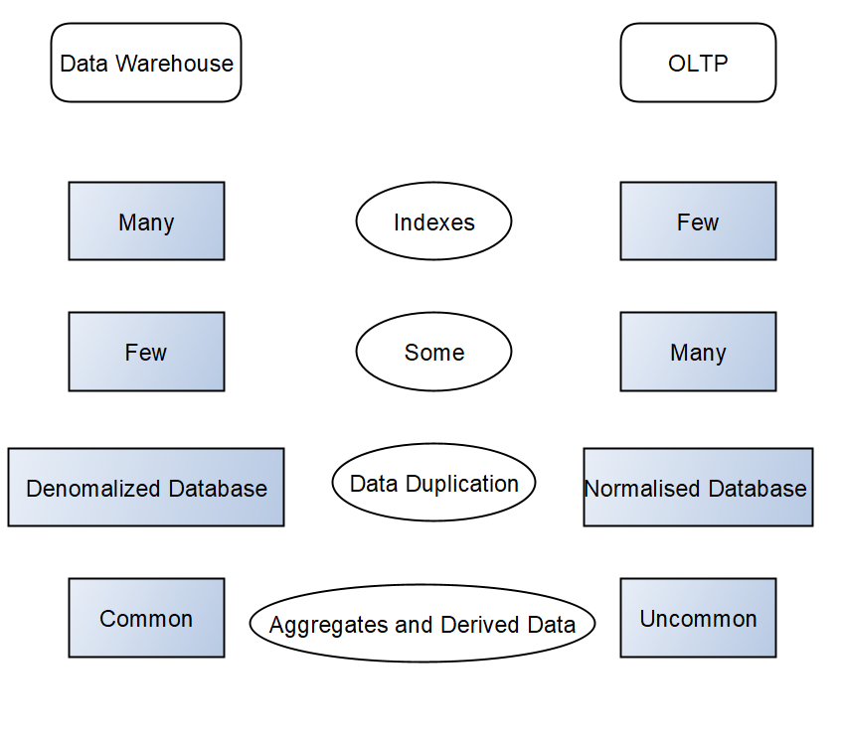 [6][7][8]
Benefits of Data Warehouse
A data warehouse is designed with the goal of analysing values and arranging them to make data retrieval quicker, thus reports easier to make [5]. Data warehouses are useful for archival purposes, keeping past and present data, being a storehouse for data ranging from inventory data, sales, and intellectual property records [8]. Data from multiple sources being kept in one place boosts efficiency for the business users, this is important here as a lot of data from different internal and external sources will need to be housed [9].
Architecture of a Data Warehouse
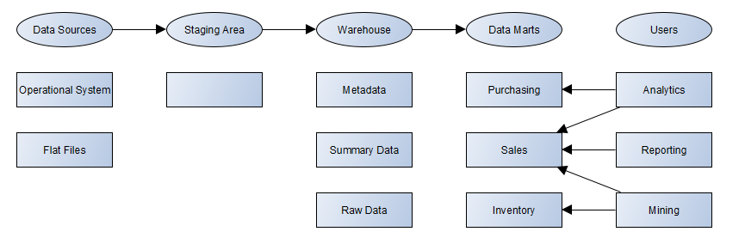[9]
A data warehouse contains many different components. Data from different sources is extracted, transformed, and loaded (ETL) into a staging area, here it undergoes standardization. The data is then transformed into a unified form, before being delivered to the warehouse for storage. The data is segmented into subsets, before being transferred into several data marts [9].
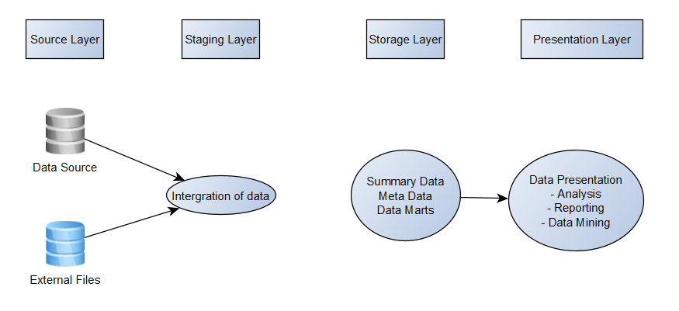[20]
The source layer is where the data sources are. If a data warehouse was using a Customer Relationship Management (CRM) system, a backend database will then hold the application data in a tabular format – this database would then be one of the data sources in the data warehouse [19].
The staging layer as explained prior is where data is standardized – made to be consistent, converted into a preferable format for reporting from a sole repository. This is especially vital when obtaining data from external sources which have a bigger variance of possible formats. ETL tools are necessary in the staging layer, as it allows for data manipulation [19]. ETL is the process of data being extracted from multiple sources and loaded into a warehouse [3]. ETL organises data in a way which accommodates specific business intelligence needs, such as annual and monthly reports. Advanced analytics can be conducted, this improves back-end process and the experiences of the user [11]. ETL would not affect operations of the business, working in the background, requiring little resources to execute [11][3].
The storage layer is where data needed for queries is sourced from. Data in the storage layer can be kept in many different formats depending on the design – whether it’s a single database, data marts or operational data stores.
The presentation layer is where users interact with the data warehouse. Queries are run from here (sourcing data from the storage layer) to perform analyses from a graphical user interface (GUI). [19]
Data Marts
Data Marts can be used by different sectors, allowing for data to be available quickly, with accessible critical insight, avoiding the need to search a data warehouse for relevant info [11][12]. Analysis and reporting do not need enterprise-wide data, so using a data mart can save on time and resources[9].

Data marts are useful for a managing director in an organisation because it provides simple maintenance of data and quicker access to insights [12]. This avoids much micro-management on maintenance. The amount of useful data discovered in a small span of time will be higher - Queries utilising data marts would be beneficial for the managing director as they can offer deeper reporting analysis and deduce useful information – leading to a more productive and successful team [20].

Data marts can be useful for the finance director and others in the finance department by providing extended budget balances, expense reports, purchase orders, requisitions, spend authorizations, supplier contracts and supplier invoices. An in-detail history of transactions with obligations, commitments and actuals can be extracted with use of data marts [13].

The sales and marketing director will benefit from insights being found quicker, with the increased productivity making their team more successful [12]. The sales and marketing director will find the benefits brought to the finance director will also apply to them - in-depth reports of budgets, transaction histories and invoices being of use for archive purposes and for providing sales reports and developing new marketing ideas [13].
Normalised and Dimensional Data Structures
Normalised Data Structure
An OLTP utilises normalised data structures.
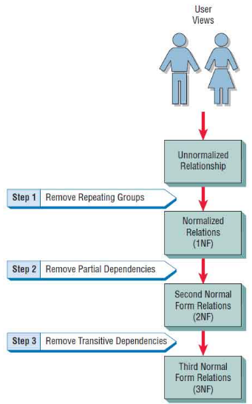Normalising data involves removing repating groups of information, identifying primary keys, ensuring attributes are dependent on the primary key, with all partial dependencies being deleted entirely, and all transitive dependencies being removed [14].
The normalised approach groups tables by subject areas, which show their data categories, then dividing normalised data into entities used for the construction of a relational database. Data warehouses are large in scale, so the number of tables which would be involved in one would make it hard for users to connect data from different data sources together, as well as access info without having specific knowledge of the data sources and the structure of the warehouse [17].
Dimensional Data Structure and differences.
Dimensional data structures in a warehouse are intended for optimizing data storage. Dimensional data structures are integral to a warehouse’s use in the quick retrieval of data. Information such as values, balances, and counts can be analysed using the dimensional model [15], this contrasts to the system of an OLTP which is more used for updating data in real time. [16] [17].
Data is partitioned into what is called “facts” and “dimensions”. Facts are typically transaction data, which is numeric, dimensions are references to information which can provide context to facts. Dimensional data structures are largely considered to have a high ease of access with users [15][16].
Star Schema
A typical star schema follows a fact table (or tables) with connected dimensions
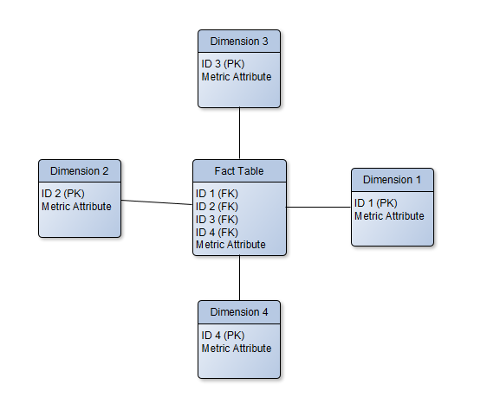
A star schema is the most used schema for data warehouses [22] because of its simplicity, allowing for queries and aggregation operations to made with ease [23] [21]. The join logic does not need to fetch data from a transactional schema. Business reporting logic is simplified compared to transaction schemas, as the business reporting logic options such as “period-over-period” and “as-of reporting” are available [18].
A star schema involves the indexing of dimensional tables, with a fact in the centre and dimension tables acting as the star’s points. For example:
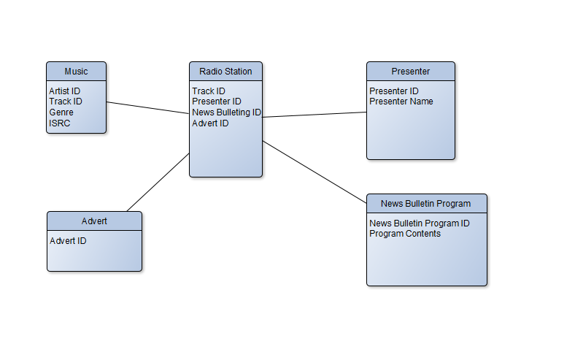

The Radio Station fact table has attributes which refer to the dimensions surrounding it [18].

Task 2: Star Schema Development
Internal and External Sources
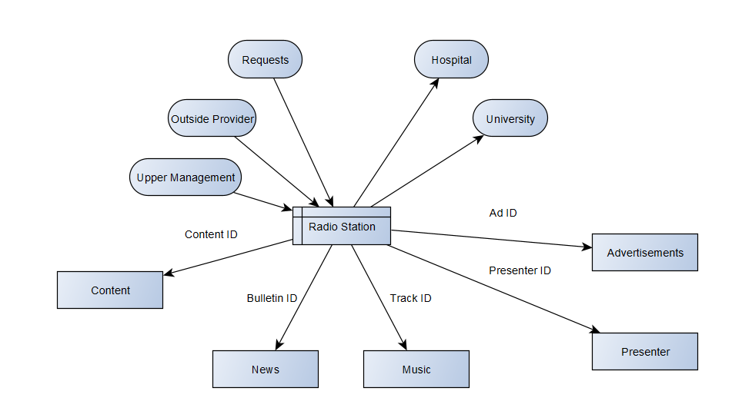
Here is a diagram displaying the internal and external sources systems. The radio station processes information sourcing from the advertisements, music, presenter, news, and content. Requests made by listeners are stored onto the radio station to work out which track to play, which is found using the unique identifier (track ID). The content serves as a unique identifier for which news, music and advertisements were played/used on that broadcast, and which presenter was on. Each of those are identified using their unique identifiers (the IDs). Info on the radio station is then used by the hospital for purposes of archiving content and knowing what is being broadcasted to patients. The music department of a local university uses the radio station’s data to access the playlist history database, as a part of their ongoing project.
The external data here is the content, news, music, advertisements, and presenter. News, music, and advertisements are all originated from their respective parties – the news agency, the record label, and the private organisation.
The internal data being the archive of listener requests, upper management of the radio station and the outside provider. 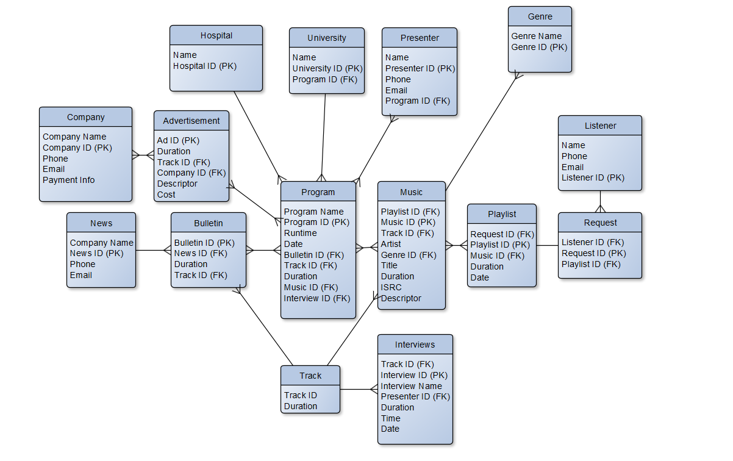
This ERD displays how data from each source is used in relation to each area in the warehouse – with what information is stored on which record, and where it may source its foreign keys from.

Star Schema
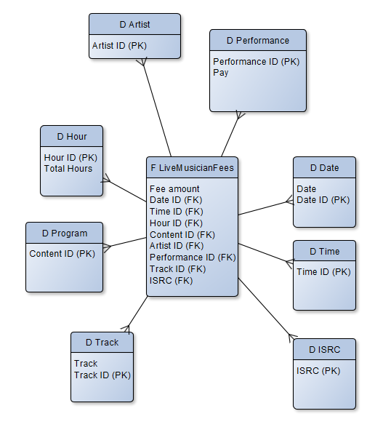
This fact table is for the fee that live musicians will receive. Dimensions such as time and date determine when the performance commenced (as this impacts the fee). The hour dimension is for calculating the total time the performance lasted, the performance is for working out the pay-per-hour the artist requires. The track and ISRC dimensions determine the songs performed.
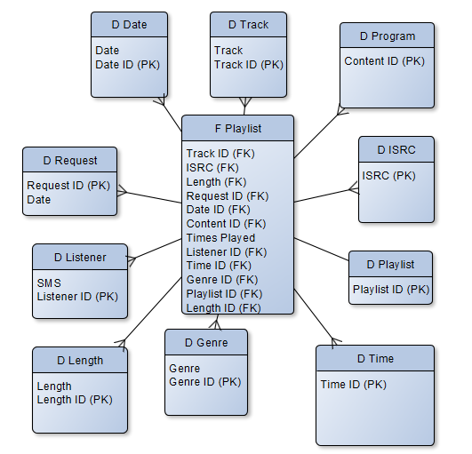This fact table shows the playlists that the warehouse would store. Each radio station which uses pre-recorded content would use playlists in some form to contain the tracks they intend on playing. The date is for when a playlist was used. The track dimension is for the tracks on the playlist itself. The program dimension and the content ID is for which program the playlist was featured on. ISRC specifies the ownership of the tracks. The length dimension refers to the runtime of the playlist and its individual tracks, as the playlist would need to fit into a specific allocated time period – with each radio station having different time requirements, and different ads which may play at different times with different lengths. The listener dimension refers to the listener who made the request for the playlist, with their SMS being listed as metadata as a form of contact.
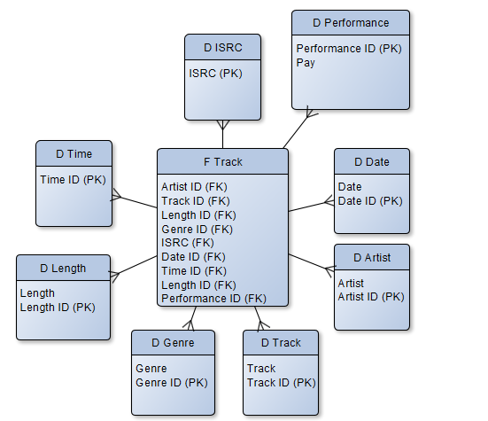
Tracks played by the radio stations will need to pay royalties to their record label (which is why the ISRC, and artist dimensions are there), and data about the song’s length and genre are important for knowing appropriate times to play the track. The performance dimension is for when/if the song is played live, date and time are for queries involving said track.
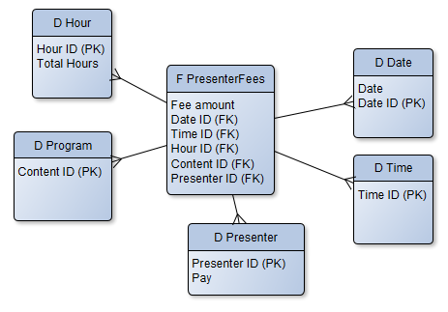
This fact table is for calculating the fees required to be paid to presenters on relevant radio stations. This is worked out by seeing the hourly wage the presenter is intended to be paid, from the presenter dimension, and seeing how many hours they worked based on the hour dimension. Payroll is impacted by time and day worked, as working ‘graveyard shifts’ and on holidays changes pay.
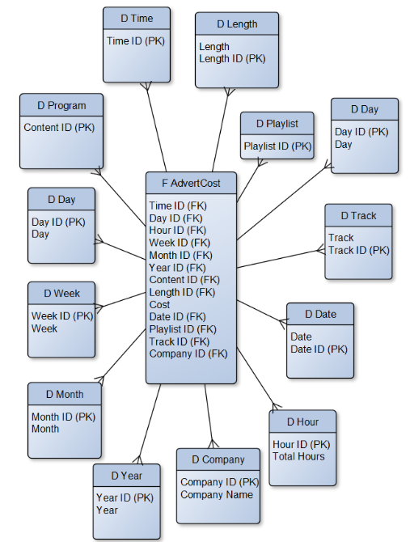 This fact table exists for the intention of calculating the value an advertisement has, and thus how much a company should pay to have it aired on the radio station during a specific time and date. The playlist dimension is for which playlist the advertisement would be placed in, the length dimension is for the total runtime of the advertisement, the longer an advertisement, the more expensive it is. The time and date affects the cost, as certain hours have more listenership, and certain dates have higher listenership and listener retention. The hour, day, week, and year dimensions exist for querying purposes (such as viewing listener retention during specific tracks or ads). ‘Track’ determines the specific ad. Program refers to the station the advertisement is played on.
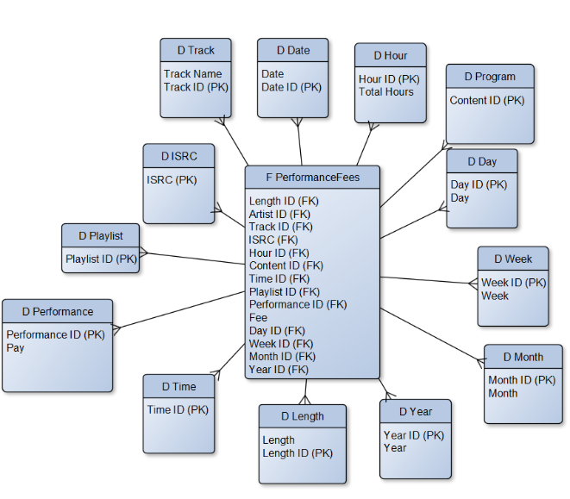The performance fee fact table refers to the Performing Rights Society (PRS), to which Recovery Radio must pay public performance fees to for music that plays. The PRS requires a complete record of the track played and details of the track, such as when it was played exactly (which is why the ISRC, time, date, day, week, hour, month, and year dimensions are connected to the fact table). Other details on the track needed are the track name, which is included as data on the track dimension, the amount paid for the performance is kept on the performance dimension. Information regarding the program and playlist are noted in their relevant dimensions as it is stated the playlists would be used for calculating performance fees.
Data Marts
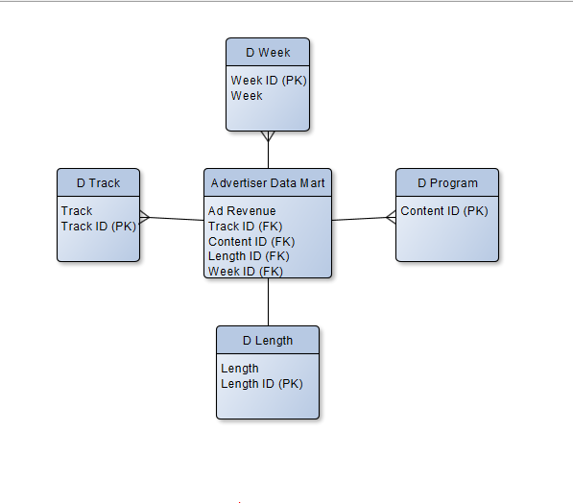
This is a data mart for the advertisers. The dimensions needed are the length, which is important for working out time slots, the program the ad is played on, the track that the ad assumes as well as what week it is shown – for financial reasons. The Ad revenue field is for working out the cost of the ad, and how much the radio will receive.
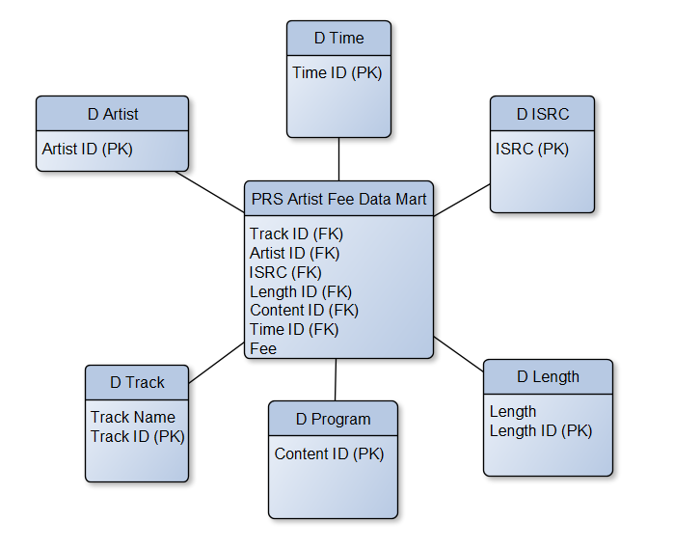This is the data mart for the PRS and calculating the fees an artist is entitled to be paid. This fee is calculated based on the length of the track, the track name, the time it is played and the program it is played on. The ISRC code is for identifying the track and record label.
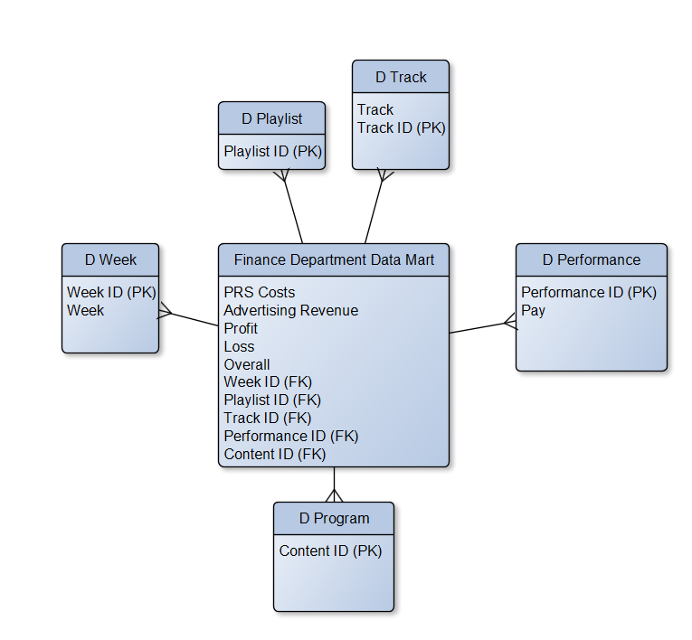 The finance department’s data mart contains data on and the overall profit and loss during a specific week, with the overall money earned/lost too (which is impacted by ad revenue and PRS payments). The week is identified using the week dimension. The popularity of specific tracks and playlists is identified via their dimensions, as is the program they were played on.
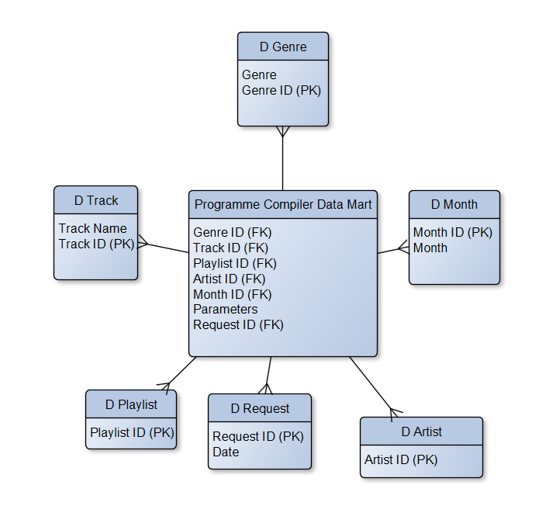The programme compiler exists to work out the popularity of certain songs, artists, and genres during specified months – based on this data, as well as the requests received, parameters are then altered to fit the new data in order to generate more relevant playlists.
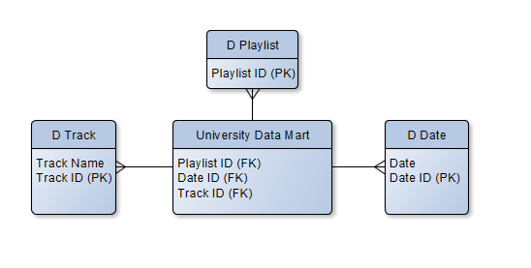The university uses data for their own study into the changing popularity of different types of music overtime, for this they are given data on playlists, tracks played, and the dates of the playlists and the dates certain tracks were played.

ETL Plan
Simplified ETL plans were drawn up for each data table in the database for Recovery Radio. Some of the data sources used to obtain info to populate the warehouse includes databases from third parties, flat files, and other dimensions. Primary Key fields (with one exception) are validated via an AutoNumber data validation rule, which obtains info for the primary keys by its corresponding position in a data table, which is determined by the order in which that field was created.
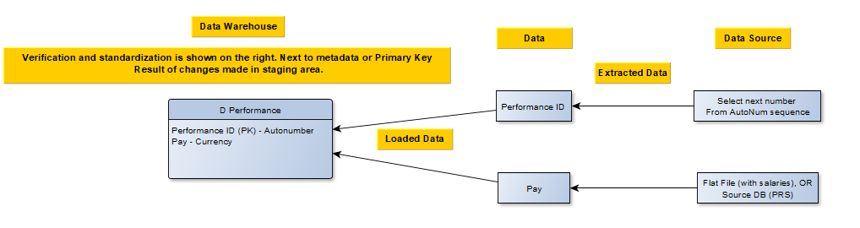
Next to the fields in the dimension is the data type that said field would be displayed as, this provides some validation to ensure the info remains consistent, and is input correctly, and uses as much disk space as necessary. The pay field’s data originates from a flat file containing the salaries meant to be given to the performer, alternatively it can be sourced from a third-party database, specifically that of the PRS – who themselves keep records of performing fees.
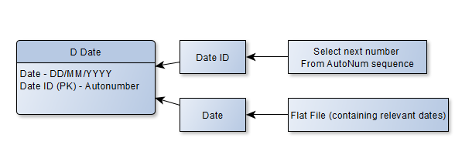 the metadata for the date uses a day-month-year format and is validated as so, originating from a flat file containing relevant dates.
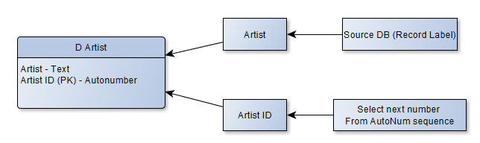 An archive of artists is kept by record labels who have signed the artists, their names follow a simple text format.
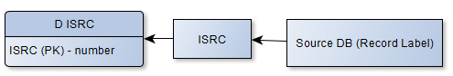 Each ISRC code does need to be unique from one another – however they do not follow a “1, 2, 3, 4” format as AutoNumber would have them generate as so. Information on the ISRC codes also comes from a third-party database.
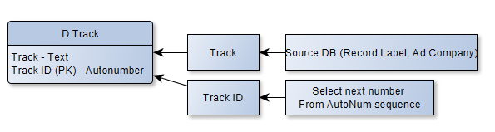 The metadata stored here is the track’s name in the “track” field, the info on the names originates from the third-party company who owns the track’s database. The track follows a regular text format allowing for a variety of characters to be used.
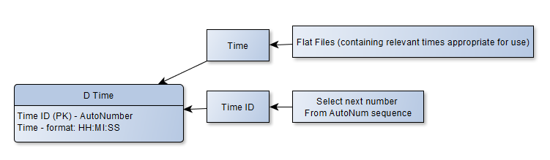 The time follows a data validation allowing data to only be entered in an appropriate time format. The time dimension is used for calculating fees based on when a presenter or artist is performing, this info can be sourced from general information regarding when an artist will be performing, a presenter’s contract, or a contract with a third-party company detailing when their ad will be on air.
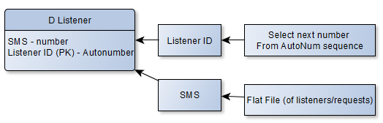 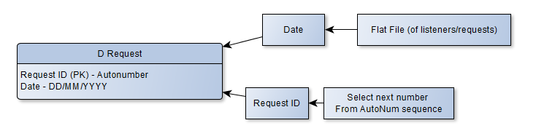The SMS of a listener is recorded when they call in to make a request. The info comes from a flat file with info regarding listeners who send in requests, as is info on the date of the request made.
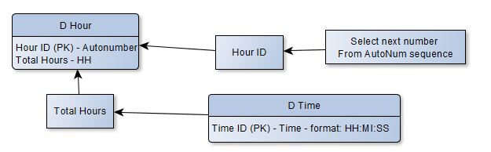 Info on the total hours comes from the time dimension. It is entered as just the hour portion of the time format. This is to save on characters used, saving disk space.
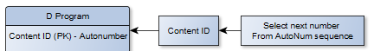
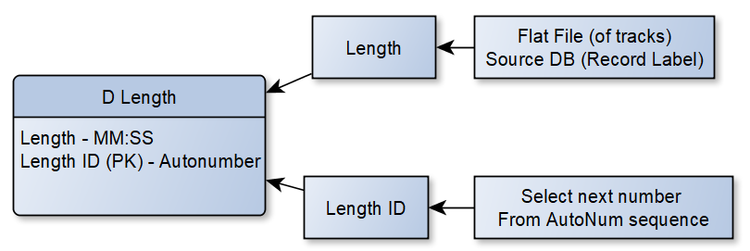 The data specifying the length of the tracks would come from a flat file with the track’s details but could also come from the database of the record label. The validation rule for length is minute:second, for consistency’s sake.
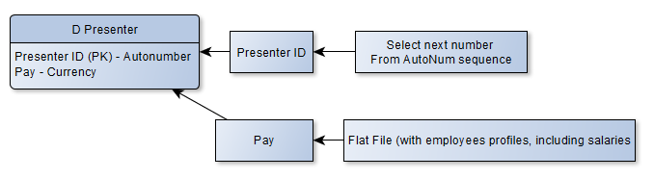 The salary of the presenter is kept on a flat file containing their employment information, or contract info if they were hired. This info being in an unstructured format, handed to Recovery Radio upon hiring.
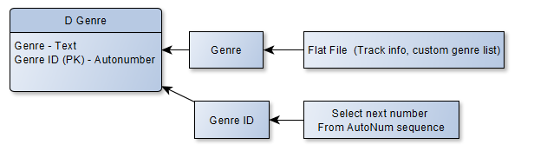 Music genres are generally pre-determined by a radio station themselves, with there existing no objective list of genres necessarily (for example, Prince falling under Pop, Rock and R&B genre categories depending on the music store or radio station). Recovery Radio may create their own genre list and determine themselves what certain artists/tracks may fall under.

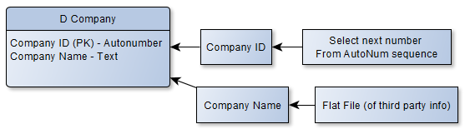 The flat file of third-party info specifically here would be the contract made for advertisements of said company to be played, or a contact list of clients.
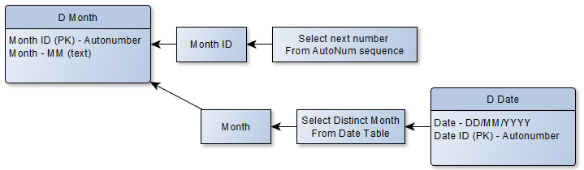 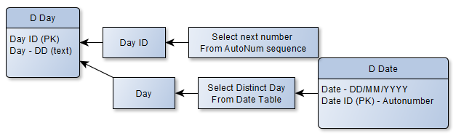 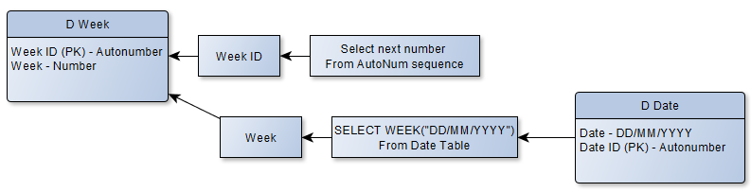 Information regarding the relevant week/day/month can be sourced from the date dimension, which has all the data on relevant dates to the warehouse. The format needs to be altered for weeks, as the weeks in a year are not in the DD/MM/YYYY format, an SQL code to source weeks from a correct date format would need to be used. 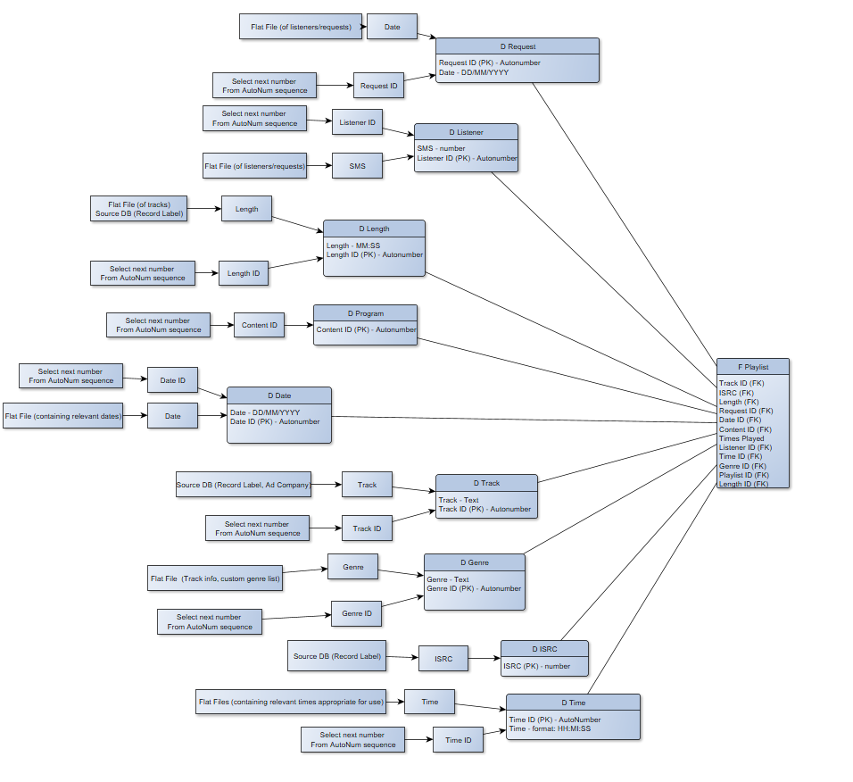
Word Count: 2999 Words
Bibliography
1. Bog A, Benchmarking Transaction and Analytical Processing Systems [Internet]. Google Books. 2021 [cited 13 October 2021]. Available from: https://books.google.co.uk/books?id=fV0NAAAAQBAJ&redir_esc=y
2. Application and System Performance Characteristics [Internet]. Docs.oracle.com. 2021 [cited 13 October 2021]. Available from: https://docs.oracle.com/cd/A87860_01/doc/server.817/a76992/ch3_eval.htm#2680
3. Nedim D and Clare S, An evaluation of the challenges of Multilingualism in Data Warehouse development - STORE - Staffordshire Online Repository [Internet]. Eprints.staffs.ac.uk. 2021 [cited 15 October 2021]. Available from: http://eprints.staffs.ac.uk/2770/
4. PINAR BAŞARAN B, Citeseerx.ist.psu.edu. 2021 [cited 22 October 2021]. Available from: https://citeseerx.ist.psu.edu/viewdoc/download?doi=10.1.1.463.1611&rep=rep1&type=pdf
5. Kimball R, Ross M. The Data Warehouse Toolkit [Internet]. Google Books. 2021 [cited 15 October 2021]. Available from: https://books.google.co.uk/books?hl=en&lr=&id=XoS2oy1IcB4C&oi=fnd&pg=PA1&dq=data+warehouse+dimensional+approach&ots=1DHdmHmQbC&sig=MSS8Nc2KrBBxCZN0YxGQM4Wo-8o#v=onepage&q=data%20warehouse%20dimensional%20approach&f=false
6. Baqer K, Identify the Different Between Database and Data Warehouse [Internet]. Lms.nuc.edu.iq. 2021 [cited 16 October 2021]. Available from: http://lms.nuc.edu.iq/journals/web/articles/DB%20and%20DW%20(1).pdf
7. Kour A, Data Warehousing, Data Mining, OLAP and OLTP, Technologies Are Indispensable Elements to Support, Decision-Making Process in Industrial World [Internet]. Citeseerx.ist.psu.edu. 2021 [cited 16 October 2021]. Available from: http://citeseerx.ist.psu.edu/viewdoc/download?doi=10.1.1.735.3208&rep=rep1&type=pdf
8. Renjith Kumar P, Next Generation Data Warehouse Design with OLTP and OLAP Systems Sharing same Database [Internet]. Research.ijcaonline.org. 2021 [cited 16 October 2021]. Available from: https://research.ijcaonline.org/volume72/number13/pxc3889282.pdf
9. Bontempo C, Zagelow G, The IBM data warehouse architecture | Communications of the ACM [Internet]. Dl.acm.org. 2021 [cited 17 October 2021]. Available from: https://dl.acm.org/doi/abs/10.1145/285070.285078
10. Denney M, Long D, Armistead M, Anderson J, Conway B. Validating the Extract, Transform, Load Process Used to Populate a Large Clinical Research Database [Internet]. NCBI. 2016 [cited 22 October 2021]. Available from: https://www.ncbi.nlm.nih.gov/pmc/articles/PMC5556907/
11. Simitsis A, Vassiliadis P, Sellis T. Optimizing ETL processes in data warehouses [Internet]. Ieeexplore.ieee.org. 2021 [cited 26 October 2021]. Available from: https://ieeexplore.ieee.org/abstract/document/1410172
12. Fulcher JA, Designing data marts for data warehouses | ACM Transactions on Software Engineering and Methodology [Internet]. Dl.acm.org. 2021 [cited 27 October 2021]. Available from: https://dl.acm.org/doi/10.1145/384189.384190
13. Finance Data Mart | Administrative Reporting & Analytics [Internet]. Admindata.yale.edu. 2021 [cited 27 October 2021]. Available from: https://admindata.yale.edu/support/finance-data-mart
14. Doherty K.A.J, Adams R.G, Davey N, Unsupervised Learning with Normalised Data and Non-Euclidean Norms, Uhra.herts.ac.uk. 2021 [cited 5 November 2021]. Available from: https://uhra.herts.ac.uk/bitstream/handle/2299/588/102107.pdf?sequence=1
15. Moody D. [Internet]. Neumann.hec.ca. 2021 [cited 5 November 2021]. Available from: http://neumann.hec.ca/sites/cours/6-060-00/MK_entreprise.pdf
16. SATYANARAYANA REDDY G, SRINIVASU R, POORNA CHANDER RAO M, REDDY RIKKULA S. [Internet]. Citeseerx.ist.psu.edu. 2021 [cited 5 November 2021]. Available from: http://citeseerx.ist.psu.edu/viewdoc/download?doi=10.1.1.301.5615&rep=rep1&type=pdf
17. Jarke M, Quix C, Blees G, Lehmann D, Michalk G, Stierl S, Improving OLTP data quality using data warehouse mechanisms | ACM SIGMOD Record [Internet]. Dl.acm.org. 2021 [cited 5 November 2021]. Available from: https://dl.acm.org/doi/abs/10.1145/304181.304568
18. Sidi E, Merouani M, Amin E. [Internet]. Citeseerx.ist.psu.edu. 2021 [cited 5 November 2021]. Available from: https://citeseerx.ist.psu.edu/viewdoc/download?doi=10.1.1.736.4061&rep=rep1&type=pdf#
19. Vassiliadis P, Data Warehouse Modeling and Quality Issues. [Internet]. Cs.uoi.gr. 2021 [cited 6 November 2021]. Available from: https://www.cs.uoi.gr/~pvassil/publications/PhD/pv_eng_phd.pdf
20. Ponelis S, Britz J. Comparative analysis of the use of data marts in two different manufacturing organizations [Internet]. South African Journal of Information Management. 2003 [cited 11 November 2021]. Available from: https://sajim.co.za/index.php/sajim/article/view/341
21. Nabli A, Feki J, Gargouri F. Automatic construction of multidimensional schema from OLAP requirements [Internet]. Ieeexplore.ieee.org. 2021 [cited 18 November 2021]. Available from: https://ieeexplore.ieee.org/abstract/document/1387025
22. Dedić N, Stanier C. An Evaluation of the Challenges of Multilingualism in Data Warehouse Development [Internet]. Nedimdedic.com. 2021 [cited 18 November 2021]. Available from: http://www.nedimdedic.com/wp-content/uploads/2016/01/An-Evaluation-of-the-Challenges-of-Multilingualism-in-Data-Warehouse-Development-ICEIS-2016-Dedic_Stanier.pdf
23. Nurmalasari D, Zulvi MS, Hanifah P. Performance Analysis Of Star Schema Data Modeling On Library Data. Jurnal Komputer Terapan. 2019 Nov 29;5(2):44-53. [cited 18 November 2021]. Available from: https://jurnal.pcr.ac.id/index.php/jkt/article/view/3341

