Decisions in Python 3 (if… and/or…)

We have already seen the use of conditions on if statements. However, we can also have multiple conditions.

and

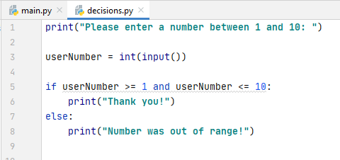

Result - In range (if)
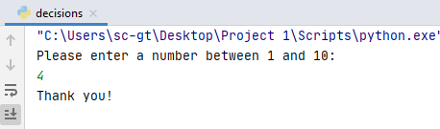

Result - Out of range (else)
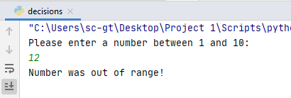

In this example, both conditions must be satisfied (and):

So for 4:
4 is greater than 1 4 is less than 10

Note: When programming, I would also test on the boundaries of conditions – ie 1 and 10. This is because I might have "between 1 and 10" in my mind and forget that I meant to include both 1 and 10. Natural languages such as English are less precise, because we infer the meaning from usage. But when programming, we need to be more precise.

If I write the following, only number 2-9 will meet the condition:

I should therefore test the program's boundaries (1 and 10) to make sure, and adjust my code if it doesn't behave as expected.

or

In multiple conditions with or, only one of the conditions might be true. If I take the previous example, I can write the logic slightly differently:

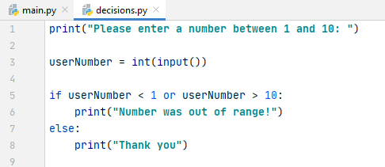

This time, I am checking to see whether the number is out of range:

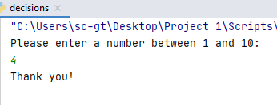

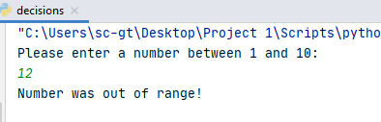

In the case of 12 the following happened:

12 is not less than 1 X 12 is greater than 10

Only one condition has to be true when it is or.

or example 2

This is a light-hearted example, but hopefully illustrates the use of or:

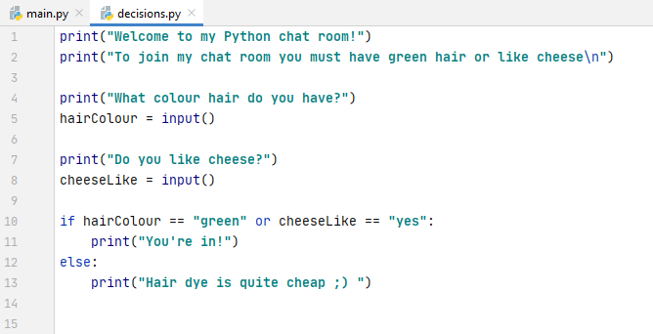

In this case you must answer "yes" to having green hair or liking cheese – or both. Or only requires one condition to be true, but it is fine if they both are.

Green hair/no cheese: (1 condition satisfied)
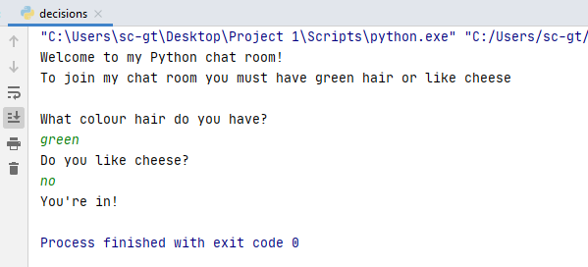

Blue hair/yes cheese (1 condition satisfied)
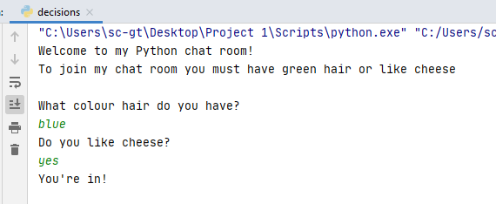

Green hair/yes cheese (both conditions satisfied – still OK for or)
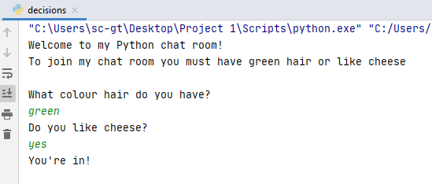

Neither condition satisfied, so Python goes to else:
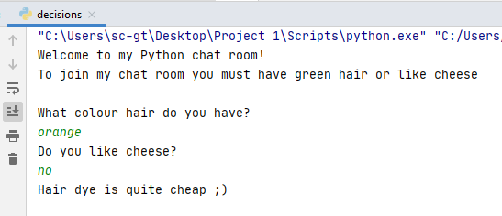

Note: I might extend my conditions to allow for people typing "y" or "n" instead of yes and no. I always need to anticipate what a user might do and account for it in my code

When conditions start getting long, use brackets to keep the logic on track

Either hairColor should be green or one of these should be true

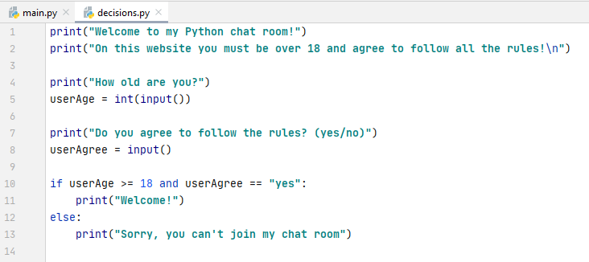

In this case, the user needs to be over 18 (ie "18 or over") and agree to the rules. If they fail to do meet one (or both!) of these things they cannot join.



