ACDB6020 – LAB #1 FT-IR Analysis and Identification of Organic Materials

Samuel Hawkins¹

¹ UWTSD IQ Campus, Waterfront, IQ Campus University of Wales Trinity, Swansea SA1 8EW, UK; 2216506@student.uwtsd.ac.uk

Contents
1. Abstract 1
2. Introduction 2
3. Results 5
4. Discussion 8
5. Conclusion 13
References 14
Annex 15

Table of Figures
Figure 1 – Fourier Transform Infrared Spectroscopy [2] 3
Figure 2 - Exported Results [Annex B] 5
Figure 3 - Sample A 6
Figure 4 - Sample B 6
Figure 5 - Sample C 7
Figure 6 - Sample D 7
Figure 7 - Sample C Transmittance [Annex B] 8
Figure 8 - Reference Spectra Methyl 3-Nitrobenzoate [7] 9
Figure 9 - Sample A Transmittance [Annex B] 9
Figure 10 - Reference Spectra Ascorbic Acid [8] 10
Figure 11 - Sample B Transmittance [Annex B] 10
Figure 12 - Reference Spectra Guanidine [9] 11
Figure 13 - Sample D Transmittance [Annex B] 12
Figure 14 - Reference Spectra Paracetamol [10] 12

Table of Tables

Table 1 - Samples 4

Abstract

  - This lab report captures the process to safely setup, operate and clean an FT-IR machine. Through interpreting results, particular functional groups and fingerprint molecules has been identified allowing for four unknown samples from a list to be successfully determined demonstrating the effectiveness of FT-IR and how it can be related to an OME setting in identifying explosive materials.

Introduction

  - The purpose of this lab report is demonstrating the principles of spectrometry by introducing Fourier Transform Infrared (FT-IR) spectroscopy to analyse unknown samples and determine what they are and how these principles can be related to an OME setting.

  - The hypothesis for this lab is “Can FT-IR spectroscopy be reliably used to identify unknown organic materials through comparison with reference spectra data?”

  - Throughout this experiment there are different variables that need to be considered. Dependant variable is what is being measured, which is the functional groups and substituents of each sample. Control variables are what must remain the same, the preparation and de-prep, steps to use the FT-IR equipment.

  - FT-IR is a method of infrared spectroscopy where IR radiation is sent through the sample where the transmittance or the absorbance is measured to determine what molecules make up the compound being tested. The energy provided equates to the energy needed to transition between vibrational states of functional groups, this produces the spectrum showed by peaks or bands to which groups can be determined.

  - Absorbance is where the FT-IR machine measures how much radiation is absorbed by the sample. Expressed as A = -log10(T) where T is transmittance. [1]

  - Transmittance is where the FT-IR machine determines the fraction of incident radiation that passes though the samples without being absorbed. Expressed as T = I/I0 where I is light intensity of transmitted light and I0 is the intensity of incident light. [1]

  - Functional Group in a molecule is what determines its characteristic chemical reaction. On the infrared spectrum is typically between 4000 and 1500 cm-1.

  - Fingerprint region is characterised by bands that are unique to each compound. On the IR spectrum between 1500 to 500 cm-1.

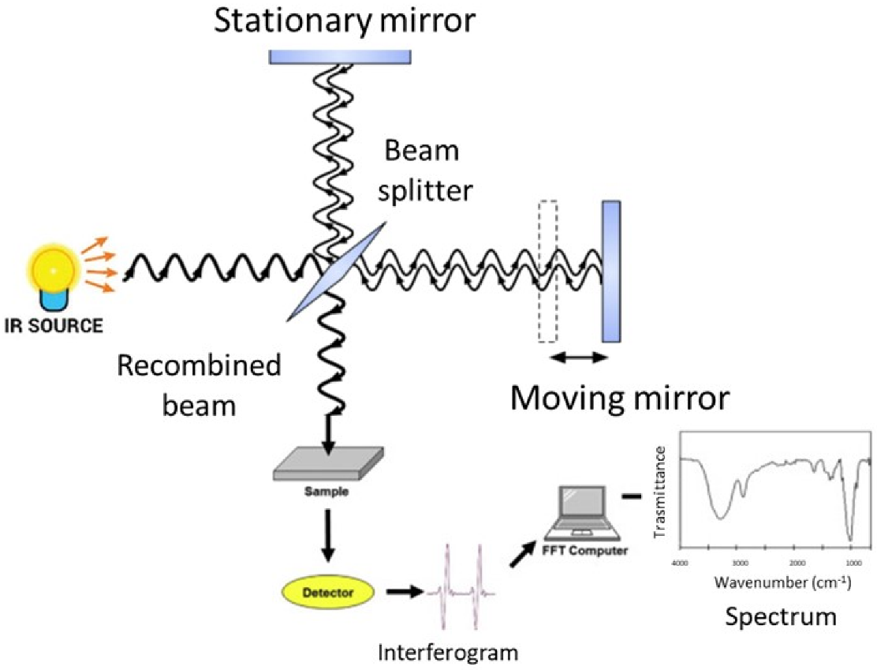
Figure 1 – Fourier Transform Infrared Spectroscopy [2]
  - The main tasks are:

- Understand the underlying principles of spectrometry and FT-IR
- Follow the steps to prepare and use FT-IR machine
- Clean down the machine
- Collect and export results
- Identify functional groups and fingerprint compounds
- Compare data to established reference spectra
- Identify which unknown sample is which from the list provided

  - The equipment used in the procedure are [Annex A]:

    - Latex Gloves
    - Goggles
    - Lab Coat
    - Samples A, B, C and D
    - Perkin Elmer FT-IR Spectrum 2 UATR 2
    - Computer with Spectrum Software
    - Micro spatula

  - The procedure is:

    - Prepare testing area and equipment; calibration of FT-IR and readying samples and wear personal protective equipment (gloves, goggles and lab coat)
    - Clean down equipment with IPA
    - Add sample
    - Swing anvil into position and torque until sample is under pressure and ratchet of anvil engages
    - Run sample through the FT-IR
    - Remove sample and clean down equipment
    - Save sample results to computer for export
  - For this experiment, four samples were provided in an unknown order. These were:

Table 1 - Samples
Name | Skeletal Formula | Features and Use
Guanidine | 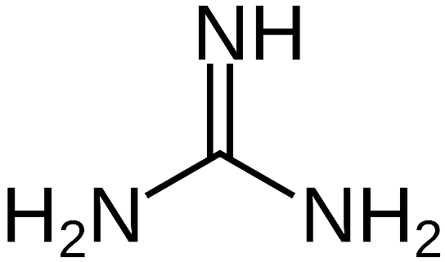 [3] | Prominent features of Guanidine are the NH₂ groups and the double bond of C=NH. Guanidine is an organic compound used in the manufacture of explosives.
Acetaminophen | 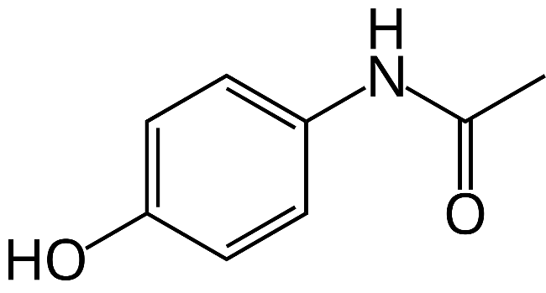 [4] | Also known as Paracetamol, it is a typical over the counter medicine. Features a phenol ring.
Ascorbic Acid | 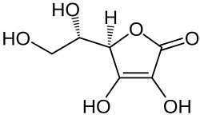 [5] | Also known as vitamin C, is important in healthy human functions. Features multiple hydroxyls attached and a lactone.
Methyl 3-Nitrobenzoate | 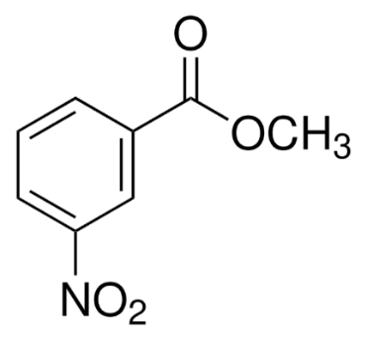  [6] | Features a benzene ring and attached nitro group. Used in pharmaceuticals, dyes and more.

Results

  - After running four samples through the FT-IR using the specified method above the raw results were collected and exported from the machine into an excel spreadsheet as seen below. The results show the wavenumber range from 4000 to 500cm⁻¹ with 15 scans at a resolution of 4cm⁻¹.

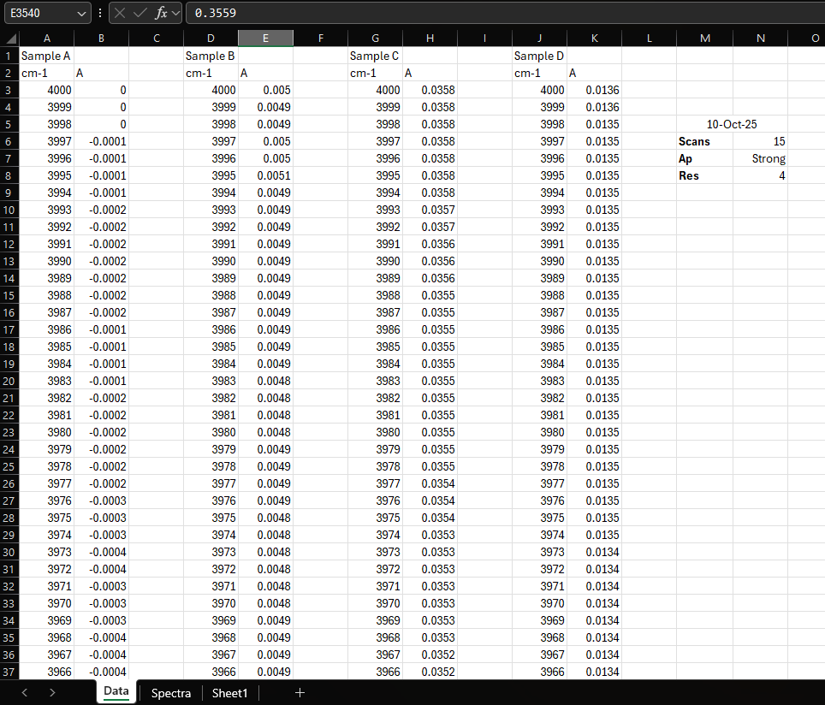
Figure 2 - Exported Results [Annex B]

  - To be able to better interpret the data, the values were taken and used to create line graphs to enable peaks and bands to be shown in each sample. This will allow for functional groups and fingerprint compounds to be identified, which have been annotated revealing what each sample is.

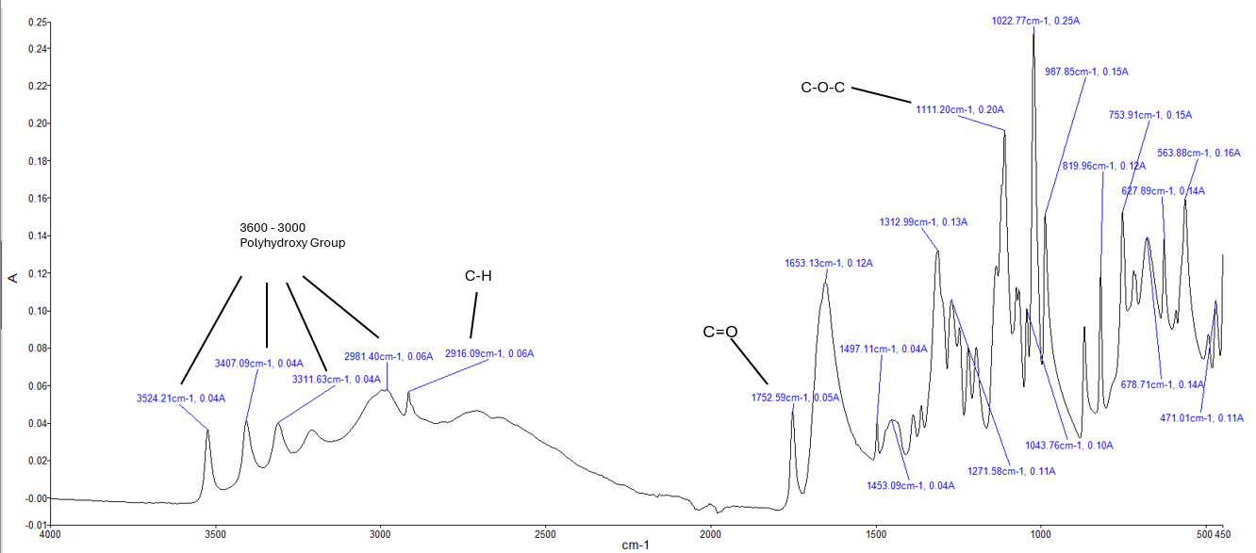
Figure 3 - Sample A
  - Sample A shows a polyhydroxy group between the range of 3600-3000cm⁻¹ as well as the C=O and C-O-C representing the cyclic ester lactone.

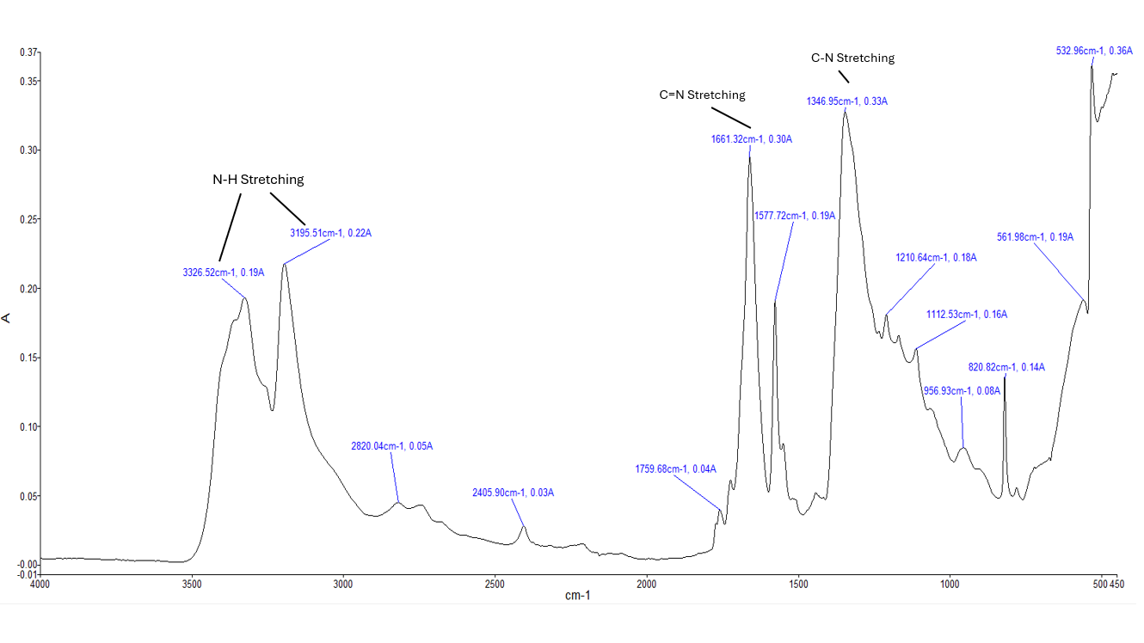
Figure 4 - Sample B
  - Sample B shows two peaks at 3326 and 3195cm⁻¹ where N-H are stretching. Also, at 1661cm⁻¹ there is C=N stretching. Compared to other compounds this one has fewer peaks. At 1346cm⁻¹ this peak is likely associated with C-N stretching vibrations within the guanidine group.

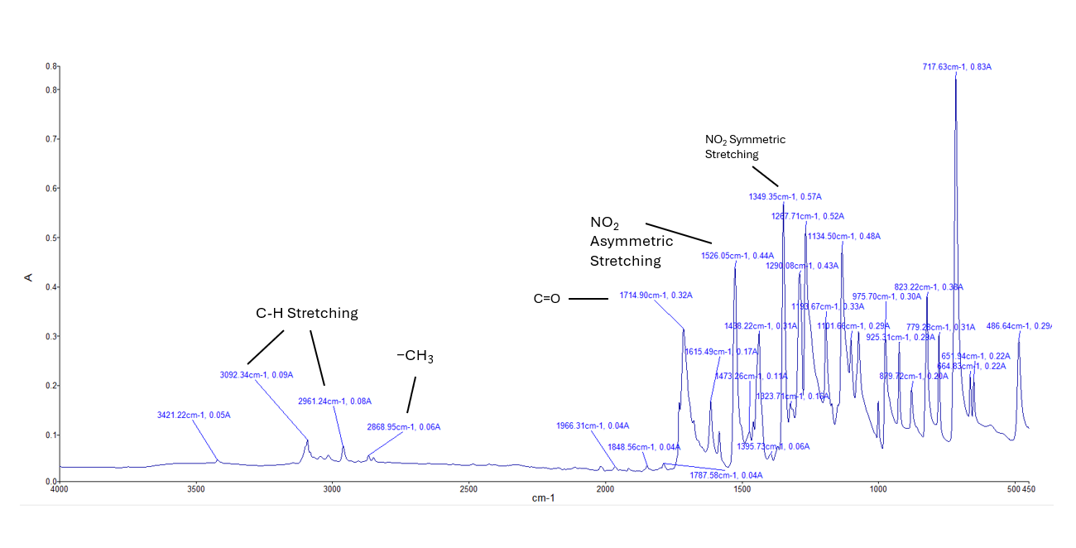
Figure 5 - Sample C
  - Sample C shows the C-H stretching at 3092 and 2961cm⁻¹ corresponding to methyl. The 1714cm⁻¹ peak shows the carbonyl of the methyl ester. The standout is the NO2 asymmetric and symmetric stretching at 1526 and 1349cm⁻¹ peaks.

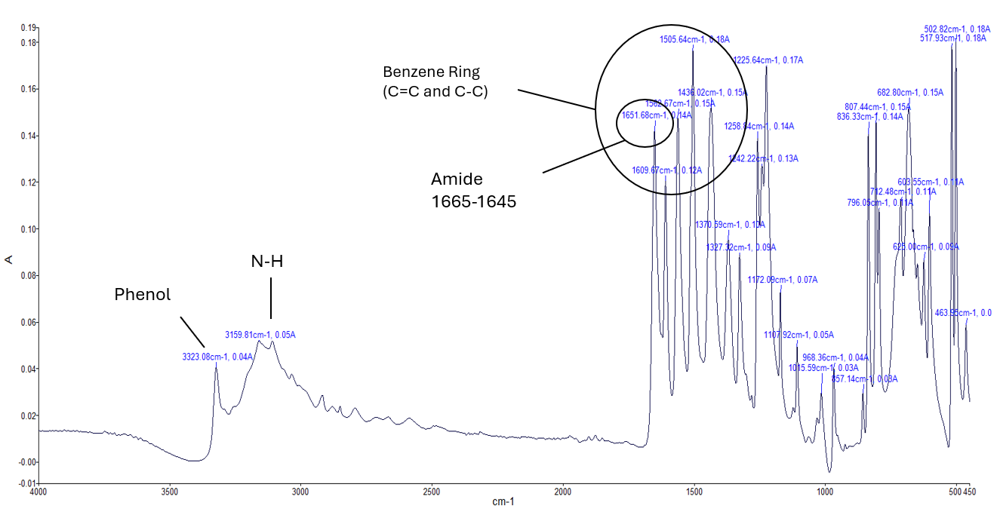
Figure 6 - Sample D
  - Sample D shows a phenol and N-H within the functional group area and a Benzene ring spanning 1600 -1450cm⁻¹. This is due to the presence of the C=C stretching. In addition, at the 1665 and 1645cm⁻¹ an amide has been found.

Discussion

  - In this section, reasoning will be explained for how each sample was determined through identifying peaks from functional and fingerprint regions. Comparisons will be made to reference spectra where possible.

  - The majority of literature readily accessible is conducted in Transmittance (T), as such the raw data has been processed using a formula (10^(A)*100) to convert Absorbance into Transmittance as shown in the following graphs. Doing this allows for better visualisation of the results and makes for an easier comparison showing where the recorded data matches with other experimental data used as reference spectra.

  - Looking at the results from the various samples, sample C can easily be identified as Methyl 3-Nitrobenzoate as it is the only compound that has a nitro group (NO₂) that exhibits asymmetric/symmetric stretching at that wavenumber as seen in figure 5.

  - Figure 7 below shows the spectra data for sample C in transmittance. When compared to Figure 8 shows similar peaks in both the functional and fingerprint region.

Figure 7 - Sample C Transmittance [Annex B]
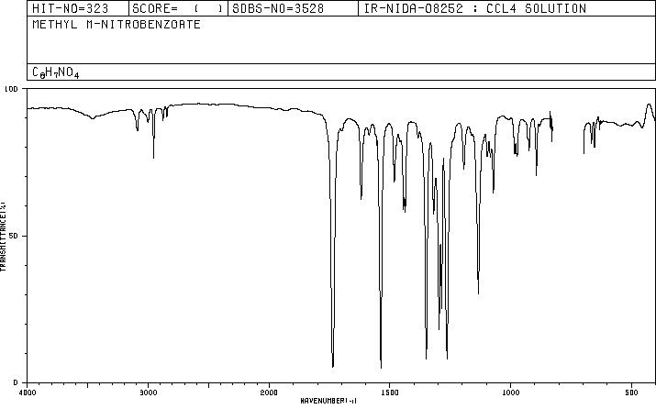
Figure 8 - Reference Spectra Methyl 3-Nitrobenzoate [7]
  - The next most obvious sample is A being Ascorbic Acid. The reasoning for this is in figure 3 shows the polyhydroxy group between the range of 3600-3000cm⁻¹ and the C-O-C bond only seen in Ascorbic acid. See figure 9 and 10 showing extremely similar peaks within the same wavenumber ranges.

Figure 9 - Sample A Transmittance [Annex B]
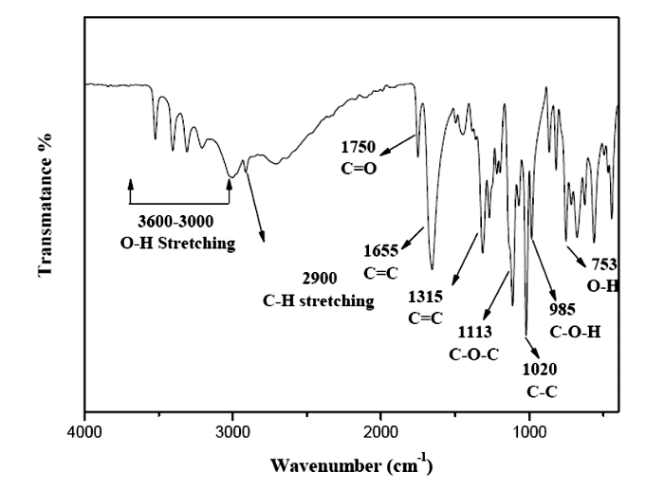
Figure 10 - Reference Spectra Ascorbic Acid [8]
  - Sample B is Guanidine. Shown by figure 4. Through process of elimination and lack of hydroxyl groups and abundance of nitrogen/amide groups. Also, at 1346cm⁻¹ this peak is likely associated with C-N stretching vibrations within the guanidine group. Both figures 11 and 12 show the broad peaks around 3341 and 3267cm⁻¹ indicating the N-H stretching.

Figure 11 - Sample B Transmittance [Annex B]

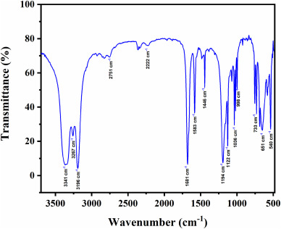
Figure 12 - Reference Spectra Guanidine [9]

  - Sample D is Acetaminophen. Shown by figure 6. shows a phenol and N-H within the functional group area and a Benzene ring spanning 1600 -1450cm-1. This is due to the presence of the C=C stretching. In addition, at the 1665 and 1645cm-1 an amide has been found. Comparing figure 13 and 14 shows similar peaks in the functional and fingerprint region.

Figure 13 - Sample D Transmittance [Annex B]

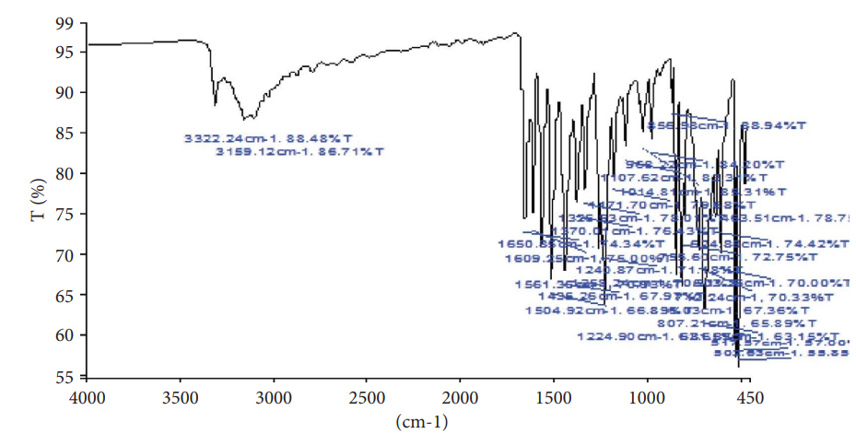
Figure 14 - Reference Spectra Paracetamol [10]
  - It can be seen that the results collected differs from that of reference data from the literature search. There can be many reasons for this, such as possible contamination of the samples either at manufacture, storage or when testing and lack of verification of the sample’s purity. This means that there is no assurance that the sample contains exactly what is being tested. This relates to OME as contamination can be introduced at these steps and verification of the energetic is important to know that the munition is produced correctly and can provide assurance through testing that it is safe and suitable for service.

  - A Limitation of this experiment is that we only ran each sample once instead of multiple times to collect more reliable data. Also, this could correct baseline drift from temperature fluctuations.

Conclusion

  - Based on the results and discussion sections, the samples have been identified as:

    - Sample A = Ascorbic Acid
    - Sample B = Guanidine
    - Sample C = Methyl 3-Nitrobenzoate
    - Sample D = Acetaminophen

  - By conducting this experiment, it can be concluded that the hypothesis has been tested as and proven that FTIR can be used to identify organic compounds.

References

[1] | R. M. Labs, “Difference between absorbance and transmittance in ftir,” Rocky Mountain Labs, 11 December 2023. [Online]. Available: https://rockymountainlabs.com/difference-between-absorbance-and-transmittance-in-ftir/#:~:text=Relationship%20between%20Absorbance%20and%20Transmittance,This%20relationship%20is%20logarithmic. [Accessed 21 October 2025].
[2] | B. Faramarzi, M. Moggio, N. Diano, M. Portaccio and M. Lepore, “A brief review of FT-IR spectroscopy studies of sphingolipids in human cells,” Biophysica, vol. 3, no. 1, pp. 158-180, 2023.
[3] | wikipedia, “Guanidine,” wikipedia, [Online]. Available: https://en.wikipedia.org/wiki/Guanidine. [Accessed 21 October 2025].
[4] | wikipedia, “Paracetamol,” wikipedia, [Online]. Available: Paracetamol - Wikipedia. [Accessed 21 October 2025].
[5] | wikipedia, “Vitamin C,” wikipedia, [Online]. Available: Chemistry of ascorbic acid - Wikipedia . [Accessed 21 October 2025].
[6] | sigmaaldrich, “Methyl 3-nitrobenzoate 99 618-95-1,” Merck, [Online]. Available: https://www.sigmaaldrich.com/GB/en/product/aldrich/155977?srsltid=afmboorkys2otglqicjbvojitscfnk0dskgvqxetdkcrpv0ailsk16z%3D. [Accessed 21 October 2025].
[7] | ChemicalBook, “Methyl 3-nitrobenzoate(618-95-1) IR1,” ChemicalBook, [Online]. Available: https://www.chemicalbook.com/SpectrumEN_618-95-1_ir1.htm . [Accessed 22 October 2025].
[8] | A. A. Ebnalwaled, H. A. Said, M. M. Mahmoud and M. YasserAlsedfy, “XRD and ftir of ascorbic acid and monosodium glutamate food additives,” International Journal of Research Publication and Reviews, pp. 2155-2159, 2022.
[9] | Kiran, N. Vijayan, N. Sarkar, D. Joshi, Jyoti, K. Kumar, S. Yadav and S. Das, “Unveiling the optical, thermal and nonlinear behavior of guanidinium benzenesulfonate: A promising organic single crystal for NLO applications,” Optical Materials, vol. 147, 2024.
[10] | S. L. Kipo, N. Kuntworbe, M. E. Boakye-Gyasi, Y. A. Osei, F. W. Owusu, R. Johnson, K. Ofori-Kwakye and M. T. Bayor, “Evaluation of the Physicochemical and Micromeritic Properties of Exudate Gum of Cussonia arborea Stem Bark in Conventional Tablet Forumula,” Journal of Chemistry, vol. 2024, pp. 1-15.

Annex

Annex A – Lab Sheet

Annex B – FTIR Results

