
BA Business Management
Carmarthen Business School
How the Digital Medium Revolutionized Marketing for SMEs
Undergraduate Dissertation
Author:
Student Number:
Module Code: SBUS6108
Supervisor: Dr. Alex Bell
Date: 15/05/2017

Declaration Form

In submitting this dissertation, I confirm the following;

- This work has not previously been accepted in substance for any degree and is not being concurrently submitted in candidature for any other degree.
- This thesis is the result of my own investigations, except where otherwise stated. Other sources are acknowledged by footnotes giving explicit references. A bibliography is appended.
- This dissertation is being submitted to fulfil the requirements for the degree of BA Business Management.
- I give my consent for my dissertation, if accepted to be deposited in the Schools dissertation library.

Name:
Signed: ______________
Date of Submission: 15th May 2017

Acknowledgment
I would like to start by thanking all the lecturers at the University of Wales Trinity Saint David in Carmarthen who have been a great help throughout my 3 years of study. I would like to thank my dissertation supervisor Dr. Alex Bell for his assistance and guidance from start to finish from picking a suitable dissertation topic to showing me the path to take with my work.
The participants in my questionnaire are also people that I want to express my gratitude to, who took 5 minutes out of their day to complete my questionnaire and return it in such a brief period. Their assistance has allowed me to gather a greater insight into how the digital medium has revolutionised marketing for them and has enabled me to complete this study.
I would also like to thank my friends and family who have given me support through this dissertation and general study at University.

Abstract
It is said that the greatest development of mankind was language, today an equally momentous development faces the world – the digital media revolution. This offers both opportunities and challenges to individuals and businesses. Are SMEs aware of this movement and do they view this as an opportunity to embrace?
The research, collected from both primary and secondary sources goes some of the way to answering this question. This data was used to clarify the intricacy of this form of media and to provide an insight into the use of the assorted digital media by SMEs in a rural area in West Wales.
This study provides recommendations for these businesses regarding their future development of digital marketing, and provides constructive advice for those who had previously not been completely convinced of the benefits.

Contents
Declaration Form 0
Acknowledgment 0
Abstract 0
1 Introduction 1
2 Literature Review 3
2.1 What is the digital medium? 3
2.2 Marketing through the digital medium 3
2.3 World Wide Web (WWW) 5
2.4 E-Business 8
2.5 Emails 8
2.6 Social Media 10
2.7 Online Communities 13
2.8 Websites 13
2.9 E-Commerce 15
2.10 Digital Capabilities in SMEs: Evidence Review and Re-survey of 2014 Small Business Survey respondents 16
2.11 Factors Affecting Digital Technology Adoption 17
2.12 Digital Strategy SME’s v Larger Businesses 17
2.13 Why should digital marketing be embraced? 18
3 Research Strategy and Methodology 20
3.1 Research Aims and Objectives 20
3.2 Planning 20
3.3 Research Overview 20
3.4 Research Design 21
3.5 Secondary Research 22
3.6 Questionnaires 22
3.7 Logistical and ethical considerations 23
4 Findings and Analysis 24
4.1 Results 24
4.1.1 Chart - Number of businesses using digital tools 24
4.1.2 Chart - Social marketing use 25
4.1.3 Chart - How is digital marketing sourced 25
4.1.4 Chart - Use of social media 26
4.1.5 Table - E-commerce current usage 26
4.1.6 Chart - E-commerce future development 27
4.1.7 Chart - Has digital marketing increased turnover? 27
4.1.8 Chart – Do you agree “Our use of digital media will increase in the next 5 years.” 28
4.1.9 Table - Estimate what percentage of the marketing budget goes into digital marketing 28
4.1.10 Chart - Do you agree that “More of your marketing budget will go into digital marketing in the future” 29
4.1.11 Chart - Do you see a time when you will rely solely on digital marketing? 29
4.1.12 Chart - How long has the company been trading 30
4.1.13 Chart - Number of employees 30
4.1.14 Table - Would you recommend digital marketing to others 31
4.1.15 Chart - Years in business VS Social media use 31
4.1.16 Chart - Increased turnover / Years trading 32
4.1.17 Chart - More of the marketing budget to digital media compared with number of employees 32
4.1.18 Chart - Businesses Categories Studied 33
4.2 Analysis 33
5 Discussion 36
6 Conclusion 40
6.1 Recommendations 41
6.2 Advice for further study 42
7 References 43
8 Bibliography 51
Appendices 52
Appendices A 52
Appendices B 53
Appendices C 54
Appendices D 55
Appendices E 56
Appendices F 57
Appendices G 58
Appendices H 59

Introduction
It has been said that the greatest development of mankind was language, this allowed for communication on a higher level. (Kiani, 1998) With that in mind, the last 26 years has seen a development that allows individuals to communicate with other individuals anywhere in the world at any time of the day or night, through the use of the digital medium. The first web page was posted 26 years ago, on the 6th of August 1991, by Sir Tim Berners-Lee and a team of engineers from CERN. (Athow, 2011) This international communication network became known as the World Wide Web.
The development of technology during the last three decades is unprecedented. Households have access to the internet through multiple platforms, personal computers, laptops, televisions and even on their mobile phones. Growth of e-commerce through these various platforms in the UK in 2016 was 12 per cent. (Chaffey, 2015)
The digital economy is of increasing importance to the UK economy, to businesses and organisations, including SME’s. Businesses are encouraged to utilise these technologies to enhance and expand their exposure, new customers, new markets are out there waiting for the services and products these companies have to offer.
In view of the progress in this field in the last thirty years, the researcher has decided to investigate these developments from the viewpoint of the rural small to medium sized business. The researcher has made the decision to give this project the working title “How has the Digital Medium Revolutionised Marketing for SMEs? The title emphasises what the researcher wants to discover from this study.
The researcher also feel strongly that businesses should have a better understanding of digital media, it is the intention of this study to inform as well as investigate.
A study undertaken in Finland in 2014 ‘Explaining the internet usage of SMEs’ (Caniëls , et al., 2015) together with research done by the Department of Business Innovation and Skills published in September 2015 provided the researcher with the impetus to look at SME’s in the local area and see whether they had embraced the ’digital revolution’. (GOV, 2014)
In the words of Michael Porter from an article ‘Strategy and the Internet’ (2001) in the Harvard Business Review, the use of digital marketing is no longer an ‘if’. (Porter, 2001)
“The key question is not whether to deploy Internet technology—companies have no choice if they want to stay competitive—but how to deploy it.”
The researcher wants to see if this is truly the case, particularly when looking at the small to medium sized sector in West Wales. SME’s accounted for 99.3 per cent of business in the private sector at the start of 2016 and therefor play a huge role in the UK economy with a combined annual turnover of £1.8 trillion. It is important therefor that they are implementing this technology and developing the appropriate skills. (National Federation of Self Employed & Small Businesses Limited, 2016)
Digital marketing is felt to be very current, with the rapid growth in social media and access to superfast broadband, it is an area that has huge potential. This research will look to see if these opportunities are being utilised by the small to medium sized businesses being scrutinised in this study. Once this information has been collected the researcher will be able to see whether the secondary data available shows the same results as the data which has been gathered and analysed first hand?
The area to be covered by this dissertation relates primarily to marketing, and how it has been revolutionised by the development of digital marketing with the emphasis on small to medium sized businesses.
To evaluate the findings from the primary research it has been necessary to look at the data available regarding the digital world. All aspects relating to the study have been researched, clarification of what each involves, and a number of statistics have been included. These statistics have been used to show the relevance of the digital revolution to all businesses, regardless of size.
Shown below are the points that form the basis to the research undertaken.
What changes have SMEs made to the way in which they market their businesses, since digital media became accessible to everyone?
Which forms of digital media have been incorporated into the marketing strategy of these businesses?
Are the businesses aware of the value of using social media to interact with customer and to what level?
Has this changed the way they spend their marketing budgets?
How have these changes impacted their customers and the businesses relationship with their customers?
Has the way they trade been affected? (Selling online for example.)
A literature review has been conducted and the information gathered allowed the researcher to compile a questionnaire which was issued to 101 businesses in the local area. The researcher then looked specifically at the information studied during the literature review with the data from the 68 organisations that responded in mind. It is intended to view the various digital mediums and the benefits offered to both customers and the organisation, the primary focus being on the business.
Recommendations will be made as to how the businesses studied can continue to progress with this medium.

Literature Review

What is the digital medium?
This can be defined as audio, video, text or graphics which have been digitized (WikiSpaces, 2011) , this data can then be transmitted over the internet or computer network. This is achieved through the conversion of analogue data to a digital format. The digital world is now as much a part in the lives of individuals as having breakfast. Digitization, particularly of social media, has metamorphosed consumer behaviour (Kaplan & Haenlein, 2010) with significant implications for businesses, products, and brands (Muntinga et al. 2011; Wymbs 2011). (Lipiäinen, 2014)
A global snapshot of digital users as shown below provide shows the extent of the opportunities available to businesses who utilise this medium.
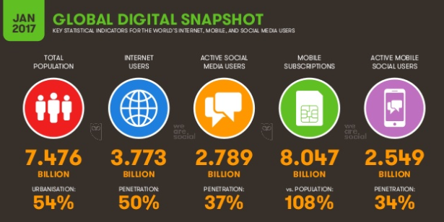
(Smart Insights, 2017)

Marketing through the digital medium
The digitisation of interactions between individuals, and between organisations and their clients has provided significant challenges to business. (Lipiäinen, 2014) These challenges can have substantial implications for organisations, these can be financial, technical and skill related. One of the big changes to businesses in the digital era is having to balance their marketing budgets, how much is allocated to digital marketing and how much to conventional forms.
The chart below shows marketing spending forecast for 2015 with the shares allocated to traditional and digital marketing, the UK is leading the field with regards to the use of the digital medium. (Glennie, 2015)
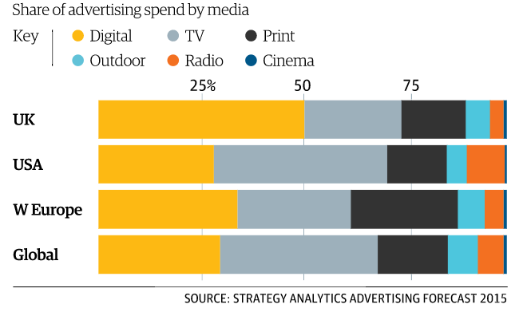
(Brown, 2015)
The chart below shows the results of a study of global Digital Trends undertaken by Econsultantcy in association with Adobe in 2017, the data covers 2017 and the two previous years.
To what extent does digital permeate your own organisation’s marketing activities?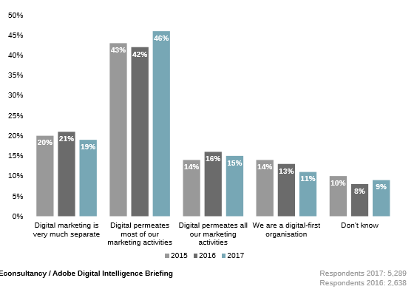
(Econsultancy London, 2017)
For the purpose of this study the decision has been made to focus on three specific elements, those of emails, websites, and social media. Search optimisation and content marketing have been not been included for the purpose of this research but it is an area that can be developed once a business has got to grips with the fundamentals.
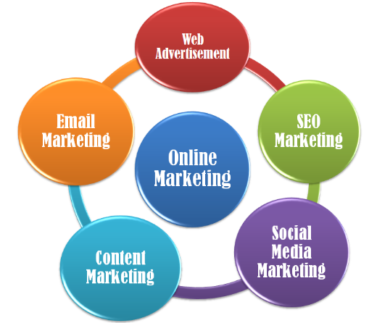
(SI Fitures, 2017)

World Wide Web (WWW)
Twenty-six years ago, on the 6th of August 1991 we saw the beginning of the World Wide Web. Scientists initially used it to share data and collaborate on projects. Today, however, it is used by more than 7 billion people across the world. The WWW has provided companies with the possibility of increasing their hours of business and on a global scale. Instead of a typical forty-hour week, businesses have increased their trading hours by providing 24-hour access, to customers, clients, and business contacts through the use of the digital medium. This provides exposure to a global market for even the smallest of businesses, both to the prospective customer but also to new suppliers and contacts. (G., 1998)

The chart below shows the data for population on a regional basis, it also shows the number of internet users in that area and the level of penetration in comparison to population. The other notable data is that of growth, we can see that since the year 2000 global growth is over 900 per cent.

WORLD INTERNET USAGE AND POPULATION STATISTICS
MARCH 25, 2017 - Update
World Regions | Population  (2017 Est.) | Population % of World | Internet Users 31 Mar 2017 | Penetration Rate  (% Pop.) | Growth 2000 - 2017 | Users % Table
Africa | 1,246,504,865 | 16.6% | 345,676,501 | 27.7% | 7,557.2% | 9.3%
Asia | 4,148,177,672 | 55.2% | 1,873,856,654 | 45.2% | 1,539.4% | 50.2%
Europe | 822,710,362 | 10.9% | 636,971,824 | 77.4% | 506.1% | 17.1%
Latin America / Caribbean | 647,604,645 | 8.6% | 385,919,382 | 59.6% | 2,035.8% | 10.3%
Middle East | 250,327,574 | 3.3% | 141,931,765 | 56.7% | 4,220.9% | 3.8%
North America | 363,224,006 | 4.8% | 320,068,243 | 88.1% | 196.1% | 8.6%
Oceania / Australia | 40,479,846 | 0.5% | 27,549,054 | 68.1% | 261.5% | 0.7%
World Total | 7,519,028,970 | 100% | 3,731,973,423 | 49.6% | 933.8% | 100%
(Internet World Statistics, 2017)
It is also interesting to note that there is still significant room for development especially in the lesser developed areas of the world, some of which have the highest growth forecasts as assessed by the International Monetary Fund. The chart below shows the projected growth forecast for the top G20 countries in 2017. As already discussed growth in the lesser developed areas is out stripping some of the more developed countries, India and China especially.
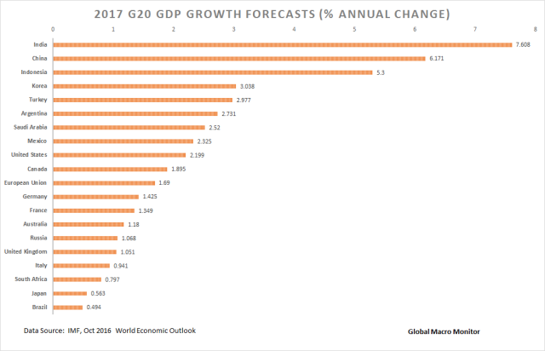
(Global Macro Monitor, 2017)

In the interest of clarity, it is pertinent to mention at this point the term Web 2.0, this does not refer to an update of the web but to more of a transition post dot-com collapse. There is no definitive answer as to what it is, but it is a term that was popularised by Tim O’Rielly and Dale Dougherty in 2004 but was originally used by Darcy DiNucci in 1999. The best explanation from O’Rielly himself is that although it has no hard boundaries it is seen as a set of principles and practices that tie together a ‘solar system of sites’. (O'Reilly, 2005)

E-Business
E-business is explained as the method and apparatuses that allow companies to use internet-based information technologies to run their business internally and externally. The broader definition of the e-business term covers all digital business processes, which also include e-commerce. (Graaf & Muurling, 2003)

Investments into the e-business infrastructure and e-business solutions have been considered to be of principal importance for the organisations seeking to compete effectively in any industry or market (Pilinkiene, et al., 2013). E-business provides new marketing and sales opportunities. Rodgers argued that companies endeavouring to be competitive could barely manage without e-business. (Rodgers, et al., 2002) This is seen as central to the development of any business strategy.

This is the current growth area for organisations of all sizes and needs to be embraced, availability of internet access over many platforms, 24 hours a day provides level of exposure for businesses never previously experienced. E-business can be used for:
- To sell and purchase goods/services online
- To conduct electronic retailing
- To create intranets or extranets to conduct research and manage business activities
- For website marketing
- Online communications such as email and online chat
- As online training for staff
- Communicating with the outside world via social media.
Pertinent to this study is the quote below,
“If organisations want to stay competitive, they need to understand the importance of E-business to successful strategy execution.”
(Thompson and Strickland, 2010)

Emails
Our ability to communicate with anyone, anywhere, anytime is increasing our opportunities for interaction. Emails are a bi-directional electronic communication between two parties. These have several uses, both internally and externally. It can be an effective form of communication within the business without the disruption of a phone call, files can also be sent along with the message.
Externally they are an excellent form of communication, allowing information to be sent to prospective customers, statements, invoices can all be emailed. For the customer, they are also a convenient method of contacting businesses, the email is an instant method, not reliant on a third party as with mail. A study of 1,000 office workers from top management on down and found that 55 per cent of those surveyed opened e-mails immediately or shortly after they arrived, irrespective of what they were doing. (Turner & Reinsch, 2007)
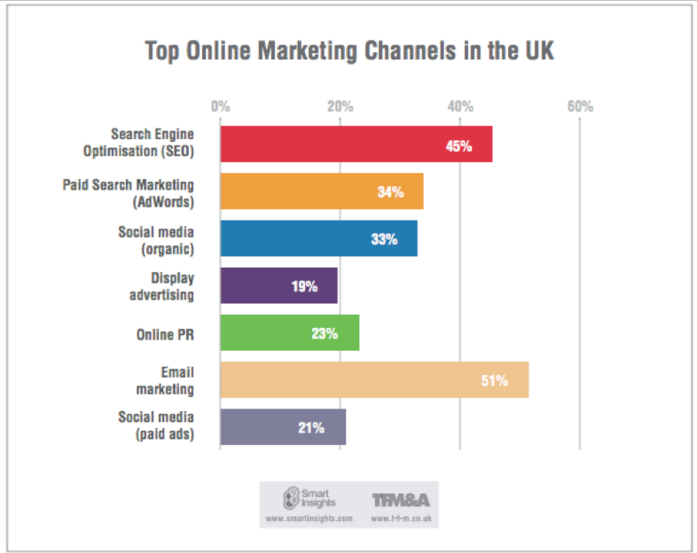
(Brynley-Jones, 2015)
Email comes out as the top digital marketing tool. An email marketing campaign can provide a logical marketing programme which can develop an effective outbound campaign along with a system to manage the incoming responses. It has a comparatively low deployment cost, it can be quickly actioned, responses are direct and can be immediately dealt with. (Chaffey & Smith, 2013) Personalisation is easy and this method can easily be integrated into a wider campaign.
This can be done in house with, existing customers or with access to relevant database. This process can be automated either through specialised software, or using an outside agency. Statistics from a study in 2013 sponsored by Alchemy Worx show a number of interesting figures. (DMA, 2013)
- Email marketing remains critical to business, with 89 per cent of respondents declaring email to be “important” or “very important” to their organisation.
- For roughly a third of respondents, email marketing accounts for 50 per cent or more of all digital business revenue.
In addition to its value as a marketing tool, emails also have the benefit of providing quick responses to any issues that may occur or by providing support. Being proactive is one of the five fundamental ways of adding value. Adding value to a customer’s experience makes retention of their business more likely. (Mercia, 2014)

Social Media
Also, known as ‘user generated communication’. (Michaelidou, et al., 2011) Social media is the setting provided so that social networking can take place. (Paquette, 2013)
This is best defined as a group of applications, or internet based media that allow for online communication between different parties. (Arca, 2012) The characteristics of this media group is participation, openness, conversation, community, and connectedness. Participants in this form of communication can instantly comment, provide feedback, recommend products or services to other users. Often communities who share interest are formed. (Mayfield, 2008)
There are several existing applications which can be used to engage, interact, and communicate with customers, these also allow exchange of views. Happy customers can promote the business by publicly providing feedback.
A previous study examining the social networking habits of Business to Business (B2B) small to medium enterprises find that most do so to attract new customers and of these almost 50per cent anticipated increasing their spend on this. (Glennie, 2015)
Forms of social media are varied, some of the well-known applications are Facebook, Twitter, LinkedIn, YouTube, Instagram, Pinterest, Google+ and various blog.
(Stelzner, 2015)
From the 2015 Social Media Marketing Industry report we can extrapolate these primary findings. (Department for Business Innovation & Skills, 2015)
- Twitter, YouTube, and LinkedIn hold the top spots for forthcoming development, with 66 per cent planning to increase their use.
- 93 per cent use Facebook, with 62 per cent planning to increase their use of it.
- Video is becoming increasingly important.
- Given the choice of only one platform Facebook came out on top at 52 per cent followed by LinkedIn on 21 per cent.
- Podcast (digital audio file for download) use if forecast to grow.
- Only 45 per cent of Facebook users happy with the effectiveness their posts.
- A massive 91 per cent want to know the most effective tool.
- 35 per cent are uncertain as to the rate of return of investment(ROI)
- 41 per cent spend more than 11 hours per week on social media
- more than 50 per cent of businesses who've been using social media for at least 2 years report improved sales.
- 91 per cent who have had a social media presence for more than a year felt it increased their exposure.
- Over 50 per cent reported reduced marketing costs
- 81 per cent reported increased traffic
- Which platform used varies with experience
The level of commitment made by the business is reflected in the return from this digital medium, the choice of medium is consistent but the time devoted is reflected in use. Business to business users, make more use of some of the applications such as LinkedIn, Google+ and SlideShare.
Benefits of social media marketing (Stelzner, 2015)
(Arca, 2012)
The diagram above gives a breakdown of the benefits of social media, exposure and increased traffic are seen as the two most significant benefits. Not included in this report is paid social media. (Yip, 2015)

Online Communities
These are electronic communities these are principally facilitate trading of products and services but also provide information. A community can be formed using one of the social media tools already available as in the case of a Facebook page ‘St Clears Buy, Sell or Swap’ (Facebook, 2017) or through a website, Zoopla.com (Zoopla, 2017) which brings together properties listed by assorted estate agents, providing with the house buyer with all the properties on one website. These can be used as tools to market a business or simply to keep customers informed. (Armstrong & III, 1996)

Websites
The third element covered in this study are websites. These are a selection of pages hosted on the internet under a domain name, these can be used to give business details, location, direction. Information regarding services or products along with images and/or videos. Contact details or direct link for email can be provided for easy enquiries. Websites can also be developed for e-commerce; this involves commercial transactions (purchases or sales) being made electronically via the internet.
Achrol and Kotler (1999) described the growth of e-commerce as the single biggest opportunity and threat facing almost every industry. (Achrol & Kotler, 1999) Porter 2001 suggested that businesses had no choice but to deploy this technology to remain competitive. (Porter, 2001)
Today we see that website design and content is crucial to the effectiveness of a website, the use of content has become one of the fastest growing areas of marketing. (Pugsley, 2013) Websites allow for a more interactive relationship between customer and business, especially with the incorporation of email and live chat. The interaction over the internet is often perceived as leading to a more 'direct' relationship than traditional media, especially if email is integrated within a web site. (Boyle & Alwitt, 1999)
Websites are no longer a standalone marketing tool but are at the core of a web of marketing options, as displayed in the image below. Not every business uses all those tools listed but the more the exposure the more the traffic generated. The social media element as already discussed can be linked to the website, each bringing traffic to the other.
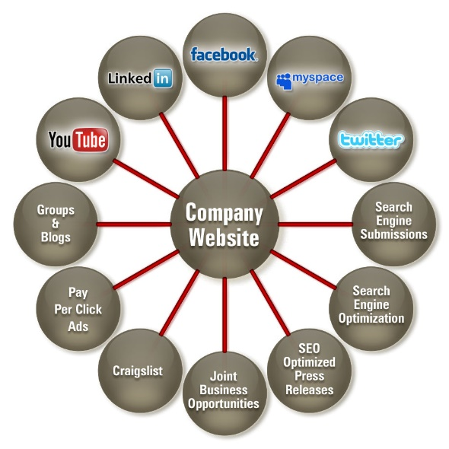
(Online Marketing HQ, 2013)
A survey of 10,000 British micro-businesses undertaken by marketing company bOnline in 2013 found it encouraging that 81 per cent had a website – earlier estimates put the figure at around 50 per cent. The concern, however, is that 80 per cent of these sites are poor quality, and can be damaging to small businesses. (Karibian, 2013)
Critical to the managing of this medium is the use of analytical tools, free options are available in the form of Google Analytics (Google Inc, 2017) along with numerous paid versions. The image below show some of the features and the data that can be obtained using one of these tools.
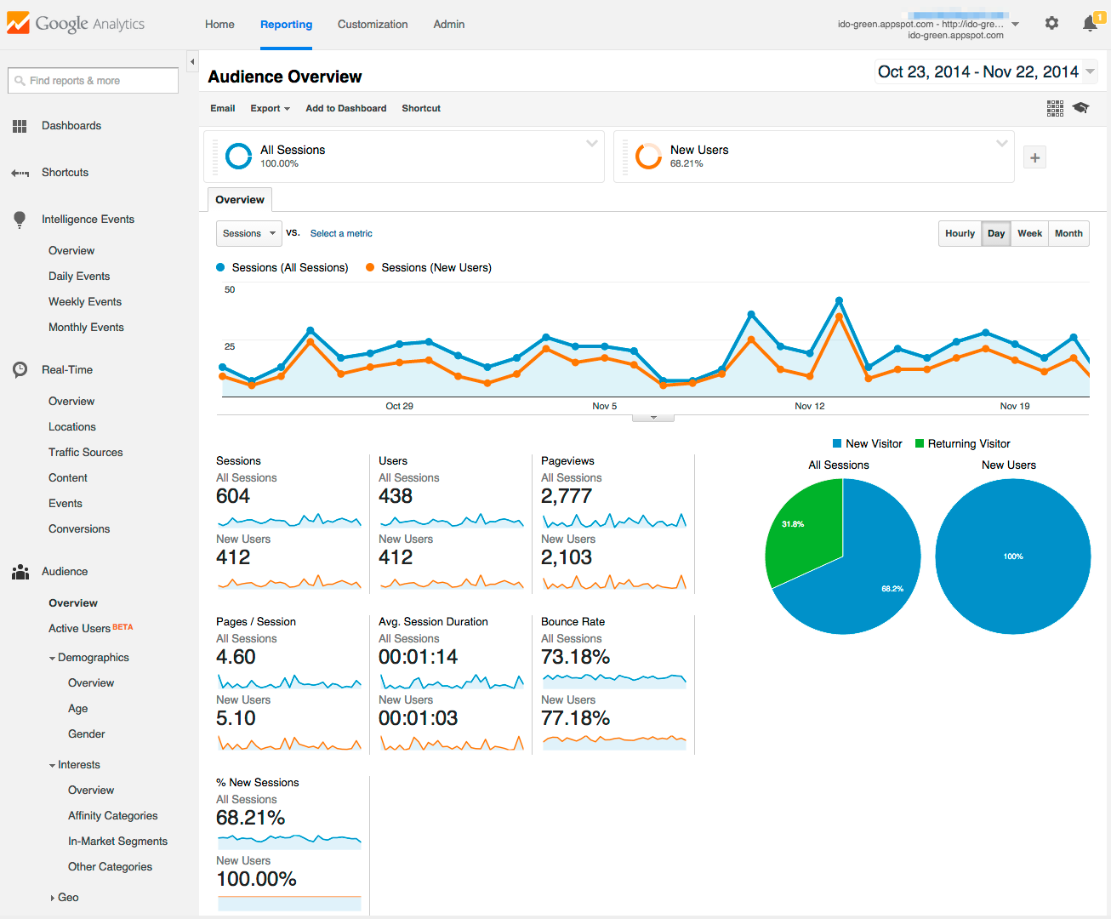
(Google Inc., 2017)

E-Commerce
The study will also research the organisations use of the internet to sell their services or products. Not all businesses use their websites for this purpose for some the business is not suitable.
Websites can be developed for e-commerce; this involves commercial transactions (purchases or sales) being made electronically via the internet.
Research undertaken by the Office for National Statistics shows the e-commerce sales for 2015 by business sector. This shows how much this sector contributes to the economy.
UK e-commerce sales via a website, by industry sector, 2015 (including micro-enterprises) (Office for National Statistic, 2016)
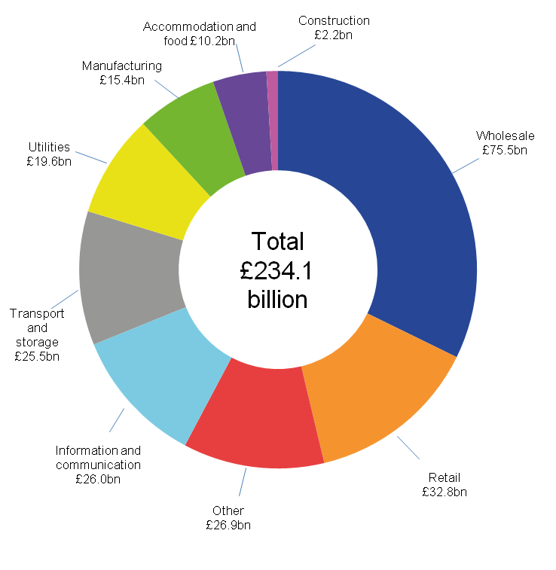
(Office for National Statistic, 2016)

Digital Capabilities in SMEs: Evidence Review and Re-survey of 2014 Small Business Survey respondents
This study was carried out by the Department of Business Innovation and Skills published in September 2015, this provides the comparison for the data collected by the researcher first hand. This report highlights the importance of the digital economy to the overall UK economy; it also emphasises the significance of the role SME’s could play. For this to happen they need to embrace and develop these new forms of marketing. (GOV, 2014)
The study found:
- That 98 per cent of businesses used the internet.
- 91 per cent have broadband
- 12 per cent consider connectivity to be poor
- 75 per cent or more use it research relating to the business, customer emails, online banking, paying bills, ordering supplies and paying taxes online.
- 64 per cent of SMEs have their own websites, this rises to 94 per cent of medium-sized businesses.
- 24 per cent don’t have their own websites
- 27 per cent of SMEs with websites pay an external person/business to maintain it
- 11 per cent of SMEs have a system of e-commerce on their own website
- 36 per cent of SMEs have a social media profile (28 per cent of all SMEs on Facebook, 19 per cent Twitter and 18 per cent on LinkedIn).
- Only 21 per cent of SMEs have ever received advice on improving their digital capabilities (47 per cent of medium-sized businesses).

Factors Affecting Digital Technology Adoption
The process of adoption can be summarised into two main sectors, these being the initiation and the implementation. These steps are also applicable to the broader implementation of technology. (Damanpour, 1991) In the view of Cooper and Zmud 1990 these can be broken down further to six steps:
- Initiation
  - Search for opportunities (new ways to reach customers, new ways to sell)
- Adoption
- website, social media accounts, e-commerce
- Adaptation
  - In house or out sourced
- Acceptance
  - Encourage employees to embrace new methods
- Routinisation
  - Use of the digital medium becomes the norm
- Infusion
  - Efficiency, productivity, and sales increased as a result
External factors Affecting Digital Technology Adoption
A study undertaken in 2000 by Oftel found that only 49 per cent of SME’s were connected to the internet. (Daniel, et al., 2002) By 2015 this figure was 83 per cent. (Office for National Statistic, 2016) Today, the figure has continued to increase to just short of 90 per cent (OfCom, 2017), but there is an issue, where around 30 per cent of businesses in rural areas have issues with reliability. (Chapman, 2017)
“Unreliable connections stunt productivity, causing needless delays, costs and frustration,” - Mr Adam Marshall, British Chamber of Commerce

Digital Strategy SME’s v Larger Businesses
There have been many studies into the use of technology by business, however, much of this study related to the larger businesses. (Voges & Pulakanam, 2011) There has been far fewer studies with a focus on the SME’s. This is surprising, as research has indicated that the smaller the business, the less likely it is to readily take up new Information and Communication Technology. (see paper)
The reasons given for this variance relate to the different decision making process in the small and large organisation, larger firms will base their decisions on a formal strategy formation, various tools can be used to provide structure to the framework, these include. (Chaffey & Smith, 2013)
The (P)RACE planning system for digital marketing focuses on 5 key areas
- The Plan
  - Branded content - importance of planning, target and positioning
- The Reach
  - search engines, social network, blogs – publish and promote your content
- The Act
  - Website, blog, communities – be worth finding
- Convert
  - E-commerce process, price, promotion – capitalise on marketing, invest in automation
- Engage
  - Customer Advocacy – Happy customers are critical to social media marketing

Smaller businesses are more likely to rely on implicit managerial perception. A study of the organisational factors affecting internet technology adoption (Aguila-Obra & Padilla-Meléndez, 2006) found that the most significant reason for the lower uptake of internet technology was not directly the size of the organisation but the managerial capabilities, this is not a reflection on the individual but larger businesses have a larger resource pool and a more advanced technology development with specialised marketing departments. Many of the decision makers in small established businesses have not had the exposure to the digital medium and this plays a part in the reluctance to evolve.

Why should digital marketing be embraced?
“’Old world’ marketing is finished’” (N., 2013)
This is the chapter heading in a book introducing the internet and digital marketing to SME’s. The reason for this bold statement is that some old-school marketing techniques no longer work, who looks at the yellow pages anymore? Others don’t provide value for money. Traditional Marketing often reaches a local market and results are difficult to measure. (Top SEO Trends, n.d.)
Digital marketing has the advantage of having global exposure, costs can be kept down, results can be measured using various tools as already discussed. (Faulkner, 2013) Digital marketing can be interactive. Newspapers, magazines are now often in a digital format.
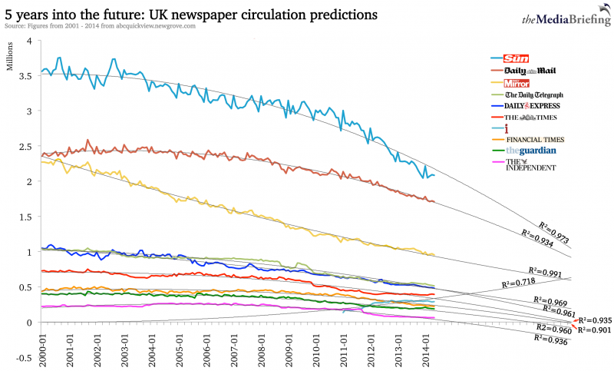
(Taylor, 2014)
The chart above shows the decline in newspaper circulation since 2000, with a 5-year projection also shown. This further promotes the urgency in developing a digital marketing strategy. (Taylor, 2014)

Research Strategy and Methodology

Research Aims and Objectives
The primary aim of this study was to discover whether the research already in place reflected a true picture of the use of the digital medium for marketing by SME’s.
It is also the intention of the study to provide clarification of the digital medium and the elements that constitute digital marketing.
- Explanation of the digital medium and its development
- Evaluate the benefits of Emails, Social Media, and website
- Appraise statistical data already available
- Report the challenges for SME’s in developing digital strategies
- Provide rationale for the use of digital marketing
- Obtain primary data from SME’s and analyse this
- Compare primary data with the secondary data
- Present findings
- Provide recommendations

Planning
The project was introduced through the creation of a dissertation proposal. (Davies, 2016) This outlined the structure for this study and provided a timeline for the project. Pertinent literature was reviewed, along with the research strategy and methodology. Three meetings with the project supervisor were arranged and attended, at these meetings progress was monitored. (see appendix G)

Research Overview
This is an investigation into the use of the digital medium by SME’s, both for marketing and interacting with customers. Its purpose is also to discover which digital marketing tools are being used and whether this work is being done in-house or out sourced. It is the primary aim of the research to establish whether this form of communication and marketing is being utilised, and whether businesses feel that they are benefiting from its use. It is intended to compare the data obtained through the primary research to that already in existence. In addition, it is intended to discover whether the number of employees or the length of time an organisation has been trading impacts on these decisions.

Research Design
Any piece of research starts with a set of questions that need to be answered, what is important is how the researcher choses to go about the collection of data. For the process to be effective then it is wise to have some structure to that planning process.
The research process set out by Saunders called the ‘Research Onion’ has been chosen as the strategy of choice (Saunders, et al., 2012). It provides a framework for the researcher to follow. The framework has been equated to that of an onion, which has five skins. Each of the skins relates to a step which the researcher undertakes. By using this structure, the researcher makes the most appropriate choice of procedure for the study.
The outer layer relates to the philosophical stances, these “provide the context and boundaries within which data collection techniques and analysis procedures will be selected” (Saunders & Tosey, 2013). Thus, ensuring that proper and comprehensible data collection techniques are deployed.
Below the philosophical layer, lies the ‘Methodical’ choice, this deals with the simple but critical choice of method. Is the data to be collected via a quantitative or qualitative method. This decision determines what type of data will be collected and subsequently analysed, for example statistical or narrative.
The next level of the framework is ‘Strategy’. The decision was made to opt for a quantitative collection of data, using a questionnaire, it was felt that the report required comparisons to be made with the secondary data which was already in a statistical format.
Layer four concerns ‘Time horizon’, this relates to the ‘time period’ to be covered by the research. The questionnaires in this study did not relate to a specific period of time, the data collected was pertinent to the day that the form was completed, the only time constraint was the 14-day period between dispatch and the closing day for return.
The final part of the ‘onion’ framework is the collection and analysis of the data itself. The data was collected and entered into the statistical analysis program from IBM called SPSS Statistics (IBM, 2017), this in conjunction with the use of Microsoft Excel provided the analysis tools.
Saunders and Tosey 2012, stress that the designing of any research is never without restraints, these include workability and of equal importance ethically.

Secondary Research
The rationale for the secondary research was multi-faceted. The researcher felt that it was necessary to clarify some of the terms that were being discussed. There can be misconceptions as to what ‘digital media’ relates to. It was also felt that because of the speed of development that a brief history of the progression of the internet should be provided. Without this medium the digital media would have little purpose. This undertaking involved the reading of numerous academic papers on the subject along with several pertinent books and articles. Research also included the reviewing of previous studies, a study by the Department of Business Innovation and Skills played a significant part in the research. (Department for Business Innovation & Skills, 2015)
No copyrighted material was used and all references have been noted. The researcher is aware of the possibility that some data may be erroneous; however, every effort was made to find research that provided substantiation to the data used. These academic papers were accessed primarily through Google scholar, Emerald Insight, which is available through Trinity St David’s online library. In conjunction with these academic sources several newspaper articles were also viewed.
In addition to the clarification and simplification of the terms and processes, the essential research was that undertaken to gather historical statistical data with which to compare the primary data. This data was mainly sourced from selection of reports, these were from studies undertaken by the Office for National Statistics, Ofcom, E-consultancy in Association with Adobe and a study by the government Department for Innovation and Skills. (OfCom, 2017)
Other information that provided background reading was accessed via the internet, google scholar and again through various books

Questionnaires
The chosen method of primary research was quantitative, using a questionnaire (see appendix A), this was selected as the most suitable for the collection of statistical data. 14 questions were selected to reflect the data that the researcher wanted to establish so that this could be analysed and compared with the secondary data. Some of the questions were multi-choice, others required the business to supply data. Businesses were selected randomly from a list of SME’s in the local area, obtained through a google search
Accompanying the questionnaire was an explanatory letter (see appendix B), which explained the researchers’ objectives, included a closing date, and a stamped addressed return envelope. The researcher used pale ivory stationery to standout from other mail, the project was costed, the total outlay was £156.03. (see appendix H)
Each participant was thanked for their time in completing the survey and given the opportunity to be entered into a draw for a £25 Marks and Spencer voucher. Included with the above was a consent slip (see appendix E). The winner was selected using excel and a random number generator (see appendix D). and a letter of thanks was sent to accompany the £25 voucher (see appendix C).
The researcher is aware that bias could have occurred, an example may be the wording of a particular question or a lack of clarity. The questionnaires were approved by another person in an attempt to reduce the occurrence of bias. They were designed with the data obtained from the secondary research in mind, so that the data could be compared and contrasted.

Logistical and ethical considerations
The logistical considerations involved the printing and distribution of 101 questionnaires, of these 15 were hand delivered and the others were posted. The printing of all the items was completed in house. The cost per questionnaire has been calculated and is shown below.
Primary research required ethical issues to be considered and dealt with. Data protection laws and privacy were paramount considerations. Each questionnaire included a consent slip (see appendix E) which contained assurances that all data would remain confidential and that there was no obligation on those selected to participate.
The questionnaires only identifying mark was that of a number in the top left corner which corresponded with the list the researcher held. Only the researcher would have access to the business details, which were required for categorisation of the response, and the allocation of the prize draw. Participants were informed of this, and that their identity would not appear in the published research.

Findings and Analysis
This first section contains the findings from the analysed questionnaires. Of the 101 questionnaires issued the researcher received back 68 completed forms, this was a completion rate of (68 / 101) x 100 = 67.33%. The data will be displayed in several formats, tables and charts A brief explanation will be included for each question.
The completion of the questionnaires was not without error; these errors have been noted (see appendix F).
With the intention of providing the widest range of information for analysis, the researcher has in addition to recording the responses via the questionnaires, used the IBM SPSS software to create several crosstabulations. These comparisons have been used to further enhance the research findings, to see whether there are possible correlations between different factors. The intention is to provide a more in-depth insight into the subject.

Results

Chart - Number of businesses using digital tools

100 per cent of businesses used websites, 92.6 per cent used emails and 79.4 per cent used social media

Chart - Social marketing use

Facebook is the social media marketing option used by most businesses 73.5 per cent, in second place was Twitter at 29.4 per cent, 22.1 per cent did not use social media for marketing purposes. An error of 1.5 per cent occurred, 1 incomplete response.

Chart - How is digital marketing sourced

48.5 per cent of businesses do their own digital marketing. Two participants failed to answer this question this has been noted as an error.

Chart - Use of social media

Social media is used almost equally for all purposes.

Table - E-commerce current usage
E-commerce current
 |  | Frequency | Percent | Valid Percent | Cumulative Percent
Valid | No | 34 | 50.0 | 50.0 | 50.0
Valid | Yes | 34 | 50.0 | 50.0 | 100.0
Valid | Total | 68 | 100.0 | 100.0
Of the participants 50 per cent currently use their website for e-commerce.

Chart - E-commerce future development

26.5 per cent of businesses have no plans to develop and e-commerce website. An error of 1.5 per cent occurred, 1 incomplete response noted as an error.

Chart - Has digital marketing increased turnover?

69 per cent of participants agree that digital media has increased their turnover. Only 3 per cent disagree.

Chart – Do you agree “Our use of digital media will increase in the next 5 years.”

Only 5 per cent see no increase in their use of digital media in the next 5 years.

Table - Estimate what percentage of the marketing budget goes into digital marketing
Estimate percentage of marketing budget is spent on digital marketing
 |  | Frequency | Percent | Valid Percent | Cumulative Percent
Valid | Unsure | 29 | 42.6 | 42.6 | 42.6
Valid | None | 1 | 1.5 | 1.5 | 44.1
Valid | 1% to 25% | 20 | 29.4 | 29.4 | 73.5
Valid | 26% to 50% | 5 | 7.4 | 7.4 | 80.9
Valid | 51% to 75% | 5 | 7.4 | 7.4 | 88.2
Valid | 76% to 100% | 8 | 11.8 | 11.8 | 100.0
Valid | Total | 68 | 100.0 | 100.0

42.6 per cent were unsure what percentage of their overall marketing budget was spent on digital media.

Chart - Do you agree that “More of your marketing budget will go into digital marketing in the future”

60 per cent agreed that more of the marketing budget would be spent on digital marketing in the future. 1 missing entry marked as an error.

Chart - Do you see a time when you will rely solely on digital marketing?

19.1 per cent could see themselves relying solely on digital marketing in the future.

Chart - How long has the company been trading

The highest percentage of business studied have been trading for 10 years or less.

Chart - Number of employees

An error of 3 participants (4.4 per cent) noted as an error. Largest group is the 1-2 employee category.

Table - Would you recommend digital marketing to others
Recommend digital marketing
 |  | Frequency | Percent | Valid Percent | Cumulative Percent
Valid | Yes | 68 | 100.0 | 100.0 | 100.0
100 per cent responded with a yes.

Chart - Years in business VS Social media use

All 9 businesses who have been trading for 41 years or more use digital media.

Chart - Increased turnover / Years trading

Businesses who have been trading for between 21 to 30 years have the highest rate of uncertainty regarding the effect of digital marketing on turnover.

Chart - More of the marketing budget to digital media compared with number of employees

Only the 3-5 employee group was unsure about the increased allocation to the digital marketing budget.

Chart - Businesses Categories Studied
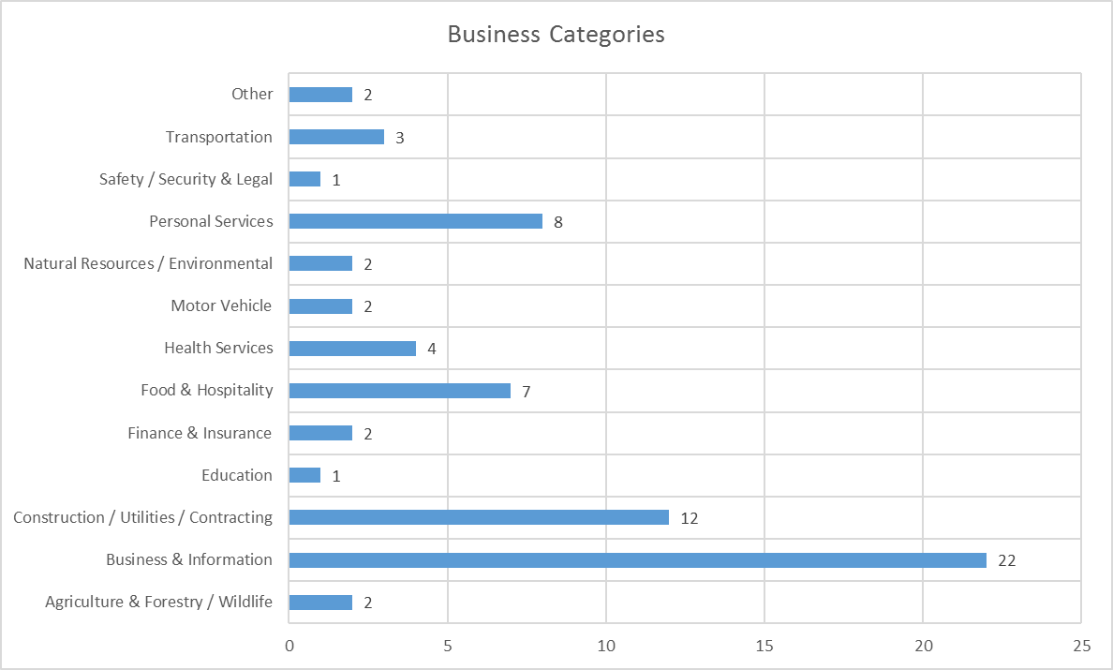
To provide some background to the business studied the business categories (Louisiana Secretary of Sate, n.d.) they belonged to was recorded and the data illustrated using the chart above.

Analysis
The data was collected as outlined in the methodology. Analysis of the data from the primary study, using the tools discussed previously has provided the researcher with information relating to how SME’s use and view the digital medium.
The participants who responded, all used websites in their business in some form or another, 92.6 per cent used emails and 92.6 per cent used social media.
Out of the 68 businesses, 15 (22 percent) of them did not use social media for marketing, the remainder used a variety of applications. Facebook had the highest rating at 74 per cent, followed by Twitter on 29 per cent and Instagram on 13 per cent, with YouTube, LinkedIn, and Pinterest all at just short of 3 per cent, Google+ and a blog were at 1.5 per cent.
The researcher was interested to discover that almost half of the businesses did their own digital marketing and a further 27 per cent did some of the marketing in house. A quarter of businesses outsource their digital marketing, of these 16 businesses 12 have been trading for more than 13 years. Two of the participants did not complete this section, they were not included in the calculations but noted as errors.
Participants were asked, for which purpose they used social media in their business, apart from the 23.5 per cent, who did not use social media, over 30 per cent used it for marketing, interaction with customers and for promoting products.
Of the 68 businesses in the survey, exactly half currently use their website for e-commerce. Of the remainder, only 18 businesses had no plans to develop e-commerce in the future. 14 planned to do so, with 3 of those intending to do so in the next six months. This equated to 26.5% with no plans to develop e-commerce.
Over 69 per cent feel that the use of digital marketing has increased their turnover, 3 per cent thought that they had not benefited. Of some concern is the 28 per cent who were unsure.
The positive influence of digital media is reflected in the high percentage, over 85 per cent who agree that they will be using more digital media over the next five years. Only 3 businesses, the equivalent of just over 4 per cent disagreed.
When asked businesses to estimate the percentage of their marketing budget that was allocated to the digital medium, a significant proportion of participants 43 per cent were unsure. Interestingly almost 12 per cent spent between 76 and 100 per cent of their budget on digital marketing.
60 per cent say they will be putting more of their marketing budget into the digital medium. Again, there can be seen some signs of uncertainty as just over 32 per cent are unsure.
Good news for the traditional marketing methods, over 70 per cent don’t envision depending entirely on the use of digital marketing, in contrast to the 19 per cent who do.
Questions 12 and 13 were designed to provide additional background information about the businesses. Although not a deliberate goal the businesses in the survey cover a broad spectrum, both from the number of employees and the number of years the businesses have been trading. It had been noted from the research that 99,3 per cent of SME-s in the UK employed between 1 and 49 (Chahal, 2015), we felt that this would be interesting to compare with our study.
The final question dealt with whether the business would recommend the use of digital media to other organisations. The response was an unequivocal yes, all 68 participants agreed that they would indeed recommend this medium to others
In the chart 1.15 the data relating to years in business was combined with that of social media use. The results are interesting, each group has a majority who use social media, the final group which contains the longest established businesses all use social media.
The combination of ‘Has digital marketing increased turnover’ and ‘How long has your company been trading’ highlights that the newer established and the longest established businesses share a conviction that digital marketing has a positive impact on their turnover. Those in the group that have been trading 21 to 30 years have the highest rate of uncertainty regarding the benefits of digital marketing to their turnover.
When it came to the chart showing the relationship between the number of employees and the increase of the digital proportion of the marketing budget, the group that was the least positive employed between 3 and 5 employees, the most positive groups were the business employing the least and the most.
The final chart shows which business category the businesses surveyed fall into. The survey included businesses from a wide range of different business sectors, 13 in total. The researcher felt that this information added to the validity of the findings as they covered a wide range of business sectors. The largest proportion of the respondents came from the business and information sector; this covers many different businesses from retail to publishing.
The study of primary data by the researcher has highlighted several factors that might have been improved given the opportunity to repeat the process. This included the clarification of some of the questions in the questionnaire. One of the questions that could have been explained was the number of employees, some business owners did not include themselves in the total although they were employed. An additional tick box should have been included in question 6 for those who already use e-commerce as shown in the previous question.

Discussion
The research has now been concluded, the collection and analysis of the data required for this study has been completed. This was undertaken using the methods already outlined in the methodology. The discussion will now look at whether the data collected by the researcher, follows the same pattern as that of the secondary data.
One of the prime objectives of this study was to see whether the SME’s in question had embraced the ‘digital revolution’. In the research by the Department of Business Innovation and Skills published in 2015 into the digital capabilities of 803 SMEs (Department for Business Innovation & Skills, 2015), 98 per cent used websites for business use. This research found that all 68 of the participants used a website, therefor providing an indication that progress has continued.
Email use by those studied came in at just short of 93 per cent this compares favourably with data from a 2013 study where 89 per cent thought emails were important. The researcher was surprised that this figure was not at the same level as the website use as the use of email has many benefits both for the businesses and the customer. It is a near instant form of communication, the sender can even monitor its arrival using digital receipts.
Of the participants 79 per cent use social media for business purposes, this shows a significant increase when compared with the 36 per cent recorded in the Department of Business 2015 Survey and reflects the increasing popularity of this medium. The data from the 2015 study showed Facebook use at 28 per cent, 19 per cent on Twitter and 18 per cent on LinkedIn. The statistics from this study follow a somewhat similar pattern with Facebook having the highest traffic at 74 per cent, Twitter at 29 per cent. This study has Instagram taking the third place on 13 per cent. It has been interesting to note that even with a small sample of data, the participants were found to be using 8 different social media applications. The secondary research showed a global snapshot taken in January 2017 (Allen, 2017), it shows that there are 2.789 billion active social media users, it is positive to see that the participants of this study are embracing the opportunities that this form of marketing can expose then to on a truly global scale. Social media is a low-cost option available to anyone with internet access, it provides business with an instant form of communication, the customer also has the same opportunity to respond. Customers can use this medium to both recommend and criticise a service or product, as well as the business itself.
The adoption of certain digital marketing options can be costly, but if the businesses understand this technology, some of this can be done in house to keep down costs. This research shows that almost a half of the respondents do this work in house, with a further 27 per cent playing some part in it, only 24 per cent outsource this work. The biggest barrier to this being done in house is a lack of skills this doesn’t appear to be holding back most of the businesses studied. It was interesting to note that of the 16 businesses who outsourced the work, 12 had been trading for over 13 years, this could be indicative of a skill shortage in the businesses that were established before the digital revolution took hold.
When questioned about their use of social media it was found that most of those using this medium used it for multiple purposes, interacting with customers, marketing the business and promoting/marketing products. Over 60 per cent used it for all three, the 2015 study showed higher rates for promoting business and interaction with customers but lower for marketing products. It is pertinent to mention at this point that those using social media as a percentage is significantly higher in this study as compared with the 2015 study and this may be responsible for the difference in rates.
The benefits of social media marketing are many, from increased exposure, reduced marketing costs, to improved sales. The importance cannot be over stated and the primary research provides promising results, it has shown that this study has delivered data that shows a significant increase in the use of this form of digital marketing.
When dealing with the subject of e-commerce, clarification is often required when dealing with this term, it is best explained as commercial transactions (purchases or sales) being made electronically via the internet. Of the 68 participants 50 per cent already use their website for transactions of this kind. As the aim of this study was to see whether progress was being made in the use of the digital medium, these figures when compared with those of the 2015 study show edifying results. The 2015 figures showed that only 11 per cent could take orders through their website, increasing to 31 per cent when third party websites were included. This study has shown significant progress in this field.
Of the other 50 per cent who did not at the time of the study, have an e-commerce website, 21 per cent had plans to do so in the future, 4 per cent in the near future. This compared with only 6 per cent from the 2015 study having plans to develop e-commerce. A global snapshot taken on January 2017 show there are 3.773 billion internet users, these provide SME’s with the opportunity to sell 24/7 to every corner of the planet. Restrictions that would have at onetime put this out of the reach of most SME’s such as marketing costs, lack of exposure do not apply in the digital market place. Investment into e-business, e-commerce is seen as critical for organisations wanting to compete effectively in any market (Pilinkiene, et al., 2013). It should be mentioned at this point that the customer is also a winner, the choice of products available from the comfort of their own home is now at a level unimaginable only a few years ago, with the luxury of next day delivery to their door too.
The benefits of the digital medium are being recognised by most of those surveyed, over 69 per cent attributed an increase in turnover to the adoption of digital media. Only 22 per cent of the turnover for SME’s was attributed to the digital medium in 2015 study, this against a backdrop of UK e-commerce sales in 2015 alone returning a total of £234.1 billion. Of concern to the researcher, is the 28 per cent of those who were unsure as to whether their use of the digital medium had in fact increased their turnover. This suggests to the researcher that there may be an under analysis of the performance of the business in the digital market place, this can easily be rectified through better recording of data and the use of analytical tools, as covered in this document, Google analytics is a free program which can provide lots of relevant data regarding the performance of a website.
Further to the information already drawn from the study, the SME’s questioned show that they have also recognised the importance of the digital medium, over 85 per cent envision an increased use of digital media over the next 5 years, compared with only 4 per cent who disagree.
In conjunction with the high percentage who believe their use of the digital medium will increase, there are also a significant number, just under 60 per cent who see more of the marketing budget going towards digital media marketing. When it comes to the financial aspects of digital marketing, there seem to be a substantial percentage of businesses who are unsure. This raises the same question as previously, is there an under recording of the essential data which would provide these businesses with the information required to be able to make an educated decision, either for or against this medium.
Secondary research pointed towards the decline of traditional marketing methods, for example the decline in newspaper readership over the last 15 years, many of which now are 50 per cent down on where they were in 2000. with still further declines predicted. This might have pointed the way to businesses relying solely on digital marketing. The primary research for this study, however, showed that over 70 per cent of the businesses who responded did not see themselves relying on digital marketing alone. In contrast, just short of 20 per cent saw this as being a probability.
The most categorical response came to the final question which left the researcher in no doubt that digital marketing would go from strength to strength. Not a single participant would not recommend digital marketing to other organisations, although on a lighter note one did suggest that he would “not recommend it to a competitor!”
The number of employees in our businesses fell around the usual standard for 99 per cent of SME’s in the UK with only 1 with more than 49 employees.
The researcher used two of the questions to provide a background to the businesses, this allowed more depth to be applied to the study. These were used in conjunction with other questions to allow for some further analysis. The researcher questioned whether the older established businesses might be more resistant to change. To see if this was the case, the data relating to ‘Use of social media’ was integrated with data from ‘How long the business had been trading’. The analysis provided did not confirm the researchers thinking, in fact it turned it on its head, the 9 businesses who had been trading the longest all used social media.
The process was also applied to ‘Increased turnover from digital marketing’ and ‘How long the business had been trading’. The highest number of ‘unsure’ came from businesses that had been trading for between 21 and 30 years, the most positive were those who had traded the longest and the shortest, only 2 of the 68 disagreed, they also came from these groups. In conclusion, there is very little to suggest that the longevity of a business has anything to do with increased turnover from digital marketing.
A crosstabulation was also applied to ‘More of the marketing budget into digital marketing’ and ‘The number of employees’. This was done to see if there was a link between the size of the organisation and its digital marketing aspirations. In the 1-2 employee group 5 businesses disagreed with the statement, this was the only group that recorded a negative. In groups 3-5 and 6-10 came the highest unsure figures of 6, in the 3-5 group this outperformed the positive which was on 5. It seems from this data that the larger businesses are more confident about investing in digital marketing. This may be because they have more resources to devote to this medium, either financial or manpower or both.

Conclusion
The literature reviewed during this study has without exception promoted the use of the digital medium to market and promote business. Journals, articles, and previous studies have left the researcher in no doubt that the digital revolution is here to stay, in fact it may only just be beginning. Growth figures for global growth particularly in some of the previously underdeveloped countries provide new opportunities and new markets.
Improved connectivity and increased accessibility, anytime, anyplace via an ever-increasing number of platforms has opened the door to new markets and new customers. No longer are businesses held back by ‘close of business’, trading hours on the internet are 24 hours a day 365 days a year. The trade continues even when the physical business closes its doors for the day, orders come through to be processed in normal business hours.
The digital revolution has indeed revolutionised business, no more so than for the SME’s who would previously have been restricted by costly marketing, particularly when dealing with foreign trade. Today an item can be listed on the internet and be immediately accessible to someone on the other side of the world. No costly marketing, no delays. Globalisation has happened alongside the digital revolution and people now relocate all over the globe, but communication is now easier country to country via the various digital media than it was between two counties a few years ago. Purchases can be made just as easily.
It was also intended when this study was planned that it would offer some clarification of the digital medium. It is hoped, that through the provision of the various explanations this study can provide constructive advice to SME’s regarding the subject. The researcher feels that it is important that businesses especially those who have limited experience in this field are not held back either by fear of the technology or lack of the skills to embark on the digital media revolution themselves.
There are opportunities for everyone to learn some of the skills that could enhance their ability to perform much of this work themselves, especially the social media aspects. In the case of websites, content and design are very important to its effectiveness and this can sometimes be better provided by a specialist or at least built by a specialist, security is also a consideration particularly when financial transactions take place. An understanding of the various risks to any business that is connected to the outside via a network connection is essential and no business should overlook its cyber security.
There is little doubt that this study has provided evidence that the SME’s studied have overall embraced the use of digital media, both for communicating with customers, for marketing their business and their products. Of those surveyed 100 per cent have already taken their business online, of those, 50 per cent are using their websites to sell their products and services. Social media use is well established with Facebook leading the way, many have benefited from gaining skills through the personal use of this application which may explain its popularity amongst businesses, on average in March 2017 it had 1.94 active monthly users. (Facebook, 2017) Twitter which rated second in our study by comparison has 313 million monthly users. (Twitter, 2017)
The only negative, in the opinion of the researcher was the lack of clarity exhibited by the participants regarding the return from digital marketing. Nearly 28 per cent were unsure whether they were getting any return from their use of digital media for marketing. The same uncertainty showed up when they were asked whether ‘more of their marketing budget would be spent on digital marketing in the future’ these ring alarm bells for the researcher, it seems to be an indication of a serious lack of evaluation of the returns from marketing, it would appear that some of these businesses are unaware which form of marketing is generating their sales and in turn their income.

Recommendations
It is recommended that all businesses have in place a marketing strategy, this in turn should include some form of recording of the source of leads and sales, which would allow for an analysis structure. There are tools and statistics readily available. As already discussed there are even free tools such as Google analytics which analyse website traffic for you.
These measures can provide organisations with the information needed to make informed decisions about where they spend their marketing budget. If a website is not performing then a redesign may be called for, or the use of a specialist web designer. Traditional marketing can be very expensive, if no records are kept then money from the marketing budget that could be better utilized elsewhere can be wasted, or spent for little return.
For the businesses who have websites but are unhappy with the search position they can look at Search Engine Optimisation (SEO) (Google Inc., 2010). If they are outsourcing their website this is likely being done by the web design company but if the business built its own site they may not have looked at SEO, it is something that will help, Google offer free advice, other businesses provide a paid service. Progress up the list does not happen overnight, so a little patience is required.
For any business that has a product to sell e-commerce offers them a platform to significantly increase their turnover, should they be reluctant to commit to their own e-commerce site, third party websites are an easy way to test the water, the only proviso would be to be aware of any fees or charges that apply when setting the price of the product, eBay is one option.
In today’s climate, cyber security is a major concern and should not be neglected. Data protection is also a factor that requires consideration. It is essential that all employees are made aware and take the appropriate measures to reduce the impact of any attack. Secure storage of data, use of appropriate anti-virus software, off-line back of data at regular intervals and a knowledge through training of the basic risks, these included phishing emails, rogue emails with infected attachments, false invoicing, these are a few of the ever-increasing hazards. (Information Systems and Technology, 2017).

Advice for further study
If this study was to be carried forward, there would be a few things that would benefit from change. Clarification of some terms on the questionnaire would have been an advantage. More in depth questions would have provided additional data. Had the questionnaires been hand delivered the response rate would have undoubtedly improved.
The researcher has also discovered that the study has only increased the desire to further investigate this subject and given the resources would love to do so
It would not be fair to end on a negative note as the study has fulfilled the researchers desire to know whether SME’s in a small area of West Wales have indeed embraced the digital revolution. It has shown that even with the limitations of connectivity in the area, businesses overall have taken on the challenge and launched themselves in the digital marketplace, some have flown higher but all have made some progress. The future looks bright for those who are prepared to embrace technology, the market place is global and the opportunities infinite.

References
Achrol, S. R. & Kotler, P., 1999. Marketing in the Network Economy. Journal of Marketing, Volume 63, pp. 146-163.
Aguila-Obra, A. R. D. & Padilla-Meléndez, A., 2006. Organizational factors affecting Internet technology adoption. Internet Research, 16(1), p. 94.
Allen, R., 2017. Screen Shot 2017-02-23 at 14.27.2. [Online]
Available at: http://www.smartinsights.com/social-media-marketing/social-media-strategy/new-global-social-media-research/attachment/screen-shot-2017-02-23-at-14-27-27/
[Accessed 11 May 2017].
Arca, C., 2012. Benefits of Social Media Marketing. Master of International Marketing, p. 33.
Arca, C., 2012. Social Media Marketing benefits for businsesses: Why and how shold every business create and develop it's Social Media Sites. [Online]
Available at: http://vbn.aau.dk/ws/files/63562608/CelineArca_MScInternationalMarketing_MasterThesis2012.pdf
[Accessed 11 May 2017].
Armstrong, A. & III, J. H., 1996. The Real Value of On-Line Communities. [Online]
Available at: https://hbr.org/1996/05/the-real-value-of-on-line-communities
[Accessed 11 May 2017].
Athow, D., 2011. First Website Launched 20 years Ago Today. [Online]
Available at: http://www.itproportal.com/2011/08/06/first-website-launched-20-years-ago/
[Accessed 11 May 2017].
Boyle, B. & Alwitt, L., 1999. Small Businesses Investment in Digial Marketing Rises. eWeek, 28(4), pp. 327-341.
Brown, A., 2015. Digital advertising – the (next) big thing. [Online]
Available at: http://marketing-news.co.uk/digital-advertising-the-next-big-thing/
[Accessed 11 May 2017].
Brynley-Jones, L., 2015. UK Digital Marketing Statistics and Analysis 2015. [Online]
Available at: http://oursocialtimes.com/uk-digital-marketing-in-2015-statistics-and-analysis/
[Accessed 11 May 2017].
Caniëls , M. C. J., Lenaerts, H. K. L. & Gelderman, C. J., 2015. Explaining the internet usage of SMEs: The impact of market orientation, behavioural norms, motivation and technology acceptance. Internet Research, 25(3), pp. 358-377.
Chaffey, D., 2015. Forecast growth in percentage of online retail / Ecommerce sales. [Online]
Available at: http://www.smartinsights.com/digital-marketing-strategy/online-retail-sales-growth/
[Accessed 11 May 2017].
Chaffey, D. & Smith, P., 2013. Email Marketing. In: Emarketing excellence: Planning and Optimizing Your Digial Marketing. Abingdon, UK: Routledge, pp. 454-459.
Chaffey, D. & Smith, P., 2013. Tacticts, action and control. In: Emarketing Excellence: Planning and Optimizing Your Digital Marketing. Abingdon, UK: Routledge, pp. 44-45.
Chahal, M., 2015. How SMEs make marketing add up. [Online]
Available at: https://www.marketingweek.com/2015/04/01/how-smes-can-make-marketing-add-up/
[Accessed 11 May 2017].
Chapman, B., 2017. Quarter of UK businesses don’t have reliable broadband despite government pledges on ‘superfast’ internet. [Online]
Available at: http://www.independent.co.uk/news/business/news/uk-business-broadband-quarter-connection-reliable-superfast-internet-connection-british-chambers-of-a7647661.html
[Accessed 11 May 2017].
Damanpour, F., 1991. Organizational Innovation: A Meta-Analysis Of Effects Of Determinants and Moderators. Academy of Management, 34(3), pp. 555-590.
Daniel, E., Wilson, H. & Myers, A., 2002. Adoption of E-Commerce by SMEs in the UK. International Small Business, 20(3).
Davies, D. J. U., 2016. How has the digital medium revolutionized marketing for SMEs, Carmarthenshire: s.n.
Department for Business Innovation & Skills, 2015. Digital Capabilities in SMEs: Evidence Review and Re-survey of 2014 Small Business Survey respondents. [Online]
Available at: https://www.gov.uk/government/uploads/system/uploads/attachment_data/file/457750/BIS-15-509-digital-capabilities-in-SMEs-evidence-review-and-re-survey-of-2014-small-business-survey-respondents.pdf
[Accessed 11 May 2017].
DMA, 2013. National client email report. [Online]
Available at: https://dma.org.uk/uploads/National%20Client%20Email%20Report%202013_53fdd7e6684de.pdf
[Accessed 11 May 2017].
Econsultancy London, 2017. The hard realities of digital transformation. [Online]
Available at: https://offers.adobe.com/content/dam/offer-manager/en/uk/marketing/wp/2017_Digital_Trends%20report.pdf
[Accessed 11 May 2017].
Facebook, 2017. Company Information. [Online]
Available at: https://newsroom.fb.com/company-info/
[Accessed 11 May 2017].
Facebook, 2017. St.Clears Area: Buy, Sell and Swap. [Online]
Available at: https://www.facebook.com/groups/1484703355110324/forsaleposts/
[Accessed 11 May 2017].
Faulkner, R., 2013. 10 Benefits of Digital Marketing V. Traditional Marketing. [Online]
Available at: http://www.businesszone.co.uk/community-voice/blogs/robbo75/10-benefits-of-digital-marketing-v-traditional-marketing
[Accessed 11 May 2017].
G., R. K., 1998. Marketing opportunities in the digital world. Internet Research, 8(2), pp. 185-195.
Glennie, A., 2015. UK's digital advertising spend set to outstrip all other forms. [Online]
Available at: https://www.theguardian.com/media/2015/feb/18/digital-advertising-spend-set-to-outstrip-all-other-forms
[Accessed 11 May 2017].
Global Macro Monitor, 2017. 2017 Fastest Growing Economies. [Online]
Available at: https://macromon.wordpress.com/2017/01/02/2017-fastest-growing-economies/
[Accessed 11 May 2017].
Google Inc., 2010. Search Engine Optimization Starter Guide. [Online]
Available at: https://static.googleusercontent.com/media/www.google.com/en//webmasters/docs/search-engine-optimization-starter-guide.pdf
[Accessed 11 May 2017].
Google Inc., 2017. Google Analytics. [Online]
Available at: https://analytics.google.com
[Accessed 11 May 2017].
Google Inc, 2017. Features. [Online]
Available at: https://www.google.com/intl/en_uk/analytics/features/index.html
[Accessed 11 May 2017].
GOV, 2014. Government Digital Inclusion Strategy. [Online]
Available at: https://www.gov.uk/government/publications/government-digital-inclusion-strategy/government-digital-inclusion-strategy
[Accessed 11 May 2017].
Graaf, X. d. & Muurling, R., 2003. Underpinning the eBusiness Framework - Defining eBusiness Concepts and Classifying eBusiness Indicators. [Online]
Available at: http://aisel.aisnet.org/cgi/viewcontent.cgi?article=1131&context=bled2003
[Accessed 11 May 2017].
IBM, 2017. IBM SPSS Statistics. [Online]
Available at: https://www.ibm.com/us-en/marketplace/spss-statistics
[Accessed 11 May 2017].
Information Systems and Technology, 2017. Internet Risks. [Online]
Available at: https://ist.mit.edu/security/internet
[Accessed 11 May 2017].
Internet World Statistics, 2017. Internet Usage Statistics. [Online]
Available at: http://www.internetworldstats.com/stats.htm
[Accessed 11 May 2017].
Kaplan, A. M. & Haenlein, M., 2010. Users of the world, unite! The challenges and opportunities of Social Media. Business Horizons, 53(1), pp. 59-68.
Karibian, A., 2013. Why a good (cheap) website is vital for small businesses. [Online]
Available at: https://www.theguardian.com/small-business-network/2013/jan/24/create-good-business-website
[Accessed 11 May 2017].
Kiani, G., 1998. Marketing opportunities in the digital world. Internet Research, 8(2), pp. 185-194.
Lipiäinen, H., 2014. Digitization of the Communication and. [Online]
Available at: https://jyx.jyu.fi/dspace/bitstream/handle/123456789/44602/978-951-39-5930-2_vaitos14112014.pdf;sequence=1
[Accessed 11 May 2017].
Louisiana Secretary of Sate, n.d. Industry Business Type List. [Online]
Available at: http://www.sos.la.gov/BusinessServices/PublishedDocuments/Industry%20Business%20Type%20List.pdf
[Accessed 11 May 2017].
Mayfield, A., 2008. What is Social Media. [Online]
Available at: http://www.icrossing.com/uk/sites/default/files_uk/insight_pdf_files/What%20is%20Social%20Media_iCrossing_ebook.pdf
[Accessed 11 May 2017].
Mercia, 2014. Five Ways to Add Value to Your Client Relationships. [Online]
Available at: http://files.mercia-group.co.uk/add_value_to_your_clients_relationships.pdf
[Accessed 11 May 2017].
Michaelidou, N., Siamagka, N. T. & Christodoulides, G., 2011. Usage, barriers and measurement of social media marketing: an exploratory investigation of small and medium B2B brands. [Online]
Available at: https://dspace.lboro.ac.uk/dspace-jspui/bitstream/2134/15705/4/IMM10_806R%20Michaelidou%20Siamagka%20Christodoulides.pdf
[Accessed 11 May 2017].
N., E., 2013. Small Businesses Investment in Digial Marketing Rises. eWeek, 30(4), pp. 9-9.
National Federation of Self Employed & Small Businesses Limited, 2016. Business Population Estimates for the UK and Regions in 2016. [Online]
Available at: https://www.fsb.org.uk/media-centre/small-business-statistics
[Accessed 11 May 2017].
OfCom, 2017. The SME experience of communications services: research report. [Online]
Available at: https://www.ofcom.org.uk/__data/assets/pdf_file/0030/96348/Ofcom-SME-consumer-experience-research-2016-Report.pdf
[Accessed 11 May 2017].
Office for National Statistic, 2016. E-commerce and ICT activity: 2015. [Online]
Available at: https://www.ons.gov.uk/businessindustryandtrade/itandinternetindustry/bulletins/ecommerceandictactivity/2015
[Accessed 11 May 2017].
Online Marketing HQ, 2013. The Best Recommendations to Enhance Your Online Marketing Strategies. [Online]
Available at: https://www.onlinemarketinghq.co.uk/best-online-marketing-strategies/
[Accessed 11 May 2017].
O'Reilly, T., 2005. What Is Web 2.0. [Online]
Available at: http://www.oreilly.com/pub/a/web2/archive/what-is-web-20.html
[Accessed 11 May 2017].
Paquette, H., 2013. Social Media as a Marketing Tool: A Literature Review. [Online]
Available at: http://digitalcommons.uri.edu/cgi/viewcontent.cgi?article=1001&context=tmd_major_papers
[Accessed 11 May 2017].
Pilinkiene, V., Kurschus, R.-J. & Auskalnyte, G., 2013. E-business as a Source of Competetive Advantage. Economics and Management, 18(1), pp. 1-9.
Porter, M. E., 2001. Strategy and the Internet. [Online]
Available at: https://hbr.org/2001/03/strategy-and-the-internet
[Accessed 11 May 2017].
Pugsley, J., 2013. Good web content can increase online sales. [Online]
Available at: https://www.theguardian.com/small-business-network/2013/mar/14/web-content-online-sales
[Accessed 11 May 2017].
Rodgers, J. A., Yen, D. C. & Chou, D. C., 2002. Developing e‐business; a strategic approach. Information Management & Computer Security, 10(4), pp. 184-192.
Saunders, M. N. K., Lewis, P. & Thornhill, A., 2012. The Layers of Research Design. In: Research Methods for Business Students. London: Pearson, pp. 58-59.
Saunders, M. & Tosey, P., 2013. The Layers of Research Design. [Online]
Available at: http://www.academia.edu/4107831/The_Layers_of_Research_Design
[Accessed 11 May 2017].
SI Fitures, 2017. Online Marketing. [Online]
Available at: http://www.sifutures.org/
[Accessed 11 May 2017].
Smart Insights, 2017. Global Digital Snapshot. [Online]
Available at: http://www.smartinsights.com/wp-content/uploads/2016/12/Screen-Shot-2017-02-23-at-14.27.27.png
[Accessed 11 May 2017].
Stelzner, M. A., 2015. How Marketers Are Using. [Online]
Available at: https://www.socialmediaexaminer.com/SocialMediaMarketingIndustryReport2015.pdf
[Accessed 11 May 2017].
Stelzner, M. A., 2015. How Marketers Are Using Social Media to Grow Their Businesses, s.l.: Social Media Examiner.
Taylor, H., 2014. Newspaper circulation: How far it's fallen and how far it's got to fall. [Online]
Available at: https://www.themediabriefing.com/article/newspaper-circulation-decline-2001-2014-prediction-5-years
[Accessed 11 May 2017].
Taylor, H., 2014. Newspaper circulation: How far it's fallen and how far it's got to fall. [Online]
Available at: https://www.themediabriefing.com/article/newspaper-circulation-decline-2001-2014-prediction-5-years
[Accessed 11 May 2017].
Top SEO Trends, n.d. Digital Marketing versus Traditional Marketing. [Online]
Available at: http://digital-marketing-strategy.weebly.com/digital-marketing.html
[Accessed 11 May 2017].
Turner, J. W. & Reinsch, N. L., 2007. The Business Communicator as Presence Allocator: Multicommunicating, Equivocality, and Status at Work. Journal of Business Communication, 44(1), pp. 36-58.
Twitter, 2017. Company. [Online]
Available at: https://about.twitter.com/company
[Accessed 11 May 2017].
Voges, K. E. & Pulakanam, V., 2011. Enabling Factors Influencing Internet Adoption by New Zealand Small and Medium Size Retail Enterprises. International Review of Business Research Papers, 7(1), pp. 106-117.
WikiSpaces, 2011. Definition of Digital Media. [Online]
Available at: https://wikispaces.psu.edu/display/IST432SP11Team14/Definition+of+Digital+Media
[Accessed 11 May 2017].
Yip, C., 2015. Social media for SMEs – the statistics. [Online]
Available at: http://www.experian.co.uk/blogs/latest-thinking/social-media-smes-statistics/
[Accessed 11 May 2017].
Zoopla, 2017. Property for sale. [Online]
Available at: http://www.zoopla.co.uk/for-sale/
[Accessed 11 May 2017].

Bibliography
Experian, 2015. Social Media for SMEs - The Statistics. [Online]
Available at: http://www.experian.co.uk/blogs/latest-thinking/social-media-smes-statistics/
[Accessed 11 May 2017].
Leone, C., 2016. How Much Should You Budget For Marketing in 2017. [Online]
Available at: https://www.webstrategiesinc.com/blog/how-much-budget-for-online-marketing-in-2014
[Accessed 11 May 2017].
Newsworks, 2015. Market Overview. [Online]
Available at: http://www.newsworks.org.uk/Market-Overview
[Accessed 11 May 2017].
Office for National Statistics, 2016. Internet Users in the UK: 2016. [Online]
Available at: https://www.ons.gov.uk/businessindustryandtrade/itandinternetindustry/bulletins/internetusers/2016
[Accessed 11 May 2017].
Varnali, K., 2010. The Impact of the Internet on Marketing Strategy: Revisiting Early Predictions. International Journal of E-Business Research, 6(4), pp. 38-51.

Appendices

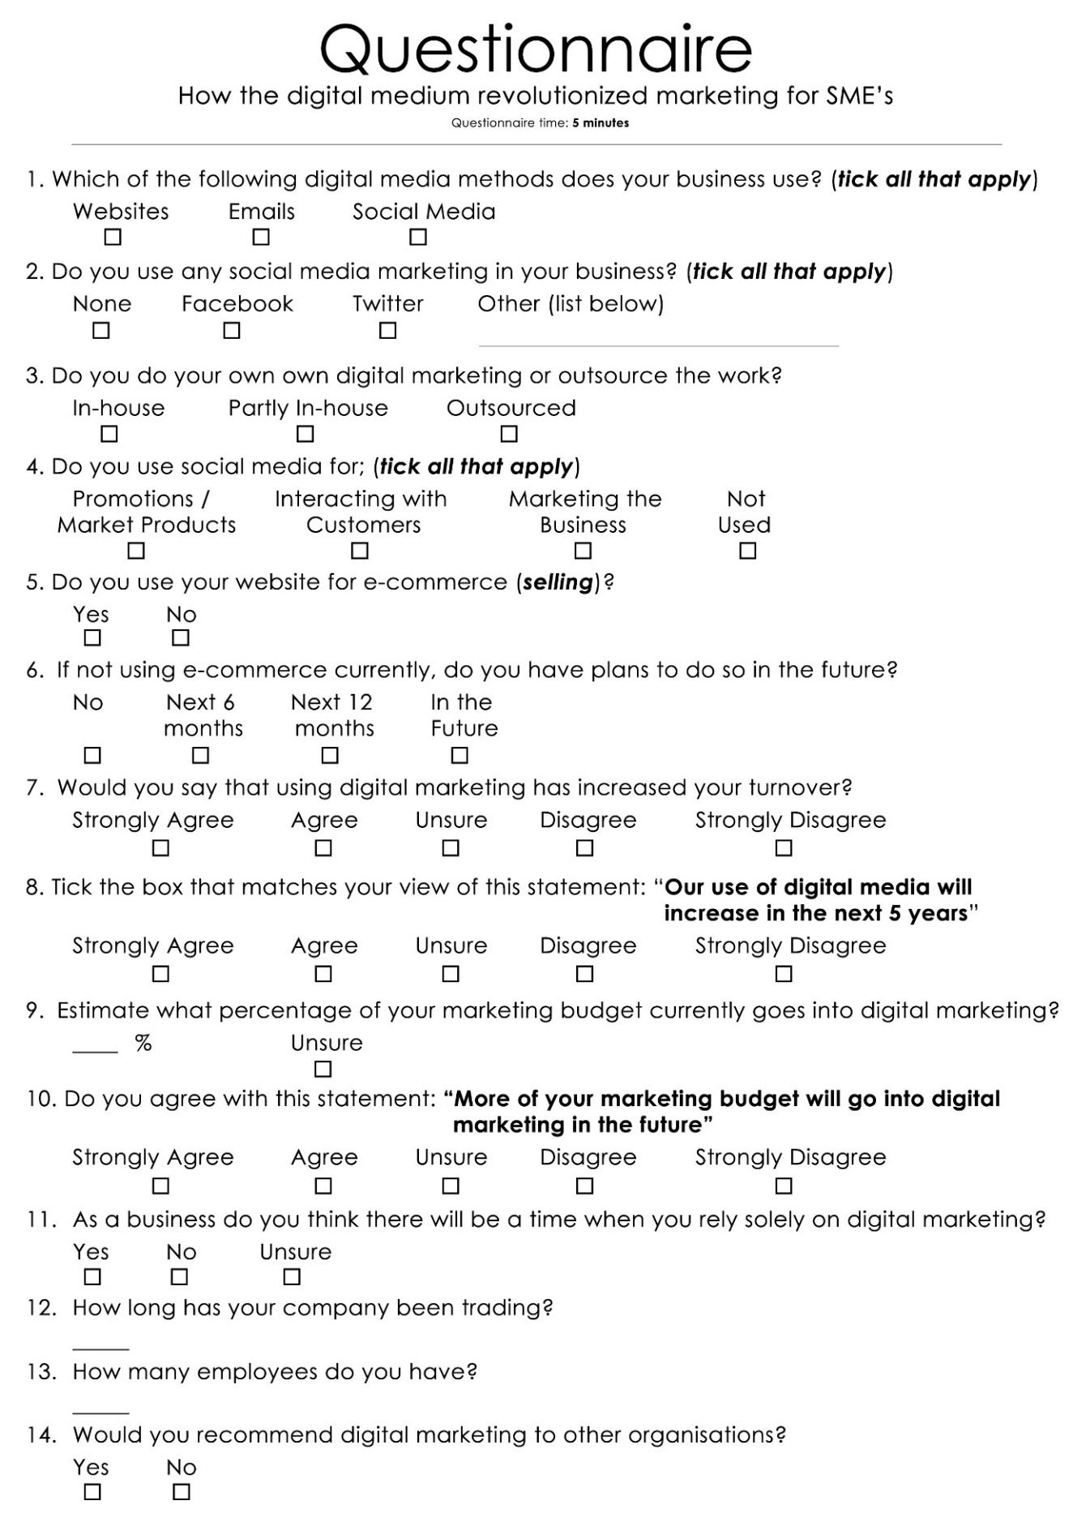
Appendices A
Questionnaire

Appendices B

<Address Here>
5th March 2017
Dear Owner/Manager
My name is Daniel Davies and I am studying for a degree in Business Management at the University of Wales Trinity Saint David in Carmarthen. To complete my degree, I am writing a dissertation titled ‘How has the Digital Medium Revolutionised Marketing for Small to Medium Enterprises’. My research into the subject requires an insight from small to medium sized businesses regarding how they use the digital medium in their business and whether this has changed during the last 10 years. This data will allow me to see what progress is being made in this field and whether improvements could be made.
I would be grateful if you would be able to spare a few minutes to complete the enclosed questionnaire. The information you supply will be invaluable to me. The dissertation will not contain any details of individual business, and all the data you supply will be aggregated and anonymised.
As a thank you for participating, all returned questionnaires will be entered into a draw for a £25 Marks and Spencer voucher.
Enclosed with the questionnaire is a stamped addressed envelope for the return of the completed form. To be eligible for the draw, items need to be returned by the 20th of March 2017.

Thank you for taking time to help me with my research.
Yours sincerely,

Daniel Davies

Appendices C
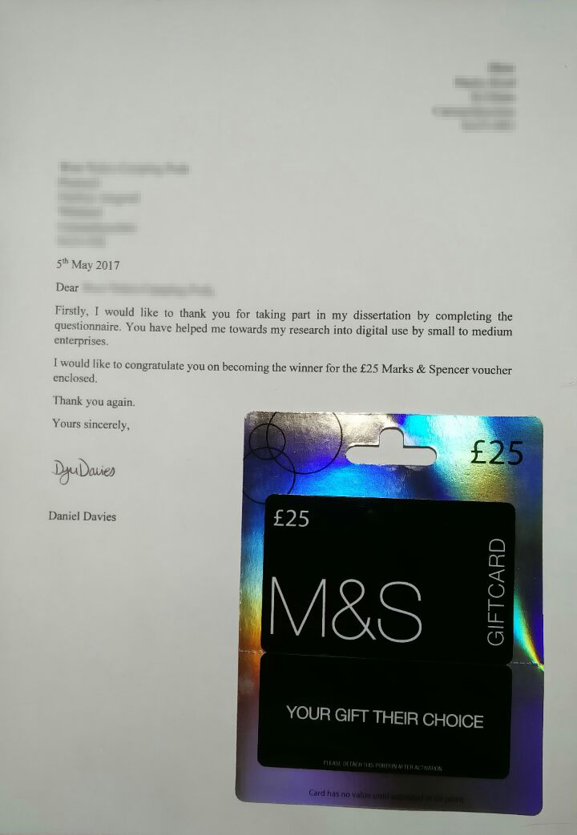
Winner selected, letter sent with voucher enclosed

Appendices D
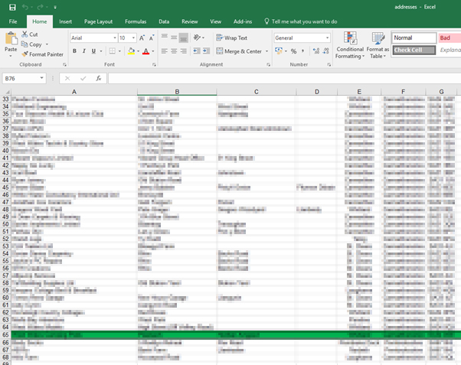
Winner of draw selected by random number generator
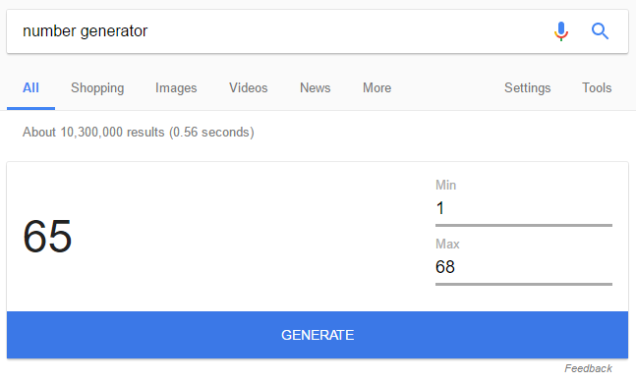
Number generator provided by Google

Appendices E
Consent Slip
- I am over 18+ years old
- I recognize that my name or organisation will not appear in any report, articles or presentations
- I understand that the data that I have supplied may be used in future documentation created by the researcher
- I will to do my best of my ability complete this questionnaire

ID (TOP LEFT OF QUESTIONNAIRE): _____ Date:

SIGNATURE: ________________

Appendices F
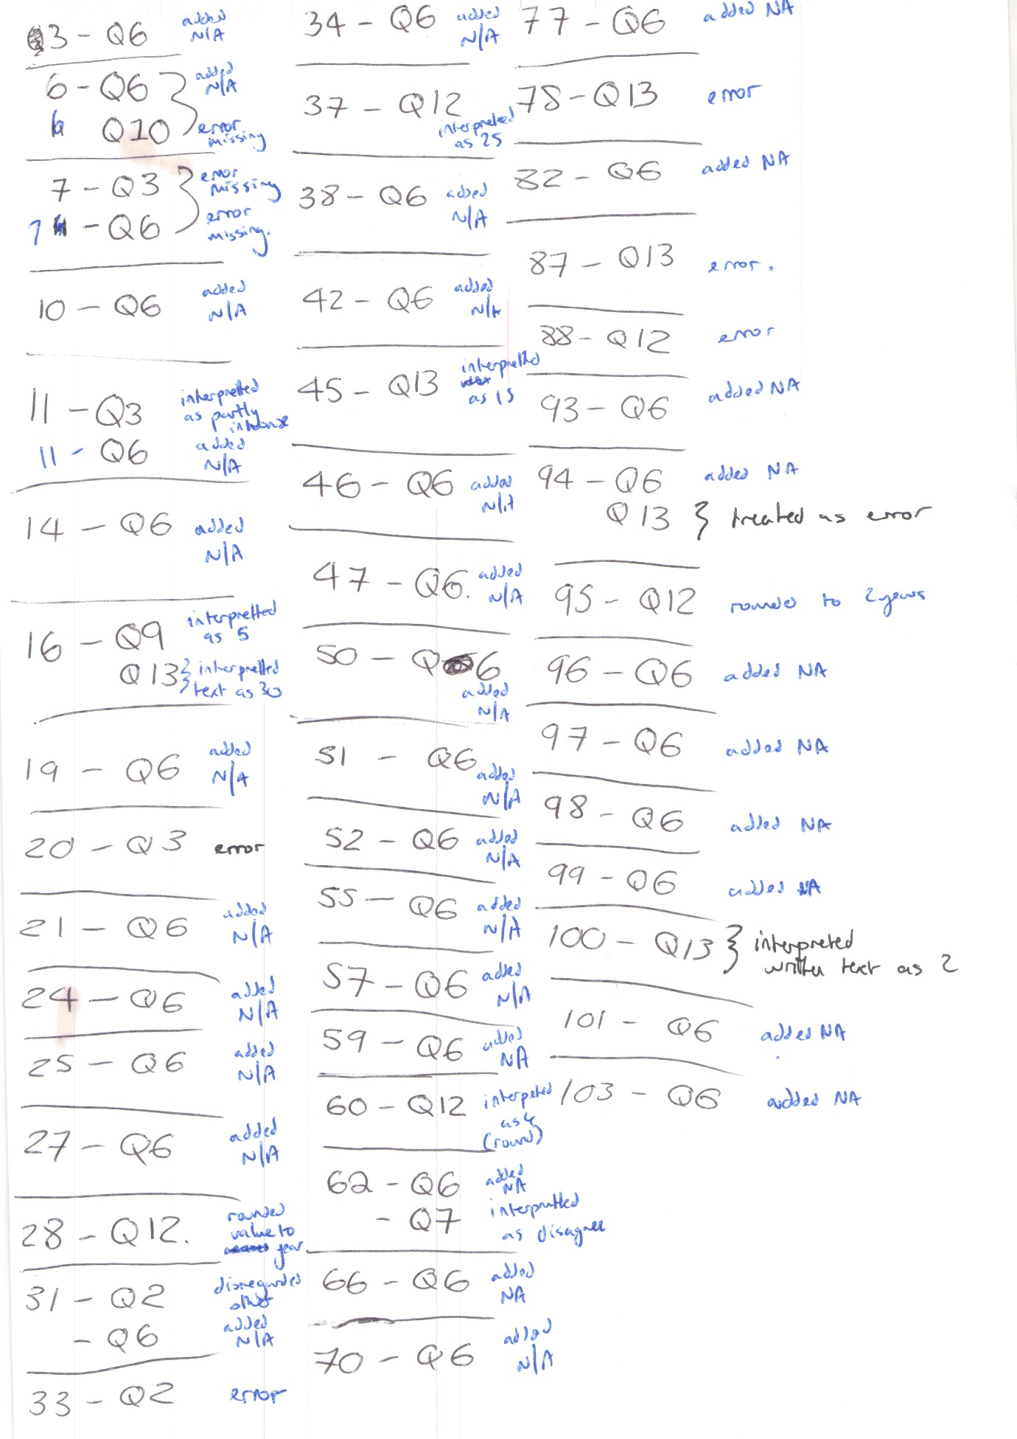
Error log - Numbers on left representing questionnaire number - numbers on right representing question errors

Appendices G
1st Meeting | 02:00 pm - 02:55 pm  25/11/2016
2nd Meeting | 10:34am - 11:25am  16/12/2016
3rd Meeting | 09:20am - 09:55am  17/03/2016
Meeting Timetable

Appendices H
 | Number of units | Per unit | Total
Postage | 172 | 0.56 | £96.32
Envelopes | 187 | 0.89 | £16.74
A 4 | 290 | 0.05 | £13.43
Printing cost | 299 | 0.005 | £1.50
Adhesive address Lables | 187 |  | £3.04
Marks & Spencer |  |  | £25.00
Total |  |  | £156.03
Cost Breakdown

