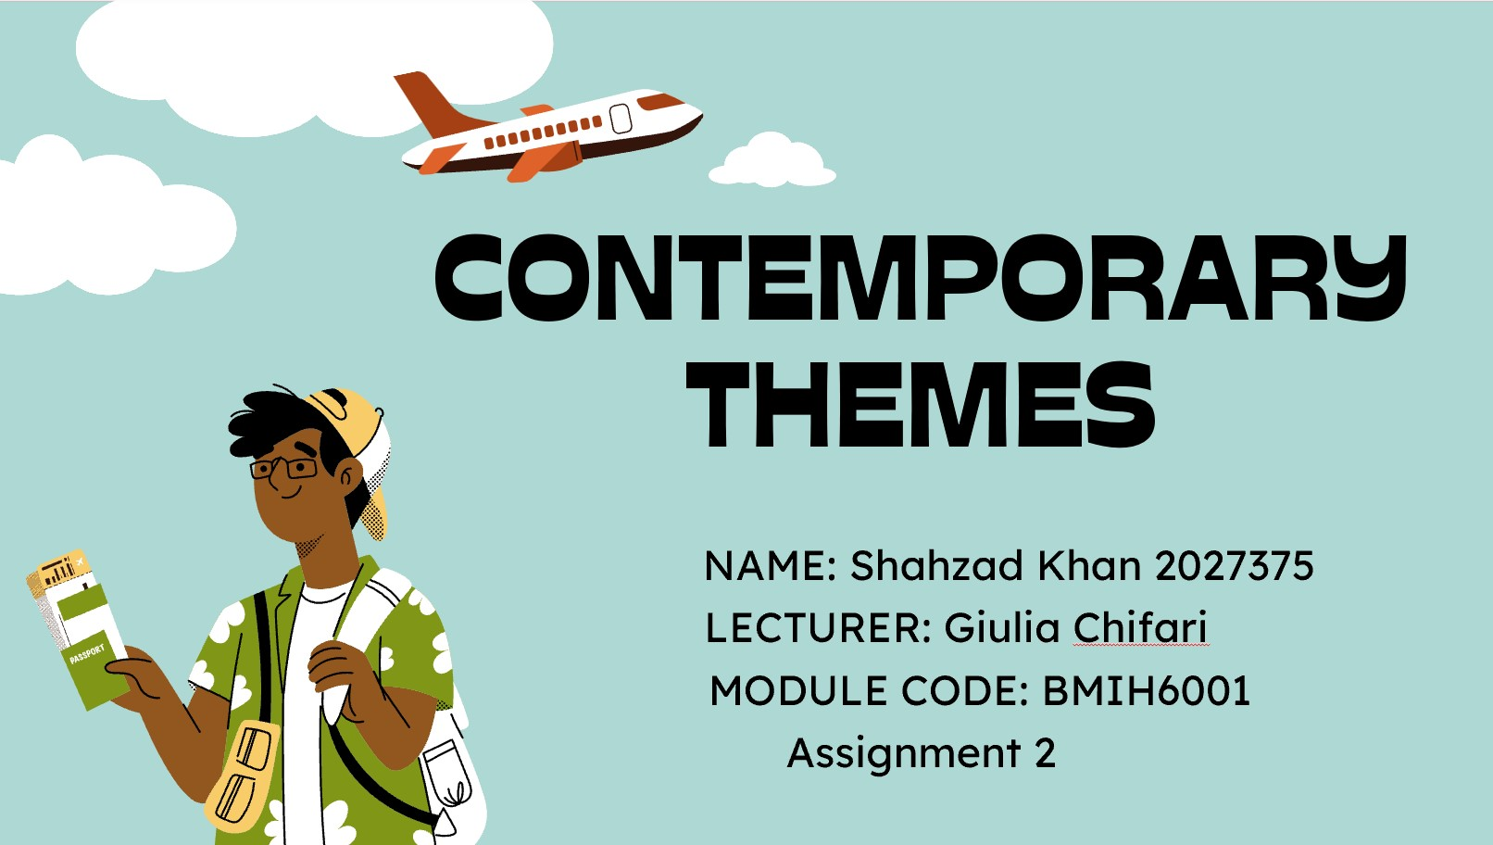
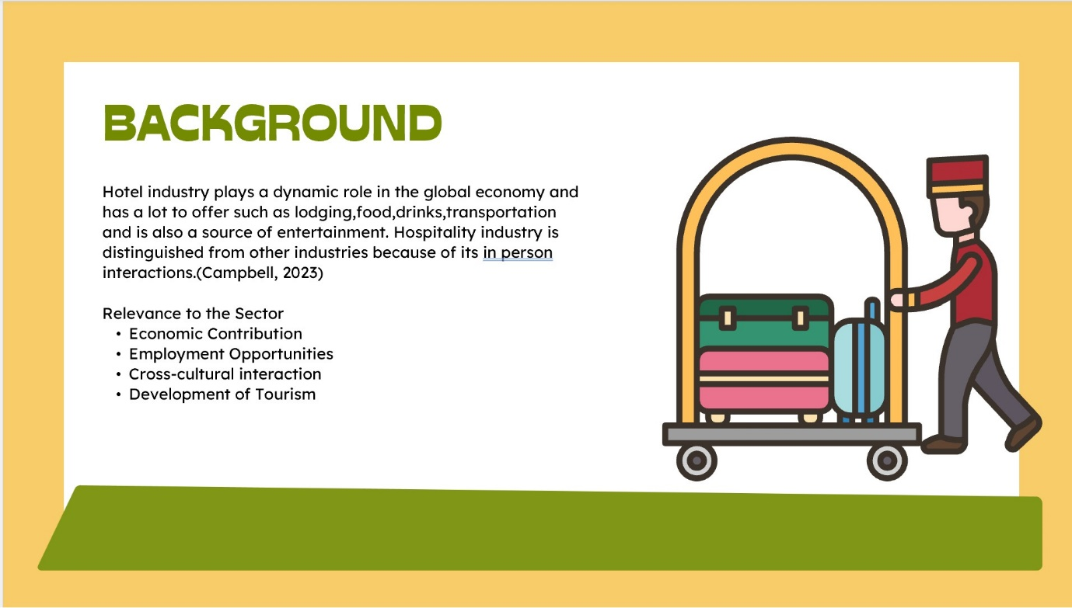
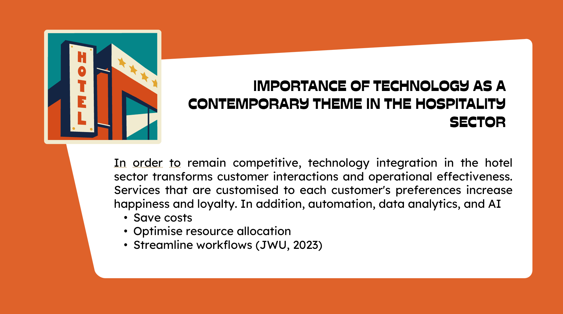
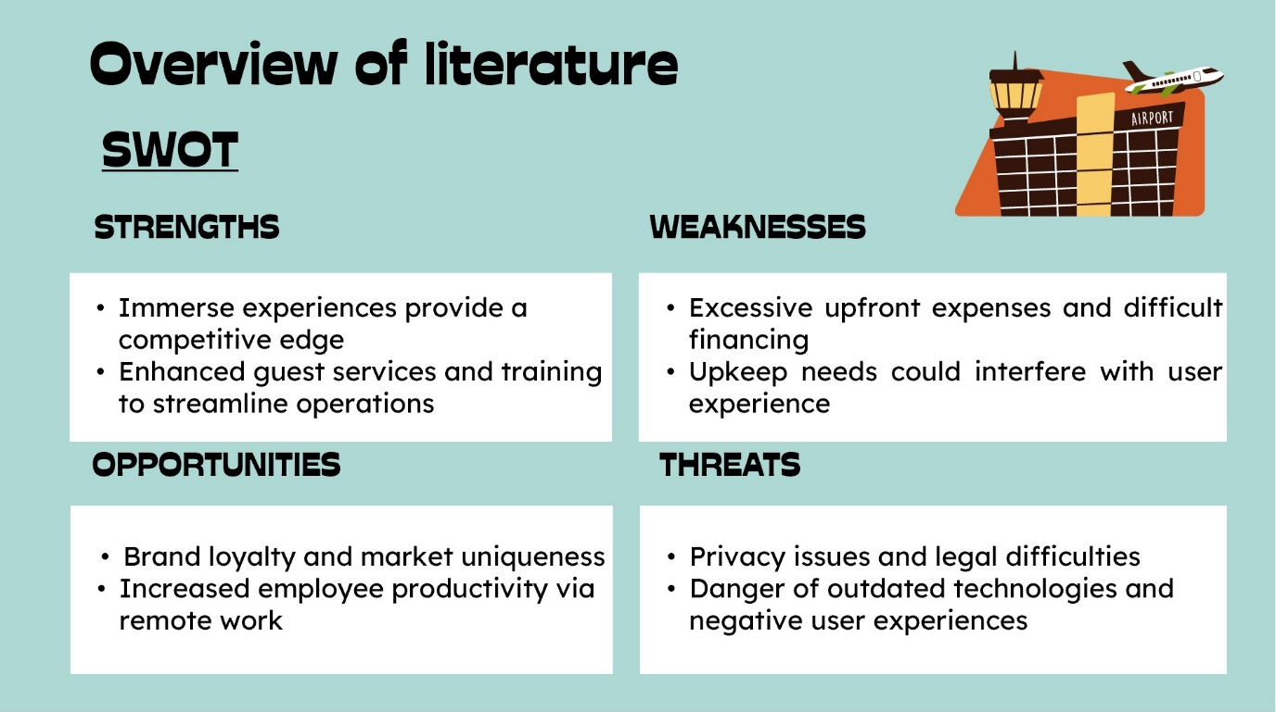

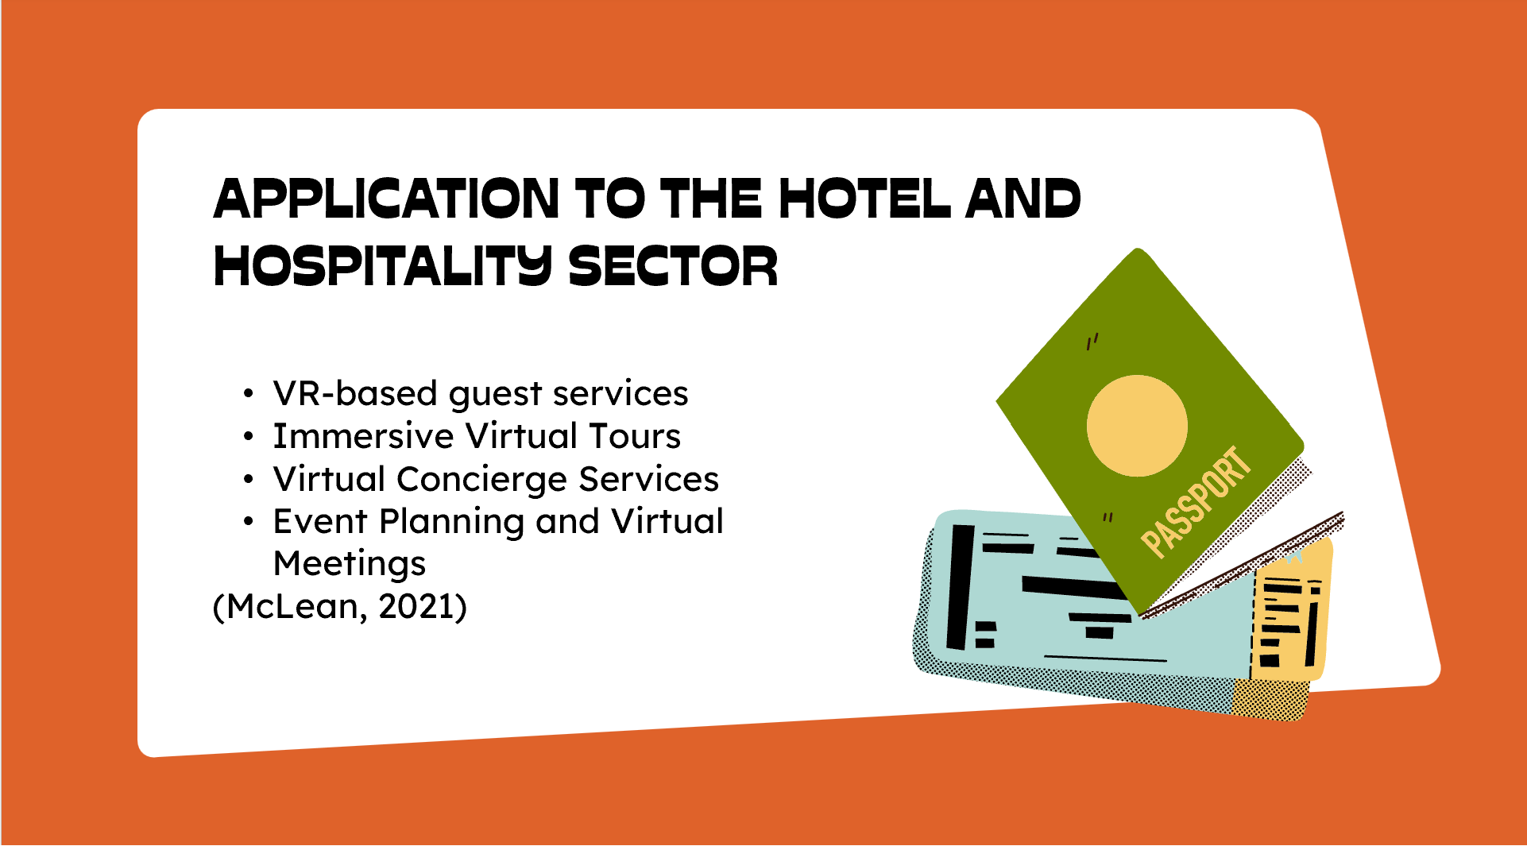
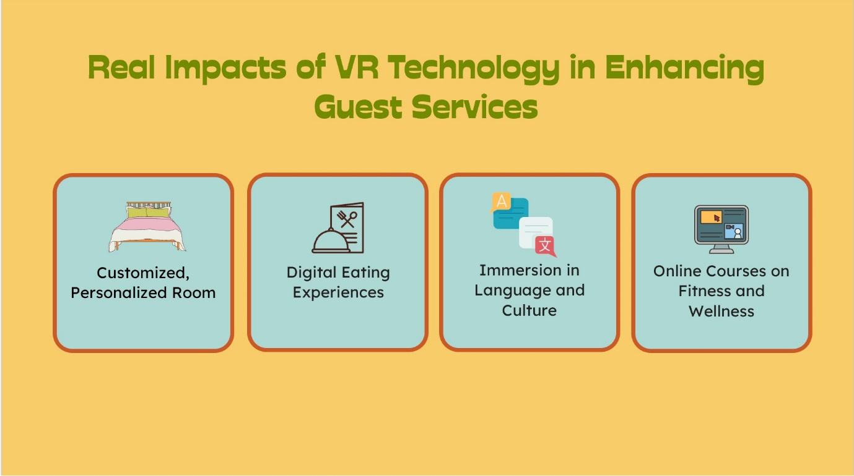
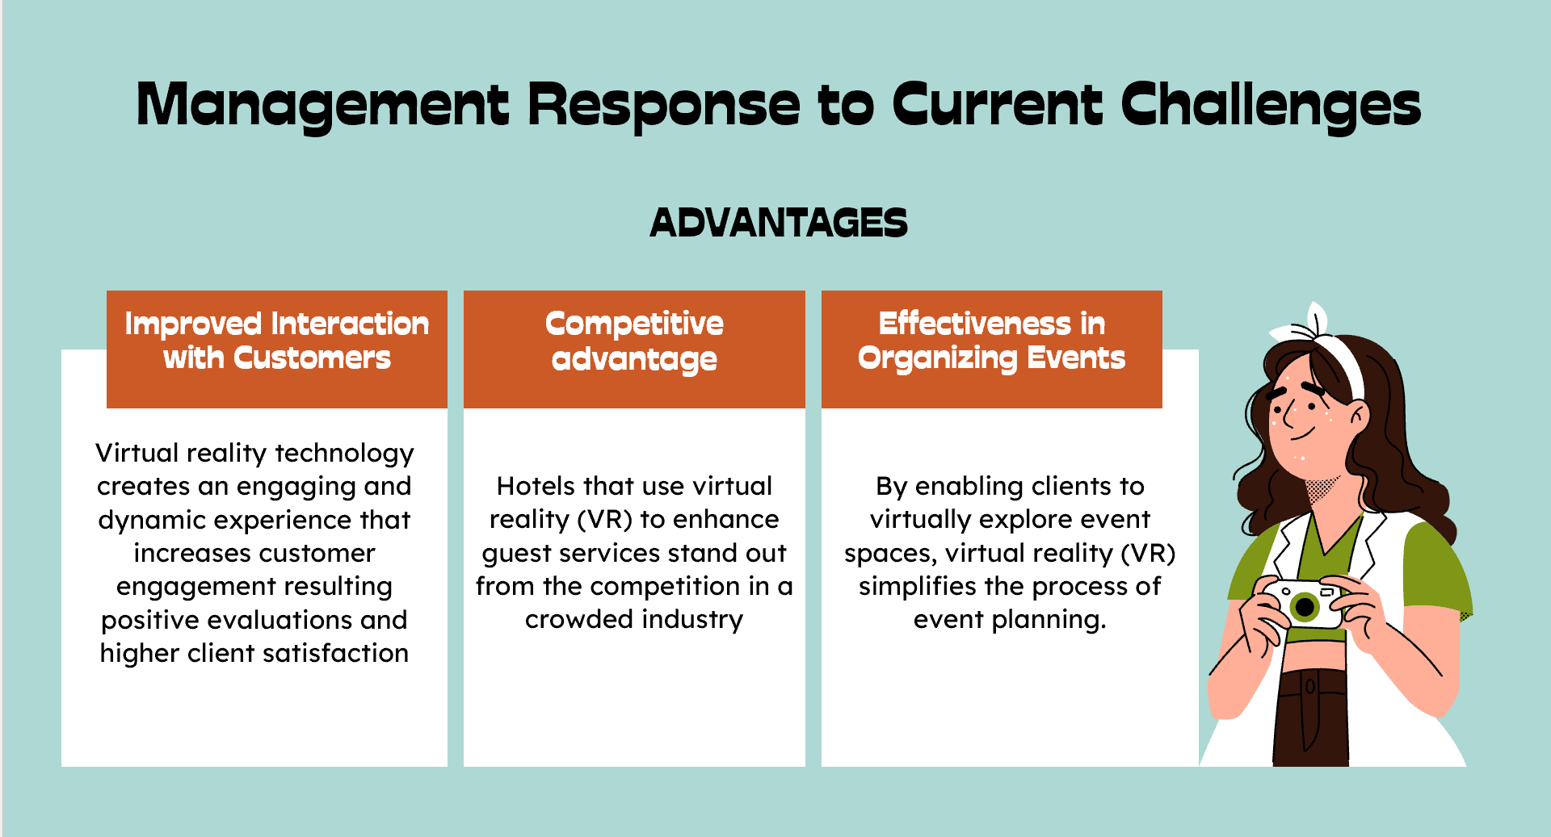
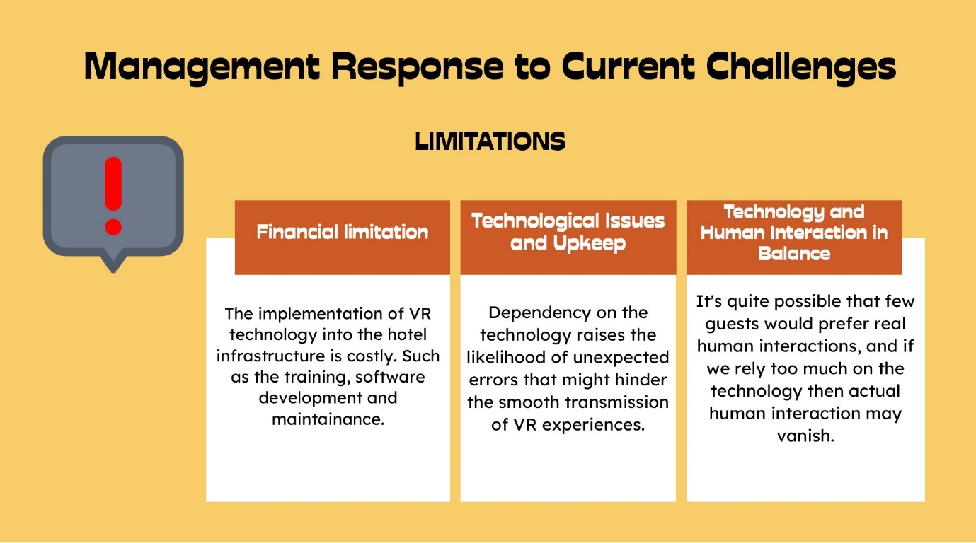
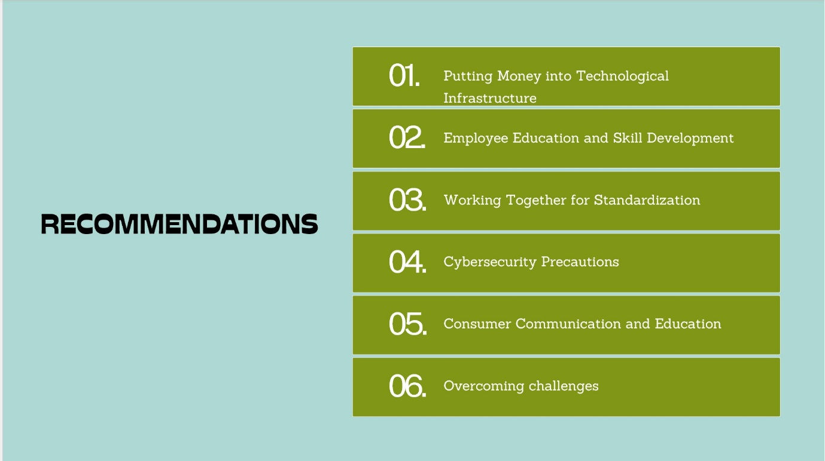
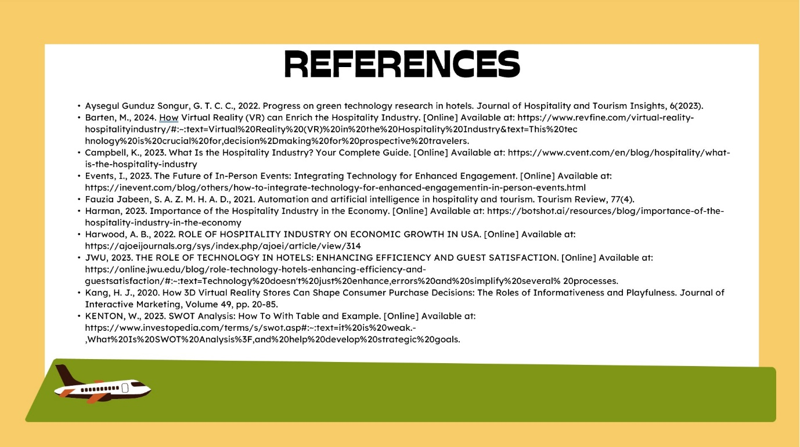

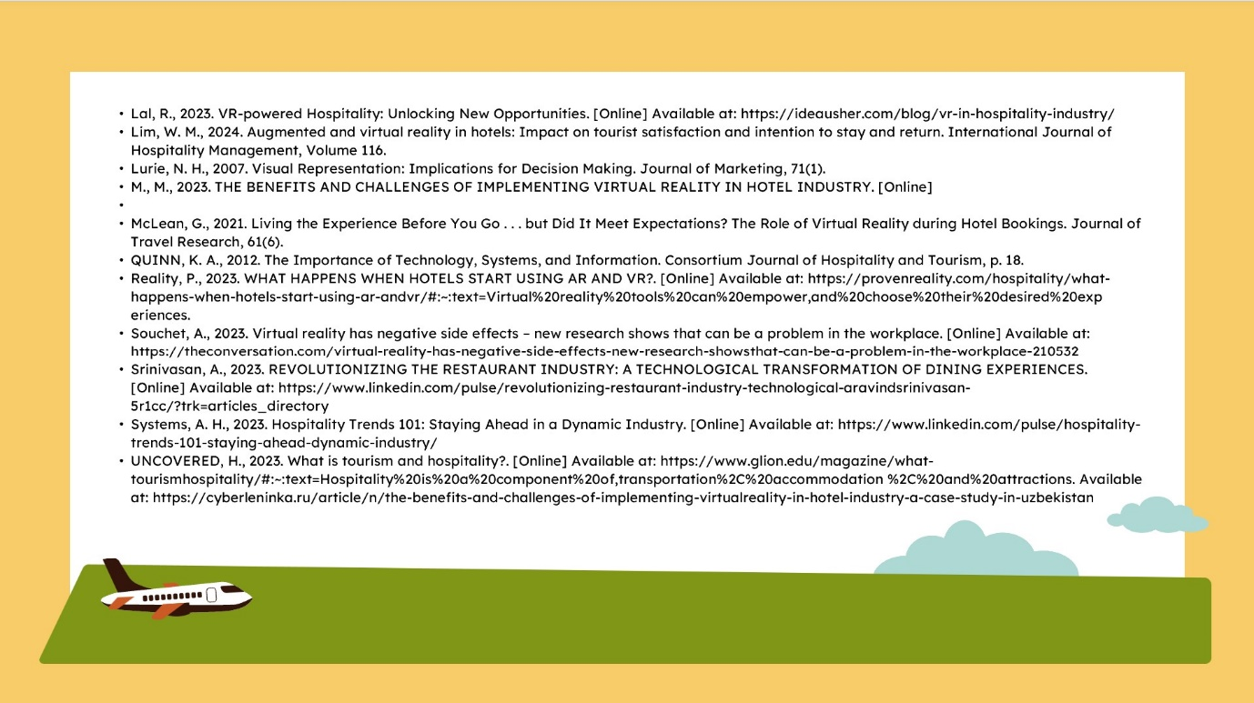

References
Aysegul Gunduz Songur, G. T. C. C., 2022. Progress on green technology research in hotels. Journal of
Hospitality and Tourism Insights, 6(2023).
Barten, M., 2024. How Virtual Reality (VR) can Enrich the Hospitality Industry. [Online]
Available at: https://www.revfine.com/virtual-reality-hospitalityindustry/#:~:
text=Virtual%20Reality%20(VR)%20in%20the%20Hospitality%20Industry&text=This%20tec
hnology%20is%20crucial%20for,decision%2Dmaking%20for%20prospective%20travelers.
Campbell, K., 2023. What Is the Hospitality Industry? Your Complete Guide. [Online]
Available at: https://www.cvent.com/en/blog/hospitality/what-is-the-hospitality-industry
Events, I., 2023. The Future of In-Person Events: Integrating Technology for Enhanced Engagement.
[Online]
Available at: https://inevent.com/blog/others/how-to-integrate-technology-for-enhanced-engagementin-
in-person-events.html
Fauzia Jabeen, S. A. Z. M. H. A. D., 2021. Automation and artificial intelligence in hospitality and tourism.
Tourism Review, 77(4).
Harman, 2023. Importance of the Hospitality Industry in the Economy. [Online]
Available at: https://botshot.ai/resources/blog/importance-of-the-hospitality-industry-in-the-economy
Harwood, A. B., 2022. ROLE OF HOSPITALITY INDUSTRY ON ECONOMIC GROWTH IN USA. [Online]
Available at: https://ajoeijournals.org/sys/index.php/ajoei/article/view/314
JWU, 2023. THE ROLE OF TECHNOLOGY IN HOTELS: ENHANCING EFFICIENCY AND GUEST SATISFACTION.
[Online]
Available at: https://online.jwu.edu/blog/role-technology-hotels-enhancing-efficiency-and-guestsatisfaction/#:~:
text=Technology%20doesn't%20just%20enhance,errors%20and%20simplify%20several%
20processes.
Kang, H. J., 2020. How 3D Virtual Reality Stores Can Shape Consumer Purchase Decisions: The Roles of
Informativeness and Playfulness. Journal of Interactive Marketing, Volume 49, pp. 20-85.
KENTON, W., 2023. SWOT Analysis: How To With Table and Example. [Online]
Available at: https://www.investopedia.com/terms/s/swot.asp#:~:text=it%20is%20weak.-
,What%20Is%20SWOT%20Analysis%3F,and%20help%20develop%20strategic%20goals.
Lal, R., 2023. VR-powered Hospitality: Unlocking New Opportunities. [Online]
Available at: https://ideausher.com/blog/vr-in-hospitality-industry/
Lim, W. M., 2024. Augmented and virtual reality in hotels: Impact on tourist satisfaction and intention to
stay and return. International Journal of Hospitality Management, Volume 116.
Lurie, N. H., 2007. Visual Representation: Implications for Decision Making. Journal of Marketing, 71(1).
M., M., 2023. THE BENEFITS AND CHALLENGES OF IMPLEMENTING VIRTUAL REALITY IN HOTEL
INDUSTRY. [Online]Available at: https://cyberleninka.ru/article/n/the-benefits-and-challenges-of-implementing-virtualreality-
in-hotel-industry-a-case-study-in-uzbekistan
McLean, G., 2021. Living the Experience Before You Go . . . but Did It Meet Expectations? The Role of
Virtual Reality during Hotel Bookings. Journal of Travel Research, 61(6).
QUINN, K. A., 2012. The Importance of Technology, Systems, and Information. Consortium Journal of
Hospitality and Tourism, p. 18.
Reality, P., 2023. WHAT HAPPENS WHEN HOTELS START USING AR AND VR?. [Online]
Available at: https://provenreality.com/hospitality/what-happens-when-hotels-start-using-ar-andvr/#:~:
text=Virtual%20reality%20tools%20can%20empower, and%20choose%20their%20desired%20exp
evidences.
Souchet, A., 2023. Virtual reality has negative side effects – new research shows that can be a problem in
the workplace. [Online]
Available at: https://theconversation.com/virtual-reality-has-negative-side-effects-new-research-showsthat-
can-be-a-problem-in-the-workplace-210532
Srinivasan, A., 2023. REVOLUTIONIZING THE RESTAURANT INDUSTRY: TECHNOLOGICAL
TRANSFORMATION OF DINING EXPERIENCES. [Online]
Available at: https://www.linkedin.com/pulse/revolutionizing-restaurant-industry-technological-aravindsrinivasan-
5r1cc/?trk=articles directory
Systems, A. H., 2023. Hospitality Trends 101: Staying Ahead in a Dynamic Industry. [Online]
Available at: https://www.linkedin.com/pulse/hospitality-trends-101-staying-ahead-dynamic-industry/
UNCOVERED, H., 2023. What is tourism and hospitality? [Online]
Available at: https://www.glion.edu/magazine/what-tourismhospitality/#:~:
text=Hospitality%20is%20a%20component%20of,transportation%2C%20accommodation
%2C%20and%20attractions.

