Tia Willock
Student Number: 2514120
Design and Implementation of a Relational Database System
Introduction to Web and Database Concepts
Course: Apprenticeship in Computing (Software Engineering) BSc

Abstract
This report outlines the design and development of a structured database for Eco-Ride, a local authority project aimed at promoting sustainable travel through electric bike rentals. The existing paper-based system creates operational challenges, including double bookings, unreturned bikes, and poor visibility of maintenance and availability. The new database addresses these issues by implementing normalised tables, foreign key constraints, and validation rules to ensure data accuracy and GDPR compliance. Core features include rider registration, bike tracking, maintenance logs, rental records, and staff management. The design prioritises scalability, efficiency, and reporting capabilities, with planned future enhancements such as a dedicated payment table, historical data storage, and rental status tracking.

Table of Contents
Abstract 1
Introduction 4
What is Eco-Ride? 4
Purpose and Context 4
Scenario Analysis 4
What are the components of a database? 4
Entities and Attributes 4
Person Entity 5
Rider Entity 6
Staff Entity 6
Bike Entity 6
BikeType Entity 7
Location Entity 8
BikeMaintenance 9
BikeTelemetry 9
Price 10
Rentals 10
Cardinalities and Foreign Keys 11
Person 11
BikeType 11
Location 12
Bike 12
Rental 12
BikeTelemetry 12
BikeMaintenance 13
Referential Integrity 13
Normalisation 13
Implementation 13
Validation Rules 13
Validation Rules and Properties Table 13
Validation and Testing 28
Testing Process 28
Test Cases and Outcomes 28
Query Design 31
Design Decisions and Reflection 32
Database Relationships 32
Attribute Selection 33
Challenges 33
What features would be improved in the future? 33
Conclusion 33
References 34

Introduction

What is Eco-Ride?
Eco-Ride is a local authority project promoting healthy sustainable travel through an electric bike rental service at parks, train stations and university. Riders scan their ID to rent a bike can return it to any rental station. The current paper-based system causes issues such as double bookings, unreturned bikes, and poor tracking of availability and maintenance.

Purpose and Context
This project aims to design a structured database to replace manual processes, ensuring accurate records, improved security [2, p.75], and better disaster recovery through online backups. The database will enable rider registration, bike tracking, maintenance management, rental records, and staff involvement.

Scenario Analysis

What are the components of a database?
The three basic components of a database are entities, attributes and the relationships between them. An entity is an object to be represented and stored in the database. Atrributes are properties that are wanting to be stored describing the object and the relationship is how the entities link together to make the database work [2, p.63]. In the database, every entity corresponds to a table whose attributes describe its features, while a primary key ensures that each entry is unique. There are also foreign keys which are represented through the relationships [3].

Entities and Attributes
The entities created include:
- Bike
- BikeMaintenance
- BikeTelemetry
- BikeType
- Location
- Price
- Person
- Rentals
- Rider
- Staff

These entities form the basis of the Entity Relationship Diagram, where rectangles represent entities and ovals represent their attributes, as seen below.

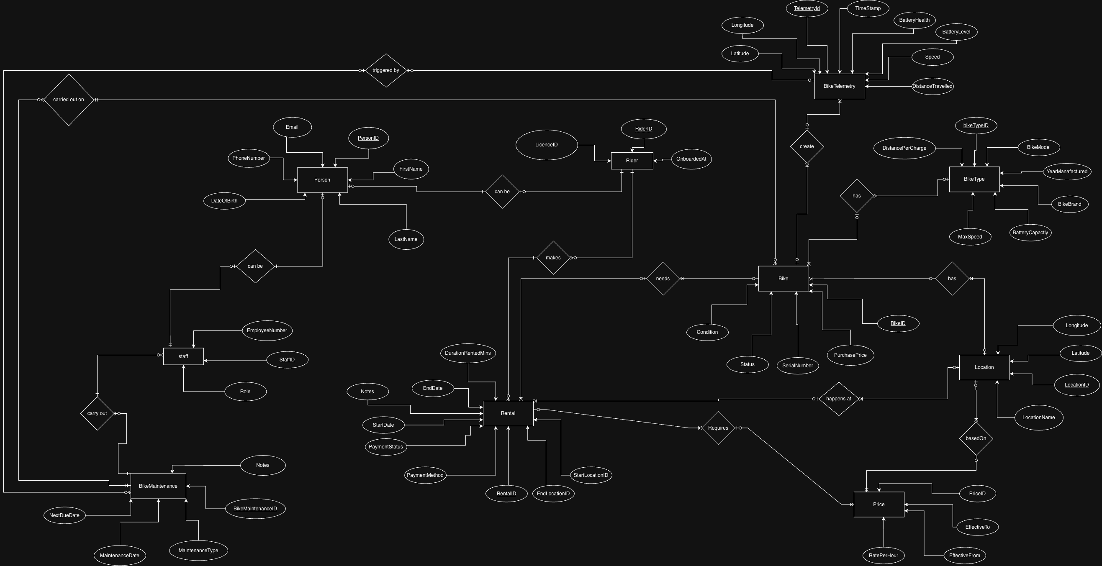
Fig 1. Entity Relationship Diagram for Eco-Ride Database.

Person Entity
Its purpose is to store the data for all the individuals that are part of Eco-Ride.
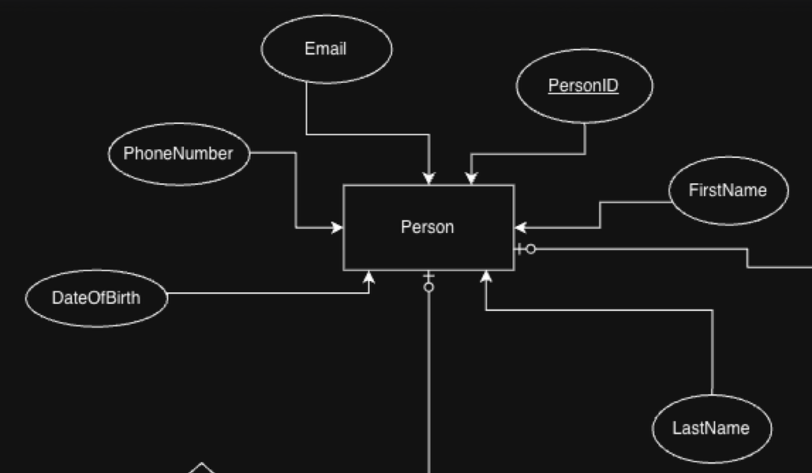

Fig 2. Zoomed in view of person Entity in ERD.

Primary Key: PersonID.
Attributes:
- FirstName
- LastName
- PhoneNumber
- DateOfBirth
- Email

Rider Entity
Its purpose is to store data specific to the rider.
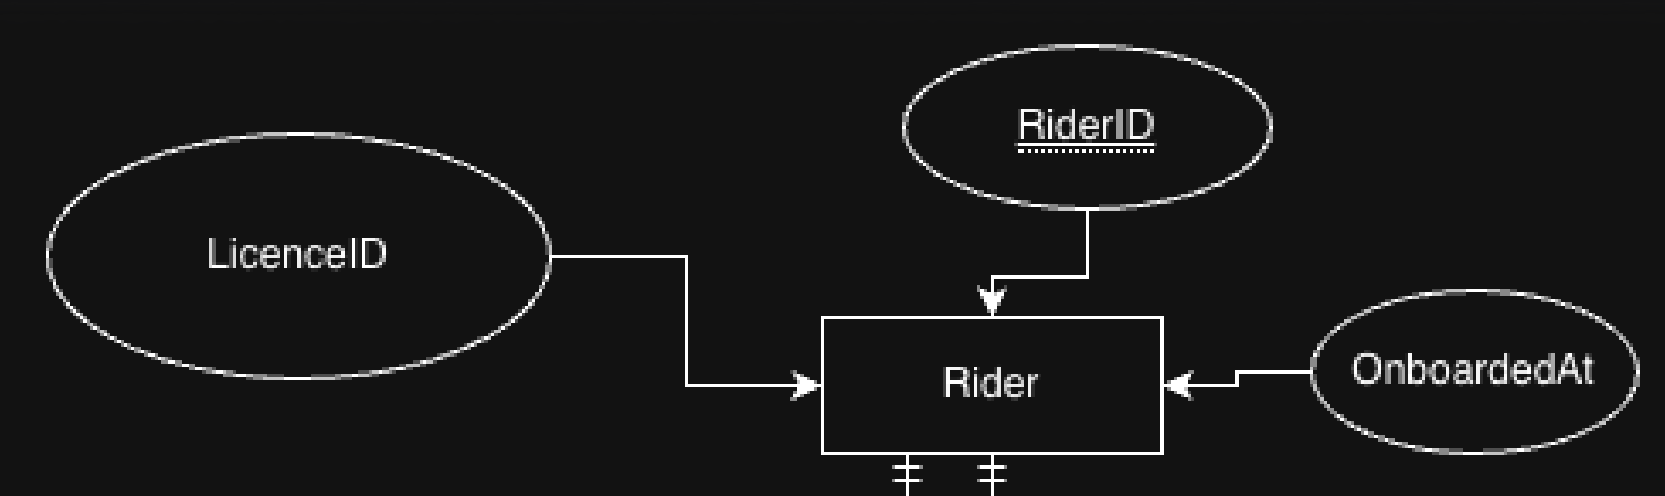

Fig 3. Zoomed in view of Rider entity in ERD.

Primary key: RiderID
Attributes:
- Licence ID
- OnboardedAt

Staff Entity
Its purpose is to store staff specific data.
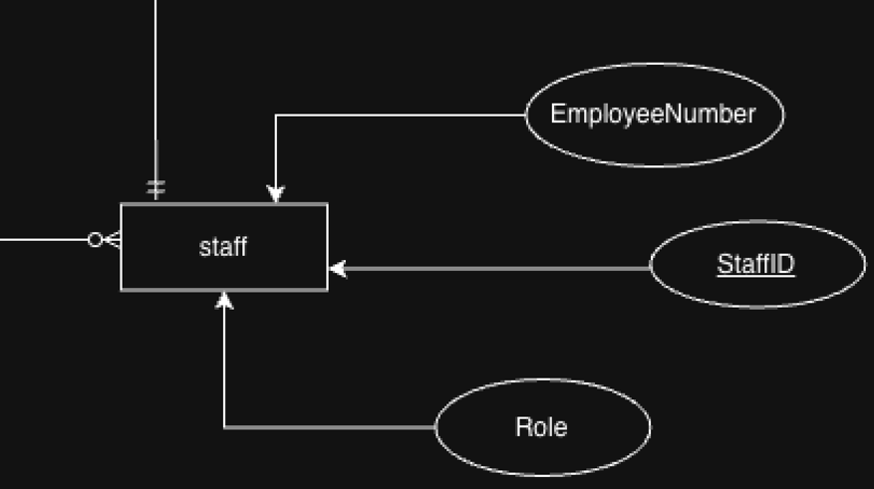

Fig 4. Zoomed in view of Staff Entity in ERD.

Primary key: StaffID.
Attributes:
- EmployeeNumber
- Role

Bike Entity
Its purpose is to store data specific to the bike.
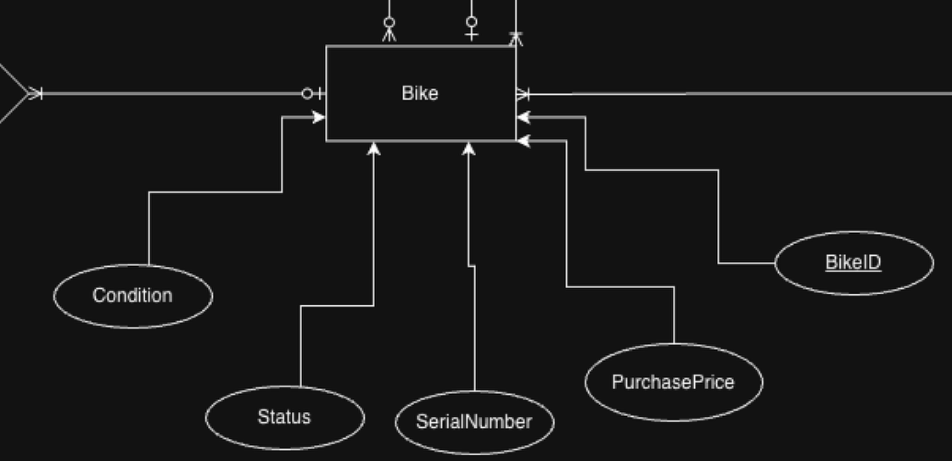

Fig 5. Zoomed in view of Bike Entity in ERD.
Primary key: BikeID.
Attributes:
- SerialNumber
- Status
- Condition
- Purchase Price

BikeType Entity
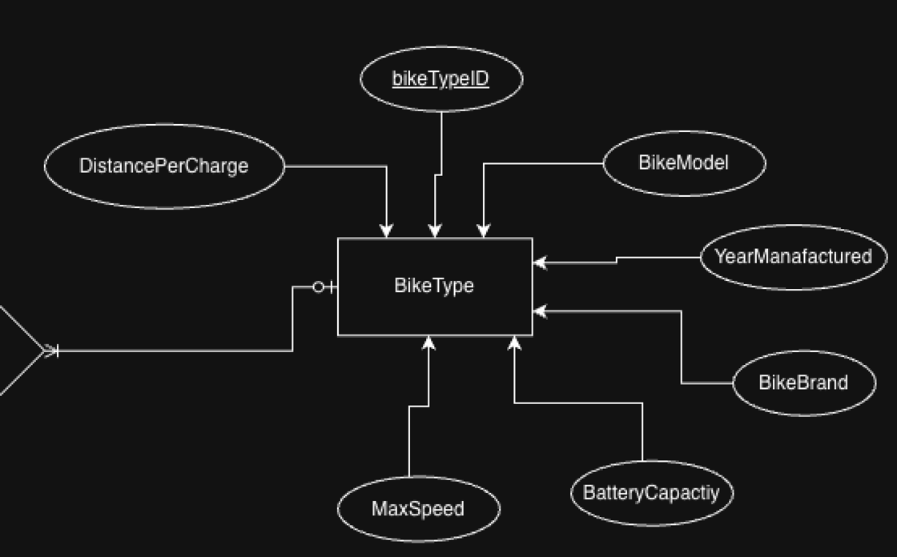
To store data specific to the bike type.

Fig 6. Zoomed in view of BikeType Entity in ERD.

Primary key: BikeTypeID.
Attributes:
- BikeModel
- YearManufactured
- BikeBrand
- BatteryCapacity
- MaxSpeed –
- DistancePerCharge

Location Entity
To store data specific to location of the bikes.
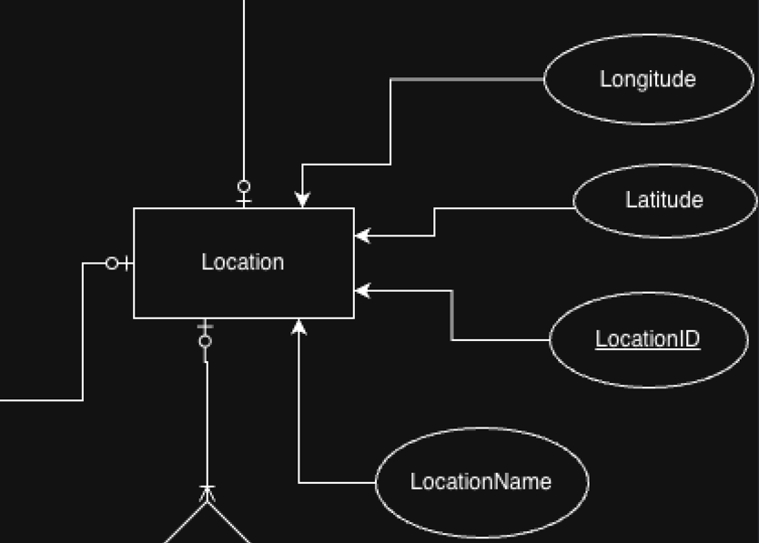

Fig 7. Zoomed in View of Location Entity in ERD.

Primary key: LocationID.
Attributes:
- LocationName
- Latitude and Longitude

BikeMaintenance
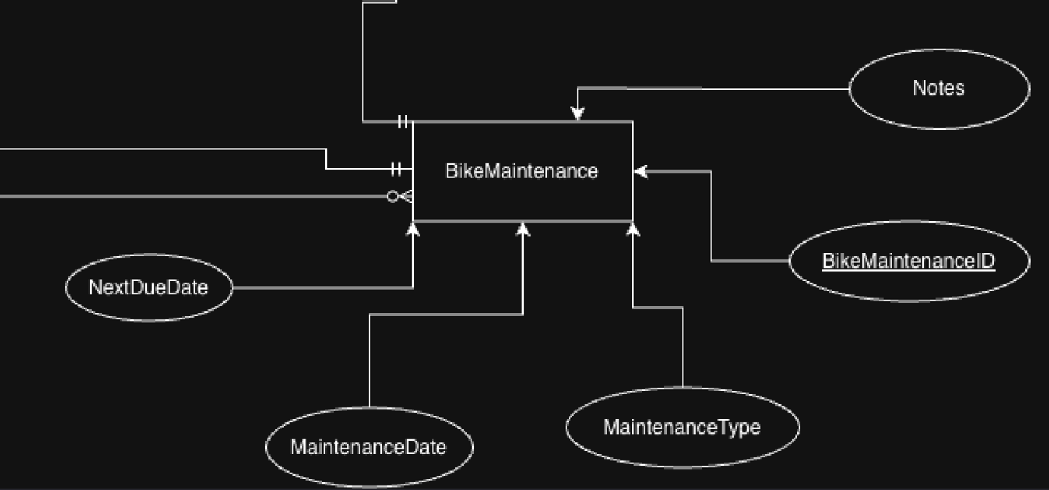
To store data specific to maintenance of the bikes including inspections.
Fig 8. Zoomed in view of BikeMaintenance Entity in ERD.

Primary Key: BikeMaintenanceID
Attributes:
- MaintenanceType
- MaintenanceDate
- NextDueDate
- Notes

BikeTelemetry
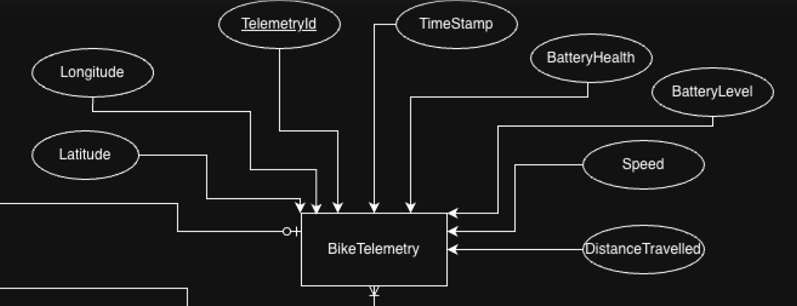
To store real time data analytics for each bike.
Fig 9. Zoomed in view of BikeTelemetry Entity in ERD.

Primary Key: TelemetryID
Attributes:
- TimeStamp
- BatteryLevel
- BatteryHealth
- Speed
- Distance Travelled
- Longitude and Latitude

Price
To store data regarding price.
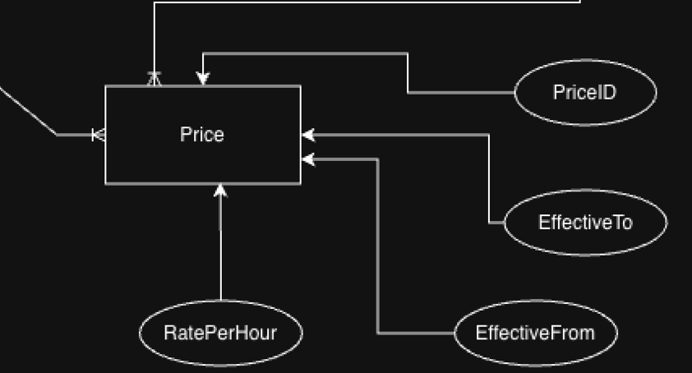

Fig 11. Zoomed in view of Price Entity in ERD.

Primary Key: PriceID
Attributes:
- EffectiveFrom
- EffectiveTo
- RatePerHour

Rentals
To store data regarding the rentals.
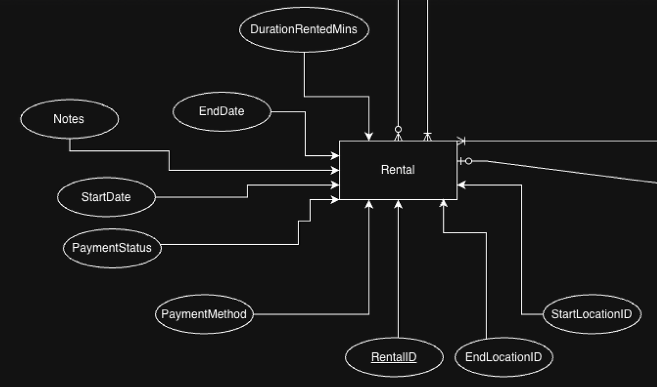
Fig 12. Zoomed in view of Rental Entity in ERD.

Primary Key: RentalID
Attributes:
- StartDate
- EndDate
- StartLocationID
- EndLocationID
- DurationRentedMins
- PaymentStatus
- PaymentMethod

Cardinalities and Foreign Keys
Foreign keys link a child table to the primary key of a parent table, ensuring valid and consistent relationships [4]. They maintain referential integrity, prevent orphaned records, and support cascading updates or deletions. In an ERD, these relationships are shown as connecting lines, with circles, straight lines, or crow’s feet indicating cardinality.
The cardinalities in my ERD are as follows:

The cardinalities displayed in my ERD are as follows:

Person
- Person → Rider
Not every person is a rider, but every rider must be linked to a person. Cardinality: One (optional) to One (mandatory).
Person → Staff
A person may not be staff, but all staff members are associated with a person record.
Cardinality: One (optional) to One (mandatory).

BikeType
- BikeType → Bike
Each bike must have a type, and a single bike type can apply to multiple bikes.
Cardinality: One (mandatory) to Many (optional).

Location
- Location → Bike
Every bike is stored at a location, but a location can exist without any bikes assigned.
Cardinality: One (mandatory) to Many (optional).
- Location → Price
Each price entry is tied to a location, but a location may have no price records yet.
Cardinality: One (mandatory) to Many (optional).

Bike
- Bike → BikeMaintenance
Maintenance records must reference a bike, though a bike might not have any maintenance history.
Cardinality: One (mandatory) to Many (optional).
- Bike → BikeTelemetry
Telemetry data is linked to a bike, but some bikes may not have telemetry records.
Cardinality: One (mandatory) to Many (optional).

Rental
- Rental → Rider
Every rental must be associated with a rider, but a rider may never rent a bike.
Cardinality: One (mandatory) to Many (optional).
- Rental → Bike
Each rental involves a bike, but a bike might not have been rented before.
Cardinality: One (mandatory) to Many (optional).
- Rental → Price
Rentals require a price, but a price record can exist without being used.
Cardinality: One (mandatory) to Many (optional).
- Rental → Location
Rentals have start and end locations, but a location might not have any rentals yet.
Cardinality: One (mandatory) to Many (optional).

BikeTelemetry
- BikeTelemetry → BikeMaintenance
If maintenance is triggered by telemetry, it must reference that telemetry record, though most telemetry entries won’t lead to maintenance.
Cardinality: One (optional) to Many (mandatory).

BikeMaintenance
- BikeMaintenance → Staff
Each maintenance job must be signed off by a staff member, but not all staff will perform maintenance.
Cardinality: One (mandatory) to Many (optional).

Referential Integrity
In the Eco-Ride database, foreign keys were implemented to enforce referential integrity, ensuring that relationships between tables remain valid and consistent. Cascading actions were applied selectively to simplify data management . For example, “On Delete Cascade” was used so that when a bike is removed, related records in BikeTelemetry and BikeMaintenance are also deleted, preventing orphaned data and reducing manual clean-up. Similarly, “On Update Cascade” ensures that if a key attribute such as LocationName changes, linked records in Price and Rentals update automatically. These actions reduce redundancy and maintain accuracy, but they were used sparingly to avoid unintended data loss, demonstrating careful consideration of risk versus benefit.

Normalisation
The schema was designed to meet Third Normal Form (3NF) to improve efficiency and maintain data integrity. This involved eliminating repeating groups and multi-valued attributes, such as storing bike telemetry in separate rows rather than combined fields [5]. Non-key attributes were ensured to depend only on the primary key, for example, BikeType details like BatteryCapacity and MaxSpeed rely solely on BikeTypeID. Transitive dependencies were also removed by storing attributes such as LocationName in the Location table rather than Bike or Rentals. These decisions reduce redundancy, simplify updates, and support scalability as Eco-Ride expands.

Implementation

Validation Rules
Validation rules and field properties were applied to ensure accuracy and consistency. Mandatory fields guarantee essential data is captured, while numeric ranges and date restrictions prevent invalid entries, such as a return date before the rental date. Input masks and text patterns standardise formats for IDs and contact details, improving data quality and query efficiency. These measures reduce human error, maintain integrity, and support compliance with GDPR, ensuring the database remains reliable and secure for operational use.
Please see below examples of the validation used throughout the database.

Validation Rules and Properties Table

Field | Validation Rule / Property | Purpose
Mandatory Fields | Is Not Null | Ensures field is not left empty.
Numeric Fields | >=1 | Ensures values must be positive. Removes the chance of negative values.
Numeric Fields | Is Null Or >=1 | Allows the entry to be optional but if a value is entered it must be greater than 1.
Date Fields | <=Now() | Prevents future dates from being entered, maintaining chronological accuracy.
Date Fields | Between #01/01/2010# And Date() | Restricts dates to a valid historical range for BikeType because no bike in the system is older than that.
Identifier Fields | [-A-Za-z0-9]* | Restricts ID entries to letters and numbers for consistency.
Text Fields | Like "*[A-Za-z0-9&'./+\- ]*" | Allows only those symbols.
Text Fields | Not Like "*[0-9]*" | Prevents numbers from being entered, where letters are expected.
Email Fields | Like "*?@?*.*" | Ensures the correct email format is followed.
Phone Fields | Like "07#########" Or Like "+############*" | Enforces phone format for UK and international numbers for person table
Status Field | In ("Available","Rented","Maintenance","Retired") | Only allows these status’ to be input. Prevents misspellings and other words being used regarding BikeType.
Condition Field | In ("Like New","Great","Good","Fair","Poor") | Standardises the assessment of item quality.
Date/Time Fields | Input Mask: 00/00/0000\ 00:00:00;0;_ | Reduces chance of date being entered incorrectly, if forced to follow that format.
Numeric Fields | Field Size: Double, Format: 0.0000, Decimal Places: 4 | Ensures precision and consistency in calculations, ensuring they are all formatted the same.

Table 1. Table of examples from my datasheets where they were used.

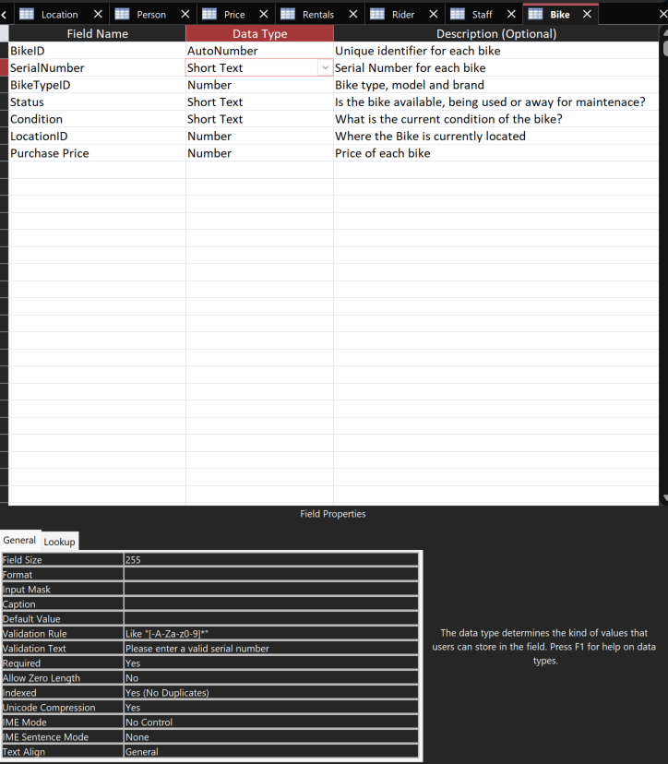
Fig 13. Screenshot of Bike table in design view showing SerialNumber only accepts, capital and lowercase letters and numbers.

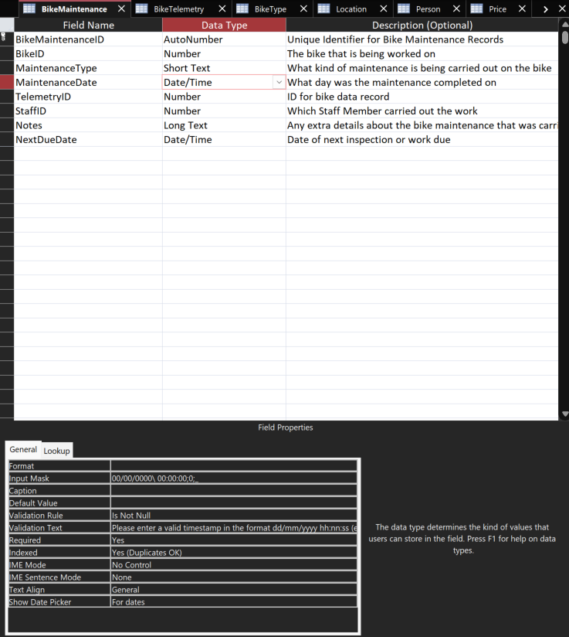

Fig 14. Design view for BikeMaintenance Table. This screenshot shows the input mask and validation rule for MaintenanceDate.

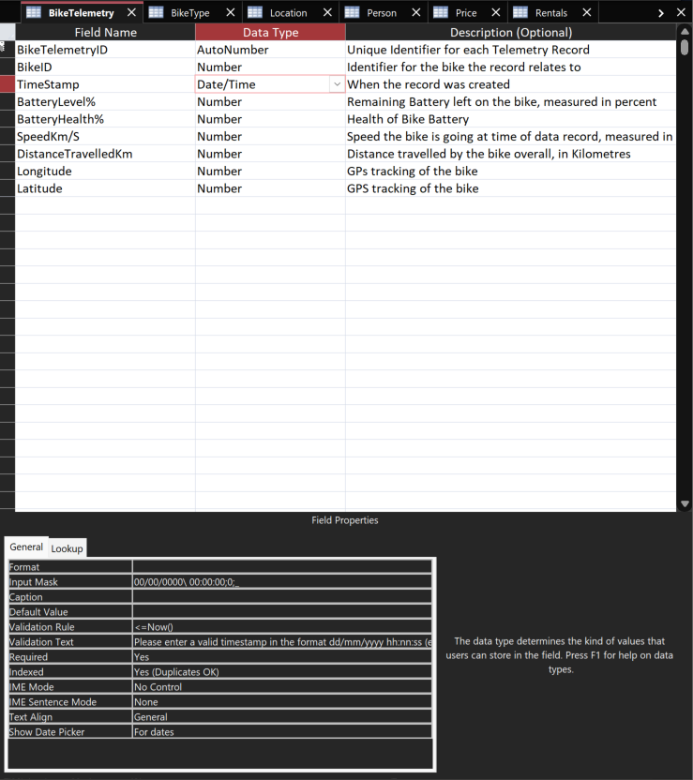

Fig 15. Design view for the BikeTelemetry table. This screenshot shows the validation rule for Timestamp and the format required to standardise the fields.

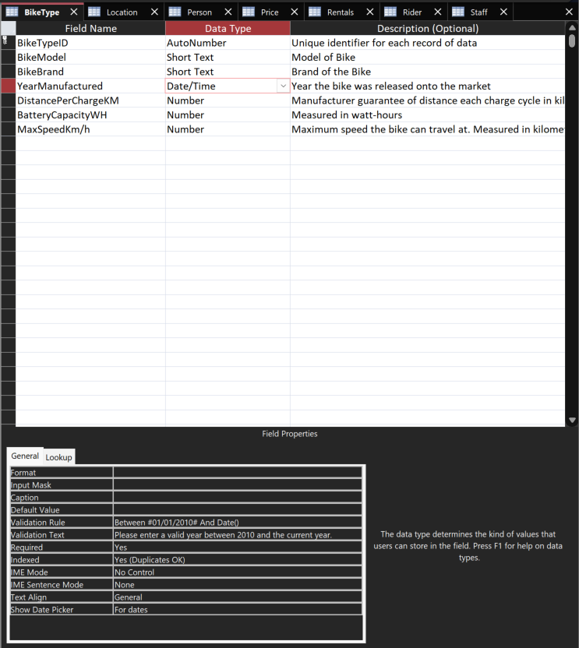
Fig 16. Design view for BikeType Table. This screenshot shows the validation rules for YearManufactured and how it must be between 2010 and this year.

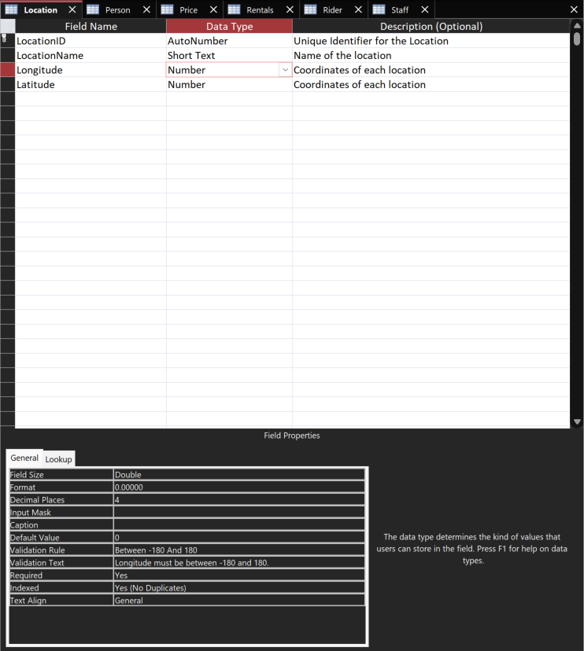
Fig 17. Design view for Location Table, specifically the validation rules for Longitude.

Figure 17 shows the field size, format, decimal place values and validation rules for Longitude. These were all required to get the longitude to display in the exact format with 4 values the right of the decimal place.

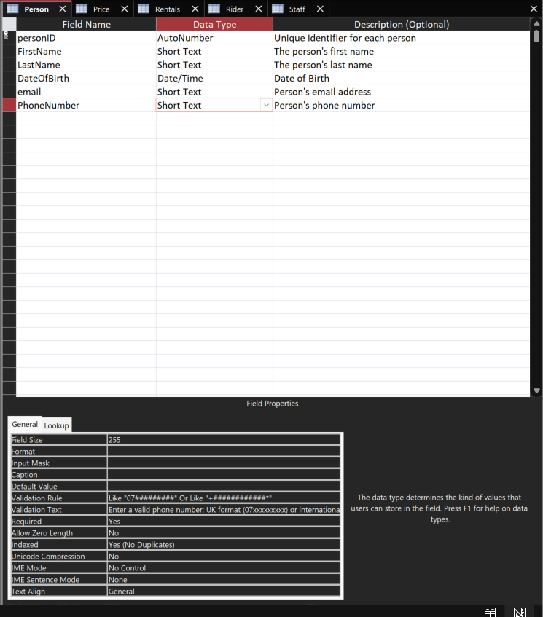
Fig 18. Design view for Person Table. This screenshot shows the validation rule for PhoneNumber.

The reason PhoneNumber was give two validation rules, as seen in Figure 18 above, was because not everyone using these e-bikes might not be from the UK, and therefore the validation should be inclusive of other phone number formats.

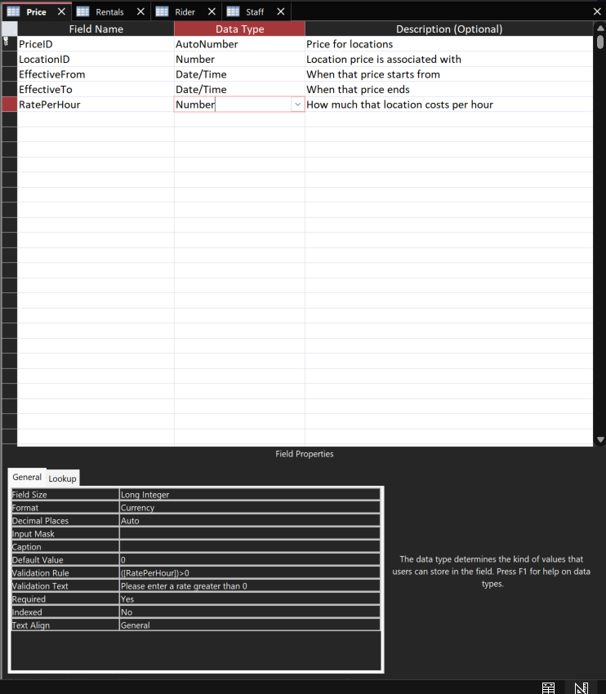
Fig 19. Design view for Price Table. This screenshot shows a different way of displaying that the rate per hour for price, should be higher than 0.

The price starts at 0 instead of higher to allow for the possibility of free rentals for promotional activities if the company so decide. The validation rule was still inputted though to ensure no negative figures could be entered accidentally.

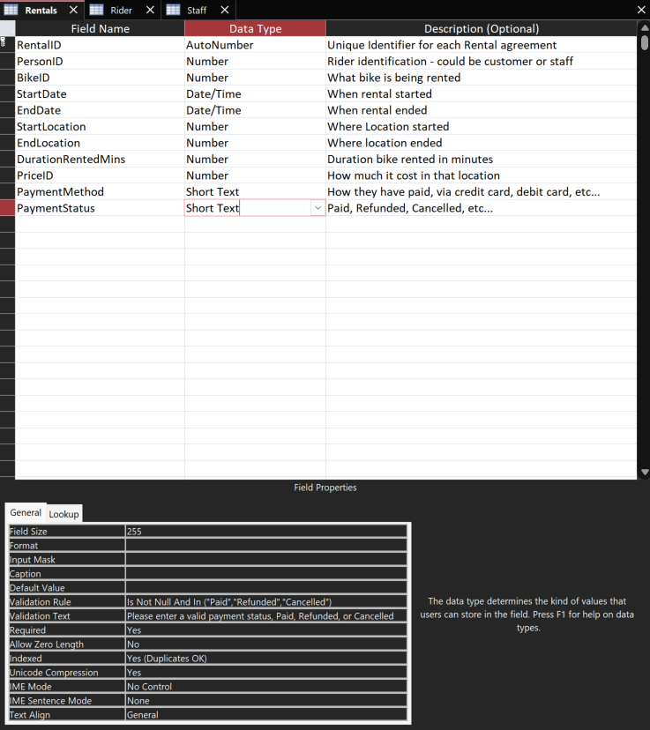
Fig 20. Design view for Rentals. This screeenshot shows the validation rule for Payment Status.

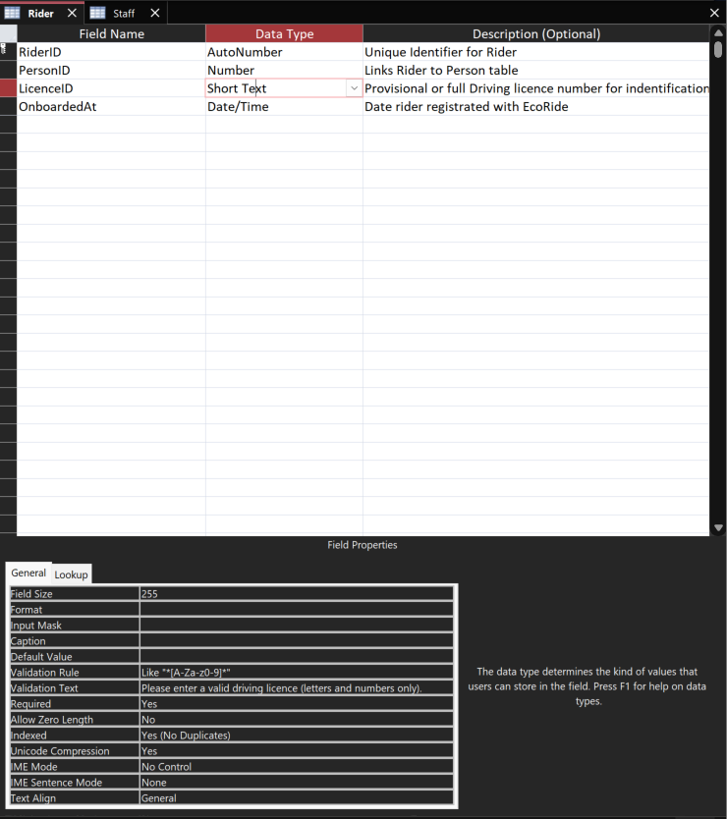
Fig 21. Design view for Rider. This screenshot shows the validation rule for LicenceID. This ensures a valid ID type is entered.

The validation rule was not made more specific due to inclusivity of other forms of Identification from other countries and not knowing what those look like. This could still be changed if necessary though.

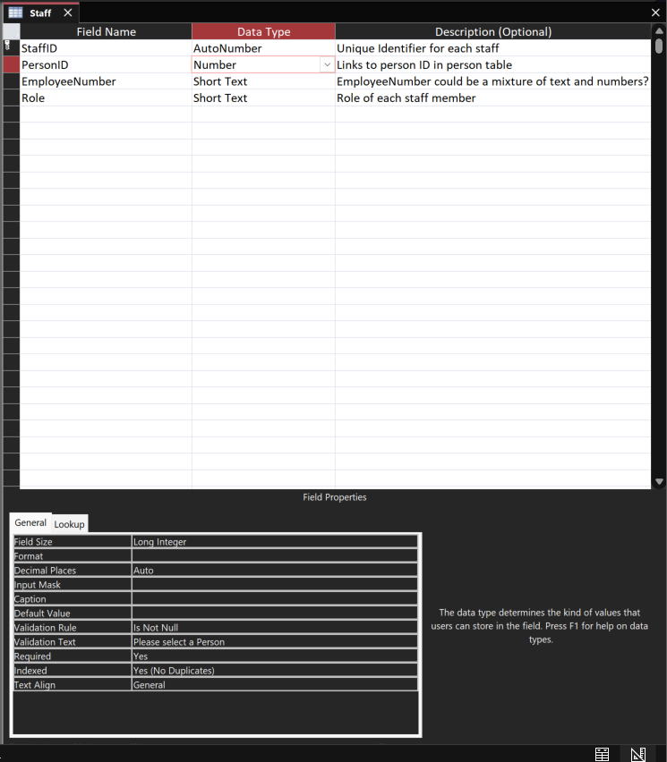
Fig 22. Design view of Staff Table. This screenshot shows the validation rule for PersonID as Is Not Null, which prevents the user from leaving it empty.

Additionally, the “Required” field was changed to Yes for most of the fields, because they are all necessary and important data. Furthermore, indexed was changed to yes (no duplicates) for most of them, however, it depended on whether data duplication was likely to occur and if that was okay (for example, bike state or payment method).

After finishing the designing of the tables, they were all populated with realistic sample data to run validation tests on and create queries with.

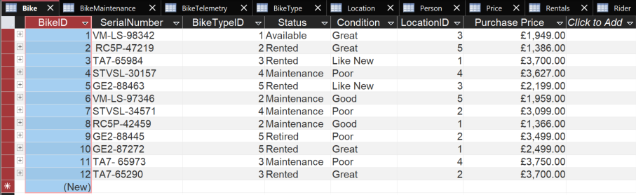
Fig 23. BikeID Table populated with sample data.

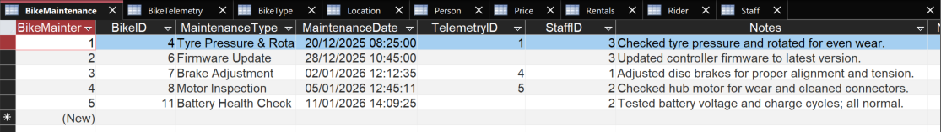
Fig 24. BikeMaintenance Table populated with sample data.

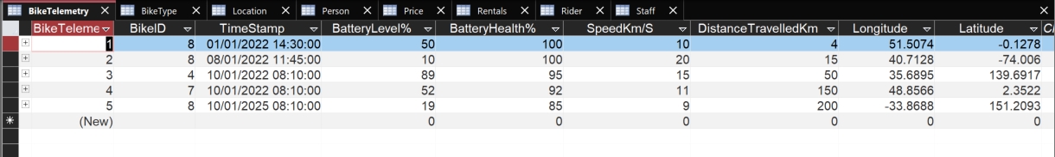Fig 25. BikeTelemetry Table populated with sample data.

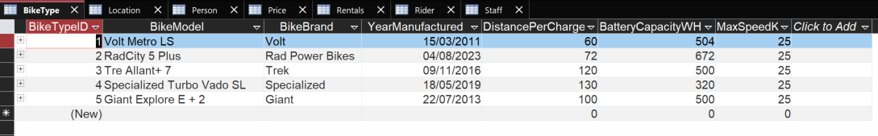Fig 26. BikeType Table populated with sample data.

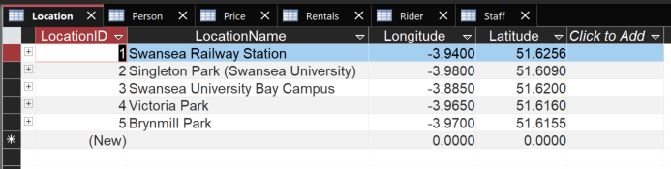Fig 27. Location Table populated with sample data.

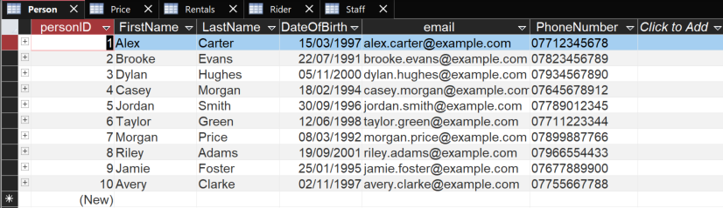Fig 28. Person Table populated with sample data.

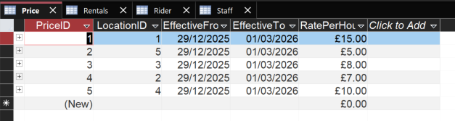Fig 29. Price Table populated with sample data.

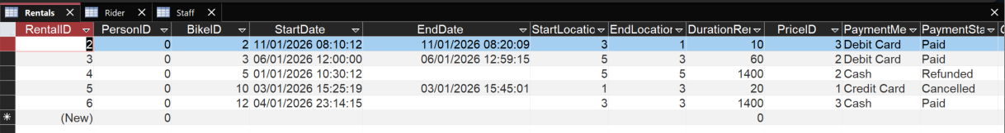Fig 30. Rentals Table populated with sample data.

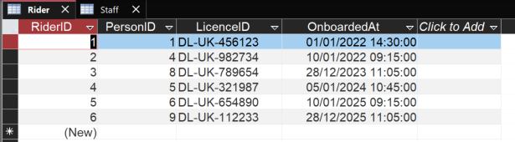
Fig 31. Riders Table populated with sample data.

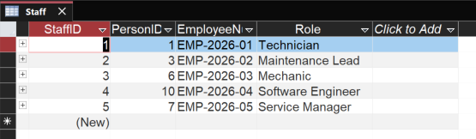
Fig 32. Staff Table populated with sample data.

Validation and Testing

Testing Process
A series of test cases were created to test the validation rules and confirm the rules and input masks do as intended. This table shows what the outcome should be versus what the outcome of each test was.

Test Cases and Outcomes
Field | Validation Rule | Test Case | Expected Outcome | Actual Outcome
- Mandatory Field | Is Not Null | Leave field blank | Error message: “Please enter the Longitude value” | Passed
- Quantity | >=1 | Enter -5 | Error message: “Please enter a value greater than 1” | Passed
- Quantity (optional) | Is Null Or >=1 | Leave blank | Accepted | Passed
- Date | <=Now() | Enter future date | Error message: “Please enter a valid timestamp in the format dd/mm/yyyy hh:nn:ss (e.g., 01/01/2022 14:30:00). It must not be in the future” | Passed
- Date | Between #01/01/2010# And Date() | Enter 2005 | Error message: “Please enter a valid year between 2010 and the current year.” | Passed
- Identifier | [-A-Za-z0-9]* | Enter special characters | Error message: “Please enter a valid employee number (letters and numbers only).” | Failed
- Text Field | Not Like "*[0-9]*" | Enter text with numbers | Error message: “Please enter a valid name without numbers.” | Passed
- Email | Like "*?@?*.*" | Enter “testemail.com” | Error message: “Please enter a valid email address (e.g., name@example.com).” | Passed
- Phone | Like "07#########" Or Like "+############*" | Enter “12345” | Error message: “Enter a valid phone number: UK format (07xxxxxxxxx) or international (+ followed by digits)” | Passed
Fig 33. Validation Testing Table

Field | Screenshots of Outcomes
- Mandatory Field | 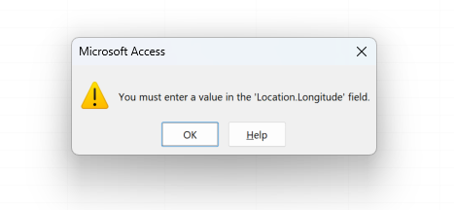
- Quantity | 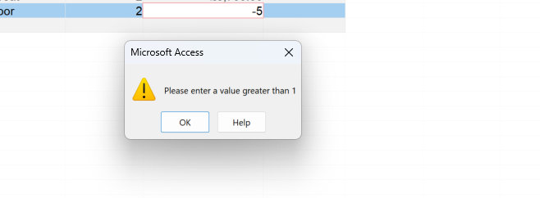
- Quantity (optional)
- Date | 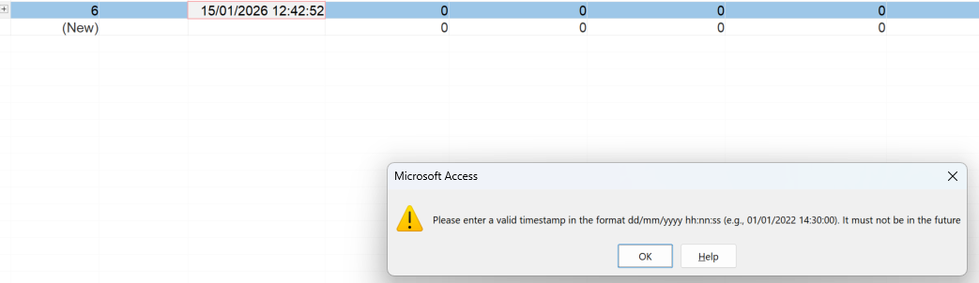
- Date | 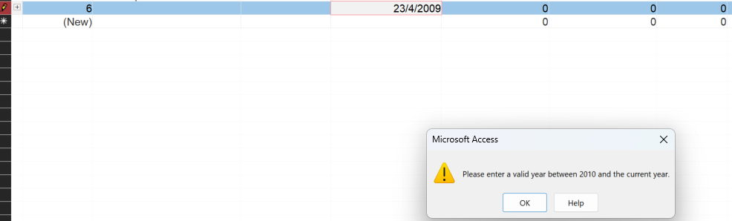
- Identifier | 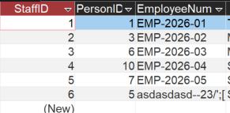
- Text Field | 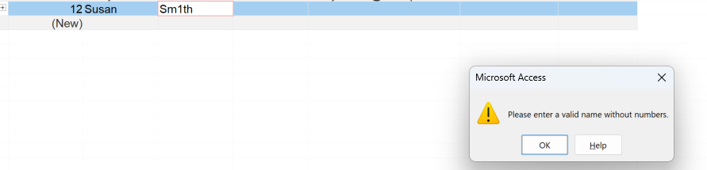
- Email | 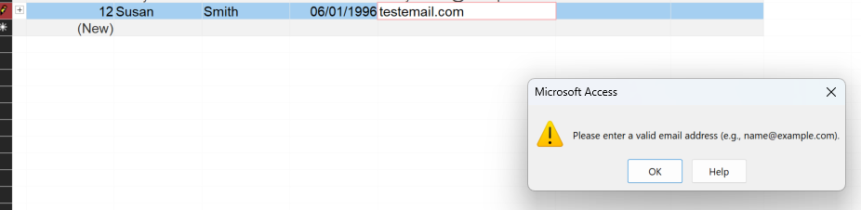
- Phone | 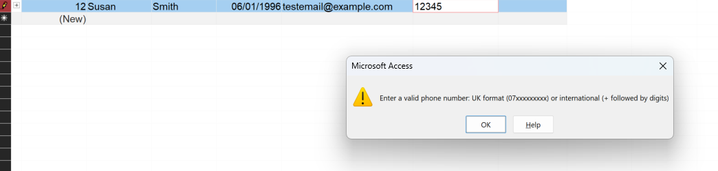
Fig 34. Validation Testing Outcomes
Validation test 6 failed because the wrong validation was used. It should have been “Not like” rather than “like”. Once that was corrected it passed the validation check.
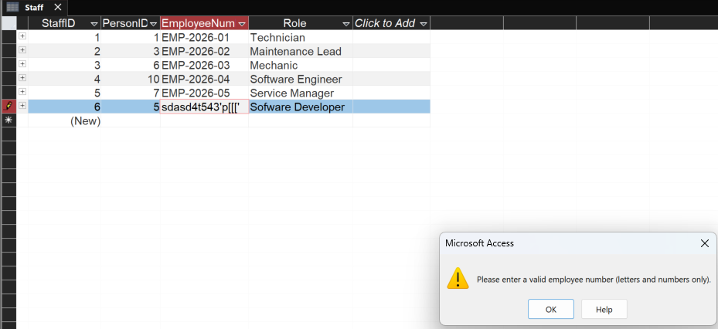Fig 35. Validation Check 6 now working due to the correction in the validation rule.
Due to this validation rule being in multiple places, the rest of the tables were then looked through and tested for this and changed where required.

Query Design

The queries were chosen to give a clear picture of how the Eco-Ride rental system would operate and to cover different aspects of the business. For example, Bike Availability (Fig 34) is essential for understanding what stock is ready for customers, while Bike Purchase Total and Total Rental Revenue help track financial performance. Maintenance-related queries such as BikeID 8 Health Check and Bikes in Maintenance were included because keeping bikes in good condition is critical for safety and customer satisfaction. Queries like New Riders After 01/02/25 and Riders > 25 (Fig 35) provide insight into user trends and demographics, which can influence marketing decisions. Overdue Rentals and Refunded Payments highlight potential issues with compliance and customer service. Finally, Rental Prices, Staff Count, and TypeBike 3 Inventory (Fig 36) support planning for pricing, staffing, and inventory management. Overall, these queries were selected because they demonstrate how the system can be used to monitor operations, make informed decisions, and improve efficiency.

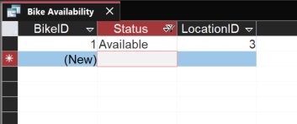
Fig 36. Query showing available stock.

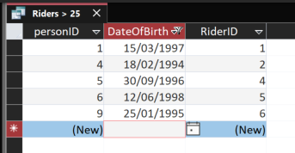
Fig 37. Query showing Riders over the age of 25.

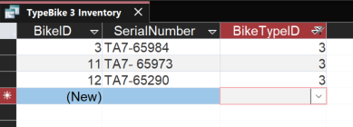
Fig 38. Query showing how many of BikeType 3 are in stock

Design Decisions and Reflection

Database Relationships
The Eco-Ride database relationships were designed to meet operational needs and ensure scalability. The Person table acts as a central repository for all individuals, reducing redundancy by storing common details like names and contacts. Rider and Staff extend from this table with role-specific attributes.
The link between Rider and Rentals ensures accountability and accurate usage tracking, while Bike and Rentals prevent double bookings and provide rental history. Connecting Bike to BikeMaintenance and BikeTelemetry enables real-time monitoring and proactive maintenance, improving safety and reducing downtime. Linking Bike to BikeType avoids repeated specifications and supports performance analysis and budgeting. Location links to both Bike and Rentals for trend analysis and optimised distribution. Finally, Price connects to Rentals for flexible rate management and accurate billing.
Overall, these relationships were chosen to minimise redundancy, support growth, and streamline operational queries such as maintenance schedules, overdue rentals, and user activity tracking.

Attribute Selection
Attributes were chosen to meet operational needs and provide analytical insights. Person includes identifiers and contact details for GDPR compliance. Riders have LicenceID and OnboardedAt for verification and tracking, while staff records include EmployeeNumber and Role for managing responsibilities. Bike attributes focus on inventory and asset tracking, while BikeType stores specifications for performance analysis. Location, BikeMaintenance, and BikeTelemetry support safety, proactive maintenance, and usage analysis. Price and Rental attributes enable flexible billing and overdue checks.

Challenges
One of the biggest challenges was deciding which tables to include so the design stayed simple but still met normalisation standards. Another difficulty was managing overlapping relationships to maintain data integrity, while also planning for scalability without making the system overly complex for current users.

What features would be improved in the future?
Future enhancements include adding a Payment table for split payments and multiple methods, storing historical maintenance and telemetry data for analysis, and introducing a RentalStatus column to trigger alerts for overdue bikes.

Conclusion
The Eco-Ride database successfully replaces outdated paper processes with a structured, secure, and scalable solution. By applying normalisation, referential integrity, and validation rules, the system improves data accuracy, reduces redundancy, and supports operational needs. While the current design meets core requirements, features such as a dedicated payment table and historical data archiving could further optimise functionality and support long-term growth.

References

[1] Curbelo, R.J., Loza, E., de Yébenes, M.J.G. and Carmona, L. (2014). Databases and registers: useful tools for research, no studies. Rheumatology International, [online] 34(4), pp.447–452. doi:https://doi.org/10.1007/s00296-014-2954-x.

[2] T. M. Connolly and C. E. Begg, Database Systems: A Practical Approach to Design, Implementation, and Management, 6th ed. Harlow, Essex, England: Pearson Education Limited, 2015, pp. 63: 75.

[3] DAMA International, DAMA-DMBOK : Data Management Body of knowledge, 2nd ed. Basket Ridge, New Jersey: Technics Publications, 2024, p. 130.
[4] W3Schools, “SQL FOREIGN KEY Constraint,” W3schools.com, 2019. https://www.w3schools.com/sql/sql_foreignkey.asp (accessed Jan. 09, 2026).

[5] M. Fayard, “What is Third Normal Form (3NF)?,” Datacamp.com, Nov. 18, 2024. https://www.datacamp.com/tutorial/third-normal-form?dc_referrer=https%3A%2F%2Fwww.google.com%2F (accessed Jan. 10, 2026).

