Title: component 1: Online Portfolio Of Set Exercises
Name: Halima Bibi
Student Number: 2320004
Module: changemakers: Building your personal brand for sustainable employment
Module Code: BMHP5015
Lecturer: Danielle Dunne

Contents
Task 1- Reflecting on my personal brand 3
Task 2- Network map and rationale 4
Task 3- Blog 6
Task 4- NHS Equality, Diversity and Inclusion Quiz 7
Task 5- A Letter to Yourself 9
Task 6- GANNT CHART 10
Task 7- Making Changes: Report 11
Task 8- Self-Reflection 13
Reference list: 14

Task 1- Reflecting on my personal brand
Personal branding is how I present my skills, values and professional identity to others, shaping how I am perceived in healthcare. It is essential in nursing, where trust, compassion and professionalism are essential to building relationships with patients and families. As I work towards applying for a Children’s Nursing degree, developing a strong and authentic personal brand will help me demonstrate my commitment to delivering safe, compassionate and child-centred care.
Currently, I believe my personal brand reflects empathy, reliability and adaptability. I am often recognised as approachable and caring, which supports my goal of becoming a children's nurse. I also bring resilience and problem-solving skills, which are valuable in handling the pressures of clinical practice. However, I recognise the need to strengthen my communication and leadership abilities further, particularly when explaining information to families and collaborating with multidisciplinary teams.
According to McCluine-Trust, et al., (2024) professional identity in nursing develops through clinical experiences and a sense of belonging, which motivates me to seek opportunities in paediatric placements. Similarly, Zou, et al., (2024) highlight the importance of autonomy, motivation and mentorship in shaping nursing identity. Highlighted by Emam, et al., (2024) to enhance my brand, I will seek structured feedback from mentors and peers, drawing on evidence that leadership development programmes using 360-degree feedback can significantly improve head nurses’ leadership knowledge and behaviour. In summary, strengthening my communication and leadership abilities will enhance my personal brand and help me succeed as a children’s nurse.

Task 2- Network map and rationale
Local organizations
Family
Close friends
Tutors
Long-term relationships
Classmates
Career
social
Colleagues
My Personal Network
Training Peers
Family
community
outreach
volunteering
Support
Best Friends
Peer Groups
Community health events

mentors
My current network is a closed network, as most of my connections are with people who share similar backgrounds, values and experiences, such as family members, long-term friends and familiar social contacts. These relationships are highly trusted and reliable, offering strong bonding ties that support my emotional well-being and everyday practical needs. The comfort and familiarity of these connections provide stability and mutual understanding. Sajuria, et al., (2015) observe that bonding ties promote emotional support and cohesion but can also limit exposure to diverse ideas and opportunities, which reflects the nature of my current social relationships.
I have chosen a closed network because it centres on trusted and familiar relationships that provide security and continuity. However, this structure also presents limitations, as I have few bridging connections outside my immediate circle. Neal (2024) highlights that connections with acquaintances, often referred to as weak ties, play a crucial role in accessing new information, diverse perspectives and opportunities beyond one’s immediate social circle. Larson, (2017) supports this argument, showing that weak and bridging ties foster creativity, innovation and the exchange of novel ideas.
To strengthen my network, I plan to expand my circle through professional, community and interest-based engagement, creating a more balanced network that enhances both emotional stability and professional development.

Task 3- Blog
Title: NHS Waiting Times: What Families and Carers Need to Know
Introduction
Long waits for treatment have become one of the biggest challenges facing the NHS today. In mid-2023, over 7.5 million people in England were on hospital waiting lists, the highest number ever recorded (Harker, et al., 2025). For families and carers, these delays can be worrying, stressful and sometimes even dangerous, affecting the health and well-being of the people you care for.
The Impact on Patients
The Kings Funds, (2024) states that waiting for treatment is not just inconvenient; it can make conditions worse. Delays in surgeries or outpatient appointments may cause increased pain, anxiety or even preventable complications (The Kings Fund, 2024). Harker, et al., (2025) states emergency care is also under pressure, with some patients waiting more than 12 hours for admission. For families, this can mean sleepless nights, constant worry and challenges in planning care at home.
Why Waiting Times Are Rising
Several factors have made the situation worse. The COVID-19 pandemic caused many appointments to be postponed, creating a backlog that the NHS is still addressing (Nicodemo, 2025). Staff shortages, financial pressures and rising demand due to an ageing population and more people living with long-term conditions have added to the strain (The Health Foundation, 2021).
The Role of Social Care
Social care services are closely linked to hospital care. When community support is limited, patients often remain in hospital longer than necessary, reducing bed availability and increasing waiting times for others (The King’s Fund, 2024). Improving care at home and in the community is a crucial part of solving the problem.
Conclusion
Reducing NHS waiting times requires long-term investment in hospitals, staff and social care services. As a carer or family member, staying informed, planning ahead and advocating for support can help manage the stress of delays. Together, we can push for a system that delivers timely, safe and compassionate care for everyone.

Task 4- NHS Equality, Diversity and Inclusion Quiz
- What is the primary goal of the NHS Equality, Diversity and Inclusion Improvement Plan?
The primary goal of the NHS Equality, Diversity and Inclusion (EDI) Improvement Plan is to strengthen equality, diversity and inclusion across the NHS workforce, while promoting fairness, respect and a stronger sense of belonging among staff.
- How does the NHS EDI Improvement Plan propose to tackle the gender pay gap?
It aims to address the gender pay gap through detailed pay data analysis, improvement plans and the adoption of recommendations from the “Mend the Gap” report to promote pay equity.
- What is meant by the term ‘intersectionality’ as used in the NHS EDI Improvement Plan?
Intersectionality recognises how overlapping identities such as race, gender, sexuality and disability interact to create compounded forms of disadvantage within the workplace.
- Why is it important for the NHS to create a psychologically safe work environment?
A psychologically safe environment enables staff to raise concerns, share ideas and admit mistakes without fear of blame, improving both well-being, improving morale and patient care.
- How does the NHS EDI Improvement Plan suggest improving the experience of internationally recruited staff?
The plan enhances the experience of internationally recruited staff through structured induction, ongoing support and career development opportunities that encourage inclusion.
- What role does leadership play in advancing EDI objectives according to the NHS Improvement Plan?
Leadership plays a crucial role in advancing EDI by setting clear and measurable objectives, embedding accountability at all organisational levels and actively promoting an inclusive culture that values diversity, equity and fairness.
- Identify one way the NHS EDI Improvement Plan aims to reduce health inequalities within the workforce.
The NHS EDI Improvement Plan aims to reduce workforce inequalities by ensuring fair and transparent recruitment, development and promotion processes that address systemic barriers to career progression.
- Why does the NHS EDI Improvement Plan emphasise the importance of collecting and analysing data on protected characteristics?
Collecting and analysing data on protected characteristics enables the NHS to identify existing inequalities, design evidence-based interventions and evaluate progress towards greater workforce equality.
- Explain how flexible working policies can contribute to equality and inclusion in the NHS workforce.
Flexible working promotes equality and inclusion by enabling staff with caring responsibilities, disabilities or other personal needs to balance work and life demands effectively, thereby improving wellbeing, retention and organisational diversity.
- What is one strategy mentioned in the NHS EDI Improvement Plan to combat bullying and harassment in the workplace?
The plan tackles bullying and harassment by offering psychological support, enforcing accountability and promoting a culture of respect.

Task 5- A Letter to Yourself
Dear Younger Me,
I know you are feeling overwhelmed and unsure of yourself right now. The challenges you are facing seem too heavy and it feels as though you have little control over your situation. At that time, you may not have realised it, but building emotional intelligence and resilience could have made a real difference.
Emotional intelligence is about recognising, understanding and managing your own emotions, while also being aware of how others are feeling. If you had paused to notice your own emotions without judgment, you might have found it easier to respond calmly rather than react in frustration. You would also have seen that those around you were not always against you; often, they were dealing with struggles of their own. Practising empathy could have helped you build stronger connections instead of withdrawing.
Resilience, on the other hand, is about adapting and bouncing back from difficulties. At that time, setbacks felt like failures, but resilience teaches us that challenges can be opportunities to grow. If you had focused more on problem-solving and self-care, you could have reduced the stress you carried and maintained a healthier perspective.
Looking back, I want you to know that developing these skills would not have solved everything overnight, but they would have given you the strength and balance you needed. Remember, resilience grows with every obstacle and emotional intelligence helps you turn challenges into moments of learning. Be kinder to yourself; you are stronger than you think.
With compassion,
Your Future Self

Task 6- GANNT Chart
Gantt Chart – Pathway to Children’s Nurse
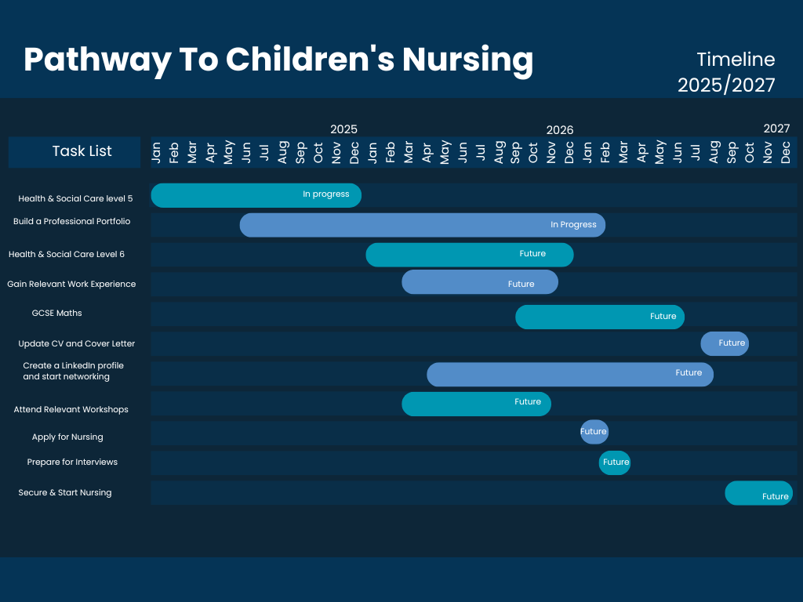
This pathway timeline provides a clear, structured and strategic plan for progressing into children’s nursing from 2025 to 2027. It begins with completing Health & Social Care Level 5, which lays the foundational knowledge and skills needed for further study. Alongside this, the plan includes building a professional portfolio, an essential tool for showcasing achievements, reflections and competencies to future nursing programmes. Progressing into Health & Social Care Level 6 strengthens academic readiness while gaining relevant work experience provides practical insight into health and social care settings, helping develop confidence and real-world understanding.
The timeline also highlights important academic milestones, such as securing GCSE Maths, which is a mandatory requirement for nursing entry. Professional preparation is supported through actions like updating a CV and cover letter, creating a LinkedIn profile and starting to network, all of which help establish a strong personal brand and increase visibility in the healthcare field. Attending relevant workshops further enhances knowledge, employability and preparedness.
Towards the end of the pathway, the focus shifts to applying for nursing programmes, preparing for interviews and developing the skills needed to succeed in the selection process. Finally, the timeline concludes with the goal of securing and starting a place in children’s nursing. Overall, this roadmap offers structure, motivation and clarity for achieving a successful nursing career.

Task 7- Making Changes: Report
Staff Wellbeing Programme Implementation Plan
Introduction
This report proposes the introduction of a staff wellbeing programme in a care home to enhance morale, reduce stress and improve overall job satisfaction. Supporting staff wellbeing is crucial, as it directly influences both employee retention and the quality of resident care. Evidence shows that structured wellbeing initiatives in long-term care settings reduce burnout, non-attendance and stress-related health issues among employees (Herz, et al., 2024).
Planning the Change
Using Kotter’s (1995) 8-Step Change Model, the change will be implemented as follows:
- Create urgency – Highlight workplace stress and its impact on staff performance and resident outcomes, as research shows wellbeing directly affects care quality (Herz, et al., 2024).
- Form a guiding coalition – Assemble managers, senior staff and wellbeing champions to lead and sustain the initiative (Kotter, 1995).
- Develop a vision and strategy – Establish a clear vision for wellbeing activities and support systems aligned with organisational goals.
- Communicate the vision – Share the purpose and benefits of the programme through meetings, newsletters and digital platforms to build awareness and engagement (Kotter, 1995).
- Empower staff for action – Enable staff participation and ownership by involving them in decision-making and planning activities, which enhances commitment.
- Generate short-term wins – Begin with small, visible actions such as mindfulness workshops or wellbeing check-ins to demonstrate progress and build momentum (Herz, et al., 2024).
- Consolidate gains – Use feedback and participation data to expand and improve activities while reinforcing organisational support for wellbeing (Herz, et al., 2024).
- Anchor new approaches – Integrate wellbeing practices into everyday routines, staff supervision and policies to embed cultural change (Kotter, 1995).
Skills Required
Key skills needed include leadership to motivate staff, communication to explain the vision, empathy to understand needs, organisation to schedule activities and conflict resolution to manage resistance.
Barriers and Solutions
Barriers include staff reluctance, time pressures and budget limits. Solutions include engaging staff in planning to increase ownership, allocating protected time for wellbeing activities and using low-cost community or online resources (Herz, et al., 2024).
Conclusion
Implementing a structured staff well-being programme using Kotter’s, (1995) model can strengthen morale, reduce stress and improve resident care. Research supports that participation, feedback and phased implementation are vital for sustainability and long-term cultural change (Herz, et al., 2024).

Task 8- Self-Reflection
Using Gibbs’ Reflective Cycle (1988) I have reflected on my learning throughout the Changemakers: Building Your Personal Brand for Sustainable Employment module and how it has influenced my personal and professional development.
Description:
This module encouraged me to explore my values, strengths and professional identity while learning how to build a personal brand that supports sustainable employability. Through group activities, class discussions and collaborative tasks I developed my understanding of teamwork, leadership and communication. Sharing ideas with peers improved my ability to listen, respect different perspectives and contribute effectively. These experiences highlighted the importance of collaboration and mutual support which are vital in nursing practice.
Feelings:
Initially I felt unsure about how personal branding related to nursing. As the module progressed I realised that developing a professional identity involves understanding how personal values and behaviours shape professional perception which strengthened my confidence and self-awareness.
Evaluation:
The module enhanced my employability by helping me identify strengths, address weaknesses and improve time management and teamwork. It also taught me the value of adaptability and reflection in professional growth.
Analysis:
I learned that I am motivated, reflective and adaptable. Recognising my values of compassion, integrity and professionalism reinforced how they align with person-centred nursing care.
Conclusion:
I now feel more confident in articulating my goals and professional identity and better prepared for future academic and clinical challenges.
Action Plan:
I will continue to refine my personal brand through reflective practice, mentorship and professional development while applying effective communication and teamwork within future nursing practice
Reference list:
Emam, S. M., Fakhry, S. F., and Abdrabou, H. M. (2024). ‘Leaders development program by 360 degree feedback: reflection on head nurses' leadership practices’. BMC nursing, 23(1), 772. Available at: https://doi.org/10.1186/s12912-024-02395-w. (Accessed: 29/09/25).
Harker, R., Stiebahl, S. and Danechi, S. (2025) NHS key statistics: England. Available at: https://commonslibrary.parliament.uk/research-briefings/cbp-7281/#:~:text=How%20long%20is%20the%20the,not%20been%20met%20since%202016. (Accessed: 29/09/25).
Herz, M., Bösl, S. and Gebhard, D. (2024). ‘Individual and organizational interventions to promote staff health and well-being in residential long-term care: a systematic review of randomized controlled trials over the past 20 years’. BMC Nurs 23, 195. Available at: https://doi.org/10.1186/s12912-024-01855-7. (Accessed: 30/09/25).
Kotter, J.P. (1995) ‘Leading change: Why transformation efforts fail’, Harvard Business Review, 73(2), pp. 59–67. Available at: http://www.lighthouseconsultants.co.uk/wp-content/uploads/2010/08/Kotter-Leading-Change-Why-transformation-efforts-fail.pdf. (Accessed: 30/09/25).
Larson J. M. (2017). ‘The weakness of weak ties for novel information diffusion’. Applied network science, 2(1), 14. Available at: https://doi.org/10.1007/s41109-017-0034-3. (Accessed: 28/09/25).
McClunie-Trust, P., Jarden, R., Marriott, P., Winnington, R., Dewar, J., Shannon, K., Jones, S., Jones, V., Turner, R., Cochrane, L. and Macdiarmid, R. (2024). Graduate entry nursing students’ development of professional nursing self: A scoping review. International Journal of Nursing Studies, 151, pp.104670–104670. Available at: https://doi.org/10.1016/j.ijnurstu.2023.104670.
Neal, Z. P. (2024). ‘The not-so-forbidden triad: Evaluating the assumptions of the Strength of Weak Ties’. Network Science. 12(3):289-304. Available at: The not-so-forbidden triad: Evaluating the assumptions of the Strength of Weak Ties | Network Science | Cambridge Core. (Accessed: 29/09/25).
Nicodemo, C (2025) Waiting lists, crumbling buildings, staff burnout: five years on, COVID is still hurting the financial health of the. Available at: https://www.brunel.ac.uk/news-and-events/news/articles/five-years-on-COVID-is-still-hurting-the-financial-health-of-the-NHS. (Accessed: 29/09/25).
Sajuria, J., vanHeerde-Hudson, J., Hudson, D., Dasandi, N. and Theocharis, Y. (2014). ‘Tweeting Alone? An Analysis of Bridging and Bonding Social Capital in Online Networks’. American Politics Research, [online] 43(4), pp.708–738. Available at: https://doi.org/10.1177/1532673x14557942. (Accessed: 28/09/25).
The Health Foundation (2021) Over a million more health and care staff needed in the next decade to meet growing demand for care. Available at: https://www.health.org.uk/press-office/press-releases/over-a-million-more-health-and-care-staff-needed-in-the-next-decade-to. (Accessed: 29/09/25).
Zou, L., Xie, Z., Tan, M., Ou, Q. and Liao, M. (2024). The effect of professional identity on nursing academic achievement: the chain mediating effect of general self-efficacy and learning engagement. BMC Medical Education, 24(1). Available at: https://doi.org/10.1186/s12909-024-05995-x. (Accessed: 29/09/25).

‌

