Jonah Lewis
P149954
BMSP4004 - Generating Business Data and Analysis

MODULE LEVEL 4
ASSIGNMENT – 2
EXCEL SPREADSHEET ANALYSIS & MODELLING
Contents
1. Spreadsheet – Modelling and Analysis 2
2. Categories of Data in the files 2
3. Data Analytics – Link to Functions 2
4. Data Visualisation – Link to Functions 3
5. Key Principles of Successful Modelling 3
Preparation 3
User Focus 3
Logic 3
Efficiency 3
Transparency 4
Scenario 1 4
Sheet 1 Prosumer Survey Data 4
Sheet 2 Electrical Appliance 6
Data Analytics – Linked to Functions: 6
Scenario 2 7
Sheet 3 Swansea Business School – Electrical Data 7
Sheet 4 Climatology Report (January) @ Lampeter Farm 8
Summary 9
Appendices 10
A. Example of Pivot Table & Chart 10
B. Example of Pie or Doughnut Chart 11
C. Example of Bar Chart 12
D. Example of Graph Data 13
E. Example of Combined Column and Graph Data 14
F. Example of Dashboard 15
References: 16

Spreadsheet – Modelling and Analysis
The spreadsheet is classed as an interactive computer program. Spreadsheets are simplistic, comprising of two components – rows and columns. But the ability to format each cell utilising a range of formulas and other tools, turn them into one of the most powerful data analysis tools that exist today.
They are available to all and are used by individuals, small businesses and major conglomerates alike. But like anything, to maximise the output and efficiency they must be operated by someone who has the experience and knows how to handle the formulas and tools on offer.
To be able to analyse all data input into am Excel spreadsheet it is necessary to build a model. It allows person or persons to make quantitative estimates or predictions based on a set of assumptions. The majority of models are used to determine outcomes based on different potential scenarios. The results can be utilised by decision makers who get a sense of how trends are moving giving assumptions made. eg estimating a person’s retirement fund based on current salary, projected salary and future benefits

Categories of Data in the files
Prior to commencement of building any spreadsheet and subsequent modelling. It is best to look at the exercise in hand.
- What are the overall end results required?
- What data is needed to achieve this end result? For example Climatology – you will need statistics for the elements – Rain, Wind, Sunshine, Daylight hours. These can subsequently be broken down again into maximum and average wind speed, hours of sunshine, times of sunset and sun,
Your final list of categories all depend on how deep a detail is required in your end report.
- Compile a category list and a ‘Method of Operation’ as to how you will achieve the desired data collation results. What format and formulae are required.
- Look at the methodology as to how you will compile this data in your spreadsheet to achieve maximum output.

Data Analytics – Link to Functions
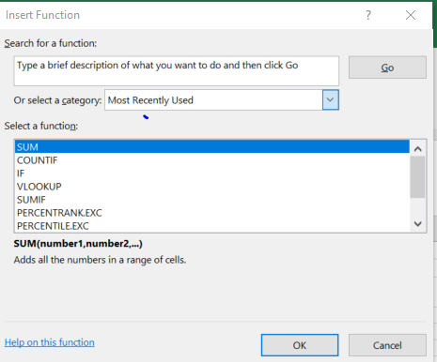
Each cell in a spreadsheet is blank. But with the use of formatting and formulae this will help simplify the data analysis operation.
This function and formulas are varied from the basic SUM, COUNT, TOTAL through to complex mathematical juggernauts.
But the insert function link is not only for figures but can analyse data as well.
This can help break down and categorise data into the required simple elements.
The spreadsheet can be as complex as required. But spreadsheets are usually under the ownership of an individual. So it will be as complex as their prowess allows.

Data Visualisation – Link to Functions
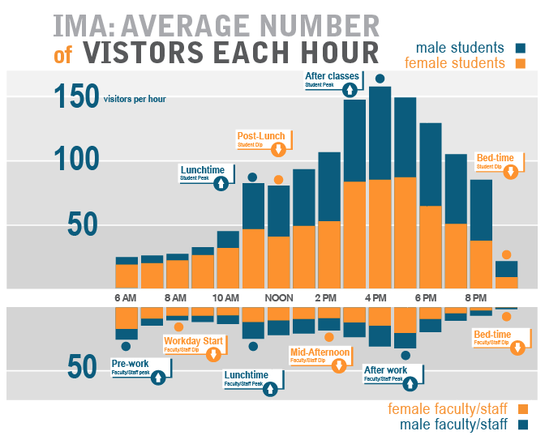
The statement ‘every picture tells a thousand words’ (Anon) is completely true. The human brain adapts better to visual representation rather than rows and columns of data.
Excel spreadsheet has been developed to compile pivot tables, the data in which can then be presented pictorially utilising a range of charts, line graphs, pie or doughnut charts. This also makes the report easier to comprehend and digest. These too can be as complex or simplistic as required. They can also be formatted to change font size, colour, and layout.
The example shown is a stacked column version. Other types are shown in Appendices A – E at the end of this report.

Key Principles of Successful Modelling

Preparation
To get the best out of any task, preparation is the key. You need to understand the concept of what you need to achieve. What information is required to achieve this how you can best collate this data to attain the best results?
The actual layout of the spreadsheet needs to be thought out too. How best to portray the data, column layout, font size, number of tables, number of tabs. It needs to be easy on the eye and even easier to comprehend.
What formulas are to be used and where, to attain the best results from the data collated.

User Focus
You have to assume that someone else will need to use the model in the future. It is often underestimated how many people will actually use the one model. So it needs to be simplistic in approach, easy for future users to understand how it was built and to be able to manipulate or input additional data.

Logic
Prior to completing the model it would be prudent to take a backward step and allow someone else to review the spreadsheet. And ask them the following questions?
Does the model make sense?
Is the collated information and results easy to read and comprehend?

Efficiency
Is the model built in such a way that it will be easy to add or amend future information input?
Has all space been used efficiently – if the layout is convoluted or does not follow any logic then it will difficult to understand or interpret the end results.
Is the format consistent throughout the workbook? It there uniformity in presentation.

Transparency
An Excel model does not need to be a juggernaut which is difficult to manoeuvre and drive. It however should contain sufficient instruction in the shape of notes or remarks (in different tabs if required) Notes and comments should be added in locations which would aid other users.
There should be no hidden tabs or cells as this would only lead to confusion.
Following on the above theory will be placed into the following exercises to build models and analyse data on Worksheets 1 – 4 in the following Scenarios:

Scenario 1
Prior to starting the process of modelling and analysis. Both spreadsheets were reviewed with respect to the current presentation and basic formatting.
The following observations were noted:

Sheet 1 Prosumer Survey Data

Initial Inspection
The basic formatting of the main sheets (font, font size, visual presentation) was checked and differing fonts were used in different sections of the sheet this was re-set and Calibri font used throughout.
In Column A (Col A), although the column header stated Company Name – the initial input (Pukka Herbs) had been input as a website. The majority of other data input followed that same format. Whilst other inputs were either the company name or a mixture of both. Ideally they all follow one trend – Company Name only or website address.
Row 4 – Incorrect information was given - The name of the company and name of the product (B and C columns) - you should type just once in this sheet. It should be copied to the other sheet automatically.
Column B is in fact correct but Column C is Number of Employees. It should have read COL H – ‘Short Description of Prosumer Activity’.

Incorrect Formula Used
Col X – was a summation column using a COUNTA function. This would give conflicting information as this formula counts any information in a cell. Thus even if there was a NO or ZERO input, this would count as a positive in the end SUM cell.
The correct function to use is =(COUNTIF, Range,”YES”) as this will count any cell containing YES.
There are two ways to counter this:
Use the Find and Replace function. Located on the Home Tab on the right hand side of the Tool Bar – Click on Find and Select.

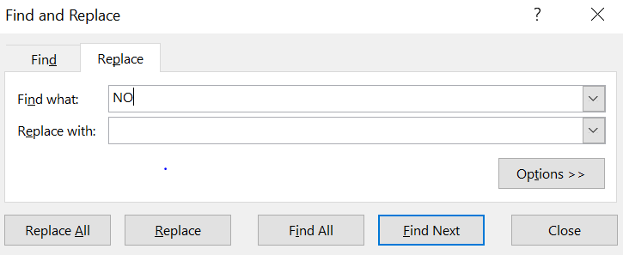
Place NO in the ‘Find What’ box and the ‘Replace’ box with Blank. Click on Replace All - This will then remove all the NO’s present in the cells of that particular sheet.

Alternatively replace the COUNT A with COUNT IF (see Col AA)
Duplicated Items
There were many duplicate companies in Col A. These were removed using the “Remove Duplicated’ function located on the Tool Bar.
However some duplicates still remained due to differing methods of input. eg www.Apple.com & https://www.apple.com/uk/ These are both the same company, thus to keep them both in the data sheet would provide incorrect statistics overall. The check and removal of these has to be done manually. Note this is time consuming and has to be redone with the 4 other linked sheets associated with this work book.
Note: The purpose of this exercise is to cover the understanding of Pivot Tables, Charts and Cell formulae. Not correct table information. Thus we will continue with 99 ‘companies’ instead of the 122 (23 removed by Remove Duplicate function at the first round)
Due to the fact the data is taken from many different companies we need to get the overall statistics as opposed to those from many entities.
Thus separate sub tables were set up on all four work sheets (one with totals of companies, the other in percentages). These consolidated the data into Companies who DO promote and those that DO NOT.

Data Analytics – Linked to Functions:
To analyse the data the following functions / formula were used on all 4 sheets contained in the workbook.
=COUNTIF(K8:K106,"YES") was used for those who do.
=COUNTBLANK(K8:K106) for companies who do not.
The second table gave the same information but as percentages.
VLOOKUP was utilised (Business Processes Work Sheet - R110/111) to give single company information if required
IF Function (Business Processes Sheet - Col D) was used to categorise company size.
Small <250
Medium 251<500
Large 501<1000
Megga 1000+
Drop Down List (Business Processes Sheet Col D)
As the data had been input by many. There were no constraints on the Business Sector data. Thus there were too many entities and this had to be re-categorised into 11 Groups. Thus you could use the filter function see what the number and type of company per category.

Data Visualisation – Linked to Functions
A Pivot Table was set up giving overall information on Company Knowledge Sharing Statistics. A chart was chosen to associate with this information. For the purpose of this exercise a standard column chart was used.
All percentage splits were shown using a 3D Pie Chart. Pivot tables were not set up for this exercise. (But if you highlight the cells and click on the charts in the Tool Bar the information is transferred.)
All charts were reformatted to increase font size or change design,
There are samples only shown on each sheet as the methodology to create is the same.
A ‘Dashboard’ was not created for this work sheet. An example is given on other worksheets.

Sheet 2 Electrical Appliance

Initial Inspection
Initial observation of this sheet showed that the formatting was inconsistent. Size of font varied, missing borders, some merged cells and the data placed ad hock within these (i.e. Digital TV appliances power and standby sections of the lower half of the sheet)
Again data input was in non-standard format eg, YES, 1, 0, No. Plus no summation columns.
Also having found out by experience. Pivot Tables do not like merged cells and also any item in the main information column which has the same description, then the Pivot Table will only recognise this once only – but add the data in their respective rows. So not all information is transferred to the Pivot Table.
Thus the whole of the main table required cleaning up prior to commencing modelling.
Looking at the data collected an assumption had to be made – Assume Standby at 17.5hrs + 6.5hrs Powered Up, on all Digital TV apparatus. This is due to the fact data was input in the Standby cells only on the original spreadsheet. It’s fair to assume if you have a TV you would use it.

Data Analytics – Linked to Functions:
There is very little useful information that you can glean from this data sheet.
- No of appliances per household?
- Carbon output per household?
- Cost of running appliances per household?

To increase the data output two rows were added to the original table.

Total Cost Per Household (£)
Total Carbon Output per Household (kg CO2)

This along with a simple summation of the cells using the COLs D & E you can calculate:
The above totals (contained in the table) per household.

=($D63*F63)+($D64*F64)+($D65*F65)+($D66*F66)+($D67*F67)+($D68*F68)+($D69*F69)+($D70*F70)+($D71*F71)+($D72*F72)+($D73*F73)+($D74+F74)
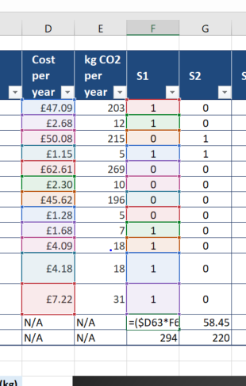
As long as you keep the $ sign in front of the initial cell. After the first calculation you can copy paste into the other cells in the row and it will auto populate the costs and carbon output.

Data Visualisation – Linked to Functions
Pivot Tables and 2D Bar Charts were set up for:
- Appliance: Annual Cost v Annual CO2 Footprint (Complete Sheet Reformatted)
- Digital TV Appliances: Annual Cost / Annual CO2 Emissions - Per Unit (Complete Sheet Reformatted)
- Annual Carbon Footprint v Annual Cost per Household (Annual Costs Pivot)
Upon completion a Dashboard was set up for all three charts.

Scenario 2
Again to apply the theory and review and analyse two spreadsheets issued in Week 6 of the second semester.

Sheet 3 Swansea Business School – Electrical Data

Initial Inspection
Spreadsheet required total clean up. Columns needed to have standard formatting, fonts, column headers etc.
Date ranges were from 2012 to 2017. But there was only data from Feb 12015 onwards. Pivot tables do not recognise rows of empty data. Thus these were deleted from the Re-formatted Sheet.
Again the raw data was lean on information. Dates and half hourly power usage for the Business School only. So you are limited as to what modelling can be done.
You need to look at outside factors to increase the usage of the data you have. As units of power and time were available it leads to power consumption and relative costs. Thus utilising https://www.ukpower.co.uk/home_energy/tariffs-per-unit-kwh we were able to obtain electricity tariffs for the year 2017. These can be added to the spreadsheet and model costs of electricity calculated. (Note: these costs are assumed and more than likely are incorrect but for the purpose of enhancing the models characteristics they were utilised – this is an exercise involving use of Excel formula and Pivot Charts etc. not to determine the actual financial figures.)

Data Analytics – Linked to Functions:
Additional columns added (Reformatted Records Sheet Cols AX - AZ) using SUM function (=SUM(B19:AW19)) for Max usage , Average Usage, Daily Usage of power.
Additional columns added (Reformatted Records Sheet Cols BA-BB) to account for Daily Cost using a mathematical formula (=(AZ19/1000)*BA19)
IF Function utilised (Reformatted Records Sheet Col BC) to show days where the cost costs were higher or lower than £10.
COUNTIF Function used (Reformatted Records Sheet Cells BC92/93) totalled the days where usage was above or below £10
SUBTOTAL Function used (Reformatted Records Sheet Cell BB 933). This will automatically total the cost of cells shown and re-calculate when there is a filter added. Thus daily, weekly, monthly costs can be shown as required.

Data Visualisation – Linked to Functions
March Data was transferred to a separate tab ‘Pivot March 2017’.
Pivot Tables and Charts and Graphs were set up to for:
Average Daily Power Usage (Watts) – Bar Type
Daily Electrical Cost (£) – March 2017 – Line / Graph type.
Upon completion the charts were copied to a Dashboard tab for presentation if required.

Sheet 4 Climatology Report (January) @ Lampeter Farm

Initial Inspection
The raw data provided everything required to build a model with Climatology Statistics. This was the best example of the four sheets as it contained more basic entities which would allow a more extensive model to be created and thus more information produced as a result.
As an afterthought you could have possible have looked at daylight hours, hours of sunshine to add to the existing data.
The complete sheet however required basic formatting for presentation purposes.

Data Analytics – Linked to Functions:
An additional column (I) was added to the Reformatted Date Sheet Tab. Where the IF function used to determine what days were above and below Zero degrees =IF(C8<0,"FROST","OK")
Additional tables were added to the Reformatted Date Sheet Tab:
- Column A-B / Row 40/41 – Using the AUTOSUM function this showed the monthly rainfall for January (=SUM(E8:E38))
- Column A-I / Rows 43/44 – Using VLOOKUP this gave a daily snapshot of all statistics.
A separate tab was set up (VLOOKUP EXAMPLE) to show that data can be transferred from sheet to sheet using this function.
See Column D (=VLOOKUP(A7,'Reformatted Data Sheet'!A8:H38,8,FALSE))

Data Visualisation – Linked to Functions
Pivot tales and charts were set up on both sheets segregating the data in WIND, RAINFALL and TEMPERATURE.
A variety of different types of chart and line graphs were utilised.
Also they were formatted to show that both bars, columns and line graphs can be utilised on the same chart for varied presentation
A separate Dashboard tab was set up to contain all charts for presentation if required.

Summary
There is no doubt that Excel is indeed a powerful tool. Its ability to organise large amounts of data into orderly, logical spreadsheets is unrivalled. This in turn allows easier digestion and analysis of data to be undertaken. The unlocking of data potential can help identify trends and assists with future forecasting, which is greatly sought after in the business world in general. Add to this its ability to produce charts and graphs makes it a powerful and persuasive tool in the marketing world.
However Excel is a complex program and the spreadsheet or model is only as good as the level of expertise of the person who sets up the model. Whoever creates the model must take into account that other persons will actually need access, visibility and transparency. This will inevitably lead to problems as the spreadsheet is usually an extension of its maker. They will have an intimate knowledge of the rules of engagement in its operation. Outside users who are not familiar with these ‘ground rules’ can have a detrimental outcome. Incorrect data input can upset formatting and sometimes deletion of information also causes major issues.
Excel can handle immense amounts of data. But this leads to megga spreadsheets with immense reams of columns and rows. Which sometimes only the elite can understand its logic and makeup. To counter this it’s best to keep spreadsheets manageable and keep the owners and gate keepers to a minimum. Also people tend to keep their own copies of spreadsheets and only update what’s their responsibility. So a business must ensure there is only one Master and have an appointed person to update.
Finally Excel is an excellent tool to have in your armoury. But it needs to be continually managed to get the optimum results.
(Words 2986)

Appendices

Example of Pivot Table & Chart

Row Labels | 1 Evaluating products by scoring | 2 Evaluating products by comments
Companies Evaluating Products | 40 | 85
Companies not Evaluating Products | 82 | 37
Grand Total | 122 | 122

Example of Pie or Doughnut Chart

Customer Feedback | Product Evaluation by Scoring
Companies Reviewing Feedback | 33
No Review by Company | 67

Example of Bar Chart

Example of Graph Data

Example of Combined Column and Graph Data

Example of Dashboard

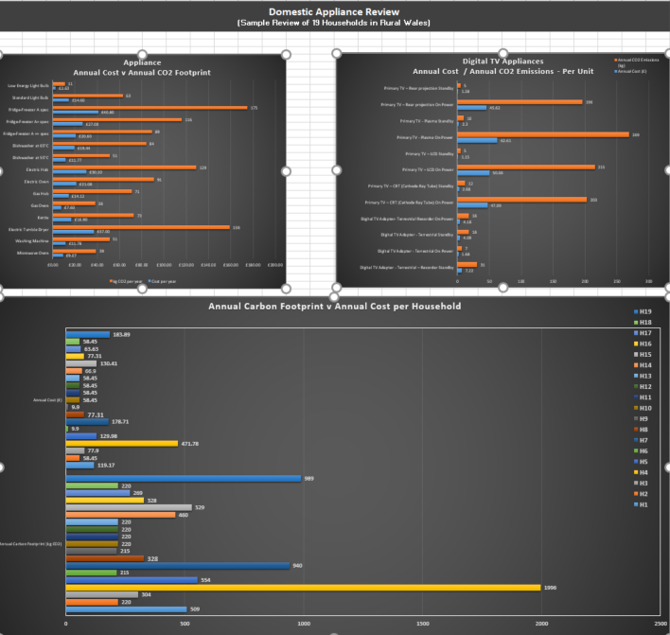

References:
What is an Excel Model (No date)
https://www.deskbright.com/excel/what-is-an-excel-model/
[Accessed 08 April 2018]

Kuo, M. (21 May 2013) How to build an Excel Model.
Available at: http://www.mbaexcel.com/excel/how-to-build-an-excel-model-step-by-step/
[Accessed 08 April 2018]

Analyse your Data Instantly (No Date)
https://support.office.com/en-us/article/analyze-your-data-instantly-9e382e73-7f5e-495a-a8dc-be8225b1bb78
[Accessed 09 April 2018]

Create a Pivot Table to Analyse Worksheet Date (No Date)
https://support.office.com/en-us/article/create-a-pivottable-to-analyze-worksheet-data-a9a84538-bfe9-40a9-a8e9-f99134456576
[Accessed 09 April 2018]

Working with Charts (No Date)
https://www.gcflearnfree.org/excel2010/working-with-charts/1/
[Accessed 10 April 2018]

Cavoulcos, A. (No Date) Model Behaviour: Master Excel in 5 Easy Steps/
Available at: https://www.themuse.com/advice/model-behavior-master-excel-in-5-easy-steps
[Accessed 10 April 2018]

Fish, L. (8 July 2016) 5 Benefits of Microsoft Excel
Available at: https://blogs.business.microsoft.com/en-gb/2016/07/08/top-5-benefits-microsoft-excel/
[Accessed 12 April 2018]

Hale, A. (July 18 2017) The Good and Bad of Excel Reporting
Available at: https://www.clearpointstrategy.com/excel-reporting/
[Accessed 12 April 2018]

