BMSW 4005
Professional and Career development

Task 3 – Reflective portfolio

Module Leader: Olubukola Adegbite

Table of Contents
Introduction 3
Task 1 4
1.1 Identify the skills required for a career of your choice. (Marketing manager) 4
1.2. Evaluate your own skills in comparison to your chosen career. (SWOT Analysis) 6
1.3 Develop an action plan to improve your skills (PDP) 7
Task 2 8
2.1 Assess and reflect on the concepts you have learned from this module 8
Conclusion 13
References 14

Introduction
Fundamentally, one of the most effective marketing tools for helping any company achieve its marketing management goals is content. As a marketing manager, having effective content management abilities may help me accomplish my aim. Additionally, newspapers and other electronic media must publish such material. In this sense, the written material must be compelling to readers in order to accomplish the marketing manager's primary goal. I can accomplish my main goals as a marketing manager by taking into account the most recent social media trends and utilising social media marketing tools (Sharma et al, 2022)

Task 1

Identify the skills required for a career of your choice. (Marketing manager)
Marketing manager skills can be explained that abilities that help a marketing manager to do their job effectively. These abilities can be both soft skills or hard skills and it depends on the industry type or any specific marketing channel of any specific company. Hard skills and soft skills are described here,
Hard skills
Hard skills can be defined that types of skills that need strong technical and industry based knowledge. Additionally, these key skills include public relations, product development, analytical skills, supply chain management, and other technical skill where the markers need strong marking campaign experience. Achieving these skills will help me to get better technical and industrial knowledge (Cazeri, 2019)
Soft skills
Soft skills can be defined as the ability to interact with people. This skill is built naturally and also it is possible to build this type of skill using a practicing approach. These key skills include motivational skills, communication skills among people, critical thinking, interpersonal skill, and so on (Melander, 2021)
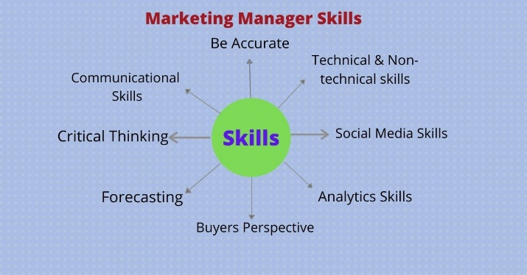
Figure: Marketing manager skill

There are more specific skills required for the marketing manager which are described below:
UX design skills
As a marketing manager, I have to understand the customer's behavior and interest. So I need proper UX design skills as most of the organizations are now online based and the clients want to collect their products through the dedicated website. So in this case, if I attract clients through attractive UX design then they invest more time in the website organization and get more clients to offer their products (Syaiful et al, 2020).
SEO skills
In the terms of marketing management, SEO skills can be a huge opportunity to get more customers. SEO skills can help me to show the products that my company offered. This can help me to activate my team member performance and boost the organization’s productivity.
Content management skills
Content is one of the great marketing tools that support any organization to complete the objectives of marketing management. Successful content management skills can help me to achieve y goal as a marketing manager. Also, that content needs to publish in various electrical media and newspapers. In these terms, the written content must be attractive to the customers so that the main objective of the marketing manager will be achieved (Lu, 2021)
Social media skills
Social media is a great platform to grab the attention of the mass people. In social media, it is easy to understand the behavior, interest, and attraction of the people, and considering all those information it is easy to identify what type of marketing is required to grab the attention of that people. Considering the latest social media trends and using social media marketing tools I can achieve my key objectives as a marketing manager (Sharma et al, 2022)

1.2. Evaluate your own skills in comparison to your chosen career. (SWOT Analysis)
My SWOT analysis will support me to identify my strengths, weakness, opportunities, and threats of mine. These are attached below table:
Strength  - I have strong communication skills so I can interact with people rapidly  - I have a quick learning ability that supports me to understand the market situation  - I have proper interpersonal skill  - I have the ability to think critically in tough situations. | Weakness  - I have lack of presentation skills and I feel nervous during the presentation  - During critical situations, I can't control my nerves and feel weak which is another weakness of mine that I need to improve (Körkkö, 2022)
Opportunity  - As I have proper communication skills so that I can interact with different companies in the marketplace.  - Evaluating proper skills help me to advance my career development which is a great opportunity for me (Lacsamana, 2018)  - As the organizations are increasing so as a skilled communicator I get better opportunities to enhance my career growth. | Threats  - After the Covid-19 pandemic, a lot of organizations suspend their employees which is a threat to me.  - Increasing market demands is a threat because it increases my work pressure and sometimes I am not able to provide the tasks in time.

1.3 Develop an action plan to improve your skills (PDP)
Personal Development Plan (PDP)
Objectives | Tasks | Resources | Success Criteria | Time Frame
Communication skills | I have to interact with different people daily | Physical resources are available in the workplace where I worked. | I can communicate with different people within a short time. | 1 year
Time management skill | I have to complete any task within a fixed time | Avoid multitasking practices to improve this skill effectively (Kivimäki, 2018) | I can complete any task within the given time. | 6 months
Social skill | Co-operate with various people in society. | Needs friendly behavior with different people in society. | Polite behavior during conversation with anyone in the society | 6 months
Technological skills | Effective work strategy using technology | Various technological platforms and online videos. | Implementing various business staff using the use of proper technology (Liedtka et al, 2021) | 2 years.

Task 2

2.1 Assess and reflect on the concepts you have learned from this module
From this module, I get a complete idea of career development and the way of how to develop the career. The whole understanding of this module is attached below-
Career development
I have learned that in this portion, we can learn the difference between a job vs career. The job can be defined as something that is paid and regular employment. Additionally, in the terms of jobs, the main goal is to earn something. Sometimes to do jobs there is not necessary to take special training or long term experience (Lejeune et al, 2021) I have learned that On the other hand, a career is something that can be referred to which needs proper education and needs special training. For a career, anyone's required proper education and special training and experience.
Learning style and Career Development
I have learned that Learning style can affect the career as every learning style has its own value from a different perspective. This will leads a person to understand the effective way to work for a better career. I have learned that A proper learning style is essential to create a person quick learner and works more effectively in their entire career. I have learned that A proper learning style can help me to understand how I'll understand my brain learns the most effectively and implement that understanding for career development.
I have learned that The strategic learning approach will help anyone to ensure a better understanding of what is the goal and what is the way to reach the goal. Considering the goal anyone can change their learning style for the betterment of their career. I have learned that To develop a career in a proper and balanced way proper and proven learning style is essential otherwise anyone might lose their rack and will not be able to reach their desired place. I have learned that From the research, there are 4 pillars of learning style that benefit anyone to reach their desired goal (Melo et al, 2021)

Those are,
- Visual
- Auditory
- read/Write
- Kinaesthetic

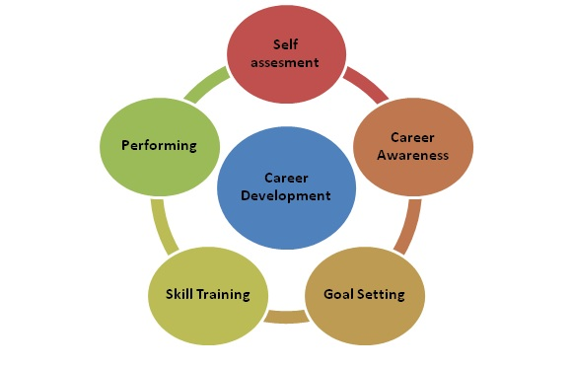
Figure: Career development
Career development process
I have learned that The career development process is an ongoing process that depends on various criteria such as self assessment, career awareness, goal setting, skill training, performance, and so on. (Melander, 2021). I have learned that the career development process is one of the important parts of anyone's life so that they can get an effective result for their whole life. I have learned that In the career development process, there are two types of approaches which are,
- Cognitive approach
- Intuitive approach

Cognitive approach
I have learned that The term "cognitive approach" describes mental processes including remembering, learning, and using language. This approach supports the student to identify how the ideas are related to each other. I have learned that The ability to handle SEO effectively might be a major opportunity to increase sales. My ability to use SEO will assist me display the items that my business offers. I can use this to increase the production of the company and motivate my team members.
I have learned that This method supports a person to learn the skills which is essential for them. After that, they are asked for thinking visualize their ideas and recall them. I have learned that There are three types of cognitive methods which are the structural method, the information-processing method, and the dynamic method (Syaiful et al, 2020). I have learned that Since the majority of businesses are now online-based, I need to have solid UX design abilities since customers want to pick up their items from a certain website. I have learned that Therefore, in this scenario, if I draw clients via appealing UX design, they will devote more time to organising the website and attract more customers to sell their goods (Syaiful et al, 2020).
Intuitive approach
I have learned that In this approach, students love to visualize their future careers. I have learned that For example, in this approach, a racer visualizes the running time with other competitors and visualizes their expected results. This approach is based on the actor’s imagination and visualization that result in their mind. I have learned that The intuitive approach is the best method for taking any crucial decision and problem solving. I have learned that In tough, unfamiliar, and complex circumstances this intuitive approach supports to take quick decisions and strong solutions rapidly. I have learned that Additionally, this career development method supports a lot to identify the career purpose which is necessary to know for everyone (Cazeri, 2019)

Mental Model
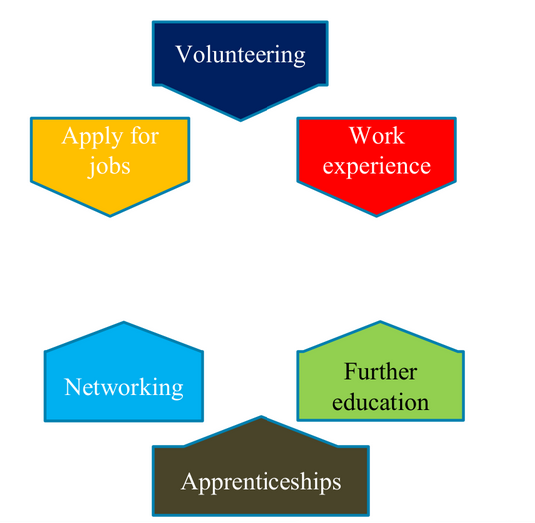
Figure: Mental model
I have learned that Individuals' mental models depend on the dedicated goals that everyone set for their future careers. I have learned that This process is an ongoing process where all the elements of this process include volunteering, work experience job applications, appropriate networking, education, etc. I have learned that As this model is based on the goal you set for the future career so adding these goals is necessary to implement this plan. I have learned that The mental model tries to provide how the real world is going and how everyone understand the process in the real world (Iqbal et al, 2020)
Continuous Professional Development (CPD)
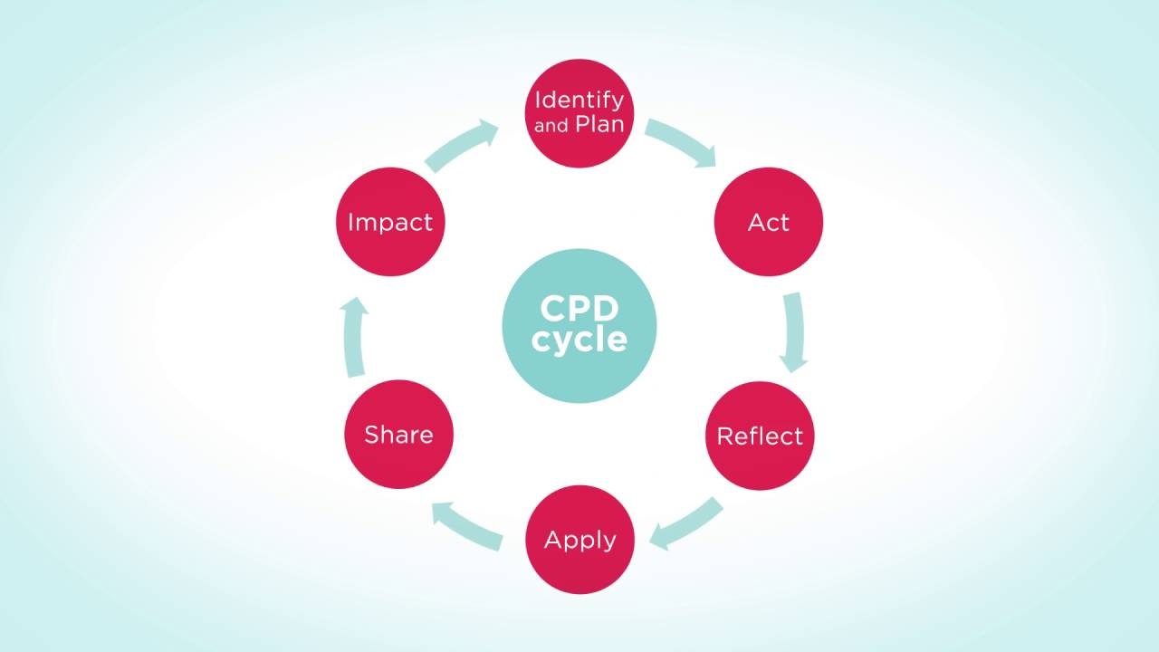
Figure: Continuous Professional Development (CPD)
I have learned that Continuous Professional Development (CPD) can be defined as the mixture of various strategies and ideas that supports to learn and ensure career development. I have learned that Continuous Professional Development (CPD) especially focuses on the result and the type of plan that is highly related to the real world plan. Interpersonal competence is a term used to describe soft skills. This ability is developed naturally, but it may also be developed via deliberate practice. These essential competencies include interpersonal, critical thinking, interpersonal, and motivational abilities (Melander, 2021)
I have learned that CPD is one of the strategic and prearranged learnings and development processes for anyone's career to ensure real development. I have learned that CPD helps to keep the knowledge and skills up to date and supports to take the responsibilities for the future career. I have learned that Continuous Professional Development (CPD) can be effective if anyone implements it in their career in a proper and strategic way. I have learned that So before creating Continuous Professional Development (CPD) everyone has to choose the proper goal for their career. I have learned that Then the combination of Continuous Professional Development (CPD) and goals can be more effective for anyone's career (Retnowati et al, 2018).

Conclusion
Thus, in conclusion, The qualities that enable a marketing manager to do their duties successfully are referred to as marketing manager competencies. Depending on the sector or any particular company's marketing strategy, these talents may be both soft and hard skills. Here is a list of both hard and soft abilities. Hard talents are those kinds of abilities that need extensive technical and business understanding. Public relations, product development, analytical abilities, supply chain management, and other technical skills are also essential, and the markers need to have extensive expertise with marketing campaigns in these areas. Having these abilities will enable me to get more technical and business expertise. (Melander, 2021)

References
Cazeri, G.T., Ordoñez, R.E.C., Anholon, R., Pereira, C.M. and Rodrigues, E.A., 2019. Performance measurement in product development process (PDP): literature review and gaps for further research. Brazilian Journal of Operations & Production Management, 16(4), pp.550-561.
Iqbal, M. and Suzianti, A., 2020, May. Improvement of new product development process by evaluating the existing development approach: Lesson learned from pharmaceutical and ICT companies. In AIP Conference Proceedings (Vol. 2227, No. 1, p. 040009). AIP Publishing LLC.
Kivimäki, V. and Meriluoto, S., 2018. Holistic perspective to individual study plan: Personal Development Project Plan. In Transforming our world through design, diversity and education (pp. 514-526). IOS Press.
Körkkö, M., Kotilainen, M.R., Toljamo, S. and Turunen, T., 2022. Developing teacher in-service education through a professional development plan: modelling the process. European Journal of Teacher Education, 45(3), pp.320-337.
Lacsamana, R.M., Portugal, L. and Delos Reyes, E.F., 2018. Learning Needs Assessment of Non-Teaching Personnel as Input to Human Resource Development Plan. Asia Pacific Journal of Education, 5(3).
Lejeune, C., Beausaert, S. and Raemdonck, I., 2021. The impact on employees’ job performance of exercising self-directed learning within personal development plan practice. The international journal of human resource management, 32(5), pp.1086-1112. Nabil
Liedtka, J., Hold, K. and Eldridge, J., 2021. APPENDIX 1: PERSONAL DEVELOPMENT PLAN. In Experiencing Design (pp. 245-255). Columbia University Press.
Lu, Q. and Gao, Y., 2021, April. Anatomy the Development Plan of University Teaching Management System in the Big Data Era. In International Conference on Application of Intelligent Systems in Multi-modal Information Analytics (pp. 768-774). Springer, Cham.
Melander, L., 2019. Customer involvement in product development: Using Voice of the Customer for innovation and marketing. Benchmarking: An International Journal.
Melo, G.A.D., Reis, Á.R.F., Peixoto, M.G.M. and Barbosa, S.B., 2021. Product development process of a digital irrigameter: a water sizing proposal for sprinkler irrigation process in different cultures. Dyna, 88(218), pp.54-61.
Retnowati, N. and Putra, D.E., 2018. Penerapan Analisa SWOT dan AHP dalam Perencanaan Strategi Pemasaran Kopi Bubuk PDP Kahyangan Jember. Jurnal Ilmiah Inovasi, 18(2).
Sharma, B., Sharma, S., Kumar, A., Kumar, N. and Pipralia, S., 2022. Analysis of Urban Development Plan Formulation in India with Special Reference to Public Participation. International Review for Spatial Planning and Sustainable Development, 10(4), pp.192-208.
Syaiful, F.F. and Elihami, E., 2020. Penerapan Analisis SWOT Terhadap Strategi Pemasaran Usaha Minuman Kamsia Boba Milik Abdullah di Tengah Pandemi Covid-19 Di Kabupaten Bangkalan. Jurnal edukasi nonformal, 1(1), pp.343-359.

