International Skills for Hotel Industry

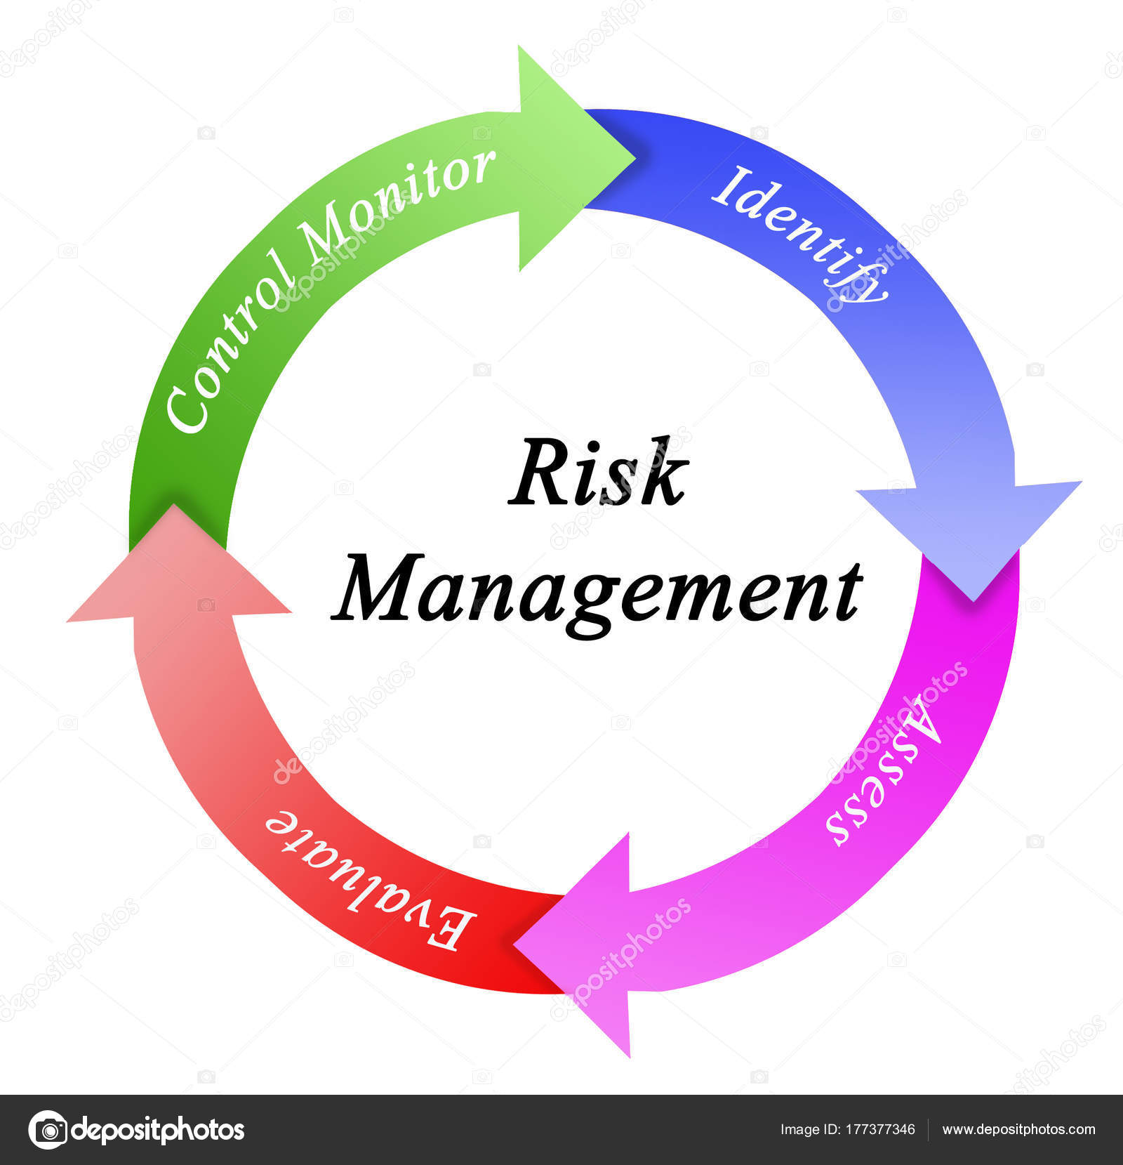

Module: M4X01917

Student: Borislav Bilitkov 1816951

Lectures: Dale Clarke

Table of Contents

Introduction…………………………………………………………………………….…….3
Analysis and Discussion……………………………………………………………………………………3
Data protection……………………………………………………………………………….........3
Health and Safety…………………………………………………………………………………………4
Food Hygiene………………………………………………………………………………….……5
Risk management………………………………………………………………………………...5
Licensing………………………………………………………………………………….….6
Hotel Proprietors Act 1956………………………………………………………………….6
Conclusion……………………………………………………………………………………7
Reference…………………………………………………………………………………….8

- Introduction
This report analyses much of the legal perspective of the risks to employees and managers in the hotel and tourism business, what problems they may face: liability, data protection, health and safety, food hygiene, risk management, licensing, including key provisions within Hotel Proprietors Act 1956.
Globally, one can safely say that the hotel industry is at the forefront of developing a country's economy. The hotel business offers a large number of customer services, whether for business meetings, conferences, family vacations or leisure.
“hospitality industry has been seen as the more experience-based service industry” Gilmore & Pine (2002)
Perhaps the most important services that are offered and are not a constant part of the hotel business are related to the catering of guests and the provision of food and drinks. To achieve all this, employees and managers have and must comply with legal obligations to avoid legal risks.
“legal risk, its importance to companies and how they can minimize it. the need to deal with legal risk to increase an organization's ability to achieve its goals, and components of the risk management process including conducting a risk assessment, identifying the risks, and evaluating the risks.” (2015)

Analysis and Discussion

- Data protection
“the impact of data protection laws on the ability of foreign governments to obtain data on citizens. Need for data protection laws to safeguard personal data from data breaches and cybercrime, the challenges of data protection laws presented to multinational cloud providers, and implementation of the European Union (EU) General Data Protection Regulation (GDPR).” (2018)
The Data Protection Act (DPA), created as an act by the United Kingdom Parliament and adopted in 1988, was written to control the personal information of individuals from organizations and government bodies. The DPA sets the rules and clarifies in the act how and for what purpose people's data is used to protect them.
Why is the Data Protection Act important?
Data protection law is very important as it provides guidance and rules for excellent use for organizations and government to monitor and use personal data, including:
- Controlling the processing of personal data received
- Protecting the rights of the data owner
- Empowering data protection authorities to impose rules
- Any organizations subject to fines in case of violation of the rights and rules imposed by the merging authority
The DPA rules are at the heart of eight basic common-sense rules, known as "data protection principles". These rules are required by all companies, holdings and organizations. The law provides for maximum protection for information that needs to be more protected, such as:
- Ethnic background
- Political opinions
- Religious beliefs
- Health
- Sexual life
- Criminal history.
How can you successfully meet data regulation standards?
When guaranteeing and complying with all legal provisions provided by DPA, you must also comply with General Data Protection Regulation (GDPR), which include important activities to consider:

- Regular assessment of the quality of the data provided so far and of what will be collected in the future. Controlling contact information and checking and cleaning them are good ways to do this.
- Ensure the ability of people responsible for certain processes in managing your data, including the Data Protection Officer's coordinator
- Analyze and update localization and validation data for gaps or issues that can help create major issues

- Held and safety
If you own a hotel, you will surely do everything you can, to get your guests enjoying their stay, to have a great time at your establishment, and ultimately to return again at a later date. Delivering excellent customer service and making sure your premises are safe by maintaining high standards of health and safety will also be a good fit for you.
If you own a hotel or hostel with more than 3 guest bedrooms, you must abide by the health and safety laws created by HSE, which applies not only to guests but also to the people who work for you. In order to comply with these laws and to keep guests safe at all times, here are some things to keep in mind;
- Slip and Trip Hazards
- Clean, Safe Drinking Water
- Fire Safety
- Guest Bedroom Safety
- Lift Safety

- Food Hygiene
Laws designed to assess food hygiene and the results of their verification reflect the food hygiene standards established at the date of inspection or visit by the local authority. Food hygiene assessment is not a guide to food quality.
The information provided for the business is stored by local authorities participating in the National Food Hygiene Assessment Scheme in England, Northern Ireland and Wales.

- Risk Management
“Providing the foundations for modernisation, scientific and technological development eliminated the hazards and risks posed by nature, while giving rise to new ones” Lányi (2011).
Тhe process of allowing certain risk events and general risk to be managed and understood is called risk management. It mitigates threats and optimizes and enhances opportunities.
Тhe process of allowing certain risk events and general risk to be managed and understood is called risk management. It mitigates threats and optimizes and enhances opportunities. The risk is determined at several levels for portfolios, programs and projects. Individual risk is defined as "a set of circumstances or an uncertain event which, if in any way, will have an impact on the achievement of the set goals" is the so-called detailed level. In addition, at the higher level of a project, program or portfolio, overall risk is defined as "exposing stakeholders to the consequences of a change in outcome" arising from the accumulation of individual risks, along with other sources of uncertainty.
The high-level process is shown in Figure 1, the first step is a start-up step, it defines the objectives of risk management. The risk management plan is a major outcome of the start-up step, which describes how risk will be mainly managed throughout the life cycle.

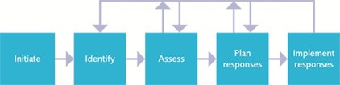
figure 1

- Licensing
State and local governments require extensive licensing to require strict regulation in the hotel industry. Often, the hotel business is subject to rigorous legal scrutiny due to safety and public health concerns. Before any establishment such as a hotel, restaurant or bar even has to start operating, it must have the necessary licenses required by the state and control authorities to be able to function.
A number of important rules have been written for the tourism business for legal reasons. In this section, I have outlined some of the key pieces of legislation that the hotel and tourism business must abide by when starting a business.
- Alcohol licensing for hotels, guesthouses and conference centres
- Updates for accommodation providers
- Consumer advice on complaints
- Food hygiene rating scheme
- Accessibility
- Disability
- Public liability insurance
- Package holidays
- Music licences
- Fire safety - tourist accommodation
- Food waste regulations
- HMRC support
- GDPR considerations for Tourism Business Providers

- Hotel Proprietors’ Act 1956
The Hotel Owners Act "1956" defines a hotel as "An establishment where the owner offers, where necessary, bedrooms, food, drinks and various entertainment to anyone who is willing to pay for the services provided, the customer must also be good-looking and welcoming. "Of course, this definition of a hotel is very old and is not valid today.
“An hotel within the meaning of this Act shall, and any other establishment shall not, be deemed to be an inn; and the duties, liabilities and rights which immediately before the commencement of this Act by law attached to an innkeeper as such shall, subject to the provisions of this Act, attach to the proprietor of such an hotel and shall not attach to any other person.” (Legislation.gov.uk, 2019)

Conclusion

When all hygiene standards and standards prescribed by government institutions are met, the risk of customers being blamed for the hotel or the Restaurant for food poisoning is minimized. Therefore, the institution may show written evidence of compliance with established standards prescribed by state institutions. It is not at all cheap to maintain a safe work environment, but in this way, employees feel safe, secure in the performance of their duties and productive.
By developing technology and digitizing information, it helps employees verify and process large amounts of data in a shorter time. Retaining and storing data is essential for companies and they invest a lot of money and time protecting the data, thus not only retaining their customers' data but also the company's reputation.
“Virtual risks as a synonym of uncertainties.” Adams (1997)

Reference

- Adams, J. (1997): Real world, virtual risk. Times Higher Education.
- Communications of the ACM, 2018, Vol.61 (9), p.19-22
- Gilmore, J.H. & Pine, B.I.I. (2002). Customer experience places: the new offering frontier, Strategy & Leadership, 30, 4–11
- Governance Directions, 2015, Vol.67 (2), p.90-93
- Lányi, A. (2011): A kockázattársadalom vége (The End of Risk Society). Kultúra és Közösség. Vol. IV, No. 2011/3, pp. 7‒13
- Legislation.gov.uk. (2019). Hotel Proprietors Act 1956. [online] Available at: http://www.legislation.gov.uk/ukpga/Eliz2/4-5/62/section/1 [Accessed 18 Aug. 2019].

