

Integrating Project

Josh Perry (1903738)

23-04-2021

—

Foundation Computing- Integrating Project (ACHA4008)

—

Word Count: 1932

Table of Contents

Section | Pages
- Introduction | 1
- Introducing the Problem | 1
- Brief Introduction of the Proposed Solution | 1
- Research | 2-4
- Tools and Techniques | 2-3
- PHP/HTML | 2
- Wireframing | 2-3
- Data Flow Diagrams | 3
- Overview of Team Roles | 3
- Design Section | 3-4
- Planning Section | 4
- Implementation Section | 4
- Proposal | 5
- Conclusion | 6
- Control Measures | 6
- Results | 6
- Amendments | 6
- Appendix | 7-12
- References | 13

- Introduction
1.1. Introducing the Problem
Active Travel can be difficult, given that less healthy and more environmentally impactful means of travel are cheaper and more accessible than ever before. Using Uber, an on-demand taxi service as an example (see fig. 1), it can be observed that throughout their years of trading, the number of trips taken per year grows exponentially. Due to the ease of access and the low cost of this type of service, active travel is less appealing. The author had asked peers and colleagues why they would rather use a service like Uber, rather than cycling or walking, and the majority answered by saying that getting an Uber is easier than planning and cycling or walking somewhere.
This poses an issue. People are becoming less healthy, and this encourages the use of cars, trains, and busses, that are damaging to the environment. Transport is the single largest source of Nitrogen Oxide (NOx) pollution and is a large part of other sources of pollution (see fig. 2).
1.2. Brief Introduction of the Proposed Solution
The solution to both issues presented is to encourage active travel. If people partook in active travel more often, emissions would be reduced, and consequently people would be healthier.
The team has decided on a solution called ‘Cardio With Friends’. This solution is a service that allows users to travel and exercise together. This solution promotes active travel through a social media platform that encourages users to carpool together and log their activity.

- Research
To create the solution proposed by the team there will be certain tools and techniques required. This section serves to identify those tools and techniques.
  - Tools and Techniques Required
    - PHP/HTML
The prototype solution will be made as a webapp initially. This requires the use of PHP and HTML.
PHP was the ideal scripting tool to use as it allows the solution to run on a server-side basis. PHP can also be embedded into HTML which makes it perfect for constructing a webapp. Many webapps use PHP due to its popularity and integration options. PHP is used for creating responsive and dynamic webpages, which is exactly what the team was looking for.
“PHP is a general-purpose web development language that is one of the most popular server-side scripting tools based on HTML. This platform is quite fast and considered as the best option for building dynamic web pages.” [1]
PHP is opensource and thus is free to use, so will cost the team nothing. PHP is also optimised for speed and quality performance. In the decision between using Java and PHP, the team opted for PHP, because while Java is an excellent contender, PHP beats it slightly in the speed factor. Furthermore, PHP has more learning support than Java.
The team will also need to use HTML to create the overall look of the webpage to ensure it looks as good as it runs.
HTML is an open standard tool. Open standard can be defined as “a standard that is publicly available and has various rights to use associated with it and may also have various properties of how it was designed (e.g. open process)” [2]
    - Wireframing
The team will also be required to create an efficient wireframe for the solution. To create this wireframe, is essentially to create a skeleton of how the overall UX will look and feel, this includes the use of colour schemes, where elements are laid out, and the overall design with the end user in mind. This will help the design team to keep the initial concept as user focused as possible. To define what a wireframe is and does is “a wireframe represents the basic page layout structure and navigational scheme of the site’s pages, as well as major site components (like web forms and ad units).” [3]
There are many benefits to creating a wireframe prior to design. The key benefit being that it gives the design team a clear-cut idea of how the finished product will look, and how the information will be displayed to the end user. The idea is to make the final product as user friendly as possible while still maintaining the delivery of all key information.
    - Data Flow Diagrams
The team will also need to create a diagram to identify the flow of information around the solution. This will serve as a point of reference throughout the design phase as it will show, correctly, how the data should be flowing throughout the solution. It will also take weight off having to design the architecture as the team designs.
Flowcharts are an excellent tool for visualising the flow of data. It is essential that a data flow diagram is created prior to implementing the solution. If this is not done first, then the implementation team are essentially ‘going in blind’. They will have to create this data flow architecture as they implement, which is an additional stress that does not need to be placed upon them. This additional stress can lead to complications, confusion, and errors throughout the system. DFD are a key first step in creating a system, because “Visualizing each element makes it easy to identify inefficiencies and produce the best possible system.” [4]
  - Overview of Team Roles
Each member had democratically decided which section they felt they should lead given their skillset. Roles were decided as below:
- Implementation- Iskander Abd-Al-Kerim.
- Design- Josh Perry.
- Planning Leader- Magdy Bkheet.
Each team member took part in all sections; however, it was the lead for each section that took the executive decisions for that section.

    - Design Section
During the design phase of the project, the leader had to first create a basic concept of how some of the pages would look. This gave the team a visual representation of what the finished solution would look like. (See fig. 3) this included the layout, colour scheme font, and font size. The main goal here is to create a system that has a balance of user-friendliness and delivery of information. Getting that balance right is paramount to an effective solution.
The second step was to create basic default avatars for users to choose from should they wish to not upload a profile picture. These avatars need to be created in a way that is appealing to the users. Research had shown that a lot of companies that operate on the web use a specific style of art, Alegria, colloquially labelled ‘corporate art’. Simply checking some sites across the web, shows this art style quite frequently (See fig. 4).
The leader for this section created Three avatars for three concept users each with their own background story taking inspiration from the Alegria art style. (See fig. 5)
More on the technical side of things, there needs to be a database for the solution to work correctly. The database needs to be able to hold all the user information that is critical for the system to run effectively. This database also needs to be able to communicate internally between tables to edit and fetch data. For this reason, the leader had decided to create an Entity Relationship diagram. This diagram is used to denote the relationships between entities in various tables in a database, and display which information Is used where. (See fig. 6)
The Leader for this section was also tasked with creating the brands image on other social media platforms to advertise the solution and update users on progress. It also serves to attract a wider audience. (See fig. 7). The team also plans to create a TikTok account once the first version rolls out. Advertising on TikTok (one of the world’s largest video sharing social media platforms) will allow the team to gain an even larger reach and expand the target audience further. It also grants them the ability to share videos from current users, encouraging active travel.
    - Planning Section
The planning section consists of assessing the costs of the project, planning for any costs, and organising the time of the team, ensuring everything runs smoothly.
The lead for this section has been quite unreliable at times, with other team members having to fill in for this portion of the work. The quality of the planning is sub-par, due to inexperience, lack of communication and reliability. There is a very basic project file denoting the initial steps of the project (See fig. 9).
    - Implementation Section
The implementation lead was the strongest role allocated. The leader essentially took over from the planning leader and took a general oversight on the project. Given that the leader had created the original concept for the solution, it makes sense that they had an idea where to take the development.
The leader had also created a plan for the implementation stage, complete with a Gantt chart denoting the time it should take each step. this plan also included a cost overview of each step. (See fig. 10)
There was also a data flow diagram, and wireframe created which was used to initiate the implementation stage. These diagrams were essential in creating the prototype. This documentation served to visualise the basic solution, which was built on further by the implementation leader, which was excellently executed. (See fig. 12)

- Proposal
The team has decided to create a solution to the issues raised in the introduction by creating a webapp called ‘Cardio With Friends’ that aims to encourage active travel by allowing users to interact through the social features of the solution. The solution works on the premise of encouraging users to partake in cardio workouts (Walking, running, cycling etc.) and logging their activity to share with their friends on the platform. This platform will also include a section called ‘Friends With Cars’ that aims to get users into the routine of carpooling, wherein they share a journey together as opposed to in separate vehicles, thus reducing emissions. The solution will utilise mapping features from What3Words to log journeys and routes taken by users to be displayed on the platform. This data will also be used in future iterations of the solution to calculate calories burnt while travelling.
The platform will also offer a rating system for users when logging their activity. They will be able to rate the intensity of their activity, how much they enjoyed it and the route they took.
The team believes that by encouraging users to commit to active travel, and ride sharing with the blended approach of a social media platform, that the issues raised in the introduction, this solution can help to reduce emissions and increase healthier travelling methods.

- Conclusion
  - Control Measures
Throughout the project, the team will measure their success at each stage by comparing their current progress to the expected progress outlined in the Gantt charts discussed earlier. There is also a Risk register created by the implementation leader where all risks will be assessed.
There will also be regular meetings between the team members to discuss progress and ask for or offer help if it is required. The meetings will also serve to propose future updates or additional features to the solution, as well as any changes that need to be made during the prototyping stage.
  - Results
The prototype works as expected despite the issues with deadlines from certain team members. There has been discussion on further developments for future iterations and implementation of some ‘quality of life’ features.
  - Amendments
There were a few issues with hitting deadlines during the project, partially from the design leader, and the project management leader. Given this information, a future project would need to assess the skills and traits of each team member more thoroughly in order to select the most qualified candidate for each role. Furthermore, assessing the skills and traits of each team member will help to identify which team members are stronger and would require less assistance in completing tasks.

- Appendix
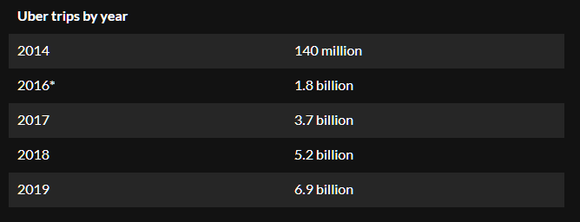
Figure 1- Uber trips by year [5]
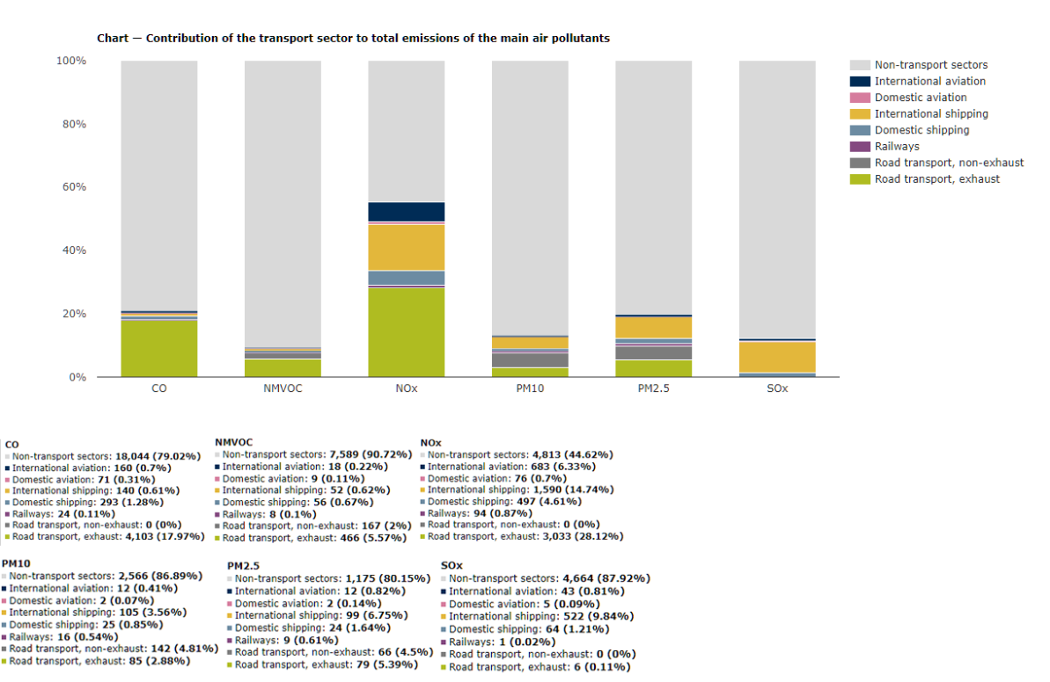
Figure 2- Contribution of the transport sector to total emissions of the main air pollutants [6]
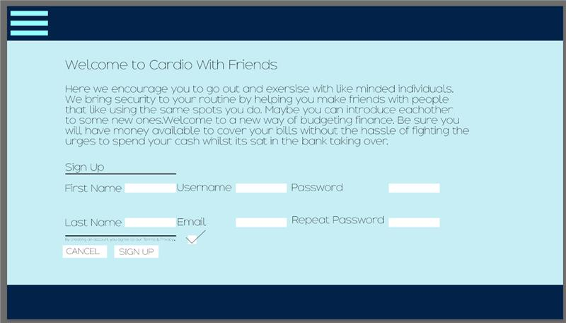
Figure 3- Webpage Concept
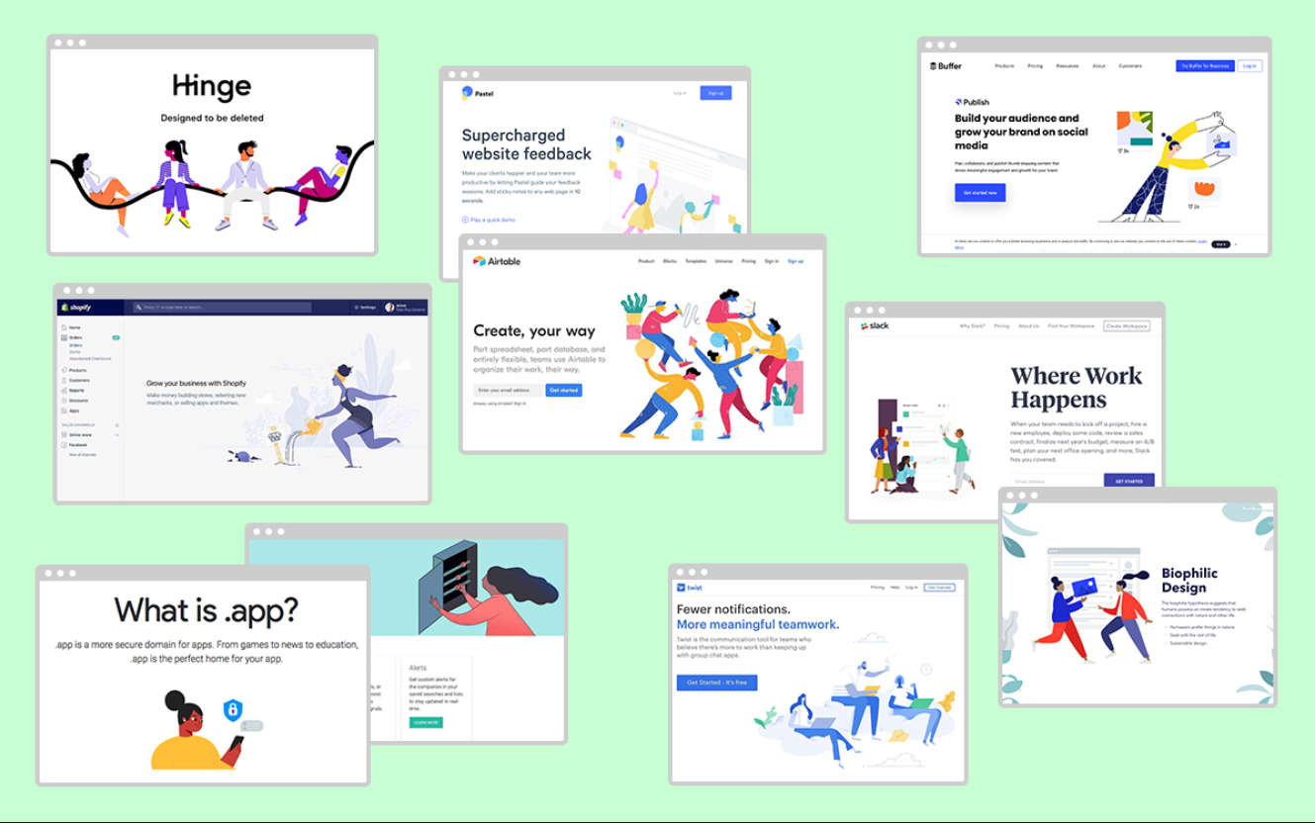
Figure 4- Examples of Algeria-style illustrations used in the tech realm [7]
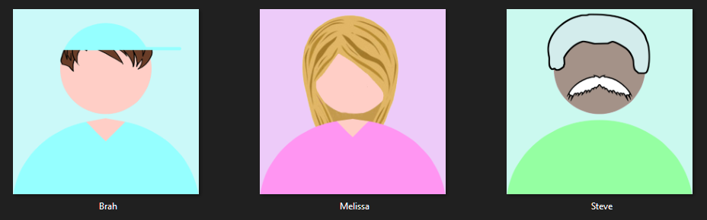
Figure 5- Avatar Concept Art
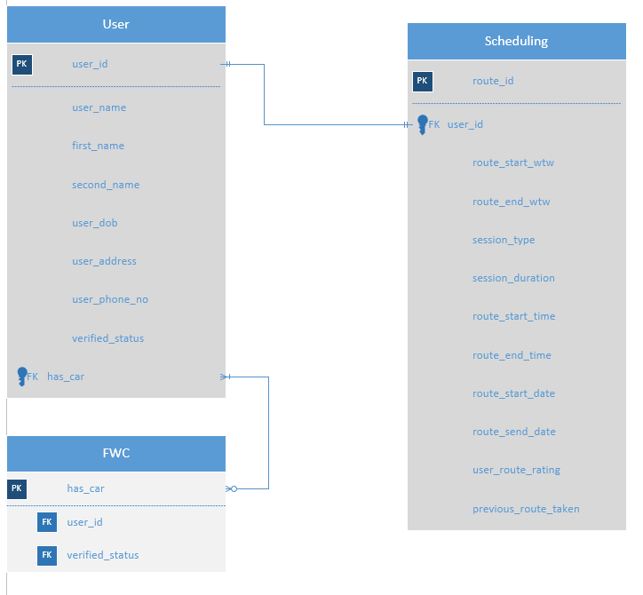
Figure 6- Entity Relationship Diagram
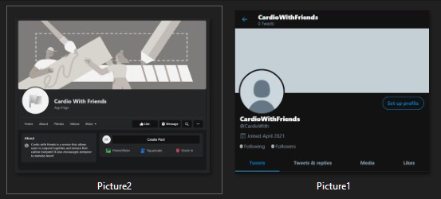
Figure 7- Social Media Pages of CWF
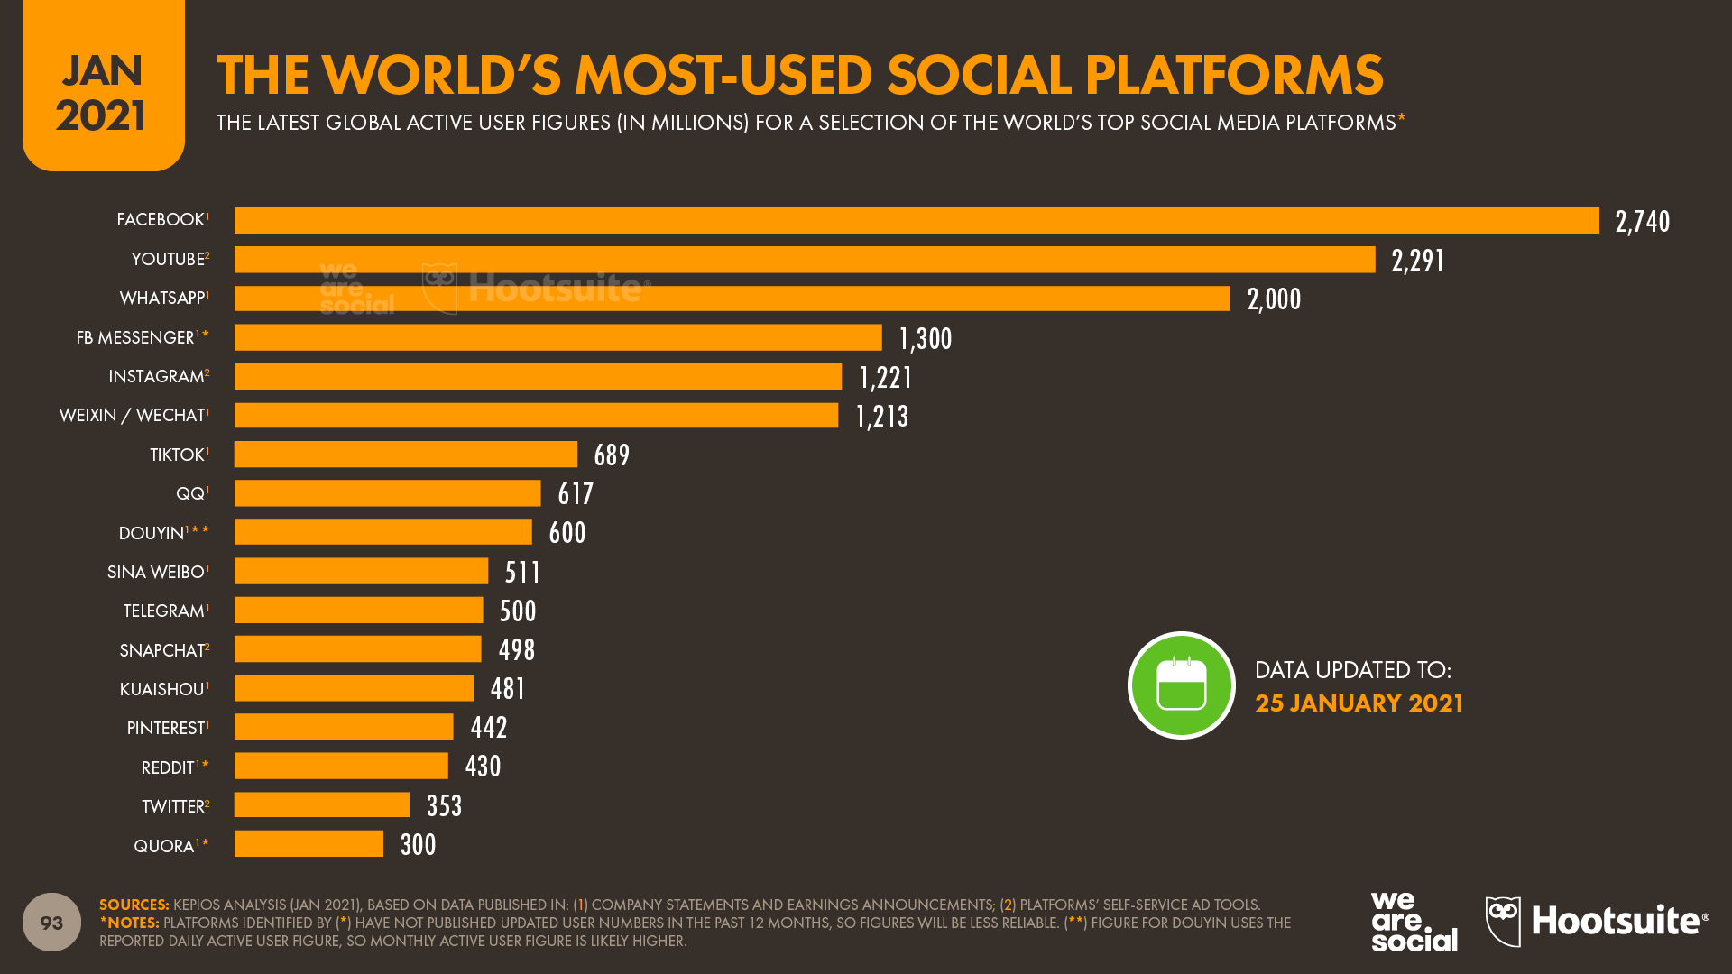
Figure 8- The World’s Most-Used Social Platforms [8]
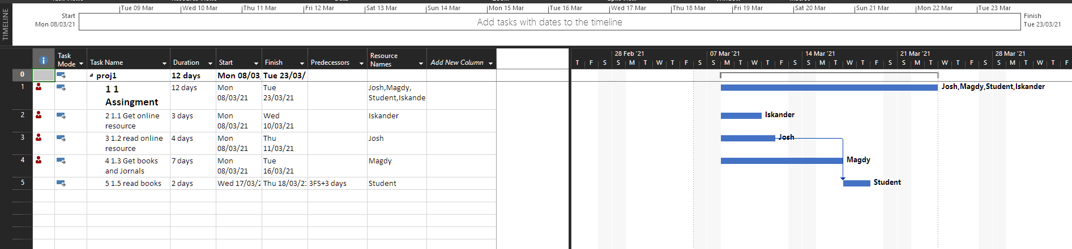
Figure 9- Basic Gantt Chart Displaying initial Project Steps
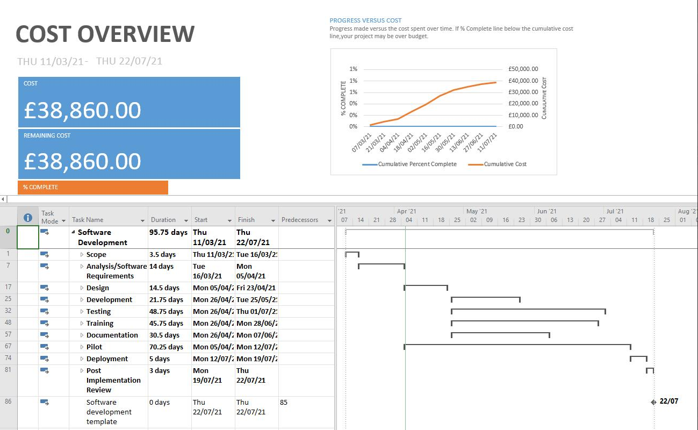
Figure 10- Cost Overview of Project
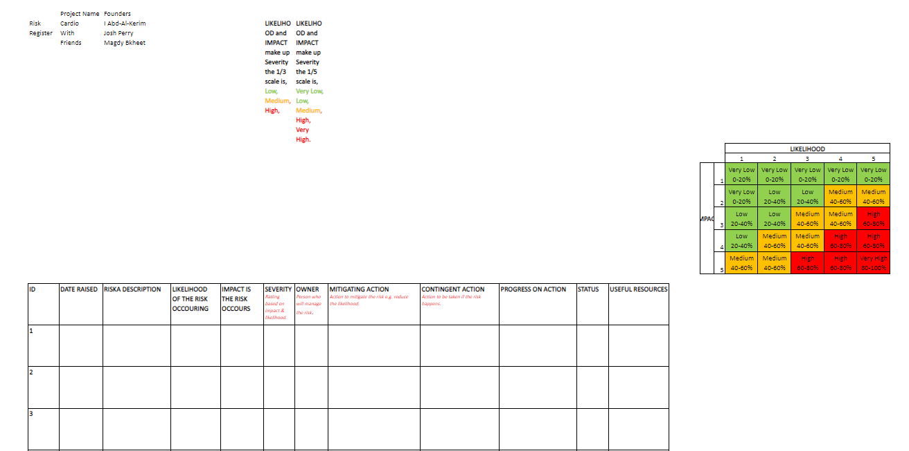
Figure 11- Risk Register
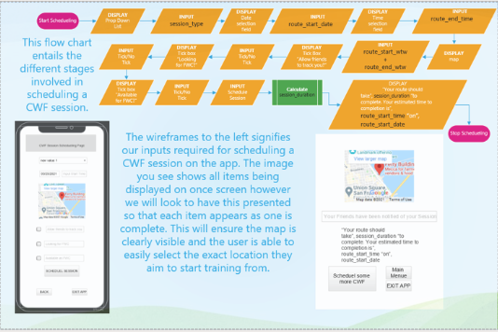
Figure 12- DFD and Wireframe slide from collaborative presentation

- References

[1] C. Garcia, “HTML Goodies,” [Online]. Available: https://www.htmlgoodies.com/beyond/php-vs.-java-better-programming-platforms-for-seamless-web-development.html. [Accessed 23 03 2021].
[2] Wikipedia, “Wikipedia,” 10 03 2021. [Online]. Available: https://en.wikipedia.org/wiki/Open_standard. [Accessed 30 03 2021].
[3] W. Craig, “WebFX,” [Online]. Available: https://www.webfx.com/blog/web-design/wireframing-benefits/. [Accessed 06 04 2021].
[4] J. Bangerter, “LucidChart,” [Online]. Available: https://www.lucidchart.com/blog/data-flow-diagram-tutorial#:~:text=A%20data%20flow%20diagram%20shows,various%20entities%20and%20their%20relationships.. [Accessed 12 04 2021].
[5] M. Iqbal, “Business of Apps,” 8 03 2021. [Online]. Available: https://www.businessofapps.com/data/uber-statistics/. [Accessed 15 03 2021].
[6] European Environment Agency, “Contribution of the transport sector to total emissions of the main air pollutants,” 17 12 2019. [Online]. Available: https://www.eea.europa.eu/data-and-maps/daviz/contribution-of-the-transport-sector-6#tab-chart_4. [Accessed 19 03 2021].
[7] R. Hawley, “Don’t Worry, These Gangly-armed Cartoons Are Here to Protect You From Big Tech,” AIGA Eye on Design, 21 08 2019. [Online]. Available: https://eyeondesign.aiga.org/dont-worry-these-gangley-armed-cartoons-are-here-to-protect-you-from-big-tech/. [Accessed 20 04 2021].
[8] Kemp, Simon; We Are Social, Hootsuite, “Digital trends 2020: Every single stat you need to know about the internet,” 30 01 2020. [Online]. Available: https://thenextweb.com/news/digital-trends-2020-every-single-stat-you-need-to-know-about-the-internet. [Accessed 21 04 2021].

