

BA International Hotel Management
Module: Foreign Languages & Cultural Awareness
Assignment Title: Intercultural Competence Report
Student Name: Iuliana-Daniela Giurea
Student ID: 2226406

Executive Summary
The report has highlighted the concept of England’s heritage which is the governmental body that manages historic sites. The key findings are the religion and beliefs of England which shows that 30% of the UK population is affiliated with the Church of England. It has been understood that Indian culture has thriving sources of different languages and religions. The report has discussed that Indian culture strongly believes in personal bonding and long-lasting relationships with close ones. Additionally, the discussion indicates that charismatic leadership in England believes in high-performance outcomes.

Table of Contents
Introduction 4
Key differences between England and India 5
Analysis and Comparison of England and India with the GLOBE Project 7
Challenges of Intercultural Leadership 10
Recommendations 11
Conclusion 12
References 13

Introduction
Language and culture both are interconnected and facilitate the exchange of social values and beliefs. Foreign language and cultural awareness are significant aspects of the hospitality industry specifically for the hotel chain business operation. The communication and interaction process with the members of the organisation and global visitors is a strategic and significant aspect of the hotel business. The development of inclusive culture and behaviour within the business operation helps to create brand awareness and brand reputation. The report will identify the differences between England and India with special emphasis on the Globe Project’s culture and leadership analysis and study. The report will highlight the St. James' Court, Taj Hotel in London whose headquarter is in India.

Key differences between England and India
England | India
Culture  The culture of England is the type of individualistic in nature. It is less hierarchical and less conservative. The rich customs and traditions are famous in England. It has been observed that the culture of England is influenced by the imperial past. The country has made many significant contributions to global literature, art, and philosophy (Cressy, 2023). Heritage and tourism are widely developed in this country and it is observed that English Heritage is the governmental body that manages historic sites. In terms of religion and beliefs, 30% of the UK population is affiliated with the Church of England. The major festivals like Christmas, Good Friday, Easter Sunday and others have impacted the lives of the people (Commisceo-global, 2022).  Customs  England believes in greetings and formal etiquette such as a handshake when it comes to meeting someone. Similarly, the people in England say ‘Hello’, ‘Please’ in their normal conversations. Gift giving is there of the customs however, it is only given at the time of special festivals and occasions like Christmas and birthdays. Furthermore, it is considered to be rude in England to ask personal and uncomfortable questions to someone (Cressy, 2023). | Culture  India is known to be a unity in diversity-based country in terms of its multicultural values and beliefs. The country has the world's largest collection of music, arts, theatres, folk culture, traditions and rituals. Indian culture is the amalgamation of history, heritage and tradition which reflects different festivals and occasions. Indian culture is known to be the oldest civilisation that impacts the country. It has been observed that Indian culture has thriving sources of different languages and religions. In India, around 79.8% of the population follows Hinduism as their religious belief. The majority of the people use Hindi as their official language for better communication (Irwin, 2020).  Customs  India is known to be a rich country when it comes to customs and beliefs. The India believes in traditional gestures when meeting someone. India is seen to be exceptionally hospitable when it comes to taking care of its guests. Indian people generally remove their shoes before entering someone’s home. They touch the feet of respected and elder people. India believes in giving gifts to their friends, and relatives on their special days and festivals (Irwin, 2020).

Analysis and Comparison of England and India with the GLOBE Project
Societal Culture
Performance Orientation- The study of performance orientation is the degree to which the collective can encourage and reward the group members. This can improve the performance of the individual and excellency. England is considered to be a high-performance orientation country. It has been observed that England has given value to training development. They are given importance to the results rather than to people. Additionally, India emphasises social values and family traditions. They value harmony and respect the quality of the work. They also value for group members very highly (Globeproject, 2020).
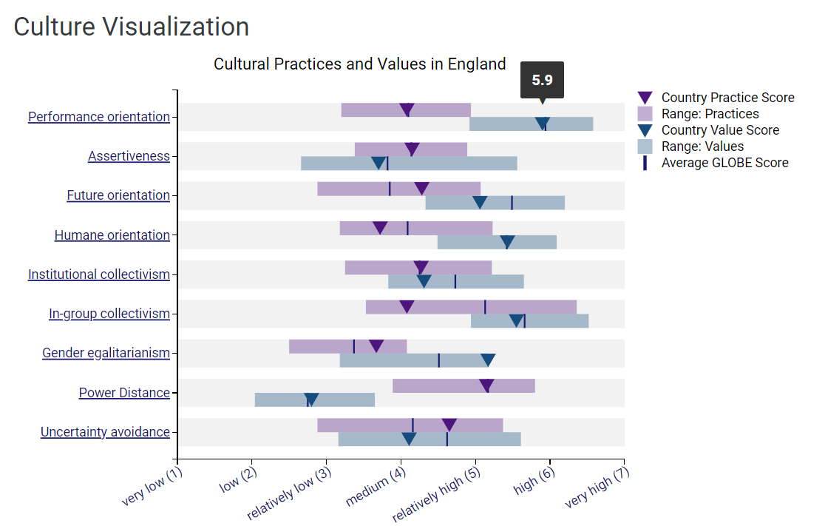
Source- (Globeproject, 2020)
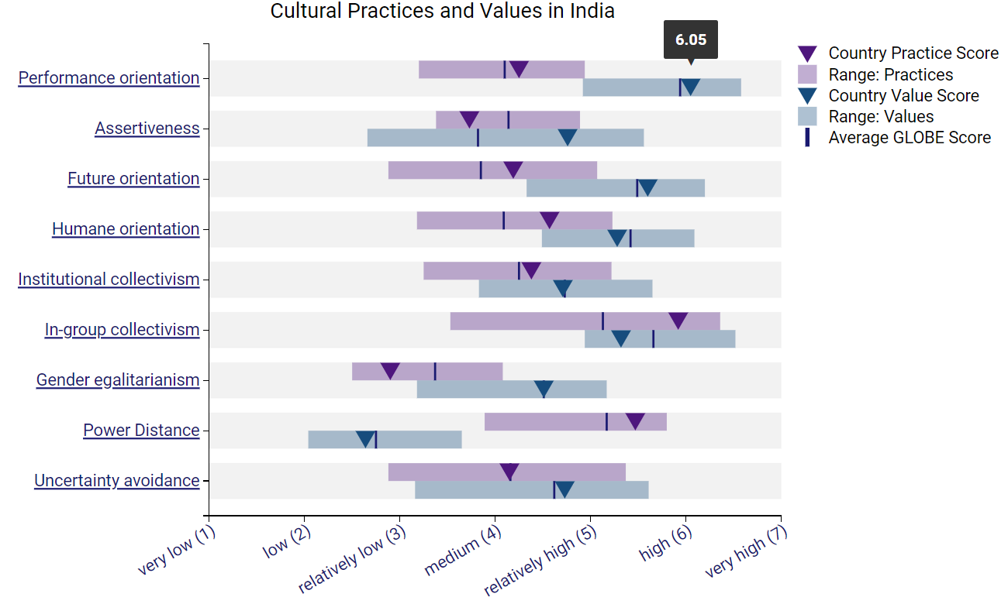
Source- (Globeproject, 2020)
In-Group Collectivism- This study emphasises the individuals who express pride and cohesiveness in the organisation. Indian culture and society are seen to be collectivistic and they are promoting social cohesion. Indian culture strongly believes in personal bonding and long-lasting relationships with close ones. On the other hand, England is more seen to be an individualistic country as they believe in personal freedom and entrepreneurship.

Leadership
Team-oriented leadership- Indian culture reflects their leadership dimensions to develop diplomatic relations, team integration and administrative competence.
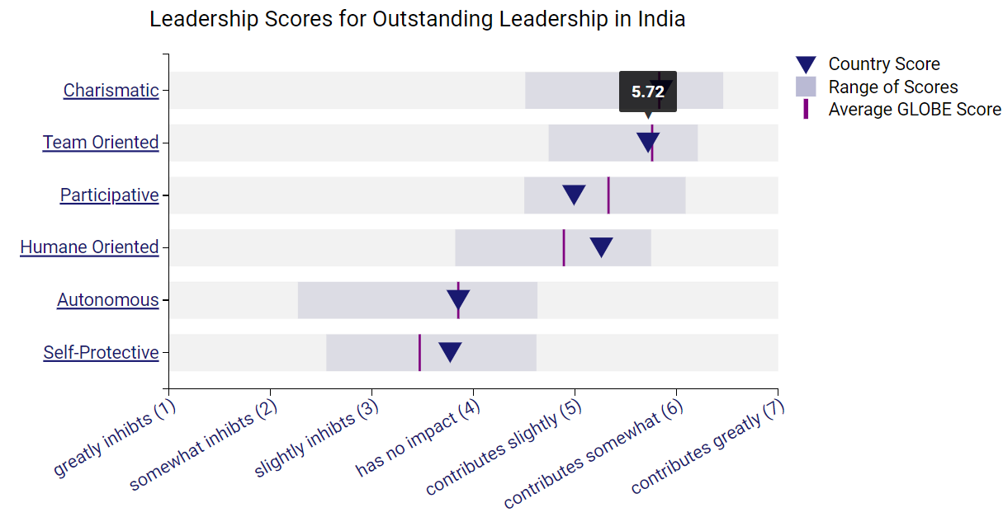
Source- (Globeproject, 2020)
Charismatic- The leadership in England is more likely to deal with unique attributes and independent working perspectives. With charismatic leadership, England believes in high-performance outcomes.
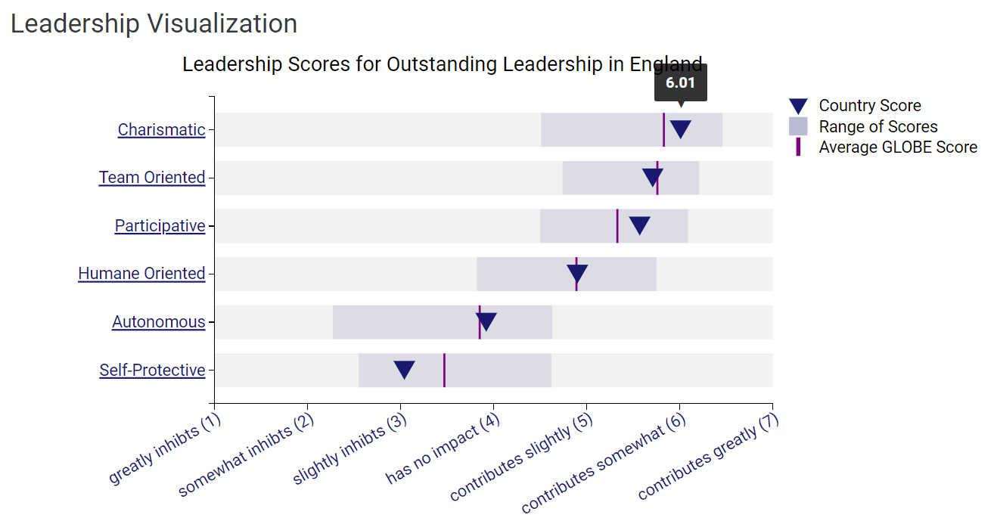
Source- (Globeproject, 2020)

Challenges of Intercultural Leadership
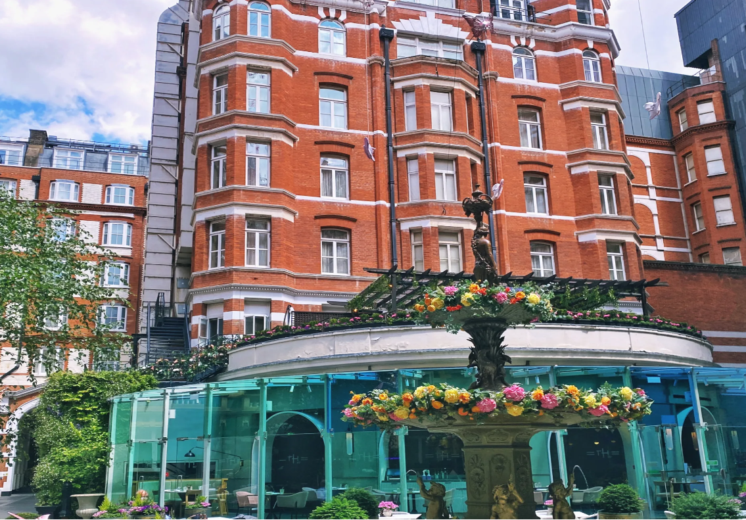
Figure- St. James' Court, Taj Hotel in London
Source- (Stjamescourthotel, 2024)
Cultural barriers can be one of the significant challenges for hotel employees of Taj in India who are planning to join the hotel team of St. James' Court, Taj Hotel in London. As the new members will be join the new team in different cultures and countries it can be difficult for them to adopt the culture quickly. The main issues can be communication styles and processes. In the London chain of Taj Hotel, there will be global guests from all around the world (Stjamescourthotel, 2024). Therefore, it can be challenging for the new employees who will go from India to understand sensitive issues regarding cultural awareness. Additionally, the potential areas where new employees can face challenges are a lack of understanding between local customers due to different cultural beliefs. As Indian employees tend to be conservative and stereotyping in nature, they can face leadership issues in communication.

Recommendations
Organising cross-cultural training- St. James' Court, Taj Hotel in London is recommended to organise cross-cultural training within the hotel management team. The training should highlight social skills, communication processes, values and local cultural study (Tsang, 2020).
Implementation of coaching leadership styles- The hotel management team of St. James' Court, Taj Hotel should implement a coaching leadership style to guide and motivate new employees.
Performance appraisal programme- The hotel should regularly review the employee’s performance and needs to arrange feedback sessions on a regular basis to understand the issues and challenges of the new employees (Valamis, 2023).

Conclusion
The report has demonstrated the cultural and leadership aspects and values of two different country which are England and India. The key differences between these countries have been observed in the report. The key findings are England has a less hierarchical and less conservative society and culture, on the other hand, India gives value to the rich heritage and cultural values with the conservative nature of society. Both India and England are considered to be a high-performance orientation country which has been understood from the study on the GLOBE Project.

References
Commisceo-global, (2022). Welcome to our Guide to British Culture, Business Practices & Etiquette. [Online] Available at: https://www.commisceo-global.com/resources/country-guides/uk-guide [Accessed 23 01 2024].
Cressy, D., (2023). Society and culture in early modern England. Taylor & Francis.
Globeproject, (2020). An overview of the 2004 study: Understanding the Relationship Between National Culture, Societal Effectiveness and Desirable Leadership Attributes. [Online] Available at: https://globeproject.com/study_2004_2007#societal [Accessed 23 01 2024].
Globeproject, (2020). England. [Online] Available at: https://globeproject.com/results/countries/GBR%3Fmenu=list.html [Accessed 23 01 2024].
Globeproject, (2020). India. [Online] Available at: https://globeproject.com/results/countries/IND%3Fmenu=list.html#list [Accessed 23 01 2024].
Irwin, H., (2020). Communicating with Asia: Understanding people and customs. Routledge.
Stjamescourthotel, (2024). ABOUT THE HOTEL. [Online] Available at: https://www.stjamescourthotel.co.uk/about/ [Accessed 24 01 2024].
Tsang, S., (2020). 9 Ways to Manage a Multicultural Team. [Online] Available at: https://www.fond.co/blog/9-ways-multicultural-team/ [Accessed 24 01 2024].
Valamis, (2023). Performance Appraisal. [Online] Available at: https://www.valamis.com/hub/performance-appraisal [Accessed 24 01 2024].

