Sadie Russell
Documentary photography and visual activism
Ryan moule
2004028
manifesto writing
An image can be a powerful means of communication, open to manipulation it’s therefore important that the photographer understand the potential of the image and the way this can be used. To have a manifesto enables the photographer to ensure that they have “ownership” of the images they produce and that they are able to maintain the integrity of the image.

I believe that images can illustrate parts of life that are unknown about by certain viewers. The image can take people to places they have never seen. The image can also be playful and multifaceted by indicating a hidden meaning, what I describe as finding the naughty in the nice.
Poignancy is a strong device that depicts beauty within pain, in searching for this within the image it’s possible to find the emotional link that has a deep resonance.
Truth is a difficult word- to find the truth within an image is quite a monumental task , is there in fact any such thing as truth? we all see truth from our own perspective. The best that can be achieved by this would be to ensure that the image speaks truth to the photographer.
.
The power of an image is undisputable, a single image can stand out and signify so much. There is a clear need for the photographer to illustrate “What’s going on and is essential to document historic events. When we think about the Vietnam war the image of protesters putting flowers in the barrel of the soldier’s riffles has become etched in our brain. The image itself therefore confronts injustice.

To find the essence of an image is about striping the image down to what’s important, to get rid of all the things that are superfluous, this doesn’t mean that an image has to be minimal but it means that everything in the image needs to be essential to telling that particular story.

The story behind the image refers to the fact that a single image can also be a part of a narrative, an image can make the viewer eager to learn what the subjects are looking at, where they have been and where they are going. This expands the image so that It can’t just be seen in isolation, the meaning of a depiction of an image is part of the bigger story that the viewer will be engaged in.

I think that being able to shock is a good is a good way to involve and intrigue the viewer, to draw the viewer in. Shock is a powerful emotion so that by producing an image that is shocking the photographer has already begun to work on the viewers emotions. The idea of creating stunning realism. I want every image to work on both an emotional level but also to create an image that is stunning and and powerful in its own right.

A photographer can be a force for good, the public need to be made aware of social injustice and its therefore part of the role of the photographer to be the voice to the voiceless. The camera can be a tool to that enable this voice, the image is a powerful object that has the ability to actually change lives, my hope is that this is a force for good

Fact from fiction? Being able to distinguish between the two is getting increasingly difficult by the day. The new era of deep fakes, photo shopping where the subject might not even been present. Currently there’s an average of 1.8 billion photos taken per day. That mean that over the course of two minutes the worlds population takes more photos then existed in a total of 150 years. Every photo no matter on how quick or random, has a meaning.
The significance of semiotics in this capacity is enormous- the signs and signals within the
Photographic image could be the objects being photographed, the colours, clothing to the
background, the location or the atmospheric environment. The semiotics within the
photographic image are basically redolent with meaning.
Semiotics allows the viewer to deconstruct the image and bring out the deeper meaning, the latent meaning. For example, a simple still life of a jug on a table, it’s meaning is dependent on the symbolic significance of the setting, lighting, colour etc - is the lighting harsh?, do the shadows make this a melancholy image?- what’s in the jug? Is it fresh or decaying? Through analysing the image, we imagine a back story- we start to piece together the symbolism and a narrative.

Observational writing
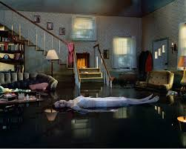
In Gregory Crewdsons 2001 Twilight series, Ophelia. The narrative I construct by analysing semiotics is one of a never ending loneliness. Ophelia lies in a flooded suburban home. When deconstructing the image- the pills on the table- did she kill herself? The romantic novel- timeless addiction? The clock face 5am or 5pm ? Time passing- is she dead or dying? There is a strong sense of isolation reminding me of the current experience of quarantining. It’s clear from this that the semiotics within the image were not always a conscious decision of the photographer. Gregory Crewsdon would not have known the experience we were to have during the pandemic.

The image Ophelia, the isolated presence that is shown within the shot reminds me of the feeling of isolation. as a whole, although not purposefully resonates with the feelings that I had over the last few months, It shows a dream like sense of reality. The image of Ophelia is also theatrical, like a theatre set and exudes a dreamlike sense of reality. The water she lies in is dark and oily, otherworldly yet calm. I am led through my understanding of the symbolism to believe that she has the moral high ground not just a victim. The sombre lighting feels as though she might be sinking into the abyss.....

The suburban home where the photo is shot appears lived In, a little bit cluttered to me this resembles the feeling of being overcome with stress.
The photographer Gregory crewsdon uses twilight as a theme in most of his work and this piece especially he uses lighting to show the contrast between night and day
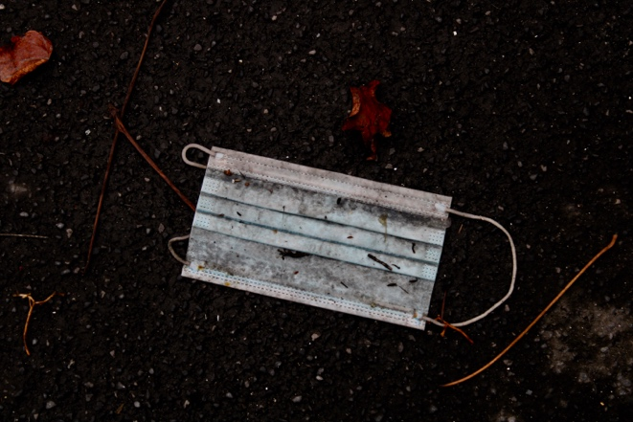
Practise based writing

I choose this image as it will be iconic and come to identify the past year, ‘the year of the pandemic’!

The image is simple but I wanted it to contain the essence of what we have all been dealing with and there can be no other more potent symbol that will sum up the past 12 months than a surgical mask. it is probably the single enduring object that the whole world will identify with

The surgical mask is ubiquitous; we have all had to get used to wearing one it has become a social imperative it is a symbol of fear of catching this disease but also a symbol of humanity to protect our fellow citizens

To depict the surgical mask discarded on the street, is, I feel, an ambiguous message. It can be seen as being carelessly discarded- does that mean that we no longer care? Is the hope of stopping this disease no longer possible? Have we given up? The mask discarded is so laden with symbolism even though it’s something we all see on a daily basis.

The dark sombre background helps to give this image and melancholic feeling. The surface is gritty – unforgiving – it’s harsh and cold – this could be seen as symbolising the difficulty the world has been in, the harshest climate. The addition of leaves and natural debris can be seen as being symbolic of the natural world but not in fresh spring with green growth but autumnal, the year coming to a close the sense of an ending – the failure of hope?

The image is almost atonal, the brightest part of the image is the mask itself, it’s new unused yet as a discarded object becomes a negative image, hope trodden into the ground? The mask is dirty and we are fearful of touching it, unseen germs could be circling this image. If the background were brighter with some sense of the regrowth of spring, rather than the Brittle leaves of autumn in a subdued pallet, then the image may be more hopeful but the picture sums up the depressive state of the virus that is not yet under control, of lives limited and hope suspended.

Marcus Sperlich’s photograph of “isolation’ comments, “our senses have been restricted, we are isolated and afraid and incapable of rational thought”. His work is powerful and explicit he uses the body to convey meaning, my image however shows this isolation by the absence of the body yet still portraying isolation

Tom Croft painted an A&E nurse in full PPE and says of the mask “the mask protects hopefully but it also creates a barrier between patient and the health worker and impacts the human connection we’re used to” .

Bibliography

