digital skills and research methods: assigment 2- research report
Impact of virtual learning environment.

Table of content.

Introduction: page 2

Background: page 3

Aims and objectives: page 4

Method: page 5

Results: pages 6-10

Discussion & conclusion: page 11

References: page 12

Appendix: pages 13-14

Introduction to the report

Virtual learning environment.

Virtual learning is a learning environment which is completed online by the teacher and student. This is an easier way for both parties to teach and learn without face-to-face interaction. In the UK and around the world, there are different types of educational systems that use this platform. Regardless of the change of the environment, it does not change the way the student is taught. (Kanimozhi, 2018)
Virtual learning is used in all educational systems and is used by teachers and students all over the world. This was introduced in 1986, however it expanded when we experienced a pandemic. The reason for this was because it was no longer safe to be socialise face to face, therefore other procedures needed to be put in place, the main feature being virtual learning.
In this report I will discuss the advantages and disadvantages of virtual learning and what impact it has had on teachers and students. I will also be giving my personal opinion along with my peers (via google form) on VLE.

Background

(Literature review)

Virtual learning environment (VLE) is providing many services. For example, online classes, learning/ reading supplies, technical support, video calls and assessment uploading are all frequently used by student and teachers.
VLE uses different types of technology, preferably a computer or laptop is best, however phone and tablets can also be used.
Virtual learning has many benefits, for instance, classes can still take place without having face to face interaction. Also, work can still be submitted, learning/ reading resources can be accessed, and any questions can still be answered without being in the classroom. During the pandemic, it was unsafe for anyone to socialise, this meant teachers were unable to teach in the classroom. Therefore, all learning was completed online through either zoom, teams, google meet etc. Many people preferred this way of learning, although a few people did not because they found it hard to concentrate and understand the work.
However, there are also many negatives to VLE, this can include your computer being hacked, your work being stolen/copied, your personal details being used and your lack of concentration when trying to learn.

Aims and objectives of this research.

Virtual learning has a positive and negative impact on everyone. Some of the positive impacts can include remaining safe during the pandemic and getting your work completed when you are unable to attend classes due to health or personal reasons. Another positive is flexibility, for instance, students can complete or submit work in their own time, instead of when they’re only in the classroom. Also having access too learning and reading resources any time you need is a big positive.
VLE has had a negative impact as well. Some of the negative impacts it has on people is lack of concentration and finding it harder to understand the work, also a negative impact on your mental health, this is because some people need to socialise and interact with others avoid their mental health becoming bad and effecting there learning ability. Finally virtual learning can give you more temptation to cheat and copy other pupils work, it can also put your own work at risk of being copied or stolen.

method.

During my secondary research of virtual learning environment, I used the internet too search up different articles. I visited different websites, read through the articles and I read through numerous articles on people giving their own opinion on VLE. The links for the websites can be found under references on page 10.
For my primary research, I conducted a questionnaire in the classroom. I did this using google forms. I then sent the questionnaire to my peers, and they individually answered each of the questions.
Screenshots of my questionnaire has been listed under appendix (pages 12-14).
After my secondary research, I conducted my primary research. I did this using google forms. I created a questionnaire; this was made up of 10 questions with multiple choice answers. Shortly after I sent the questionnaire too all the students in my class for them to answer. Once the students completed my questionnaire and I got over 15 responses, I then took a screen shot of my results and uploaded them in results (pages 6-10).

Results.

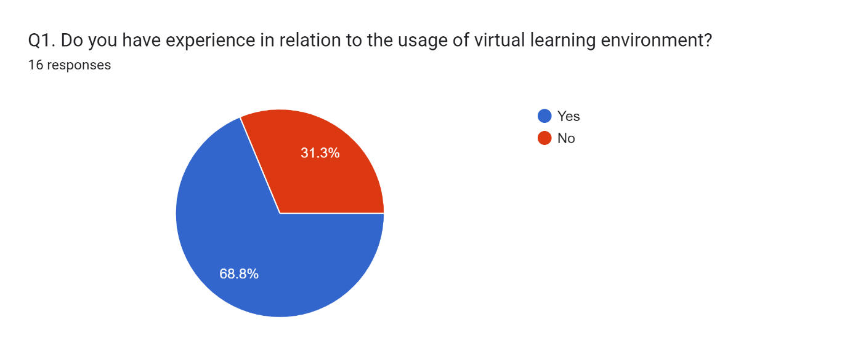
As you can see from the responses above in question one, majority of the people did have experience in virtual learning environment. However, over a third of the people still did not have experience in virtual learning. 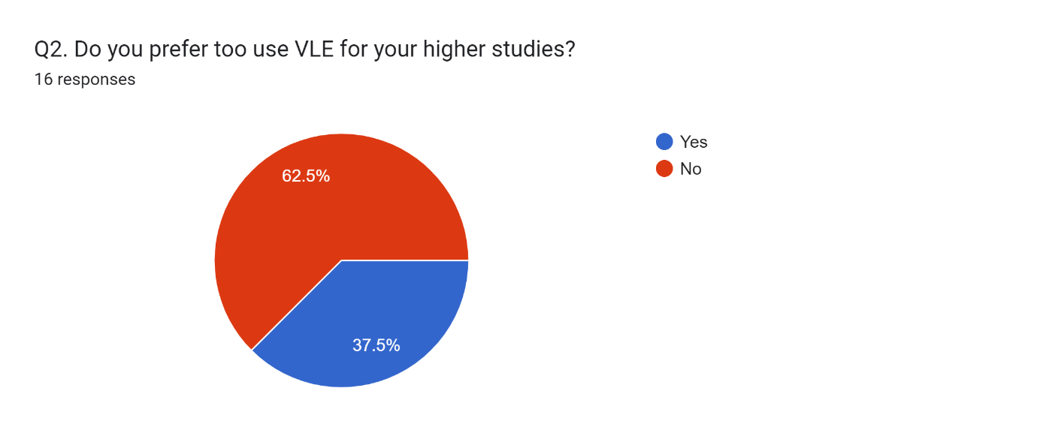
From the results above, 62.5% of people prefer to use virtual learning. However, 37.5% prefer to do learning in the classroom.
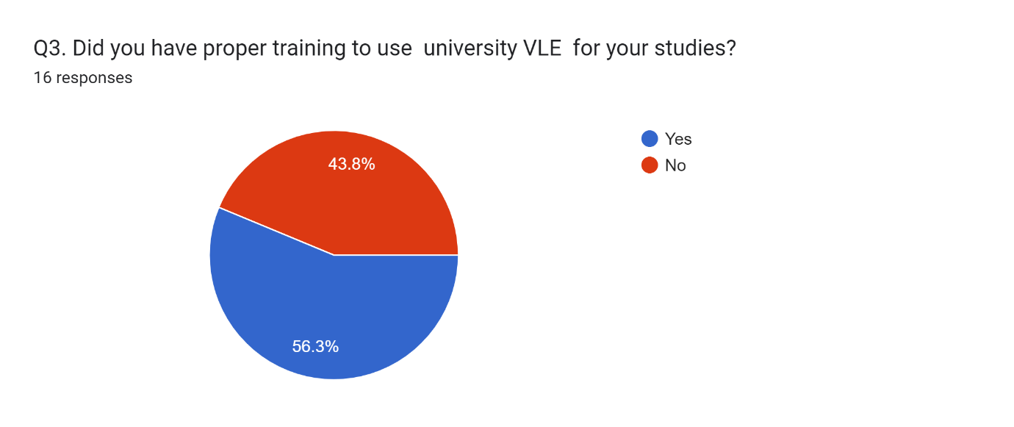
As shown above in question 3, over half the people had proper training too use VLE in their studies. The remainder of the people (43.8%) did not receive training. 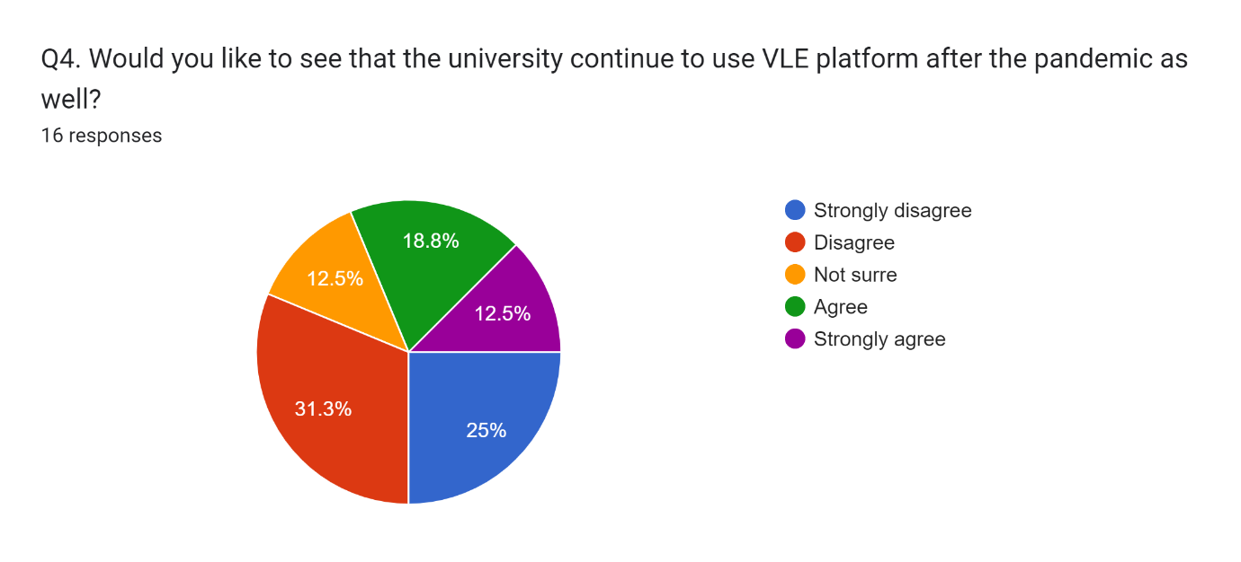
In question 4, a pie chart was used to show if students prefer to continue to use VLE after the pandemic. As you can see, majority of the people disagreed.
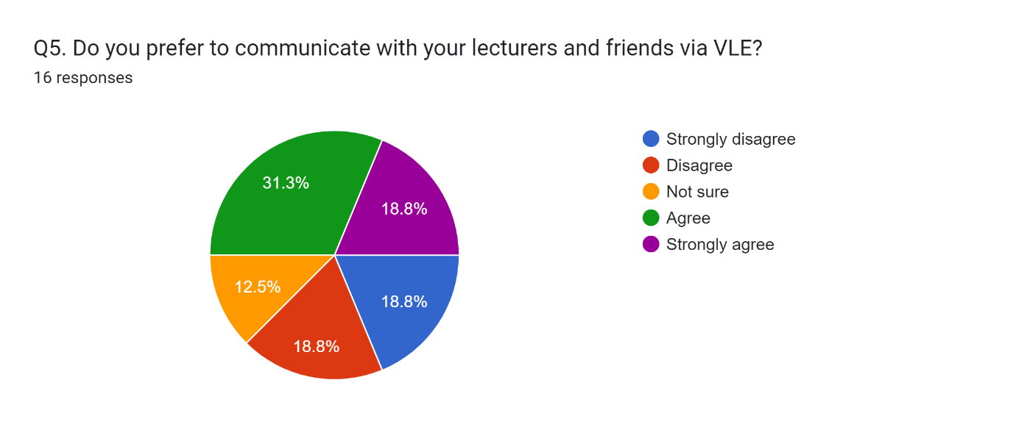
Question 5 shows a pie chart, explaining how many people prefer to communicate with their lecturers vie VLE. As you can see, majority of the people prefer to communicate through VLE.
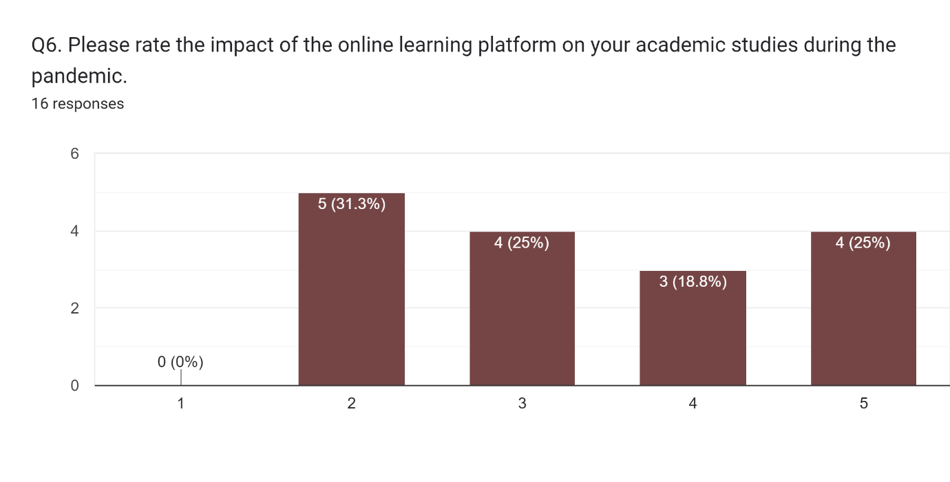
As shown above, students were asked to rate their impact of the online learning platform. 31.3% had a positive impact on their studies through VLE.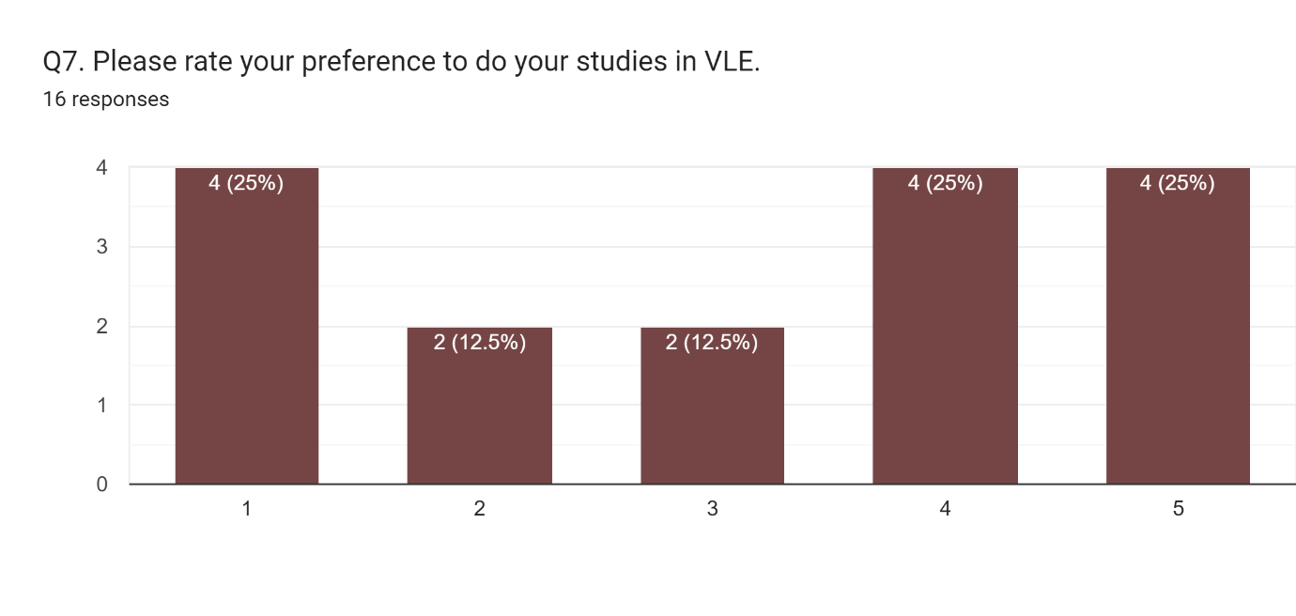
Shown here is a chart on whether students prefer too to do their studies via VLE. The results show that everybody’s opinions were mixed and there was not a majority result for this question.
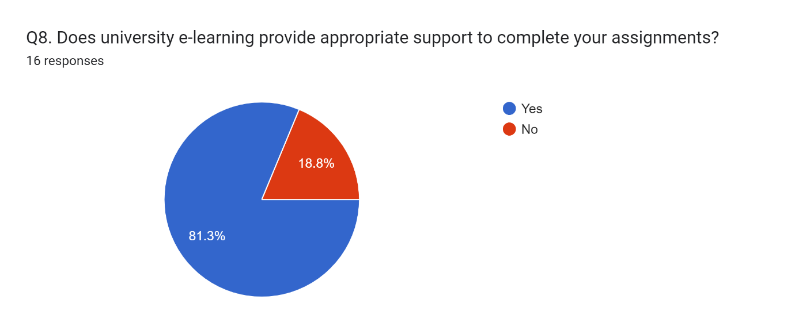
In question 8, students were asked if they think e-learning provides appropriate support to complete their assignments. Majority of the students agrees that is does. 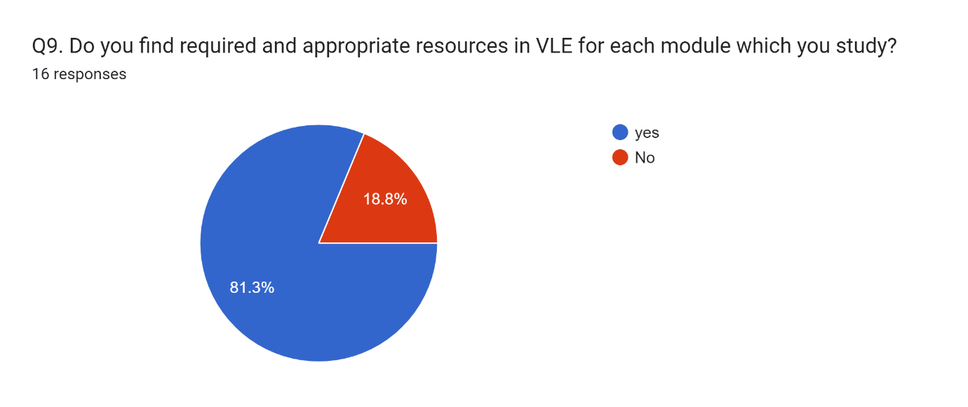
In this question, a pie chart was used to show if required and appropriate resources were easy to find. As you can see, majority of the student thinks that’s it is.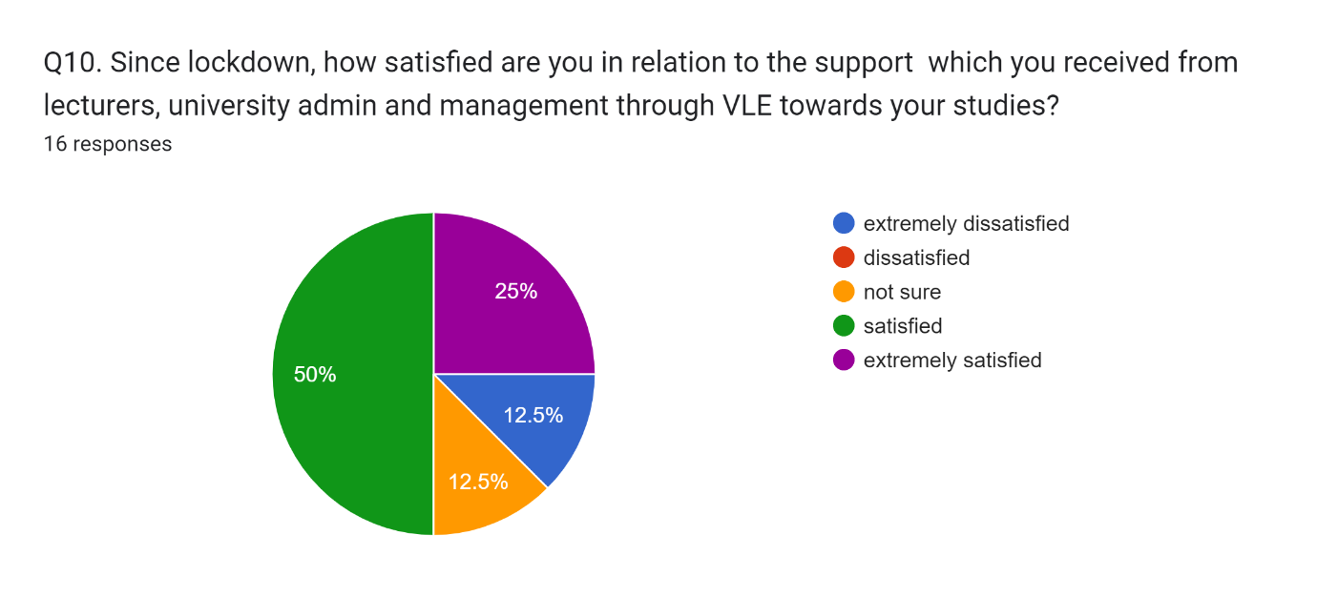
Finally, question 10 shows students’ opinions on how satisfied they was with VLE. The pie chart shows that majority were wither satisfied or extremely satisfied.

Discussion.

Overall, virtual learning has more of a positive impact then negative on students and teachers. During my research I realised that without VLE it would have been impossible for students to pass their assignments during the pandemic. The results of the questionnaire confirmed that over 60% of students had a positive impact from virtual learning.
However, I prefer face-to-face learning in the classroom instead of virtual learning. The reason for this is I find it easier to concentrate on my work and understand the assignments when I am in the classroom. Another reason is that I am easily distracted when learning from home.

Conclusion.

During this assignment I learnt how to create a questionnaire using google forms, how too screenshot and finally how too reference. Everything else that was taught during this assignment I was already familiar with.

References.

Melanie Arden (august 11, 2021) top benefits of virtual learning and its potential drawbacks. Top Benefits of Virtual Learning & Its Potential Drawbacks | Prodigy Education (prodigygame.com) (accessed 1st august 2022).

Sander Tamm (January 7, 2022) 10 biggest disadvantages of e-learning. 10 Biggest Disadvantages of E-Learning - E-Student (accessed 1st august 2022).

Ajidoku Lucky (May 7, 2020) Ten affordable devices for virtual learning. Ten (10) Affordable Devices for Virtual Learning (nigerianscholars.com) (accessed 2nd august 2022).

Ed Sattar (March 14, 2018) 4 common challenges faced by virtual instructors. 4 Common Challenges Faced By Virtual Instructors - Training Industry (accessed 2nd august 2022)

Veronica Racheva (November 29, 2017) what is virtual learning? What Is Virtual Learning? | VEDAMO (accessed 2nd august 2022).

Appendix (screenshots of my survey).



