Richard Jones - 1809132
rojones@gmail.com
PRograms in C and documentation
ACCA4017 – Gaynor Thomas

Abstract
The author will be producing documentation that will discuss and evidence the programming skills in C that the author covered during the academic and employability skills module. The document will break down several requested aspects of programming that were worked on during the semester and provide working solutions to multiple exercises.

Table of Contents
Abstract 1
Table of Contents 2
Introduction 1
1. Part C – Exercise (Implementation) 2
1.1 Implementation (Function Based) of a memory game. 2
1.1.1 Identifying the problem: 2
1.1.2 Annotated Code: 3
1.1.3 Testing: 7
1.2 Conclusion and Future Improvements. 11
1.2.1 Entering letters in the X or Y Co-ordinates of the program 11
1.2.2 Providing an outcome for an end game scenario without user input 11

Introduction
In this document the author will complete the PART C section of the assignment. The PART C section asks for an implementation of a memory game utilising functions as part of the overall solution. A clear explanation of the requirements along with an outline of the problem, the author will then provide annotated coding to demonstrate a working solution, along with testing documentation and further conclusions around the solution to the exercise that was set.

Part C – Exercise (Implementation)

Implementation (Function Based) of a memory game.

1.1.1 Identifying the problem:

- User is welcomed to the game and the last best score is displayed (file read)
- User is prompted to play the game Y for Yes or N for No (scanf)
- If user replies Y for yes, user prompted to enter X and Y Co-Ordinates (functions)
- If user selects a co-ordinates outside of the range they are asked to enter again
- First card is displayed (integer)
- User is prompted to enter X and Y Co-Ordinates for card two (function)
- If same card coordinates are entered user will be prompted to try again
- Second card is displayed (integer)
- If cards match user is informed cards match and current score (integer)
- If cards match both cards are taken out of the game
- User is prompted to have another go Y for Yes or N for No (scanf)
- If reply is Y for Yes steps 3-8 are repeated
- During Steps 3-8 Program will not allow duplicate cards to be selected
- If reply is N for No, user is shown their score and thanked for playing
- If current score beats best score, current score is now best score (File Write)

1.1.2 Annotated Code:
#include<stdio.h>
#include <stdlib.h>
#include <time.h>

int xcol(); //asks for x coordinate of grid and compares to 2D array
int yrow(); //asks for y coordinate of grid and compares to 2D array

void main()
{
char userreply; //Captures user reply
int disp[3][4] = { 1, 2, 3, 4, 5, 6, 1, 2, 3, 4, 5, 6 }; //Pre-Define the 2D Array
int row = 3, col = 4; //Setting the number of Rows and Columns
int i, j, k, l; //Integers for the for loops
int v, w, x, y; //Integers for the rows and columns for both cards
int temp, r1, r2, r3, r4; //random number for the for loop
int userscore = 0, userattempts = 0, bestuscore, bestuattempts, total1, total2; //Integers for the scores and best scores + totals to work out updating best score file
int low1 = 0, high1 = 2; //Integers for the rows random number generator
int low2 = 0, high2 = 3; //Integers for the columns random number generator
srand(time(NULL)); //Set the time for random number generator

FILE *fp;
fp = fopen("TopScore.txt", "r"); //Open the TopScore file to read

fscanf(fp, "%d", &bestuscore); //Read the file and set as bestuscore
fscanf(fp, "%d", &bestuattempts);//Read the file and set as bestuattempts

fclose(fp); //Close the file

for (i = 0;i < 10;i++) //For loop to shuffle the pre-defined array of numbers
{
r1 = rand() % (high1 - low1 + 1) + low1; //generate random number between 0 and 2
r2 = rand() % (high2 - low2 + 1) + low2; //generate random number between 0 and 3
r3 = rand() % (high1 - low1 + 1) + low1; //generate random number between 0 and 2
r4 = rand() % (high2 - low2 + 1) + low2; //generate random number between 0 and 3

temp = disp[r1][r2]; //Store the current row/column in temporary
disp[r1][r2] = disp[r3][r4]; //Set r1+r2 contents to be r1+r3 contents
disp[r3][r4] = temp; //Store the temp contents back to the r3+r4 content
}

for (k = 0; k < row; k++) //Prints the Random number table out to view for testing, will be commented out when the game is in production.
{
for (l = 0; l < col; l++) {
printf("%d ", disp[k][l]);
}
printf("\n");
}
printf("Welcome to the matching pairs game!! \n\n"); //Welcomes the user to the matching pairs game

printf("The best score so far was %d matched pairs in %d attempts", bestuscore, bestuattempts); //Displays the current best score

printf("\n\nWould you like to play the memory game? [Y] for Yes or [N] for No: "); //Asks the user if they would like to play the game
scanf(" %c", &userreply); //Captures users reply

while (userreply == 'y') //while loop to start the game if user replies with Y for Yes
{
v = xcol(); //requests x coordinate for 1st Card
w = yrow(); //requets y coordinate for 1st Card

while (disp[w][v] == 0)//while loop if card is out of the game already
{
printf("Sorry that card has already been used");
v = xcol(); //requests x coordinate for 1st Card if already taken
w = yrow(); //requets y coordinate for 1st Card if already taken

}

printf("\nFirst card is %d ", disp[w][v]); //searches 2D array and prints out the 1st card

x = xcol(); //requests x coordinate for 2nd Card
y = yrow(); //requets y coordinate for 2nd Card

while (disp[y][x] == 0 || (v == x && w == y))//while loop if card is out of the game already
{
printf("Sorry that card has already been used");
x = xcol(); //requests x coordinate for 2nd Card
y = yrow(); //requets y coordinate for 2nd Card
}

printf("\nSecond card is %d ", disp[y][x]); //searches 2D array and prints out the 1st card

if (disp[w][v] == disp[y][x]) //If cards match carry out action
{
userscore = userscore + 1; //Update userscore by 1
userattempts = userattempts + 1; //Update userattempts by 1
printf("\n\nCongratulations, those cards match,"); //Print Congratulate user on getting a match
disp[w][v] = 0; //Set cards to 0 to put them out of the game
disp[y][x] = 0; //Set cards to 0 to put them out of the game

}
else //If cards do not match then carry out action
{
userscore = userscore + 0; //Leave current userscore as it is
userattempts = userattempts + 1; //Update userattempts by 1
printf("\n\nSorry, no match this time,"); //Print sorry no match to the user
}
printf(" you have have %d matched pair in %d attempts", userscore, userattempts); //Print out current score
printf("\n\nwould you like to have another go? [Y] for Yes or [N] for No: "); //Ask user if they would like to play again
scanf(" %c", &userreply); //Capture user reply

}

total1 = userattempts - userscore; //Best current score
total2 = bestuattempts - bestuscore; //Best Score to date

if (total1 < total2 && userscore > bestuscore) //To update best score match both criteria
{
fp = fopen("TopScore.txt", "w"); //Open File

fprintf(fp, "%d ", userscore); //Save userscore to file
fprintf(fp, "%d", userattempts); //Save userattempts to file

fclose(fp); //Close File
}

printf("\n\nThank you for playing, Your score was %d matched pair in %d attempts\n\n", userscore, userattempts); //Print on exit, Thank user for playing and show their score
}

int xcol() //Function to capture X Column
{
int xcol; //Integer for the xcol

printf("\n\nPlease enter the X coordinate (column) [0 to 3]: ");//Ask user to enter an X Coordinate
scanf("%d", &xcol); //Capture user reply
if (xcol < 0 || xcol > 3)
{
printf("The number you have entered is outside of the grid");
printf("\n\nPlease enter the X coordinate (column) [0 to 3]: ");//Ask user to enter an X Coordinate
scanf("%d", &xcol); //Capture user reply
}

return xcol; //Return the integer

}
int yrow() //Function to capture Y Column
{
int yrow; //Integer for the yrow

printf("Please enter Y coordinate (row): [0 to 2]: ");//Ask user to enter an Y Coordinate
scanf("%d", &yrow);//Capture user reply
if (yrow < 0 || yrow > 2)
{
printf("The number you have entered is outside of the grid");
printf("\n\nPlease enter Y coordinate (row): [0 to 2]: ");//Ask user to enter an Y Coordinate
scanf("%d", &yrow);//Capture user reply
}

return yrow;//Return the integer

}

- Additional file needs to be created (which is referenced in the code to open and write as necessary. This file has two numbers contained in it, the first number is the number of matches and the second is the number of attempts. When starting the code, the file is set to 0 1000 (0 Matches in 1000 attempts) this then allows for the file to be overwritten subsequent attempts.

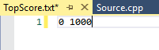

1.1.3 Testing:
- Test of code with expected entries (no user duplicated entries), two attempts with one match.
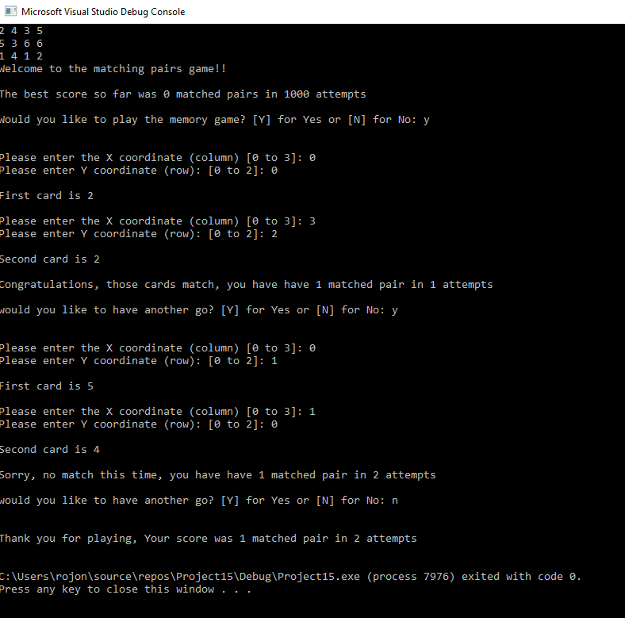

Result: Program ran as expected, user entered four sets of card locations (2 attempts at matching) with one set being a match, user then selected N for no further attempts and score was displayed and logged in TopScore.txt (Success)

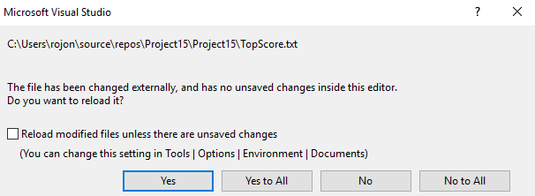
- Test of code with attempts to enter same card on the 1st set of matching attempts.
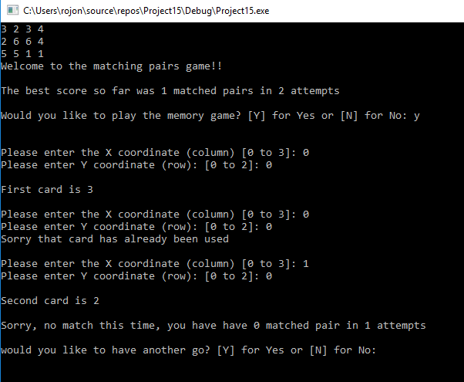

Result: User entered first card coordinates (0,0) then on the second card to match incorrectly selected (0,0) again. The program notifies the user that the card has already been used and prompts user to select another card (Success)

- Test of code with attempts to use both matched cards (Pair) on the second attempt at matching another pair.
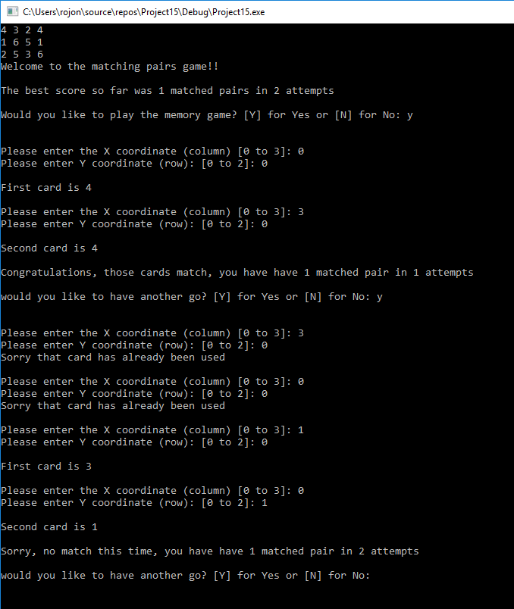

Result: On the first attempt at matching the user inputs cards (3,0) and (0,0) The cards matched and are therefore out of the game. When the user then attempts to user same cards on their second attempt, both times the user I told the cards are out of the game and given another attempt to pick a card (Success)

- Test of code when numbers outside of the requested X,Y axis are selected.
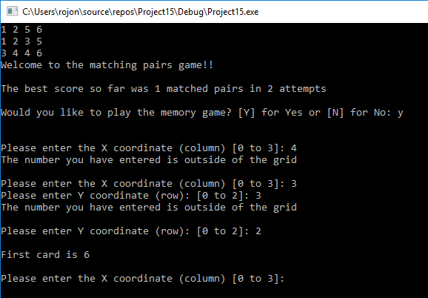

Result: When numbers outside of the pre-defined X (Column) or Y (Row) are selected the program will inform the user that they are outside of the grid and prompt the user to re-enter a correct entry (Success)

- Test of code when letters are entered in coordinate fields rather than numbers in the X Coordinate.
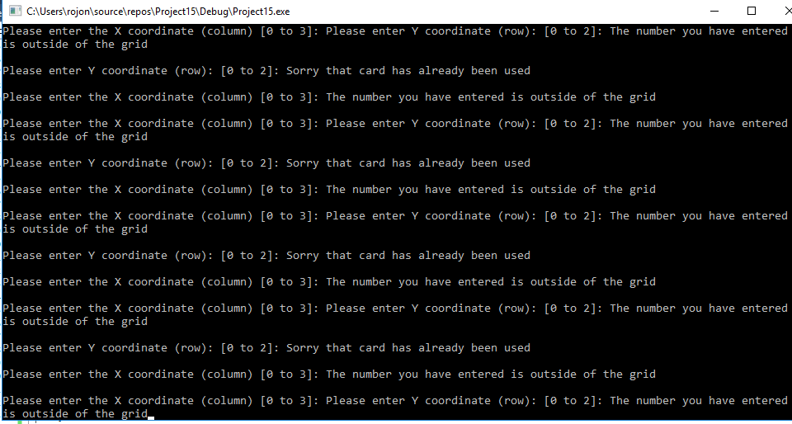

Result: The program runs in a loop constantly asking for entry without user being able to intervene (Failed)
- Test of code when letters are entered in coordinate fields rather than numbers in the Y Coordinate.
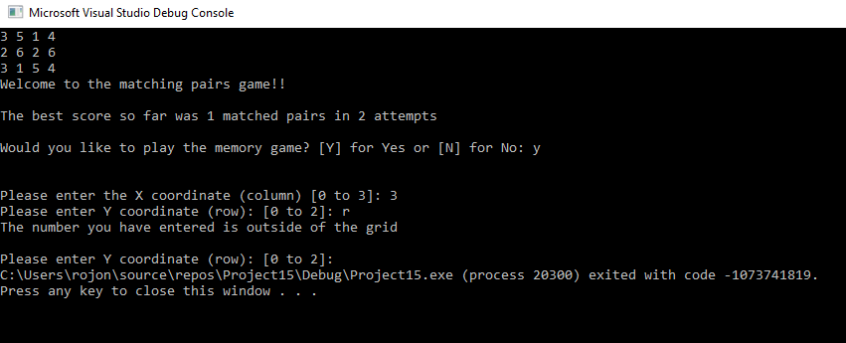

Result: The program accepts the correctly entered X Coordinate, then when a letter is entered in the Y coordinate the program exits with an error code (Failed)

Conclusion and Future Improvements.
In Conclusion the above code and testing has demonstrated that the functionality of the memory game works as detailed in the introduction. While there are areas that the author can look at for future improvements that were demonstrated in the testing.

Entering letters in the X or Y Co-ordinates of the program
The author would need to look at adding the ability to prevent the end user from entering characters when prompted for the X and Y axis and the looping back the prompt to allow the user to enter the correct values.

Providing an outcome for an end game scenario without user input
The author would need to look at adding the functionality to allow for the user to have a successful game outcome without having to end the game themselves. For example, when user correctly guess 6 matches out of however many attempts (all pairs are now matched) and therefore the game is complete, and no further attempts needed. Currently the game would simply loop telling the user the cards are all out of the game. To remedy this the code shown below would need to be inputted before the “Total” calculations are worked out for the user score at the end of the program.

if (userscore != 6)
{
printf(" you have have %d matched pair in %d attempts", userscore, userattempts); //Print out current score
printf("\n\nwould you like to have another go? [Y] for Yes or [N] for No: "); //Ask user if they would like to play again
scanf(" %c", &userreply); //Capture user reply
}
else
{
printf(" Well done you have matched all the pairs"); //Confirms to the user that the maximum matched pairs has been achieved and ends the game
userreply = 'N'; //pre-populate the user reply to continue to end the game. }

The following screen shot confirms the above code working as expected once implemented. The user in this instance had 6 correct matches in 6 attempts and therefore no more matches are available. The same outcome would happen once 6 matches are recorded regardless of attempts.


