2/16/2026
University of Wales Trinity Saint David
London campus
E-Portfolio Link:
Module Name: Learning In the Digital Era
Module Code: ACCA 4025

Student Name:Ullubiy Zairbekov
Student ID:2528745
Group: 1

Lecturer’s Name: Koushik Modak

LDE Assignment 1
E-Portfolio
Table of Contents
Introduction 2
Main Body 2
Task 1: Essential Academic and Employment Skills for the future career Path 2
Task 1 (a): Report on Essential Academic and Employment Skills 2
Task 1 (b): Evaluation of Task 1 (a) based on Similarity report 2
Task 2: Collaborative Mind Map and Individual Poster 2
Mind Map (Collaborative) 2
Poster (Individual) 2
Task 3: Virtual Collaboration and RefWorks 2
Report on Virtual Collaboration 2
Step-by-step process of using RefWorks with visuals 2
Task 4: E-Portfolio Creation and Evaluation 2
Task 4 (a): E-Portfolio Creation 2
Task 4 (b): Illustrative Review of E-Portfolio tool Selection 2
Conclusion 2
References 2
Task 1 References: 2
Task 3 References: 2

Introduction

Main Body

Task 1: Essential Academic and Employment Skills for the future career Path

Task 1 (a): Report on Essential Academic and Employment Skills
Essential Academic and Employment Skills are the key abilities that help people succeed both in education and in the workplace. These skills are important for students, graduates, and professionals in any field.
Communication Skills
Good communication is one of the most important skills. It includes speaking clearly, writing well, listening carefully, and understanding others. In academic life, students must write essays, give presentations, and participate in discussions. At work, employees communicate with managers, colleagues, and clients. Strong communication helps avoid misunderstandings and build good relationships.
Time Management
Managing time effectively means planning tasks and completing them before deadlines. Students need this skill to balance classes, assignments, and exams. Employees use time management to handle multiple responsibilities and meet targets. Good planning reduces stress and increases productivity.
Critical Thinking and Problem Solving
Critical thinking helps people analyse information and make logical decisions. In university, students must evaluate sources and develop arguments. In the workplace, problem-solving helps employees find solutions quickly and efficiently. Employers value people who can think independently.
Teamwork
Both academic and professional environments require teamwork. Students often work on group projects, while employees collaborate with different departments. Being respectful, flexible, and supportive makes teamwork successful.
Digital Skills
Today, technology is essential in education and employment. Students use online learning platforms and research tools. Workers use emails, software programs, and digital systems daily. Basic computer skills and the ability to learn new technologies are very important.
Adaptability
The world is constantly changing. New technologies, new systems, and new challenges appear every day. Adaptability means being open to change and willing to learn new skills. This quality helps individuals stay competitive in both academic and professional life.
Conclusion
Essential academic and employment skills are not only about knowledge but also about personal abilities and attitudes. Communication, time management, critical thinking, teamwork, digital literacy, and adaptability prepare individuals for success in education and future careers. Developing these skills early can lead to long-term achievement and professional growth. Transferable Skills-Skills are applicable across various industries and roles.
Professionalism and strong work ethic: There is one thing every employer has in common. They want their employees to have a strong work ethic and be professional. No matter what job or career you find yourself in after graduation, your employer will expect you to have a strong professionalism and work ethic. Some of these tasks may include finishing your work in an efficient and timely manner.
[1, pp. 3,4], [2, pp. 3,4], [3, pp. 3,4], [4, pp. 3,4], [5, pp. 3,4], [6, pp. 3,4], [7, pp. 3,4]
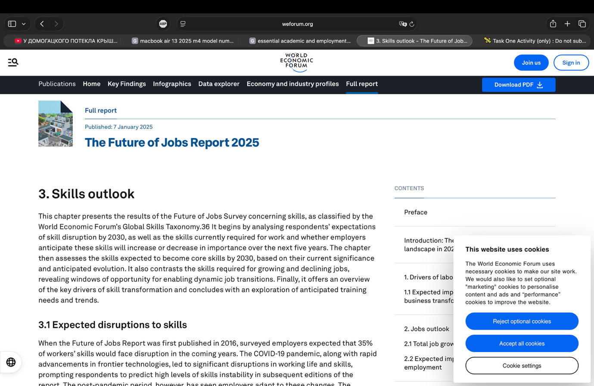 [8]

Works Cited

[1] | C. GPT. [Online].
[2] | “NFER,” [Online]. Available: https://www.nfer.ac.uk/key-topics-expertise/education-to-employment/the-skills-imperative-2035/#:~:text=The%20Skills%20Imperative%202035%20project%20is%20a,in%20declining%20occupations%20could%20disappear%20by%202035.

Bibliography

[1] | C. GPT. [Online].
[2] | “NFER,” [Online]. Available: https://www.nfer.ac.uk/key-topics-expertise/education-to-employment/the-skills-imperative-2035/#:~:text=The%20Skills%20Imperative%202035%20project%20is%20a,in%20declining%20occupations%20could%20disappear%20by%202035.

Task 1 (b): Evaluation of Task 1 (a) based on Similarity report

Task 2: Collaborative Mind Map and Individual Poster

Mind Map (Collaborative)

Poster (Individual)

Task 3: Virtual Collaboration and RefWorks

Report on Virtual Collaboration
Put your Chosen topic here

Step-by-step process of using RefWorks with visuals

Task 4: E-Portfolio Creation and Evaluation

Task 4 (a): E-Portfolio Creation

Task 4 (b): Illustrative Review of E-Portfolio tool Selection

Conclusion

References

Task 1 References:

Task 3 References:

