Lecturer: Kathryn Flynn
Student name: Victor Badaluta Student id: 2212187
Assessment Component 1
Module Number: BMIH6007
Module Name: International Meetings Management for the Hotel Industry
Autumn Term 2024

Table of Contents
1. Slide 2: Introduction 3
2. Slide 3: Event Overview 3
3. Slide 4: Market Factors 4
4. Slide 5: Financial Factors 5
5. Slide 6: Operational Factors 6
6. Slide 7: Justification for Feasibility 7
7. Slide 8: Tools for Receiving Feedback and Participants Engagement 8
8. Slide 9: Challenges and Opportunities 9
9. Slide 10: Conclusion 10
10. References 12

Slide 2: Introduction
The goal of the Winter Wellness Summit is to host an event that improves the mental and physical health of attendees. The main aim of this winter wellness summit is to focus on mindfulness, mental health and physical well-being during winter season. This summit will be held for three days which is specifically targeting professionals in the hospitality businesses (Al-Alawi et al., 2021). This event will be held in the University Wales Trinity Saint David. The goals of this event are to encourage easy to reach wellness methods. This helps in boosting involvement with interactive resources (Thomas, 2024). This summit is a must attend for the individuals who are conscious about their well-being and health.
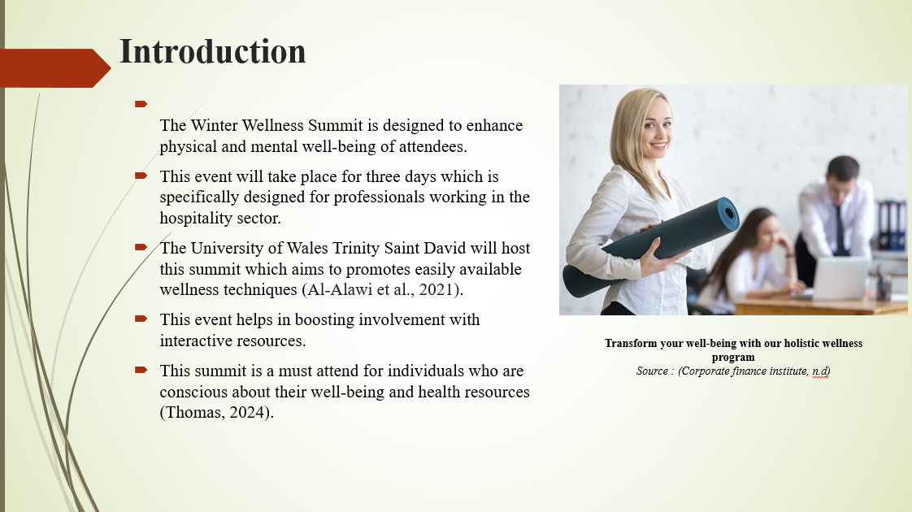

Slide 3: Event Overview
This summit will consist of a variety of discussions presented by various health experts and business executives. These experts will provide guidance related to mental and physical well-being during winters. This event is created to support relaxation, mental health and wellness for professionals in stressful industries like hospitality (Ashton and Klinhom, 2020). Sometimes workers may face several challenges related to their mental health because of the work pressure which heightened the level of frustration (Berry et al., 2020). This event will cover the multiple topics such as self-care, workforce well-being and mindfulness practices. Individuals who will attend this summit will figure out on how to include mental well-being as a significant part of their everyday life (Dowd, 2024). This summit will also consist of mindfulness sessions and nature walks. Workout, meditation and yoga sessions are essential part of this summit. This summit will be supervised by expert instructors.
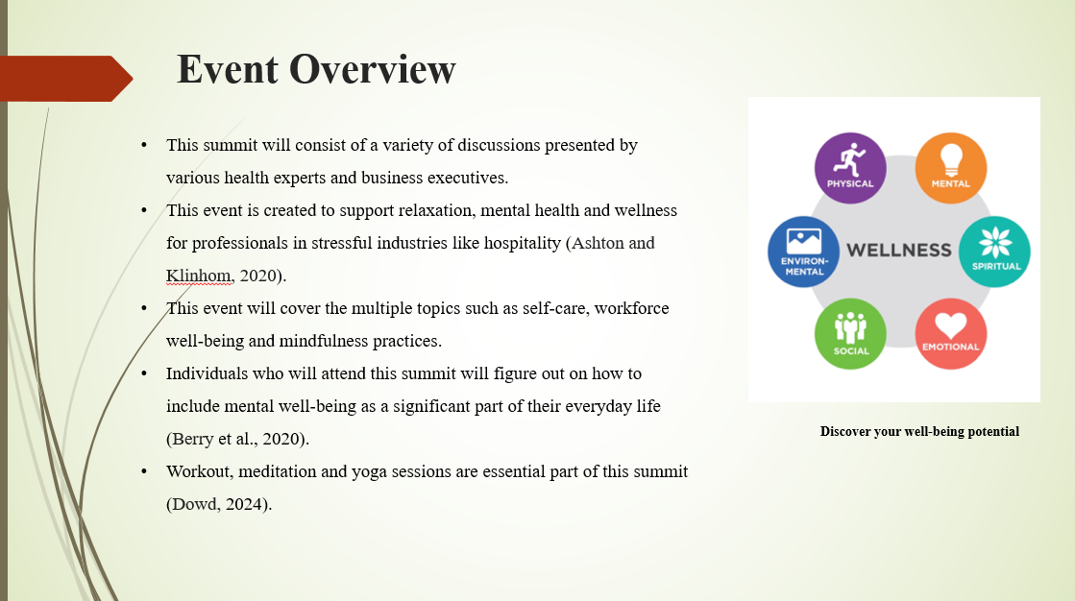

Slide 4: Market Factors
The main focus of the Winter Wellness Summit is on business professionals in stressful fields like finance, healthcare, and hospitality. Furthermore, those in the hospitality industry looking to improve their work-life balance will be drawn to this summit as they manage the difficulties of their intense jobs (Fink et al., 2020). Post-pandemic, there has been a significant increase in the need for wellness options as people are now placing more importance on both their mental and physical well-being. Many workers are searching for easy-to-use wellness solutions to reduce stress and enhance their general well-being (Gordon and Lehto, 2024).
The program targets the increasing desire for unique well-being and health choices that can meet demanding deadline. In the hotel and business sectors, this enables the Winter Wellness Summit to stand out as a flexible and alluring option. Specific tactics for marketing will be employed by the event to successfully interact with the target audience (Jones, 2024). In order to draw those looking for a holistic approach to wellbeing, partnerships with celebrities and wellness applications will boost visibility and reputation.
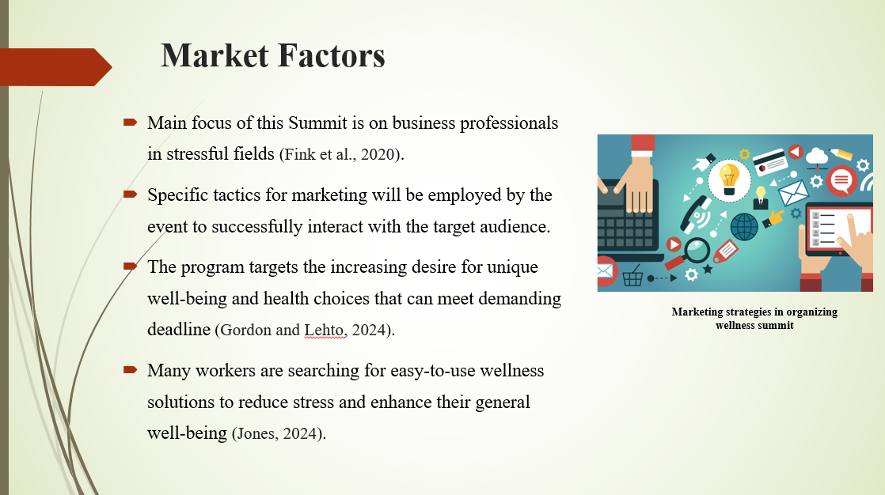

Slide 5: Financial Factors
The Winter Wellness Summit is projected to cost £30,000, including setup and maintenance at £10,000, expert fees of £12,000, marketing expenses of £5,000, and miscellaneous costs of £3,000 (Tish, 2023). Revenue from purchases and access to premium content is anticipated to reach £5,000, while sponsorship from wellness brands and businesses is estimated to bring in £15,000 and £40,000, respectively, to fund this conference (Varga et al., 2020). Company sponsorships and wellness companies will be the primary sources of funding for the event. This confirms that strong financial foundations are ensured (Torres and Zhang, 2021).
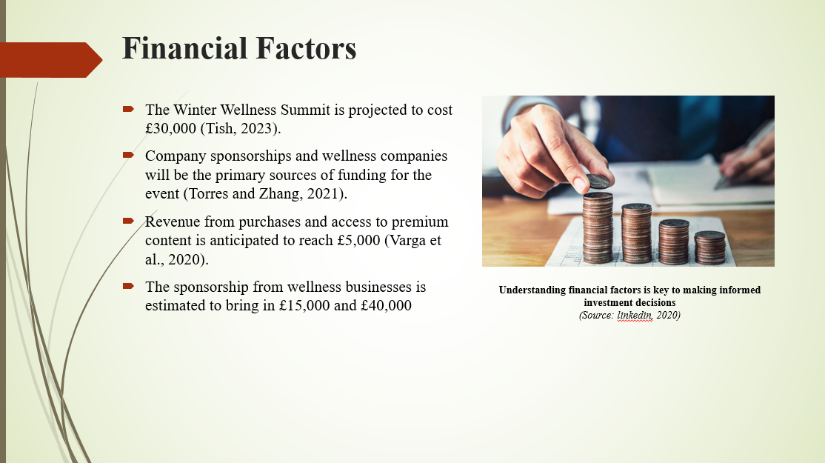

Slide 6: Operational Factors
Successful marketing tactics involve social media platforms and collaborating with several health experts. The Winter Wellness Summit is based on various operational factors which will provide a smooth experience for attendees. It is important to select the appropriate venue at the University Wales Trinity Saint David for this summit. Proper way of handling logistics is essential in a success of this event. It is important to arrange transportation, catering, audio and visual tools to guarantee smooth operations (Rahmani et al., 2024). By involving participants in several networking prospects such as taking feedback and workshops will provide a positive culture. This summit will be organized by expert staff, fitness coaches and various health experts for offering thorough understanding related to mental and physical well-being (Taylor and Ray, 2023).
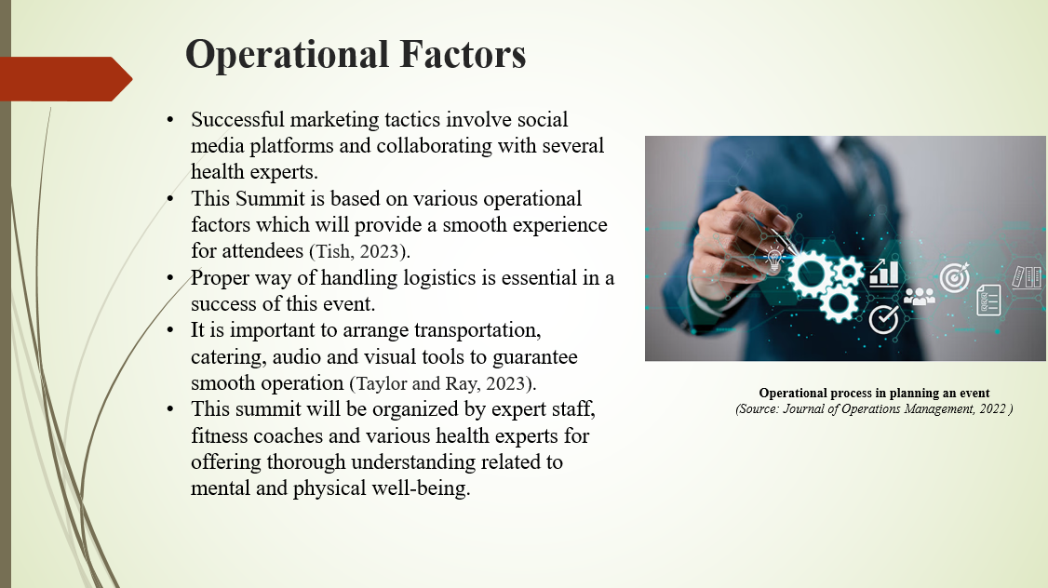

Slide 7: Justification for Feasibility
In recent times people are more aware about the role of physical and mental well-being in their everyday routine. When healthier workers produce better work and more corporate success, the return on investment is clear (Skoumpi et al., 2021). Nowadays, businesses consider the wellness sector to be quite important, particularly those in the hotel and corporate environments. Employers who want to retain their workforce and reduce attrition must implement wellness initiatives. The venue of this summit will make it easier for the individuals to attend this event. However, proper financial planning is also helpful in making this event successful (Siggers, 2022). This summit will also provide a positive influence among several groups in order to foster a knowledge related to mental well-being.
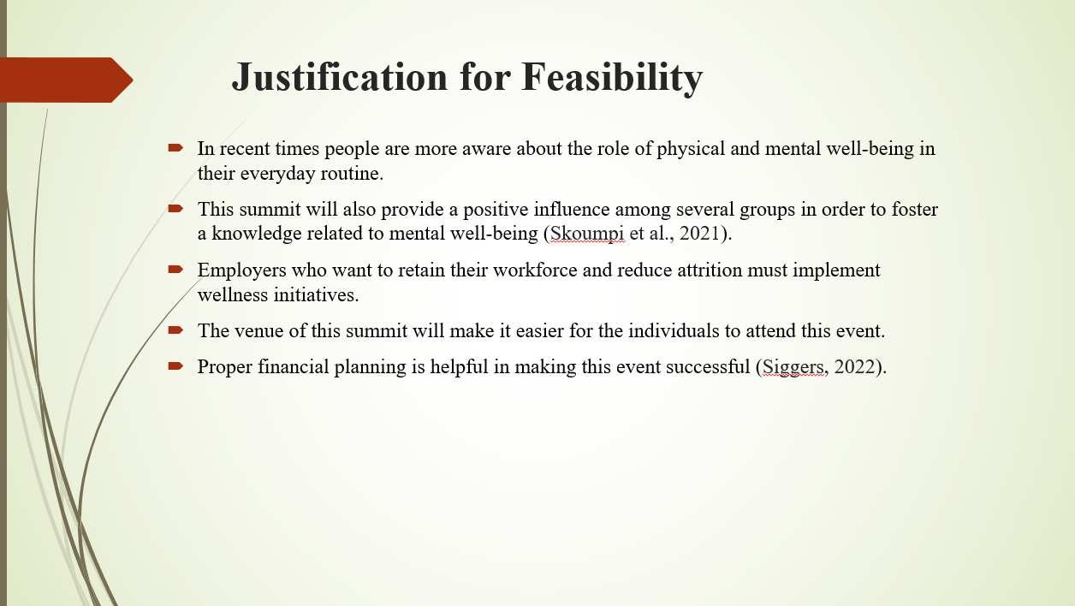

Slide 8: Tools for Receiving Feedback and Participants Engagement
In order to make sure that the Winter Wellness Summit are aligned with the requirements of participants. Multiple tools can be utilized in order to collect participant feedbacks and reviews regarding the summit (Schneiderhan et al., 2023). It is important to take feedbacks from the participants involved in this summit. This can be done by establishing a survey form for collecting feedbacks after the event (Morris et al., 2021). In order to engage participants, various polling tools can be utilized. This thing will increase interaction of participants by answering polls on their smart phones. By making several social media platforms and hashtags enable members to share their experience (Sawchuk et al., 2020). More than that, feedbacks of participants can also be collected through conducting a focus group discussion. This is the best way to gather their feedbacks regarding their experiences.
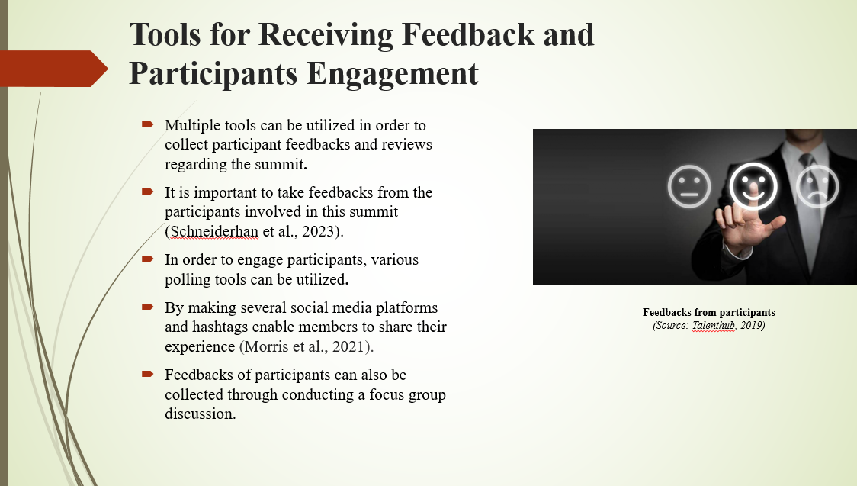

Slide 9: Challenges and Opportunities
This summit will provide various benefits but it has various challenges as well. These challenges include logistics issues, economic downturns and health and safety problems. Economic factors can result in decreased funding for wellness summit. This also has an impact on the rate of participation (Lonhart, 2020). Planning a big event can arise several logistics problems incorporating availability of venue, catering and technical issues. Moreover, maintaining interest of attendees during the summit can be a problem. It is important keep attendees engaged throughout the event. This enables a wider reach in the market and greater recognition of the business (Kumar, et al., 2023). The summit allows for adaptable involvement of participants. Moreover, utilizing various feedback tools will provide special chance to grasp participant behavior, session popularity, and engagement patterns, allowing for the enhancement and customization of future wellness summits, ultimately increasing their effectiveness (Khwaja, 2021)
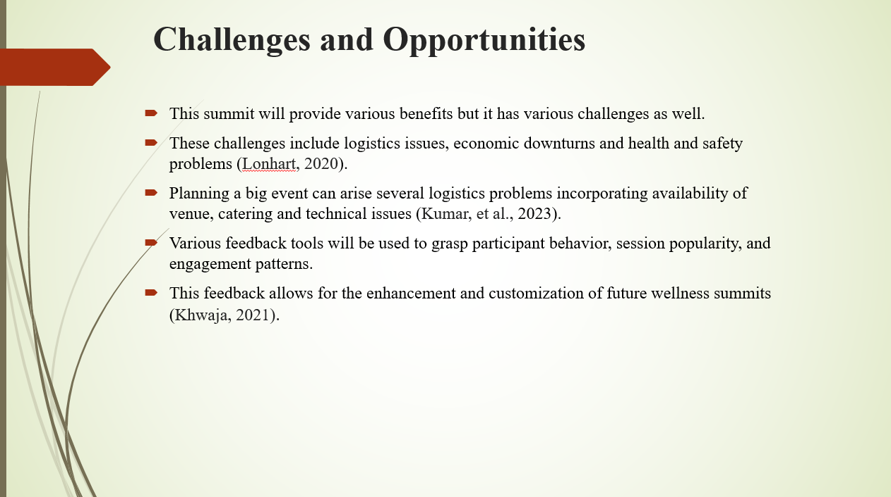

Slide 10: Conclusion
This Winter Wellness Summit is organized to benefit individuals who more concentrate on the physical and mental well-being. At the same time, several challenges can be arise with that like health and budget concerns as well as logistic problems. However, multiple solutions are available in order to tackle these challenges. Furthermore, by integrating several activities in this summit, there is a chance to appeal more people towards this event. These activities incorporate workout sessions, nature walk, spa sessions, mediation and yoga sessions. This summit will include collaborating with several local and health communities which foster a strong support for this summit.
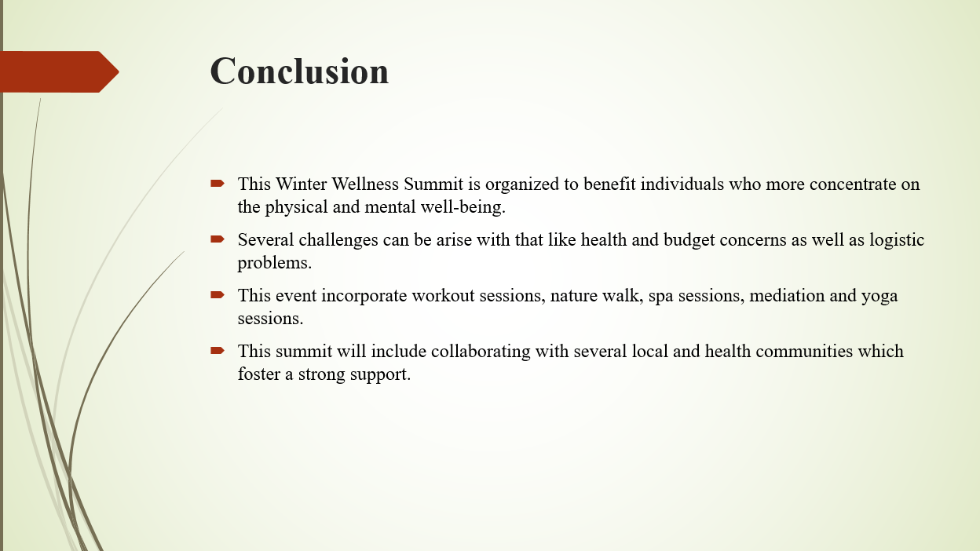

References
Al-Alawi, A.I., Al Mahamid, S.M. and Baloshi, M.B., 2021. Factors associated with participation in a corporate wellness program: The case of international hospitality company. Jurnal Pengurusan, 62, pp.65-80.
Ashton, A.S. and Klinhom, C., 2020. Wellness tourism development in the hotel industry: Tourist perspective. Journal of Tourism Quarterly, 2(3-4), pp.54-66.
Berry, L., Mirabito, A.M. and Baun, W.B., 2020. What's the hard return on employee wellness programs? (pp. 2012-2068). SSRN.
Dimitrova, B., WELVET SURVEY ON STATUS OF EU HEALTH AND WELLNESS TOURISM. RECREATION, WELLNESS INDUSTRY AND NICHE TOURISM, p.6.
Dowd, M., 2024. CREATING A CULTURE OF HIGH-LEVEL WELLNESS TO COMBAT THE COLLEGE MENTAL HEALTH CRISIS (Doctoral dissertation, University of Pennsylvania).
Fink, J., Zabawa, B. and Chopp, S., 2020. Employee perceptions of wellness programs and incentives. American Journal of Health Promotion, 34(3), pp.257-260.
Gordon, S.E. and Lehto, X., 2024. Healthy hotels: contribution of employee wellness programs. In A Research Agenda for Tourism and Wellbeing (pp. 57-76). Edward Elgar Publishing.
Jones, P., 2024. Wellness in the Global Hospitality and Tourism Industry. Athens Journal of Tourism, p.225.
Khwaja, M., 2021. Navigating the winter blues. BDJ In Practice, 34(12), pp.18-20.
Kumar, J., Nazir, F. and Nisar, Q.A., 2023. Empowering wellness worldwide: A critical analysis of the Global Wellness Institute (GWI) journey 2014-2021. Revista Turismo & Desenvolvimento (RT&D)/Journal of Tourism & Development, (41).
Lonhart, M.C., 2020. Motivation Matters: Wellness in the workplace (Doctoral dissertation, University of Oregon).
Morris, S.L., Newhouse, I., Larocque, T., Gillis, K.J., Smith, L. and Nisbet, E.K., 2021. Becoming one with nature: a nature intervention for individuals living with cancer participating in a ten-week group exercise and wellness program. International Journal of Exercise Science, 14(3), p.498.
Sawchuk, C.N., Russo, J., Ferguson, G., Williamson, J., Sabin, J., Goldberg, J., Madesclaire, O., Bogucki, O. and Buchwald, D., 2020. Barriers and bridges to implementing a workplace wellness project in Alaska. Rural and Remote Health, 20(3), pp.1-6.
Schneiderhan, J., Bishop, T., Guetterman, T.C. and Dobson, M., 2023. Faculty and Resident Perspectives of the Complexity of Wellness Program Implementation: A Qualitative Exploration. PRiMER: Peer-Reviewed Reports in Medical Education Research, 7.
Siggers, B., 2022. Promoting Wellness in Underserved Communities: Issues, Design Guidelines, and Programming (Master's thesis, Tufts University).
Skoumpi, M., Tsartas, P., Sarantakou, E. and Pagoni, M., 2021, June. Wellness tourism resorts: A case study of an emerging segment of tourism sector in Greece. In Culture and Tourism in a Smart, Globalized, and Sustainable World: 7th International Conference of IACuDiT, Hydra, Greece, 2020 (pp. 477-495). Cham: Springer International Publishing.
Taylor, Z.W. and Ray, S., 2023. 2023 Survey of Financial Wellness Programs in Higher Education. Higher Education Financial Wellness Alliance (HEFWA).
Tish, L.A., 2023. ACSM and IDEA Health & Fitness Association Join Forces for A Game-Changing Winter 2024 Fitness Professional Conference. ACSM's Health & Fitness Journal, 27(6), p.3.
Torres, E.N. and Zhang, T., 2021. The impact of wearable devices on employee wellness programs: A study of hotel industry workers. International Journal of Hospitality Management, 93, p.102769.
Varga, S., Mistry, T.G., Ali, F. and Cobanoglu, C., 2021. Employee perceptions of wellness programs in the hospitality industry. International Journal of Contemporary Hospitality Management, 33(10), pp.3331-3354.

