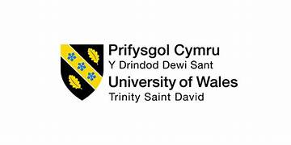

“Are we there yet?” –
Exploring gender parity and gender representation in the UK Police workforce.

Alison Cooke
Student No 2134539

(word count - …….)

A b s t r a c t

The 2026 workforce data for policing in England and Wales shows that 36.8% of police officers are female; representing the highest number and proportion of female officers since records began in 2003. Yet despite this success, some allege that progress remains slow, with policing ‘still too far away from their goal of ensuring that women officers are proportionately represented at all levels of policing’ in the UK. This study employed a cross-sectional quantitative methodology to explore gender parity and representation within policing utilising a published secondary data set of workforce statistics. Having undertaken both descriptive and inferential statistical analysis, the research findings suggest that there is no significant statistical difference in the gender balance within the workforce, its rank structure, promotion outcomes or those leaving the organisation which is contrary to the picture depicted by the workforce statistics. However, it does point to a significant statistical difference amongst the gender of senior leadership which is supported in previous research and the workforce statistics. The research concludes by arguing that despite numerical representation placing UK policing on the road to a representative workforce and highlighting areas of gender disparity for future action, the lack of defined ‘appropriate representation’ may question if gender parity is a journey that will never reach its ultimate destination.

Key words:
Gender, Gender Parity, Gender Equality,
Policing, Female police officers, Women in policing

- I n t r o d u c t i o n

The 2026 UK workforce data for policing in England and Wales shows that 36.8% of police officers are female; representing the highest number and proportion of female officers since records began (Gov.uk, 2026). Twenty years earlier, Silvestri, in her 2006 study, highlighted that the ‘glass ceiling’ in policing had been broken with the appointment of the first UK female chief officer, adding that ‘theoretically there was now no acceptable rationale why women could not achieve parity with their male colleagues in every facet of policing’ (2006, p.266, Cooke, 2025, p12). In celebrating 100 years of women in UK Policing, the Metropolitan Police claimed that ‘there truly are no limits’ in terms of women’s potential career successes within current day policing (Met Police, 2026; Charman, 2024 p.399), with some contemporary academics declaring that the increasing number of women across policing in England and Wales is testament to these claims (Charman, 2024, p.399). However, more recently, despite recognised achievements, some allege that progress remains slow, with policing ‘still too far away from their goal of ensuring that women officers are proportionately represented at all levels of policing’ in the UK (HeForShe, 2025; p.4). Others suggest that at the current rate of progress it will take another twenty years for policing in England and Wales to achieve a representative workforce in terms of gender (i.e. 50%) (Price et al 2026, p.25 cites Police Foundation, 2022), thereby providing support for Silvestri’s (2006, p.266) assertion that it is too premature for researchers to declare the end of policing ‘patriarchy’.
Despite notable statistical success in women’s growth within policing, and their progression amongst its rank structure, there remains a gap in establishing what true gender parity or representation looks like in UK policing. It is against this backdrop, that this quantitative study utilises secondary data only to explore whether UK Policing, has arrived at its destination, or is on the correct trajectory of achieving a truly gender representative service in 2026.
The next section of this paper presents a literature review that explores existing research and policy on women’s equality position within policing both in the UK and globally. The literature review is then followed by an overview of the methodology employed highlighting limitations to the data and its interpretation. Subsequent sections then present the findings and discussion of the study before concluding by addressing the research question posed and suggesting areas of further research.

- L i t e r a t u r e R e v i e w.

2.1 Gender
Gender, according to Gregor (2025, p12), has ‘diverse implications when women police the public’ as society identifies and labels policing as a male orientated profession. However, given its ‘diverse implications’, gender persists as a ‘fundamental characteristic’ that manipulates every component of policing for women. Huff et al (2024) emphasise the need for gender-responsive policing which acknowledges the integration of women into policing as being transformative, resulting in healthier organisations and improved service provided to the public. Research further demonstrates that women in policing come with many benefits at individual, institutional and societal levels, where women’s inclusion has contributed to reductions in gender bias and increased police integrity both locally and globally (Price et al., 2026, p.25), with Strobl (2020, p.102) advocating that globally the short term ‘resource benefits’ of women in policing needs to be strongly emphasised even before the attainment of gender balance is achieved.
2.2. Global workforce
In 2026, it is reported that women comprise of 44% of the global workforce but hold only 31% of leadership roles around the world (Global Woman Leader, 2026), thereby underlining a continued hiatus between women’s participation and women’s representation. However, despite some evidenced advancement, the representation of women remains low and below 50% globally (United Nations, 2024, p.30) with the United Nations reporting that the global commitment to realising gender equality by 2030 ‘remains a distant objective’ (2024, p.10). Increasing female leadership numbers and ‘investing in gender equality’ are seen by the UN as being fundamental at ‘national, regional, and global levels’ (2024, p2-6). Lara and Baird (2025) suggest that over the past decade women’s representation within leadership roles globally has grown, however since 2022, progress has slowed significantly with a dip in growth in 2024 coinciding with a downturn in labour market conditions which had a negative impact on women seeking leadership positions (2025, p.2). In mitigation, some argue that women’s reduced visibility amongst leadership positions and their omission from decision making roles are also disproportionately affected by discrimination within employment (Cooke, 2025: A4AID, 2022). The organisation Advocates for International Development (A4ID) propose that such inequality and discrimination occur as a by-product of traditional and ‘often institutionalised beliefs, behaviours and culture which emerge at personal, societal, institutional, and political levels’ (A4ID, 2022, p.iii) – an argument that is claimed to exemplify the current UK policing landscape (Cooke, 2025).
2.3 Global Landscape of Policing
Within the global landscape of women in policing, England and Wales appear to be numerically at the forefront with regards to the representation of women within the service in comparison to other countries; and are deemed to be above the international averages (Charman, 2024, p.399-400). The global picture, according to Bailey et al (2025, p.1296), emphasises how ‘macro-level and embedded cultural issues’ may, in many countries, regard policing as a ‘difficult environment’ in which women face challenges in relation to engagement and progression, with others claiming that previous studies on progression barriers for women has only ‘scratched the surface of the problem’, supporting this with a call for further research to be undertaken (Bailey et al, 2025, p.1297). In the past decade, it is claimed that UK policing has consistently reported high numbers of female officers in comparison to some other international countries (Gov.uk, 2026, Charman, 2024), however current literature fails to establish the detail of how this has been achieved (Price et al, 2026, p.24) in order to share best practice. UK policing is the only police service in the world to join the HeForShe movement with its focus on gender equality and good practice for an inclusive workplace (Charman, 2024, p400). In 2019, authors of the HeForShe report indicated that the representation of women at senior levels ‘is the most obvious means of showing the imbalance of power between men and women in police forces across the UK (2019, p11).
2.4. Women’s Career Experiences in UK Policing
An awareness and understanding of women’s career experiences in policing has rapidly accelerated across the globe, yet despite the emergence of this critical body of research and new knowledge, women officers are habitually presented as an ‘homogenous group’ (Silvestri et al, 2023). Academics will argue that some evolution has been made with ‘policies now in place, glass ceilings broken and conversations about the representation of women in policing evident’, with women in UK policing having established ‘relatively significant inroads in police leadership’ (Silvestri et al, 2023, p.1). However, although progress has been made, male officers still overtly occupy more senior, and leadership positions within policing than their female counterparts (Bailey et al, 2025, p.1297). Addressing this gender disparity in policing is a matter that has persistently ‘plagued governments in the UK and internationally’ (Bailey et al, 2025), and has become a critical priority for organisations, including policing (Du, 2024; p.1).
Globally the UK is being hailed ‘a success story’ with statistics being used as the ultimate evidence of progress (Silvestri, Tong, 2022) however, genuine equality for women in policing remains fragmented (HeForShe, 2021; Skills for Justice, 2024, Cooke, 2025), and visibly conflicts with academic views and research findings (Alexander & Charman, 2024, Cooke, 2025 p.14).The chronicled progression of women within UK policing, and more recently police leadership, has therefore arguably become one of the broadest, protracted, and unrelenting campaigns to accomplish any equivalence of parity between genders (NARPONews, 2024.; Cooke, 2025a).
2.5. Gender Parity and Gender Equality
According to the United Nations ESCWA (2020), ‘gender parity’ is the term used for ‘equal representation of women and men in a given area’ (e.g., organisational leadership or education) and that ‘working towards gender parity is integral to achieving gender equality’. Manlosa and Matias (2018, p.2) however, refer to ‘gender parity’ as ‘a statistical measure that provides a numerical value of female to male ratio for various indicators’ (e.g., education, health, income etc). Some however refer to it as a ‘numerical concept’, one that measures ‘relative equality in terms of numbers and proportions of women and men’ (UNGEI, 2026). The gender parity index (GPI) sets out to measure the progress towards gender parity in the participation of females compared to males and can also reflect the level of advancement and evolvement of women in society (UNESCWA, 2025). It is claimed that the greater the difference between females and males, the lower the gender parity value is (Manlosa and Matias, 2018).
Manlosa and Matias (2018, p.2) advise that gender parity is not the equivalent of gender equality and assert that achieving gender equality translates into creating real transformation in women’s lives, not only in relation to the proportion of women and men but in the ‘deeper dimensions of societal norms and sense of identities’ of being equally valued and respected. They do however assert that gender parity is a useful tool ‘for assessing gender inequality in specific areas, in setting goals and in assessing change and progress under specific indicators of gender equality’ (2018, p.2), advocating that gender parity indicators could assist in highlighting problem areas for action.
2.6 Statistics
Annually, the UK Government publish statistics in relation to the UK Police workforce and provide figures on numbers of police officers and other police staff within a number of variables. All 43 UK police forces in England and Wales are contained within the data set on an individual basis (UK Gov, 2026). These administrative statistics are calculated by using aggregated data provided by each police force which is extracted from internal recording systems. They are considered high quality and comply with the standards set out in the Code of Practice for Statistics (OSR, 2025), however the authors do caveat the published figures with a number of limitations within each variable and data set (U.K. Gov., 2026a). These statistics are publicly available and utilised by a range of users to monitor trends in the police workforce; and within policy to monitor the state of the workforce including resource levels, diversity, recruitment, and retention.
UK Government have been recording police workforce statistics since 2003 and can evidence increases and decreases in workforce numbers up to the present time (Gov.uk, 2026). In 2026, these statistics show that as of 31 March 2026, there were 145,886 police officers within England and Wales, a slight decrease on the previous year (0.4%) and down 1.3% compared to the peak of 149,768 officers in 2024, with women currently representing 38.6% of the workforce; the highest number in the data’s recording history.
One key use of the statistics is the ability to track demographic diversity. Demographic diversity refers to ‘the statistical characteristics of a population’(e.g. gender, age etc.) and is normally employed for identifying and analysing groups within a given setting (Oxford Review, 2026). Within the context of policing, it plays a significant role in providing insight into the composition of its organisational population – thereby assessing representation, highlighting disparities, and furthering inclusivity and equity (Oxford Review, 2026). It is argued that when the balance of the organisational population favours one group, diversity is lower. When policing is demographically diverse, it helps build trust, improves communication and confidence, and fosters improved perceptions of institutional legitimacy (Orakhelashvili, 2026). However, achieving and maintaining demographic diversity does present challenges and is innately complex. Studies suggest that numerical representation by itself is not sufficient (Chang, 2025), and that having an equal and proportional representation of individuals is ‘critical for both the well-being of those individuals and for an effective force’ (Bury et al, 2018, p.13).
2.7 The Measurement of Success
Statistics are a useful guide for measuring success but are arguably rarely a complete or perfect measure on their own. Azcona et al (2024) suggest that although growth relies heavily on official statistics, there is also a ‘need to understand the complexity and nuances of inequality – information that is hard to capture numerically’. Strobl (2020) supports this in regard to policing and asserts that ‘reliable statistics depicting the true levels of women in policing are difficult to find’.

Danbold (2022) asserts that when we try to establish how diverse an organisation is we often look at numbers that illustrate the representation of different groups (such as females) in an organisations ranks. An equal parity of males (50%) and females (50%) is deemed to show a diverse organisation whereas a workforce of 100% in favour of one gender as opposed to another (0%) is seen as not diverse or equitable. Somewhere between 0% and 100% must lie a threshold; a juncture where people will concur that sufficient diversity has been achieved; this is referred to as the ’diversity line’ (Danbold, 2022). Within policing, it is argued that the threshold for sufficient diversity is not known and is absent from contemporary literature, government and policing policy, thereby making it difficult to establish if gender parity, or a representative workforce has been or will ever be achieved.

  - The Conceptual Model

The below conceptual model has been developed to illustrate the relationship between variables that influence gender representation that can lead to establishing a gender threshold so as to reach parity. Across this concept lies areas that could highlight identified gaps in research and policy. The model suggests that external influences of society, government and stakeholders influence the key variables of gender, recruitment, role, rank, promotion, retention, and leavers within policing to facilitate a gender equal organisation. However, to achieve that status of parity there must be a threshold, or a numerical figure, as suggested by Danbold (2022) where UK policing, its stakeholders and external influencers can agree that gender parity has been achieved – that percentage can lie anywhere between 0% and 100%.

Gender
Recruitment
Role
Rank
Promotion
Retention
Leavers

Society
Gender Parity

0%..... DIVERSITY LINE….. 100%
Government

Stakeholders
Agreed threshold of Diversity

Diagram 1 – Proposed Conceptual Model (Source: Researcher)

- M e t h o d o l o g y

This study utilises a quantitative research design, to analyse publicly accessible cross-sectional police workforce data. A review of literature published between 2016 – 2026 is utilised to give contemporary context to the study and to identify gaps in current knowledge, however where relevant, key academic research published outside of these parameters is used to support or mitigate key arguments.
Initially, secondary workforce data for all 43 police forces in England and Wales was obtained – which comprised of a number of variables including Police Force, gender information, rank by numbers and gender, age groups, promotion information by ethnicity and gender, rank by gender, recruitment, and length of service and a number of others. The UK wide data was significant spanning a period of 23 years and 43 police forces, therefore due to the parameters of the research study a sample was identified. Four police forces were selected whose collective numbers was deemed a suitable sample size (8243 officers from UK total of 145,886) equating to 5.65% of the total UK police workforce. The following variables were then chosen as relevant for both descriptive and inferential statistical analysis – gender; rank; progression and leavers. North Wales, Dyfed Powys, South Wales, and Gwent became the focus of this study allowing a comparative and correlational examination of gender balance amongst them as of 31 March 2026.
A final data set was subsequently obtained and utilised as the primary quantitative resource. Using an existing (secondary) data set from open access government source allowed the research to be based on recent figures. However, the use of this secondary data set did result in some issues which are reported under ‘limitations’.
The data was analysed through Microsoft Excel software. The descriptive statistical analysis provides an overview of the data set including frequency, central tendency, and variability (Hasnat et al, 2025, p.7) utilising univariate and bivariate analysis where relevant. Inferential statistical analysis tools were then used to consider links or relationships between the different variables with parametric and non-parametric testing used when appropriate.
This methodological approach allowed the researcher to provide insight into the gender demographics and the degree of parity or equity of the Four forces individually and collectively at a specific time, thereby filling a gap in the existing academic research available and guiding future study in the field.
3.1 Limitations
A number of significant limitations have emerged regarding the data set, and it is fitting to outline them, and their potential impact, at this juncture so as to assist in interpreting the study’s findings.
The sample was obtained from aggregated data provided by each of the 43 police forces in England and Wales. Although arguably considered a strong and reliable data set, cognisance must be taken of the following:
- The Data Set – is secondary in nature and is produced annually by the UK Government under the Home Secretary’s statutory powers. It is populated from UK forces records of the staff that they employ on internal Human resource (HR) and payroll systems (Gov.uk.,2026a). Completion of the workforce returns is reliant on each Force’s systems to identify variables correctly and to populate responses accurately (Alexander, Charman, 2023). The reliability and alignment of each Force’s systems and quality assurance process is not known, and feeding the changes in staff numbers into the statistics can sometimes be delayed (Gov,uk, 2026a). On occasion data sets can be superseded by revised sets following any revised submissions by Forces (Gov.uk 2026). The statistics are provided alongside guidance notes which detail a number of limitations of the data against each variable (see Appendix A).
- Utilising a secondary data set - the initial variables, definitions and measurements used may not exactly correspond with the requirements of the study being undertaken, therefore reviewing the research strategy periodically was required so as to highlight any issues or limitations to the study.
- Four police forces were selected whose collective numbers was deemed a suitable sample size (8243 from UK total of 145,886) however the sample workforce equated to just 5.65% (i.e., 4 forces) of the total UK police workforce which may limit the power of the statistical findings.
- Aggregated data does have many strengths in its ability to summarise data however one inherent challenge found in the sample is the absence of underlying detail which impacts the ability to assess relationships between variables at an individual level or to assist with reliability (i.e., Cronbach’s alpha) (Bloodgood,2025)
- ‘Data granularity’, i.e., how detailed, and specific data is (Cheung, 2026). The data set for the sample in the context of a population was of a low granularity (i.e., it only summarises or aggregates the data without any detail). However, within the context of the sample, it provides a wider view that is summarised and is deemed to have a high degree of granularity (Cheung, 2026).
- ‘Selection bias’ – although the sample represents a specific group (i.e., Welsh police forces), it is still arguably considered representative of policing as its data collection is standardised and employs set variables making it useable for analysis (Gov.uk, 2026). However, there is a risk that if the underlying data is incomplete or flawed the final aggregated metrics inherit those errors (LexisNexis.com, 2026). The underlying data in the study is not known and can’t be easily established.
- ‘Geographical bias’ - The four forces cover both rural and urban landscapes so as to eliminate any geographical bias. There are no regional features in the sample that may impact negatively on the results or the ‘demographic stability’ (Pollard, 2015) of the individual forces. However, the demographic and geographic nature of a policing area does directly influence the number of police officers allocated and funded (Disney, Simpson, 2017). Funding is provided from UK central Government with allocation being influenced by factors such as government grants (Gov.uk, 2013) and local authority levies (i.e., community charge) at different levels, as well as ‘socio-economic conditions and population density’ (Disney, Simpson, 2017).

- R e s u l t s

4.1. Descriptive Statistical Analysis

The initial analysis of the data provides a breakdown of the overall number of officers per police force.
Table 1 – Workforce breakdown by Force area
Force | Number of officers | % Of Welsh Workforce
South Wales | 3568 | 43%
North Wales | 1759 | 22%
Gwent | 1562 | 19%
Dyfed Powys | 1347 | 16%

A total of 8236 officers are employed within the Welsh police forces as of 31 March 2026, with South Wales having the highest percentage of officers at 43% of the overall sample total, and Dyfed Powys with the least at 16% (Table 1). When considering the UK Police workforce, the sample collectively makes up 5.65% of its total numbers (UK police workforce total = 145,886).
4.1.1. Gender Breakdown by Police Force and Rank
The total gender composition of the four police forces highlights a majority in favour of male officers (Table 2) at 59.6%, with female officers at 40.3%, with a 19.3% difference between the genders.
Table 2 – Gender breakdown per Force
Police Force | Total Workforce No | Female Officers | % Of females in relation to total workforce | Male  Officers | % Of males in relation to total workforce
North Wales | 1759 | 774 | 44% | 985 | 55.9%
Dyfed Powys | 1347 | 536 | 39.7% | 811 | 60.2%
South Wales | 3568 | 1389 | 38.9% | 2179 | 61.0%
Gwent | 1562 | 621 | 39.7% | 941 | 60.2%
TOTAL No: | 8236 | 3320 |  | 4916

Table 3 – Percentage difference between genders
 | % Of Females | % Of Males | % Distance away from 50/50 parity
North Wales | 44% | 55.9% | 6.0%  (Closest to parity)
Dyfed Powys | 39.7% | 60.2% | 10.%
South Wales | 38.9% | 61.0% | 11.0%  (Furthest from parity)
Gwent | 39.7% | 60.2% | 10%

The percentage of female officers (40.3%) in the sample is slightly above the national figure for women in policing at 36.8% (Gov.uk, 2026). North Wales Police has the highest percentage of female officers and has the lowest percentage difference between genders highlighting a greater degree of equality. Previous research has recognised the higher percentage of female officers within North Wales for a number of years as being in the top 5 UK forces with regards to robust female numbers (Price et al, 2026) and has sought to highlight and share its good practice regarding recruitment and workplace initiatives nationally and internationally. However, one criticism of recent research is the lack of detail around the Force’s methodology for gaining its success (Price et al, 2026).
4.1.2. Breakdown by Rank
Policing in Wales, like the UK, is governed by a hierarchal rank structure from Constable through to the highest leadership positions of Chief Officers (see Appendix C for overview). Initial analysis of gender by rank in the sample illustrates that females are not proportionately represented across all ranks (Diagram 1).

(Diagram 2 – Male and Female Officer Numbers Across all Ranks in Wales)

Critically within the higher ranks of the forces, only 31.5% (n=3) females occupy Chief officer roles less than half the number of males. Within Dyfed Powys there is a significant absence of female representation within the Chief officer rank, with South Wales in contrast having the highest number with three. At each rank the data appears to show that females are disproportionately represented, with the rank of Chief Superintendent highlighted as the area having the least percentage of females at 19.2% (n=5). This is supported by previous research that highlights that females face a number of structural and cultural barriers to their progression (Charman, 2024; Price et al, 2026, Silvestri et al 2023) The highest representation of females is visible in the entry level of Constable at 42.7% (2673) and the first line management -Sergeant at 34.7% (451).
    - Promotions 2025/2026 by Rank, Gender, and Force
A breakdown of the number of promotions during the financial year 2025/2026 shows a disparity amongst the genders:
Table 4 – Breakdown of promotions in the financial year 2025/2026 by Force and Gender
 | North  Wales |  | Dyfed  Powys |  | South Wales |  | Gwent
 | Males | Female | Male | Female | Male | Female | Male | Female
Chief Officers | 0 | 0 | 1 | 0 | 1 | 1 | 1 | 1
Chief Superintendent | 0 | 0 | 0 | 0 | 2 | 1 | 5 | 0
Superintendent | 0 | 0 | 1 | 1 | 1 | 1 | 1 | 1
Chief Inspector | 4 | 2 | 2 | 0 | 7 | 6 | 8 | 5
Inspector | 12 | 4 | 1 | 1 | 6 | 3 | 0 | 0
Sergeant | 16 | 16 | 22 | 9 | 7 | 4 | 20 | 14

(Diagram 3 – Female and Male Promotions in 2025/2026 per Rank)

A total of 188 promotions took place during the financial year 2025/2026, with 118 (62.7%) secured by male officers and 70 (37.3%) by female officers. Closer examination of the statistics does however highlight a number of significant gaps in the representation of female promotions into specific ranks. Within North Wales there were no recorded female promotions within the top three leadership positions (Superintendent, Chief Superintendent or Chief Officers); Dyfed Powys recorded no promotions within the top two leadership positions (Chief Superintendent and Chief Officers) and Gwent highlighted no promotions within the middle management rank of Inspector and no promotions into the second-tier leadership position of Chief Superintendent. The rank which saw the most female promotions was Sergeant with 43 (39.8%) officers.
An inherent weakness is observed within this data in that it does not provide details of the number of applications made by officers seeking promotion or the success rate for applications, an issue previously identified by Alexander & Charman (2023).

  - Mean, Median, Mode and Range Statistics
The mean number of female officers was 830, as compared to 1229 for their male counterparts; with female officers having a median value of 697.5. Calculating the mode value was not deemed useful as each force had a different value number of female officers. The range value, which illustrates how spread out the number of female officers is across the sample, was calculated as 853.

(Diagram 4 – Mean, Median, Mode and Range Values for Male and Female officers – Workforce Numbers)
.
4.3 Inferential Statistical Analysis
Inferential statistical analysis allows this study to make generalisations about the wider police force population by using a sample. Within the study the sample size was 8236 officers, accumulated from 4 police forces. In undertaking statistical calculations, the study employed a 5% (0.05) significance level, with a 95% confidence level. A number of statistical tests were undertaken to establish whether statistically there is any significant differences in the balance of gender within policing and whether any inferences can be drawn from the results. Six areas are explored as follows:
- Gender balance in policing as of 31 March 2026
A chi-square test of independence was conducted to establish if the gender balance within policing differs significantly across the sample as of 31 March 2026:
Null Hypothesis - There is no significant statistical difference in the gender breakdown within the sample.
Alternative - There is a significant statistical difference in the gender breakdown within the sample.

A chi-square (non-parametric) test was deemed appropriate as it doesn’t assume a normal distribution and is designed for categorical data (McHugh, 2013). The threshold for statistical significance is typically 0.05 (p>0.05), which has been adopted in this study (Rumsey, 2011, p231-232.), therefore when interpreting the results:
- If the p-value is less than 0.05 – there is a significant difference,
- If the p-value is more than 0.05 – there is no significant difference.
The analysis revealed that the gender distribution across the sample was statistically balanced and didn’t significantly differ in each force, providing a p-value of 0.338. (p=0.338) As the p- value is more than 0.05 (p>0.05), this indicates that even though the overall size of the forces were different, the ratio of males to females remained consistent.
Result: there is no statistically significant difference in the gender balance amongst the sample, therefore the researcher fails to reject the null hypothesis.
- Gender balance across the rank structure in each Force
An Independent T-test (two sample assuming unequal variances) was undertaken to determine whether there was any significant statistical difference between ‘males’ and ‘females’ across the hierarchal rank structure in each of the forces:
Null Hypothesis - There is no significant statistical difference in the gender breakdown within its rank structure
Alternative - There is a significant statistical difference in the gender breakdown within the rank structure

Individual t-tests were undertaken for each of the four forces and are presented collectively in Table.4. below (see also Appendix D)
Table 4 – T-tests two sample assuming unequal variances results for all four forces.
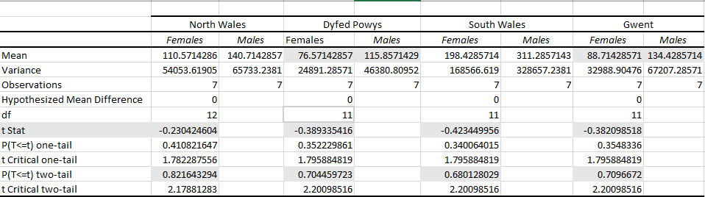

The statistical analysis found that Females,
- had a slightly lower ‘mean’ value compared to Males when considering all ranks in a force,
- had a low t- score.
- the p-value for each force was higher than the 0.05 significance level adopted (p>0.05).

A low t-score indicates that the groups are similar and a p-value over 0.05 (p>0.05) indicates there is no significant statistical difference.

For each force the analysis showed:

Force | t-score | p-value | Finding
North Wales | -0.23 | 0.82 (p>0.05) | Fail to reject null hypothesis
Dyfed Powys | -0.38 | 0.70 (p>0.05) | Fail to reject null hypothesis
South Wales | -0.42 | 0.70 (p>0.05) | Fail to reject null hypothesis
Gwent | -0.38 | 0.70 (p>0.05) | Fail to reject null hypothesis

The results suggests that there is no significant difference in the gender breakdown amongst the ranks and any differences in the raw data is probably likely to be by chance rather than any perceived gender bias, especially when considering the demographics of each force individually.
Result: There is no significant statistical difference between gender across the Ranks in the forces, therefore the researcher fails to reject the null hypothesis
- Gender balance across senior leadership

A chi-square test of independence was conducted to establish if there is a balance of gender within senior leadership (i.e., Chief superintendent and above):
Null - hypothesis - No significant statistical difference in the gender balance within senior leadership
Alternative - There is a significant statistical difference in gender balance amongst senior leadership

The analysis revealed that the gender distribution across senior leadership positions across the sample was not statistically balanced and differed in each force, providing a p-value of 0.001. (p=0.001) As the p- value is less than 0.05 (p<0.05), this indicates that statistically there is a significant difference in gender amongst senior leadership and may highlight a trend.
Result: there is a statistically significant difference in the gender balance amongst senior leadership, therefore the researcher rejects the null hypothesis and accepts the alternative.
- Gender balance within promotion outcomes
A z-test two proportion test was conducted to establish if there is a statistically significant difference in promotion rate outcomes between genders:
Null Hypothesis – There is no significant statistical evidence that promotion outcomes are based on gender
Alternative - There is real and significant statistical evidence that promotion outcomes are based on gender

The sample consisted of:
- Male promotion rate: 2.40% (118 promotions out of total male employees 4916)
- Female promotion rate: 2.11% (70 promotions out of total female employees 3320), and the
- Overall pooled promotion rate across the sample of 2.28%
The analysis showed that the percentage difference between the male and female promotion rates was not significant Z=0.87, and the p-value was 0.384, higher than 0.05 (p>0.05). This suggests that there is no significant difference in promotion rates by gender and are probably likely to be by chance rather than any gender bias.
Result: There is no significant statistical evidence that promotion outcomes are based on gender. The researcher fails to reject the null hypothesis.
- Gender balance in officers leaving the police.
A chi-square test of independence was conducted to establish if there is a balance of gender within those officers who leave the police:
Null - hypothesis - No significant statistical difference in the gender balance of officers leaving.
Alternative - There is a significant statistical difference in the gender balance of officers leaving.

Officers can be categorised as leavers under the following headings – normal retirement, medical retirement, voluntary resignation, transfer, dismissal or contract termination, voluntary exit scheme and death. Analysis was undertaken based on the collective number of leavers for the sample in the financial year.
The analysis revealed that the gender distribution across all categories of ‘leavers’ in the sample was statistically balanced and didn’t significantly differ in each force, therefore any differences in the raw details may be down to chance rather than a trend.
A p-value of 0.20. (p=0.20) was calculated, therefore as the p- value is more than 0.05 (p<0.05), this indicates that statistically there is no significant difference in the gender balance of police leavers.
Result: There is no statistically significant difference in the gender balance amongst police leavers, therefore the researcher fails to reject the null hypothesis
The above findings will be discussed in the next section.

- D i s c u s s i o n
This quantitative study was designed so as to explore gender parity and representation within UK policing in 2026, with an aim to establish if gender parity had been reached or whether policing was on the correct trajectory to achieve proportionate representation amongst its workforce. Utilising UK Government workforce data as its primary source, a sample of four forces became the subject of statistical analysis. When considering the study’s findings, interpreting the statistical significance of the analytical output informs the reader as to whether the result amounts to a real pattern or trend, or a random occurrence (Kriegler, 2025) and specifically within policing whether this is then important or ‘meaningful in a practical sense’ (Cave, 2025).
The findings of the study reveal that there are no significant statistical differences in the gender make-up of the sample over a number of areas - gender balance within workforce numbers, within rank structure, promotions, and leavers with just one area highlighted as having a significant difference: the gender balance in senior leadership. Cave (2025) asserts that when a finding is not statistically significant, ‘but it holds practical significance, it could still be valuable despite not meeting statistically significant thresholds’. It is therefore argued that it is important to interpret the results within their particular context, in this study within policing.
a. Gender balance in the policing workforce (Hypothesis 1)
The study considered the gender balance in the police workforce sample both individually and collectively and found that there was no significant statistical difference between genders. However, in contrast the workforce statistics reveals that there is currently an approximate 19.3% difference between the genders, with a 27% difference in the wider UK policing population (Gov.uk, 2026). The question as to whether this is significant is open to consideration, however Cave’s (2025) suggests that it should be considered in the wider context of its practical significance for policing. Price et al supports the workforce statistics by highlighting significant differences in the representation of female officers between the 43 UK Police forces, and claim that gender equity remains a ‘critical issue’ in UK policing (2026, p.1)
Charman (2024, p.400) in contrast asserts that the UK landscape is one of a higher-than-average number of women in policing compared to other countries but does however argue that whilst ‘numerical gains are convenient as measurable target’s’, they mask the more inherent matter of ‘organisational integration’ that shrouds the intricacies of ‘addressing the structural and cultural gendered inequalities rising through the police service’.
Previous research suggests that a ‘critical mass of 35% of women in policing’ is needed to attain ‘cultural integration’ and to absorb the rewards of gender diversity (Price et al, 2026, p25, Carrington et al, 2023). Some suggest that formal targets can be an effective tool to accelerate growth on gender representation, with research evidence suggesting that organisations that employ targets improve diversity quicker than those without especially if those targets are publicly visible (Office for Equality and Opportunity, 2026). It’s argued that contemporary policing avoids strict targets for gender representation due to key operational and legal reasons and alternatively refer to ‘appropriate representation’ and cultural obligations like the HeForShe movement (2025) as measurements. The critical mass target of 35% has arguably been exceeded by a number of forces since it was initially debated, including the sample in this research which showcases achievement at or above that level. However, Carrington et al (2023) claim that despite some success in ‘feminizing policing’, policing remains ‘a male dominated profession where masculinity overpowers, regardless of the proportions of women that reach the hypothesized thresholds’.
b. Promotion, retention, and distribution of gender across the ranks (Hypothesis 2,4 &5)
The police service is a heirachial organisation where progress from entry level to the highest leadership position is clearly defined and relies on a combination of time in the role, performance, and formal exams. The process of advancement has historically presented, and according to some contemporary researchers still continues to present, a gender bias in favour of males (Charman (2024, p.402).
The findings of this study found that there was no significant statistical difference in the proportion of females across all the ranks, nor within the gender balance of those that were promoted during the 2025/2026 financial year. However, in comparison, the workforce data, suggests a picture of disproportionality within the promotion numbers, with females obtaining 37.3% of the promotions and males with 62.7%. Furthermore, female numbers were visibly reduced in comparison to their male colleagues across the different ranks (see Diagram 1 above).
Drew and Saunders (2020, p.487) provides support for the findings, where their study of the promotion system found that it was ‘largely non-gender’ with similarity evidenced in the ‘factors associated with engagement and disengagement’ for both genders. Charman (2024) supports this and asserts that the number of female applications for promotion to sergeant (the first line manager position in the structure) is generally lower than men despite them being as proportionately likely to pass promotion exams as their male colleagues. This does however have implications for females as the first step of career progression subsequently becomes deferred, when time is really a crucial factor to future rank success (Alexander & Charman, 2023).
Price et al (2026, p.2) propose that ‘recruitment, retention and promotion’ are frequently cited as essential areas of focus ‘when improvements are key to women’s advancement’, claiming that recruitment integrally controls the initial ‘pipeline for women', producing a foundation for future promotion opportunities, it is therefore deemed a vital first step for cultivating women’s participation.
Time, alongside the availability of flexible working and informal networks have also been highlighted as key reasons that influence female’s adeptness to progress through the rank structure (Charman, 2024, p.403). Silvestri et al (2023) argues that ‘time’ in policing is a ‘gendered concept’ that influences female officers’ ability to progress alongside their ability to fit into the ‘ideal worker’ concept, both of which are deemed to be innately associated to career progression in policing., with Alexander & Chapman (2023) highlighting ‘time’ to be a ‘critical feature of career success’.
Flexible working was arguably introduced to assist women in their careers; however, some researchers claim that part time working restricts or inhibits promotion and progression in various ways specifically within policing due to the impact of cultural and structural practices. Charman (2024, p403) declares that there is evidence to support the claim that career advancement is compromised by the decision to work part time and goes on to propose that in order to take advantage of the benefits that a more gender-representative workforce offers, women must be represented in all ranks calling for ‘a relaxation of the traditional command and control structure of policing’ to achieve that success.
The study further suggested that there was no significant statistical difference in the gender of those officers leaving the force. The workforce data however suggests that there is a bias towards men with 74% of those who voluntarily resigned being males and 32% being female.
Researchers argue that the total workforce numbers of leavers from the service will often be higher than women due to their higher proportion of representation in the workforce, however a 2024 study by the University of Portsmouth claimed that a lack of flexible working or organisation inflexibility had resulted in a record number of women resigning from the service. Historical research output has consistently highlighted the attrition rates for female officers as being high, the current workforce data is therefore significant, highlighting a gender trend biased towards male officers, that warrants further research.
- Leadership (Hypothesis 3)
Women’s leadership within policing has arguably become the focus of sustained academic research highlighting their disproportions and absence, alongside the challenges that women face in reaching the higher ranks of the service. The result of this study shows that there is a statistically significant difference in the gender distribution in senior leadership therefore supporting the findings of published contemporary research such as the HeForShe Movement referred to earlier. The workforce statistics shows that females currently represent 31% of the sample leadership strength which surprisingly matches the national percentage of 31.5% (UK.gov., 2026), providing further support for the finding.
Drew & Saunders (2020, p.477) – contend that increasing the representation of females in senior positions is a ‘contemporary challenge for policing’, with their research claiming that police organisations foresee the transition of females into senior leadership occurring naturally when aligned to recruitment, and ‘will provide the necessary talent pool to take on leadership role(s)’. Citing others, they however further claim that a considerable fluctuation in gender representation is required so as to benefit from small growths in gender equity at senior levels. Charman’s (2024, p.403) research conversely highlights that females are consistently less successful than men at the senior leadership promotion process, in particular for the position of Chief Superintendent despite applying in proportionate numbers to their male colleagues. Interestingly within the workforce numbers of the sample this rank has the lowest percentage of females at 19.2% compared to others - highlighting a gap in current knowledge as to why this occurs and inviting further research.
Previous research has cast light over a number of challenges that women face in reaching senior leadership – the majority of which can also be claimed by women seeking promotion to the other managerial and middle leadership roles. Interestingly Drew & Saunders (2020, p485) found that officers, irrespective of gender, will self-assess their confidence, motivation, and readiness for promotion to take on the challenge of the next rank, with some naturally choosing ‘to self-select themselves out of the process’ if they so wished. This therefore emphasises the power of personal choice over individual progression and its impact on gender dispersion (Cooke, 2025a, p20), an area which is under-researched.
The policing workforce is arguably seen as ‘fluid’ where numbers constantly change due to recruitment, promotions, transfers, and retirements. More recently it has been labelled a ‘revolving door’ workforce (Police Federation, 2026) where an increase in voluntary resignations is not being met with recruitment numbers. This climate of constant change can arguably affect the gender balance on any given day, month, or year.
Gender equality, and parity within UK policing, continues to attract much academic interest and exploration despite some evidenced progress. In an attempt to understand why the underrepresentation of females continues to feed this appetite for academia and others, Silvestri (2005) suggests that the solution is to be found within women themselves, rather than organisational barriers, Therefore, acknowledging numerical representation of females is according to Price et al (2026, p.26) one marker of progress, which should be considered alongside a more significant measure, that of women’s ‘lived experience’.

- C o n c l u s i o n
The journey of achieving a gender representative workforce in policing is considered prolonged and complex, with its ultimate destination arguably some distance yet to be travelled.
Globally UK policing is seen as a success with the numerical representation of women in the workforce continuing to increase annually. Previous research opines that numerical representation is not sufficient and calls for a better understanding of the complexity and nuances of experienced gender inequality to be examined which is challenging to depict numerically. However, the true measurement of success is complicated by the lack of a defined threshold, with reliance instead being firmly placed on’ cultural measurements’, or individual definition and interpretation of what constitutes ‘appropriate representation’.
Despite visible progress, this study shows that the under-representation of women in senior leadership is now becoming a significant issue that needs timely intervention. Research provides evidence that greater diversity within police leadership indicates higher levels of procedural ‘justice and legitimacy’, and strongly reflects the society it serves; yet academics argue that despite some significant achievements, women continue to face organisational and cultural barriers within policing that impact upon their continued progression through the ranks.
The researcher concludes by arguing that despite numerical representation placing UK policing on the road to a representative workforce and highlighting areas of gender disparity for future action, the lack of defined ‘appropriate representation’ may question if gender parity is a journey that will ever reach its ultimate destination.

R e f e r e n c e s

APPENDIX A

Link to UK Government Policing Workforce Data England & Wales 31 March 2026 –
https://www.gov.uk/government/statistics/police-workforce-england-and-wales-31-march-2026/police-workforce-england-and-wales-31-march-2026.

Link to User guide to police workforce statistics (July 2026) –
https://www.gov.uk/government/publications/user-guide-to-police-workforce-statistics/user-guide-to-police-workforce-statistics.

Rank Structure in UK Policing

APPENDIX B
Inferential Statistical analysis – Calculations in Excel
P-Value
P-value is a probability value, a number that describes the likelihood of obtaining your results by chance. Normal threshold is 0.05.
- If the p-value is less than 0.05 – there is a significant difference,
- If the p-value is more than 0.05 – there is no significant difference.

- Hypothesis 1 – T-test to establish if there is any statistical difference in the gender balance of the overall sample ( four forces)
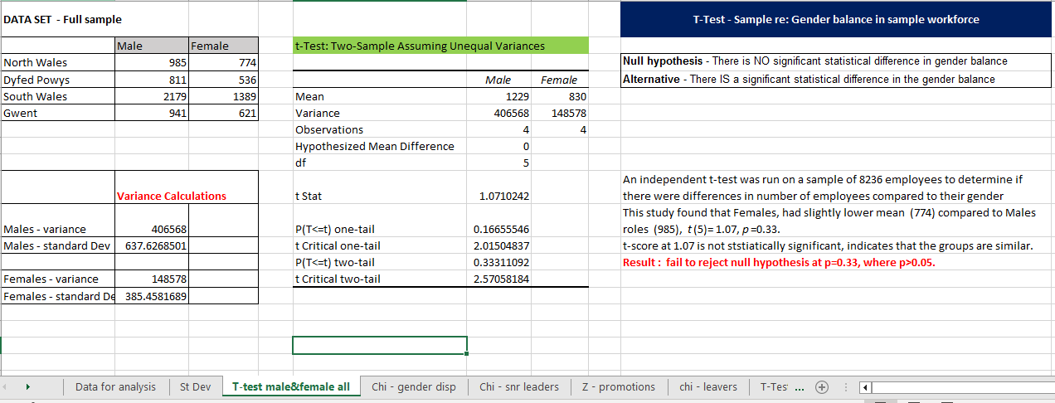

- Hypothesis 2 – Chi-square test to establish if there is any significant difference in the gender dispersion across all ranks.
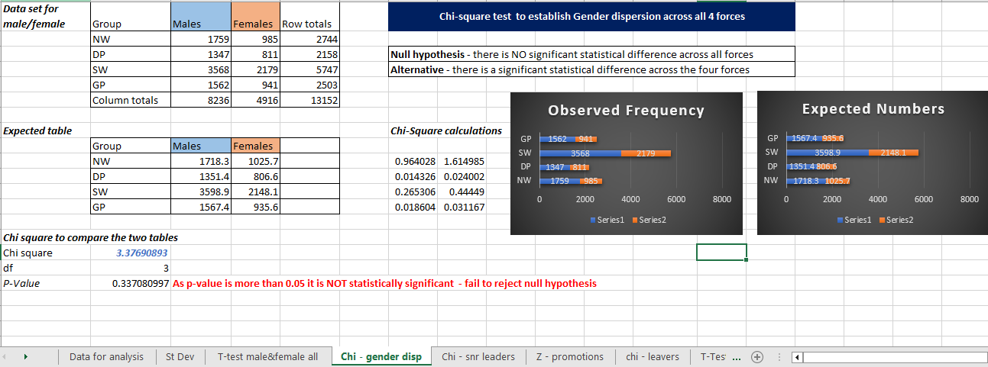

- Hypothesis 3 -Chi-square test to establish if there is an y significant difference in the gender balance within Senior Leadership
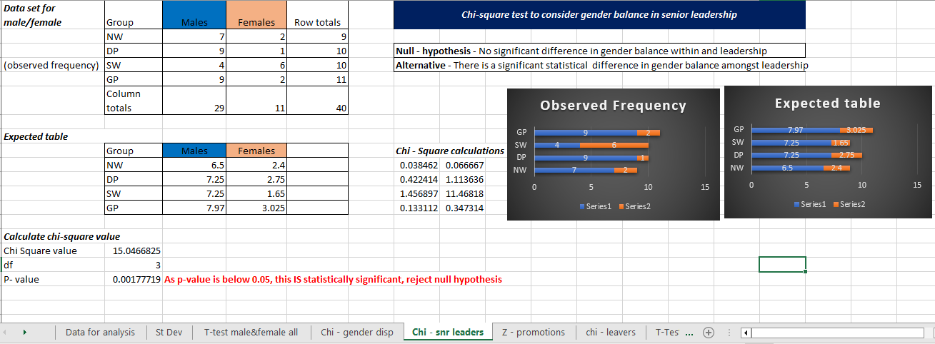

- Hypothesis 4 – Z-test to if there is any significant difference Promotion outcomes based on gender.
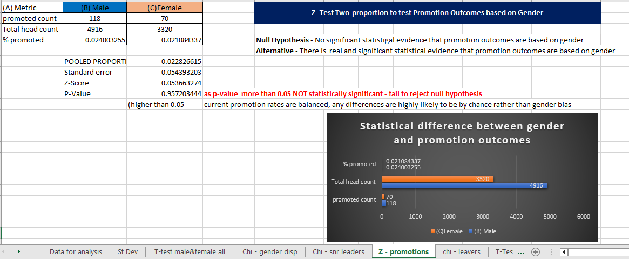

- Hypothesis 5 – Chi-square test to establish if there is a significant difference in the gender of leavers.

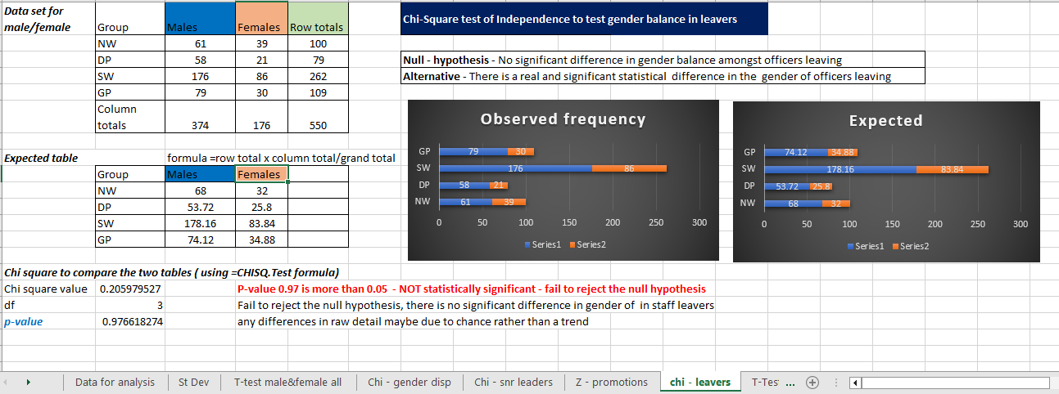

- Hypothesis – t-test to establish any significant difference in gender distribution across the workforce in each Force.

- Dyfed Powys Police
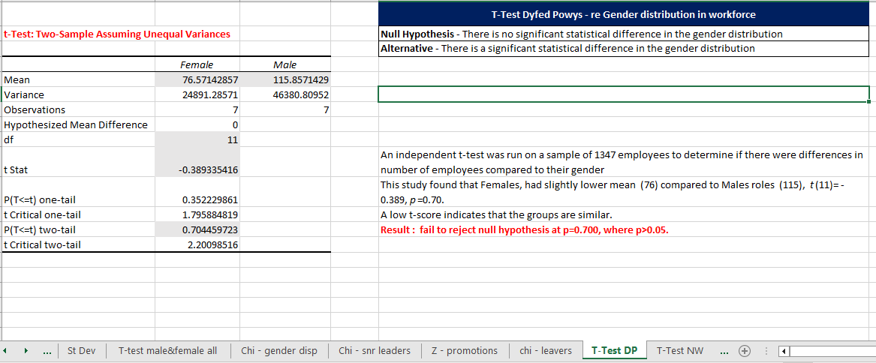

- Gwent Police
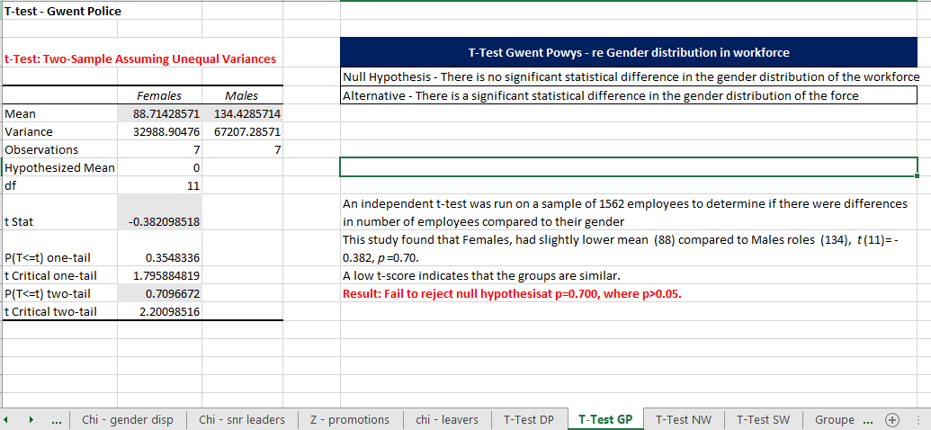

- North Wales Police
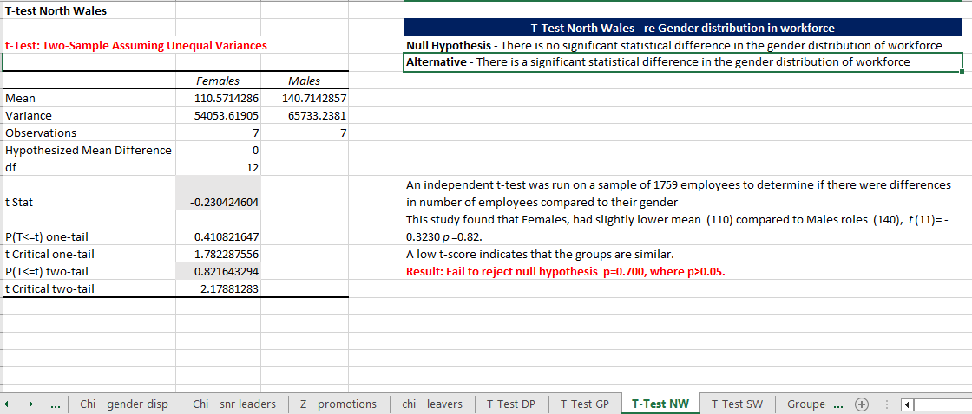

- South Wales Police


