Student Self Evaluation Form

This section repeats in brief the common assessment criteria detailed on previous pages. The extent to which these are demonstrated by you determines your mark. Using these criteria, tick the box that best indicates the level of achievement you feel you have achieved with regard to each of them.

Common Assessment Criteria Applied
Common Assessment Criteria Applied | REFER |  | D |  | C |  | B | A
 | OUTRIGHT FAIL | UNSATISFACTORY | SATISFACTORY | GOOD |  | VERY GOOD |  | EXCELLENT
1. Subject Knowledge and Understanding (which includes using research-informed literature and knowledge and understanding of the subject)
 |  |  |  |  |  | B
2. Intellectual Skills (Analysis)
2. Intellectual Skills (Analysis) |  |  |  |  |  | B
3. Pedagogic and Professional Applications (Practical Application and Deployment)
 |  |  |  |  |  | B
4. Key Transferable Skills
4. Key Transferable Skills |  |  |  |  |  | B

PLEASE COMMENT ON AREAS IN WHICH YOU FEEL THAT YOU HAVE PERFORMED WELL | PLEASE COMMENT ON AREAS you feel that you need TO DEVELOP
- Reviewing literature to support research enquiry  - Analysing interview recordings  - Connecting finds to interpret results | - Further research into methodology

Student’s Name | Casey MacDonald | Date | 14/04/18
Student’s Signature

How do continuous plenaries affect children’s understanding during KS2 mathematics lessons?

A critical reflection and analysis of a small-scale Lesson Study, following refinement to improve personal Primary School practice.

The Enquiring Teacher (TET)
Level 7; ECPP7001

Word Count: 6,600

For this research project, the issue that appealed to me was the implementation of continuous plenaries. In my class, this is an element of the lesson which proved most challenging to execute due to the short amount of time allocated for mathematics. As a subject that requires precise calculation, the class teacher spent the majority of the lesson modelling, to ensure that the pupils understood each step, rather than distributing more autonomy to independent tasks that requires interpretation, such as tasks in English Language. Consequently, the class teacher regarded teacher-input as fundamental, since misconceptions were more likely to arise in mathematics but with so much time placed on modelling, not enough time was left to include continuous plenaries throughout the rest of the lesson. It then became of interest whether different pedagogical approaches could be examined to determine whether continuous plenaries can be effectively applied as a useful Assessment for Learning (AfL) instrument throughout the lesson.
This was also expressed as a concern amongst the triad since misconceptions were commonly identified in this particular subject. Thus, understanding how children construct their own meanings in mathematics is pivotal in order to successfully assess understanding and help reduce misunderstandings. The use of continuous plenaries has therefore been considered a key element to explore which led to the research question; how continuous plenaries affect children’s understanding during KS2 mathematics lessons.

Literature review:

To support this research enquiry, a variety of resources have been analysed to aid refinement of the question: how the provision of continuous plenaries impact on pupils’ understanding. Firstly, DFES (2004) have found that using plenaries during the lesson help to evaluate the current learning taking place, and confirm the next step in a child’s progression. Indeed, this evidence is outdated but nonetheless, the acknowledgement of continuous plenaries raises interest for further research into the influence of this particular AfL strategy. Furthermore, Ofsted (2003) evaluate mini-plenaries as an essential part of the lesson but the implementation of the strategy has been of poor quality in both literacy and mathematics. It has been summarised as the weakest part of lessons due to uncertainty of its purposes. According to Ofsted (2003), continuous plenaries should intend to assess pupils’ understanding of the lesson content, provide feedback, consolidate conceptual understanding and evaluate, alongside connecting the lesson to future lessons or other areas of the curriculum. Therefore, if a plenary does not execute these crucial elements, then a teacher’s pedagogical approach should be reconsidered and ensure each feature is appropriately fulfilled. Conversely, Ofsted’s findings could be perceived as outdated, with a role of inspecting standards in English schools, a curriculum that differs to the Welsh prospectus taught in Wales, suggesting further research into the impact of continuous plenaries in a Welsh educational context.
Support for plenaries throughout the lesson is shared by Spendlove (2009), indicating the effectiveness to assess pupils’ understanding and their current position of achieving the learning objective, before being challenged by the next one. Additionally, understanding is highlighted collaboratively as a sharing point of thoughts and ideas; acknowledging good practice and contesting misconceptions. Questions can arise from this such as, what makes good practice and how are misconceptions identified?
Vickery (2013) values the significance of time, underlining how children need sufficient time to connect their experiences in practical work with conceptual development. Continuous plenaries serve as interventions within the lesson that assist in consolidating learning and must give children time to reflect on what they have learned but also provide opportunities to extend learning. This leads to the query of whether there is enough time in one lesson to sustain continuous plenaries? Correspondingly, Grigg (2010) identifies that effective monitoring and making time for plenaries should be internalised in teachers planning and classroom management, in order to deliver excellent teaching. Distinctively, ‘excellent teaching’ remains an attractive topic for debate and ultimately relies on the authors interpretation, therefore possibly being susceptible to bias.
Beadle (2013) confirms how essential planning is for continuous plenaries. Ultimately, they cannot be incorporated into a lesson to simply ‘tick’ the specific planning box but must confirm progress of understanding and secure the learning objective in an engaged and active manner, before the lesson is complete. Indeed, Beadle (2013) has been criticised for being controversial. However, his work must be appreciated, with expertise in literacy and behaviour management and the ability to reform underachieving schools, his insight on the deliverance of mini plenaries can be regarded as valuable.
In contrast, more recent findings by Ofsted (2012) recognise how incorporating self or peer evaluation into the lesson before any solid learning has been embedded, can become counter-productive and distracting, perceiving continuous plenaries as impacting negatively on pupils if timed inaccurately. Therefore, the execution of plenaries in relation to planning, may not be successful in every session which ultimately comes down to the teacher’s assessment of what is needed for the pupils in that specific lesson, reflecting personal professional pedagogy.
Ultimately, understanding how children construct their own meaning and misconceptions within their learning process, can be perceived form a social constructivist lens (Vygotsky 1978, cited in McAteer, 2013). If misconceptions are not acknowledged or addressed, they may never be corrected. Therefore, as teachers, it is essential to create a class ethos that welcomes misconceptions to aid cognitive development, alongside creating an effective curriculum that reveals misconceptions so that children can effectively learn and understand accordingly. McAteer (2013) interprets how high-quality talk and structured questioning, scaffolded by the teacher, is vital to illuminate misconceptions. Through this, the notion of scaffolding can be accepted as a focus for pedagogy, tailoring questions specifically to generate high-quality responses and ensure pupil progression. Scaffolding is directly supported by Donaldson (2015), fundamentally valued for manoeuvring the new curriculum, who states that:

“direct teaching involves the active engagement of the teacher in ‘scaffolding’ learning. Creative contexts within which learners can demonstrate the ability to apply learning independently’’
(Donaldson, 2015: 65).

Coe at al (2014) also underline the importance of questioning throughout lessons to help identify misunderstandings, whilst Ofsted (2003) addresses how the lesson objective should be carefully revisited by checking pupils’ responses on whiteboards for example, as an effective plenary strategy. Thus, a variety of sources have been analysed, portraying a number of factors and suggestions towards identifying misconceptions and implementing strategies to aid learning in regard to these misunderstandings; exposing the fundamental point of understanding your learners and adopting a whole school and personal philosophy to ensure that AfL takes its full effect (Hattie, 2012). Consequently, all the literature provided has helped towards the refinement of the research question; exploring the impact of continuous plenaries.

Methodology:

The methodology used for this research followed the Lesson Study process (LS) which is a form of action research that Bell (1999) proposes, is highly attractive to practitioner-researchers as through a practical and problem-solving nature, problems identified in practice can be investigated and improved. LS is described as classroom action research which encourages teachers to develop their own agenda for enquiry and focuses on the development of teacher practice knowledge (Dudley, 2014). During the LS process, a group of teachers work together to plan, teach, observe and analyse the learning for further development. LS works over a cycle of lessons in which observation and reflection takes place to enhance the teaching practice and consequently, improve the learning taking place. In our research cycle, refining took place as one person taught a lesson whilst the other two researchers observed, followed by bringing findings together and altering pedagogical approaches upon reflection. Collaboration between all three researchers meant that new insights into teaching was acquired whilst accelerating intrinsic motivation, as being in complete control of progressing personal practice and pupil learning led to a sense of empowerment (Lewis and Hurd, 2011).
Mixed methodologies were used to collect the data, including field notes, non-participant observation, and focus group interviews. Firstly, as a non-participant observer, this standpoint led to the ability of stepping out of the teacher role, strictly concentrating on pupils’ responses and behaviour, capturing context-specific evidence which eliminated subjectivity and bias, associated with participant observation (Palaiologou, 2008). Thus, it was essential to remain objective and eliminate any interactions with these pupils. Fundamentally, the company of another observer meant that interpretations could be compared to eradicate any preconceived ideas or prejudices (Coe et al, 2012). However, the pupils were made aware of the research being conducted through a process requiring ascent prior to the lesson to avoid deception. Subsequently, it was recognised that the pupils could potentially modify their behaviours, posing the problem of reactivity as underlined by Babbie (2013). To overcome this, the LS activity was explained, accentuating the aim of improving teacher practice so that the pupils felt at ease and not under pressure from being watched.
Acting as a variable to ensure that a range of reactions could be recorded, three target pupils of mixed abilities were selected. Target child observation gathers detailed information in a concise way, employing an observation schedule created in advance. For this particular method, delineation of behaviours and contextual features are identified through codes that are carefully executed and trialled before the data collection (Papatheodorou and Luff, 2013) but time was inevitably a constraint for this research project and wasn’t possible. It must also be acknowledged that learning and applying these codes isn’t always clear-cut and also entails experience. Consequently, the findings were documented as field notes but within a tailored semi-structured schedule to obtain a continuum of quantitative and qualitative data such as allocating identification of trends that can be compared between the target pupils in each school and for example, quantifying the different types of plenaries being used. Alongside this, documenting an account of the event exactly as it was happening which was then elaborated and analysed following the observation, led to qualitative results and conceptions of themes (Brodie, 2013). This assortment of methods reflects a concurrent design, also represented by triangulation where separate studies of the same experience have been conducted then bought together as a triad, sharing findings for each phenomenon, to then reflect upon and produce more comprehensive findings (Coe et al, 2012).
Following the same observation schedule format for each lesson enabled structure and facilitated diverse but fair results for each researcher and target pupil, so that the results accurately reflected the data, promoting validity. Additionally, Phillippi and Lauderdale (2018) emphasise, a well- framed approach to field note collection is preferably produced prior to the study, then revised persistently based on findings to integrate new constituents while retaining stability of key themes throughout the data collected. Indeed, following a predetermined structure could have eradicated something significant that wasn’t considered prior to data collection, therefore it was essential that anything unique to the encounter could be noted, integrating the use of field notes as advantageous. Regarded as a crucial element of precise qualitative research, it is understood that field notes provide rich contextual data that enhances the data collected and analysis (Creswell, 2013). However, the amount of detail was determined by the amount of time the lesson took, illustrating time as a significant constraint. As a result, the approaches combined and implemented were most purposeful for gaining a range of context-based findings within a semi-structured format, compatible with the amount of time allocated for the research conducted.
Following the observation, the three target pupils selected, undertook focused interviews with the aim of collecting personal views and opinions on continuous plenaries. A fundamental concern when collecting data with children is to ensure the creation of a natural environment in which the children don’t feel intimidated. Despite this, power dynamics between the interviewer and interviewee in evitable as the interviewer is in control of the questions (Holstein and Gubrium, 2003a). To reduce the power differentiation, focus group interviews seem most appropriate for children who secure knowledge and construct new meaning collaboratively through interaction and discussion with peers (Holstein and Gubrium, 2003). Thus, children can build on each-others’ thoughts and understanding which ultimately generates more accurate accounts. For example, with more than one opinion on a chosen subject, the individual needs to justify their responses. Furthermore, to ascertain honest views, questions must remain open-ended and inclusive. Crucially, it must be recognised how provoking discussing through non-directed questions could lead to off-topic dialogue, posing issues of effectively measuring results with the possibility of no correlation or validity. Therefore, to overcome this problem, questions remained open-ended but tailored specifically to the research question with additional objective probe questions to extend responses.
Similarly, Holstein and Gubrium (2003b) bring to light the power difference between peers in which some children tend to dominate the group interview, inflicting their views as more superior, whilst other children may not actually say their sincere thoughts, complying with their friends’ ideas due to peer power. In attempt of avoiding this, the questions used were mixed up for each interviewee rather than extending on from what the previous person had said in hope of gaining authentic personal answers (Crowther and Lauesen, 2017).
Audio recording was considered as most effective for analysing the focus group interviews, as Bryman (2012) reveals, the use of recording captures greater detail, a natural limitation of drawing conclusions from memory. Recording ensured sufficient information was gathered, depicting every part of the conversation, including expression and tone, making transcriptions easier and possibly allowing more time for reflection (Papatheodorou and Luff, 2013). Pupils can become anxious knowing that their words are being preserved, so it was decided that an IPad would be used as a type of technical device that the pupils felt most comfortable with, as larger equipment may have increased behaviour moderations (Bryman, 2012). Following the interview, field notes were used to immediately dictate non-influenced initial ideas. These field notes were also useful to use alongside the interview transcript for further analysis (Phillippi and Lauderdale, 2018).
Finally, critical reflection took place following the interviews in which the researcher teaching, self-evaluated and adapted inferences to interpret the lesson (Zimmerman, 2000). Mezirow (1990) transfers critical reflection in to a meta-cognitive process or a zone of ‘critical consciousness’, being aware and in control of the individual’s awareness (Redmond, 2006: 17) which Brookfield (1995) declares, is the path to understanding the value of personal teaching. Therefore, reflection is a crucial component of data collection, combined with feedback from teachers and pupils to improve the teaching practice. Following Brookfield’s four lenses of critical reflection; self, student, peer and scholarship was considered most effective for the research as feedback from each participant was shared between each researcher and liked to relevant literature, adapting pedagogical approaches for the next lesson. Gabriele and Jarom (2007) expose how reflections help identify teaching problems but also foster teachers’ ability to focus on children’s thinking processes in mathematics such as reasoning and choice of method, nurturing appropriate assessment criteria through evaluations and constructive responses. This proved essential for the lesson study, complimenting why this method was considered as most suitable.

Ethical Considerations:

The context for this research and with children as the participants involved meant that ethical considerations were considered. Based on BERA Ethical Guidelines for Educational research (2011), alongside EWC Code of Professional Conduct and Practice for Registrants with the Education Workforce Council, many steps were put in place in light of these guidelines to ensure there was no risks to the participants involved. By no means were any children treated differently, regardless of if they were involved in the focus group interviews or not. Following the documents stated above, myself and my colleagues made sure that no emotional distress was caused at any point of the research. Children have the right to choose whether they want to participate in the research and could autonomously withdraw with no consequences. Consent forms were sent out to parents/ caregivers whilst personal assent was obtained through a class register, confirming their participation in the research. The children who gave assent and consent participated in focus groups where there was no sense of intrusion.
The lesson corresponded with activities the children undertake on a daily basis and therefore faced no risk of any physical harm in unfamiliar contexts. The room where the focus group interview took place was in the hall, therefore a large open room, with four classrooms easily accessible and in sight. No child was pressured into participating in the research, with no incentives involved, reducing any impact of bias on the data. Throughout the whole research we complied with the legal requirements for storage and data, complying with both the school and the university, where data has been protected in a password protected account, made confidential with all names and identification of children removed. All researchers involved were fully aware of the schools safe guarding policy, which was adhered to at all times.

Lesson Study 1 Analysis:

The first lesson was a Year 6 class with 28 pupils of mixed abilities with the learning objective: to use probability to identify the outcome of simple events. In response to reviewing literature, it was decided that the continuous plenaries integrated in the lesson would be sufficiently planned for which included: questioning, talk partners, modelling, quiz and exit cards, to determine whether plenary diversity would impact on achievement of the learning objective. How securely the learning objective was achieved however, is of a debatable nature as the class consisted of mixed abilities with a wide range of responses that varied through pupil feedback. For example, a quiz was used to demonstrate understanding which the pupils perceived as ‘fun’ and ‘not like work’ underlining enjoyment engagement with the task. However, cognitive engagement can be challenged since the use of ‘finger tools’ to assess the understanding from the quiz was unreliable as Pupil C responded with a ‘thumbs up’, suggesting the learning was consolidated but the answers given didn’t match the conceptualisation of ‘even chance’ on a probability scale. Rather, a misconception was identified, querying the validity of Pupil C’s action and the usefulness of ‘finger tools’ as an AfL strategy.
Furthermore, the teacher’s modelling of examples for probability inadvertently led to the formulation of this misconception as probability was emphasised as interpretation, linked to personal experiences which is evident of how the misconception arose, with no demonstration of fractions when covering the concept of ‘even chance’. The use of dice was present as a resource on the table which could have improved Pupil C’s perception of ‘even chance’ as a visual representation of something being 50/50, such as rolling odd or even on a dice could, potentially aiding their understanding. Despite this, the misconception wasn’t addressed, questioning other pupils understanding of even chance and fundamentally, questioning the rigid planning of continuous plenaries as possibly distracting teachers’ flexibility. However, following the quiz, the teacher addressed misconceptions of using negative numbers as Pupil C shared confusion between negative and odd numbers. Using a number line, enabled Pupil C to conceptualise negative numbers, physically creating a number line, allowed visual learning to occur. Therefore, addressing this misconception was vital for Pupil C’s conceptualisation.
It was observed that the use of talk partners worked well with Pupil A and B and can be considered as a highly effective tool that enhanced learning through discussion and justification; Pupil C however, tended to rely on their talk partner, indicating too much dependence. Nonetheless, the pupils shared more confidence and were eager to answer questions after finding reassurance in their partner. All three pupils also expressed their interest in using talk partners to share ideas and aid their understanding if they were unsure of the question or task outlined. Alongside the importance of talk partners, modelling was also understood as crucial by the observers. Even though the task was verbally explained, the layout wasn’t demonstrated, meaning that calculations weren’t displayed but there was also an uncertainty of what method to choose, leading to Pupil A, taking it upon themselves to create a method and help construct their partners understanding. This highlights Pupil A’s ability to take responsibility of their own learning but as a more able and talented pupil, insinuates possible issues for other pupils to independently establish without any modelling by the teacher. Consequently, modelling needs to be executed thoroughly to meet the needs of all pupils, emphasising how plenaries need to be clearly implemented and understood by the whole class.
Surprisingly, Pupil C expressed the quiz as the most effective learning tool as opposed to teacher-modelling and talk partners which didn’t correspond with the learning episode, illustrating how pupils’ responses can be unreliable. Pupil C added that the lesson could be improved with more fun tasks like the quiz, indicating how the notion of fun was prioritised, contesting whether cognitive development was enhanced, since the learning episode was characterised by misconceptions, contradicting Pupil C’s response. Exit cards were also used as a final plenary to gain pupil feedback on the learning objective but the comments given again, like the thumb rating for self-assessment of the quiz, conflicted with the learning episode.
To improve the next lesson, it was discussed that the number of plenaries used would be reduced with a specific focus placed on modelling, perceived as vital by all researchers for conquering misconceptions alongside increased use of talk partners, communally accepted as potentially the most effective learning tool by all researchers, with highly positive feedback from pupils. Most importantly, attempting to use frequent plenaries placed more pressure on planning and obstructed the teacher’s ability to deliver flexible pedagogy. Therefore, less plenaries would be used in the next lesson and the number of plenaries was altered as a variable. The research tools would be kept the same as modification of this wouldn’t make the research fair. For this reason, the data collection instrument would remain the same until future reflection and refinement.

Lesson Study 2 Analysis:

The second lesson study included a class of 28 pupils in a Year 4/5 setting, of mixed abilities with the learning objective: to multiply using 1,2 and 3 digit numbers. Specifically refined from the previous lesson, modelling was executed more systematically during the introduction to ensure accomplishment of the learning objective. In the observation, Pupil A in particular found the partitioning element challenging which was acknowledged by the teacher after identifying answers using the white board. Misconceptions arose concerning place value but using the whiteboards to assess individual answers, meant that the teacher could remodel using a familiar strategy: the grid method. An activity was then set up involving partner and group work which aided discussions and filled Pupil A with confidence, securing part of the learning objective; to multiply by 1 and 2 digit numbers. Likewise, during the interview, Pupil B articulated positive feedback regarding whiteboards as a useful tool for speeding up thought processes, quickly documenting calculations that would take longer to calculate mentally. Thus, whiteboards can be accepted as a helpful apparatus for both teacher and pupils, to simultaneously, rapidly record work and examine conceptualisations or misconceptions.
Modelling was perceived by the researchers as essential for demonstrating how to structure and present work, saving time on individually working out a method. However, with an over emphasis placed on modelling, a significant amount of time was spent practising a more complex example, leading to the teacher complicating the sum and making a mistake. As a result, Pupil B recognised this error and brought it to the teacher’s attention. Arguably, teacher subject knowledge could be perceived as deficient but significantly, this event accentuated the teacher’s capacity to flexibly transform the incident into an engaging task, to identify error in the method and consequently, welcome misconceptions (McAteer, 2013). Such flexibility indicates how assessment for misconceptions but also engagement can’t always be planned and is determined by what happens in the lesson.
Interestingly, during the interviews, Pupil A, B and C agreed that the use of the PowerPoint helped their understanding more than modelling by the teacher, advocating the use of ICT as a comfortable resource for pupils, with less intervention from the teacher. Arguably, the preference of ICT may be connected to not only a constantly evolving digital curriculum but in this class particularly, the class context fostered a digital culture, with the class teacher being a digital co-ordinator and the term theme of ‘technotastic’, meant that the use of technology was familiar on a daily basis. This may suggest that using technology was suitable for this class as an effective learning tool but may not be the case for a different class in a different school context. Therefore, the context and familiar theme could have influenced and manipulated these responses as the PowerPoint played little part during the introduction and had no further input throughout the lesson, compared to precise modelling and flexible creativity by the teacher.
Talk partners was also expressed as a favourite learning tool by all three pupils during the focus group interview, gaining confidence in answers but also checking the validity of an individual answer by comparing against a peer’s response. However, pupil C added that talk partners and questioning can slow down the lesson and become distracting, especially when in a concentrated state, it can interrupt the state of flow, revealing constant plenaries as not just an assessment tool for engagement but also interference. Nonetheless, questioning remains a vital strategy for seeking individual learning, including pupils who aren’t as confident with the task or learning objective. Furthermore, Pupil B deciphered talk partners and questioning as beneficial for developing oracy skills, consolidating learning by explaining thought, valuing an alternative method to writing down ideas. This not only verbally communicates pupils’ cognitive development but significantly bring to light, the acknowledgement of pupils’ aptitude to understand the importance of talk as increasing presentation skills and taking accountability for self-improvement in oracy.
Finally, to improve this lesson, it was suggested by the pupils that continuous plenaries, referred to as ‘pit-stops’, was better executed individually as they found the continuous deliverance of this distracting and slowing down the number of answers they were able to complete. However, pupil C acknowledged that ‘pit-stops’ were useful for drawing attention to calculating something correctly even if you are unaware of misunderstanding, clarifying plenaries as pivotal for distinguishing misconceptions. Therefore, as refinement for the final lesson, it was agreed that the total of plenaries would balance whole class ‘pit-stops’ with individual help, emphasising teaching in a flexible manner as the amount of individual help would be determined by the learning taking place.

Lesson Study 3 Analysis:

The final lesson took place in a Year 5/6 class consisting of 28 pupils, set at a higher ability for mathematics. The lesson objective was: to generate input and output using multi-step function machines. Due to the class being top set, the work was more challenging but as the pupils stressed that they were unfamiliar with the subject, a sufficient amount of time was spent on modelling during the introduction, breaking down each section that became more complex for each example. Pupil A and Pupil B conveyed modelling by the teacher as sufficient as a stimulating topic was explained well which challenged their ability, pushing them to their limits. Pupil A also stated the importance of modelling when a new topic was introduced as the use of whiteboards and talk partners were meaningless without firstly, acquiring knowledge on the subject, meriting teacher input as the initial aid for learning. Additionally, the use of white boards was perceived as useful for comfortably trialling methods with no worry about making mistakes, reflecting the class culture of appreciating ‘marvellous mistakes’ as all three pupils understood this as a crucial element in learning.
How securely the learning objective was achieved is hard to interpret until the topic was revisited but following the systematic modelling, the pupils could then choose what method they wanted to apply, giving them more autonomy. Ultimately, this gave the teacher an opportunity to assess the choice of strategy during independent work but also assess misconceptions at an individual level. Allowing the teacher to discuss with the children their choice of method, enabled the pupils to verbally articulate their thinking and problem-solving process, placing great emphasis on the importance of dialogue and how the notion of teacher-pupil interaction is vital for scaffolding independent learning (Vygotsky 1978, cited in McAteer, 2013; Donaldson, 2015). Pupil A and B were highly engaged and demonstrated secure understanding of the learning objective but Pupil C needed additional help which was acknowledged and offered by the teacher through one-to-one support. During the interview, Pupil C expressed their opinion on this method as comforting, without creating any pressure as opposed to addressing the learning point of the whole class.
Moreover, Questions were tailored specifically to engage learners to ensure that they were on task and understood how to seek patterns and identify the function. In response to the previous lesson, the amount of ‘pit-stops’ used to question the class as whole was reduced and questions were applied individually to avoid disruption and preserve more time. However, the issue with this was that the teacher didn’t have enough time to check the misconceptions of every individual in the class in such a short period of one lesson, meaning that some pupils dismissed further help, unaware of potential misconceptions they may have conjured. Pupil C preferred this method but as a target pupil for the focus of this research, other pupils may have subconsciously been excluded, underlining time as a constraint for ensuring extra support with all learners. Therefore, finding a balance of preventing disruptions and interacting with individual pupils to assess misconceptions proved challenging.
Finally, talk partners was considered as a favourite learning tool by Pupil B who gave an honest response of how it’s an opportunity to create personal discussions, not related to the task. Indeed, honestly can be valued but the efficiency of talk partners as a learning tool may be regarded as weak, exploited by certain pupils to eliminate learning. Despite this, talk partners cannot be generalised as a weak tool from the response of one pupil, suggesting that to improve the data, obtaining feedback from a larger study scale would be more effective. The fact that this class was top set must also be highlighted as this response may not be replicated by pupils from a lower set. By contrast, Pupil C answered ‘white boards’ as the most effective learning tool but again, this didn’t correspond with the learning episode. Pupil C faced difficulty during the lesson and was ensured support by the teacher to aid learning unlike the white board which didn’t provide Pupil C with the same provision, bringing attention to the reliability of this response as not completely trustworthy.
To collect better evidence for future lesson studies, the time-scale for gathering the data needs to be over a longer period of time, including the opportunity to revisit the learning objective to more accurately assess the consolidation of learning that takes place. Furthermore, to ensure more reliable responses, the research questions could be cut down to avoid confusion, with more time allocated for pupils to answer the questions, ensuring more accurate connections being made to the lesson.

Discussion of research findings:

The findings displayed justifies delivering quality continuous plenaries as a combination of effective teacher pedagogy, which specifically involves being flexible and innovate, alongside the careful planning of AfL strategies, as conveyed by Beadle (2013). However, rigorous planning of plenaries can place more pressure on teachers and obstruct flexibility as demonstrated by lesson study 1, contradicting the purpose of continuous plenaries: to address misconceptions and consolidate learning (Ofsted, 2003). Thus, a balance needs to be found which may entail the implementation of fewer plenaries, with a clear purpose of assessing progress rather than including different AfL methods as a tick-box completion (Beadle, 2013). Although the number of continuous plenaries was pre-determined, the teacher subject knowledge could also be contested as aiding the formulation of misconceptions for lesson study 1, highlighting pedagogy as crucial for verifying high-quality deliverance of plenaries but additionally, the connotation of good pedagogy must be respected as subjective and based on individual interpretation.
Fundamentally, modelling, questioning, talk partners and the use of white boards were expressed as effective by the target pupils from all of the lesson studies but the responses were based on individual interpretation, possibly influenced by the school or class context, including welcoming misconceptions as ‘marvellous mistakes’ by trialling work on a white board or favouring questioning and talk partners to boost oracy skills. Regardless, the responses highlight sound understanding of how important plenaries are for examining learning throughout the lesson but how the pupils are also aware of its purpose, cooperating with AfL strategies to ultimately self-improve individual progression i.e. through discussion and interaction with the teacher (McAteer, 2013; Donaldson, 2015). Acknowledgement for pupils of a higher ability sharing this perspective has been appreciated but the integration of plenaries was expressed in a positive light by all of the pupils, resulting in the acceptance of misconceptions as a focal point for learning in lesson study 2 and 3. This reflects the importance of creating a classroom culture that influences pupils to confidently take responsibility for their own learning and secure the learning objective through these mistakes or misconceptions, as portrayed by McAteer (2013).
The number of plenaries and how often they are successfully used will depend on the learning episode, since a new topic may take longer than one lesson for learning to consolidate and learning itself will depend on the individual and the lesson. Thus, not every lesson will deliver high-quality plenaries (Ofsted, 2012) and is dependent on the class context since lesson study 3 consisted of higher ability pupils; comparing this class with a younger class of mixed abilities would be unfair.
The notion of time can also be appreciated as a constraint for both teachers and pupils and pupils’ feedback reflected how more plenaries eliminated valuable time for the pupils to complete their work, again, evaluating continuous plenaries as distracting (Ofsted, 2012). As a result, as Grigg (2010) revealed, planning is essential for allocating specific time to execute plenaries appropriately, whether this means reducing the amount but in pursuit of quality over quantity.
Furthermore, pupils’ recommendations pointed out how teachers can increase their input for individual learners who need extra support, rather than addressing the whole class who may not need further help, to avoid distraction and counteracting the aim of plenaries (Ofsted, 2012). Nonetheless, ‘pit-stops’ even if executed less often, are highly important to help pupils identify misconceptions as in construction of their own thinking processes (Vygotsky 1978, cited in McAteer, 2013), they may not be aware of them, suggesting a balance between addressing members of the class collaboratively and individually.
Regardless, the provision of continuous plenaries and how they are implemented is dependent on the class context and its pupils, interpreting AfL strategies as vital for exercising excellent pedagogy but more importantly, understanding the individual needs of every learner. Thus, planning AfL into all lessons as essential but with the flexibility and innovation to be in control of the classroom and planning rather than being consumed by it.

Conclusion and recommendations:

Firstly, it must be noted that recording for the observation schedule proved challenging as two observers had to record three target pupils, assuming that a significant moment or behaviour by one pupil may have been missed if the observers were focusing on the remaining two. To avoid such losses, recording the observation may have been more effective as this would depict sufficient detail, including gestures and body language (Bryman, 2012). Although this would be beneficial, it must be considered that children’s acknowledgement of recording equipment could have modified their actions, questioning the validity and authenticity of the learning episode. Bryman (2016) also emphasises how time-consuming the recording procedure can be and that the requirement of good quality equipment to obtain high quality results, can be very costly.
Similarly, the pressure of observing more than one child may have caused frustration, faced with too many options could have a detrimental impact on the validation of results (Bryman, 2016). According to Bryman (2016) the validity of the observation can be connected to the amount of time spent observing. Since the observers were only present for one lesson, behaviours may have been modified to present themselves in the most favourable light, which is regarded as the ‘reactive effect’ (McCall, 1984a). However, the longer the researchers spend observing, the easier pupils become accustomed to their presence, feeling a sense of comfortability and less invasion, mirroring the lesson studies in this research project (approximately 45 minutes long in total). McCall also suggests that for structured observations, planning and recording is pre-set, assuming that the researcher can become susceptible to personal bias (McCall, 1984b). To overcome this, McCall (1984) praises field observation as more natural and less vigorous for triggering behaviours. Indeed, this method could create more authentic result but given the short period of time for the research, pre-determined subheadings was considered as a rigor tool, replicating each method for each researcher.
Indeed, focus group interviews were most suited for the purpose of this research, to gain collaborative feedback through stimulating conversations on the phenomena of plenaries, offering a range of responses. However, the social context must be considered and this particular method has been regarded as an unnatural form of data collection, possibly generating dishonest responses as a consequence of setting up an artificial environment. In addition, some pupils involved may dominate the conversation and influence other pupils’ answers which also portrays the responses as misleading (Crowther and Lauesen, 2017; Holstein and Gubrium, 2003).
Furthermore, reliability has been considered as weak for focus group interviews; if the data was replicated with the same group and in the same setting, the responses would not be the same. If the same questions were also asked in a different order, the responses would also differ (Lunt and Livingstone, 1996), reflecting this method as unreliable. To overcome this weakness of reliability, more rigorous methods could be applied to ensure the data could be replicated such as more defined questioning to establish clear codes and themes (Crowther and Lauesen, 2017). Questions were decided to be mixed in attempt to reduce the amount of influence a participant may have over another but more research could have been applied to developing better questioning, including tasks that actively engage the participants. For example, creating a debate or asking the pupils to draw pictures or make lists would have not only made the interview enjoyable but gathered insightful information (Morgan and Krueger, 1998).
Bryman (2016) makes further reference to the importance of time sampling and how children being observed or interviewed at different times of the day can impact on the behaviours displayed. As lesson study 1 and 2 were both the first session of the day, participants may have behaved more differently to the pupils in lesson 3 which was the lesson after break and before lunch. Thus, engagement and commitment to cooperating with the research may have been distracting as the target pupils were possibly more interested in finishing for lunch. To overcome any distortion, the children could have been observed at more than one point of the day but again, this wasn’t possible for the research as the time slot was for one lesson only.
Although I am aware that this is a small-scale research project, as stated, time was a constraint. For future lesson studies, better investigation into how understanding is established and consolidated would be revisited in future lessons, something that wasn’t possible during this research. Therefore, time is a crucial element, particularly in assessing understanding. Further experience in a classroom would also improve pedagogical approaches, improve AfL strategies and ultimately, knowing pupils’ individual needs in order to best implement plenaries. Indeed, this sort of experience will work simultaneously with time, appreciating this research as a learning curve to better conduct future lesson studies. Furthermore, this lesson study has provided insights into the importance of continuous plenaries especially in mathematics, creating personal excitement for investigating the impact of continuous plenaries across other areas of the curriculum.

References:

Babbie, E. (2013) The Practice of Social Research. (13th Ed) Chapman University: Wadsworth Cengage Learning.

Beadle, P. (2013) The Book of Plenary: Here Endeth the Lesson… London: Crown House.

Bell, J. (1999) Doing Your Research Project. Buckingham: Open University Press.

BERA (2011) ‘Ethical Guidelines for Education Research’ Available at: https://www.bera.ac.uk/wp-content/uploads/2014/02/BERA-Ethical-Guidelines-2011.pdf [Accessed on: 20th March 2018].

Brodie, K. (2013) Observation, Assessment and Planning in the Early Years. Maidenhead: Open University Press.
Brookfield, S. (1995) Becoming a Critically Reflective Teacher. San-Francisco: Jossey-Bass.
Bryman, A. (2016) Social Research Methods. (5th Ed) Oxford: Oxford University Press.
Bryman, A. (2012) Social Research Methods. (4th Ed) Oxford: Oxford University Press.
Coe, R., Aloisi, C., Higgins, S. and Elliot Major, L. (2014) What makes great teaching: Review of underpinning research. Available at: http://www.suttontrust.com/researcharchi ve/great-teachi ng/
Coe, R. Waring, M., Hedges, L.V., and Arthur, J. (2010) Research Methods and Methodologies in Education, (2nd Ed) London: Sage Publications.

Creswell, J. W. (2013) Qualitative inquiry and research design: Choosing among five approaches. (3rd Ed) Thousand Oaks, CA: Sage.
Crowther, D. and Lauesen, L.M. (ed) (2017) Handbook of Research Methods in Corporate Social Responsibility. Cheltenham: Edward Elgar Publishing.
DFES (2004) Pedagogy and Practice: Teaching and Learning in Secondary Schools. Available at: http://learning.gov.wales/docs/learningwales/publications/130423-pedagogy-and-practice-teaching-and-learning-in-secondary-schools-en.pdf [Accessed: 2nd March 2018].

Donaldson, G. (2015) Successful Futures: Independent Review of Curriculum and Assessment Arrangements in Wales. Available at: http://gov.wales /topi cs/ed ucati ona ndski l ls/sc hools ho me/c ur ri culum - for- wales- curri culum-for- li fe/ w hy-we -are-c ha ngi ng /success f ul -f ut ures/?lang=en [Accessed: 15th March 2018].
EWC Code of Professional Conduct and Practice for Registrants with the Education Workforce Council (2017) Available at: https://www.ewc.wales/site/index.php/en/fitness-to-practise/code-of-professional-conduct-and-practice-pdf/file [Accessed: 20th March 2018].
Gabriele, A. J., & Joram, E. (2007). Teachers' reflections on their reform-based teaching in mathematics: Implications for the development of teacher self-efficacy. Action in Teacher Education, 29(3), 60-74.
Grigg, R. (2010) Becoming an outstanding primary school teacher Harlow: Pearson Education

Hattie, J. (2012) Visible Learning for Teachings: Maximizing Impact on Learning. London: Routledge.

Holstein, J. and Gubrium, J.F. (2003) Inside Interviewing: New Lenses, New Concerns. London: Sage Publications.

Lewis, C.C. and Hurd, J. (2011) Lesson Study Step by Step: How Teacher Learning Communities Improve Instruction. Portsmouth: Heinemann

Lunt, P. and Livingstone, S. (1996) ‘Rethinking the focus group in media and communications research’ Journal of Communications, 46,2, pp. 79-98.

McAteer, M. (2013) Improving Primary Mathematics Teaching and Learning. Maidenhead: Open University Press.

McCall, G.J. (1984) ‘Systematic Field Observation’ Annual Review of Sociology, 10, pp.263-282.

Morgan, D.L. and Krueger, R.A. (1998) Developing Questions for Focus Groups. London: Sage Publications.

Ofsted (2003) The Annual Report of Her Majesty's Chief Inspector of Schools 2003-04. London: OFSTED

Ofsted (2012) Moving English Forward. London: OFSTED

Palaiologou, I. (2008) childhood Observation (Achieving EYPS Series). London: Sage Publications.

Papatheodorou, T. and luff, P. (2013) Child Observation for Learning and Research. New York: Routledge.
Phillippi, J and Lauderdale, J. (2018) ‘A Guide to Field Notes for Qualitative Research: Context and Conversation’, Qualitative Health Research, 28,2, pp.381-388.
Redmond, B. (2006) Reflection in Action: Developing Reflective Practice in Health and Social Services. Hampshire: Ashgate.
Spendlove, D. (2009) Putting Assessment for Learning in to Practice. London: Continuum International Publishing Group.

Vickery, A. (2013) Developing Active Learning in the Primary Classroom. London: Sage Publications.

Zimmerman, B. J. (2000). ‘Attaining self-regulation: A social cognitive perspective’, In M. Boekaerts, P. R. Pintrich, & M. Zeidner (eds) Handbook of Self-Regulation (pp. 13-39). New York: Academic Press.

Appendix:
Appendix 1:
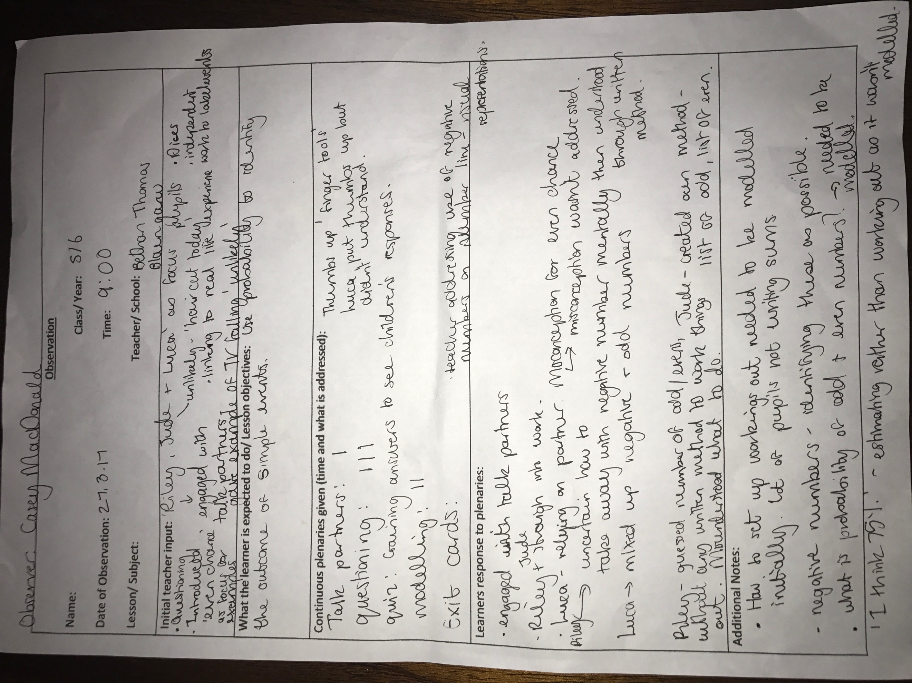

Appendix 2:

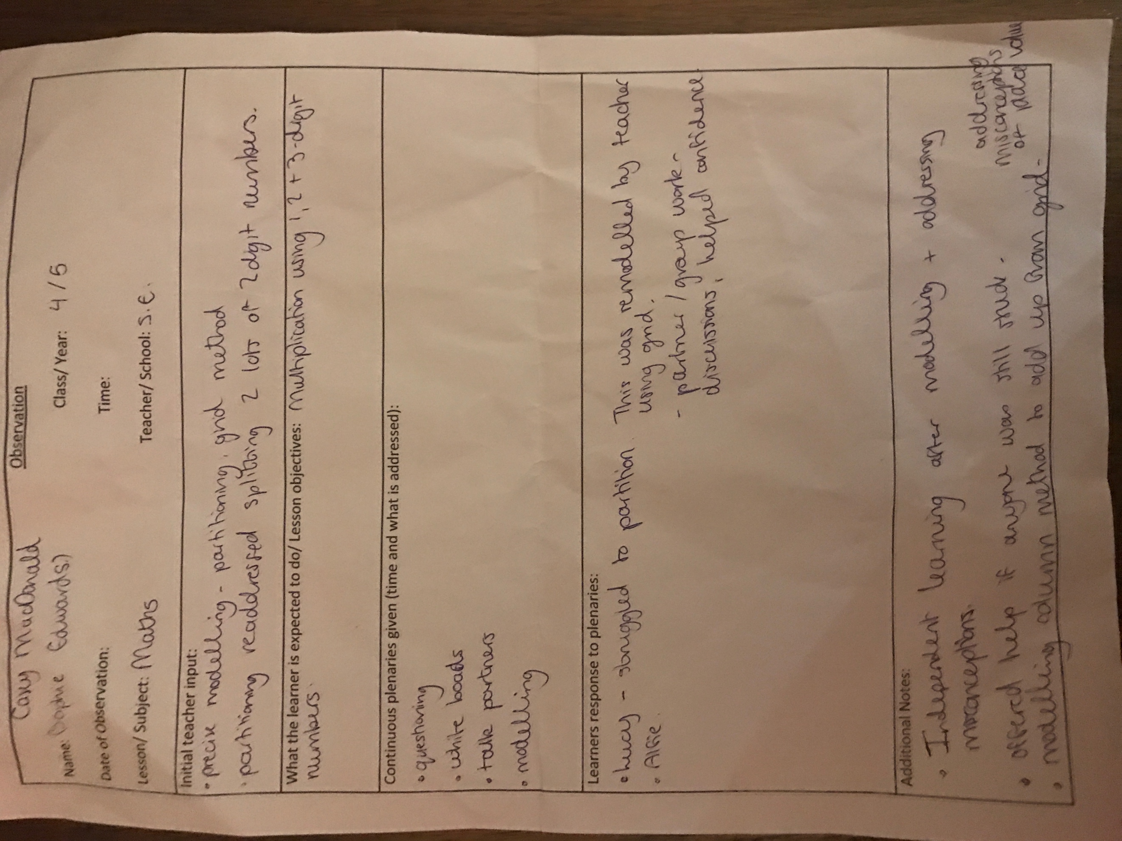

Appendix 3:



