Employability Skills
By
Giaband Hassanzadah
Student Number
1350931

Contents
1.0 Induction………………………………………………………………………………………3
2.0 Main finding………………………………………………………………………………...…4
3.0 Employability factors in the UK…………………………………………………………….5
3.1 Political Factors………………………………………………………………………………5
3.2 Economical Factor……………………………………………………………………………5
3.3 Social Factors……………………………………………………………………………….…6
3.4 Technological Factor………………………………………………………………………….6
3.5 Legal Factors…………………………………………………………………………………...6
3.6 Analysis………………………………………………………………………………………...7
4.0 Personal SWOT Analysis…………………………………………………………………….7
4.1 Figure 1………………………………………………………………………………………... 8
4.1.1 personal assessment……………………………………………………………………….9
4.1.2 Mayer Briggs Type Indicator (MBTI)…………………………………………………….10
4.1.3 16 Personality Type Test………………………………………………………………….10
4.2 Figure 2………………………………………………………………………………………...11
4.2.1 Personal development plan……………………………………………………………….12
5.0 Expected employer’s skills………………………………………………………………….14
5.1 Time managing……………………………………………………………………………….14
5.2 Negation………………………………………………………………………………………14
6.0 Conclusion…………………………………………………………………………………….15
7.0 Reference……………………………………………………………………………………...17

Introduction

This report is about “What are employability skills and why are they so important and how have employability skills changed in the last decade?”
The definition of employability skills related to what education and experiences need to find a good job and to be successful in most roles in the workplace. Many of people move across different employment sectors due to their working life to find better and professional work that can gain the ideal life.
To do this, you need to improve and adapt your skills by considering the future of jobs to look at employment skills and workforce strategy for the future. In early future, the Fourth Industrial Revelation will have happened with a lot of differences such as advanced robotics, artificial intelligence and machine learning.
Which the employability skills are the same as a decade ago and which of them are changed?
Due to World Economic Forum, 2016, Complex problem solving, Critical thinking, People management, Creativity and Coordinating with others are exist in 2015 which are in 2020 too but their priorities have changed for instance: in the ranking of 2015 creativity was the tenth grade of important but in 2020 it will be in third grade. On the other hand, we can mention some skills that will not exist in top 10 skills 2020 such as: Quality control and Active listening. Furthermore, a number of the skills in 2020 were not needed at all in top 10 skills 2015 for example: Emotional intelligence and Cognitive flexibility.

Main finding
There are many employability skills that 3 of them are the most important such as: 1. getting work well and working on interacting with other. You should be effective member of a team, make decision and solve problems with people so for this reason you should be a good listener and gook speaker as well. in order to we can point 2 ways of communication skills. There are skills requested to transport messages from people by speaking or writing.

Verbal communication: it is talking face to face that you can see other people action or reaction by body language or eye contact.
Nonverbal communication: you don’t need to meet anyone in this case you can contact people by sending message or writing letter.
2. being reliable and dependable that is mean what you say, you should do it. However, mean be able see around and check what the job needed and straight away do it. It is better to say be more organized, manage time, trustworthy and conscientious. Sometimes you need to ask for help to get experience or sometimes take some reasonability.
3. willingness to new idea and looking to improving your knowledge. Furthermore, be creative and adaptable.

- Employability Factors in the UK
In this part, I use some information of the UK statistics in the recent years of supermarket industrial about the factors that are affected in employability skills. Because Supermarket industry have huge chain of stores with groceries items and have Job opportunities for foreigner and national community. I am going to discuss the external analysis, personal analysis to find that how they are supporting me join that industry as well as which factors are threatening form to join new joining.
3.1 Political Factors
United Kingdom have high level of government stability to maintain the political stability as the long- term trading agreements have done in 2018. UK is one of the world’s largest trade agreements all over the world and it import, export good throughout the world as UK import in 2018 was 55% from EU, export 51% over the country, and overall good services were about £5.0 billion to £8.3 billion in three months of 2018 (Office of National Statistics UK, 2018). The trade agreement drives future for employee as these industries give opportunities for jobs in their supermarket chain.
3.2 Economical Factor
Current economic condition of UK is increasing every year as it grows in 2017 and Per capita GPD in 2018 was 39,879.698 USD and UK Nominal GDP reached 713.956 USD in 2018. The supermarkets industry in UK grow to strengthening economy rate as annually around 3.8% in 2017 (statista, 2018). UK have employment growth rate increasing that is 76.1 percent higher earlier and 32.71 million people in employment in UK that is annually increasing 24.12 million (Tradingeconomics, 2019). The employment-increasing rate showed feasible for the getting jobs in UK supermarket stores.
3.3 Social Factors
The population growth is increasing in United Kingdom that an estimation 2018 is 66.2 million that is about 66,874,483. The unemployment rate in United Kingdom is down to 3.9 percent and employees are highly demands for supermarket industry. The online shopping ratio increasing in UK because a number of communities uses online apps for their ease including old age community living there who take it easy to shop online (United Kingdom Government, 2019).
3.4 Technological Factor
In United Kingdom, people like to use internet resources to purchase groceries like other countries, the online purchasing increases these days that is 2.3 % in 2018. According to an estimation, total retail of online shopping is from 14.9% to 20.6% that almost $124 billion (Emarketer, 2018). Most of the companies introduced their mobile apps for shopping and keep in touch. Customers use these mobile apps to safe their time and take it much feasible to shop through smartphone.
3.5 Legal Factors
United Kingdom have rules to provide maximum facilities such as medical services, insurance, pay reference leaves from 12-52 weeks. UK market have set some rules for employees during their working hours according to age rage such as for old age labor have 20 to 30 minutes rest break after 6 hours of work. They pay on weekly basis and they have no pay gap policy for their employer as they all are equally get pay (Advisory, Conciliation and Arbitration Service UK, 2019).

3.6 Analysis

External environmental analysis of United Kingdom depicting that it has high growth rate for employment in its supermarket industrial chain. It also depicting that it may have effective government and political stability for its civilians and economic ratio shows the trading improvement in UK. Overall, external analysis depicting that UK supermarket industry is useful and workable place for new entry in business market as an employee as they provide basic facilities such as health and safety rules.
4.0 Personal SWOT Analysis
Personal SWOT analysis is a technique that is using to access about self through personal strengths, weaknesses, external opportunities and threats. This self-analysis is helped the individual to improve the strengths, reduce weakness and take benefits form opportunities through facing threats (Emiliya, Natalia, & Oleg, 2016).
Strengths
- One of my personal ability is that I fulfill my task on scheduled time
- My personal grooming helps me to negotiate professionally with colleagues at workplace
- I have sensitive nature and I do understand other’s problems and help them to solve their problems in workplace
- I can manage my time table for daily schedule plan
Weaknesses
- I feel that I face difficulty to convince customers for purchasing products if needed
- I would like to improve my skills to perfectionism that takes too much to complete big task
- I have weak communication skills
- Weak communication skills prone to stress
Opportunities
- I want to improve my skills for that help me to deal with customers and for this purpose, I must attend some workshop before joining in store
- This job will give me opportunity to support my family to resolve financial issues
- I want to get education related skills improvement that help me out for better results
Threats
- I feel that I will face competition initially from employees who is already working there from long time
- My perfectionism habit will impact my performance
- I feel that work-load on weekends will be threatening for me

4.1 Figure 1: Depicting the SWOT Analysis
Need to Increase
the strengths Need to minimize

Need to minimize Need to avoid
Personal SWTO analysis has revealed my personal strengths and weaknesses that are further needing to improve, minimize and learn new things for this job. I need to groom myself according to this job needs by attending related workshops and minimizing weaknesses and improve personal growth.

4.1.1 Personality Assessment
Personality assessment use to assess the person’s proficiency that involves administration, scoring and interpret measurements about personality traits. I used to follow two-personality test to assess my personality and find out my strengths and weaknesses that will help me to improve those aspects.
4.1.2 Mayer Briggs Type Indicator (MBTI)
MBTI is a self- report questionnaire that use to indicate the perception of people around them that how they perceive and interpret the world. (Myers & Briggs Foundation, 2018). I use this questionnaire to assess my personality type, and how it affects my perception towards surrounding. The findings declared that my personality type is ISTJ that predicting that I have introvert personality as well as less likely to work as self-employed. I am less talkative as compared to others and I do not take initiative in conversation with anyone. Most of the time I feel drained and exhausted and keep silent.
4.1.3 16 Personality Type Test
This is a self-report measure in which the individual measures about themselves and that measure indicate their thought and information about themselves. I have used this personality type test to measure my thoughts and belief that how I take things around and how those things have an effect on my belief system (Myers & Briggs Foundation, 2018).

4.2 Figure 2: Results indication of Personality Type
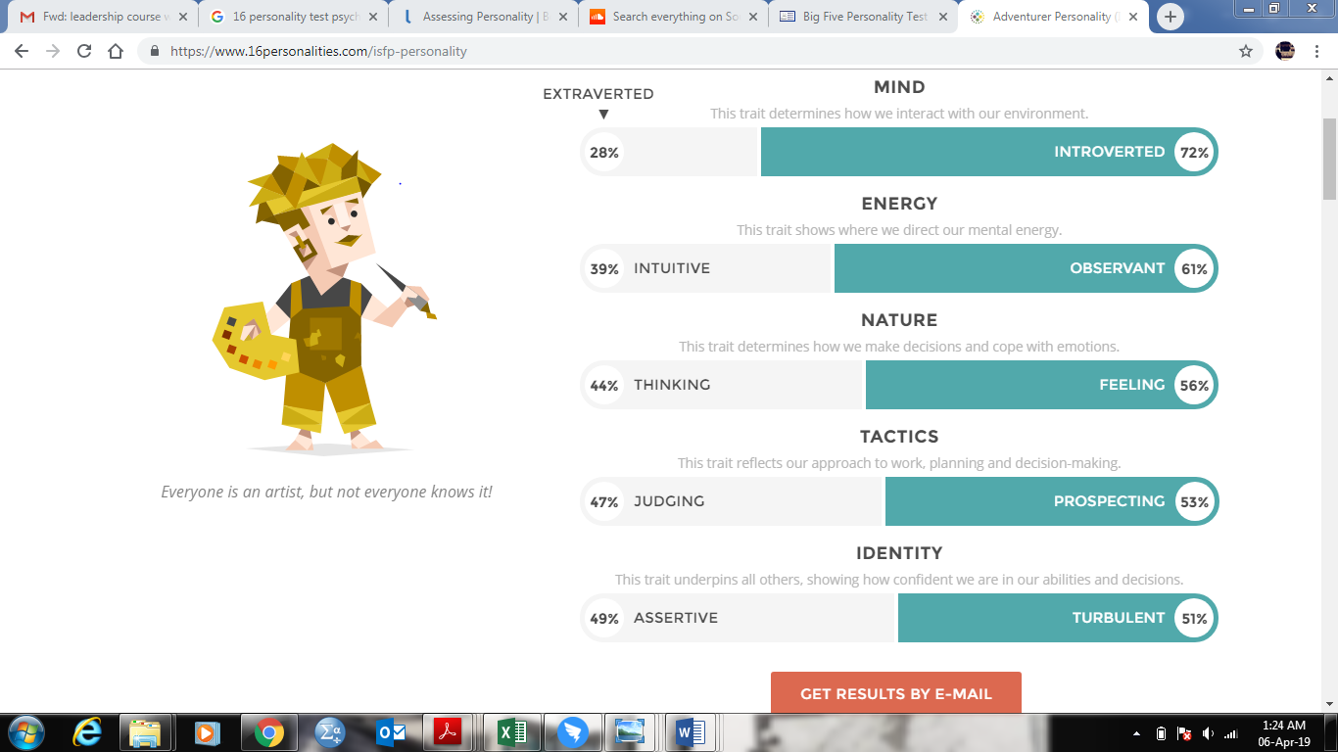
The findings of this result depicting that my personality is introvert type that is 72% in the result bar. I have 61% of energy that is positive point for learning new things and managing things in future if I utilize this energy. I have ability to cope with my emotions that is 56% that depicting I have control on my emotions. I have ability to take decision that is 53% in results, which indicated that I have ability to plan new purposeful things. In the last, I got 51% scores on identity type that illustrate that I have confidence on myself that help me to cope in future.

4.2.1 Personal Developmental Plan
Objectives | How to achieve | Resources required | How to evaluate | Duration | Deadline | Cost
Difficulty to convince customers | Attending workshops related to customer services and apply in workplace | Register in seminars who scheduled these workshops | I can evaluate through daily practice in my workplace during dealing customers | 2-3 months | June 2019 | $ 200
Communication Skills | Watching speakers who are good in conveying  Practicing at my work place with colleagues | Internet and colleagues to practice with them.  Later on, practicing with colleagues | Being able to satisfy a customer regarding purchasing | 3-4 months | August 2019 | Not Applied
Perfectionist | study about time management and follow a set time schedule | internet, related books and brochures on this topic | by maintain behavior record form on completing task in set time | 4-5 months | September 2019 | Not Applied
Reduce stress | consulting psychologist for stress management and follow the techniques given by him | psychologist appointment | By follow up to psychologist’s techniques and practicing in workplace | 6 months | October2020 | $200

In conclusion, I have discussed my personal developmental plan that is based on external analysis, internal analysis threat and opportunities of the new job in supermarket industry of United State of America. For this purpose, I have go through PESTEL and SWOT for external analysis which indicated that this job is suitable for me in US if I managed my weakness than it would be easy for me to adjust there. after that, I must assess myself through psychological assessment using 16 personality type test and Mayer’s Briggs type test that indicate my personality type as well as my perception towards world that help me to design my developmental plan

- Expected employers’ skills
There are many employability skills which are important for employers. As you know, for any businesses, special skills are considered by the employers, but it is interesting to know that several skills are common to all workplaces which are in the top priority to recruitment of people. Among them, I would like to point, time management, negotiation and inter-personal communication.
5.1 Time management
Time management is the process of organizing and planning your time to finish your plan. By time management, even in tight time you can done your work. The highest achievement of goal will happen if you have an accrue planning for your time. As a manager I sure that an employer who has punctuality and works good at specific time to do her or his duty is the best choice to hire and promote the position.
5.2 negotiation
Negotiation is a method of argument and solving problem in the good way that use by people in routine life to prevent of challenges which makes conflicting. Negotiation skills has many benefits for workplace to meet new people and discus about different subjects. To have a good negotiation skill you should following this process:
1.prepareation, is understanding the situation, place and the subject related to negotiation.
2. discussion, this stage is including of questioning, listening and clarifying. Sometimes is good a take a note during the discussion to get the keywords.
3.clarification of goals, it is often to recognize the aims and interests of both sides of negotiation. Moreover, it is so helpful to list these factors in order of priorities.
4.negotiation towards a win-win outcome, this stage focuses on the positive things in the process that both sides feel their point of view has been taken into consideration.
5.agreement, this means that both sides understand the main point of the topic and everyone involved to keep an open mind in order to achieve their goal.
6.implementation of a court of action, there are some courses to implement and get knowledge which can used by employees.
6.0 Conclusion
Employability skills are necessary at all workplaces for everyone who are looking for an employment chance and who wants to promote in their position. According the statistic, in the last ten years this essential skills have changed because of advancement in economy, businesses and technology. I try to describe employability situation by using specific field. To do this, I research in supermarket industrial in the Uk.
In the five years future, more than thirty five percent of today daily skills will have changed and many of the going to be disappeared, some of them will grow and some job will be commonplace that don’t even exist today. These changes will transform the new way for life and work. For instance, it is predicated that this skills are in the order priority of the top 10 key skills in 2020, complex problem solving, critical thinking, creativity, people management, coordinating with others, emotional intelligence, judgement and decision making, service orientation, negotiation and cognitive flexibility.
In the future robots will help us to get what we need to do easier, so it has many consequences which the most important is reduce vacancy in the workplace. In order to reduce bad affect of this in our life we have to improve our ability in the same time with this advance.

7.0 References
Advisory, Conciliation and Arbitration Service UK. (2019, Feb 10). Employment law update. Retrieved from Acas.org.uk: http://www.acas.org.uk/index.aspx?articleid=3909&gclid=Cj0KCQjw7sDlBRC9ARIsADpDFo0LCgsQyu1aqwbFUVymc9xgEoWqQCIO13ClC863HggZBaKEV95V8caAkFeEALw_wcB
Auzenne, J. R. (2012). Opportunities Overflow in Retailing Industry. California: The Black Collesion.
Emarketer. (2018, November 19). UK Retail and Ecommerce Digital Disrupts, but In-Store Remains Important. Retrieved from Emarketer: https://www.emarketer.com/content/uk-retail-and-ecommerce-2018
Emiliya, P., Natalia, V., & Oleg, A. (2016). SWOT-Analysis as a Tool to Achieve a State of Personal WellBeing. International Scientific Symposium on Lifelong Wellbeing in the World.
Lana Bandoim. (2018, september 11). forbes. Retrieved from Grocery App Usage Will Grow By 50%: What This Means For The Industry: https://www.forbes.com/sites/lanabandoim/2018/09/11/grocery-app-usage-will-grow-by-50-what-this-means-for-the-industry/#5090ebf064dd
Myers & Briggs Foundation. (2018, September 26). MBTI . Retrieved from Myers & Briggs Foundation: https://www.myersbriggs.org/my-mbti-personality-type/take-the-mbti-instrument/
Office of National Statistics UK. (2018, August 10). Office for National Statistics. Retrieved from ons.gov.uk: https://www.ons.gov.uk/economy/nationalaccounts/balanceofpayments/bulletins/uktrade/may2018
statista. (2018). Gross domestic product (GDP) year-on-year growth in the United Kingdom (UK) from 2000 to 2018. Retrieved from statista: https://www.statista.com/statistics/281734/gdp-growth-in-the-united-kingdom-uk/
Tradingeconomics. (2019, March 3). Trending Econimics. Retrieved from Tradingeconomics: https://tradingeconomics.com/united-kingdom/unemployment-rate
World Wildlife Fund UK. (2017, October 16). River health is one of the UK’s most urgent environmental crises. Retrieved from wwf.org.uk: https://www.wwf.org.uk/updates/40-rivers-england-and-wales-polluted-sewage
- World Economic Forum, 2016
- https://www.skillsyouneed.com/general/employability-skills.html

