CRAAP TEST Activity: Part 1:
In this activity, you will use the journal article provided to apply the CRAAP Test and evaluate the source. Your goal is to determine whether the article is appropriate and relevant for addressing the question:
To what extent are academic skills useful in the workplace?
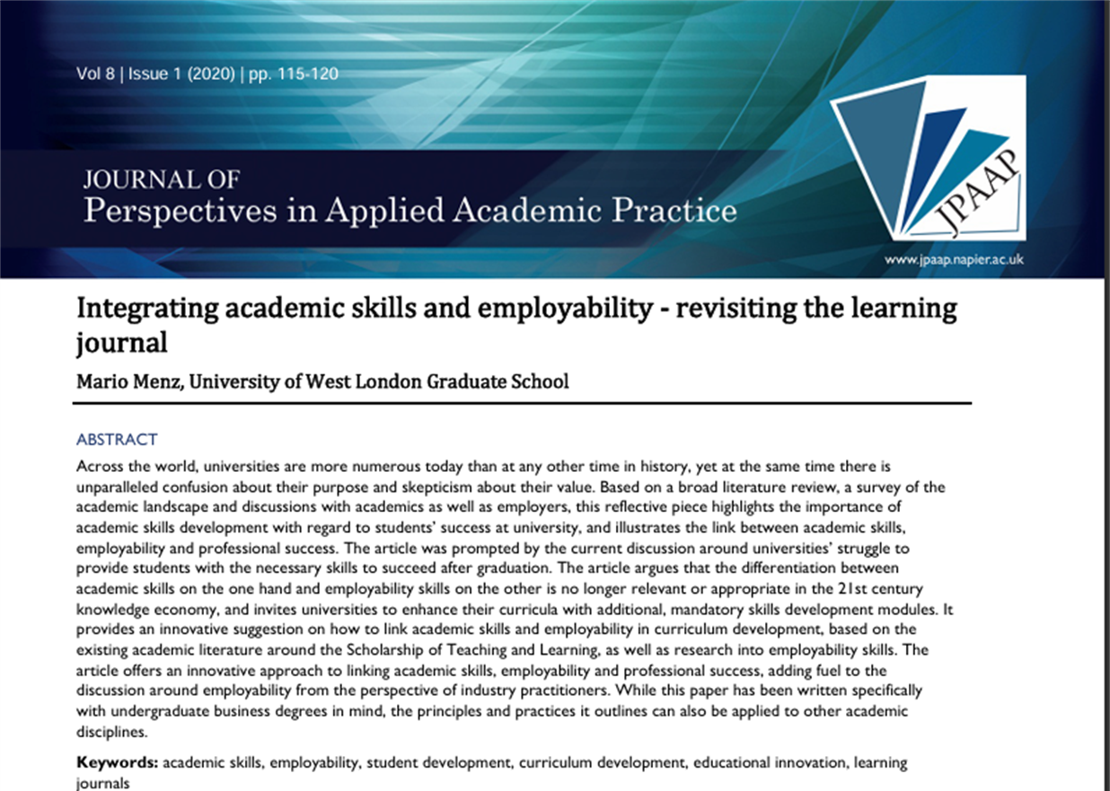

Currency
Relevance
Authority
Accuracy
Purpose

