University of Wales Trinity Saint David
Wales Institute of Science and Art


Automotive Materials and Sustainability
ACHA6012
Owen Roberts
2203329
04/05/2025
Word Count: 3248
Contents
1 Introduction 4
2 Literature Review 5
3 Experimental Testing 7
3.1 Experimental Procedure 7
4 Results 10
4.1 Aluminium 10
4.2 Hemp Non-Woven Bio-Resin 13
4.3 Carbon Non-Woven Bio-Resin 15
4.4 Carbon Woven Bio-Resin 17
4.5 Carbon Woven Epoxy Resin 19
4.6 Flax Non-Woven Bio-Resin 21
4.7 Flax Woven Bio-Resin 24
4.8 Kevlar Woven Bio-Resin 26
4.9 Comparison 28
5 Sustainability 30
6 Recommendations 31
7 References 32

Table of Figures
Figure 1 Aligned Fibres 6
Figure 2 Random Fibres 6
Figure 3 Woven Fibres 6
Figure 4 Denison Tensile Testing Equipment 7
Figure 5 Calibration Date of Tensile Testing Equipment 8
Figure 6 Aluminium Sample Piece 10
Figure 7 Stages of Aluminium Tensile Failure 10
Figure 8 Close-up of Aluminium necking 11
Figure 9 Aluminium Test Specimens after Failure 11
Figure 10 Aluminium - Ultimate Tensile Strength 11
Figure 11 Aluminium Tensile Strength sourced from ANSYS Granta 12
Figure 12 Hemp Non-Woven Bio-Resin Sample Pieces 13
Figure 13 Stages of Failure Hemp Non-Woven Bio Resin 13
Figure 14 Hemp Non-Woven Bio-Resin Specimens After Failure 14
Figure 15 Hemp Non-Woven Bio-Resin - Ultimate Tensile Strength 14
Figure 16 Carbon Non-Woven Bio-Resin Sample Pieces 15
Figure 17 Stages of Failure Carbon Non-Woven Bio-Resin 15
Figure 18 Carbon Non-Woven Bio-Resin Specimens After Failure 16
Figure 19 Carbon Non-Woven Bio-Resin - Ultimate Tensile Strength 16
Figure 20 Carbon Woven Bio-Resin Sample Pieces 17
Figure 21 Stages of Failure Carbon Woven Bio-Resin 17
Figure 22 Carbon Non-Woven Bio-Resin Specimens After Failure 18
Figure 23 Carbon Woven Bio-Resin - Ultimate Tensile Strength 18
Figure 24 Carbon Woven Epoxy Resin Sample Pieces 19
Figure 25 Stages of Failure Carbon Woven Epoxy-Resin 19
Figure 26 Carbon Woven Epoxy Resin Specimens after Failure 20
Figure 27 Carbon Woven Epoxy Resin - Ultimate Tensile Strength 20
Figure 28 Flax Non-Woven Bio-Resin 21
Figure 29 Stages of Failure Flax Non-Woven Bio-Resin 21
Figure 30 Flax Non-Woven Bio-Resin Specimens after Failure 22
Figure 31 Flax Non-Woven Bio-Resin - Ultimate Tensile Strength 22
Figure 32 Stress (MPa) vs Time (s) - Flax Non-Woven Bio 23
Figure 33 Flax Woven Bio-Resin Sample Pieces 24
Figure 34 Stages of Failure Flax Woven Bio-Resin 24
Figure 35 Flax Woven Bio-Resin Specimens after Failure 25
Figure 36 Close up image of defect in material Vs Failure Point 25
Figure 37 Flax Woven Bio-Resin - Ultimate Tensile Strength 25
Figure 38 Kevlar Woven Bio-Resin Sample Pieces 26
Figure 39 Stages of Failure Kevlar Woven Bio-Resin 26
Figure 40 Kevlar Woven Bio-Resin Specimens after Failure 27
Figure 41 Kevlar Woven Bio-Resin - Ultimate Tensile Strength 27
Figure 42 Ultimate Tensile Strength – Comparison 28
Figure 43 Graph of Time vs Stress - Aluminium and Carbon Woven Epoxy Resin 29

Table of Equations
Equation 1 Stress equation…………………………………………..……………………………..……………………..….…..7
Equation 2 Formula for Composite Longitudinal (Upper Limit)……………………………..…..………………….…..9
Equation 2 Formula for Composite Transverse (Lower Limit)……………….…….……………..………………….…..9

1 Introduction
The high strength-to-weight and superior performance of composite materials have led to an increase in their use in the automotive and motorsport industries. However, growing concerns about sustainability requires an in-depth assessment of their environmental impact and long-term feasibility.
This study investigates the properties and performance of a range of materials through empirical testing and analysis. By assessing the experimental data and comparing with existing data, trade-offs between performance and sustainability will be identified and based on these findings recommendations will be suggested.

2 Literature Review
Increasing concerns around the environmental impact of synthetic composite materials has led to increased research into natural fibre composites. Composites can reduce aerodynamic drag and improve efficiency; this can be especially important in applications such as electric vehicles where heavy battery technology can be offset by the use of lightweight composites. Traditional composite materials such as carbon fibre and Kevlar are energy intensive to produce, and the curing process makes them difficult to recycle due to complications with separation and recovery (Crowe, 2023).
Traditional synthetic composites such as carbon fibre and Kevlar are widely used because of their excellent mechanical properties. For example, carbon fibre provides good tensile strength and stiffness while maintaining low density, both of which are properties critical to motorsport applications. The production process for carbon fibre typically emits around 20-30kg of CO₂ per kg of fibre produced (Nature, 2024). Additionally, epoxy resin, the matrix material most commonly used with synthetic fibres, is derived from petrochemical sources, meaning they are not biodegradable, making end-of-life disposal and recycling complicated (Kabir et al., 2024).
Natural fibres such as hemp and flax, compared to synthetic fibres, have reduced environmental impact and increased biodegradability. According to Atmakuri. (2022), benefits of natural fibre-reinforced composites include their abundance, cost-effectiveness, sustainability and lightweight nature. There is already evidence of natural fibre composites being used in motorsport applications, most notably in formula E and some touring car series, where flax composites have been used for interior panels and non-structural aerodynamic devices (Mirmohammad, 2024).
Although natural fibre composites have many advantages, drawbacks include durability and moisture absorption which can weaken the composite material. Almansour and Luqman (2020) found that natural fibres tend to degrade at relatively low temperatures (around 200°C) and they have poor fire resistance – this could become a limitation in applications involving high temperature for example brake ducts. They also found that the overall strength of natural fibre composites increases with fibre content up to a point – after which they rapidly decline, due to the weak interfacial adhesion between the matrix and reinforcement material.
Epoxy resins are commonly used because of how easy they are to work with and their good mechanical properties. However, they have downsides too – they are not biodegradable, chemically harsh and are not skin-friendly. An alternative to Epoxy resins are Bio-Resins. Kabir et al. (2024) states that one of the most challenging issues to overcome is finding the correct balance between material performance and sustainability. Despite natural fibres being more sustainable, they are most often combined with non-recyclable resins, which limits environmental greenness when it comes to end of life.
Despite an abundance of research on short term mechanical testing under laboratory testing for natural fibre composites, these is a lack of longer-term durability studies that include the effects of UV exposure and temperature cycling for example.
Composite materials are comprised of two phases: the Primary phase, or matrix and the secondary phase, the reinforcing phase. The matrix in this case is the Bio-Resin or Epoxy; the goal of the matrix phase is to have good shear properties and a low density. The Reinforcing phase in this investigation refers to the fibres (hemp, carbon, flax, Kevlar) the main goal if the reinforcing phase is to contribute high strength and stiffness and low-density properties.
Fibre orientation has a significant effect on the properties of composite materials. There are three main ways that fibres tend to be oriented within composite materials.


Aligned Fibres orientation means that the composite will be highly effective along the fibre direction.
Figure 1 Aligned Fibres


Whilst random fibre orientation is easy and cheap to produce, they do not provide the same level of strength or directional stiffness as the aligned fibre composites (Callister & Rethwisch, 2018).
Figure 2 Random Fibres

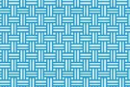
Due to their interwoven structure, woven Fibres provide far higher strength than random fibres but are comparatively far more expensive to produce. When loaded in a single direction, they tend to have lower strength than aligned fibres, mainly down to crimping effects and load path inefficiencies (Hull & Clyne, 1996).
Figure 3 Woven Fibres

3 Experimental Testing

3.1 Experimental Procedure
In order to conduct experimental testing and analysis the Denison Tensile Testing equipment will be used as shown in figure 4.
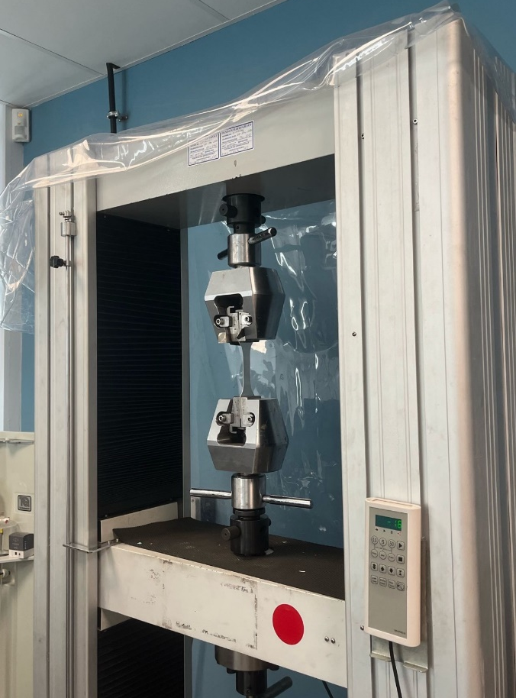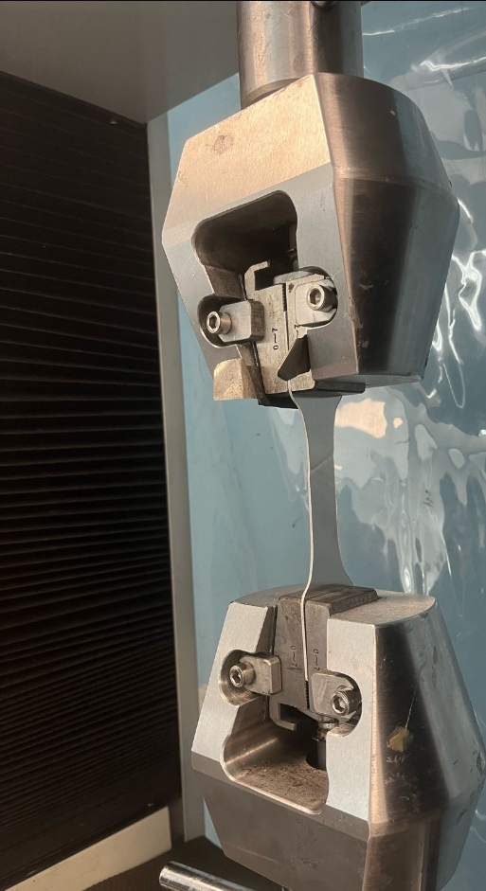
Figure 4 Denison Tensile Testing Equipment
The equipment works by clamping the material in the jaws and then applying a controlled tensile force until the material fails, whilst recording the tensile force in Kilonewtons. In order to calculate the stress at which each material fails, it is essential to take measurements of the cross-sectional area. This, combined with the load measurements recorded by the tensile testing, allows the calculation of stress. Due to the brittle properties of composite materials, extensometers were not used to record strain to avoid equipment damage. As a result, measurements of strain and Young's modulus could not be derived. Therefore, the focus of this investigation is on determining Ultimate Tensile Strength (UTS) for each material tested.
$$σ= \frac{F}{A} Stress (MPa)= \frac{Force (kN)}{Cross Sectional Area (mm^{2})}$$
Equation 1 Formula for stress
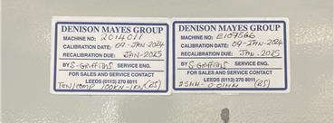
Figure 5 Calibration Date of Tensile Testing Equipment
Figure 5 shows the calibration date of the tensile testing equipment (09/01/2024), it also states that the recalibration is due January 2025, the tests for this experiment were carried out from the 24th – 28th February 2025, meaning that the machine was not technically calibrated at the time of testing. This poses issues such as potentially compromising accuracy with data, therefore this should be acknowledged as a limitation.
The aim of the experiment is to evaluate a range of materials, including both traditional and natural reinforced fibre composites, and aluminium to act as a comparison. The process used to produce the test specimens is resin infusion. Resin infusion is a process where the reinforcement material is placed into a mould and the resin is drawn through under vacuum pressure. This process helps ensure full permeation of the matrix phase (Campbell, 2010).
As composite materials tend to shatter when they fail, relevant health and safety precautions must be adhered to whilst conducting these tests, safety goggles are worn in order to protect eyes from potential shrapnel that may occur when the material fails.
The materials that will be tested in this investigation are as follows:
- Aluminium
- Hemp Non-Woven Bio-resin
- Carbon Non-Woven Bio-Resin
- Carbon Woven Bio-Resin
- Carbon Woven Epoxy Resin
- Flax Non-Woven Bio-Resin
- Flax Woven Bio-Resin
- Kevlar Woven
A minimum of 13-14 tensile tests were conducted for each material to ensure an adequate sample size for reliability. The tensile test data will then be exported and processed to find maximum stress seen by each material before failure, or Ultimate Tensile Strength (UTS). Due to the omission of strain data, other mechanical properties such as elastic modulus and failure strain could not be evaluated.
It is also worth noting that ‘high-speed’ tests were carried out, although only one test was done for each material. Due to the low sample size, this data will be excluded from this investigation.

For materials where the UTS is not stated for the material and matrix combined, equations 2 & 3 must be used, they take into account the UTS of both phases and their volumes. Equation 2 is for the UTS in the longitudinal direction, and equation 3 is for the transverse direction, therefore, because the layups are done at 45° to each other, they act as the upper and lower limits.
$$σ_{c}=σ_{f}V_{f}+σ_{m}V_{m}$$
Equation 2 Formula for Composite longitudinal UTS (Upper Limit)
$$σ_{c}=\frac{σ_{m}σ_{f}}{V_{m}σ_{f}+V_{f}σ_{m}}$$
Equation 3 Formula for Composite Transverse UTS (Lower Limit)

Where:
- $σ_{c}=Composite UTS$
- $σ_{f}=Fibre UTS$
- $σ_{m}=Matrix UTS$
- $V_{f}=Fibre Voume Fraction$
- $V_{m}=1-V_{f}$

4 Results

4.1 Aluminium
As a baseline comparison specimen, aluminium was selected due to its widespread use in automotive industries particularly for structural components and body panels where lightweighting is critical.
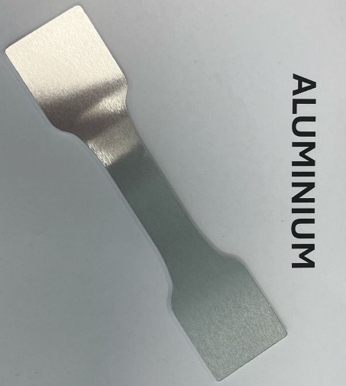
Figure 6 Aluminium Sample Piece
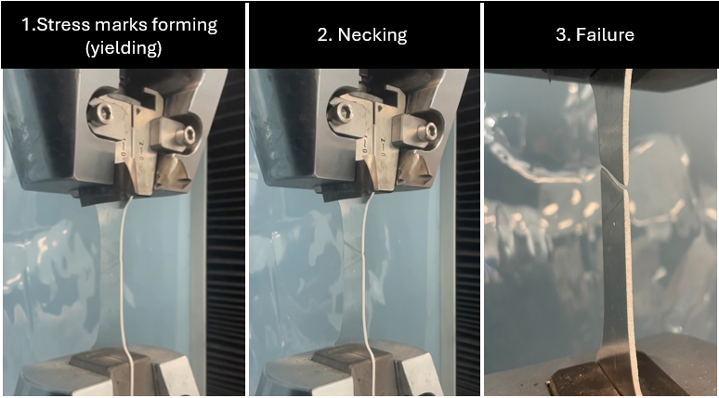
Figure 7 Stages of Aluminium Tensile Failure

Figure 8 Close-up of Aluminium necking
Figures 7 and 8 show the necking of aluminium before and after the final failure.
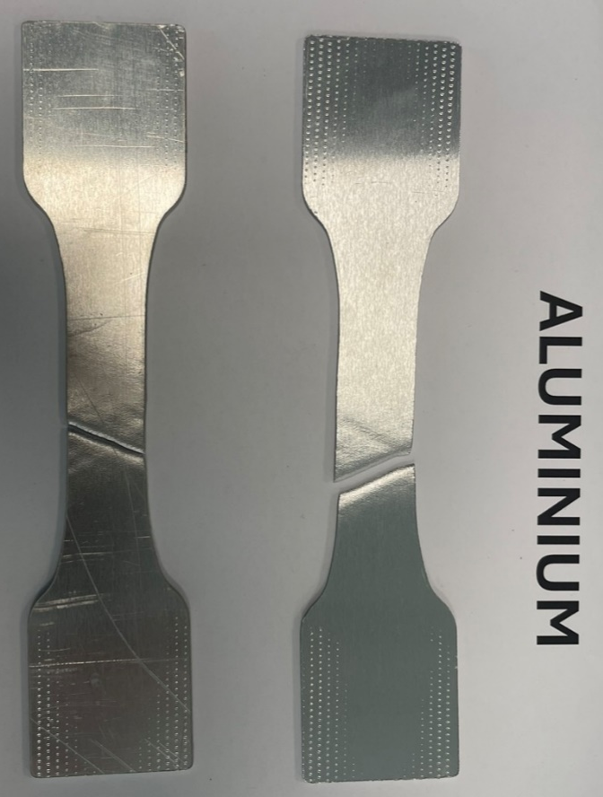
Figure 9 Aluminium Test Specimens after Failure
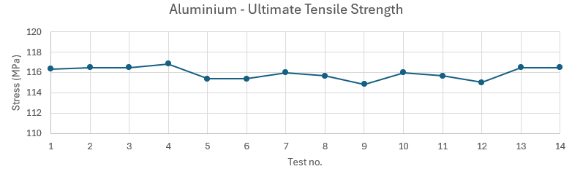
Figure 10 Aluminium - Ultimate Tensile Strength
Figure 10 shows the Ultimate Tensile Strength (UTS) for each sample tested. UTS is the maximum stress the material can withstand before failure.
Over the 14 tests carried out, there were no significant material defects or anomalies detected among the specimens, the average UTS was 115.93 MPa with a deviation of just 1.71%, pointing to reliable and consistent results.
Figure 11 Aluminium Tensile Strength sourced from ANSYS Granta
Data gained from ANSYS Granta shows that the standard tensile strength of aluminium 3105 ranges from 119 and 131 MPa, therefore the experimental average of 115.93 MPa falls within 2.58% of specified manufacturer range, validating the reliability of the testing procedure despite the machine’s overdue calibration status.

4.2 Hemp Non-Woven Bio-Resin
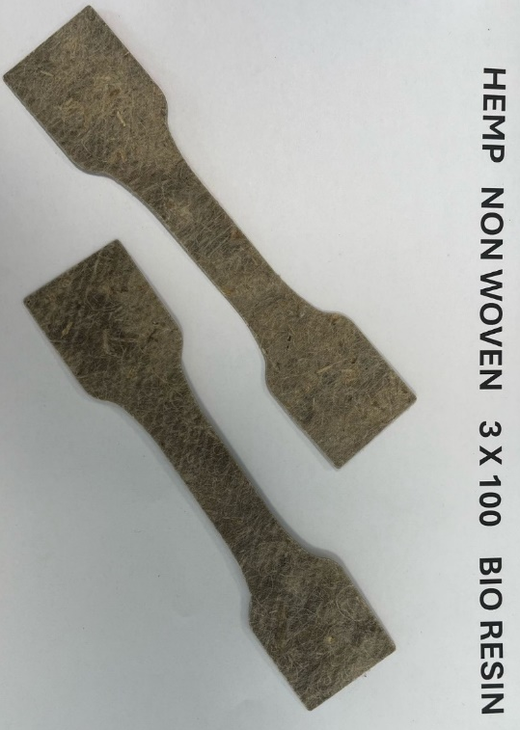
Figure 12 Hemp Non-Woven Bio-Resin Sample Pieces
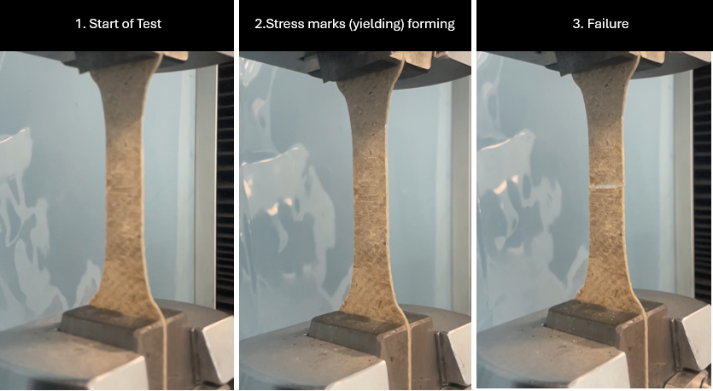
Figure 13 Stages of Failure Hemp Non-Woven Bio Resin

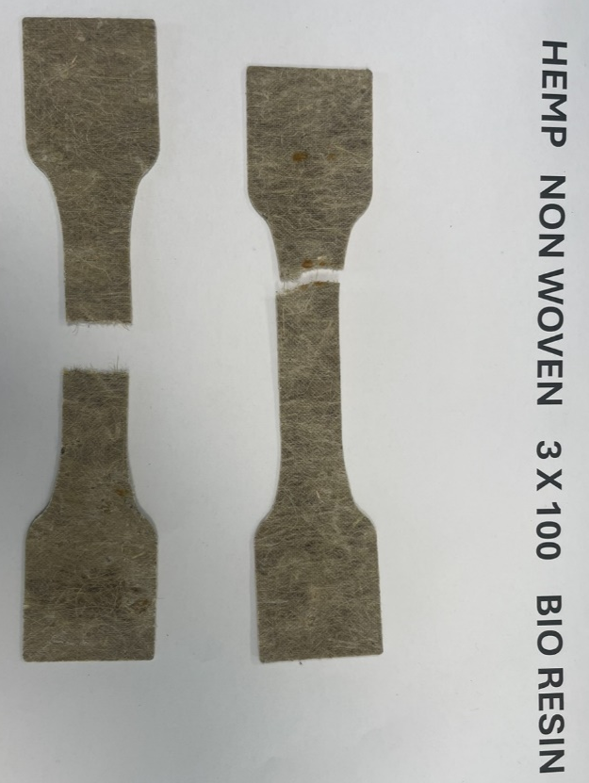
Figure 14 Hemp Non-Woven Bio-Resin Specimens After Failure

Figure 15 Hemp Non-Woven Bio-Resin - Ultimate Tensile Strength
Over the 14 tests carried out, the average UTS was 23.9 MPa with a deviation between the minimum and maximum UTS of 74.04%, pointing to unreliable and inconsistent results.
According to the technical data sheets from EcoTechnilin, where the Hemp was sourced, the minimum UTS should be 40 MPa with a tolerance of ±6 MPa. The MPa range seen by the experimental data is 29 MPa. The average experimental UTS falls well below the quoted UTS, pointing to variability in manufacturing or testing, poor fibre alignment, or material defects.

4.3 Carbon Non-Woven Bio-Resin
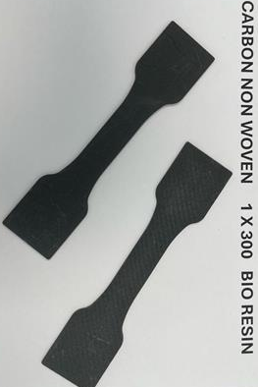
Figure 16 Carbon Non-Woven Bio-Resin Sample Pieces

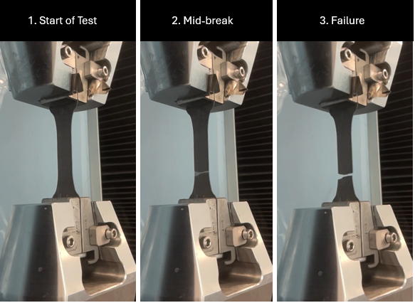
Figure 17 Stages of Failure Carbon Non-Woven Bio-Resin
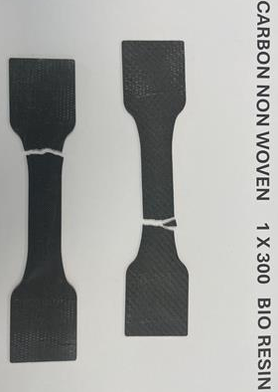
Figure 18 Carbon Non-Woven Bio-Resin Specimens After Failure

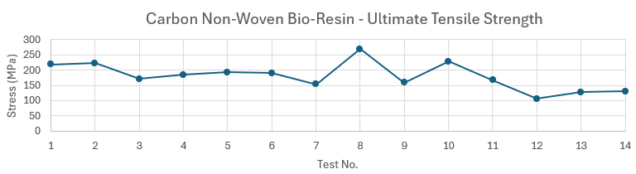
Figure 19 Carbon Non-Woven Bio-Resin - Ultimate Tensile Strength
Over the 14 tests carried out, the average UTS was 180 MPa with a deviation between the minimum and maximum UTS of 60.04%, pointing to unreliable and inconsistent results. There is a range of 163 MPa across the set of results.
According to the technical data sheets from easycomposites, where the Carbon Fibre Non-Woven mat was sourced, the minimum longitudinal UTS should be 290 MPa. The MPa seen in the experimental data is just 62% of this. Although it should be noted that the tensile strength on the data sheet is assuming a 30% fibre fraction and doesn’t consider the discrepancies between bio-resin and traditional epoxy resin, whereas the sample used in this test was a 50/50 fibre fraction (Information for the 50% fibre fraction is unavailable).

4.4 Carbon Woven Bio-Resin
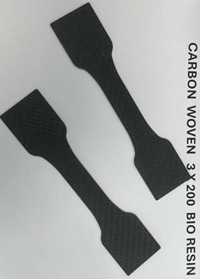
Figure 20 Carbon Woven Bio-Resin Sample Pieces

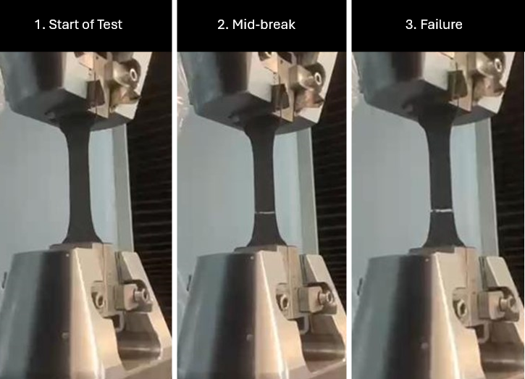
Figure 21 Stages of Failure Carbon Woven Bio-Resin
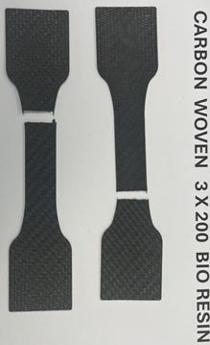
Figure 22 Carbon Non-Woven Bio-Resin Specimens After Failure

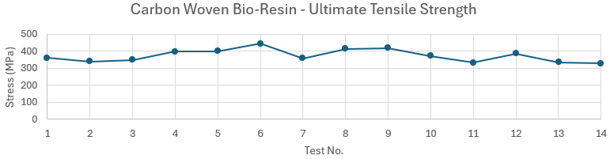
Figure 23 Carbon Woven Bio-Resin - Ultimate Tensile Strength
Over the 14 tests carried out, the average UTS was 373.83 MPa with a deviation between the minimum and maximum UTS of 26%. There is a range of 115.69 MPa across the set of results.
According to the technical data sheets from PYROFIL, where the Carbon Fibre Woven mat was sourced, the UTS of the fibre should be 4120 MPa, and the Matrix is 68 MPa, assuming a 50/50 volume fraction, the theorhetical longitudinal (upper limit) and transverse (lower limit) UTS values are calculated as follows:
$$σ_{c }(Upper Limit)=0.5*4120+0.5*68=2060+34=2094 MPa$$
$$σ_{c }\left(Lower Limit\right)=\frac{σ_{m}σ_{f}}{V_{m}σ_{f}+V_{f}σ_{m}}=\frac{68*4120}{0.5*4120+0.5*68}=\frac{280160}{2094}=133.81 MPa$$

The average MPa seen in the experimental data of 373.83 MPa falls within the expected theoretical bounds, being 82.16% lower than the upper limit, and 179.4% higher than the lower limit – possibly due to the 45° layup direction.

4.5 Carbon Woven Epoxy Resin
Figure 24 Carbon Woven Epoxy Resin Sample Pieces

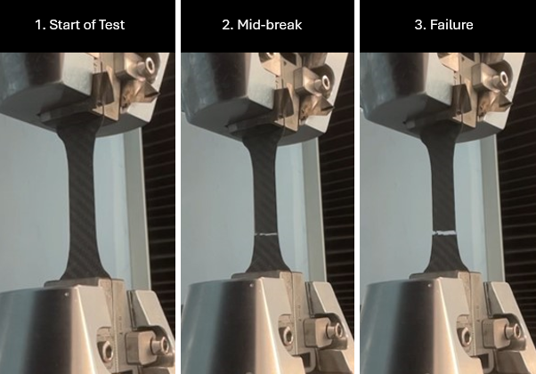
Figure 25 Stages of Failure Carbon Woven Epoxy-Resin

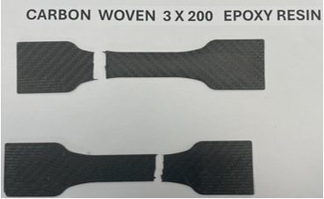
Figure 26 Carbon Woven Epoxy Resin Specimens after Failure

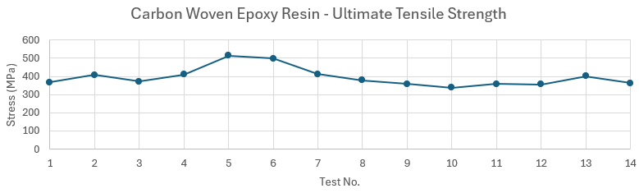
Figure 27 Carbon Woven Epoxy Resin - Ultimate Tensile Strength
Over the 14 tests carried out, the average UTS was 395.42 MPa with a deviation between the minimum and maximum UTS of 34.25%. There is a range of 175.78 MPa across the set of results.
According to the technical data sheets from PYROFIL, where the Carbon Fibre Woven mat was sourced, the UTS of the fibre should be 4120 MPa, and the Matrix is 77 MPa, assuming a 50/50 volume fraction, the theoretical longitudinal (upper limit) and transverse (lower limit) UTS values are calculated as follows:
$$σ_{c }(Upper Limit)=0.5*4120+0.5*77=2060+38.5=2098.5 MPa$$
$$σ_{c }\left(Lower Limit\right)=\frac{σ_{m}σ_{f}}{V_{m}σ_{f}+V_{f}σ_{m}}=\frac{77*4120}{0.5*4120+0.5*77}=\frac{317240}{2098.5}=151.23 MPa$$
The average MPa seen in the experimental data of 395.42 MPa falls within the expected theoretical bounds, being 81.19% lower than the upper limit, and 161.5% higher than the lower limit – possibly due to the 45° layup direction.

4.6 Flax Non-Woven Bio-Resin
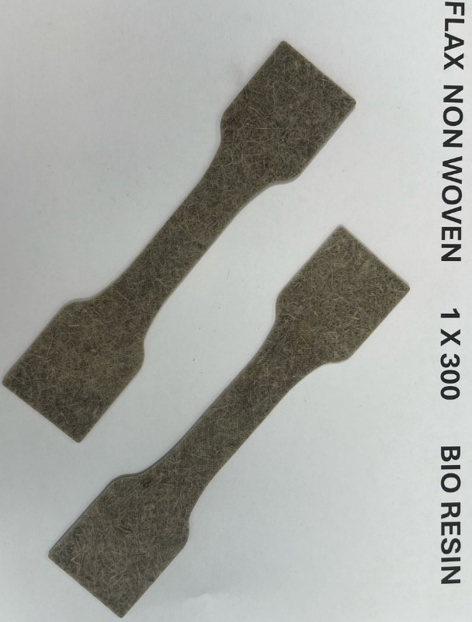
Figure 28 Flax Non-Woven Bio-Resin

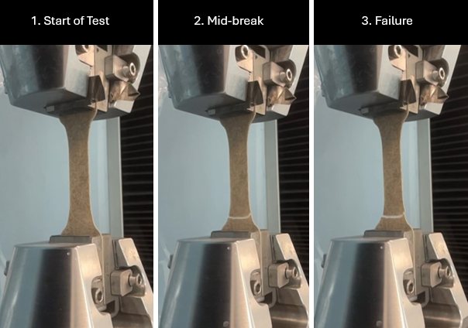
Figure 29 Stages of Failure Flax Non-Woven Bio-Resin

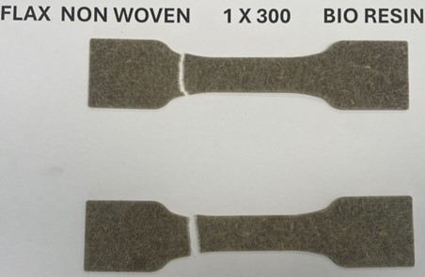
Figure 30 Flax Non-Woven Bio-Resin Specimens after Failure

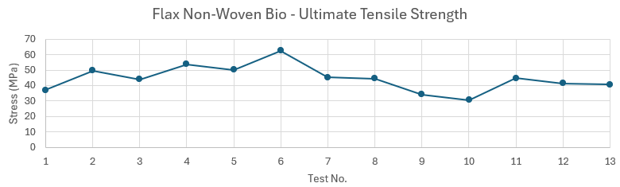
Figure 31 Flax Non-Woven Bio-Resin - Ultimate Tensile Strength
Over the 13 tests carried out, the average UTS was 44.56 MPa with a deviation between the minimum and maximum UTS of 50.93%. There is a range of 31.892 MPa across the set of results.
According to the technical data sheets from EcoTechnilin, where the Flax Non-Woven mat was sourced, the UTS should be 44 MPa ±4 MPa. This means that the average UTS seen across the range of tests is within the tolerance of the specified UTS, however only 6 out of the 13 tests fell within this tolerance range.
According to Almansour, F. and Luqman, M. (2020) flax fibres, due to their helical structure, can see nonlinear failure under tensile loading conditions, this is because these structures unwind to a looser helix under tensile loading meaning that they realign with the tensile loading axis.
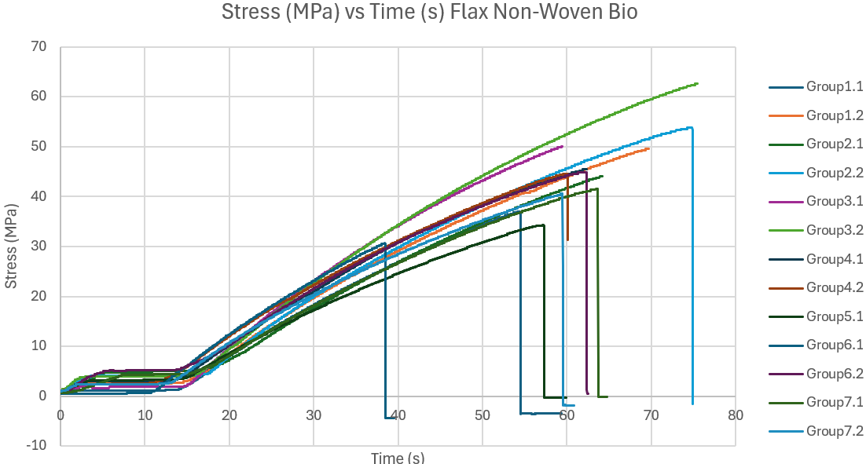
Figure 32 Stress (MPa) vs Time (s) - Flax Non-Woven Bio
Comparison of the stress vs time curves across all materials tested revealed that other materials exhibited mostly linear behaviour, whereas flax non-woven demonstrated progressive stiffening during the tensile loading, aligning with previously stated findings from Almansour, F. and Luqman, M. (2020).

4.7 Flax Woven Bio-Resin

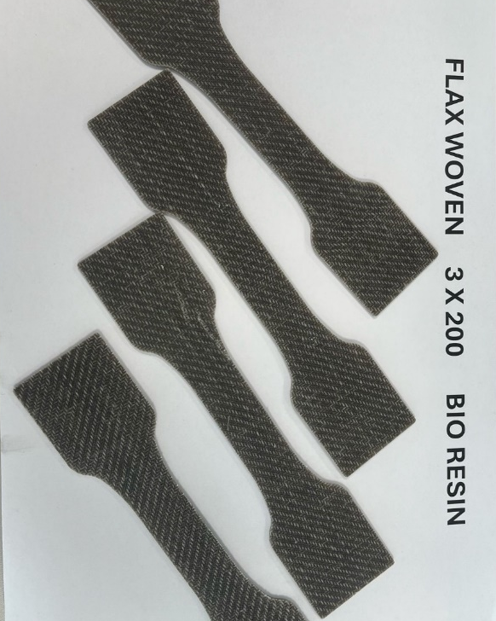
Figure 33 Flax Woven Bio-Resin Sample Pieces
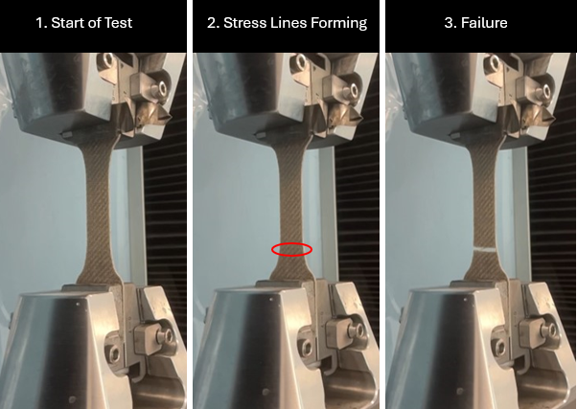
Figure 34 Stages of Failure Flax Woven Bio-Resin

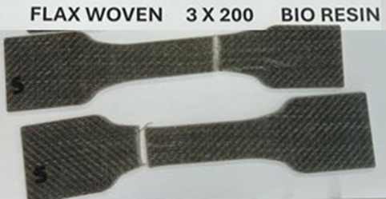
Figure 35 Flax Woven Bio-Resin Specimens after Failure

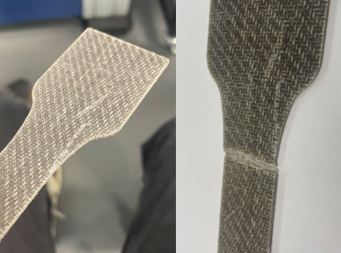
Figure 36 Close up image of defect in material Vs Failure Point
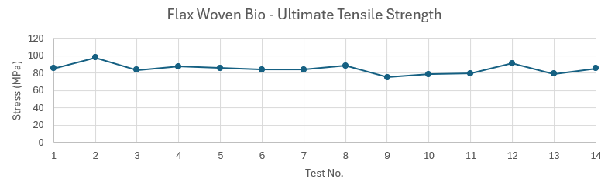
Figure 37 Flax Woven Bio-Resin - Ultimate Tensile Strength
Over the 14 tests carried out, the average UTS was 84.75 MPa with a deviation between the minimum and maximum UTS of 23%. There is a range of 22.69MPa across the set of results.
According to the technical data sheets from EcoTechnilin, where the Flax Woven mat was sourced, the UTS should be 61 MPa ±6 MPa. The UTS seen in the experimental data is around 39% higher than the expected specified UTS. Figure 36 shows a defect in one of the sample test specimens vs the area where failure occurred, emphasising the importance of ensuring materials have as little defects as possible.

4.8 Kevlar Woven Bio-Resin
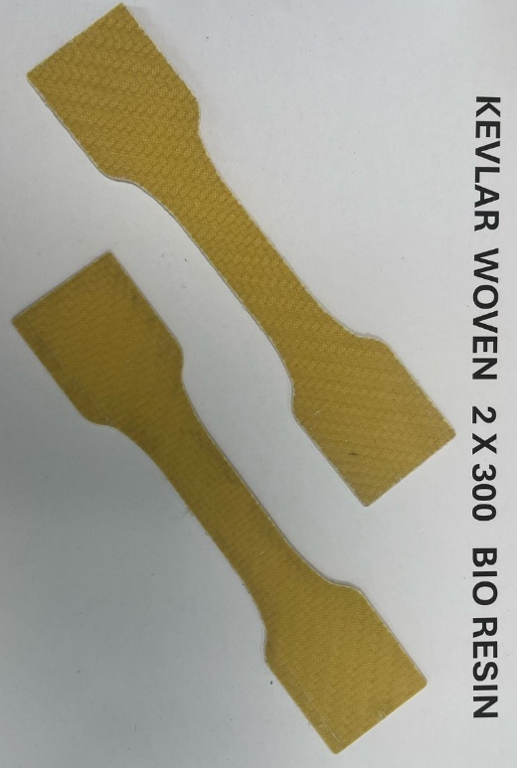
Figure 38 Kevlar Woven Bio-Resin Sample Pieces
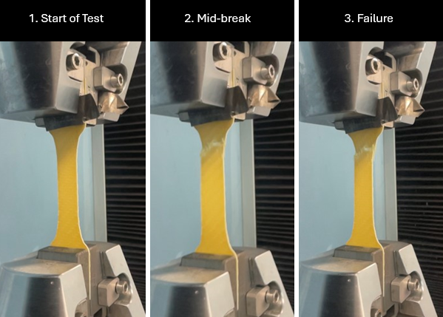
Figure 39 Stages of Failure Kevlar Woven Bio-Resin

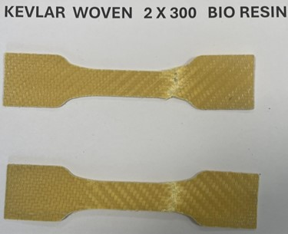
Figure 40 Kevlar Woven Bio-Resin Specimens after Failure

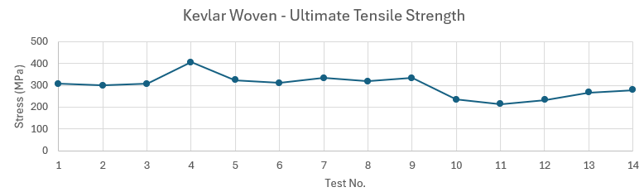
Figure 41 Kevlar Woven Bio-Resin - Ultimate Tensile Strength
Over the 14 tests carried out, the average UTS was 291.41 MPa with a deviation between the minimum and maximum UTS of 35.74%. There is a range of 119 MPa across the set of results.
According to the technical data sheets from easycomposites, where the Kevlar Woven mat was sourced, the UTS of the fibre should be 3000 MPa, and the Matrix is 68 MPa, assuming a 50/50 volume fraction, the theoretical longitudinal (upper limit) and transverse (lower limit) UTS values are calculated as follows:
$$σ_{c }(Upper Limit)=0.5*3000+0.5*68=1500+34=1534 MPa$$
$$σ_{c }\left(Lower Limit\right)=\frac{σ_{m}σ_{f}}{V_{m}σ_{f}+V_{f}σ_{m}}=\frac{68*3000}{0.5*3000+0.5*68}=\frac{204000}{1534}=132.96 MPa$$

The average MPa seen in the experimental data of 291.41 MPa falls within the expected theoretical bounds, being 81.01% lower than the upper limit, and 119.3% higher than the lower limit – possibly due to the 45° layup direction.

4.9 Comparison
The tensile testing results reveal clear differences between the tested materials in both UTS and variability. To properly compare all materials tested, analysis is required to see which materials best strike the balance between performance and sustainability considerations.
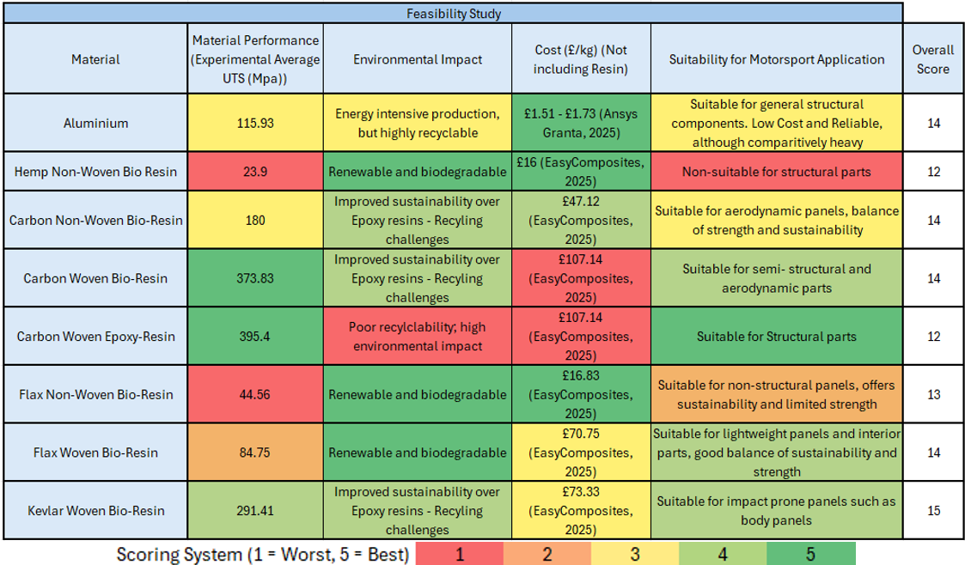
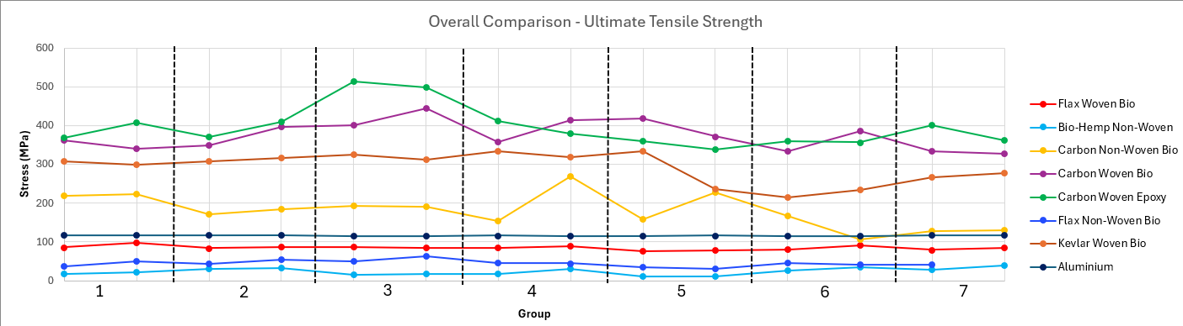
Table 1 Feasibility Study of all Tested Materials
Figure 42 Ultimate Tensile Strength – Comparison

For structural applications such as chassis or suspension components where high tensile strength is critical, carbon woven composites, both with bio and epoxy resin, are the most feasible choices. The carbon woven bio-resin, although slightly weaker than traditional epoxy offers improved sustainability without a major compromise in strength (carbon woven bio resin is only 5.8% weaker in terms of UTS). Given motorsports push towards sustainability, carbon woven bio-resin offers an optimal solution.

For non-structural applications such as interior panels, trim pieces or underbody panels, flax woven bio-resin offers a compromise between mechanical performance and environmental sustainability, despite its lower UTS value when compared to carbon composites, flax’s lightweight properties, renewability and biodegradability make it suitable for applications where load demands are lower, but sustainability is important.

Aluminium demonstrated reliable, repeatable performance with an average UTS of 115.93 MPa. Its recyclability and widespread use in the automotive industry make it a good candidate for medium load applications – especially when composites are not as cost-effective for similar strengths.

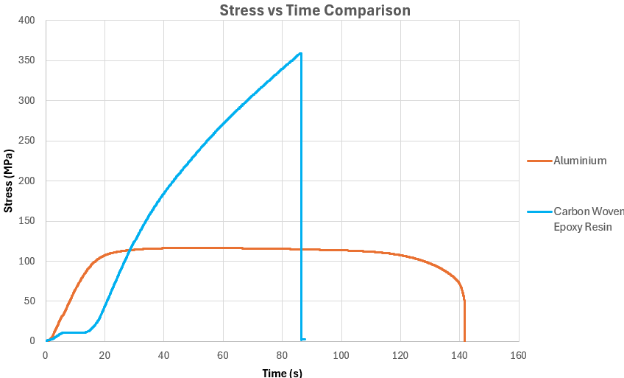

Figure 43 Graph of Time vs Stress - Aluminium and Carbon Woven Epoxy Resin
Across all tested materials, distinct failure behaviours were seen, which offer insight into the mechanical properties of each material. As can be seen in Figure 43, the aluminium sample displayed a classic metallic ductile necking before failure with smooth fracture surfaces and visible plastic deformation. In contrast, the composites, in this case carbon woven epoxy resin, exhibited brittle failure characteristics with sharp, sudden breaks and minimal deformation before failure.

5 Sustainability
When considering composite materials, a big concern is sustainability. Some composite materials, particularly carbon fibre and Kevlar, can be energy-intensive to produce. The high temperatures and pressures required during manufacturing can contribute to overall environmental impact through high energy consumption and emissions (Crowe, 2023). Natural fibre composites such as hemp and flax provide lower environmental effect during the raw material extraction and production, down to their renewability and biodegradability (Kabir et al, 2024). Although natural fibre composites are more environmentally sustainable, they can often suffer from durability and moisture absorption issues. These issues can lead to reduced lifespan of parts, and parts may have to be replaced more often.
An issue presented with synthetic fibre composites is recycling. This is due to the complications in separating resin from fibres, resulting in landfill waste. Bio-resins can offer improved recycling and biodegradability compared with traditional epoxy resins—although, according to Atmakuri et al. (2022), recycling infrastructure for these is currently underdeveloped, so they tend to end up in landfills anyway regardless of the recycling potential.
Manufacturing processes also affect sustainability, synthetic composites often require high-temperature autoclave curing, consuming substantial amounts of energy, although the resin infusion method used in this study requires lower temperatures and pressures, which significantly reduces manufacturing emissions. Natural fibre composites offer potential for even lower manufacturing emissions if room temperature curing bio-resins are used. However, inconsistencies in material properties could negate some of the environmental benefits if components prematurely fail and require replacement.
The lightweight properties of composites can directly contribute to reduced fuel consumption and extended electric vehicle range, according to Atmakuri et al. (2022), every 10% reduction in vehicle mass can lead to a 6-8% improvement in in fuel economy or electric range.
In terms of legislation, the European Union’s End-of-Life Vehicles Directive requires 85% material recovery and 95% total reuse/recycling rates by vehicle mass, pushing manufacturers to improve material sustainability across all stages (European Commission, 2024). Formula 1 has committed to achieving net-zero carbon emissions by 2030, with Formula E already incorporating natural fibre composites in their race cars (Formula 1, 2022).

6 Recommendations
Overall, this study evaluated the UTS and sustainability of a range of composite materials and aluminium. Experimental tensile testing showed that carbon woven composites have the highest UTS, with carbon woven epoxy resin recording an average UTS of 395.42 MPa and carbon woven bio-resin recording 373.83 MPa. Natural fibre composites, particularly flax woven bio-resin, exhibited moderate tensile strength (84.75 MPa) along with increased sustainability advantages. The baseline material aluminium demonstrated its reliable and consistent properties and remains an important material for applications requiring both recyclability and strength.
The sustainability analysis revealed that while synthetic composites offer the best mechanical performance, they produce comparatively high emissions, are energy-intensive to produce, and are challenging to recycle. In contrast, natural fibre composites and bio-resins offer improved properties in renewability, production energy, biodegradability, and recyclability as long as recycling infrastructure continues to improve.
In structural components requiring higher strength such as chassis parts or suspension components, carbon fibre woven bio-resin seems to be the ideal choice of composites. It offers a balance between high-strength and improved sustainability when compared to the epoxy resin alternative. Despite being slightly weaker than the epoxy resin, the reduced environmental effect aligns better with sustainability focuses.
Based on the comparison and feasibility study, the following material recommendations are made:
-Carbon Woven Bio-Resin: Recommended for structural components where high tensile strength is required alongside improved environmental performance compared to conventional epoxies.
-Flax Woven Bio-Resin: Recommended for non-structural and interior applications where moderate mechanical strength and excellent sustainability is acceptable.
-Aluminium: Recommended for components such as brackets, mounts, and medium-load structures where recyclability and durability are critical factors.
Materials such as hemp non-woven bio-resin are unsuitable for structural applications due to inconsistency and low UTS values. Kevlar woven bio-resin, and both carbon woven epoxy resin and bio-resin underperformed severely compared to expectations, meaning they require further investigation into the reasons for their low strength compared to technical data specifications.

7 References
Almansour, F. and Luqman, M., (2020). Hybridization effects on mechanical properties of Kevlar/Flax/epoxy hybrid composite. Available at: https://www.sciencedirect.com/science/article/abs/pii/S014294182030708X
Amazon UK (2024) Kevlar Fabric Price Listing. Available at: https://www.amazon.co.uk/Square-200gsm-Yellow-Kevlar-Aramid/dp/B0CXPL8M4C (Accessed: 17 April 2025).
Atmakuri, A.,Palevicius,A., Janusas, G., and Eimontas, J,. (2022). Flexural properties of hemp and flax fibre-reinforced EcoPoxy bio-composites. Available at:
Callister, W.D. and Rethwisch, D.G. (2018) Materials Science and Engineering: An Introduction, 10th ed. Hoboken, NJ: Wiley.
Campbell, F.C., 2010. Structural Composite Materials. Materials Park, OH: ASM International.
Chaharmahali, M., Nourbakhsh, A. and Ashori, A., (2024). Mechanical properties of flax and hemp fibre-reinforced composites: A comparative study. Available at: https://www.mdpi.com/1996-1944/17/19/4871
Crowe, J., (2023). Natural fibres: The new fashion in automotive composites. Available at: https://www.fibrejournal.com/natural-fibres-the-new-fashion-in-automotive-composites
DataHorizzon Research (2024) Recycled Carbon Fiber Market Report. Available at: https://datahorizzonresearch.com/recycled-carbon-fiber-market-2649
DataHorizzon Research (2024) Recycled Carbon Fiber Market Report. Available at: https://datahorizzonresearch.com/recycled-carbon-fiber-market-2649 (Accessed: 17 April 2025).
Easy Composites (2024) Kevlar Fabric – 300g 2/2 Twill. Available at: https://www.easycomposites.co.uk/300g-22-twill-kevlar-cloth (Accessed: 17 April 2025).
European Commission (2024) End-of-Life Vehicles Directive (Directive 2000/53/EC). Available at: https://ec.europa.eu/environment/topics/waste-and-recycling/end-life-vehicles_en
Formula 1, 2022. Sustainability Strategy: Net Zero by 2030. [online] Available at: https://corp.formula1.com/sustainability/
Hull, D. and Clyne, T.W. (1996) An Introduction to Composite Materials, 2nd ed. Cambridge: Cambridge University Press.
IMARC Group (2024) Carbon Fibre Pricing Report. Available at: https://www.imarcgroup.com/carbon-fibre-pricing-report (Accessed: 17 April 2025).
Islam, M., et al., (2024). High velocity impact and flexural properties of hybrid flax/carbon/Kevlar epoxy composites. Journal of Materials Research and Technology, Available at: https://www.sciencedirect.com/science/article/pii/S2238785424013024
Kabir, M.M., Wang, H., Lau, K.T. and Cardona, F., (2024). Sustainability of natural fibre-reinforced polymer composites: A review on lifecycle, recycling and environmental aspects. Available at: https://www.mdpi.com/2071-1050/16/3/1223
Market Data Forecast (2024) Europe Carbon Fiber Market Analysis. Available at: https://www.marketdataforecast.com/market-reports/europe-carbon-fiber-market (Accessed: 17 April 2025).
Mirmohammad, S., (2024). Natural Fibre Reinforced Polymer Composites in the Automotive Sector: A Review. Journal of Reinforced Plastics and Composites. Available at: https://journals.sagepub.com/doi/10.1177/08927057241254324
Nature (2024) ‘Sustainable carbon fibre composites: challenges and opportunities’, Nature Sustainability, 7, pp. 102–110. Available at: https://www.nature.com/articles/s44296-024-00006-y
Nature (2024) ‘Sustainable carbon fibre composites: challenges and opportunities’, Nature Sustainability. Available at: https://www.nature.com/articles/s44296-024-00006-y (Accessed: 17 April 2025).
Renewable Carbon News (2024) Flax Fibre Cultivation Update. Available at: https://renewable-carbon.eu/news/flax-fibre-the-2024-flax-area-under-cultivation-is-setting-a-new-record-in-response-to-the-market/ (Accessed: 17 April 2025).
Selina Wamucii (2024) Linseed (Flax) Price Insights - UK. Available at: https://www.selinawamucii.com/insights/prices/united-kingdom/linseed-flax/ (Accessed: 17 April 2025).
Strong, A.B. (2008) Fundamentals of Composites Manufacturing: Materials, Methods and Applications. 2nd ed. Dearborn: SME.
Trading Economics (2024) Aluminium Commodity Prices. Available at: https://tradingeconomics.com/commodity/aluminum (Accessed: 17 April 2025).
University of Michigan Center for Sustainable Systems, (2022). Life Cycle Impacts of Natural Fibre Composites for Automotive Applications. Available at: https://css.umich.edu/publications/research-publications/life-cycle-impacts-natural-fibre-composites-automotive
Yorkshire Hemp Supply Chain Report (2021) Yorkshire Hemp Supply Chain Map Report. York & North Yorkshire Local Enterprise Partnership. Available at: https://yorknorthyorks-ca.gov.uk/wp-content/uploads/2024/01/Yorkshire-Hemp-Supply-Chain-Map-Report-30-March-2021.pdf (Accessed: 17 April 2025).

