University of Wales Trinity St David
13th July 2018

Communication skill in the workplace
Kirsty Mitchell 1709597

Executive Summary

Contents
Executive Summary 1
Introduction 3
Main Body 4
Issues 4
Impact and supporting models 4
Teams in different locations 5
No two-way communication 5
High absence and employee turnover 7
Poor relationships 8
Conclusion 9
Recommendations 10
Reference List 11
Appendix 14

Introduction
Effective communication in the workplace is a highly sort after skill. This report will consider the communication skills required to maintain effective teams. The case study shows lots of communication and team working issues within the organisation. This report will look at the impact some of these issues are having on the teams and what team working and communication models the organisation could implement to improve these issues.

Main Body

Issues

Teams in different locations leading to some teams felling left out of the loop and therefore new procedures being a surprise.
Employee turnover and high absence rates leaving team managers having to deal with new team members and staff shortages, meaning teams are always forming.
Employee absence not being managed and managers not talking to staff to find out why they are leaving.
Poor performance not being dealt with by managers, this could lead to some team members not pulling their weight.
Inconsistent standards meaning that decisions being over turned by another team member.
No two-way communication between team members and managers, also very limited one-way communication between managers and the head of the department.
Very little face to face communication even though some important directions where being given informally and verbally, this lead to the messages being diluted to mistaken.
Lack of trust due to the high turnover in staff and poor relationships between social workers.
Insufficient induction procedures and improper training being given, leading to new team members being given to heavy caseloads and feeling unsupported.
No mechanisms for team members and managers alike to communicate ideas on ways to improve performance.
Achievements of team members and managers not being recognised, leading to low morel and individuals feeling aggrieved.

Impact and supporting models

This section of the report will expand on some of the issues above, identify what impact the issues are having on the organisation in the case study and look at what team working, or communication models could be used to overcome or improve on the issues.

Teams in different locations
Due to historical reasons two teams are in a different location to the others, even though the staff like being in a location close to their client base, the staff feel as if they are being left out of the loop, this is also not helped by the fact that some important decisions are being given informally and verbally at the main office. The organisation needs to work on making sure that important decisions are being communicated in writing. Leonard (2018) suggests that as all written communication is a permanent record, it can help individuals access the information that they require quickly and efficiently. This would mean that there would be no miss communication between employees and managers. When communicating within an organisation, individuals should keep in mind Argyle’s Communication cycle (fig 1). According to Rasheed et al (2013) the theory was first developed in 1965 by Charles Berner and then modified in 1972 by Michael Argyle. The cycle is used when an individual decides they want to communicate, the individual will take action by sending the message, which will then be received by another person, who will work out what the message means by decode the message and then lets the original sender know that the message has been received and understood, then respond to the message this is called feedback, then the whole cycle may start again.
Fig 1 ©Buzzle.com
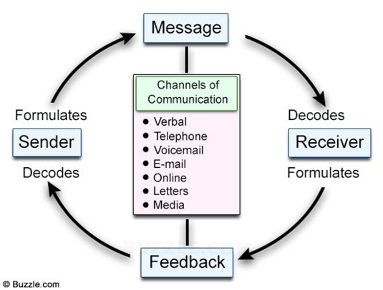

- Take action/ Send message
- Received
- Decode/ Understood
- Respond/ Feedback
- Start cycle again

No two-way communication
The case study showed a lack of two-way communication, the last head of department would stay in his office and only communicate with employees via email, although was too busy to reply to any questions. The head only held occasional face to face meetings with managers but these where only one way when wanting to communicate concerns and there was no discussion with staff. This left the staff with a lot of unanswered questions and no way to communicate ideas on how to improve performance. The new head of department could keep in mind Argyle’s Communication Cycle or they could follow the Shannon-Weaver Mathematical Model. According to Businesstopia.net (2018) and Communicationtheory.org (2018) the Shannon-Weaver model (fig 2) was created in 1948, originally there were only five components to the model, sender, encoder, channel, decoder and receiver later noise was added. The model was created to better understand and develop the way individuals communicate and to identify any factors that may affect that communication.
Fig 2 © communicationtheory.org

According to Businesstopia.net (2018) in 1960 David Berlo used the Shannon-Weaver model as a base for his SMCR Model of Communication in which Berlo studied the factors that affect the individual communication components. Berlo’s model has four main components source, message, channel and receiver, the model also shows some of the ways these main components may be affected (see fig 3). By understanding how individuals communicate and having knowledge of the factors that can affect that communication the individuals in the organisation will be able to communicate better.

Fig 3 ©Businesstopia.net

Berlo’s Model of communication also looks at non-verbal communications as a channel of sending a message. Samson (1995) cited by Quintanilla & Wahl (2017) suggest that most individuals are visually dominant, and they live in world where visual images are everywhere, therefore individuals are more inclined to believe in what they see rather than using their other senses. By holding face to face meetings with employees the head of department would also be able to pick up on non-verbal communication. Ivy & Wahl (2014) cited by Maund et al (2017) suggest that the way a person walks, the stance they take, their posture, what they are wearing and how the individual looks as well as their facial and eye expressions are all forms of non-verbal communication (see fig 4).

Fig 4 © Brace (2018)
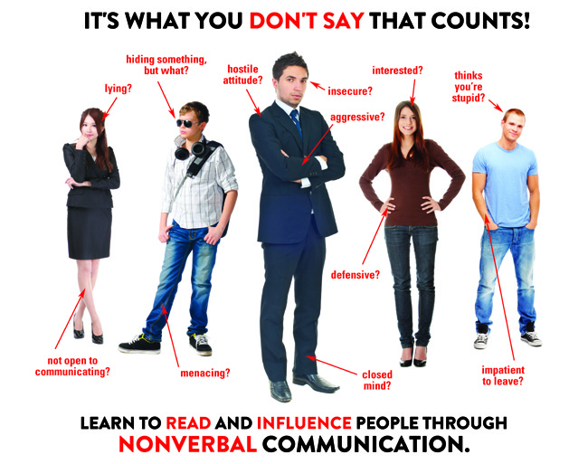

High absence and employee turnover
The case study shows that managers were constantly having to deal with new or absent employees, teams were having to deal with new team members, as a result of this the teams were constantly forming and therefore underperforming. Griffiths & Dunham (2017) cited by Maund et al (2017) suggest that the use of group development models that identify the different stages that a group goes through to become an effective team, can help both leaders and members manage their expectations and understand the changes each stage brings. Griffiths & Dunham (2017) cited by Maund et al (2017) concluded that Bruce Tuckman was the first person to identify the different stages of group development in 1965. Bird (2017) explains that Tuckman studied many teams from the beginning (forming stage) to when the task was complete. This led to the development of the Tuckman Forming, Storming, Norming and Performing Model. Mindtools.com (2018) suggest that to effectively form a new team takes time, the members of the team will often go through distinct stages as the members go from being a group of strangers to a group of people united towards a common goal. When an individual understands a model such as the Tuckman Forming, Storming, Norming and Performing model, the individual will be able to quickly help the new team to move towards the performing stage and become a more effective team. In the 1970’s Tuckman added a fifth stage Adjuring (see fig 5).

Fig 5 © Pintrest
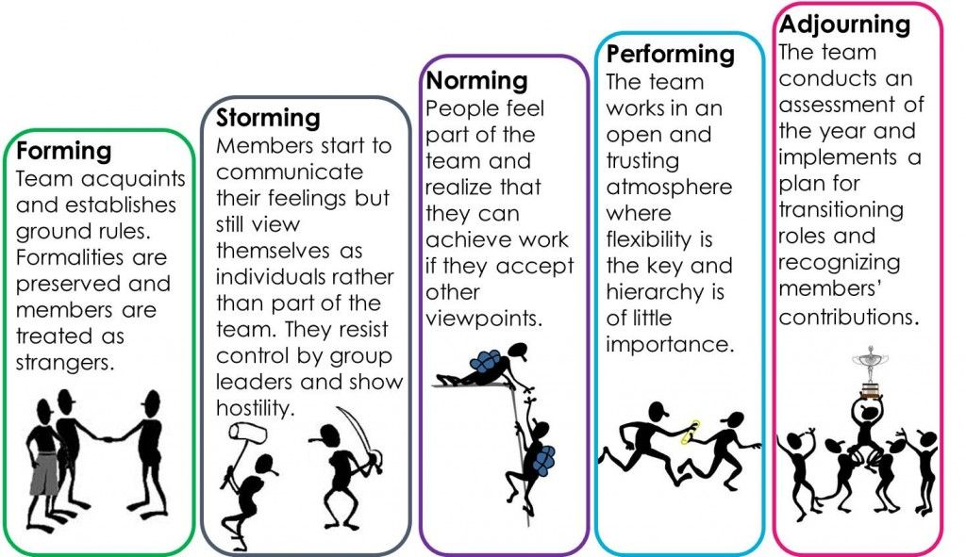

Poor relationships
The case study shows that the relationships between the social workers within the organisation is poor, this has resulted in a lack of trust. The poor relationships within the organisation has led to individuals not knowing where to turn when they needed help, resulting in poor communication and weak teams. One way the head of social services could tackle this would be to have all member of the organisation undertake the Belbin Self-Perception Inventory, which according to Belbin.ie (2015) is a questionnaire that is behaviour-based. Participants spend fifteen to twenty minutes completing the questionnaire, the results of the questionnaire will show the preferred way in which the individual likes to work, it will show which of the Belbin nine team roles will suit them best and also where the individuals weaknesses lie. Mackechnie (2018) explains that Belbin created the 9-team role theory (fig 6) in 1981, the theory is still widely used today. Belbin discovered that all individuals will normally behave in a certain way when working with others, Belbin identified nine clusters of behaviour, with individuals showing a strong preference for one or two of these ‘Team Roles’. Understanding where a team members preference lie can help a manager to create an effective team and help the individual to develop and manage their strengths and weakness and to improve on how they contribute towards the team. According to Mindtools.com (2018) If all members of a team have the same type of behavioural preference the team may become unbalanced and less productive. Belbin.com (2018) provide a variety of different tools, that are free to use to help managers and team members to understand the Belbin team roles. Once the head of the department within the organisation has the knowledge to understand the model and the results of all the employees self-perception inventory, they will know where best to place new and existing employees to maximise the effectiveness of the individual teams.

Fig 6 ©Belbin.com
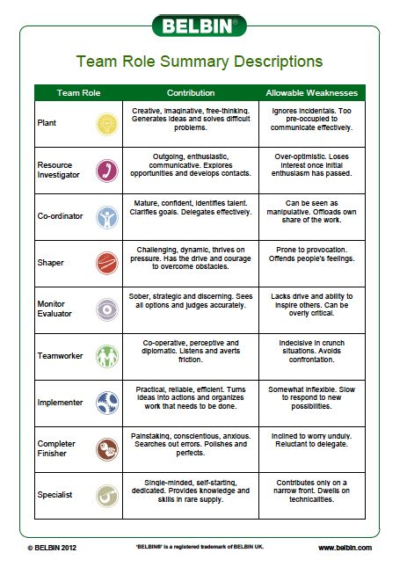
The case study has shown that the organisation has issues with team work and communication. As a starting point to improving on the issues, the head of the department and all the employees within the department need to undergo training on the communication and team working models within this report.

Conclusion

Recommendations

Reference List
Belbin.ie (2015) Self-Perception Inventory, [online] http://www.belbin.ie/wp-content/uploads/2014/08/BELBINUK-Self-PerceptionInventory+CompletionGrid.pdf , accessed 12/07/2018

Bird, V. (2017) Belbin and Tuckman: Supporting Your Team at Every Stage, [online] http://www.belbin.com/resources/blogs/belbin-and-tuckman/ , accesses 11/07/2018

Brace, C. (2018) Non Verbal Communication, [online] https://www.tes.com/lessons/XzgIxMUJipJ5iw/non-verbal-communication , accessed 11/07/2018

Businesstopia.net (2018) Berlo’s SMCR Model of Communication, [online]
https://www.businesstopia.net/communication/berlo-model-communication , accessed 11/07/2018

Businesstopia.net (2018) Shannon and Weaver Model of Communication, [online] https://www.businesstopia.net/communication/shannon-and-weaver-model-communication , accessed 10/07/2018

Buzzle.com (2018) Communication cycle, [online] https://www.buzzle.com/articles/communications/ , accessed 10/07/2018

Communication theory (2018) Shannon and Weaver Model of Communication, [online] https://www.communicationtheory.org/shannon-and-weaver-model-of-communication/ , accessed 10/07/2018

Griffiths, B.A. & Dunham, E.B. (2017)

Leonard, K. (2018) Importance of Written Communication in Business, [online]
http://smallbusiness.chron.com/importance-written-communication-business-2936.html , accessed 10/07/2018

Mackechnie, P. (2018) Belbin Team Role Theories, [online] https://www.businesscoaching.co.uk/files/belbin_team_role_theories.pdf , accessed 12/07/2018

Maund, A., Schriek, M. & Tinkler, P. (2017) Certificate in Higher Education: Skills for the Workplace Student Yearbook, London: SAGE

Mindtools.com (2018) Belbin's Team Roles How Understanding Team Roles Can Improve Team Performance, [online] https://www.mindtools.com/pages/article/newLDR_83.htm , accessed 12/07/2018

Mindtools.com (2018) Forming, Storming, Norming, and Performing Understanding the Stages of Team Formation, [online] https://www.mindtools.com/pages/article/newLDR_86.htm , accessed 12/07/2018

Pintrest (2018) Tuckman Model, [online] https://www.pinterest.co.uk/pin/571535008945968059/?lp=true , accessed 12/07/2018

Rasheed, E., Hertherington, A. & Irvine, J. (2013) BTEC Level 3 National Health and Social Care, [online] https://www.hoddereducation.co.uk/getattachment/Subjects/Health-Social-Care/Series-pages/BTEC-First-Health-and-Social-Care/Series-Boxes/Sample-chapter/BTEC-Level-3-9781444115529-sample-pages.pdf.aspx , accessed 10/07/2018

Appendix

