Design and implementation of mobile scoring applications for use in recreational and competitive archery environments
Steffan John Benson
Computer Games Development BSc
Dr Nik Whitehead
Word count: 2974

Contents
Table of Figures 3
Table of Tables 3
Introduction 4
Industrial Context 4
Background Literature 5
Java and SQL 5
Wi-Fi connectivity 5
Aims and Objectives 5
Recreational Scoring App 5
Competitive Scoring App 6
Connectivity 6
Research Methodology 6
Development Methodology 6
Analysis and Deliverables 7
Test one – Recreational Scoring 7
Test two – Competitive Scoring 7
Risks 7
Physical Resources 7
Development – Resources 7
Testing – Resources 8
Human Resources 8
Development – Resources 8
Testing – Resources 8
Timeline 9
References 11
Bibliography 11
Appendix I 12

Table of Figures
Figure 1 - Project timeline with ideal durations 11
Figure 2 - Gantt chart with task resources 11
Figure 3 - Gantt chart with task resources 11

Introduction
The purpose of this project is to develop mobile and PC applications to unify recreational and competitive archery scoring platforms, by means of allowing a mobile scoring application that can be used for recreational scorekeeping to connect to a PC system[1]–[3]. The mobile application will then transfer the data to the PC system, which will input the data into a database which will perform automatic calculations, determining the rankings. Scoring in recreational archery is typically done by using mobile applications or using pen and paper methods, whereas competitive scoring requires a system in which scores are collected and collated in a single system. In competitive archery, pen and paper systems remain as the primary system for scorekeeping, with members of a field party gathering slips of paper for each target to be transferred to a computer system[3].
To put the purpose of the project simply, the aim is to take existing templates for personal and competitive archery scoring systems and unify them into one system, which can then be distributed for use by a larger range of users than current systems allow for.

Industrial Context
Although not involved in the design and implementation of the system, the national governing body for archery in the UK, Archery GB, may be able to implement the system into national competition formats rather than using pen and paper systems that are still predominant in even the largest competitions.

Background Literature
In order to fully understand current products available and why the unification of multiple platforms into one system, products available on the market must first be reviewed. This section will be separated into two sections, literature review of methods and components that will be utilised in development of the project, as well as a review of current products available to archers.

Java and SQL
In order to develop applications capable of being installed and used on android mobile devices, the developer will be required to learn the Java scripting language. Standard android application development is done almost exclusively through the Java scripting language, although some development may be done using C++ or C# languages[4][5]. Android development has been selected over iOS development as the languages required to develop for iOS are specifically designed for iOS devices, making transferring code more difficult as it would have to be re-written to fit android development languages. Another advantage of using Android SDKs over iOS is that android devices are typically more common than iOS devices, as a larger range of manufacturers of mobile devices will utilise the operating system[5].
SQL, or Sequenced Query Language, is a language utilised in the handling of data for use in database systems. Although the project may not include the use of servers, SQL will be required in order to transfer the data from individual mobile devices into a central database, where the database will perform calculations[6].

Wi-Fi connectivity
Wi-Fi networks are already utilised in similar systems to transfer data from multiple devices to a central terminal[3][7][8]. Utilising a single access point, a small group of users will be able to connect to a central terminal and transmit data. However, should too many users connect to the access point, or if the transmitted data consumes too much of the bandwidth of the access point, Wi-Fi access points may prove ineffective. Multiple access points may be implemented, however this may require multiple databases to store larger quantities of data.

Database Systems
Database management software, such as Microsoft excel or access, are utilised in many different scenarios where data handling is required for functionality[9][10]. The collection of large quantities of data, when handled by database systems, is simplified greatly thanks to the use of macros and algorithms that perform calculations for the user. Having to perform calculations manually is both time-consuming and open to error, which can cause further issues when stored data is reused.

Product Review
Individual components of this project have already been implemented and are available for use by archers. Applications such as Archery Companion App[2] or Ianseo[3] have allowed users to score themselves in either recreational or competitive settings, however no application currently available to users is capable of allowing users to scoring in both settings. In this section of the report, existing products will be reviewed and specifications will be identified for use in the project.

Ianseo[3]
Ianseo is a competitive archery scoring system developed in conjunction with the Italian Archery Federation. The purpose of the application is to allow separate mobile devices to connect to a single terminal, which receives data transmitted from the mobile devices. Each mobile devices allows 4 competitors to input scores based on a specific pre-set round. Scores are then transmitted to a central terminal which then perform calculations which show each individual competitor’s overall score and ranking in the competition. The system is used exclusively in competitive environments and cannot be used in recreational settings for single users. Scores in the database are tabulated and then published online for spectators and competitors to review. Although widely popular in competitive archery, use of the Ianseo scoring system isn’t without its flaws. The system is prone to malfunction due to connectivity issues with the central terminal, and has been known to reset scores or remove competitors from the competition altogether. Based on personal experience, the Ianseo system serves its purpose as a platform to allow users to input scores electronically, however it is unreliable due to its use of a single access point for connecting multiple mobile devices to a single terminal.
Although the introduction of electronic scoring systems has streamlined the collection and broadcasting of scores, the system still pre-dominantly plays second fiddle to traditional pen and paper systems. Smaller scale competitions tend to forego the use of a large scale system such as Ianseo, as specialist equipment and knowledge of computer systems are required to utilise the software properly. The software also presents the issue of having to provide mobile devices for competitors to use. Larger organisations, such as Archery GB or BUCS (British University and College Sports), have larger enough budgets to provide devices for use with the Ianseo software, but smaller organisations such as small archery clubs or local governing bodies, may not be able to afford to provide devices, thus rendering the software unusable. By providing competitors with a personal app that can be connected to the competition system, it will allow organisations to remove the cost of providing devices to competitors, allowing a larger range of users to use the competition software.

Archery Companion Apps (MyTargets/Archery Companion/H2H)
Personal archery scoring apps have been designed in many different ways in recent years, with many varying features. All apps serve the same basic purpose, allowing archers to record scores of pre-set rounds. Only the World Archery H2H app, which allows 2 archers to compete against one another, is capable of connecting 2 separate devices into a competitive setting[11].
Apps such as MyTarget include a feature which allows users to plot arrows on a target on screen. The points of each arrow are then added to a single target which allows the user to view their average score per arrow as well as where their arrows tend to land on a target. Although this feature is not key to the base functionality of a scoring system, it may be used to enhance user experience, and may be implemented post development should time allow for it.

Unifying existing systems
The purpose of this project, simply put, is to develop an archery companion app, a competition control app and to connect the two via Wi-Fi. Although individual components of this project exist and are widely used by varying organisations already, a unified system would simplify use of the system and allow a wider range of users to access a system that allows for recreational and competitive scoring. Typically, users of the personal scoring apps utilise them to monitor scores in preparation for competitions. By allowing archers to use the same application to score recreationally as well as in competitive environments, many archers who feel they do not wish to use multiple different systems, or cannot understand different systems, can utilise one unified application as a source of continuity in their scoring.

Aims and Objectives
Aim
To design and develop a mobile application for recreational scorekeeping in archery, and a wireless system connected to a PC application for competitive scorekeeping.

Objectives
- Review current applications available to the public.
- Develop recreational scoring app.
- Develop PC database app.
- Implement wireless connectivity between mobile app and PC database.
- Test applications in both recreational and competitive environments.

The development of this project will be separated into 3 sections. These sections will include Recreational Scoring App, Competitive Scoring App and connectivity. The parameters for each section will be listed below.

Recreational Scoring App
The recreational scoring app will be designed to store scores input by the user of the app. The app will allow users to input scores into pre-set formats depending on the round being undertaken by the user. Scores will be stored in a database on the user’s device and will allow the user to review their previous entries upon request. Although not specifically required for the app to function, features to allow users to review average arrow scores, personal records and arrow placements on targets may be implemented once development of the initial app has been completed. Further features that allow users to download world records from a database may be implemented at a later date, however this is not required for this project.

Competitive Scoring App
The competitive scoring app will be developed to allow users of the recreational scoring app to connect to a central terminal to monitor scores in a competitive archery setting. The central terminal will run an application that will gather the scores of connected devices and perform calculations to determine rankings of participants. The central app will also control which round the participants will be scoring, following pre-set conditions for each individual round. Should any corrections to scores be required, the central app will be able to access individual participants’ scores and amend them. Once the competition has been completed, the results will be converted into a list and can be displayed on the central terminal. The connectivity section of the project must be completed to utilise the competition scoring app in conjunction with the recreational app.

Connectivity
To fully utilise both apps, a Wi-Fi connection is required to transfer data from the mobile devices to the central terminal. Mobile devices will connect to a Wi-Fi router, which will allow information from the mobile device scoring app to be transmitted to a central terminal. The Wi-Fi connection will be secured by a password which will only be disclosed to participants of the tests.

Research Methodology
This project will take positivistic philosophy, as the aim of the project is to develop software to fit a set criterion. Testing of the final product will be conducted on a small scale in order to reduce time for testing, however smaller scale testing of the product fits a phenomenological philosophy as opposed to a positivistic one. Although the testing of the product suits a phenomenological philosophy better than a positivistic one, larger scale tests after the conclusion of the project development may take on larger scale participation which would return the project to its positivistic setting. Strategies involved in this project include experiments and software development, which will go hand in hand as the software is taken from its first iteration to the final product. The experiment strategy will be implemented almost exclusively by product testing between each iteration, by modifying features and testing effectiveness.

Development Methodology
Feature driven development will be implemented by separating the project into 3 major components[4][5]. The 3 components will be the recreational scoring application, competitive scoring application and connectivity. Each of these sections will then be divided into their constituent features, which will each be developed and tested individually to ensure full functionality before final testing. Feature driven development also allows development of separate components without dependence on completion of other components. However, the connectivity component of the project will require the two individual applications to have been completed as the connectivity will be centred on data transfer between the two applications. The main advantage to Feature-driven development and the main reason this is the methodology that will be implemented, is that it affords the developer the ability to develop multiple aspects of the project simultaneously without depending on progress of other aspects of the project[5][9][10].

Analysis and Deliverables
To prove functionality of the project, two tests will be implemented. The first test will be undertaken by project developer in a recreational archery environment and the second in a competitive archery setting.

Test one – Recreational Scoring
The first test will be conducted in a relaxed environment, with a small sample of test users. A small sample, which might only include the developer, will be used to reduce time taken for testing as well as the reduced time for installation of applications to mobile devices. The mobile application will be installed on a mobile device prior to the testing session. Initial testing will be done exclusively by the project developer to diagnose and rectify initial bugs, however secondary or tertiary testing may include other participants to provide unbiased user feedback.

Test two – Competitive Scoring
The second test will be conducted in a competitive environment, featuring a larger group of participants that the recreational testing. The test will take place in the form of a small competition, using official Archery GB rules. The test will require a minimum of 1 mobile device per target. User feedback will be recorded at the end of the test and technical issues will be diagnosed and rectified. Any issues in situ will be rectified if possible, however should the application suffer a major failure the test may be abandoned.

Risks
The primary risk involved in this project comes from the handling of data produced during testing. To test the applications in a competitive environment, multiple mobile devices must connect to a central terminal in order to transfer scores to a database. Although no identifying data will be transmitted from mobile devices to the central terminal, transmitted data may include forenames or initials. This personal data will be encrypted during transfer to protect the data from theft. Data stored at the central terminal will also be encrypted for the same reason.
Another risk that the developer may encounter is malware transmission as the applications are distributed to test participants. In order to prevent the transmission of malware, anti-virus software will be utilised to ensure development devices, such as the developer’s personal computer, are free of malware and that any applications or files that are transmitted or installed onto external devices do not contain malware or corrupted files.

Physical Resources
Physical resources for this project will include multiple devices, some of which may be provided by external test participants. The devices required for this project will be separated into two sections, those used for development and those used for testing.

Development – Resources
Physical resources for development of the project include a personal computer for application development, as well as a mobile device for initial troubleshooting and installation. Additional resources include textbooks or teaching resources required to learn additional languages or techniques that will be used in development and troubleshooting. Software required for this project will include android application development software, Microsoft visual studio for PC application development and Microsoft excel in order to develop the database. The project may also require the use of a server, although measures will be taken to avoid the need for the use of a server[3][7][8].

Testing – Resources
Testing resources will require the use of devices provided by text participants. For the testing of recreational scoring application only a mobile device is required as the recreational application will be a standalone system. For competitive testing, mobile devices will be accompanied by a central PC terminal to gather all transmitted data, as well as a Wi-Fi router to allow connectivity between the mobile devices and the central terminal. Mobile devices in the competitive tests may be provided by participants to reduce costs of testing.

Human Resources
As with physical resources, human resources for this project will be separated into two sections, development and testing.

Development – Resources
During development, the major contributing human resources during development of the project will be the lead developer and the project supervisor. The project developer will be required to learn methods and techniques required to develop the project, while the project supervisor will provide guidance to the developer whenever required. Should the developer not be capable of completing a task without a specific skillset or resource, the project supervisor will provide guidance as to how the problems can be rectified.

Testing – Resources
Participants for testing of the applications will include members of local archery clubs whom have consented to installing applications to their personal devices. Participants will compete in a competition using the competitive scoring system while providing feedback to the developer as the system is used. Should any issues arise during testing, the participants will be required to make the developer aware of these issues so that troubleshooting can take place. Once the tests have concluded, test participants will be required to provide final feedback on user experiences. Should further testing be required, any participants who consent to secondary testing may repeat this.

Timeline
This project has been separated into two distinct sections, specifications and implementation. Each task has been assigned to its designated section, which will allow steady development without overlapping tasks. Figures () show the sections with all required tasks underneath, as well as project timeline in Gantt chart form. Task durations used below are ideal and thus are subject to change.
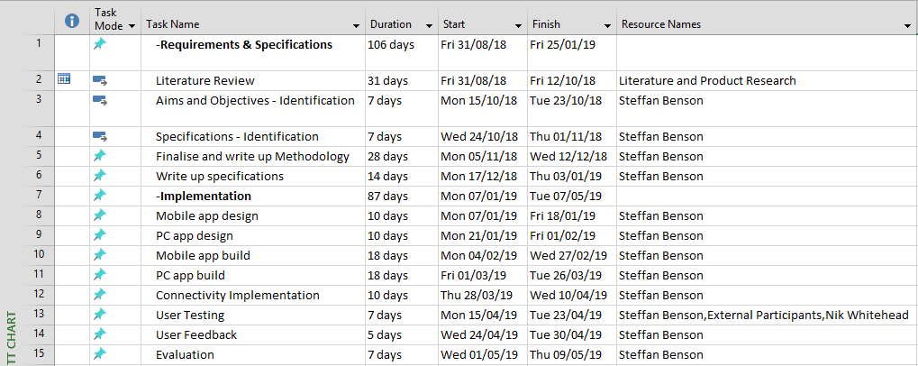
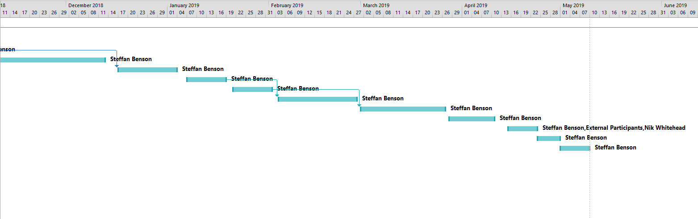
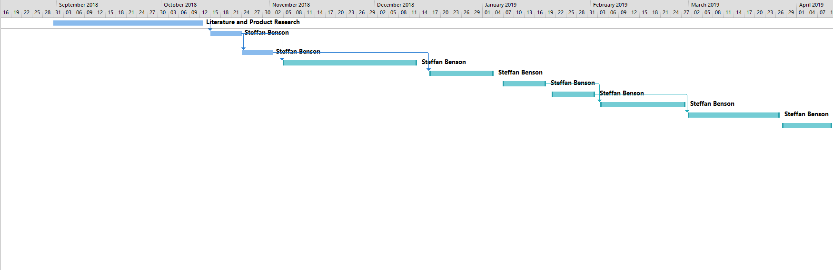
Figure 1 - Project timeline with ideal durations
Figure 2 - Gantt chart with task resources
Figure 3 - Gantt chart with task resources

References
[1] F. Dreier, “MyTargets Archery - Apps on Google Play.” [Online]. Available: https://play.google.com/store/apps/details?id=de.dreier.mytargets. [Accessed: 24-Mar-2018].
[2] T. Rosenbaum, “Archery Companion - Apps on Google Play.” [Online]. Available: https://play.google.com/store/apps/details?id=com.archerycompanion.app.android. [Accessed: 23-Mar-2018].
[3] A. Scarzella, A. Gabardi, C. Deligant, M. Pisani, and M. Carpignano, “Ianseo.net User Manual - English,” 2018.
[4] Unknown, “I want to develop Android Apps – What languages should I learn?” [Online]. Available: http://www.zipcodewilmington.com/blog/i-want-to-develop-android-apps-what-languages-should-i-learn. [Accessed: 04-Mar-2018].
[5] M. (Software engineer) Burton, Android application development for dummies. .
[6] Unknown, “java - How to connect to SQLite Database that’s on my PC from Android phone using Wi-fi? - Stack Overflow.” [Online]. Available: https://stackoverflow.com/questions/37597641/how-to-connect-to-sqlite-database-thats-on-my-pc-from-android-phone-using-wi-fi. [Accessed: 20-Apr-2018].
[7] R. Karrer, A. Sabharwal, and E. Knightly, “Enabling Large-scale Wireless Broadband: The Case for TAPs.”
[8] B. Busstra, N.-A. Le-Khac, and M.-T. Kechadi, “Android and Wireless data-extraction using Wi-Fi.”
[9] A. J. Oppel, Databases demystified. San Francisco, CA: McGraw-Hill/Osborne, 2004.
[10] R. Sapsford and V. Jupp, Data collection and analysis. Sage in association with Open University.
[11] World Archery, “head2head archery - Apps on Google Play.” [Online]. Available: https://play.google.com/store/apps/details?id=org.worldarchery.h2h. [Accessed: 04-May-2018].
[12] S. R. (Stephen R. Palmer and J. M. Felsing, A practical guide to feature-driven development. Prentice Hall PTR, 2002.
[13] A. Carmichael and D. Haywood, Better software faster. Prentice Hall PTR, 2002.

Appendix I
Find below links to archery companion scoring apps, available on Google Play Store:
World Archery Head2Head - https://play.google.com/store/apps/details?id=org.worldarchery.h2h
MyTargets - https://play.google.com/store/apps/details?id=de.dreier.mytargets
Archery Companion - https://play.google.com/store/apps/details?id=com.archerycompanion.app.android
Find below links to competitive archery systems:
Ianseo - http://ianseo.net/

