

BA BUSINESS MANAGEMENT

Module: Entrepreneurship
Code: (LCBB5001)
Lecturer: Mohammad Rahman
Name: Stefan Tsvetanov Genchev
Student ID: 2131735

Contents
Task A 2
Introduction 3
Personal SWOT Analysis 4
Business Idea Overview 5
Products And Services 6
Management Team Plan 7
Target Market and Marketing Strategies 8
Competition and Differentiation Strategies 9
Funding Requirements and Allocation 10
Conclusion 11
References 12
Task B 14
Introduction 14
Evaluating Business Idea and Motivational Factors 14
Entrepreneurship Skills, Traits, and Behavior 15
Evidence-Based Self-Assessment 16
Individual Skills Audit 16
SWOT Analysis 17
Extensive Market Research including PEST Analysis of the UK 17
Conclusion 19
References 20

Task A
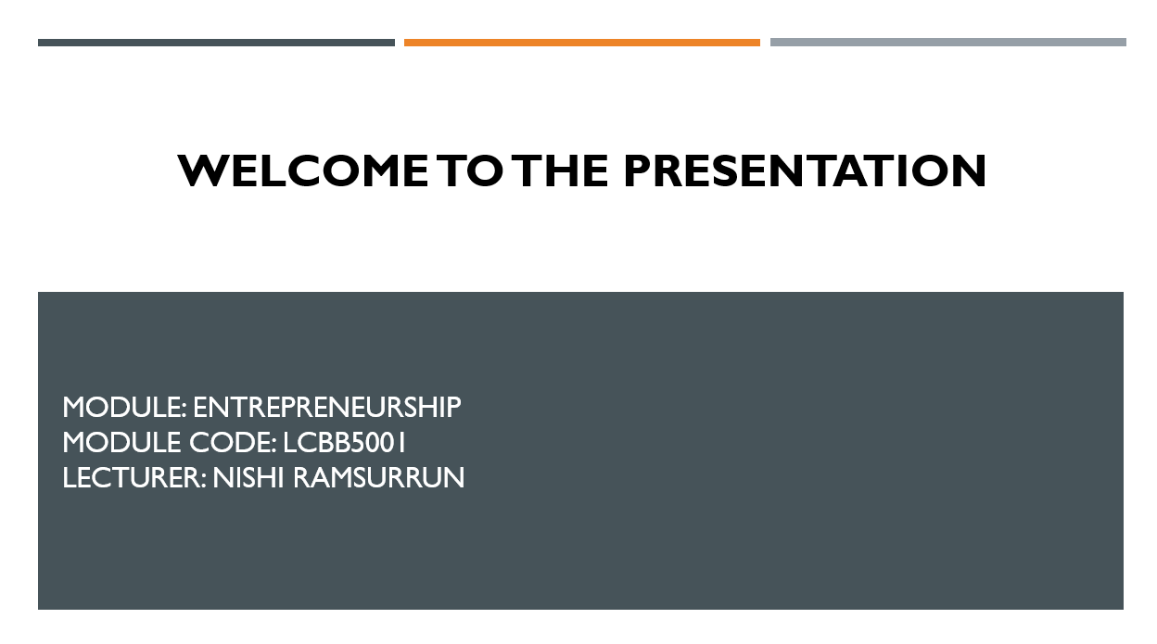
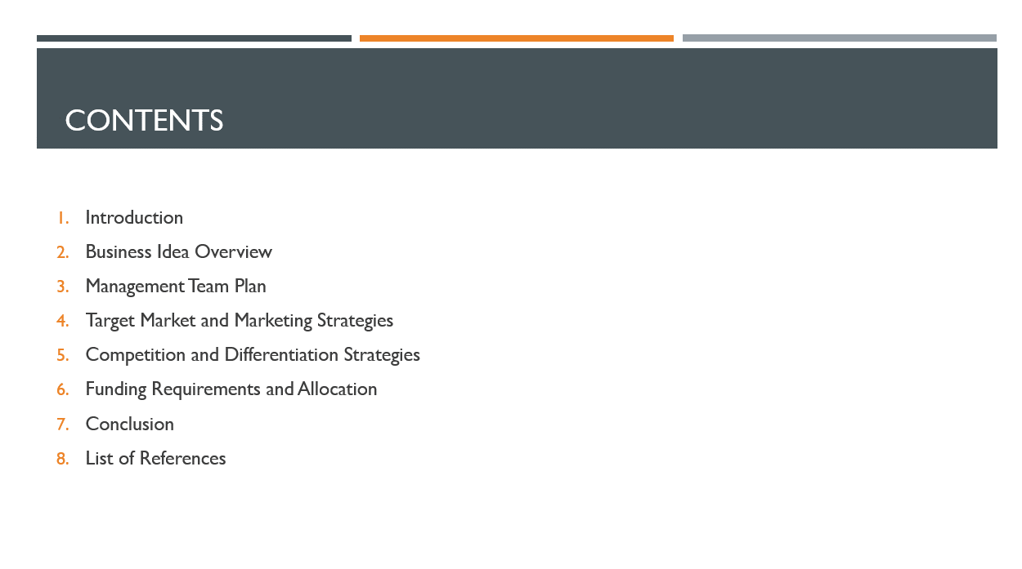

Introduction
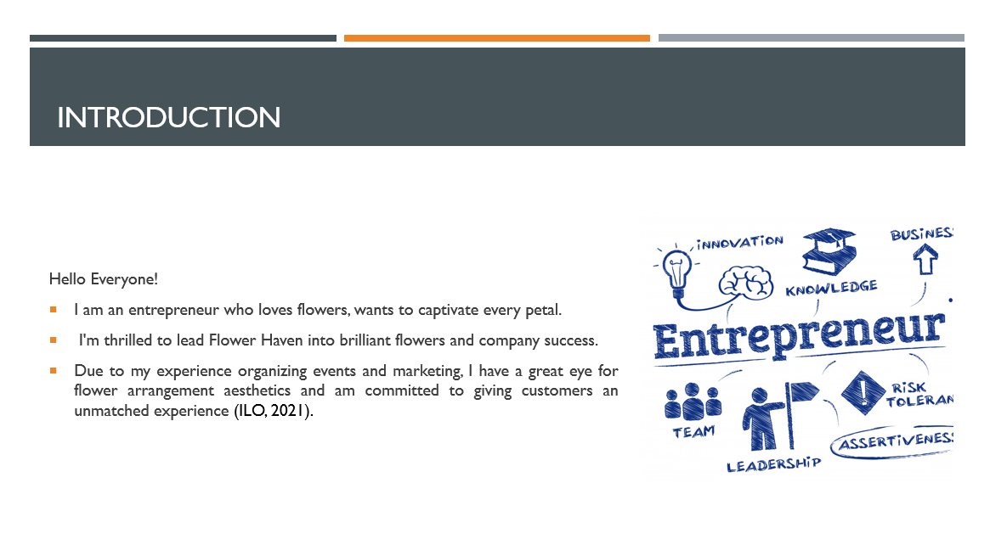
Hello, distinguished individuals! My name is Stefan Genchev, an entrepreneur motivated by a profound enthusiasm for the art of floral arrangement and a goal to imbue every blossom with a sense of magic. Regarding my background, my professional expertise in the field of marketing and event coordination has provided me with a keen ability to appreciate floral aesthetics and a strong dedication to providing exceptional client experiences (ILO, 2021). I am of the opinion that any event, regardless of its scale, warrants the application of floral artistry to bring about a transforming effect.

Personal SWOT Analysis
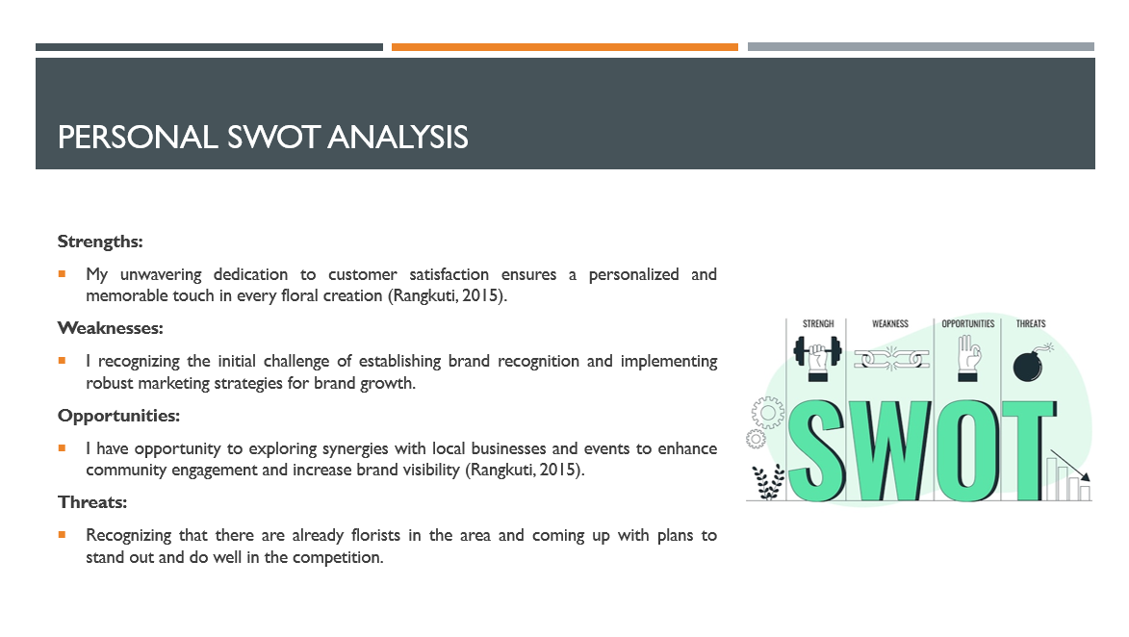
In the ever-changing floral industry, my entrepreneurial agility keeps me ahead. My customer-centric approach gives every floral arrangement a unique touch. Regarding the flower industry's learning curve, I seek ongoing education and mentorship. Strengthening marketing and brand growth tactics helps build brands (Rangkuti, 2015). Seizing opportunities, I see floral expressions and gifts developing. Flower Haven capitalizes on the market's elegant and unique tastes. Engagement and brand visibility are improved by local business and event alliances. Amid danger, established florists are respected. Flower Haven differentiates and competes by predicting and managing seasonal movements with diversified product ranges and clever marketing efforts. Flower Haven promises to make every occasion beautiful and joyful.

Business Idea Overview
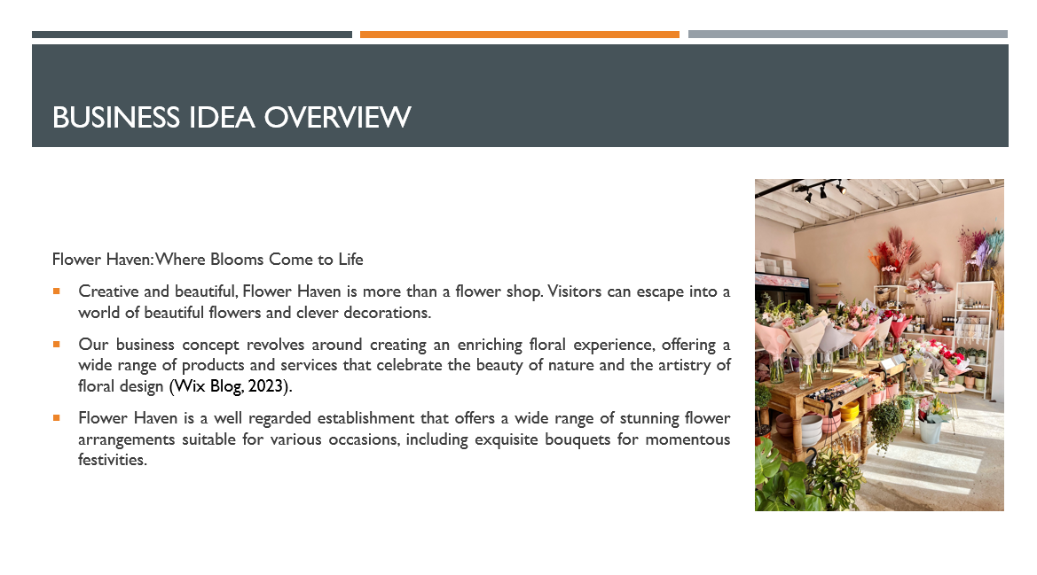
Besides selling flowers, Flower Haven is a creative and beautiful space. We imagine a world of beautiful flowers and intelligent designs where visitors can escape. Our mission is to enrich the floral experience by offering a wide range of products and services that honor nature and floral design (Wix Blog, 2023). We provide a variety of carefully crafted floral arrangements designed to evoke emotions and capture the essence of special events. Flower Haven is a reputable florist that offers a wide range of beautiful flower arrangements for various occasions, including exquisite bouquets for special occasions and sophisticated floral installations that can transform any space.

Products And Services
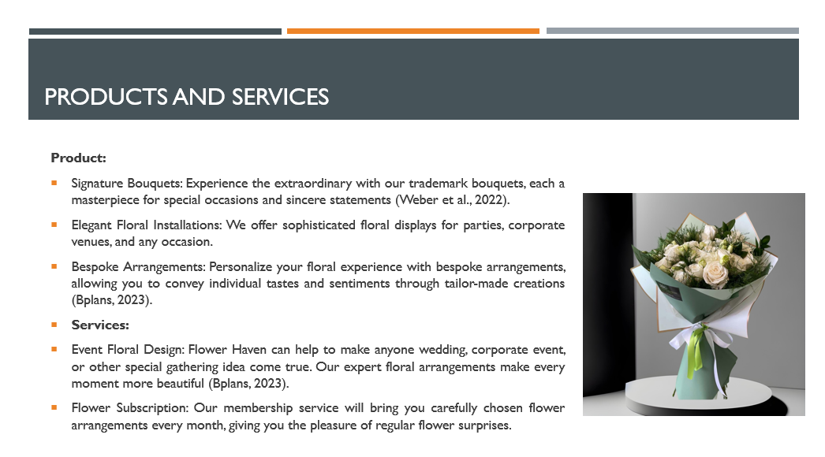
We use local producers to acquire fresh, seasonal flowers for the finest quality and community support. We also make custom floral arrangements to fit customers' tastes and messages. Flower Haven offers many services in addition to our amazing flower displays (Bplans, 2023). We offer wedding, corporate, and special occasion floral design, as well as flower subscription services for individuals who desire a constant dose of beauty. We create lasting memories at Flower Haven by curating customer experiences (Bplans, 2023). Join us on this floral journey where every petal tells a tale and every bloom will be remembered. Flower Haven is a celebration of nature's finest creations.

Management Team Plan
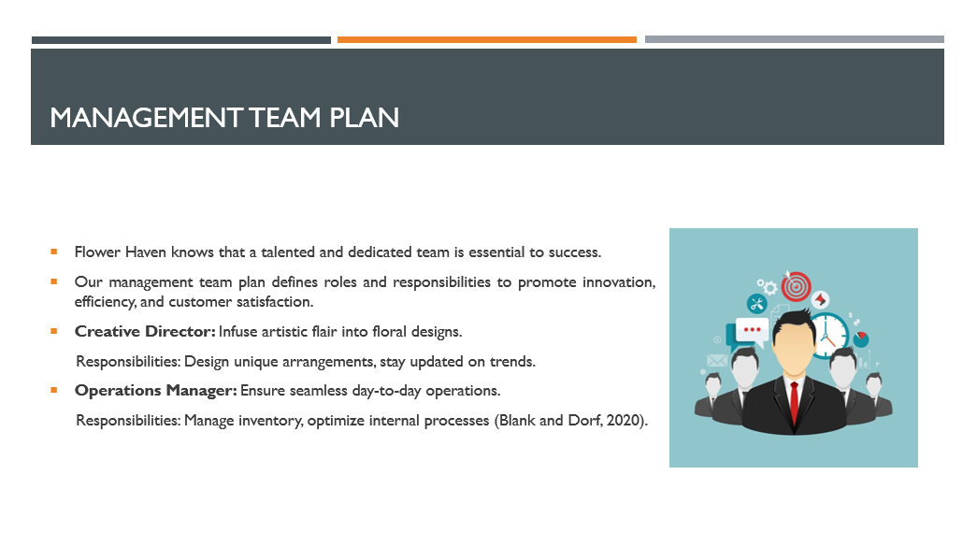
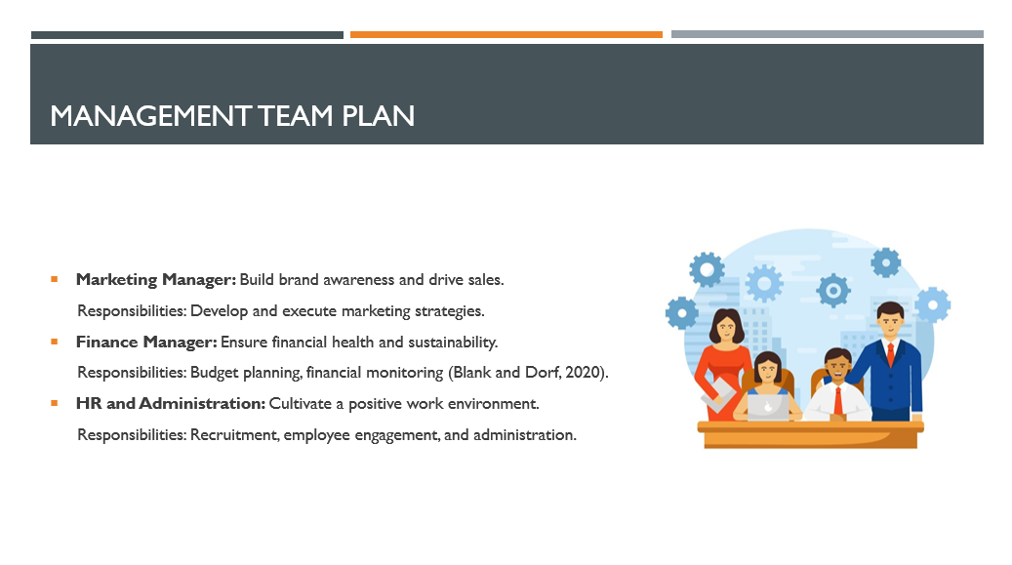
Creative Director creates innovative arrangements and follows trends to add artistic flair to our floral designs. Operations Manager oversees inventory management and internal process optimization to assure daily operations. The Marketing Manager develops and implements comprehensive marketing strategy to increase brand awareness and sales. Finance Manager oversees budget planning and financial monitoring to ensure Flower Haven's financial health and sustainability (Blank and Dorf, 2020). Our HR and Administration team manages recruitment, employee engagement, and general administration to provide a healthy work environment.

Target Market and Marketing Strategies
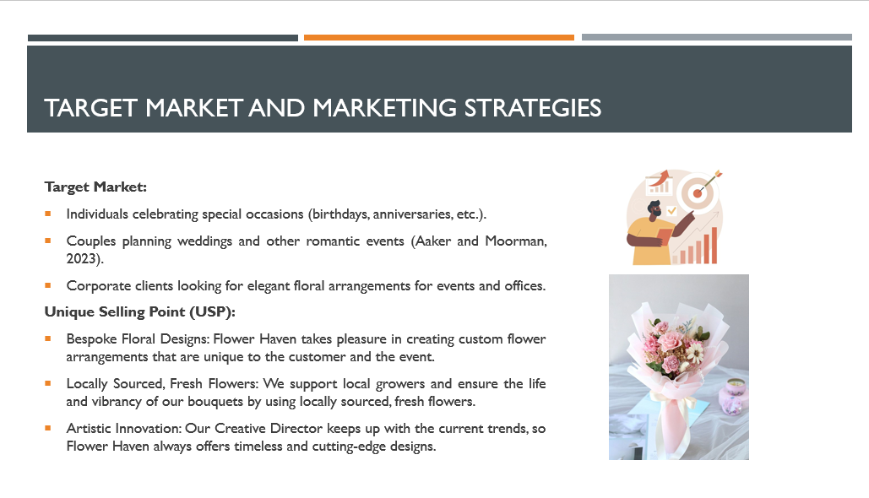
Flower Haven specializes in unique, high-quality floral arrangements for various events. Our target market is individuals and corporations seeking great designs. We serve birthday and anniversary celebrants, couples planning weddings and other romantic events, and business clients needing sophisticated floral arrangements for events and offices (Aaker and Moorman, 2023). Flower Haven stands out in the flower industry with its USPs. Our Bespoke Floral Designs guarantee that each arrangement is a one-of-a-kind beauty that reflects the customer's tastes and the event (Williams-Oerberg, 2020). Our arrangements last longer and are more vibrant because we utilize Locally Sourced, Fresh Flowers, which ensures quality and supports local growers.

Competition and Differentiation Strategies
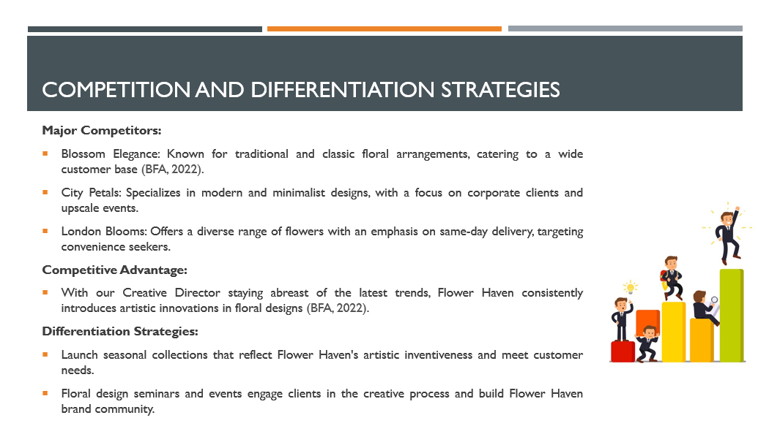
Flowers Haven competes with Blossom Elegance, which specializes in classic arrangements, City Petals, which produces modern floral arrangements for business clients, and London Blooms, which delivers quickly for convenience (BFA, 2022). We specialize in custom flower arrangements, giving Flower Haven a competitive edge. Our Creative Director's drive to staying ahead of trends creates unique and imaginative floral designs, setting us distinct. Flower Haven launches seasonal collections that meet customer needs and artistic creativity.

Funding Requirements and Allocation
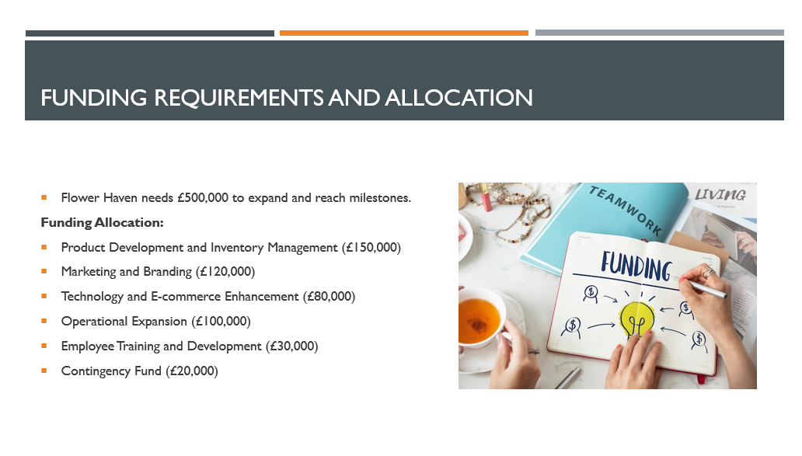
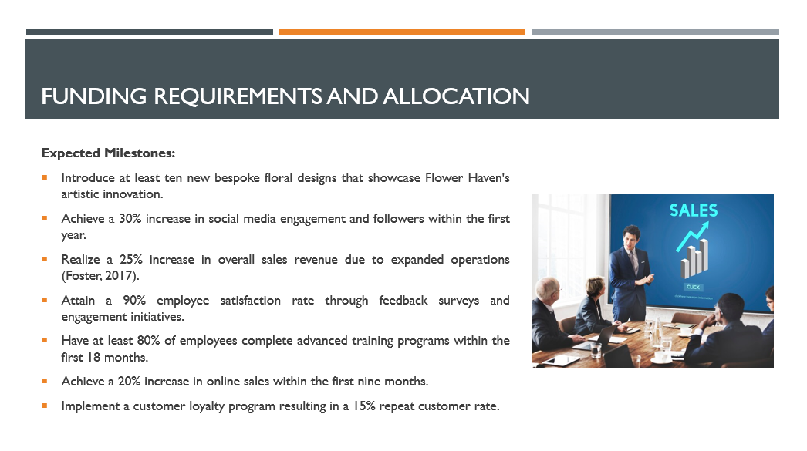
To expand and reach milestones, Flower Haven needs £500,000. Strategic fund allocation guarantees that every pound helps our firm succeed and survive. Product development and inventory management will receive £150,000, marketing and branding £120,000, technology and e-commerce £80,000, operational expansion £100,000, employee training and development £30,000, and a contingency fund £20,000. This will result in a 30% increase in social media engagement and followers in the first year, a 25% increase in sales revenue due to expanded operations, and a 90% employee satisfaction rate through feedback surveys and engagement initiatives (Foster, 2017). Flower Haven will use this cash to thrive in the competitive flower business.

Conclusion
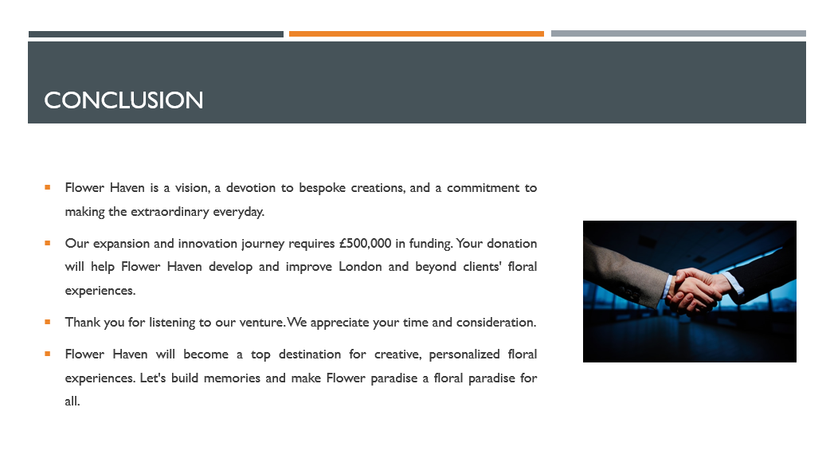
Flower Haven is a vision, a devotion to bespoke creations, and a commitment to making the extraordinary every day. Our expansion and innovation journey requires £500,000 in funding. Your donation will help Flower Haven develop and improve London and beyond clients' floral experiences. Flower Haven will become a top destination for creative, personalized floral experiences. Let's build memories and make Flower paradise a floral paradise for all.

References
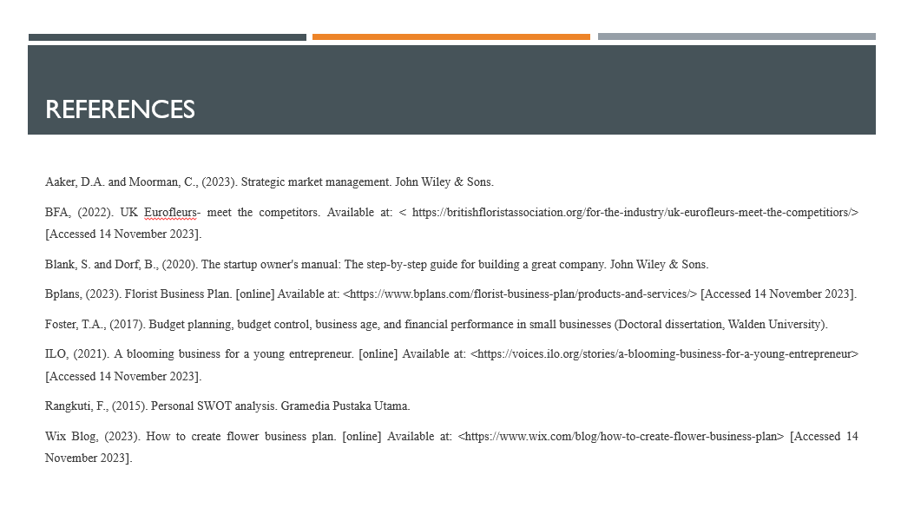
Aaker, D.A. and Moorman, C., (2023). Strategic market management. John Wiley & Sons.
BFA, (2022). UK Eurofleurs- meet the competitors. Available at: < https://britishfloristassociation.org/for-the-industry/uk-eurofleurs-meet-the-competitiors/> [Accessed 14 November 2023].
Blank, S. and Dorf, B., (2020). The startup owner's manual: The step-by-step guide for building a great company. John Wiley & Sons.
Bplans, (2023). Florist Business Plan. [online] Available at: <https://www.bplans.com/florist-business-plan/products-and-services/> [Accessed 14 November 2023].
Foster, T.A., (2017). Budget planning, budget control, business age, and financial performance in small businesses (Doctoral dissertation, Walden University).
ILO, (2021). A blooming business for a young entrepreneur. [online] Available at: <https://voices.ilo.org/stories/a-blooming-business-for-a-young-entrepreneur> [Accessed 14 November 2023].
Rangkuti, F., (2015). Personal SWOT analysis. Gramedia Pustaka Utama.
Wix Blog, (2023). How to create flower business plan. [online] Available at: <https://www.wix.com/blog/how-to-create-flower-business-plan> [Accessed 14 November 2023].



Task B

Introduction
Flower Haven's entrepreneurial journey is examined in this paper. Flower Haven's strategic foundation from our business idea, entrepreneurial skills, and market research to the UK flower industry's PEST components and technical landscape is covered in this Flower Haven uses creativity, flexibility, and customer-centricity to reinvent the floral experience for current tastes.

Evaluating Business Idea and Motivational Factors
Flower Haven's main goal is to do more than just make flower arrangements. They want to create a place that is all about flowers and nature a floral sanctuary. The unique offer includes personalized plans, a strong dedication to buying fresh flowers from local sources, and a strong determination to being very creative (Wix Blog, 2023). This idea comes from a strong belief that flowers are not just objects, but can also carry emotions and make ordinary things look amazing. The flower industry, when looked at from Flower Haven, is more than just business. It helps people connect emotionally and shares important experiences (Frederick et al, 2018). The goal is to change the way we usually see flowers and make them more personal, better for the environment, and an authentic reflection of someone's personality. Every petal and arrangement are like a different stroke on the canvas of life, making beautiful and memorable moments. The reason for choosing Flower Haven is a story of personal passion, business vision, and a strong dedication to helping people and the environment. Flower Haven is a way for someone to show their love for arranging flowers. They really like how flowers can make people feel and make life better. This strong love and interest help lead the way in starting a business, making everything creative and intentional. Flower Haven decided to start the adventure because they saw there was a need for their product in the market. Flower Haven started because people wanted unique, local flower arrangements that are made just for them. The company wants to make sure customers are really happy by making special and creative products that tell interesting stories and fit personal preferences. The reason for doing something goes beyond making money and includes a promise to help the community continue to thrive. The motivational context is about facing the challenge of competing in a tough market (Tech Funnel, 2023). Flower Haven sees this as a chance to come up with new ideas and stand out, instead of a problem. Flowers have the power to make people feel strong emotions. This is why Flower Haven works hard to do well, in a world where every flower arrangement is an emotional work of art. Artistry is the main focus of the brand.

Entrepreneurship Skills, Traits, and Behavior
Vision and Creativity: A clear vision is important for success, and to make a floral sanctuary. Creativity is the most important part of this business, making it different from other businesses in a market full of the same old things (Hisrich et al., 2017). Flower Haven can make special flower designs and experiences that no one else has. This helps Flower Haven stand out and appeal to many different people. Having good ideas and being creative are really important for making new things. They help Flower Haven to offer unique products and experiences that attract customers who want something special. In a fast-changing market, this skill helps to keep growing and adjust to new trends.
Resilience and Adaptability: The process of entrepreneurship is intrinsically arduous, necessitating the possession of resilience in order to effectively manage obstacles and adjust to changing conditions (Frederick et al, 2018). Flower Haven acknowledges the intricate nature of the flower industry and embraces the concept of resilience as a valuable means of acquiring knowledge from past experiences and adapting methods to ensure long-term expansion. The quality of resilience is crucial in maintaining the unwavering nature of Flower Haven when confronted with difficulties, effectively transforming hindrances into advantageous circumstances.
Customer-Centric Approach: Understanding and putting customer needs first is very important at business (Baum et al., 2014). Flower Heaven focus on creating unique designs and involving customers in the process, which shows that we care about putting customers first. This skill makes sure that customers are happy and keeps them coming back, which is important for the business to do well in the long run. In a market where lots of companies are fighting for customers, putting the customer first gives an edge over others.
Leadership and Team Building: Good leadership and building a strong team are very important for business to be successful (Drucker and Maciariello, 2014). Teamwork is important for the success of the project, from designing to making sure everything runs smoothly. Being a good leader and working well with a team are very important for reaching goals together. A good team that works well together makes Flower Haven a nice place to work and helps the business run smoothly. Good leadership helps make good decisions and gives the business a clear plan for success.
Risk-Taking and Decision-Making: In the entrepreneurial landscape, Flower Haven recognizes the value of calculated risk-taking and quick decision-making (Drucker and Maciariello, 2014). Flower Haven embraces the risk of standing out in a competitive market by making decisive decisions that are consistent with its goal. This competence ensures market agility and staying ahead of trends. In a volatile and fast-paced economy, the ability to assess risks and make sound judgements is critical. Flower Haven's proactive risk-taking attitude encourages innovation and positions the company as a pathfinder, ready to adapt and capitalize on emerging opportunities.

Evidence-Based Self-Assessment

Individual Skills Audit
SKILLS I HAVE | EXAMPLE
Creativity | Designing unique floral arrangements.
Decision-Making | Making strategic decisions aligned with Flower Haven's vision.
Adaptability | Pivoting business strategies in response to market trends.
SKILLS I’D LIKE TO IMPROVE | HOW? EXAMPLE?
Networking | By attending industry events to expand professional connections.
Digital Marketing | By taking an online course to enhance digital marketing skills.
Data Analysis | By learning data analysis tools to make informed business decisions

SWOT Analysis
Strengths | Weaknesses
- My inherent creativity serves as a strength, fueling the design of distinctive and captivating floral arrangements (Rangkuti, 2015).  - I pivot swiftly to align with market trends and stay ahead in the floral landscape.  - My unwavering dedication to customer satisfaction ensures a personalized and memorable touch in every floral creation. | - Acknowledging the learning curve of entering the floral industry and actively seeking continuous education and mentorship.  - Recognizing the initial challenge of establishing brand recognition and implementing robust marketing strategies for brand growth (Drucker and Maciariello, 2014).
Opportunities | Threats
- I have opportunity to seizing the upward trajectory of floral expressions and gifts in a market that values uniqueness and elegance.  - Exploring synergies with local businesses and events to enhance community engagement and increase brand visibility. | - Acknowledging the presence of established florists and devising strategies to differentiate and compete effectively (Sarsby, 2016).  - Anticipating and mitigating the impact of seasonal shifts by offering diverse product lines and strategic marketing campaigns.

Extensive Market Research including PEST Analysis of the UK
Market Research: Extensive market research illuminates a dynamic landscape within the UK floral market, where discerning consumers are increasingly gravitating towards personalized and sustainable products (Bplans, 2023). The traditional approach to floral purchases is evolving, driven by a heightened awareness of environmental impact and a desire for distinctive, locally sourced experiences. This shift creates a significant opportunity for businesses like Flower Haven, poised to cater to the changing preferences of the eco-conscious and individualistic consumer.
PEST Analysis
Political Factors: The flower business in the UK is affected by rules made by the government and trade agreements. Rules about bringing in and sending out things from a country, especially after Britain left the European Union, affect how easy it is to get certain flowers and how much they cost (BW, 2019). Following the rules for protecting the environment is also important to think about. It's very important for Flower Haven to follow these rules so that they can keep their supply chain running smoothly and save money. The UK government is helping local businesses and sustainability projects, which could be good for Flower Haven.
Economic Factors: Floral expenditure is influenced by economic variables, including disposable income and consumer confidence. Gaining insight into the impact of economic fluctuations on consumer behavior is of paramount importance for Flower Haven's pricing and marketing initiatives. Flower Haven possesses the capability to adapt its product offerings and marketing communications in response to economic developments, so ensuring congruence with consumer expenditure patterns. The costs of flowers and operational expenses are influenced by inflation rates and currency fluctuations.
Social Factors: Social trends affect what flowers people like (Perera, 2017). The different cultures in the UK and the importance of special events affect the way people give flowers as gifts. Flower Haven should think about popular cultures and special occasions when making and selling its products. By making sure that our flower designs match with cultural and event trends, Flower Haven can serve many different customers and events.
Technological Factors: Technology shapes market dynamics in the ever-changing UK floral sector. Flower Haven understands the expanding impact of e-commerce on consumer behavior and prioritizes online optimization (Mintel, 2022). Using innovative inventory management solutions regulates the supply chain, reduces waste, and keeps fresh flowers flowing. Social media and CRM technologies are used to personalize customer experiences and build brand loyalty. Flower Haven also uses flower preservation technology to follow ecological trends and give consumers longer-lasting arrangements. Data analytics helps Flower Haven understand market trends and consumer preferences, guiding strategic decisions and keeping the company competitive in the technology driven floral industry.

Conclusion
This evaluation report reveals Flower Haven's complex entrepreneurial story. Flower Haven may survive in the dynamic UK flower sector with a well-evaluated business plan, entrepreneurial abilities, and market knowledge. Flower Haven pioneered personalized, eco-friendly floral experiences with its devotion to sustainability, technological integration, and client happiness. The journey continues, and Flower Haven is ready to bloom in the floral market.

References
Baum, J.R., Frese, M. and Baron, R.A. eds., (2014). The psychology of entrepreneurship. Psychology Press.
Blundel, R., Lockett, N. and Wang, C., (2017). Exploring entrepreneurship. Sage.
Bplans, (2023). Florist Business Plan. [online] Available at: <https://www.bplans.com/florist-business-plan/products-and-services/> [Accessed 14 November 2023].
BW, (2019). The Flower Market in United Kingdom: 2019 Business Report - ResearchAndMarkets.com. Available at: <https://www.businesswire.com/news/home/20190305005752/en/The-Flower-Market-in-United-Kingdom-2019-Business-Report---ResearchAndMarkets.com> [Accessed 14 November 2023].
Drucker, P. and Maciariello, J., (2014). Innovation and entrepreneurship. Routledge.
Frederick, H., O'Connor, A. and Kuratko, D.F., (2018). Entrepreneurship. Cengage AU.
Hisrich, R.D., Peters, M.P. and Shepherd, D.A., (2017). Entrepreneurship. McGraw-Hill Education.
Mintel, (2022). UK Cut Flowers and Houseplants Market Report 2022. Available at: < https://store.mintel.com/report/uk-cut-flowers-and-houseplants-market-report-2022> [Accessed 14 November 2023].
Perera, R., (2017). The PESTLE analysis. Nerdynaut.
Rangkuti, F., (2015). Personal SWOT analysis. Gramedia Pustaka Utama.
Sarsby, A., (2016). SWOT analysis. Lulu. com.
Tech Funnel, (2023). Role of Motivation in Entrepreneurship. Available at: < https://www.techfunnel.com/martech/role-of-motivation-in-entrepreneurship/> [Accessed 14 November 2023].
Wix Blog, (2023). How to create flower business plan. [online] Available at: <https://www.wix.com/blog/how-to-create-flower-business-plan> [Accessed 14 November 2023].

