Managing Projects in the Workplace

Module code: BMSW5104
Student Name: Nicusor – Ionut Aliu
Student ID: 2131114
Lecturer name: Aderemi Ojebode

Table of Contents
1. Introduction 3
2. Project Description 4
3. Project Scope 5
4. Work Breakdown Structure 6
5. Quad Chart 7
6. Gantt Chart 9
7. Stakeholders Involvement 10
8. Resource Allocation 12
9. Risk Analysis 14
10. Conclusion 16
11. References 17

1. Introduction
The project management plan (PMP) is the central document used as a facilitator in designing and delivering the project structure to succeed (Portny, 2019). It acts as a prompter of sorts, identifying the different stages and aligning the project’s goals with doable tasks. Very critical resource allocation, risk management, and stakeholder engagement plan. The paper will give a better understanding of critical components of PMP, namely the project scope, worker breakdown structures, quad chart and Gantt charts, stakeholder involvement, resource allocation, and risk analysis. It is an effort to emphasise the importance of the PMP framework as a facilitator of goal attainment by stating the facts of the project without going into details for the introductory phase.

2. Project Description
The project in hand, Little Sprouts Nursery, is intended to be a top-class childcare centre that is able to take care of the needs of infants and children aged under 5 years. The nursery is situated in a great residential area to be, in essence, a second home in which the children are brought up in a safe, cosy, and intellect-stimulating location. This programme was conceived keeping in mind the increasing demand for day-care centres that are designed to cater for the busy lifestyles that working parents follow in the United Kingdom. Parents are provided with a great deal of peace of mind to carry out their professional obligations because they are well aware that their children are in good hands in safe and secure day-care centres. Little Sprouts Nursery will be distinguished by its commitment to advocating for early child growth. The curriculum is going to be designed to enhance learning, socialisation, and cognitive development, based on the latest pedagogical research and practice. The architecture of our nursery would take into account the impact of environmental and layout designs on kids learning and growth processes, which would then be seen on the walls filled with nature, interactive spaces, and modernised rooms that would excite young minds. Moreover, the crèche offers an elastic timetable that caters to the different needs of the families, thus conferring accessibility and ease. The aim is also to transform it into an inexpensive option, but the level of care and education provided would not be less than other alternatives. The goal of Little Sprouts Nursery is to establish quality standards for child care and education in order to be a leading example in early childhood education and truly make a difference in the community. It will be the basis of success for children in the first years of life.

3. Project Scope
The Little Sprouts Nursery Project is a whole procedure involving the planning and running of a nursery school for children from 0–5 years old. This undertaking is aimed at creating a proper educational and safe environment where children can spend a wholesome and balanced life with regard to their physical, emotional, and mental well-being. The process of project realisation will be broken into a number of important steps, each of which is important for the nursery further on. The project will commence by choosing an appropriate location that will be accessible to families and that will also be compatible with creating a child-friendly environment. This is the stage where a property that complies with all regulatory requirements and can easily be custom-made into a nursery centre of international standard is acquired. Next, after the site lease, the project enters the design and development phase through an approach that mixes education and entertainment within a safe and stimulating setting. It involves the preparation, interior design, and provision of the supply of age-appropriate equipment and materials to assist in a variety of activities (Jones, 2021).The range covers obtaining all necessary licences and permits and also doing discipline in line with all local and national standards for childcare providers. Legal setup and regulation setting have to be prepared for the operationalization of the nursery. Operational planning forms another critical aspect of the project scope. It includes employing qualified professionals, designing training programmes, and adopting operational policies and procedures that ensure the highest quality of care and education delivered (Jones, 2021). Besides, marketing and community engagement plans will be developed for promoting the nursery, bringing in families, and creating collaboration that will ensure the nursery’s growth and continuation. The all-encompassing nature of this coverage will provide a chance for Little Sprouts Nursery to have all operational processes designed to suit children and families, hence becoming a benchmark for quality early childhood education and care.

4. Work Breakdown Structure

Figure 1: WBS of the Project, Source: Author.
The Work Breakdown Structure (WBS) for the Little Sprouts Nursery project divides the project into four main phases, each of which comprises tasks that are critical for the project to be successful. The goal of the first phase, planning, is to establish a foundation for market research, financial planning, and site selection. Tasks include the determination of market demand, competitive analysis, mapping potential customers, budget issues, and searching for the location of the nursery (Gladden, 2020). The pre-construction phase follows the planning phase and involves design, government regulation compliance, and procurement. At this stage, the project shifts to the readiness stage for actual realisation by generating architectural and interior designs, ensuring legal and safety conformity, and acquiring necessary materials and services. In the construction stage, construction of the building runs parallel to the installation of infrastructure, which is where the plans of the project are implemented. Those activities will include the planning of inner space and preconstruction work, building construction, and the installation of important utilities and facilities for a child-friendly environment (Mikkelsen, 2021). Lastly, the nursery preparations operational stage is of crucial importance. This includes personnel, infrastructure, and marketing functions, which focus on the recruitment of skilled staff, the establishment of operating standards and systems, and the advertising of the nursery to get enrolments.

5. Quad Chart

Figure 2: Quad Chart, Source: Author.
Project Objectives: The objectives quadrant of the quad chart is the basic objective of the Little Sprouts Nursery project. Thus, the enterprise demonstrates the creation of a firm and dependable site for planting the nursery, which constitutes the foundation of the project. The building of child-centred facilities allows the environment to support the development of early childhood as these elements of safety, stimulation, and comfort are addressed. Compliance with legal and safety standards is non-negotiable to meet legal regulations and enhance parents’ trust (Shtub, 2019). Nursery entry is to be with full enrollment, which is a sign of successful market entry and the satisfaction of market demand for the service of early child care.
Key Activities: This section contains a list of the major tasks that will influence the project in reaching its objectives. Blau (2019) also notes that complete market research, which includes the gathering of information and then its analysis, will lead to the process of decision-making and strategic planning in order to make the offered services comply with market demands. Site identification and site assessment make up the first stage in establishing the physical location of the nursery, and the submission of legal and regulatory documents will provide a formal framework for the nursery. The essence of marketing in bringing clients and earning respect in the community is developing and implementing widely accepted marketing strategies.
Key Milestones: The lease or purchase of the property is the first crucially practical act in the establishment of the nursery. The essence of being legally operated is obtaining all the necessary licences and permits (Blau, 2019). The real project is the completion of the construction process and the implementation of nursery services, although successful hiring and onboarding of employees extend the nursery service capacity.
Risks and Challenges: This quadrant allows for the fact that there are some barriers that can mess up the deadline or even the result of the project. The unexpected delay in the construction may shift the opening date, thus reducing revenue and customer satisfaction (Shtub, 2019). The modifications to the existing childcare regulations may necessitate “tuning their business models” and ultimately cost or time overruns. Therefore, both staff recruitment and retention are key to the provision of high-quality care services, and the variable nature of initial enrollment may result in instability of funding and reduced quality of care services.

6. Gantt Chart
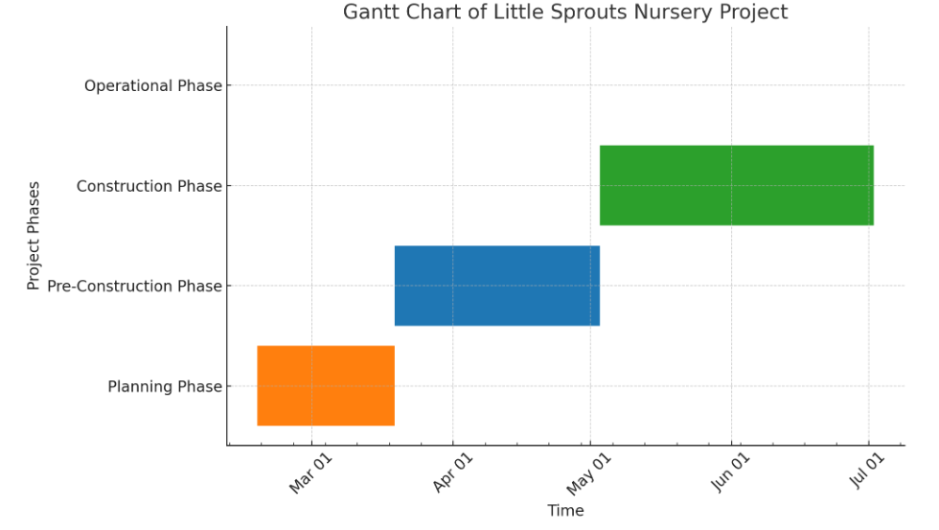
Figure 3: Gantt Chart, Source; Author.
The Gantt chart for the Little Sprouts Nursery project is a sliced view of the project’s critical phases plotted against a timescale. The planning phase is estimated to start first and take 30 days to provide market research, financial planning, and site selection. The post-costing stage follows this period and is 1.5 months long; the next one is the pre-construction phase, which is also 1.5 months long and includes detailing, getting permits, and preparing for construction. The construction phase takes two months and consists of the actual building of the nursery, such as the installation of required facilities and safety systems. The blocks therefore depict the phases in a sequence, that is, a phase that starts right after the completion of the preceding one (Shtub, 2019). The post-creation phase reflects a model without a specific end; hence, immediately after construction is over, operations begin, and they continue in perpetuity as the nursery starts operating and serving the community. This type of Gantt chart is suitable for presentations of the schedules of actions and the occurrence order, with the activities and transitions being evident.

7. Stakeholders Involvement
The theme of the Little Sprouts Nursery project will be the synthesis of stakeholders who will provide a range of inputs that will be influential on the way this nursery develops.

Figure 4: Key Stakeholders, Source: Author.
Parents and Families: Because they are consumers of the services that the nursery provides, parents’ recommendations carry a great deal of weight, and this directly influences some of the most important choices. They are concerned about the dietary limitations in a nursery that, however, provides unique meal plans (Wigert, Berg, and Hellström, 2020). Their advisory role in the nursery is more than just advisory; it is also inside community building that enhances the nursery image and public trust.
Project Team: The project manager, who is backed by a strong team of professionals, is the project centre around which it revolves from birth to maturity. They micromanage everything, every detail, so that the play area design will become safety itself and a learning instrument.
Investors and Sponsors: These financial stakeholders are critical to the project since they provide the finance necessary to maintain and develop operations. Also, they often invent different innovative ways to do it by, for instance, combining renewable energy sources that directly affect the efficiency and sustainability of production processes (Palisano and Orlin, 2022).
Local Community and Businesses: The partnership of the nursery with the local organisations creates symbiotic relationships and increases the network of the nursery. For instance, the kindergarten may liaise with a local library to have a reading corner, thus enriching the curriculum and promoting early reading and literature in this regard.
Regulatory Bodies: The stakeholders ensure that the nursery delivers the highest standards of child care (Palisano and Orlin, 2022). They represent the issue of credibility and ensure the health and safety of the children through the regulation of staff-child ratios.
Staff and Employees: Nurses and educators are the educational institution’s activity-supporting elements, providing the curriculum and taking care of the children. Yet, their effectiveness in working with children and their professional understanding of the growth of the child are essential to children receiving quality care and education.

8. Resource Allocation
The right resource distribution is a must for the effective performance of the Little Sprouts Nursery program. The project’s ability to meet deadlines and quality standards depends on the availability of all project resources, including financial as well as human capital.

Figure 5: Resource Allocation, Source: Author.
Financial Resources: Having enough financial means ensures that the project will not suffer from underfunding at any stage of development (Atkinson, 2019). Budget allocations are for construction, staffing, operational expenditures, and a reserve fund for unforeseen costs. A strategically planned marketing investment will increase the enrollment prospects, resulting in the financial stability and profit of the nursery.
Human Resources: Resource people are the core of the element and include project managers, educators, and support staff. Recruitment of competent workers and establishment of a staff development programme result in a good educational environment that, in rn, m makes it possible to provide quality child care services.
Material Resources: The learning environment requires physical resources through child-friendly building materials. These physical resources will also include educational supplies necessary for a good learning environment. The project significantly gains from investments in technology for operational efficiencies and quality and innovation in education (Cicmil et al., 2016).
Time Resources: Proper time management, accomplished by a precise schedule and the inclusion of buffer periods, prevents the project schedule from going haywire (Atkinson, 2019). Time for regulatory compliance and operational readiness is a determinant factor in the birth and viability of Little Sprouts Nursery.

9. Risk Analysis
The risks should be well managed so that Little Sprouts Nursery can commence and be run successfully. Determining the challenges of the future and employing systematic corrective measures for the patient and the viability of the project. Here are five key risks and their mitigation strategies:

Figure 6: Key Risks Associated with the Project, Source; Author.
Construction Delays: Challenges associated with construction disruption in the new locations are a typical problem, and thus, the nursery opening date may be postponed. Delays may occur as a result of unforeseen events, for instance, terrible weather or a discontinuity in the supply chain (Mikkelsen, 2021). For this purpose, a construction manager, who would shield the changes in schedules and foresee them, should be employed.
Regulatory Changes: The threat of abrupt changes in child care regulations would influence the operational practices inside the organisation, and non-compliance with programme standards would result. Staying alert to the prospect of newer legislative amendments and having a good rapport with the regulatory bodies. It is essential to seek advice from a legal consultant who has a good understanding of child care legislation to ensure the nursery stays in compliance with current and future laws (Portny, 2019).
Funding Shortfalls: Cost overruns or other unexpected costs cause a lack of money, though they do not permit the project to be finished. To solve this, a good financial plan is required, with a budget and access to all possible emergencies. Financial reviews and audits on a regular basis allow comparing the costs with the budget, and early identification of problems is guaranteed (Portny, 2019). Investors’ commitments or decisions to use other funds, such as loans or grants, would be another financial pillow for the business.
Staff Recruitment and Retention: The functioning of the nursery is the main factor in the attraction and retention of qualified staff members. Even though the risk is rather high from the labour market, which can result in a shortage of qualified workers, Competing for an attractive place to work with the nursery includes salaries, benefits, and job development opportunities (Atkinson, 2019). Establishment of partnerships with the local teaching colleges will also contribute to the poor pace of creating a pool of qualified staff.

10. Conclusion
The project management plan thoroughly describes a plan to open a good nursery. Rather than proper preparation, the involvement of the stakeholders, resource allocation, and risk management, the project is now set to feed the market with educational content that serves the needs of early childhood. The organisation guarantees a completely comprehensive technique that begins with site selection and ends with functional launch to develop an effective and educational environment for children. The base of the project is made more resilient and flexible through identification of the risks and control, thereby causing sustainability to be achieved (Gladden, 2020). Morphing from a concept to a realisation, Little Sprouts Nursery is an example of the success that project management has, sort of a standard of childcare service, and a mark in the community it serves.

11. References
Atkinson, R. (2019). Project management: cost, Time and quality, Two Best Guesses and a phenomenon, Its Time to Accept Other Success Criteria. International Journal of Project Management, [online] 17(6), pp.337–342. doi:https://doi.org/10.1016/s0263-7863(98)00069-6.
Blau, D.M. (2019). The Effect of Child Care Characteristics on Child Development. The Journal of Human Resources, 34(4), p.786. doi:https://doi.org/10.2307/146417.
Gladden, R. (2020). Book Review: Managing Project. Project Management Journal, 41(3), pp.100–100. doi:https://doi.org/10.1002/pmj.20188.
Jones, S. (2021). A Guide to the Project Management Body of Knowledge. 6th ed. Newtown Square, Pennsylvania, USA: Project Management Institute.
Mikkelsen, H. (2021). Quality of Project Work and Project Management. International Journal of Project Management, 8(3), pp.138–143.
Portny, S. (2019). Project Management . 5th ed. Hoboken, Nj: John Wiley & Sons, Inc.
Shtub, A. (2019). Project segmentation—a tool for project management. International Journal of Project Management, 15(1), pp.15–19.
Wigert, H., Berg, M. and Hellström, A.-L. (2020). Parental presence when their child is in neonatal intensive care. Scandinavian Journal of Caring Sciences, [online] 24(1), pp.139–146. doi:https://doi.org/10.1111/j.1471-6712.2009.00697.x.

