University of Wales Trinity Saint David London

BMSK5002 Developing Relationship and Workplace Achievement

Student’s Name: Mamunur Rashid Chowdhury
Student’s ID: 1604640

Lecturer’s Name: Dr. Rexon Nting

Contents
Introduction 1
Task: LO 1
Assessment of organizational & individual benefit for individual’s development 1
Evaluating available development vehicles to development needs 6
Developing a plan to meet the identified development needs & expectations 9
Evidence of wide reading, research and academic theories 11
Conclusion 13
References 14

Introduction
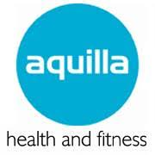
In case of any organizational setting, human resources are treated as the lifeblood for the specific organizations. Maintaining proper relationship within the working employees is one of the best ways to bring out the best output from them in an integrated approach. McCarthy, (2015) refer that, interactive relationship between the employees within any particular organization is the cornerstone of having both individual and organizational success. Higher the employee relationship, higher the output. These sorts of employee relationship within an organization lead the organization to make proper workplace achievement through the individuals. In the form of accomplishing this study, our chosen organization is Aquilla health & fitness center which is situated in Knightsbridge, London. This organization basically works with the fitness, personal care and spa treatment. This is very famous in London with its wonderful swimming pool, gymnasium, body care and personal care services. In this organization, there prevails a very satisfactory interactive relationship among the employees so that they can work hard in order to achieve required workplace success. In this study, we are going to discuss about benefits of individual’s development, available development programs according to needs, an inclusive plan to meet the needs by relating various sorts of theories and models in line with the organizational context of Aquilla health & fitness center.

Task: LO

Assessment of organizational & individual benefit for individual’s development
Individual’s development within any particular organizational setting refers enhancing the skills and job knowledge of the employees through giving training and giving development aid by the organizational authority. In this task, we are going to illustrate both organizational and individual benefits of individual’s development in line with the organizational setting of Aquilla health & fitness center.

Assessment of organizational benefits for individual’s development:
In what extent organizations are benefited from the individual’s development discussed in below.
- Effective goal setting: In the form of development programs, individuals are given various sorts of training and guidelines by which they can come to know about the current organizational needs and practices. So, they can make proper goal setting in line with the organizational mission and vision. Employees with proper workplace training, they can understand what they should to do and what they should not do. Thus, the goal setting procedures become very effective and efficient (Boyd, 2017).

- Uncover employees’ potentials: In the form of development programs, employees are observed in the matter of their running gaps or weaknesses and organizations try to develop them to make them reach into the organizational desired goals. When performances of them are assessed then organizations can find out their weaknesses and development needs. By doing so, organizations can come to know about what exactly need. Thus, all the existing potentials of employees can be sought out properly.
- Increased productivity: Employee development programs enable employees to be more vibrant and efficient as they get proper guidelines and training programs for doing a specific job. For example, Aquilla health & fitness center gives guideline and training to the care professionals about how they should give beautification treatment to the clients in the form of hair removing, facial or spa related activities. When the organization gives proper training and guidelines, employees can perform these sorts of works properly. Then organizational productivity or service delivery become effective.
- Reduction of errors: An integrated development programs increase the skills and job knowledge of the employees within any organization like Aquilla health & fitness center. In this case, the numbers are being reduced day by day and the organizational performances are increased as errors are reduced slowly.
- Reducing the employee’s turnover: Proper development programs for the employees make the employees confident and qualified for doing their assigned activities like assisting clients to develop their bodies at gymnasium in Aquilla health & fitness center (Bager-Charleson, 2012). In this case, employees get their expected job satisfaction and they do not want to leave organizations.
But sometimes, the development programs may not bring out satisfactory result for the organizations. Sometimes unplanned development programs can cost lots of money. In addition to, giving development by not identifying the development needs can waste time or organizational normal operational procedures.
Assessment of individual benefits for individual’s development: Now we are going to make assessment about how the individuals are benefited from the development programs taken by Aquilla health & fitness center.

- Personal growth: This about the way of improving habits, behavior, mental ability that assists them in getting good jobs or proper duties accomplishment. Individual’s development programs make the employees more confident and their mental ability is increased in a great extent. By having proper personal growth, employees can make an enriched career in terms of giving their input to the organizational internal business processes and they become fit in case of doing any sort of job in any kind of organizational perspective.
- Change of mindset: In the form of psychological and mental learning processes individuals are given lots of development need aids. The negatively impacted employees can alter their mindset into very positive direction. In the form of soft skill classes, employees are psychologically treated and they can increase their mental ability in the way of performing organizational activities (Tansley, Hafermalz & Dery, 2016). With positive mindset, they can perform organizational activities properly.
- Career development: Development programs for the employees assist developing the career in a large extent indeed. Employees can know about their weaknesses and current strength stages. By having these sorts of knowledge employees can develop their career to the way of their personal achievement. They can flourish their job life with the promotion, recognition due to contributing properly to the organizational productivity.
- Establishment of a corporate culture: Employees with various sorts of development programs learning mechanisms, practices assist employees to develop their corporate culture. In this case, they become accustomed to the corporate environment so they can contribute to the organizational productivity and employees are treated as very potential actors for the organizations.
In case of the personal life for the employees, the development may not also bring about satisfactory result. Employees often do not want to learn new things, they may feel shy or hesitated in participating the learning programs. In addition to, organizations can demand from the employees an unexpected increased performances. In this case, employees can find themselves with so much pressure or burden. So they may not want to have development needs. In this case, the overall procedures can be gone in vain.
Application of theory:
In order to describe the potential benefit derived from the individual’s development taken by Aquilla health & fitness center is described in below through applying the Honey & Mumford Learning theory:
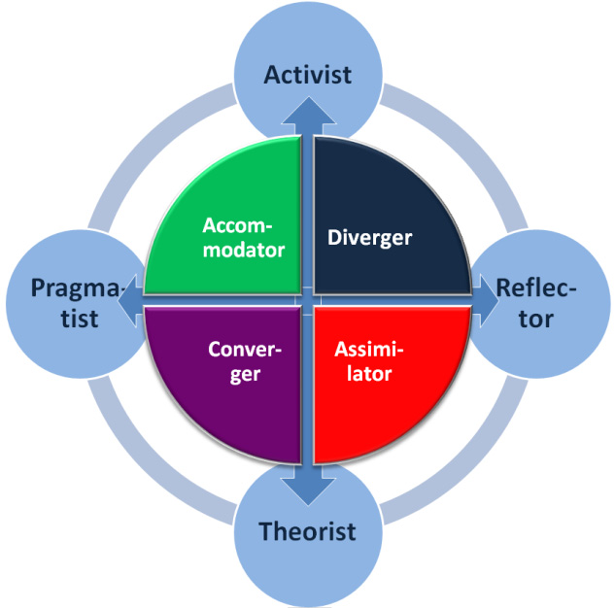
- Honey & Mumford learning theory: This theory actually refers to the way through which the employees go for the particular learning programs in order to develop themselves for contributing to the organizational mission and vision accomplishment. This theory was given Peter Honey and Alan Mumford in 1986. There are basically four aspects of this theory those are illustrated in below.
- Activist: This is the way in which employees basically takes part to the learning and development programs. They learn by their own effort and this sort of learning is so easy and smooth and employees can make their personal and professional growth.
- Reflector: This is way of learning and development programs are initiated by following the already developed or senior employees (ELN Resources, 2018). Through this way, employees can easily learn from the organizational setting in a large extent and it’s so much practical so it assists employees to give more input to organizations.
- Theorist: Employees are given some sorts of written guidelines or documents by which employees try to develop themselves by studying or taking part in various sorts of learning conferences or seminars.
- Pragmatists: Employees get developed by adopting knowledge from the organizational context greatly. In this case, Employees learn from the practical workplace activities. Employees can have required knowledge through the practical world.
These sorts of way of learning and development lead the employees to the way of making proper personal and professional developments. Employees along with the organizations can have their expected feedback from the developed employees.
- Kolb’s learning theory: This theory was given be David A. Kolb in 1984 in order to show the way of learning the people in order to be developed in case of working in any organizational employee development. There are basically four ways of getting developed by employees, those are illustrated in below.
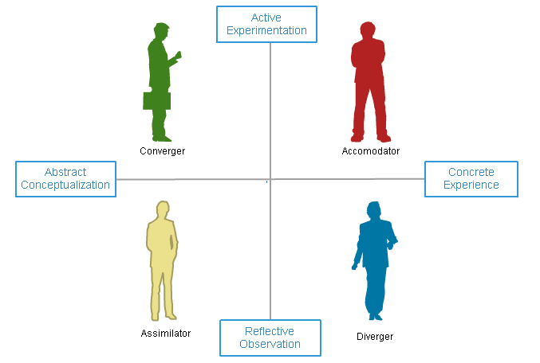
- Diverging: This is the way in which employees basically learn by watching anything both in the workplace or others. In this case, already developed employees work and the new employees learn by watching them. This sort of learning assists employees to contribute to the organizational activities by giving their effort.
- Assimilating: Employees get developed by having the knowledge from explanation or case analysis. They learn how to deal with the critical moments and how to contribute to management processes logically and utilizing the own sense.
- Accommodating: By being developed through this learning style, employees become practical and situational so they can be leaders in solving any difficulties.
- Converging: This sort of learning style develop employees by providing them the ability relating the practical issues with the theoretical issues. In this case, employees can easily their academic knowledge in the real workplace (McLeod, 2018). This ability gives the opportunity of solving any problems very easily and technically so employees become very potential to the organizations.
This is the way by which employees get developed by participating in different sorts of learning programs and they become able to do bring out potential benefits both for the organization and for themselves.

Evaluating available development vehicles to development needs
Development vehicles is basically a framework or mechanism through which the organizational authority of any particular organization bring out the development needs from the employees. By applying the development vehicles, employees are really engaged in participating their personal development program and the learning or development programs become successful. In the light of the organizational structure of Aquilla health & fitness center, the available development vehicles to assess the individual’s personal development expectations are evaluated in below.
Evaluation of appropriate framework for assessing individual’s development needs:
- Mutual consultation: In order to know the personal development expectations from the employees, the employers or the organizational authority of any particular organization should go for mutual consultation so that the authority can come to know about the expectations and demands of the employees. By doing so, the employees might have a floor or platform by which they can easily mention to the employers about their personal development needs like soft skills need, confidence build up needs etc.
- 360 Degree appraisal: In order to increase the both employee’s and organizational performance, the employers must know about the current development needs of the employees so that employers can arrange for the required learning programs and the employees can be developed by fulfilling their needs. In this case, the employers of Aquilla health & fitness center can come to know about the current personal development needs of the employees (Tansley, Hafermalz & Dery, 2016). In this case, the 360 degree appraisal may include survey analysis, asking about the colleague’s performance from employees, organizational performance records etc.
- Critical incident review: Organizations like Aquilla health & fitness center can conduct critical incident review in order to know about how is the current personal development situation now. In this case, the organizational authority can assess all the negative incidents conducted by employees during conducting their organizational responsibilities like motivating clients about taking service from the Aquilla health & fitness center. In this case the trainer might not make realize the clients about the benefits of physical exercise at the center for not having proper presentation or communication skill. In this case, the clients might not come to take service. These sorts of errors or criticism should be conducted so that employees’ real capability or strengths can be known properly.
- Practical review: This way can be used in order to collect from the employees about their needs and expectations for making their personal development. Aquilla health & fitness center sometimes prepare a set of questionnaire for each of the profession or posts for finding out their development needs. In this case, the organizational authority prepare the questions very technically with logically made questions. In this case, the employees are asked about how their assigned works are going on, to what extern they are facing problems and what sorts of aid they need for recovering the difficulties. Thus from the practical job life the employees are questioned and they can give the appropriate answers.
- Building up a communication channel: In order to identify the personal development expectations from the employees, the organizational authority of Aquilla health & fitness center try to maintain an effective communication channel so that bot the employees and employers can come close and they can discuss about the overall problems and the tentative solutions (Johns, 2012).
- Building a friendly environment: In Aquilla health & fitness center, there always prevails a friendly environment where employee relations is at very good position. In this case, employees can share their problems with the seniors or the colleagues. After knowing the existing personal development gaps or needs of the employees, the organizational authority of Aquilla health & fitness center always try to give them various sorts of mental ability training, psychological therapy or other needed development need so that they can be very potential for the company in a large extent indeed.

All these available systems within Aquilla health & fitness center always assist in identifying the personal development needs of the employees from their workplace. By applying these sorts of ways, a clear understanding about them can be gotten. Then the organizational authority and the human resource department can easily give development aid in order to make them fit for the organizational activities accomplishment. So, these available systems within Aquilla health & fitness center are really vital for finding out the personal development expectations and fulfilling them.
Theories related to assessing the personal development expectations:
The relevant available theory about the personal development expectations assessment is described in below.
- Dawn Lennon thoughts: At the book of Big picture Dawn Lennon, he showed about how to know about the personal development expectations from the employees. In that book he showed that, employees should be engaged in mutual communication, consultation or discussion program so that they can present their personal development expectations to the organizational authority. In this case, organizations should have proper friendly environment in which the employees can get together and urge for taking proper personal development needs (Jr, 2018). In addition to, the employers should respect the employees in order to find out their personal development needs. The employers must be respectful to the conduced errors in terms of doing their job. By overlooking the errors, employers should aware training or mental therapy program so that their personal development is ensured.
- Harrison assessment solution tools for understanding the development expectations: Harrison invented new talent solution technique in order to know about the current development needs of the employees and give proper solution to that matter. He suggested some sorts of matters regarding finding out the personal development expectations.
- Dialogue between employees and employers: The talent solution theory of Harrison suggests about conducting dialogue between the employees and employers for sharing the personal development needs from the employees. Only smooth and spontaneous dialogue between the parties can make proper solution.
- Performance culture engagement: The organizational authority of any particular organization should create such a performance culture where everyone will compete for increasing their own skills and competencies (Trusted coach, 2018). In this case, the employees will try to overcome their personal development needs and the employers will be active to solve the problems by giving proper persona development aid.
These are the related theoretical framework with finding out the personal development expectations from the employees. By applying these Aquilla health & fitness center can easily find out the development expectations from the employees in a large extent indeed.

Developing a plan to meet the identified development needs & expectations
In the modern age of corporate culture, human resources are treated as the lifeblood for any sort of organization. In this case, employees should be developed professionally and personally so that they can be the key asset for any organizational operational mechanism. Based on the organizational context of Aquilla health & fitness center, the plan for meeting the already identified development needs and expectations is discussed in below.
Development of a plan to meet the identified development needs & expectations:
The development of a plan to meet the already identified development needs and expectations in line with the organizational context of Aquilla health & fitness center is outlined in below.
- Defining goals: In order to meet up any development needs for the employees there should have a unified goal setting so that both employees and employers can work in line with a coordinated way (Cottrell, 2010). In this case, both employees and employers can set up a mutual goal and both of them can try to achieve the goals.
- Prioritize: In order to meet up the development needs, the already identified development needs should be arranged based on the priority so that the most prioritized needs can be met up and then based on the importance, the other needs can be met up properly. In this case the organizational authority of Aquilla health & fitness center can first concentrate on developing the confidence of the employees so that employees can learn handling any sort of challenging activities within the organizational context.
- Setting a deadline: In order to develop any sort of personal and professional development, there must have a deadline so that the overall personal and professional development can be effective to be implemented. In this case, the deadline should be set based on the range or volume of the programs to be initiated. For example, if Aquilla health & fitness center take the development of the mental ability development programs for the employees, then the organization should have long time so that it can be accomplished properly. Because these sorts of development programs take much time.

- Understanding the strengths: The organizational authority should have proper knowledge about their current level of strengths in meeting up the development needs of the employees in a great extent. In this case, based on the technicians, specialists, resources, time, the organizational authority should take the learning and development plan for the employees. For example, Aquilla health & fitness center is not so big organization so the organization should take training program for a certain range of employees so that the training programs can be conducted using the available resources.
- Recognizing threats and opportunities: Organizational authorities should consider all the possible threats and opportunities at the way of developing the individuals in terms of working environment. For example, in order to increase the resistance capability within the employees, the behavioral therapies for the employees may be inappropriate because trainees may not learn the thing willingly (McLeod, 2018). On the other hand, the opportunities like outsourcing trainers from big organizations at low cost can be big opportunity for the organizations in order to make proper personal and professional development. These sorts of things should be properly recognized during developing the plan.
- Taking action: By considering all these matters in the way of plan development of personal and professional development plan, the organizational authority should take proper action by interpreting the threats and opportunities. In this case, the organization should first recruit an specialists who will give training and a psychologist also need to be appointed who will give mental help therapy in order to build up proper mental capability. In addition to, the organization should take actions for increasing the convincing capability of the employees and building up their mental resistance. The organization should also create a proper learning culture so everyone can learn by making interactive actions (Hughes, 2009). All these actions should be taken in order to meet the development needs in a large extent.
- Evaluation: After taking all the possible actions and measures, the organizational authority of Aquilla health & fitness center should take evaluation program in order to assess the current progress or development. In this case, a famous third party should be recruited because evaluation conducted by third parties are tended to be more credible, unbiased and appropriate.
Through developing this personal and professional development, Aquilla health & fitness center can make meet the development needs and a very satisfactory feedback can be got from this plan and implementation.

Evidence of wide reading, research and academic theories
In the previous task, we have already discuss about various aspects of personal and professional development needs and expectations. We have also a devised an inclusive plan about how to deal with these needs and how the effective feedback can be gotten from these programs. Now we are going to show the related evidence of wide reading, research and academic theories in order to support our discussion.
Evidence of wide reading, research and academic theories:
In the light of each of the ways, the evidence is mentioned in below.
- Research: A study conducted by Ferguson (2007) demonstrates that, personal and professional development is the way improving all the internal and external skills of employees in such a way that, the employees can be treated as very vital resources and they can contribute to the organizational internal business properly. In order to make an effective workplace environment in terms of high productivity, sales and revenue, the development of the employees are the mandatory things. Now-a-days the newly emerged business organizations are retaining the market by putting emphasis on making human resource development.
- Academic theories: In the form of relating all the conducted discussion in previous discussions can be linked with some models of professional and personal development. In this case, some sorts of models are narrated in below in the light of some development models.
- Training model: Training model is basically known as the ADDIE model. This model shows five phases of training by which the employees can overcome their existing professional weaknesses and they can go for a wide range of professional development. The phases are given in below.
- Analysis: In the form of giving training to the employees, the trainers should analyze all the relevant problems or benefit with giving training. The cost-benefit analysis should be considered.
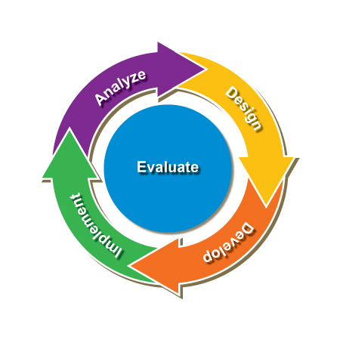
- Design: Based on the organizational capabilities and individual’s needs, the training programs should be designed in terms of both on the job and off the job training required for the organization.
- Development: In this phase, trainers are trained and the target audiences are set. In addition to, training materials are arranged in order to teach them.
- Implementation: After arranging all the things and preparing the workplace environment, the required training is given to the employees (Bizfluent, 2018).
- Evaluation: With the help of the third party or organizational authority, the evaluation and assessment should be done in order to see about how the training and sessions have been done.
- Performance agreement model: This model is also one of the best of making proper personal and professional development for the employees. In this case, employees have to go for a contract before being appointed and before getting any sort of promotion. Employees have to be obliged and they have to be develop themselves by participating in various sorts of self-managed learning programs (Boyd, 2017).
Thus, based on these sorts of theories and studies, we have tried to link up and discuss everything regarding the workplace achievement by making proper personal and professional development.

Conclusion
In the very last stage of this study, it can be said that, human resources are regarded as the key asset or key actors for operating any sorts of business organizations. As success of the organizations are mostly depended on the contribution or effort of the employees, so they should be developed both professionally and personally in order to have expected result or output. Following these things, Aquilla health & fitness center is trying to adopt proper personal and professional development so that the personal or spa care, exercise facilities can be given properly in the form of organizational services (McLeod, 2018). All these things have been tried to discuss in this study by narrating about how the workplace achievement can be ensured by making proper personal and professional development.

References
Aquilla. (2018). Aquilla Health & Fitness Knightsbridge, London | Official site. [Online] Available at: https://www.aquillahealthclub.com/ [Accessed 1 Aug. 2018].
Bager-Charleson, S. (2012). Personal development in counselling and psychotherapy. Exeter: Learning Matters.
Bizfluent. (2018). The Five Phases of Training Model. [Online] Available at: https://bizfluent.com/info-8302159-five-phases-training-model.html [Accessed 2 Aug. 2018].
Boyd, M. (2017). Comparative Performance and Model Agreement of Three Common Photovoltaic Array Configurations. Journal of Solar Energy Engineering, 140(1), p.014503.
Cottrell, S. (2010). Skills for success. Basingstoke: Palgrave Macmillan.
ELN Resources. (2018). Honey and Mumford four Learning Styles. [Online] Available at: http://resources.eln.io/honey-and-mumford-learning-styles/ [Accessed 31 Aug. 2018].
Ferguson, K. (2007). Personal and Professional Development (PPD) Facilitators' Guide. MedEdPORTAL Publications.
Hughes, J. (2009). Personal development and clinical psychology. Malden: JBPS Blackwell.
Johns, H. (2012). Personal development in counsellor training. London: SAGE.
Jr, R. (2018). Dawn Lennon | Something Different HR. [online] Rorytrotter.com. Available at: https://rorytrotter.com/tag/dawn-lennon/ [Accessed 1 Aug. 2018].
McCarthy, C. (2015). Learn how to develop your personal brand to achieve greater career success. Campus Security Report, 11(12), pp.8-8.
McLeod (2018). Kolb's Learning Styles and Experiential Learning Cycle | Simply Psychology. [Online] Simplypsychology.org. Available at: https://www.simplypsychology.org/learning-kolb.html [Accessed 1 Aug. 2018].
Tansley, C., Hafermalz, E. and Dery, K. (2016). Talent development gamification in talent selection assessment centers. European Journal of Training and Development, 40(7), pp.490-512.
Taylor, J. (2014). Organizational Culture and the Paradox of Performance Management. Public Performance & Management Review, 38(1), pp.7-22.
Trustedcoach.com. (2018). Harrison Assessments Talent Solutions HATS | Pathfinders CTS. [Online] Available at: http://www.trustedcoach.com/assessments/harrison-assessments/ [Accessed 1 Aug. 2018].

