Computational Thinking – Design and implementation of a Lego Mindstorms Solution to a series of problems

Rhien Williams (1901571)
20th January 2020

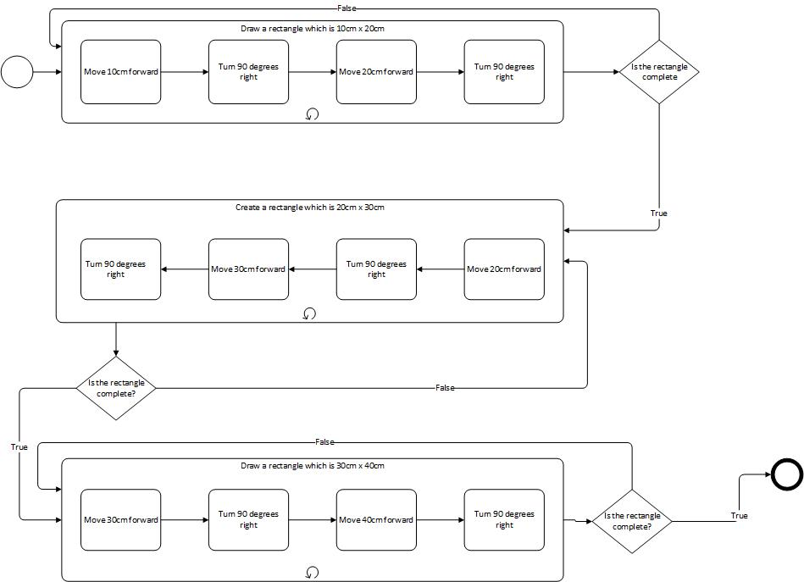
Rectangle BPMN Diagram
The is the BPMN diagram for the Rectangle, it has been created for all 3 sizes of the rectangle.

Triangle BPMN Diagram
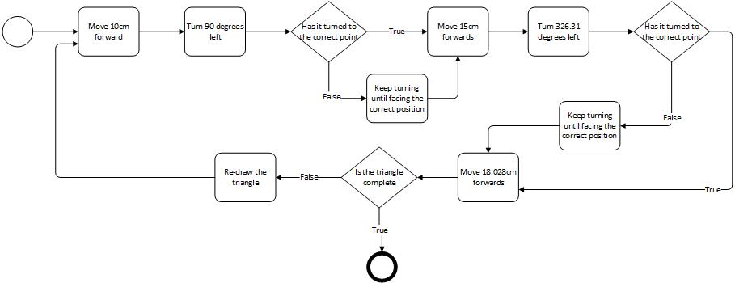
BPMN diagram created for the triangle program.

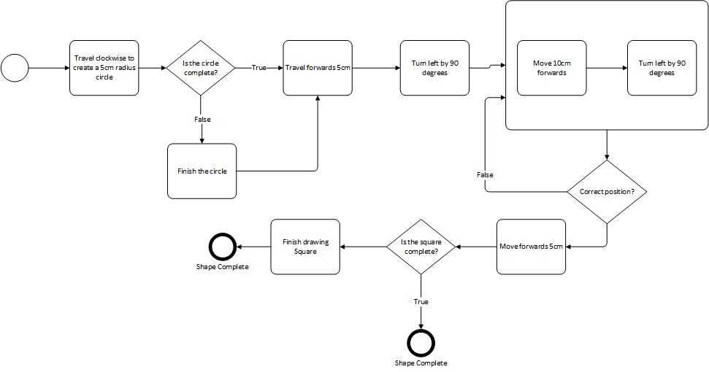
Circle Within a Square Diagram
This is the BPMN diagram which was going to be used for the Circle within a square code.

Join Symbol Diagram
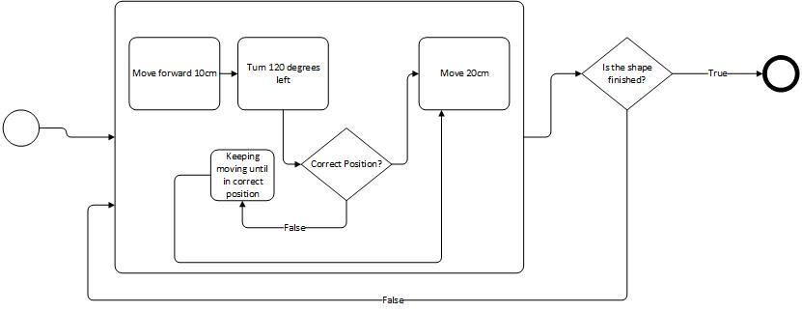
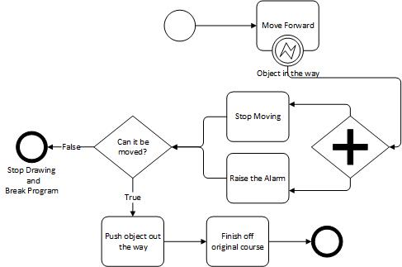

This is the BPMN diagram created for the join symbol. It is only created for the original sized design.

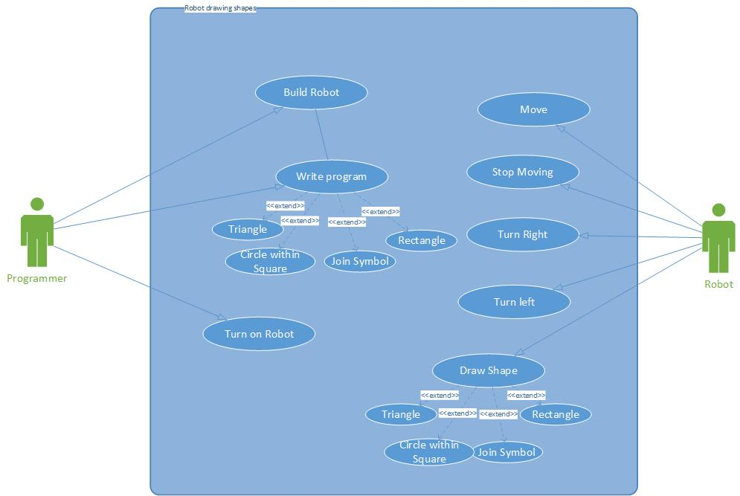
Use Case Diagram
This is the Use Case diagram for the program

Program for drawing a rectangle
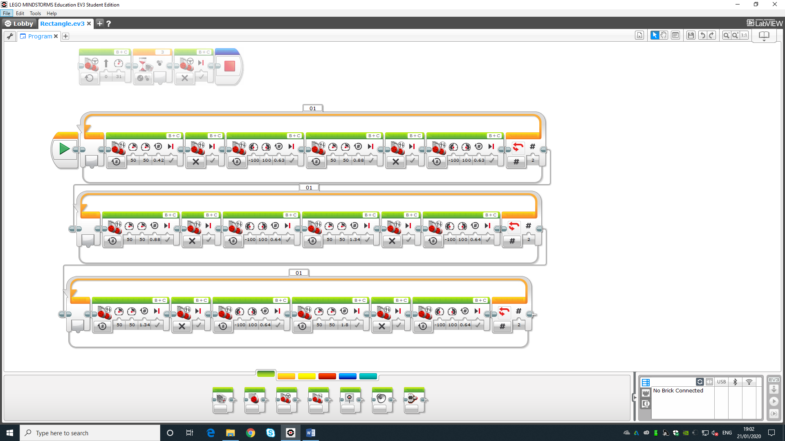
The code created 3 rectangles of different sizes. The rectangles got bigger after the code was repeated

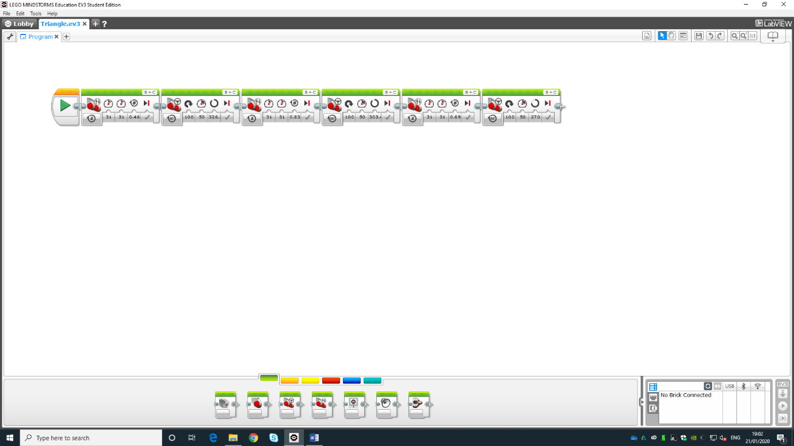
Program for drawing a triangle
This code was created to make a triangle but we struggled to make the ends meet.
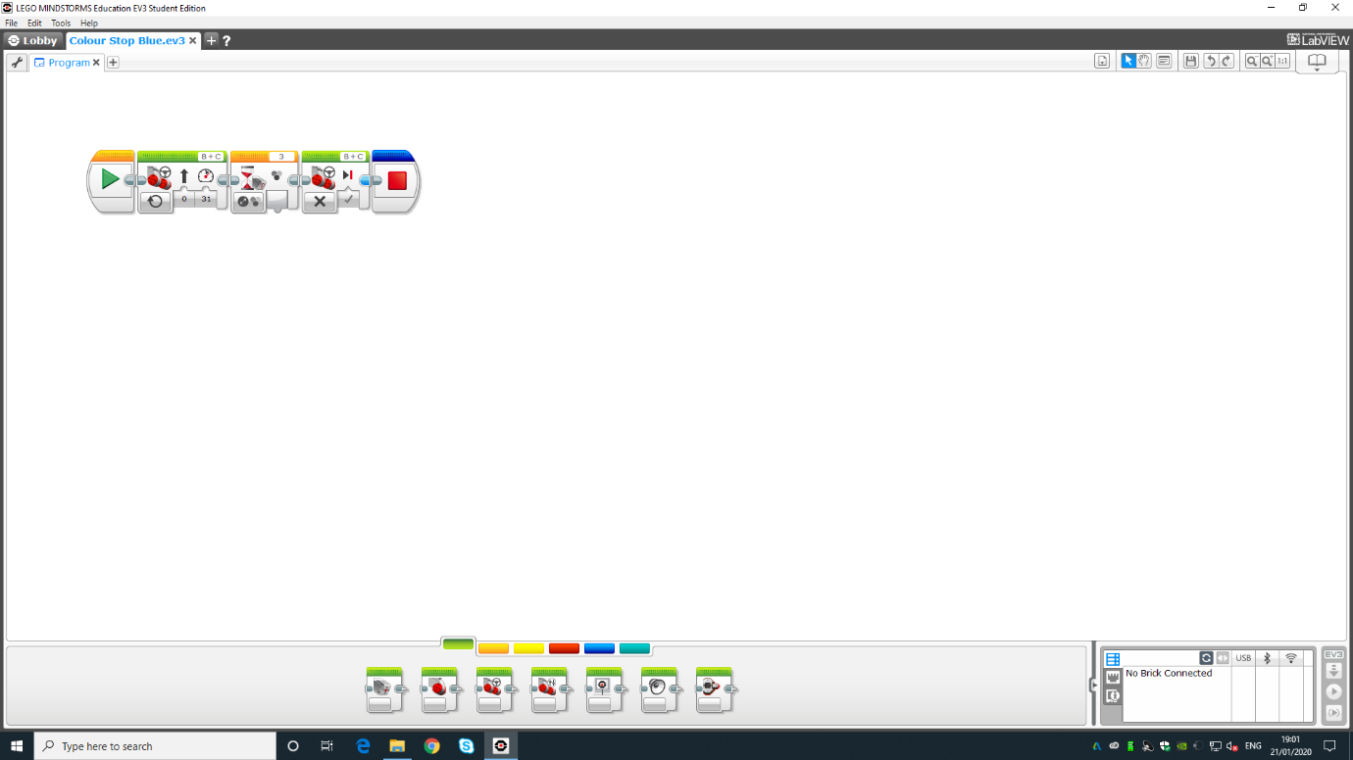
Program for stopping at the colour Blue
This code is for stopping at the colour blue, letting off a noise then stopping the program as the blue line is classed as an immovable object.

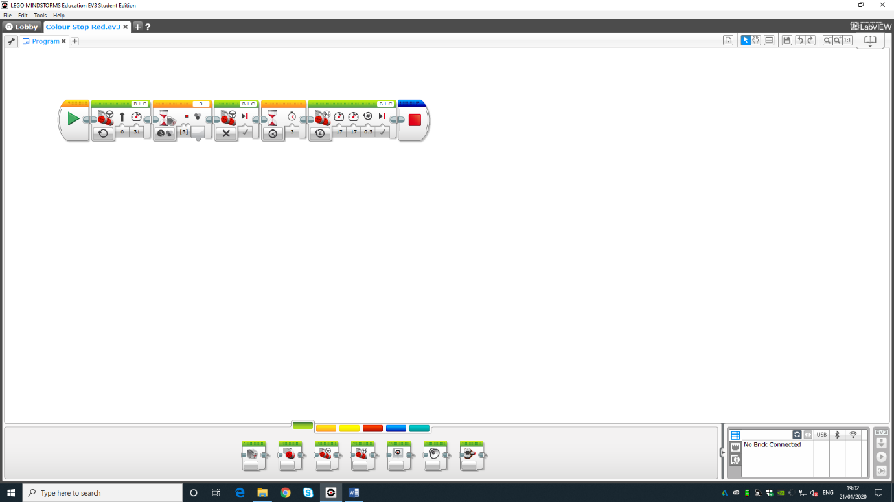
Program for stopping at the colour re.

This is the code which was used to cause the robot to stop at the colour red, then carry on once the barrier had been removed as the red line is classed as a movable object.

