Module Code: LCHS7006
Module Title: Quality Assurance and Service Improvements
Assignment: Component 2
Title: Enhancing Incident Reporting and Governance in Neonatal Care

Student Name: Mst. Shahrin Sultana
Student ID: 2503591

Table of Contents
1. Introduction 3
2. Main Body 5
2.1 Theoretical Underpinnings of quality and Governance 5
2.1.1 Principles of clinical governance 5
2.1.2 Patient Safety Frameworks (NHS, WHO) 5
2.1.3 Relevance of Theories on Quality Improvement 6
2.2 Root Cause Analysis Tools 6
2.2.1 Resolving Reporting Errors using Fishbone (Ishikawa) Method 6
2.2.2 Application of the 5 Whys 7
2.2.3 Donabedian Model: Structure Process Outcome Analysis 7
2.3 Analysis at the Organizational and Systemic Levels 8
2.3.1 Analysis of Internal and External Factors (SWOT) 8
2.4 Analysis: Applying Connection Theory to the Issue 8
2.4.1 The Inadequacy of Governance Leading to the Risky Practice 8
2.4.2 Fatality, Outcomes, and Patient Safety Consequences 9
2.4.3 Evidence from Studies, Policies, and Real-World Cases 10
3. Recommendations and a Plan for Enhancing Quality 11
3.1 A summary of the recommended enhancements to the service 11
3.2 Applying Quality Improvement Tools 11
3.2.1 Enhancing Incident Reporting via the PDSA Cycle 11
3.2.2 Lean Culture to minimise Reporting Barriers 12
3.2.3 Six Sigma (DMAIC) in order to increase the accuracy of reporting 12
3.3 Implementation Strategy 13
4. Conclusion 14
References 15

1. Introduction
Organizational Background
The Countess of Chester Hospital NHS Foundation Trust is an acute and specialized district general hospital serving Cheshire and North Wales. As a component of the NHS, it is governed by national rules pertaining to quality, safety, and clinical governance. Prior to the aforementioned difficulties, the organization exhibited a conventional service delivery profile; nonetheless, significant deficiencies in internal governance, leadership response, and event management subsequently revealed substantial vulnerabilities within its safety systems.
Overview of the Neonatal Unit
The hospital's neonatal section provides Level 2 care, catering to preterm and clinically compromised new-borns requiring specialized, ventilator-assisted, and continuous care. The unit comprises interdisciplinary teams, including neonatologists, nurses, and several allied health workers. The patient group is fragile, necessitating robust safety measures, meticulous documentation, and prompt escalation procedures. The high-risk nature of the unit necessitates strict adherence to national safety regulations for neonatology, along with effective early warning systems.
Quality issues: incident reporting and whistleblowing failures
The persistent ineffectiveness of the new-born unit's incident reporting and whistleblowing mechanisms was identified as a key issue (Zarbock et al., 2023). Clinical concerns about repeated unexplained new-born deteriorations were not adequately escalated or recorded. Staff reports were often disregarded or minimized by leadership, leading to an atmosphere of intimidation, defensiveness, and organizational protectionism. The system's governance, communication, and accountability structures were all weakened because of these failings, which meant that the abnormal clinical patterns went uninvestigated for too long and dangerous situations went unchecked.
Importance of the Issues from a Health Perspective
Failed reporting or whistleblowing poses serious threats to the general public, but notably to neonatal intensive care units, where delayed treatment may have fatal consequences. In order to avoid preventable injury, safeguard vulnerable infants, and maintain the public's faith in healthcare institutions, effective monitoring systems are required. Not addressing the issues leads to an increase in morbidity and death. The overall quality of healthcare and national patient safety goals is both undermined by these systemic weaknesses.
Report Objectives and Scope
Problems with incident reporting and whistleblowing in the newborn unit are examined in this paper, which provides a critical examination of governance failure problems and their involvement in dangerous clinical practice. It employs established models including the Fishbone, Donabedian, SWOT, and quality improvement models to evaluate underlying issues and organizational weaknesses. Additionally, the paper offers recommendations supported by research to enhance reporting culture, safety mechanisms, and sustainable service in healthcare settings with a high risk of adverse events.

2. Main Body

2.1 Theoretical Underpinnings of quality and Governance

2.1.1 Principles of clinical governance
According to Whiteing (2024), clinical governance is the foundation for increasing healthcare quality via accountability, transparency, and continuous improvement. As pointed out by Majumdar and Hussain (2018), clinical governance encompasses a wide range of activities, including staff management, risk management, auditing, clinical efficacy, and patient engagement. The Countess of Chester Hospital newborn unit's principles were so dismantled that risky practises were accepted despite the clear signs of unanticipated infant decline. The organization failed to prioritize physician concerns and establish adequate mortality monitoring measures, which is a systematic failing of numerous pillars of governance. Good governance demands quick discovery of irregularities. This is in keeping with what Ellis (2025) says: that companies undermine professional accountability standards when they ignore warning indicators. As the Lucy Letby ethical case showed, there were clear signs of a decline in clinical governance, including ineffective monitoring, unresponsive leadership, and a lack of organizational learning.

2.1.2 Patient Safety Frameworks (NHS, WHO)
Safe systems, a reporting culture, and an active risk management strategy are the focal points of patient safety models such as the NHS Patient Safety Strategy and the worldwide safety standards of the WHO. The primary elements of a strong safety culture, as stated by Ammouri et al. (2015), are psychological safety, open communication, and non-punitive reporting methods. In the new-born unit, they were non-existent, and physicians who tried to report problems were either ignored or faced institutional pressure. When safety principles are not integrated into organizational behavior, as the Letby case shows, devastating repercussions might ensue when whistle-blowers are unable to expose a failure (2023). While NHS models place a priority on event learning, Macrae (2016) argues that organizations often fail to implement effective systems because they prioritize avoiding blame rather than redesigning them. The hospital's administration failed to adhere to national rules that called for the immediate escalation of many serious occurrences, demonstrating a lack of consistency with NHS and WHO safety standards. These oversights enable sentinel occurrences, like the unnecessary fatalities and collapses that occurred in the unit, to go undetected.

2.1.3 Relevance of Theories on Quality Improvement
Theoretical frameworks for quality improvement (QI) provide orderly approaches to identifying problematic areas and developing safer alternatives. Continuous quality improvement, according to Kronick et al. (2015), requires constant vigilance, feedback loops, and action. There is a strong correlation between the goals of improving incident reporting and governance and the Lean and Six Sigma methodologies, which center on reducing waste, increasing process dependability, and managing variances. The neonatal unit at Chester did not make extensive use of the QI-based incident management systems, despite the fact that Arabi et al. (2016) shown that these systems may significantly aid in learning from mistakes. When it comes to high-risk clinical settings like newborn care, where prompt action, consistent escalation, and thorough documentation are of the utmost importance, quality improvement models are indispensable.

2.2 Root Cause Analysis Tools

2.2.1 Resolving Reporting Errors using Fishbone (Ishikawa) Method
In many types of organizations, the Ishikawa analysis reveals problems on several levels. This reluctance on the part of leadership to comply with consultant requests exemplifies managerial bias and a lack of competent supervision; this finding is in line with that of Lewis (2023), who stresses the importance of regulating managers in the NHS so that they do not bury safety concerns. The procedures were defined by a lack of documentation, disconnected reporting routes, and examination of mortality trends. Policies pertaining to critical event escalation and whistleblowing were particularly disregarded or ignored. Work load difficulties and an organizational culture that prohibited open communication were environmental factors. Furthermore, there were deficiencies in technology; for example, the unit lacked effective digital analytics and tools, and digital incident reporting systems improve data accuracy (Alotaibi and Federico, 2017).

2.2.2 Application of the 5 Whys
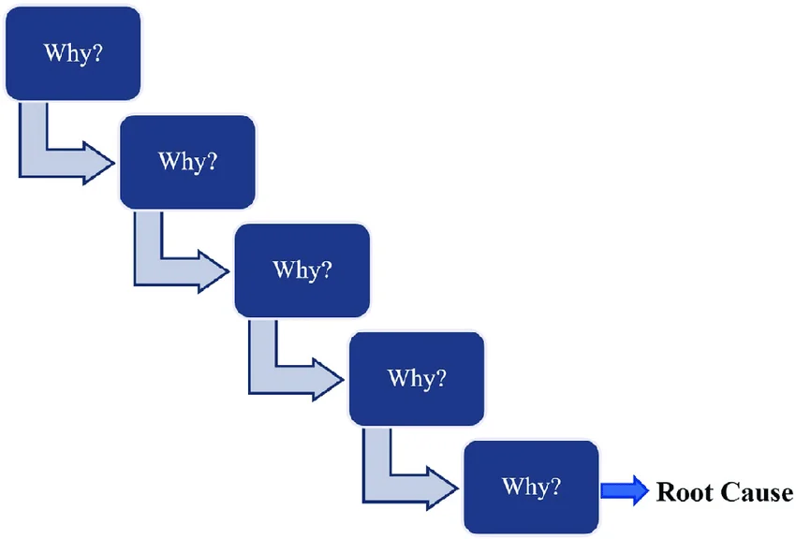
Figure 1: 5 whys analysis procedure (Demirkesen, 2021)
Tomašev et al. (2019) found that the 5 Whys method may be used to determine the extent of dysfunction inside an organization. Because incident reports were not routinely submitted, the situation was not over-escalated. If employees were worried about repercussions and assumed management would ignore their concerns, they may not have reported them. doctors, especially senior doctors, were afraid to speak out for fear of facing formal disciplinary action in the past. This occurred because top management prioritised the company's image above the well-being of its patients. Since the clinical governance structure lacked any accountability mechanisms, this was handled by the leadership. As Kirkup and Titcombe (2023) point out, whistleblowers in the NHS are often met with retaliation rather than assistance, which is in line with the institutional barriers to expressing professional concerns. Organizational protectionism is cyclical, and the 5 Whys show how this prevented early action.

2.2.3 Donabedian Model: Structure Process Outcome Analysis
The Donabedian model is a system of criteria by which people may judge the quality of health-care services.
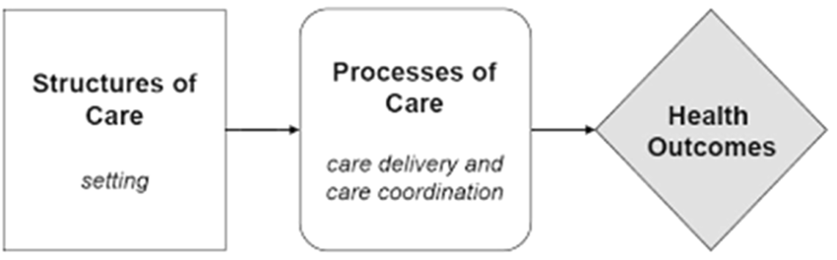
Figure 2: Donabedian Model (Arabi et al., 2016)
The failure of the processes and its catastrophic outcomes may be better understood by using the Donabedian model (Schwendimann et al., 2018). There were no effective systems for reporting incidents, management skills, or oversight in the newborn unit. Realized process failures included insufficient clinical pattern detection, staff concerns were ignored, and mandatory escalation did not occur. Several unexplained infant fatalities and collapses occurred within a short period of time, and the systematic review was not conducted until much later, despite the dismal outcomes. This lines up with what Glasper (2024) says: that the Letby case exemplifies how cultural and structural weaknesses may make it easier to abuse children since they make it harder to see warning signs. Thus, the Donabedian model reveals how avoidable deaths are directly attributable to systemic problems in previous organizations.

2.3 Analysis at the Organizational and Systemic Levels

2.3.1 Analysis of Internal and External Factors (SWOT)
Internal Factors:
According to the results of the SWOT analysis, the neonatal unit's internal flaws outweighed its strengths (Scandal, 2023). Another feature that was not fully used was the availability of specialist clinical neonatal physicians and the ability to access safety procedures that are used across the NHS. Similar to the criticisms leveled against reporting systems by Macrae (2016), these shortcomings included a lack of digital incident recording, inefficient communication, inadequate documentation, and hierarchical leadership. Technology-based reporting and external audits were considered, but ultimately not implemented.
External Factors:
The impacts of governance failures were amplified by extrinsic threats, such as national staffing shortages, increased neonatal acuity, and increasing public attention. Although Chester failed to link leadership to frontline employees' concerns, Greenhalgh et al. (2016) argue that clinicians' participation in the co-creation process improves governance. Because of this, an atmosphere was being created where unsafe care may go unreported due to a mix of vulnerabilities and risks.

2.4 Analysis: Applying Connection Theory to the Issue

2.4.1 The Inadequacy of Governance Leading to the Risky Practice
According to Richardson et al. (2017), the harmful behavior was able to persist due to the absence of oversight in the newborn unit. Consultant concerns were often disregarded, and the project was not guided by established NHS governance protocols. The organization's ability to learn was hindered since incident data was not systematically reviewed or escalated. This agrees with Flower (2015), who stresses that companies that don't reveal their actions honestly tend to cover up their operational shortcomings. A hallmark of organizational defensiveness rather than responsibility is the alleged request that doctors in the Chester instance apologize for voicing concerns. This kind of therapeutic voice suppression is associated with long-term harm and goes against safety standards.

2.4.2 Fatality, Outcomes, and Patient Safety Consequences
In clinical terms, the outcome was disastrous because people ignored the early warning symptoms. The cluster of inexplicable collapses in the newborn unit in Chester was even greater than the critical event rate of 5.2% in European pediatric anesthesia (Habre et al., 2017), according to the APRICOT research. Multiple infant fatalities occurred during 2015 and 2016, which is much higher than the predicted mortality rates in comparable Level 2 neonatal centers. To summarize, this excess mortality is:
Table 1. Comparative Neonatal Safety Outcomes
Source: Hospital investigation reports and Lewis (2023)
Indicator | Expected Level 2 Neonatal Unit | Countess of Chester Neonatal Unit
Severe critical events | 5.2% | Elevated cluster reported
Unexplained collapses | Rare | Multiple recurring events
Neonatal mortality trend | Stable or decreasing | Significant increase 2015–2016
Incident escalation rate | High in safety-focused units | Low, with suppressed reporting
The table displays the discrepancy between the expected and actual safety indicators. A defective safety system is shown by the persistent malfunction leading to fatalities and collapses, together with the little official reporting of occurrence events. While Curley et al. (2015) demonstrated the value of standardized clinical procedures in reducing pediatric hazards, the techniques used in Chester went against best practises for patient safety. Consequently, infants were put at risk of harm that they might have avoided, and systemic issues inside the organization contributed to the promotion of even more hazardous settings.

2.4.3 Evidence from Studies, Policies, and Real-World Cases
According to research done all across the world, one major source of preventable harms is people's incapacity to bring concerns to light. Capper et al. (2024) notes that neonatal doctors in Chester are one example of a group that is reluctant to blow the whistle on a problem for fear of reprisal. When NHS leadership is unwilling to listen to its people, crises happen (Jesudason, 2024) in the organization. Similar to how the hospital lacked good predictive systems, Leveson (2015) notes that leading indicators and active monitoring are necessary for safety. Managerial defensiveness, poor accountability, and failure to react to clinical warnings are recurring tendencies, as seen in previous examples such as the Mid Staffordshire debacle. Inadequate implementation of the NHS Duty of Candour policy framework reveals a mismatch between policies and practices.

3. Recommendations and a Plan for Enhancing Quality

3.1 A summary of the recommended enhancements to the service
Any service enhancements should concentrate on fixing the problems with reporting incidents, whistleblowing, and governance control. It is critical to implement digital reporting channels, provide psychological safety measures, and increase leadership responsibility in order to prevent future injury. According to Arabi et al. (2016), systematic analytical procedures are required for more advanced defect learning when complete incident management systems are used. To ensure that the warning indicators are promptly handled, it is important to include strong escalation methods that align with the safety requirements of the NHS. A shift in culture is necessary so that workers may speak out about problems without fear of punishment. In order to make these improvements stick, we need to work with quality improvement approaches to ensure they are long-lasting and successful.

3.2 Applying Quality Improvement Tools

3.2.1 Enhancing Incident Reporting via the PDSA Cycle
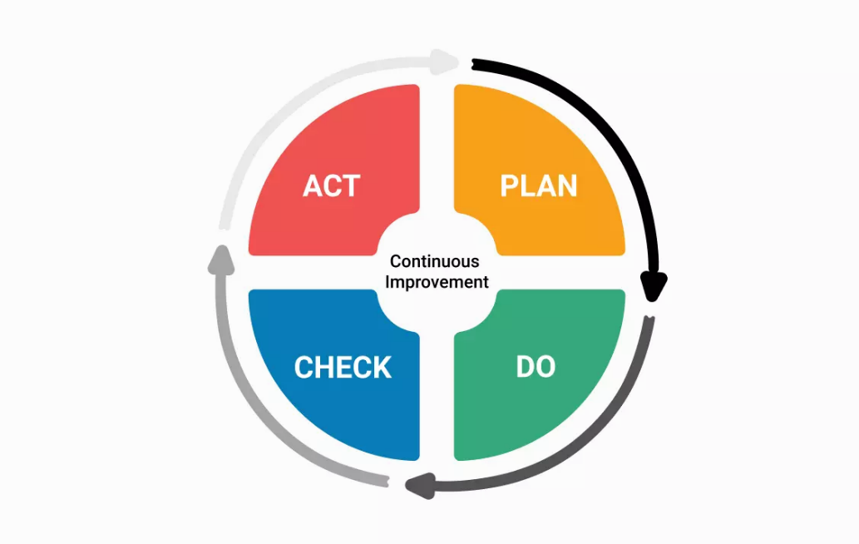
Figure 3: PDSA Cycle (Peerally et al., 2017)
Repeatedly improving reporting reliability is possible with the help of the PDSA framework. During the Plan phase, it is recommended to rethink reporting regulations, establish explicit escalation triggers, and use digital reporting systems. During the Do stage, the new-born unit may conduct pilot trials of these approaches to uncover operational constraints. In order to uncover the persistent problems, the "Study phase" will include analysing incidence patterns, employee engagement rates, and feedback. The last stage, known as the Act phase, involves incorporating the changes into the governance structure in order to make them permanent. In a setting that requires escalation and high vigilance, PDSA cycles are useful because, as Kronick et al. (2015) point out, they are the best at continuous quality monitoring.

3.2.2 Lean Culture to minimise Reporting Barriers
Reduced work-process waste and streamlined reporting are two benefits of using lean methodologies. Find the phases that don't bring value to the reporting process and remove them. This might be extra paperwork or unclear approval processes. Additionally, Lean's emphasis on improving flow ensures that critical information reaches decision-makers in a timely manner while simultaneously reducing the likelihood of abnormalities being ignored. The importance of Lean is confirmed by Favarò et al. (2017), who show that high-reliability systems have more accurate and timely reporting with simplified reporting. Redesigning and standardizing the reporting forms and eliminating bureaucratic hurdles that prevent personnel from reporting concerns without hesitations would be part of implementing Lean in the new-born unit.

3.2.3 Six Sigma (DMAIC) in order to increase the accuracy of reporting
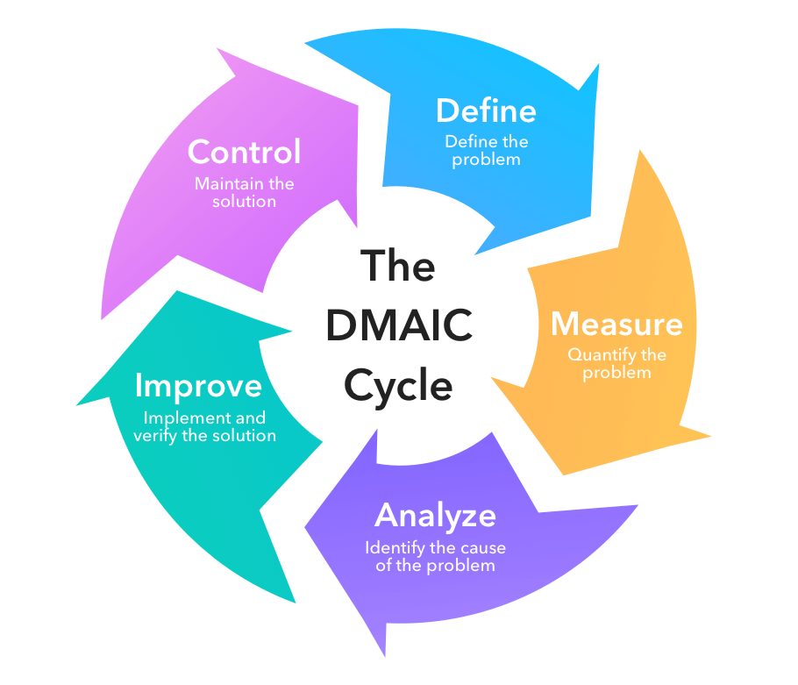
Figure 4: Six Sigma (DMAIC) (Peerally et al., 2017)
Six Sigma provides a methodical way to improve incident reporting dependability and eliminate variability. The potential to discover faults in the current reporting method is presented by the DMAIC model, which contains the definitions, Measure, Analyze, Improve, and Control. Officially, in the "Define phase," system issues such as improper reporting and whistleblower flaws are specified. Quantifying the timeliness, accuracy, and frequency of reporting is what measurement is all about. The analysis is focused on identifying the underlying issues, which include cultural resistance and passive leadership styles. Digital reporting systems and employee training are two treatments that fall within the purview of Improve. With the use of controls, such as dashboard monitoring and regular audits, we can guarantee long-term compliance. One reason DMAIC works in that setting is the evidence provided by Huq et al. (2016), who show that structured risk-analysis methods significantly improve the safety of healthcare systems.

3.3 Implementation Strategy
Leadership and Workforce Engagement Plan
Transparent and responsive behaviours demonstrating commitment to patient safety should be embraced by the leadership. Building psychologically secure environments to validate and resolve worker grievances is essential for engagement. Trust is engendered and shared responsibility for safety is encouraged via multidisciplinary meetings that are frequent, have observable leadership, and have accountability mechanisms.
Developing Skills and Strengths
Staff members need to be better able to report incidents, identify early warning signs, and know how to escalate a situation via targeted education programs. Following the training, the safety practises should be implemented universally across the workforce. The training should include simulation exercises, case studies, and an introduction to the digital reporting system.
Evaluation Strategy and Monitoring
Dashboards that display data in real-time, monthly analyses of event patterns, and independent evaluations to ascertain compliance with safety standards should form the basis of the monitoring. There should be measurable gains in safety, and the interventions should be tested to see if they increase reporting volume, timeliness, and responsiveness.
Environmental Factors to Think About
Organizational rules should include reporting practises for long-term sustainability, leadership should be held accountable, and audits should be conducted periodically. Constant participation, frequent retraining, and backing from national patient safety models will ensure that changes connected to time and clinical demands will keep improving the situation.

4. Conclusion
Summary of Key Findings
This analysis has indicated that the neonatal unit's governance structure, absence of whistleblowing, and incident reporting failure were the main reasons of the continuous dangers. at line with more systemic problems highlighted by Mitchell et al. (2016), it has been shown that patient safety systems at healthcare facilities are impeded by poor reporting cultures, defensive management, and an absence of learning processes. Slow damage detection, exacerbated by inefficient root cause investigation, lends credence to the systemic nature of governance problems (Peerally et al., 2017).
Consequences for Quality and Client Safety
According to Oliver (2024), the findings show that patient safety models aren't as good as they may be since transparency standards like the Duty of Candour aren't properly implemented. If organizations aren't committed to being responsive and learning, then strong reporting systems like Critical Incident Reporting Systems won't be able to aid with trend identification and damage avoidance (Petschnig and Haslinger-Baumann, 2017). Consequently, patients are justified placed at danger when reporting failures occur.
Finally, some ideas for improving services
Incorporating formal reporting systems, supporting staff members who voice concerns, and ensuring analytical rigor in event investigations are all critical to achieving lasting change. Prioritizing organizational learning and actively identifying risks is in line with the findings that suggests a well-developed monitoring system may detect the first indications of a developing safety problem (Raschi et al., 2019). In order to make clinical settings safer and prevent catastrophic system failures, it is important to improve governance, openness, and accountability.

References
Alotaibi, Y. K., and Federico, F. (2017). The impact of health information technology on patient safety. Saudi medical journal, 38(12), 1173.
Ammouri, A. A., Tailakh, A. K., Muliira, J. K., Geethakrishnan, R., and Al Kindi, S. N. (2015). Patient safety culture among nurses. International nursing review, 62(1), 102-110.
Arabi, Y. M., Owais, S. A., Al-Attas, K., Alamry, A., Alzahrani, K., Baig, B., ... and Taher, S. (2016). Learning from defects using a comprehensive management system for incident reports in critical care. Anaesthesia and Intensive Care, 44(2), 210-220.
Capper, T., Ferguson, B., and Muurlink, O. (2024). Health professionals' experiences of whistleblowing in maternal and newborn healthcare settings: A scoping review and thematic analysis. Women and Birth, 37(3), 101593.
Curley, M. A., Wypij, D., Watson, R. S., Grant, M. J. C., Asaro, L. A., Cheifetz, I. M., ... and Pediatric Acute Lung Injury and Sepsis Investigators (PALISI) Network. (2015). Protocolized sedation vs usual care in pediatric patients mechanically ventilated for acute respiratory failure: a randomized clinical trial. Jama, 313(4), 379-389.
Demirkesen, S. (2021). From Lean Manufacturing to Lean Construction: How Principles, Tools, and Techniques Evolved. Lean Manufacturing. Doi: https://doi.org/10.5772/intechopen.96191.
Ellis, P. (2025). Professional development. Learning lessons 1. Wounds UK, 21(2).
Favarò, F. M., Nader, N., Eurich, S. O., Tripp, M., and Varadaraju, N. (2017). Examining accident reports involving autonomous vehicles in California. PLoS one, 12(9), e0184952.
Flower, J. (2015). The international integrated reporting council: a story of failure. Critical perspectives on Accounting, 27, 1-17.
Glasper, E. A. (2024). Child Killers in Our Midst: Why the Lessons Learned About Safeguarding Shortfalls in the Care of Sick Children Must Not Be Confined to the Trash Can of History. Comprehensive Child and Adolescent Nursing, 47(1), 1-6.
Greenhalgh, T., Jackson, C., Shaw, S., and Janamian, T. (2016). Achieving research impact through co‐creation in community‐based health services: literature review and case study. The Milbank Quarterly, 94(2), 392-429.
Habre, W., Disma, N., Virag, K., Becke, K., Hansen, T. G., Jöhr, M., ... and Didier, A. (2017). Incidence of severe critical events in paediatric anaesthesia (APRICOT): a prospective multicentre observational study in 261 hospitals in Europe. The Lancet Respiratory Medicine, 5(5), 412-425.
Harkensee, C. (2023). Letby case: the public deserves the truth; whistleblowers deserve protection. bmj, 383.
Huq, M. S., Fraass, B. A., Dunscombe, P. B., Gibbons Jr, J. P., Ibbott, G. S., Mundt, A. J., ... and Yorke, E. D. (2016). The report of Task Group 100 of the AAPM: Application of risk analysis methods to radiation therapy quality management. Medical physics, 43(7), 4209-4262.
Jesudason, E. (2024). Reducing the risk of NHS disasters. Journal of medical ethics, 50(7), 482-488.
Kirkup, B., and Titcombe, J. (2023). Patient safety: listen to whistleblowers. bmj, 382.
Kronick, S. L., Kurz, M. C., Lin, S., Edelson, D. P., Berg, R. A., Billi, J. E., ... and Welsford, M. (2015). Part 4: systems of care and continuous quality improvement: 2015 American Heart Association guidelines update for cardiopulmonary resuscitation and emergency cardiovascular care. Circulation, 132(18_suppl_2), S397-S413.
Leveson, N. (2015). A systems approach to risk management through leading safety indicators. Reliability engineering and system safety, 136, 17-34.
Lewis, R. (2023). Lucy Letby: child murder case highlights need to regulate managers and improve whistleblowing procedures. The Conversation.
Macrae, C. (2016). The problem with incident reporting. BMJ quality and safety, 25(2), 71-75.
Majumdar, S., and Hussain, S. M. (2018). Clinical Governance and its Role in Patient Safety and Quality Improvement. In Scott-Brown's Otorhinolaryngology and Head and Neck Surgery (pp. 389-394). CRC Press.
Mitchell, I., Schuster, A., Smith, K., Pronovost, P., and Wu, A. (2016). Patient safety incident reporting: a qualitative study of thoughts and perceptions of experts 15 years after ‘To Err is Human’. BMJ quality and safety, 25(2), 92-99.
Oliver, D. (2024). David Oliver: How well is the duty of candour enforced in the NHS?. bmj, 385.
Peerally, M. F., Carr, S., Waring, J., and Dixon-Woods, M. (2017). The problem with root cause analysis. BMJ quality and safety, 26(5), 417-422.
Petschnig, W., and Haslinger-Baumann, E. (2017). Critical Incident Reporting System (CIRS): a fundamental component of risk management in health care systems to enhance patient safety. Safety in Health, 3(1), 9.
Raschi, E., Mazzarella, A., Antonazzo, I. C., Bendinelli, N., Forcesi, E., Tuccori, M., ... and De Ponti, F. (2019). Toxicities with immune checkpoint inhibitors: emerging priorities from disproportionality analysis of the FDA adverse event reporting system. Targeted oncology, 14(2), 205-221.
Richardson, A., Peart, J., Wright, S. E., and McCullagh, I. J. (2017). Reducing the incidence of pressure ulcers in critical care units: a 4-year quality improvement. International Journal for Quality in Health Care, 29(3), 433-439.
Scandal, M. S. (2023). The Lucy Letby case: lessons for health systems. Lancet, 402(747), 01839-1.
Schwendimann, R., Blatter, C., Dhaini, S., Simon, M., and Ausserhofer, D. (2018). The occurrence, types, consequences and preventability of in-hospital adverse events–a scoping review. BMC health services research, 18(1), 521.
Tomašev, N., Glorot, X., Rae, J. W., Zielinski, M., Askham, H., Saraiva, A., ... and Mohamed, S. (2019). A clinically applicable approach to continuous prediction of future acute kidney injury. Nature, 572(7767), 116-119.
Whiteing, P. (2024). Lucy Letby inquiry could be a missed opportunity if it does not look at the wider issue. Journal of Patient Safety and Risk Management, 29(1), 5-7.
Zarbock, A., Nadim, M. K., Pickkers, P., Gomez, H., Bell, S., Joannidis, M., ... and Forni, L. G. (2023). Sepsis-associated acute kidney injury: consensus report of the 28th Acute Disease Quality Initiative workgroup. Nature Reviews Nephrology, 19(6), 401-417.

