“Nobody come back after death and explain how is it…”
Self presentation
Student : 1814723 2019/2021

Table of Contents:

- Introduction…………………………………………………………pag.2
1.1 CV………………………………………………………………………...pag. 3
- Part of my past……………………………………………………...pag. 4
- Goals and skills
3.1 Honesty explanation……………………………………………….pag. 5
3.2 Hard worker and stress resistant…………………………..………..pag. 6
3.3 Family guy……………………………………………………..…pag. 7
3.4 Curious, Intuitive and Ambitious…………………………………………pag. 7&8
3.5 Improve, things to do, goals………………………………………………pag. 8
4. Index………………………………………………………………………...pag. 9

INTRODUCTION

Vlad Calin Maxim…

Was born in a east European country named Romania in a small town Dorohoi situated in north-east around 90’s (18 May 1990).
Sovietic influence remain in that zone after the second Mondial war till nowadays.
Some countries have recovered hard, others not at all like mine one.
I believe that we going to involution instead evolve.

VM  Objective  Trying to finish what I start in the past like degree the university, care on my family and care on my job.  Skills  As a normal and healthy person I can be a hard worker, stress resistant, quick learner, can be a patience person etc. | Experience  delivery driver • amazon •april 2016– april 2017  Daily parcel delivery with a medium van around Basildon area (Essex area usually)  phv driver• Uber • may 2017 – present  This job is an interesting one because of flexibility but the bad thing with this flexibility they have a lot of restrictions during you are connected on their web platform  Education  high school • septeber 2005 - june 2009• “grigore Ghica”  Degree with a high school diploma on mathematics and computing class.  Cloud computing • just start • UWTSD  Just start this university and really enjoy it and I hope to degree
  VLAD MAXIM
  Student : 1814723 2019/2021

Somewhere in my past…

Me as a kid:

My name is Vlad and I am 29 years old now and, sometimes when I’m looking at me in the mirror I try to remember who I was in the past and how do I progress myself....fine, in my head, I describe myself as a kid in next mode:

“ I like playing football with my friends. I also enjoy rugby and basketball, but football is my favorite sport. I have blond hair, blue eyes and I am quite tall for my age. I live in Dorohoi city in a four bedroom house and a large and beautiful garden in backyard. When it’s raining and I can’t play sports I stay inside and watch on TV. I like traveling a lot. I have visited a lot of cities in my country, Romania. My dream is to move to the United Stated of America one day. I want to go to New York and Hollywood and meet famous people. My dream is to become a football player one day. I know that it is hard to get famous, but I want to try my best. I admire people like Christiano Ronaldo and Lionel Messi. They inspired me and that is why I like this sport so much. I have a huge collection of posters with a lot of football stars and musicians. My favorite music genres are rock, pop, jazz and techno. My favorite bands are AC/DC, Metallica, Scooter, Depeche Mode and Parov Stelar. My favorite school subjects are English, mathematics and Geography. In my free time, I also like going to the theatre, cinema, museums and art galleries. I like creative people and I consider myself to be one. Apart from my football career I would also like to participate in theatre plays or movies. I go to the German State Theatre of Dorohoi almost every week. I think that their actors are very talented. I like the fact that they have subtitles in Romanian projected on the walls, so you can go even if you don’t know German. The last theatre play that I enjoyed was The Little Prince. I loved the actors but also the sound and decorations. My goal is to visit as many theatres, art galleries and museums as I can. Why? Because I think that they don’t get much appreciation. I think that more people should start doing these things. Some people wonder how I can appreciate art and sports at the same time. I always tell them that anyone can do that. I think stereotypes are bad for anyone.
My favorite season is summer. I like going both to the sea and to the mountains. I think nature is beautiful in all seasons, but I like summer more because I don’t have to wear winter clothes. I am openminded and want to experience new things.”

To be honest with you reader, this is my first composition at second English class when I start high school.
In time with education I got a lot of skills to perform in life and to be able to do my life easier.
One of them wich I am applying everywhere and is so rare is honesty. This teenage period is an important step for me in becoming a men, a prove for my seven years from home where my parents give it to me.

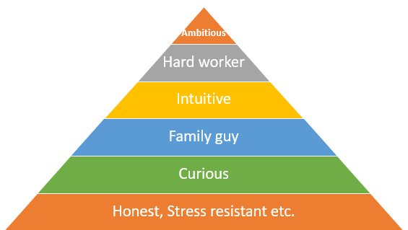
Figure 1

Honesty

One of my skills and the first with wich I prefer to start with…

“Honesty may not get you a lot of friends, but it will get you the right ones.”
When I think about honesty, I think about the rare virtues that can be found in humans. We all lie from time to time for a variety of different reasons. You might lie in order to protect a loved one from a painful truth, to comfort them. You might lie in order to get yourself out of trouble. There can be many reasons, but most of the times, lies do more harm than good. A rather touching quote from one of my favorite cyberpunk video games, Deus Ex, comes to mind: “A forgotten virtue such as honesty is worth at least 20 credits”. Only one phrase, yet it’s so impactful. All of us have been affected by someone else’s lies. It might so happen that we ourselves have negatively affected someone else. Being honest to someone is a sign of respect. The incapability of lying to someone shows that you care about them. But as stated earlier, there are exceptions to this rule. Say that, for example, one of your relatives suffers from an incurable disease. You might tell them that they’re healthy or that they have something else entirely, in the hope that their spirit won’t be broken. Honesty has an effect upon every type of relation between humans. Whether it’s about friendship, relationships, family relations or colleagues, having integrity is essential both in ethical and practical standpoints. If you’re honest, you will not have to remember any lies in order to keep other people’s opinions about you intact. Lying can lead to one or more people spotting things that don’t add up in your stories, thus revealing to them that you’re a fraud and you automatically lose their respect. Tell them the truth from the start and it makes it easier for you to build up appreciation, even if you are unqualified in certain aspects of life. Honest people deserve to get more appreciation than ever. Only then will others realize the importance of this dying virtue. Honesty has also become an issue in the online environment. People can pretend or even fake lives while they’re on social media. Unpopular opinions get a lot of hate instead of actual criticisms, while following trends becomes almost obligatory for those who want popularity. This creates a rather vicious cycle of lying and pretending in order to keep likes and views up. It has become a sort of business without money, a trade for the appreciation of falsehood. Not only does this inflate people’s egos without any of the deserve, but lying on the internet is much easier than it is in real life, because you can barely be held accountable for your words and deeds in this type of situation. Even worse, one can keep their anonymity when spreading disinformation. So what would be the final conclusion after all these facts? Does anyone have any reason to be honest anymore? I think they do, simply for ethical reasons alone. A painful truth might not be as appreciated as a comforting lie, but in the end, the truth shall set you free!

Hard worker and stress resistant

In this chapter I’ll explain my vision about actual job and how this two skills help me to progress in life.

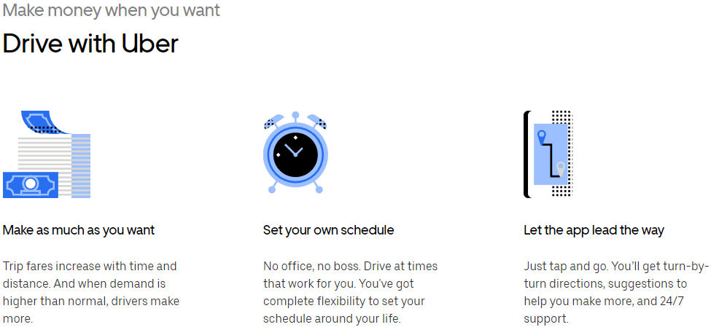
Figure 2.

To be honest, is never like that, this is the perfect example with the minimum losses and with maximum earnings wich are not possible all the time.
In my opinion is not possible to survive only with your luck.


This company inform you as a beginner that they help you with everything but they do not inform you that the control is in they’re hands and with a simple press button you can wake without nothing.
Figure 3
To many, to much, to bad.

Was take this decision to work with uber in may 2017 because before this job I was a delivery driver on Amazon.
To work at Amazon is , how they declare and hide from public view , to be a modern slave.
If you look on the statistics of employability on this company, you can see that more than 80% of employees are immigrants. Why that?, because they accept bad conditions of work for less money, that’s mean the immigrants who hope to find a better life in UK are bad informed about what happened in and they don’t know how is normal or not.
After this job exchange I realize that the uber is worse because I got more time to spend with my family but get less money.

Family guy

What’s mean family guy for me?
Well…

One single word – Everything
I can’t express just by words, they are my emotions.
They have been with us through all the thick and thin. They have taken the best possible care of you since the Day 1. They gave everything beyond their ability to you. If we disrespect them, it would be crime indeed. Whenever I take a decision, I consider my family's opinion no matter what. So, they are everything to me and in same manner I am everything to them.
Family for me is a delicate subject and I prefer to stay confident about it and prefer not to talk to much in this way.



 !
"#

$%&'!
()*
++,
#+++

-
' 

$.!
/ 
,




#&0"
# &0
#

-
*


**



 !
"#

$%&'!
()*
++,
#+++

-
' 

$.!
/ 
,




#&0"
# &0
#

-
*


**


Curious, Intuitive and Ambitious

Preferred to explain about all three together.
Why I chose to start studying Cloud Computing on University of Wales Saint David Trinity?

I possess strong team-working skills, can work individually or as part of a group. I have always been interested in IT and how computers operate, as well as being fascinated by other languages and cultural differences. For me your course can teach me all of these things and more.
After researching, talking with my friends and much reading online I have decided that University of Wales Trinity Saint David is an ideal fit for my personal development and career progression by enrolling with a reputable university on a Cloud Computing degree. I hope that I will be able develop the personal qualities, as well as the academic ones.
From my point of view Cloud Computing is one of the most popular courses at university. Computing is the way of the world.
I strongly believe that such a course will satisfy this need of mine and at the same time develop it and make it better as well. With the appropriate studies I believe that I am capable of becoming a very successful employee- and a master in this sector.
Apart from the superb career prospects what are my other reasons for choosing this subject? The answer is that I enjoy it. I am a forward-thinking individual who has driven, ambition and ability, all of which are traits that are vital for this type of course. I want to learn the theories that are required to operate and improve the operations in a rapidly changing global environment.
I believe that I have the intellectual ability to complete a degree and I have illustrated my drive, ambition and dedication to do this in many ways. I am capable of working as part of a team as I have developed the initiative and ability to follow instructions and have the capacity of working with others.
Finally, I chose UK as the country that I want to study because it can offer very many important and useful things to students. First of all, there are the extra-curriculum activities that exist in all UK universities.
From my point of view, these activities are very important because they enable the students to discover new interests, work together as a team and of course make new friends that share the same interests with you.
I am a very reliable and committed person who has always had an interest in computers. I am able to work both individually and in a group. I am confident in learning new things and expanding my knowledge in this sector. I am also a very motivated person who works hard and has the ability to make decisions and use certain strategies to solve problems.
I very much look forward to the challenge and rewards of university life and am confident it will enable me to fulfil my ambitions and lead to a rewarding career.

Improve, things to do, goals

Closer future:

Firstable I need to finish courses what I start on UWTSD mean Cloud Computing and for the future for my personal mind healthy to talk when I have the word, doesn’t matter what – is my right.
In this way I can realize that if I talk when I have to and say it after I can stay mind clear and never think about and fell bad about “I could say it but I didn’t because I’m weak”

Far future:

Not so far but I’m thinking about, I’m planning to buy a flat somewhere in my country or to build a house (wich is harder variant for me) to have it for emergency like a saving account because I don’t know how will be in the future living/ surviving as an immigrant and me and my family needs a backup plan.

That’s all for the moment.

INDEX

- “Nobody come back after death to explain how is it…” part of chapter from Holly Bible;
- Figure 1. is a pyramid of my skills based and linked somehow together;
- Figure 2. few objectives who make you to take they’re decision, source website : “https://www.uber.com/gb/en/” also Figure 3.
- “Honesty may not get you a lot of friends, but it will get you the right ones.” Google.ro dex search for Romanian old word,

