2D Animation Sequence – Samantha Osborne – Student ID: 2105043
https://1drv.ms/v/s!Aq5MfN6NRKavdvu_hHUpw5qf0Rg?e=mUYeLU
When it came to animation, I have never really been aware of how animations are made. After the previous lessons and introductions to After Effects, I sought out to make an animation of my own. I struggled to come up with ideas that I could use towards an animation. But I came across various tutorials on You tube, with one that piqued my interest. I decided to work with a worm animation [1], making my own little worm slide across the screen. I investigated adding small things into the background, maybe a butterfly or some moving grass to add to the animation a little. But I ended up just having the small worm due to feeling overwhelmed with what I had.
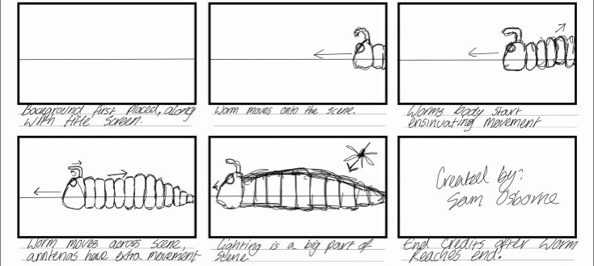
I began with creating a little storyboard based on what was going to happen in this small animation.

After working on this storyboard and studying some YouTube videos, including the one tutorial that piqued my interest. I then installed After Effects and began to work on my animation. I began by going to the website that I followed through the You Tube video. I installed the worm JPEG [2], which is free to use and started following the tutorial.
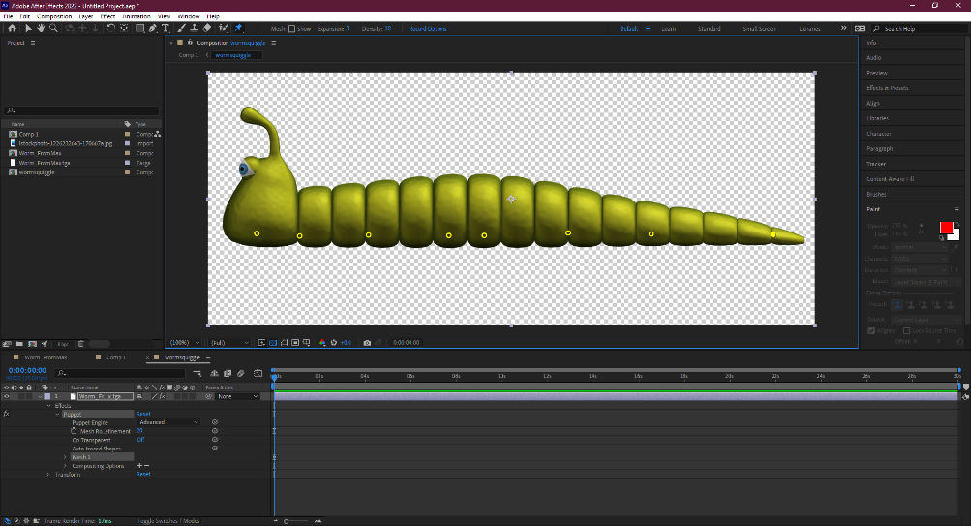
I first started by placing the worm image in After Effects and adding the puppet pin tools to various points of the image. To engage movement within the image I placed puppet pins at the head, neck, middle of the body, and near the end, spreading towards the tail.

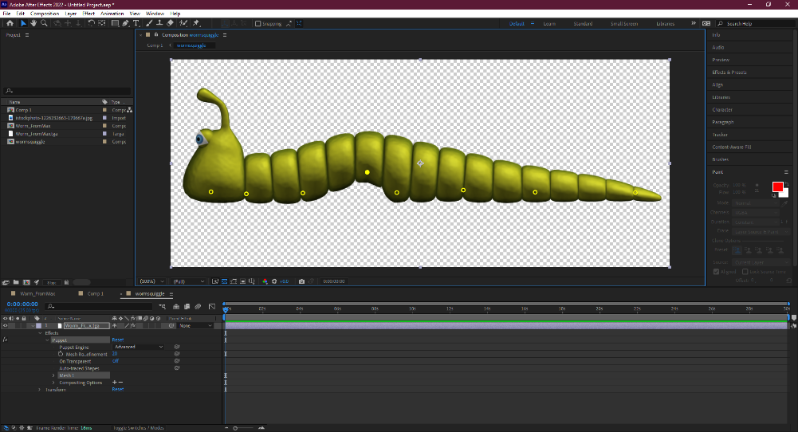
I started experimenting with moving the body around in sections, getting to know how far I can move the body parts before they start to break and become distorted.

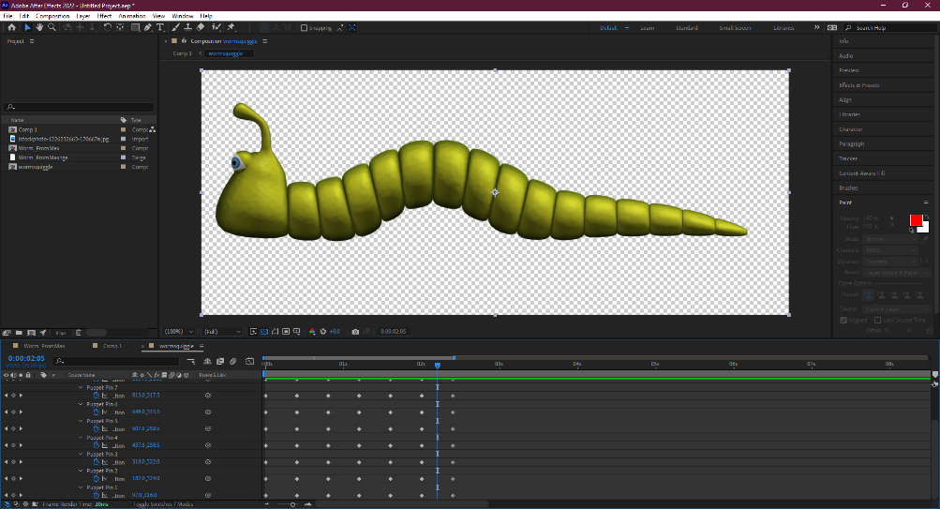
I then opened each pin in the worm’s sidebar and began the animating process.
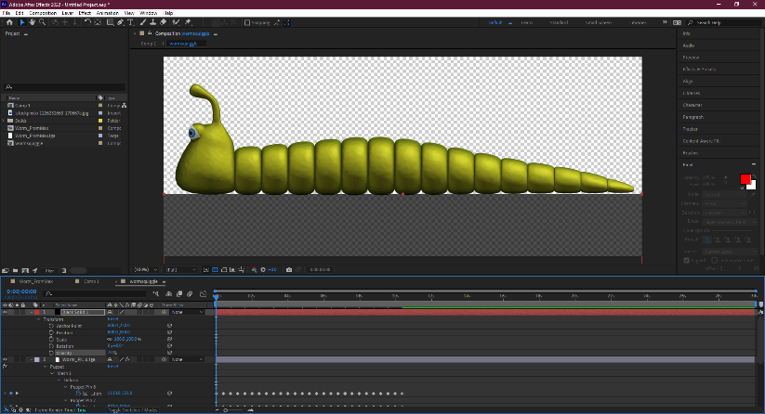
I began by placing a pin at the start of the animation. I moved 10 frames forward then started moving the middle of the body upwards by the middle pins, with the head moving up ever so slightly. I moved 10 frames forward and placed the same movement pin I placed at the beginning at the start of the animating process, causing the worm to fall back into its original position. I copied the 2nd movement pins and the 3rd still pins and started pasting them at 10 frame intervals across the animation times.

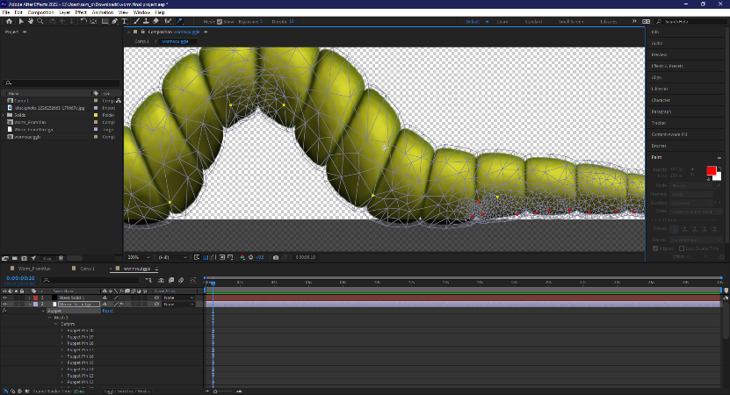
I returned the worm to its original position and placed a solid black bar underneath the worm and placed the opacity quite low down. Once I moved the worm to the movement position with the middle of the body arched, because of the opacity black bar, I can see where the body will almost clip into the ground once the ground is placed.
I then used the puppet starch tool, to move and distort small parts of the body upwards above the black bar, helping the body stay level with what will become the ground afterwards.
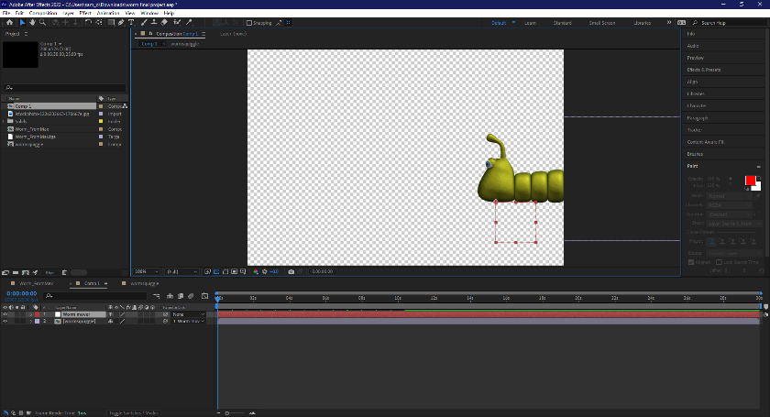
After working on the animation, I then moved back to the original composition page I created.
I moved the worm onto the edge of the screen and generated a Null object. I moved the null object to underneath the worm, just between the head and the neck. I made the worm be a parental object to the null object, attaching them together to prepare to move the worm for the animating process.
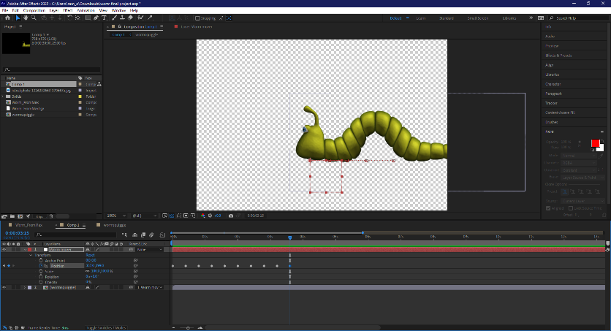
I placed a still pin at the start of the animation. The worm starts at the end of the screen, hiding out of site. I move 10 frames forward and then place a movement pin as the worm powers forward into frame. Once the worm has moved forward, I place a small pin, creating a small pause before the worm begins to form an arch again as I move forward another 10 frames. I place a still frame pin, before moving 10 frames forward again, and make the worm move forward. I repeat this animation until the worm moves across the screen and eventually reaches its destination, disappearing.
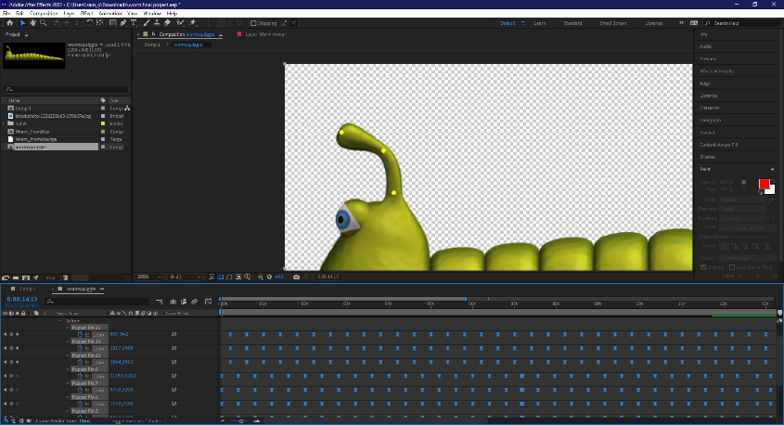
I decided to go back and work on the movement of the antennas, creating 3 puppet pinpoints at the bottom, middle and ending of the antenna. I then created another small animation loop to make it seem the antennas bounce as the worm moves forward on its journey.

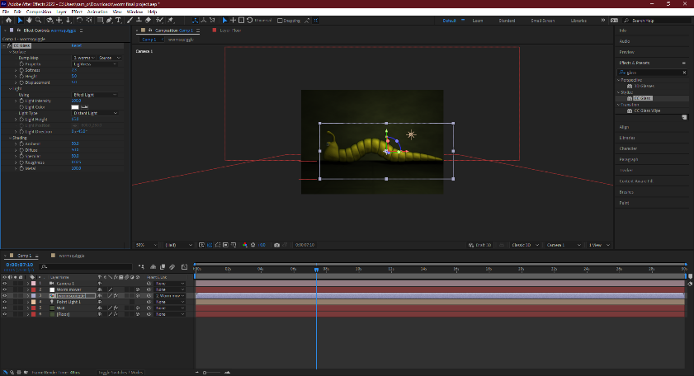
Once the animating part has finished, I began working on the background. I created a dark, textured green look to the floor and walls. Almost creating a cave look or a dark house infestation feel. I also added a pointed light with a yellow tint, as I feel a white light would look too technical within the type of environment the worm is in.
I worked a little on the shadows, creating a shadow effect underneath the worm. I defused the shadows a little to make the shadows not appear so harsh.
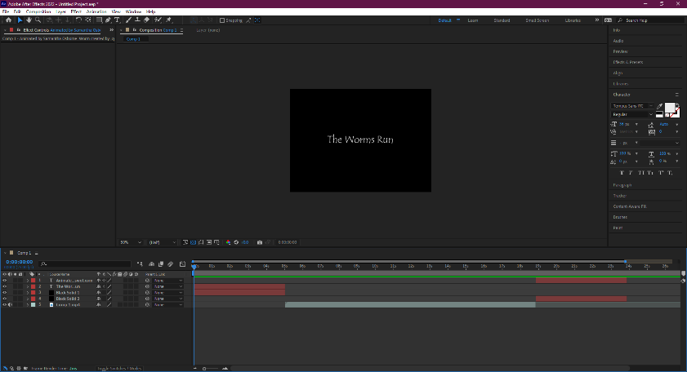
After finishing on the shadows. I exported the file, then went back in to edit in the title scene and credit scene. I tried to experiment with transitions, but I ended up taking up too much time trying to figure it out.
I picked some royalty free music from Adobe [3], that I thought would fit well within the background and exported the video.
Although I struggled a little with this animation, I am very proud with what has come out of it. I think I did well, and I have achieved new skills and I learned so much more by doing this project. But I could have added more into the animation, perhaps worked on the background more and incorporating a bigger story of the worm going on an adventure and adding more bugs into the background. That is something I want to work towards in the future. I want to work on another animation in something more of my style in the future, perhaps incorporating my own style of artwork and something more complex with the storyline.

[1] YouTube. CG Swot. Puppet Animation in After Effects – Tutorial. Jan 24th 2015. https://www.youtube.com/watch?v=Dh-yw7VKbmg&t=695s
[2] cgswot.com. Motion Graphics Tutorials. 06 Puppet Animation in After Effects. 2015. http://cgswot.com/index.php/tutorialsall/motion-graphics/161-06-puppet-animation-in-after-effects
[3] Adobe Stock. Pop Audio. This Hopeful Day. http://cgswot.com/index.php/tutorialsall/motion-graphics/161-06-puppet-animation-in-after-effects

