
Andrew Campbell

Chemistry Lab Report:
Calorimetry

School of Applied Computing
Ordnance, Munitions and Explosives

Chemistry Level 4
Academic Year: 2024 - 2025

Supervisor: Eva Kazimierska
March 2025

Academic integrity declaration
I declare that:
- the thesis submitted has been written by me alone.
- the thesis submitted has not been previously submitted to this university or any other.
- that all content, including primary and/or secondary data, is true to the best of my knowledge.
- that all quotations and references have been duly acknowledged according to the requirements of academic research.
I understand that to knowingly submit work in violation of the above statement will be considered by examiners as academic misconduct.

Contents
1. Introduction 1
2. Results 3
2.1. The Heat Capacity of the Calorimeter 3
2.2. Measuring the Specific Heat Capacity of a metal (c_{p metal}) 8
2.3. Measuring the Molar Heat of Reaction of HCL with NaOH (Q_{reaction}) 8
3. Discussion 8
4. Conclusions 8
5. References 8
6. Appendix 8
6.1. Materials and Equipment 8
6.2. Procedure 8
6.3. Lab Notes 8

Figure 1 2

Eq. 1 3
Eq. 2 3
Eq. 3 3
Eq. 4 3
Eq. 5 4
Eq. 6 4
Eq. 7 6
Eq. 8 6
Eq. 9 6

Table 1: Measured results from Experiment 1 4
Table 2: Calculated results from Experiment 1 4
Table 3: Plotted results of the change in temperature over time in Experiment 2 5
Table 4 Measured Results from Experiment 2 5
Table 5: The values of the Reactants 6
Table 6: The measured temperatures 6

Introduction

This experiment was to examine specific heat capacity and to measure the energy change in a reaction by measuring molar heat of reaction. This will be done in three parts and by using a calorimeter. First the heat capacity of the calorimeter must be measured. Then the experiment where the specific heat capacity of an unknown metal and the molar heat of reaction of Hydrochloric Acid and Sodium Hydroxide will be observed.
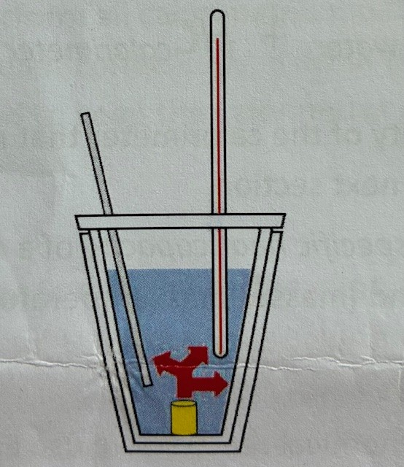
Heat is a type of energy that when exchanged between objects or an object and its surroundings will see a change in temperature. Note that an ‘object’ is not merely something physical but can also be an ionic or chemical reaction. In this experiment the metal in water in the calorimeter for the first part and, the reactants are placed in it for the second part.
Figure 1
Schematic of the calorimeter used in the experiments. It is made of two Styrofoam cups stack on one another, a lid with thermometer and a stirring rod. A hot object (yellow) releases heat (red) into the water (blue) and calorimeter (cups, thermometer and rod).

With the assumption that the calorimeter is an isolated system we can from the first law of thermodynamics expect that there is perfect energy transfer of heat in the calorimeter until equilibrium is reached. In the case of the metal, the hot metal would be placed in the cold water, the metal would begin to cool down as the water heats up until they are the same temperature and thus in equilibrium.
The heat change of an object can be defined as:
$$Q=m×c_{p}×∆T$$
Eq. 1
- Q is the heat change of the object in Joules, J
- m is the mass in grams, g
- c_{p} is the specific heat capacity in (J per g per ○C
- ΔT is the temperature change in degrees Celsius, ○C
The specific heat capacity is defined as the amount of energy required to raise the temperature of 1g of an object by 1○C.
As ΔT will be negative when an object cools down so will Q be and thus the inverse will be true if it is positive.
Therefore, abiding by the first law of thermodynamics and with the assumption stated that the calorimeter forms an isolated system we can state that in the metal experiment:
${-Q}_{metal}=Q_{water}+Q_{calorimeter}$
Eq. 2
Combining Eq.1 and Eq.2 we can derive the following relationship:
$$m_{metal}×c_{p metal}×{∆T}_{metal}=-(m_{water}×c_{p water}×{∆T}_{water}+\left({HC}_{calorimeter}×{∆T}_{calorimeter}\right))$$
Eq. 3
- Where HC_{calorimeter} is the Heat capacity of the calorimeter that was measured experimentally
Therefore, Eq. 3 can be used to calculate the specific heat capacity of a metal with all other parameters either being measured experimentally or referenced (the specific heat capacity of water is (4.186 Jg^{-1 ○}C⁻¹[SQA Handbook reference]).
To measure the heat of the reaction for a chemical reaction we substitute the heat exchange of the reaction (Q_{reaction}) for the heat exchange of the metal (Q_{metal}) in Eq.2. Hence:
$$Q_{reaction}=-(m_{water}×c_{p water}×{∆T}_{water}+\left({HC}_{calorimeter}×{∆T}_{calorimeter}\right)$$
Eq. 4

All the experiments should reach an equilibrium point in temperature when the hot object and the cold object equalise their temperatures through energy transfer to one another. No energy is destroyed but is transferred from on object to another. The same is true in a reaction that if two reactants go from a higher energy state to a lower more stable energy state they will release excess energy in the form of heat.

Results

The Heat Capacity of the Calorimeter

 | T (○C) | m(ml) | ΔT
Hot | 60.0 | 50 | -15.4
Cold | 23.1 | 50 | 21.5
Max | 44.6

Table 1: Measured results from Experiment 1
This is the table of the temperatures recorded from Experiment 1. The temperature is accurate to ±0.05○C (using a digital thermometer) and the volume to 0.5ml (using a graduated measuring cylinder) as these are the margins of uncertainty for these instruments.
With these results we can calculate the Heat Capacity of the calorimeter using Eq. 1, Eq. 5 and, Eq. 6.
$$-Q_{hot-water}=Q_{cold-water}+Q_{calorimeter}$$
Eq. 5

$$Q_{calorimeter}={HC}_{calorimeter}×{∆T}_{calorimeter}$$
Eq. 6
First, we must use Eq. 1 to determine Q_{hot-water} and Q_{cold-water}. The c_{p} of water was given in the lab handout and was stated to be 4.186 J/(g○C). Thus:

Q_{hot-water} | Q_{cold-water} | Q_{calorimeter} | HC_{calorimeter}
-3223.22 J | 4499.95 J | -1276.73 J | 59.38 J/○C

Table 2: Calculated results from Experiment 1
Add stuff here.

Measuring the Specific Heat Capacity of a metal (c_{p metal})
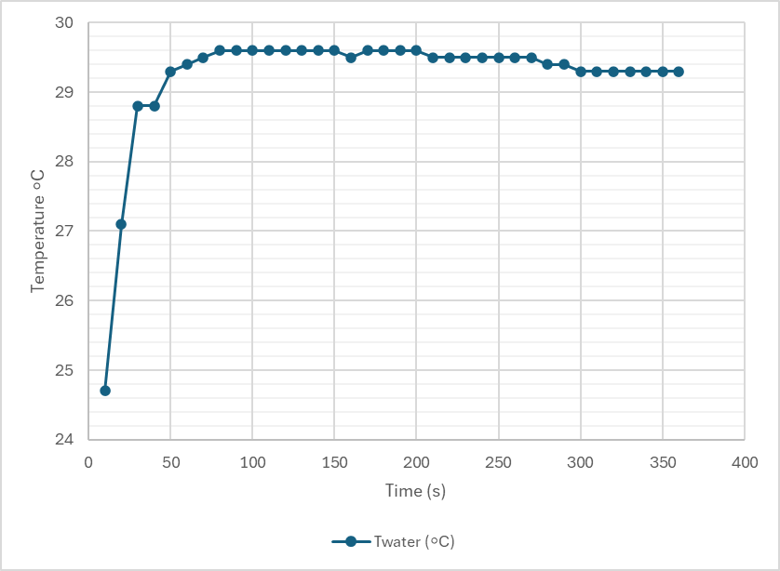

Table 3: Plotted results of the change in temperature over time in Experiment 2
 | T (○C) | m(g) | ΔT(◦C)
Hot/Metal | 91 | 18.6 | -61.4
Cold | 23.6 | 30 | 6.0
Max | 29.6
Table 4 Measured Results from Experiment 2
Using Eq. 3 we can calculate the specific heat capacity of the metal.
C_{p metal} = 0.9717 J/g◦C to 4 sig. figs.
This is higher than the expected value of 0.900 J/g◦C [1] for the specific heat capacity for aluminium which was the metal used in the experiment. This higher value is probably the result of outside influences in the experiment as it was not a perfectly isolated system as is assumed in the calculations.

It is observed that the temperature of the water rose quickly before plateauing when it reached the point of equilibrium with the temperature of the metal. The temperature fell slightly in the measured timed afterwards showing that the calorimeter is not a perfectly isolated system as is assumed.

Measuring the Molar Heat of Reaction of HCL with NaOH (Q_{reaction})

Experiment 3 was to measure the energy change for the following reaction:
$$HCl+NaOH→NaCl+H_{2}O$$
Eq. 7
V_{HCl} | C_{HCl} | n_{HCl}
50ml | 1M | 0.05
V_{NaOH} | C_{NaOH} | n_{NaOH}
52ml | 1M | 0.052

Table 5: The values of the Reactants
Where V is the volume of the reactant, C is the concentration of the reactant and n is the number of moles of the reactant. The number of moles was calculate using:
$$n_{Reactant}=V_{Reactant}×C_{Reactant}$$
Eq. 8
T_{Start} | T_{End}
26.9◦C | 32.9◦C
Table 6: The measured temperatures
Assuming that the specific heat capacity of the reactants is the same as water we can thus calculate the heat of the reaction using Eq. 4. Thus:
Q_{Reaction} = 2206 J to 4 sig. figs.
To calculate the Molar Heat of the Reaction we must calculate the heat of the reaction per mole of the limiting reactant. Since HCL and NaOH react equally HCL is the limiting reactant due it being a slightly lower volume than the NaOH. Therefore:
$$q_{reaction}=Q_{reaction}÷n_{reactant}$$
Eq. 9
Where q is the molar heat of the reaction. Using this equation, we can therefore calculate that the observed molar heat of rection of the experiment was:
q_{reaction} = 44.11 kJ/mol to 4 sig. figs.

Discussion

Experiment 1 and 2 demonstrate clearly that when two substances of different temperatures mix, they will both reach a new temperature at an equilibrium point. Experiment 3 clearly demonstrates and exothermic reaction with HCL and NaOH releasing energy in the form of heat to attain a lower energy state with stronger bonds.
Calorimetry is an important measuring tool in the OME world. While a much more robust calorimeter is required than what was used in the experiments in this paper (typically the explosive is within a thick walled vessel or bomb in a water bath with the change in water temperature upon detonation used to measure the heat of the reaction [2]) Measuring the heat of explosion, it gives a very strong indicator as to how powerful an explosive is. The larger the amount of energy given off the greater the potential effects due to the amount of heat given off making it one of the most important parameters when determining the effectiveness of an explosive [3].
The use of a calorimetric bomb also allows for testing the explosives under unusual conditions where it may find atypical use such as in a controlled environment where the composition of the atmosphere is atypical or filled with a fire suppressing gas such as argon [4].

Conclusions

The experiments conclusively showed that two objects of different temperatures will reach an equilibrium and when two reactants attain a lower energy state they will release energy in the form of heat.
To pursue this further measuring different reactions to observe larger or smaller changes in energy levels or even endothermic reactions. Indeed, using different pressures to simulate for example a high-pressure steam system and the heat transfer within such as system. To improve accuracy of the results a purpose built calorimeter with an electronically recorded thermometer for more accurate temperature measurements as well as getting closer to a perfectly isolated system.

References

[1] | Matweb, “Matweb,” MatWeb, LLC, [Online]. Available: https://www.matweb.com/search/datasheet.aspx?bassnum=AMEAL00&ckck=1. [Accessed 28 4 2025].
[2] | T. M M. Künzel, O. Němec, “The Effect of Detonator Shell Materials on Detonation Calorimetry Results,” Central European Journal of Energetic Materials, vol. 17, no. 4, pp. 552-565, 2020.
[3] | M. H. a. K. T. M. Keshavarz, “"1 Heat of detonation",” in Energetic Compounds: Methods for Prediction of their Performance, Berlin, Boston, De Gruyter, 2020, pp. 1-22.
[4] | W. Kiciński & W. A. Trzciński, “Calorimetry studies of explosion heat of non-ideal explosives,” Journal of Thermal Analysis and Calorimetry, vol. 96, no. 2, pp. 623-630, 2009.

Appendix

Materials and Equipment

- 2 Styrofoam coffee cups with lid
- A digital thermometer
- Stirring rod
- Water
- Aluminium sample
- Bunsen Burner with heat pad and stand
- Beaker
- Measuring cylinder
- Digital scales
- 1M HCL
- 1M NaOH
- Stand and clamp
- Tongs

Procedure
Experiment 1: measure HC_{calorimeter}
- Add 50.0mL of water to the Styrofoam coffee cups and close the lid. Add the thermometer and the stirring rod. Record the temperature as T_{cold}
- Heat 50mL of water in a beaker till it reaches 80◦C. Turn off the Bunsen and wait until its temperature reaches 60◦C, this is T_{hot}.
- Add T_{hot} t the calorimeter stirring while watching the thermometer record the equilibrium temperature
- Calculate the heat capacity of the calorimeter using Eq. 1, Eq. 5, & Eq. 6

Experiment 2: Measure the specific heat capacity of a metal
- Obtain a metal sample weigh recording its mass as m_{metal} .
- Boil water in a beaker. Add the metal to the beaker for 5 minutes before removing it from the heat for 2 minutes. This is to allow the metal to reach thermal equilibrium.
- Measure 30ml of cold water and add to the calorimeter. Measure the temperature as T_{cold}.
- Once the metal has reached thermal equilibrium record the temperature of the water as T_{Hot.} Add the metal to the calorimeter using tongs.
- Stir the water and record the temperature every 10 seconds filling in the datasheet.
- Calculate the specific heat capacity of the metal using Eq. 3 and the Heat Capacity of the calorimeter calculated previously.

Experiment 3: Measure the Molar heat of Reaction of HCl with NaOH
- Measure 52mL of 1M NaOH and 50mL HCL into the calorimeter and a beaker respectively wait till they attain the same temperature and record as T_{start}.
- Add the HCL to the calorimeter and record the temperature as it reaches the maximum as T_{end}.
- Calculate the heat of the reaction using Eq. 4 and then calculate the molar heat of reaction using Eq. 9

Lab Notes



