Generating Business Data Report
Matthew Edward Kilgariff
University of South Wales Trinity
Dr Rosin Mullins

Table of Contents
PART 1 3
Introduction. 3
Nature of the Brand. 3
Roles of a Business Analyst. 3
Future Generations Wales Act. 3
Purpose of a Database. 4
Definition and Functions of a Database Management System. 4
Database Design Lifecycle. 4
Planning and Creation of the Database. 5
The Rational of Location Choice. 6
Tools and Trends of Capturing Data 7
References 8

PART 1

Introduction.
The aim of this report is to find a suitable conference location for the University of South Wales Trinity Saint David. The location must be on the Welsh coastal path and fit the criteria of the Future Generation Wales Act. Information on 36 venues has been collated from around the coastal path with comparisons on price, size, location and other contributing factors in order to find the best possible location.

Nature of the Brand.
The University is seeking an imaginative solution for the location of the conference. The venue must comply with the Future Generations Wales Act. It is important in the business sector to look at the environmental impact and choose options which are environmentally friendly, especially as the business sector makes up for 65% of all greenhouse gases (Hoffman, A, (2005).

Roles of a Business Analyst.
‘Business Analyst is the task of understanding business change needs, assessing the business impact of those changes, capturing, analysing and documenting requirements and supporting the communication and delivery of requirements with relevant stakeholders.’ – (What is a Business Analyst?(2018).
Business analysts often bridge the gap between information technology and stakeholders. Stakeholders will set a brief for what information they want collected and the business analyst can then produce tailored techniques to match these requirements or an IT team will build or modify a system accordingly. It is up to the analyst to collect the data, arrange it in a suitable format and then calculate the business case and make sure it fulfills the proposition. It is a similar relationship as that between a customer, architect and builders. If someone planned to a build a house they would hire an architect to form plans to their specifications and then pass the information on to the building team.
The role of a business analyst requires problem solving, both written and verbal communication skills and knowing what data is useful. It is key that the business analyst can engage and respond to stockholders needs in a changing business environment (Cornel, C & Morris, S (2015).

Future Generations Wales Act.
The Future Generation Wales Act is legislation that reached Wales on April 1st 2016 (Gov.wales. (2017). It aims to ensure that public bodies such as Local Authorities, the Arts Council and Higher Education Funding Council for Wales work together to carry out 7 goals to help Wales become more sustainable and to encourage traditional identity.
The Act requires all the public bodies involved to consider the long-term effects of their decisions and not only short-term goals. It aims to prevent problems such as poverty, health inequalities and climate change (Future Generations Act (2017).
From the 7 goals ‘the prosperous Wales’ is the one with the most relevance. “Prosperous Wales” aims to promote a low carbon society which can react to environmental restraints and changes . This includes using resources efficiently, educating the population on sustainability and acting on climate change.
A organisation could also show compliance with the Prosperous Wales goal by obtaining a sustainability certificate. The Institute of Sustainable Practice, Innovation and Resource Effectiveness or INSPIRE is a certificate available from University of Wales Trinity Saint David. This is a good way to prove the sustainability of an individual or business (UWTSD (2018).

Purpose of a Database.
Databases are tools to help process and log information in a way which is accurate, easily accessed and updateable. A database transforms data into information which can be compiled and edited freely. It is key when creating a database that the expected use is clear as there are different types of databases which range from relational databases to cloud databases. If the database is not designed correctly there are chances that the data may become inaccurate and cause data redundancy (duplication of data).

Definition and Functions of a Database Management System.
Organisations use large amounts of data so a database management system is a necessary tool used to store this information into a database format. The Database Management Systems or DBMS provides users and programmers with a way to create, update and manage data (Rouse, M. (2017). There are a range of functions that a database can be designed to do, not simply storing data. One key function is to create an easy to use format from which all the complex functions such as relationships and primary keys are hidden. This means that even computer illiterate users can enter information on to the database easily, a good example of this is an online mailing list (Harrington, J. (1998). The DBMS serves as an interface between the database and end users.

Database Design Lifecycle.
There are 5 main stages of data generation and storage; planning, analysis, conceptual design, implementation and maintenance. When starting a database, it is key to plan what data needs to be stored and to consider the purpose of the research. A data analyst should consider the purpose of the data and any constraints that may limit the database design.
The next step would be to identify the information needed within the brief. The main entities need to recognised; an entity is an object or a person in a system of significant interest. The relationships between entities then needs to be defined as it could be one to one, one to many or many to many. Next the attributes, primary keys and foreign keys need defining for each of the entities (Cornel, C & Morris, S (2015). Attributes are database components that have characteristics eg. height, age. A primary key is important within a database as it makes it possible to uniquely identify every row in a table. It also makes sure that each piece of information in the database is accessible (Harrington, J. (1998). Foreign keys are primary keys that appear in more than one of the entities. An entity relationship diagram can then be created which is a visual representation of the database. It may help to draw the entity relationship diagram on paper first to avoid errors.
The next stage is the implementation of the database. A database management system needs to be chosen, examples of these are Microsoft Access, Oracle and FoxPro. Also the database creator may want to use programming tools such as SQL and VBA and add security features to the database to ensure that only the desired personnel has full access. This can be achieved by adding a password or even data encryption in some cases. It is important to check that all set criteria have been met and to test the system for performance and how easily it operates. The final step is to maintain the database ensuring that there is no data redundancy and regular backup.

Planning and Creation of the Database.
The purpose of the database was to find a suitable conference location with attributes that best fitted the criteria of the task. Google maps was a useful tool to locate venues as it showed them in a map format with direct links to the hosts’ websites (refer to figure 1.0).
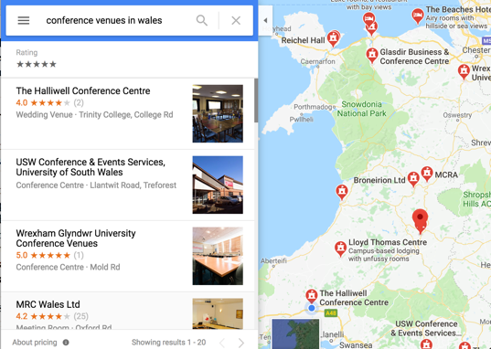
Google maps also gives customer satisfaction ratings which can be helpful when choosing venues.

Figure 1.0: Google Maps tool.

When sufficient planning had been carried out , the plans were entered onto Microsoft Access which is a database creation tool or a database management system. The database was a relational database management system. Three separate entities with corresponding tables were created. The entities were labelled as county, town and venue. Fields were then added into each of the entities. Then a primary key was added into each entity table.

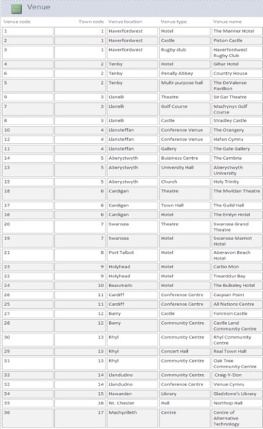
Entity Tables

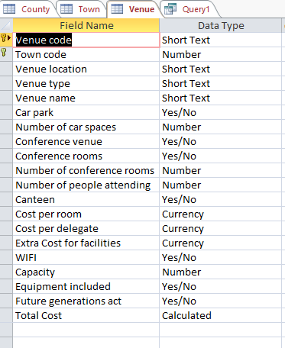
Primary Key

Figure 2.1: List of venues, locations and type.
Figure 2.0: Design View of entity table.

The entity tables contained primary keys which were situated in more than one table and therefore became foreign keys which helped with creating relationships between the entities. The venue table contained most of the attributes which were characteristics of interest. A variety of data types were used within the table to standardise the data within each column. Attributes were created with characteristics such as costing, car parking, wifi, canteen options and compliance with the Future Generations Wales Act.
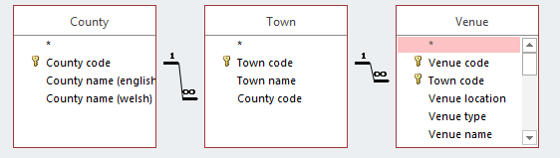

Figure 3.0: Entity tables and relationships

Foreign Keys One to many relationships.

Relationships were made between the entity tables. Relationships are the connectivity or association between one or more entity. There are three possible relationships, one to one, one too many and many to many. This database only uses one to many relationships.

The Rational of Location Choice.
After compiling data on 36 venues, the Centre of Alternative Technology in Machynlleth was found to be the best location for the conference. The first deciding factor was that it fit the Future Generations Act; a “Prosperous Wales” for having low carbon emissions and taking environmental restraints as an element of their business. They actually exceed it and have the largest range of installed renewable systems anywhere in the world (Centre for Alternative Technology. (2018). There are 8 conference rooms with the largest having a capacity of 180 and all 8 having a combined capacity of 350. It is also an educational centre aimed to stimulate discussion.
Another contributing factor to the decision was the reasonable price, renting of a conference room for as little as £300 or £6 each on an assumed 50 attendances. They also do delegate packages from £18 per person with tea, coffee, bottled water, biscuits and an organic Fairtrade lunch provided within the price. Many of the other venues considered did not have this option and food prices were often a costly extra.
The Centre for Alternative Technology did not have the best I.T. resources unlike venues which are specialist conference centres such as Caspians point in Cardiff. It does however come with free WIFI, built in audio visual equipment and low-tech resources such as flipcharts and pens. Free parking is also available with wheelchair access to the main conference room.
The centre is situated amongst beautiful countryside which would create an inspiring environment for delegates to appreciate. This is a contributing factor in the choice to hold the conference on April 6th which is the first day of the financial year.
Following the analysis of the 38 venues it was a clear that the Centre of Alternative Technology fitted the brief best and although other venues surpassed it on technology from the attributes it had the best all round environment for the conference.

PART 2

Tools and Trends of Capturing Data

In 2013 IBM released statistics that 90% of the worlds data had been created in the last 2 years alone. These changes have come about with an increase in access to the internet globally and changes in how we use it (Tripathi, A. (2016). One main contributing factor to this is the rise in popularity of social media during the last decade. When people are posting statuses and videos online it is easy to forget that they are actually generating data. This has led to a surge in data which needs increased storage and fetching requirements.
This sudden increase in velocity and variety of data is referred to as Big Data. Big data analytic is the process of analysing this data to find correlations or to spot market trends. This can be advantageous to organisations and helps them target markets with more accuracy.
The change in the amount of data means that RDMS are no longer fit for purpose for some companies. RDMS have problems handling unstructured data which can occur in social media. Therefore, a new system is required to deal with this change, NoSQL.
Structure query language databases or SQLs have been around since the 1970s, originating from Dr E F Codd’s paper for the Association of Computer Machinery (Buckler, C. (2015). Usage soared in the 1990s with the popularity of open-source options such as MySQL and PostgreSQL. SQL is a language computers use to request information from a database.
NoSQLs stands for Not Only Structure Query Language. It is different from most database systems as it does not run SQL as its primary query language, instead using Application Programming Interfaces. The advantages of NoSQL are lower cost, more flexibility, no complicated relationships and the ability to handle unstructured data better (Tripathi, A. (2016).

There are different database management systems available including Oracle, RDBMS, dBASE, Clipper and FoxPro but the latest trends in database tools are programs that do not stick to a single database structure but use both SQL and NoSQL. This gives the user a wider range of capabilities within the same system. Also, it allows the user to access NoSQL databases as if they were relational.
Another tool which is becoming popular is a Cloud Database. Cloud Databases are like traditional data storage systems but typically run on a cloud computing platform. They also differentiate from normal databases in that they are provided as a service where the vender manages certain tasks such as installation and can also be accessed from a web browser. This means that the user can save and retrieve on different computers without the use of a memory device. Cloud storage or online backup service is becoming increasingly popular with programs such as OneDrive and DropBox which allow large documents to be saved and retrieved online. This is perfect for sending files which are too large for other traditional methods.
The world is changing at a rapid pace and to keep competitive companies need to make sure their technology meets the needs of ever more sophisticated data. Globalisation and the accessibility of internet has meant that organisations must compete with each other and any advantage in the market place must be exploited.

References

Cadle, J & Paul, D and Turner, P. (2010). Business Analysis Techniques: 99 Essential Tools for Success.

Centre for Alternative Technology. (2017). Cat.org.uk http://www.cat.org.uk/index.html

Cornel, C & Morris, S (2015). Database Systems: Designs, Implementation, & Management. Cengage learning. Stamford, USA.

Buckler, C. (2015). SQL vs NoSQL: The Differences. https://www.sitepoint.com/sql-vs-nosql-differences/

Future Generations Act (2017). The Future Generations Commissioner for Wales. Https://futuregenerations.wales/about-us/future-generations-act/

Gov.wales. (2018) Future Generations Wales Act http://gov.wales/docs/dsjlg/publications/160401-wfg-easy-read-en.pdf

Harrington, J. (1998). Relational Database Design. Academic press, USA.

Hoffman, A. (2005). The Business Logic Behind Voluntary Green House Gas Reductions. Berkeley, California.

Rouse, M. (2017). What is database management system (DBMS). http://searchsqlserver.techtarget.com/definition/database-management-system.

Rustici, G. Kolesnikov, N. Brandizi, M. (2012). Trends in database growth and links to data analysis tools. Nucleic Acids Research,
https://academic.oup.com/nar/article/41/D1/D987/1066874

Steven, R. (2002). Access Database Design and Programming, 3rd edition. O’Reilly

Tripathi, A. (2016). A Short History of Databases: https://www.3pillarglobal.com/insights/short-history-databases-rdbms-nosql-beyond.

UWTSD (2017). Institute of Sustainable Practice, Innovation and Resource Effectiveness (INSPIRE) - University of Wales, Trinity Saint David. Uwtsd.ac.uk. http://www.uwtsd.ac.uk/inspire/

What is a Business Analyst?. (2018). Businessanalystsolutions.com., http://www.businessanalystsolutions.com/what_is_a_business_analyst.html

APPENDIX



