My Screenshots/Photos
Hello,
My name is Bogdan, and I use digital tools in many parts of my everyday life. I use them for playing games, livestreaming on YouTube, creating videos, generating AI music for different occasions, browsing the web, reading news and fulfilling customer orders for my online store.
I decided to focus on this skill because it is something I really enjoy doing, but also something I would like to keep improving.
I started my YouTube channel three years ago without really knowing what was involved or what skills I needed. It has been a long learning process, but I have learned a lot along the way, and hopefully one day it will pay off.
At first, I thought making YouTube videos was just about recording gameplay and uploading it online. After doing it for a while, I realised there is a lot more involved. I need to plan the video, edit it properly, choose a good title, create a thumbnail and think about what viewers would actually want to watch. This made me understand that digital skills are not only about knowing how to use different apps, but also about learning how to make better choices with the tools I use.

Screenshot/Photo 1
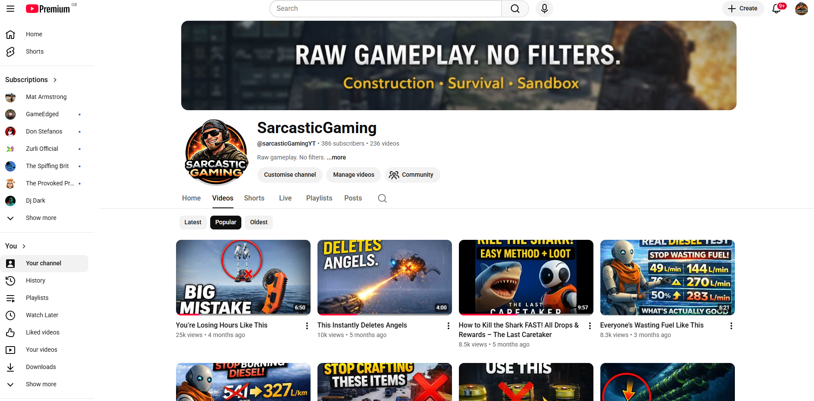
This is my YouTube channel, where I upload videos that I make while playing games on my PC or PS5. My channel focuses on gaming videos, mostly tutorials about gameplay and how to play certain games better. I share tips and tricks after trying them myself, so viewers can understand the game better and enjoy it more.

Screenshot/Photo 2
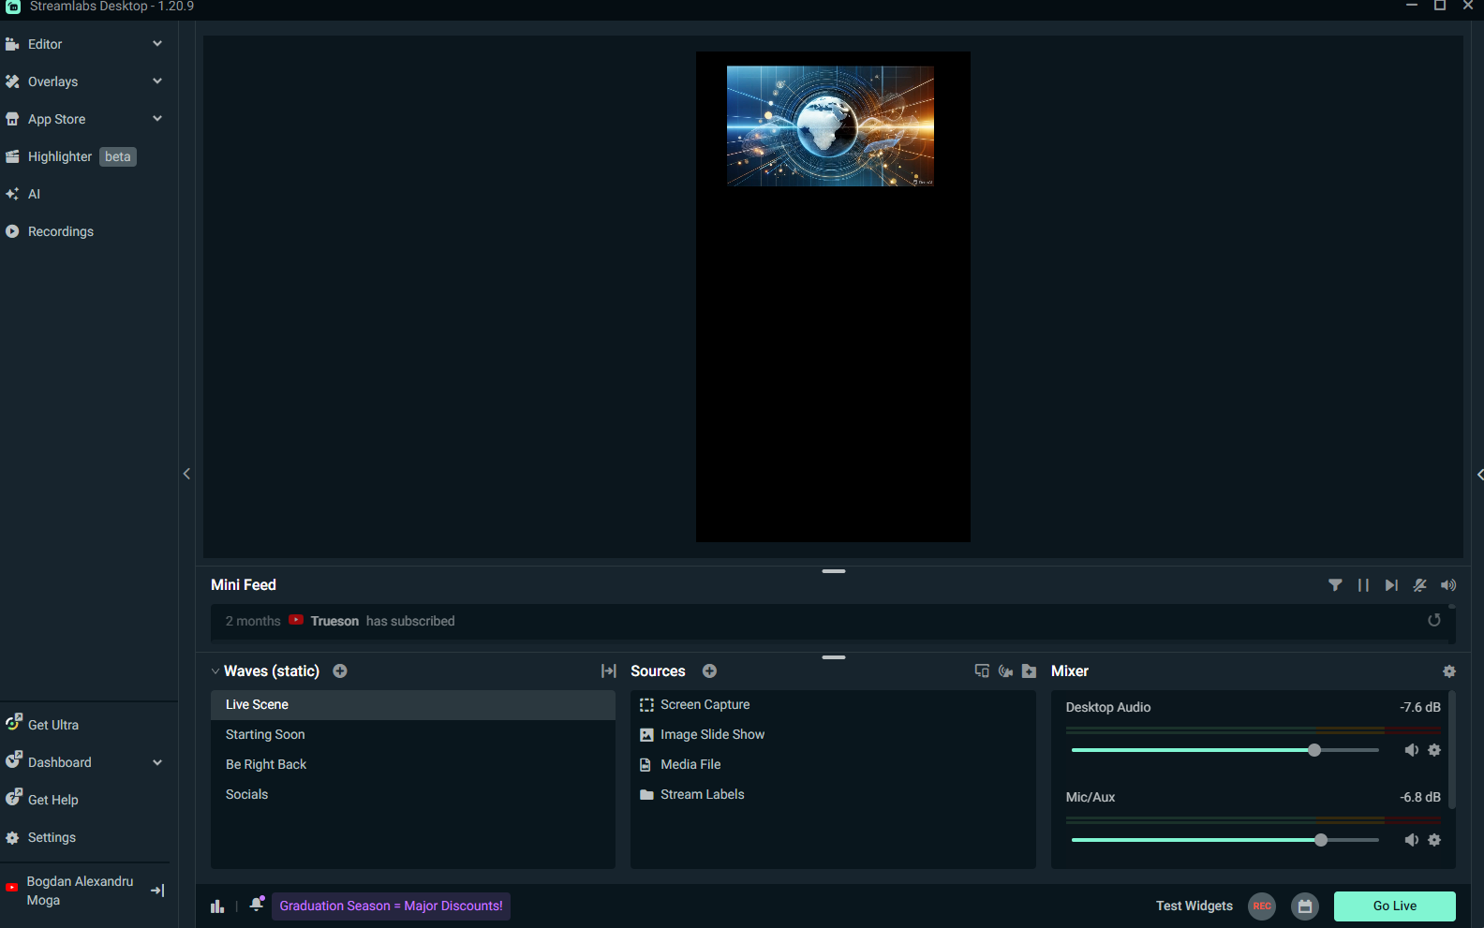
To record videos, I use an app called Streamlabs, which allows me to record my screen and save the video. I can also livestream on YouTube, TikTok, Twitch or other streaming platforms, either one at a time or simultaneously. Streamlabs also allows me to create unique scenes, set up custom donation alerts, and create a more engaging live experience for viewers.

Screenshot/Photo 3
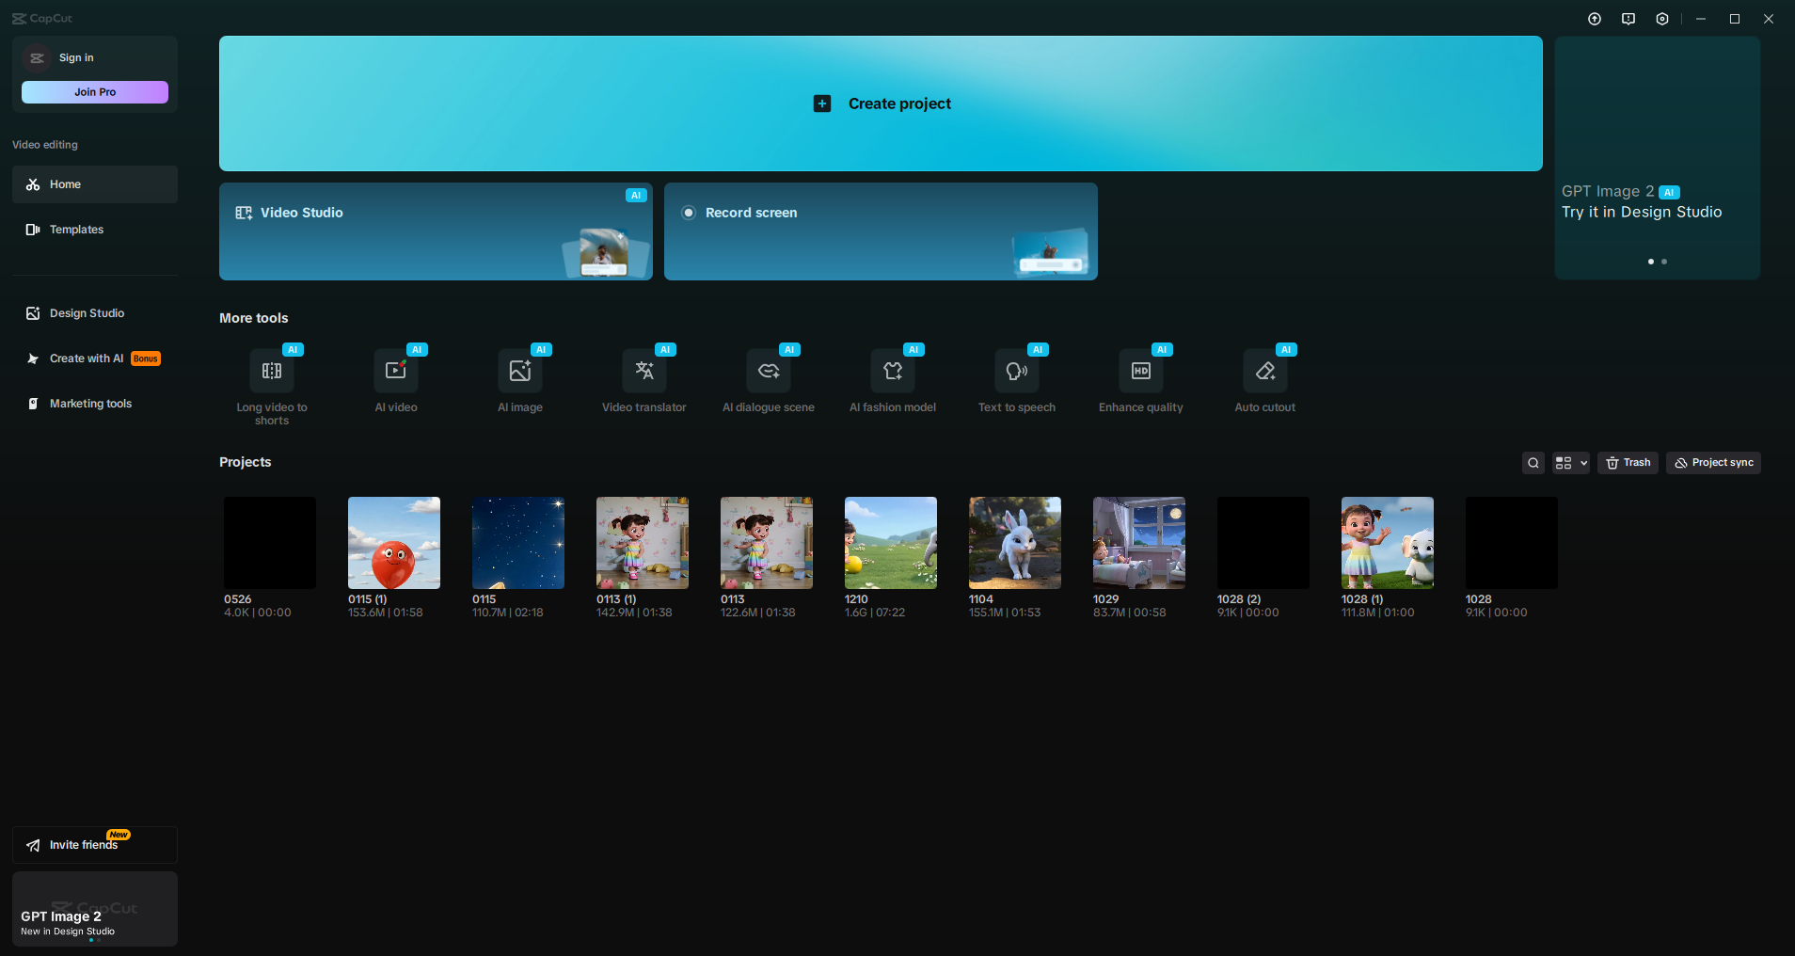 In this screenshot, I am presenting an app called CapCut. This app allows me to edit raw videos and combine clips to create the final version. In CapCut, I can cut and merge clips, record voiceovers, add effects, generate English subtitles, and create AI-generated short-form videos that may help improve the channel’s exposure. I also use ChatGPT during the editing process to create scripts, which I then use for voiceovers. This helps me test how different scripts affect my views, viewer engagement and other metrics. So far, this has shown a clear improvement in my channel growth. After having my YouTube channel for over three years, I had around 12 subscribers in November 2025, but after using ChatGPT to help create video scripts, my channel grew to 395 subscribers. Although this is not a large number, it is an important achievement for me and supports my goal of reaching 1,000 subscribers and eventually monetising the channel.

Screenshot/Photo 4
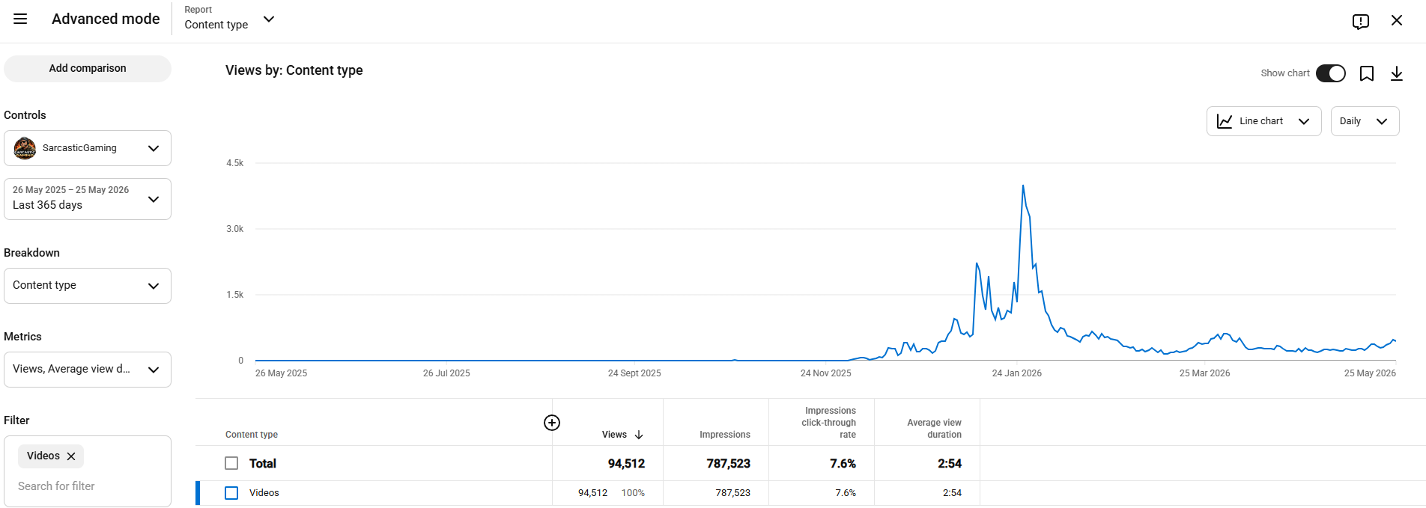
Here is a brief overview of my channel analytics and growth in YouTube views over the past year. The graph shows a large spike after I found a strong topic to explore in a specific game. It also shows a downward trend after I started playing a different game, where the topics were not as interesting to viewers. I have also posted less frequently because I have not had as much time to edit videos. I recently started playing a very complex game, and it took me over 150 hours to learn the basics. I still need to explore more of it before I can create a useful and compelling tips-and-tricks video.

Screenshot/Photo 5
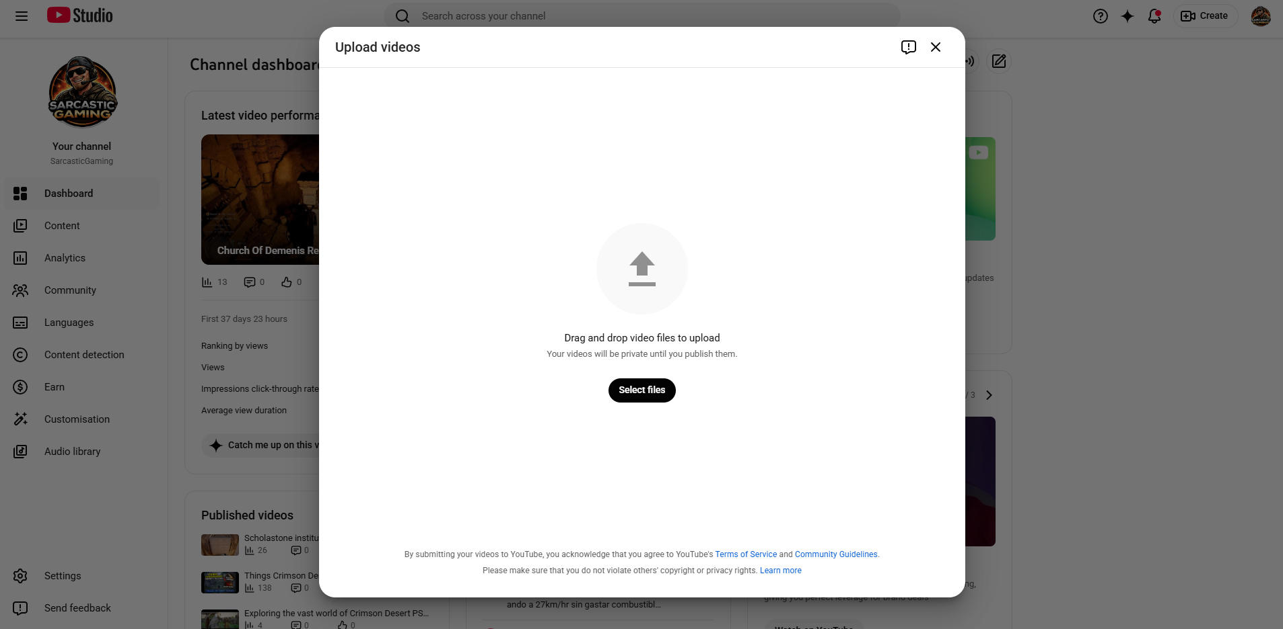
This screenshot shows how I upload videos to YouTube. After uploading a video, I need to create a thumbnail, brainstorm title ideas, choose relevant tags, and write a short description. ChatGPT supports me with this process by suggesting keywords, title options and description ideas. I still review the suggestions myself and choose the final version. This helps me think more carefully about how the video could be found through YouTube and Google search.

Screenshot/Photo 6
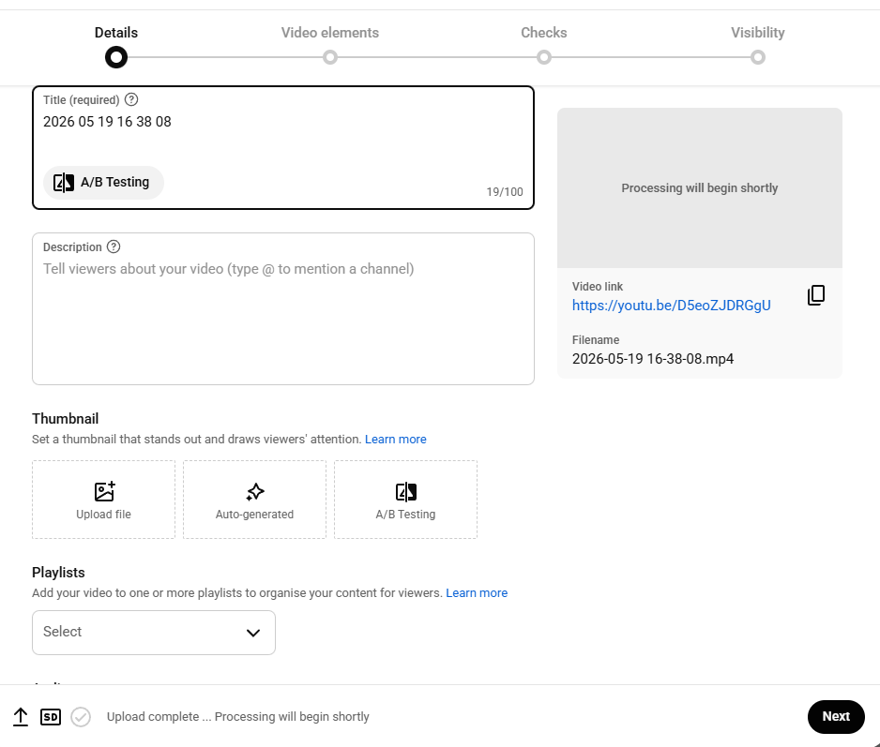 This is YouTube’s interface, where I add the video title, description and thumbnail. I can also test different titles and thumbnails. This is one of the most important parts of creating a video because the title and thumbnail strongly influence whether viewers decide to click. As a creator, I only have a few seconds to catch a viewer’s attention before they scroll past. The title and thumbnail need to create curiosity without giving away too much information. YouTube also measures impressions, click-through rate, watch time and viewer engagement, so these choices can affect how widely a video is recommended.
It also tracks how long viewers watch the video, whether they leave a like or subscribe, if they leave in the first few seconds, and whether they continue watching after 30 seconds. These measurements are part of viewer engagement. I also use ChatGPT to help create thumbnails by providing it with an in-game screenshot. It then generates several thumbnail options, and I choose the one I think will work best. Creating a video usually takes between one and six hours, depending on its length, the amount of editing required, and how many voiceover takes I need to record.
My Video Creation Workflow
My usual workflow starts with choosing a game or topic, then recording the gameplay using Streamlabs. After that, I use ChatGPT to help me plan the script or improve my ideas. I then edit the video in CapCut, create or choose a thumbnail, upload the video to YouTube Studio and check the analytics afterwards. This helps me understand what worked well and what I should improve next time.

My Short Reflection
This short presentation shows how I use YouTube Studio, Streamlabs, CapCut and ChatGPT as part of my digital life and content creation process.
I chose this topic because making gaming videos is something I enjoy, but it is also something I still want to improve. When I first started my YouTube channel, I did not really understand how much work goes into making a good video. I thought it was mostly about recording gameplay, but over time I realised that editing, titles, thumbnails, scripts and analytics are also very important.
I feel quite confident when recording and editing videos because I have been doing it for a while and I enjoy the process. At the same time, I know I still have a lot to learn, especially in CapCut, because there are many features I have not used properly yet.
One thing I still find difficult is recording my voice over the video. English is not my first language, so sometimes I worry about pronunciation or I start stuttering. Because of this, I often need to record the same part more than once. Even though this can be frustrating, I can see that my confidence and communication skills have improved compared to my older videos.
Streamlabs helps me record and livestream my gameplay, while CapCut helps me turn raw clips into a final video. ChatGPT also supports me with scripts, titles, descriptions and ideas, but I still choose what fits my video best. I think this is important because the final video still needs to feel like my own work.
When I compare my earlier videos with my recent ones, I can see progress. I am better at planning, reading from a script and thinking about what viewers might find useful. My channel growth also shows me that using digital tools in a better way can make a real difference.
The digital skill I would like to improve the most is video editing. I want to become faster and more confident with CapCut, so I can spend less time editing and still create better quality videos. This skill can also help me in my business because I could create better advertising videos and social media content in the future.
I also think these skills can help me with my studies because they make me better at organising information, presenting ideas clearly and using digital evidence. In my personal life, they help me build confidence, especially with speaking English and expressing my ideas more clearly.
I use ChatGPT as a support tool, but I do not want it to replace my own thinking. It can give me ideas for scripts, titles or descriptions, but I still decide what sounds right for my video. This is important because the final work should still feel like my own.
Overall, this project helped me understand that digital skills are not only about using apps. They are also about problem-solving, creativity, confidence, communication and learning from mistakes.

Submission Checklist
Before you submit, please check:
​​​ ☒ I added 4–6 screenshots
☒ I wrote short sentences for each screenshot
☒ I wrote my short reflection
☒ My work is my own
☒ My file opens correctly
​​☒ My file opens correctly

