University of Wales Trinity Saint David
School of Engineering
Manufacturing Process and Material Selection
Structure and Properties
M5X01185
Courteney Peart
1910902
06/04/2020
Contents
1 Abstract 2
2 Introduction 2
3 Crystal Structure 2
4 Lattice Defects 3
5 Carbon-phase Diagram Under Equilibrium Conditions 4
6 Heat Treatment 5
7 Experimental Method 6
8 Results 7
9 Conclusion 10
10 Works Cited 11

Abstract
The objective of this experiment was to determine the effects carbon has on the mechanical properties of steel, by conducting tensile tests and the observing the grain structure using optical microscopy of different steel grades containing various carbon content. A series of mechanical properties and crystal structures were observed to determine whether the steel was affected by the carbon content.

Introduction
Steel is an alloy mainly consisting of carbon and iron. Iron is a polycrystalline metal, whose structure at room temperature consists of small groups of iron atoms forming repetitive patterns, known as unit cells, throughout a closely packed lattice. The unit cells interlock forming crystals or grains. These grains can be of different size and exist in different orientation to each other, forming a grain boundary when two or more grains meet. Carbon atoms are smaller in size compared to iron atoms and are able to sit in the interstitial sites of the iron crystal lattice, which occupy the spaces between the larger iron atoms (Davis, 2003).
This investigation was conducted to explore the effects the addition of carbon atoms has on the iron lattice, therefore effecting the mechanical properties of the steel.

Crystal Structure
Iron is an allotropic element that can exist in two crystalline forms. At room temperature, pure iron has a body-centred cubic crystal structure (BCC) stable up to 912˚C, called ferrite or alpha iron. A BCC crystal structure has atoms located at each corner as well as in the centre of the unit cell (Callister JR & Rethwisch, 2014).
At 912˚C the structure of iron is that of a BCC and FCC crystal structure which coexist at equilibrium (Lawrence S. Darken, Robert W. Gurry, 1953).

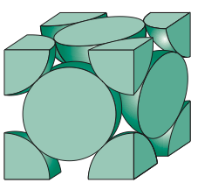
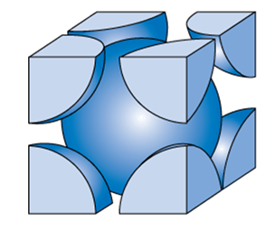

Figure 1: Crystal structure of iron, body-centred cubic left, face-centred cubic right (Dutton, 2018).
Above 912˚C, the packing arrangement of the iron atoms changes to face-centred cubic (FCC) and forms austenite, remaining stable until it reaches 1390˚C. The FCC structure has atoms at each corner of the cell as well as at the centre of each face of the cube. There are more interstitial sites in the FCC lattice resulting in more soluble carbon within the lattice.
At higher temperature the packing arrangement reverts back to BCC with different crystallographic parameters and changes to delta iron (Ashby & Jones, 2013).

Lattice Defects
Theoretically, the crystal structures of metals contain relevant atoms in a perfectly ordered pattern which accordingly fill the lattice. However, metal crystal structures often contain point defects which are localised disruptions in the crystal lattice structure.
Vacancies are point defects where there are missing atoms in the crystal lattice, disrupting the arrangement of atoms causing misalignment in the atoms positions. Vacancies within the lattice are important as they allow atoms to move positions within the lattice and permit the process of diffusion (Callister JR & Rethwisch, 2014).
Carbon is an interstitial element within an iron lattice positioned at a point that is typically unoccupied. An interstitial defect distorts the crystal structure as the atom is larger than the interstitial site it is situated in. This differs from a substitutional defect where an atom from the host is replaced (Mouritz, 2012).
A linear defect within a crystal lattice is a dislocation which affects the row or line of atoms in the lattice, being of two types namely edge dislocations and screw dislocations (Callister JR & Rethwisch, 2014).
Edge dislocations are at the edge of an incomplete plane of atoms, perpendicular to the plane of atoms in a displacement in the lattice, and screw dislocations exists parallel to the displacement.
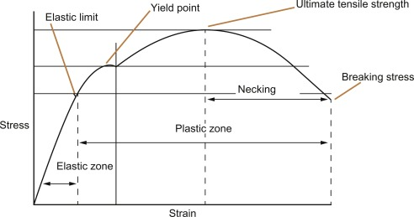
Dislocations are able to move in response to stresses applied along a slip plane and in a slip direction by bonds being broken and reformed which relieves tension within the lattice. Plastic deformation occurs when a large number of dislocations move at once. By restricting the movement of dislocations the ductility of the material will be reduced and the hardness and strength increased. Grain boundaries and the interaction of point defects obstruct the movement of dislocations. At grain boundaries, where the adjacent grain does not align, a build-up of dislocation where they can become intertwined occurs. The entanglement of dislocations prevents the movement and plastic deformation, increasing the strength of the material (Callister JR & Rethwisch, 2014). Obstructing the movement of dislocations increases the applied stress required to move dislocations to result in plastic deformation (Bacon, D.J; Osetsky, Y.N; D.Rodney, 2009). In turn this increases the yield strength.

Figure 2: Stress/strain Graph showing the different regions when a load is applied to a material (Jitendra Pratap Singh, 2017).
A stress-strain graph (figure 2) illustrates the behaviour of a material when a load is applied, showing the process of the reaction and its mechanical properties. Throughout the elastic zone, a load can be applied to the material and once removed can return to its original position up to the elastic limit point. The yield point shows the stress where the extension of the material occurs more quickly with little increase in load. The ultimate tensile strength is the maximum stress a material can withstand before breaking (Afsar, 2014). The degree of plastic deformation that has been sustained can indicate the ductility of the material (Callister JR & Rethwisch, 2014).
“Work Hardening” is the process where stress is applied to a point of plastic deformation then released then reapplied, increasing the yield strength as the dislocation density increases, decreasing the ability for dislocations to move and increasing the stress needed to deform the metal (Callister JR & Rethwisch, 2014). “Cold rolling” or “tempering it” to elongate and distort the grains causes the strength and hardness to increase however loses ductility.

Carbon-phase Diagram Under Equilibrium Conditions
The phase diagram (figure 3) shows how temperature and carbon content combine to form a variety of metallurgical structures.
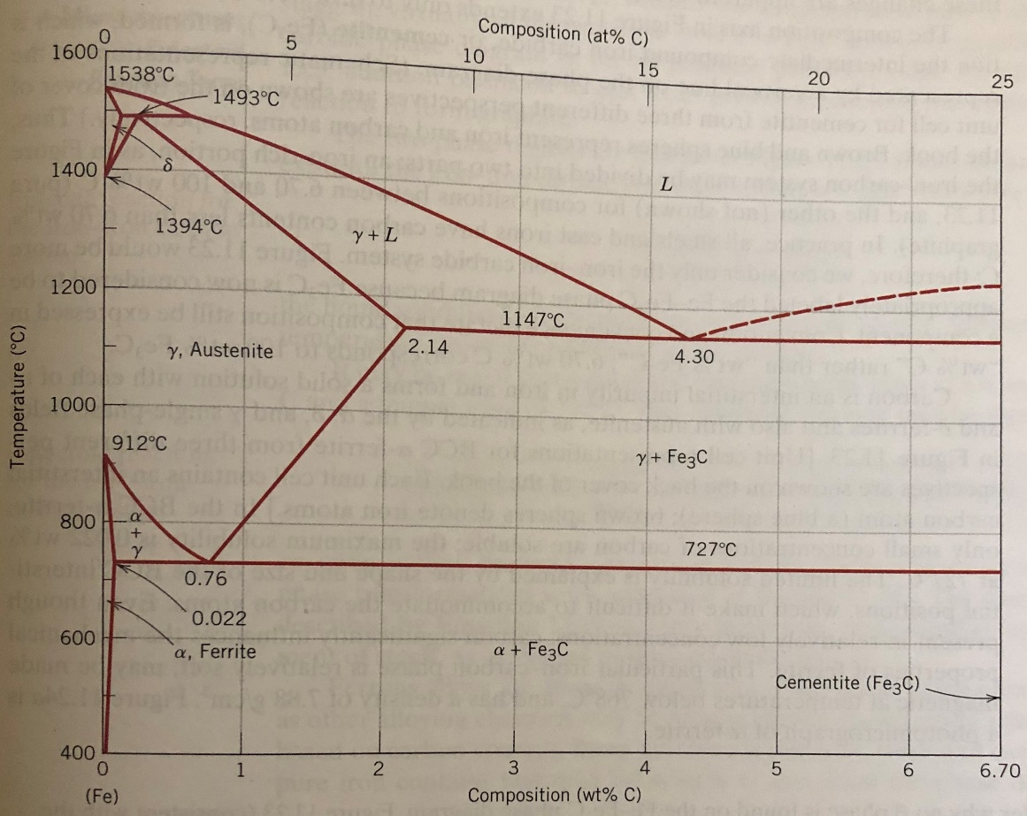

Figure 3: Iron-Carbon Phase Diagram (Callister JR & Rethwisch, 2014).
Steel alloys have a composition of carbon ranging from 0.008 and 2.14%, the microstructure that is formed depends on the carbon content and the heat treatment.
The maximum solubility of carbon in ferrite is 0.022% and exceeding this limit results in excess carbon forming a carbide phase, cementite, which is shown on the right hand-side of the iron-carbon phase diagram. Cementite is very hard and brittle though its presence can enhance the strength of some steels.
Within Tata, the steel produced is known as hypoeutectoid alloys as the composition of carbon ranges from 0.0011% to 0.067%, which is less than the eutectoid. The microstructure initially consists entirely of grains of austenite (gamma phase). As cooling persists the microstructure coexists as austenite and ferrite (alpha and gamma phase region).The ferrite phase changes with temperature becoming slightly richer in carbon along the phase boundary, with the ferrite grains growing larger. Below the eutectoid temperature, all the austenite grains that were present at higher temperatures transform to pearlite. A redistribution of carbon atoms occurs by the process of diffusion because the composition of austenite is different from that of ferrite and cementite, carbon atoms diffuse from the ferrite regions to the cementite regions as pearlite extends from the grain boundary to the unreacted austenite grain. Carbon atoms diffuse very little distance to form this structure which is why layered pearlite is formed. The microstructure of a hypoeutectoid alloy will consist of pearlite and ferrite if cooled under equilibrium conditions. It is possible to calculate the quantity of the phases formed in a two-phase alloy at equilibrium, according to the Lever Rule, at any given temperature using tie lines (Callister JR & Rethwisch, 2014).

Heat Treatment
Using heat treatment and controlling the cooling rates of the steel can alter the physical and mechanical properties of steel. Annealing is a form of heat treatment where the steel is heated to a specific temperature, held at the temperature, then cooled. Time is a crucial factor in respect to the annealing process, as it must be long enough to allow necessary transformations in the structure to occur and the rate at which cooling occurs has a great influence on the structure and properties of the steel (Callister JR & Rethwisch, 2014).
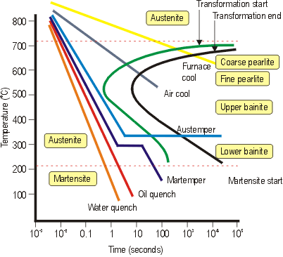

Figure 4: Continuous Cooling transformation diagram for steel (Robinson, n.d.).
The transformation temperature (Figure 4) during the transformation of austenite to pearlite can be altered to form different forms of pearlite.
When cooled quickly finer grains are formed, whereas at higher temperatures more coarse pearlite is located and the difference in the thickness of the lamellae (layers) is due to the difference of the diffusion rate of carbon. At higher temperatures, carbon can diffuse relatively long distances, resulting in the formation of thick lamellae, but as the temperature drops the carbon diffusion rate decreases and the layers become thinner. Coarse pearlite is more ductile than fine pearlite but fine pearlite is harder and stronger. (Callister JR & Rethwisch, 2014).
Rapid cooling forms Martensite. Excess carbon does not have time to diffuse out of the lattice structure and becomes trapped, distorting the lattice. The higher the carbon content, the easier martensitic structures can be formed as carbon decreases the critical cooling temperature. The martensite microstructure forms needle like grains which interlock with each-other resulting in a very hard and strong material but very brittle. By tempering martensitic steel the ductility and toughness may be enhanced making it suitable for applications. The process of hardenability allows the steel alloy to be hardened due to the formation of martensite (Callister JR & Rethwisch, 2014).
By cooling steel rapidly to form pearlite, then slowly to form martensite, a microstructure known as Bainite is formed. Bainite has a microstructure that contains very fine and parallel plates of ferrite that are separated by elongated particles of cementite. The nucleation of ferrite begins at the austenite grain boundaries, carbon diffuses from the lattice allowing the FCC structure to fully transform to BCC. As ferrite forms, austenite becomes richer in carbon and iron-carbide precipitates in the remaining austenite layers between ferrite. Bainite has a desirable combination of strength and ductility though not as strong as martensite (Dye, 2013).

Experimental Method
A tensile test provided information on the tensile strength (Rm), yield strength (Rp 0.2) and ductility (A80) of the test material (Mohammad, Jawaid; Mohamed, Thariq; Naheed, Saba, 2019).
The test pieces used were MS4 Spec, which is an ultra-low carbon steel consisting of 0.0011% carbon, a DC01 spec coil, which has a carbon content of 0.045%, HC380LA, which has a carbon content of 0.056%, and S355JRC, which has a carbon content of 0.166%. These four test pieces have slightly increased carbon content all in the low to mid carbon region.
The test pieces were cut to a standardised size of 38mm x 250mm, then machined using a CNC milling machine to achieve the ‘dog bone’ shape, before being tested on the Instron.
The test pieces were securely clamped at each end of the Instron and an increasing load was applied in a single linear direction. This pulled the test pieces apart until failure was achieved. From this, the amount of load applied and the amount of extension in the test piece was measured directly from the Instron and plotted on a stress/strain graph, with stress on the y axis and strain on the x axis.

Results
Table 1 shows the results obtained through the tensile test. There is a clear rise in both yield and tensile strength, followed by a decrease in the ductility with the rise of carbon.
Sample ID | C  % | Rp 0.2  MPa | Rm  MPa | A₈₀ %  Elongation
MS4 | 0.0011 | 142 | 283 | 46.5
DC01 | 0.0450 | 213 | 345 | 39.2
HC380LA | 0.0560 | 413 | 521 | 19
S355JRC | 0.1660 | 446 | 578 | 16.0

Table 1: Table of results displaying the ID, % Carbon, yield strength, tensile strength and elongation of each material.

The MS4 is produced at JLR specification and below is a table of the chemical composition;
Chemical Composition in Wt%
ID | C | Ni | Al | Ti | Nb | V | B
MS4 | 0.0011 | 0.0018 | 0.054 | 0.046 | 0.00 | 0.001 | 0.0030
Table 2: MS4 Chemistry Composition.
This steel type is known as ‘forming steel’ as it of low strength but very high ductility making it a suitable material for the application for domestic appliances such as drain pipes, electrical good and tubes (TataSteel, 2018).
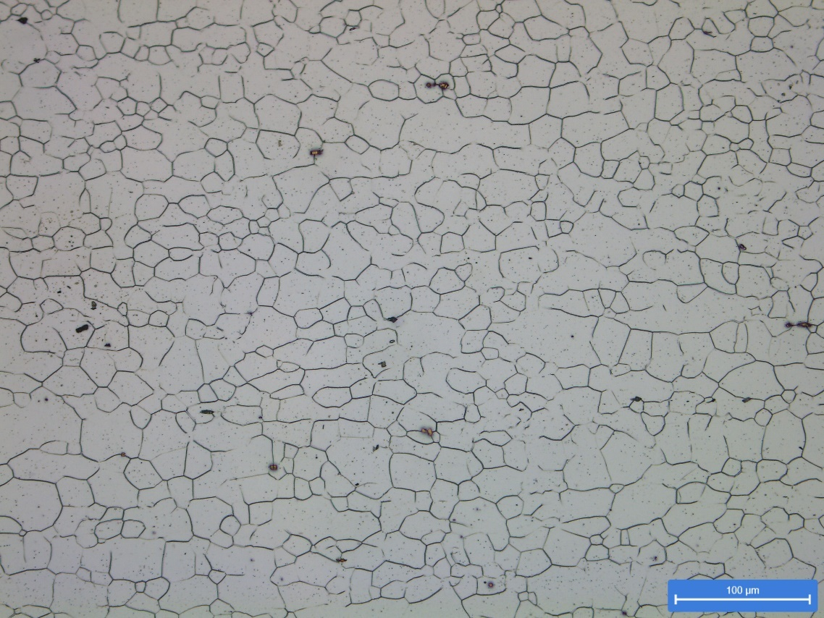

Figure 5: Optical Microscope image of MS4 material. X200 magnification.

It is an interstitial free grade steel meaning there are no interstitial solute atoms in the lattice. It is a ferritic steel which contains titanium-carbides which are the shown as the coloured cuboids in the microstructure. Titanium is added to the liquid iron in order to react with free soluble carbon and nitrogen to form stable carbides or nitrides. The formation of carbide prevents the atoms diffusing to dislocations and prevents the dislocations being pinned in place with the dislocation atmosphere (Pussegoda, 1978). The lack of interstitial atoms in the structure enables the steel to have a high ductility property, though have low strength relative to other steel grades.
The low carbon DC01 steel is a cold rolled, annealed steel which is used in applications such as radiators, domestic appliances and tubes (TataSteel, 2018). The table below shows the average cast chemistry.
Chemical Composition in Wt%
ID | C | N₂ | Al | Ti | Nb | V | B
DC01 | 0.0450 | 0.0028 | 0.028 | 0.001 | 0.001 | 0.001 | 0.0030
Table 3: Average cast chemistries for DC01 grade steel (Tata Steel, 2018).
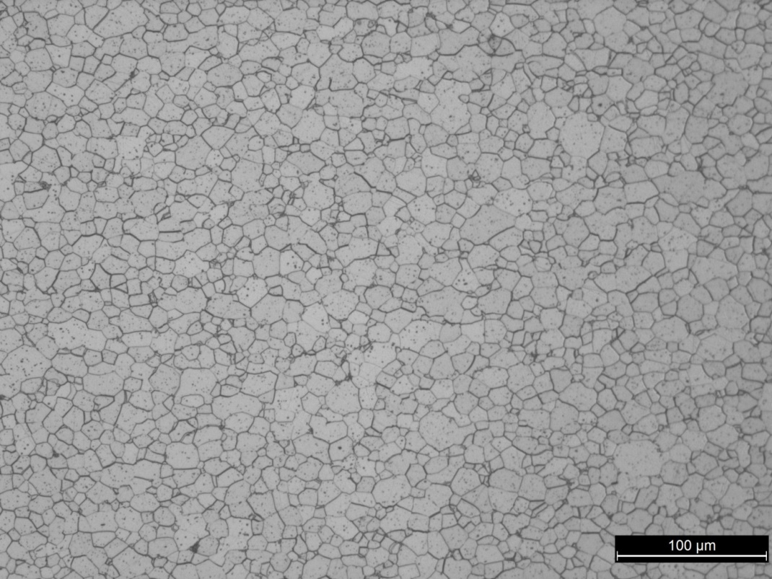
Figure 6 : Optical Microscope image of DC01 material. X200 Magnification
This steel grade has a ferritic crystal structure consisting of uniform sized grains with equiaxed shape. In order to achieve this microstructure the steel has been cold rolled which produces elongated and deformed grains making the steel stronger and harder. It has then been annealed to a specific temperature to allow recrystallization in order to regain ductility.

HC380LA is a cold rolled, continuously annealed product that is for high strength, low weight applications for automotive and construction (TataSteel, 2018). Table 4 shows the average cast chemistry for this material.
Chemical Composition in Wt%
ID | C | N₂ | Al | Ti | Nb | V | B
HC380 | 0.0560 | 0.0054 | 0.040 | 0.001 | 0.031 | 0.002 | 0.0002
Table 4: Average cast chemistries for HC380LA grade steel (Tata Steel, 2018).
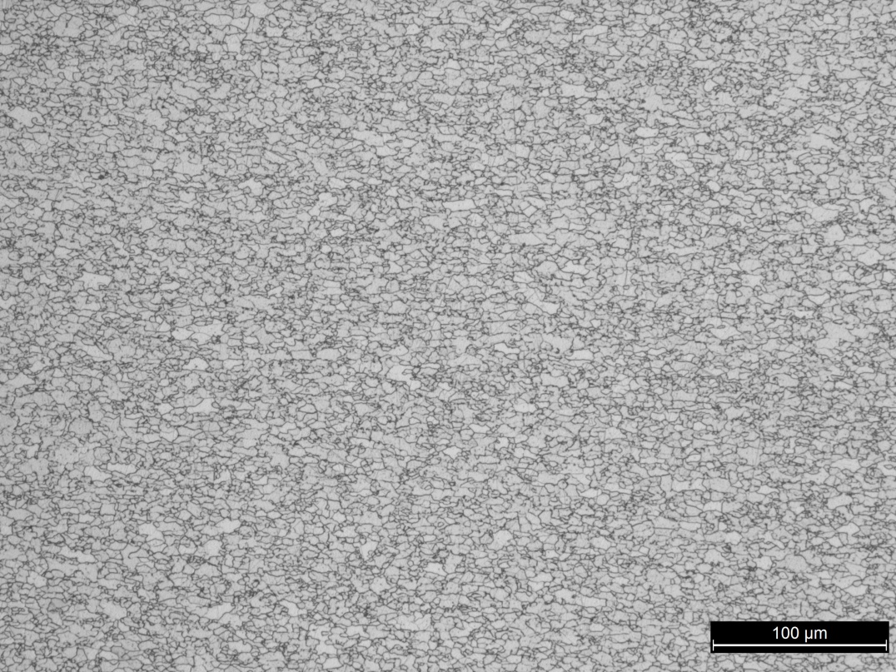
Figure 7: Optical Microscope image of HC380 material. X200 magnification.

The crystal structure of HC380 steel grade is also ferritic but has very fine grains when compared to that of DC01. This is achieved through a different annealing cycle of heating and cooling rates.
Finer grains are stronger and harder than coarse grains. As the grain size decreases, the yield strength increases which is predicted by the Hall-Petch relationship (Whang, 2011). The ductility of HC380 is lower than those of DC01 and MS4 which is explained by its fine microstructure, where there are more grain boundaries present for dislocations to move across causing them to entangle.
This particular steel grade does not require ductility as its used for structural panels for strength and rigidity.

S355JRC is a hot rolled structural steel material used in applications such as automotive wheel rims and chassis components, construction and building and heavy vehicle equipment due to its high strength and weldability properties (TataSteel, 2018).
Chemical Composition in Wt%
ID | C % | N₂ % | Al % | Ti % | Nb % | V % | B %
S355JRC | 0.166 | 0.0058 | 0.041 | 0.001 | 0.001 | 0.004 | 0.0002
Table 5: Average cast chemistries for S355JRC grade steel.
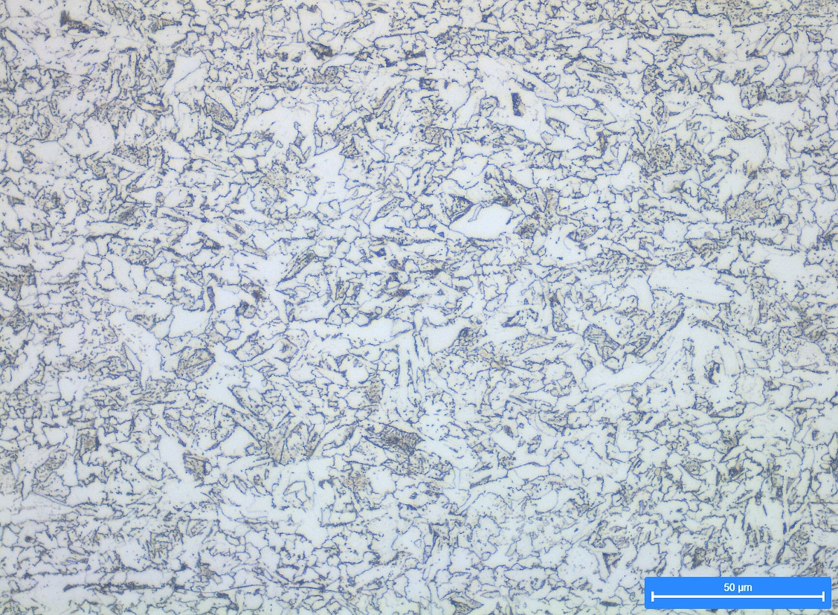

Figure 8:Optical Microscope image of S355JRC Material. X500 Magnification.
The microstructure of the S355JRC steel grade shows bainite and ferrite structures giving the property of high strength. The carbon content in this steel is higher than the others, as without a higher carbon content the bainitic structure cannot be formed.
The grain boundary of two different phases are obstructions to the movement of dislocations, which strengthens the steel (Callister JR & Rethwisch, 2014). Bainite consists of unlocked dislocations with a variety of obstacles to dislocation motion to obstruct plastic deformation (C. Garcia-Mateo; F.G Caballero, 2014) with more stress being required to move the dislocations, resulting in higher yield strength.

Conclusion
The tensile tests performed on the different steel grades of increasing carbon content demonstrated that as the carbon content increased, the strength and hardness increased with the loss of ductility.
The carbon content influenced the microstructure that was formed. Increasing the carbon content increased the amount of carbide formed which formed pearlite grains in the structure, which were harder than ferrite grains, however mechanical properties were gained through the processing of the steel. The increase in carbon allowed the steel to become more harden-able by heat treatment and cooling rates.
Therefore, an increased carbon content within the iron interstices directly correlated to increased strain fields in the interstitial sites resulting in less dislocations movement, thereby creating a stronger steel but of less ductility.

Works Cited
Afsar, J., 2014. Strss stain curve Explanation. [Online]
Available at: https://www.engineeringintro.com/mechanics-of-structures/stress-strain-curve-explanation/
[Accessed 27 04 2020].
Ashby, M. F. & Jones, D. R., 2013. Chapter 4 - Phase Diagrams 2 . In: Engineering Materials 2 (Fourth Edition). s.l.:Elsevier , pp. 63-87.
Bacon, D.J; Osetsky, Y.N; D.Rodney, 2009. Chapter 88 Dislocation-Obstacle Interactions at the Atomic Level. In: Dislocations in Solids. s.l.:Elsevier, pp. 1-90.
C. Garcia-Mateo; F.G Caballero, 2014. Advanced High Strength Bainitic Steels. In: Comprehensive Materials Processing. s.l.:Elsevier, pp. 165-190.
Callister JR, W. D. & Rethwisch, D. G., 2014. Material Science and Engineering. 9 ed. s.l.:Wiley.
Davis, J. R. ed., 2003. Metals Handbook; Desk Edition. 2nd ed. Ohio: ASM International.
Dutton, J. A., 2018. Materials In Todays World. [Online]
Available at: https://www.e-education.psu.edu/matse81/node/2133
[Accessed 23 04 2020].
Dye, D. D., 2013. Microstructure and Properties of Materials. [Online]
Available at: http://core.materials.ac.uk/repository/icl/104phases-notes-1314-c.pdf
[Accessed 23 04 2020].
Jankowski, P., n.d. Effect of Adding Carbon to Steel. [Online]
Available at: https://study.com/academy/lesson/effect-of-adding-carbon-to-steel.html
[Accessed 21 04 2020].
Jitendra Pratap Singh, S. V., 2017. Raw Materials for Terry Fabrics . In: Woven Terry Fabrics - Manufacturing and Quality Management . s.l.:Woodhead Publishing, pp. 19-28.
Lawrence S. Darken, Robert W. Gurry, 1953. Physical Chemistry of Metals. New York: McGraw-Hill Kogakusha.
Llewellyn, D. T. & Hudd, R. C., 2000. Steels: Metallurgy and Applications. 3rd ed. Oxford: Butterworth Heinemann.
Mohammad, Jawaid; Mohamed, Thariq; Naheed, Saba, 2019. An Overview of Mechanical And Physical Testing of composite Materials. In: Mechanical and Physical Testi ng of Biocomposites, Fibre-Reinforced Composites and Hybrid Composites. s.l.:Woodhead, pp. 1-12.
Mouritz, A. P., 2012. Strengthening of Metal Alloys. In: Introductio to Aerospace Materials . s.l.:Woodhead Publishing , pp. 57-90.
Pussegoda, L. N., 1978. Strain Age Embrittlement in Reinforcing Steels, Christchurch: University of Canterbury.
Reed-Hill, R. E., 1973. Physical Metallurgy Principles. 2nd ed. London: Van Nostrand Reinhold.
Robinson, E., n.d. Blacksmith tools. [Online]
Available at: https://www.azom.com/work/pAkmxBcSVBfns037Q0LN_files/image004.gif
[Accessed 23 04 2020].
Tata Steel, 2018. Cast Analysis. Port Talbot: Tata Steel.
TataSteel, 2018. Tata Steel Strip Products and Services Catalogue. [Online]
Available at: https://www.tatasteeleurope.com/static_files/Downloads/General%20Industry%20Strip/Strip%20Products/English/Tata%20Steel%20strip%20product%20range%20catalogue%202018.pdf
[Accessed 16 04 2020].
Whang, S., 2011. Nanostructured Metals and Alloys. s.l.:Woodhead Publishing .

