INTERNATIONAL MARKETING

APPLE COMPANY
ASSIGNMENT
LCMB 7006

LINA BIRMANTE
STUDENT NUMBER 2010698
Module Leader Tushara Balendran
21/08/2021

Abstract
This report is included with the discussion based on the company Apple that belongs to the two different counties USA and UK. In this study the discussion is based on the background of the company and the compare and contrast of this two countries market regarding Segmentation, targeting and positioning. On the other hand, it also deals with 7ps of marketing mix and the strategies of directional development that Apple Company used. It also relates with the effectiveness of this approaches and strategies of organizations also discussed. Apple keeps focus on several performance indicators such as behavioural metrics, memory metrics, physical ability metrics, marketing activity metrics, financial metrics, and customer profile metrics. It follows Golden Circle method of marketing.
Table of Contents
Introduction 4
Background of Company 4
Critically evaluate the differences and similarities across a wide range of variables 5
Segmentation, Targeting, and Positioning of Apple in the USA and UK 5
PESTLE Analysis 10
Hofstede’s cultural dimension model 11
SWOT Analysis 11
Porter’s five forces 12
7ps of marketing mix of Apple in the USA and UK 13
Directional Development of Apple in the USA 18
Directional Development of Apple in the UK 20
Marketing or Business performance measurements 21
Effect in the market of the United States of America 25
Effect in the market of the United Kingdom 26
Conclusion 27
References 28

Introduction
International Marketing is the concern that helps in boosting the reputation of the brand within international markets. The brand which works for soldering the services and products internationally is generally perceived better than the companies that are sold the products and services locally. Most of the customers are effectively purchasing the kind of products that are generally widely available. The international marketing approach works for the expansion of the business and also provides a competitive advantage to the entire business. This is also essential to provide bits of help in expanding the target market for the particular company or brand and also an important aspect that helps in connecting business with worldwide. In this report, this discussion is based on Apple Inc. company relationship with two different countries the USA and the UK regarding the comparison and contrast of the marketing strategies, and the differences and similarities across a wide range of variables related to organizational strategies and approaches.

Background of Company
Apple Inc. is a multinational company of technology-based in America or in the market of the USA, which specializes in computer software, consumer electronics, and effective online services. This is the world’s largest company regarding technology having an overall revenue of €274.5 billion in the year 2021 and became the most valuable company within the world (Apple.com, 2021). The company is based on retail, media, AI, financial technology, and other essential industry-based. This company is founded by Steve Jobs, Ronald Wayne, and Steve Wozniak in the year 1976 with about 512 retail locations (Apple.com, 2021). The company effectively runs the business worldwide and the products list of the company are Macintosh, iPhone, iPod, iPad, Apple TV, macOS, tvOS, Siri, and a variety of other products. The company is also related to some of the essential services like App Store, Apple Arcade, Apple Card, iCloud, Mac App Store, and others. The company is dealing with about 147,000 employees and also develops to spread the entire business in the market of UK also which provides growth and expansion worldwide (Apple.com, 2021). The company stays on top for many years as this company is dealing with providing the products with very generous margins.
The success of this company is lies within its strategic vision that mostly transcend the computing of simple desktops which included wearable and mobile devices. The design and performance both are the key practices of the Apple brand and for its effective on-going success worldwide effectively in USA and UK market.

Critically evaluate the differences and similarities across a wide range of variables
This part is involved with the discussion based on the Apple Company Regarding its products high and low involvement in the market of two different countries that are USA and UK. According to Bishop et al. (2018), this critical evaluation is a compare-contrast of the different marketing strategies in these two markets regarding STP, 7ps of the marketing mix and directional development for this company. It also deals with a wide range of variables relates to organizational approaches and strategies for discussing these essential factors in these two markets.

Segmentation, Targeting, and Positioning of Apple in the USA and UK
Apple Inc. Segmentation, Targeting, and Positioning generally represent the efforts of the marketing department within the company to gain a competitive advantage for developing the business worldwide. According to Gonchar et al. (2019), then the strategy of market matching or which is popularly known as segmentation, targeting, and positioning in short STP strategy is an effective evolved technique. This strategy is used by this company or generally other companies for choosing a specific market and also decided a specific targeted audience towards whom the company’s products are mainly sold. However, Akbar et al. (2017) stated that the market of the Apple Company is generally segmented within both markets of the USA and UK. STP is the concept that is related to marketing concern and it relates with the three most effective step model which works for examining the services and products for this Apple Company to connect with the target customers.
This company uses effectively the model or strategy of STP as it allows Apple to focus on the breaking of the base of the customers within smaller segments or groups and to developing the essential strategies of marketing. The company by utilizing the strategies based on segmentation, targeting, and positioning gets the advantage by reporting the march quarterly revenue that is recorded about $89.6 billion, which is up to 54% over the year in 2021(Apple.com, 2021).

STP | USA | UK
Segmentation | - This is the process related to driving or segmenting the customers or audiences within smaller segments or groups mainly based on a certain type of characteristics like gender, age, occupation, and also other preferences in the market of the USA. According to Al Amin and Islam (2017), for making this strategy useful for the marketing purpose within the Apple Company they work for being accessible, measurable, and actionable towards the segmentation of the essential audiences. The strategy regarding segmentation is generally formed on certain criteria that are divided into four types of segmentation of audiences; they are such as Demographic, Geographic, Behavioural, and Psychographic segmentation.  - On the other hand, based on the four characteristics in the market of the USA, Apple works for segmenting the audiences based on the location, age, earning, and lifecycle stage to sell the devices and services to the customers. Apple Inc. in the market of USA recorded the growth rate for revenue of about $111.4 billion that is up by 21% over the year 2021(Apple.com, 2021).  - The company in the market of USA to get more competitive advantage focus for the segmentation based on users status, social class and other areas which provides the company best understanding to set the strategies and development of the products. | - The segmentation of audiences in the market of UK, Apple Inc. works for focusing on the three characteristics of segmentation synch as Demographic, in this, the company specializes within men about the age group of 17-35, and generally, the average income that is about 3 million in monthly based and relates with the upper-middle class.  - On the other hand, Al-Fadly (2019) stated that based on the geographic segmentation, Apple company works for marketing of the products mainly globally as throughout the entire world.  - The psychographic segmentation used in the market of UK mainly focuses on men that are involved in the age group of 17-35; as they are generally like the sophisticated kind of gadgets for meet the determination and needs of the different classes. This provides the company advantages regarding the market share of the company in march 2021 provides the percentage of up to 51.15% in the market of UK(Statista.com, 2021).
Targeting | - Apple Company to determine the targeting or the target market in the USA generally considers the four essential segments that are teenagers, business people, Adults, and University and college students.  - As per the opinion of Mohammadi et al. (2018), compared to the market UK, the company is dealing well in this market regarding targeting the customers based on these four segments to sell the products regarding the user perception of the audiences. | - The company Apple is generally targeting each of its products within the market of UK and to the people who are generally concerned for design, style, and also the product’s simplicity.  - According to Zahid et al. (2020), almost all of the products of this company in the market of the UK having a user interface that is related to style in the appearance of the product but very easy to use for the people.
Positioning | - Apple Company positions as mostly a luxury brand regarding its products as different and exclusive products that are providing this company competitive advantage regarding its customers. As per the opinion of Doroshenko (2017), as per this in the market of USA, this company gives the essential impression that the products of this company are for the upper class as even the several cheapest product of this company.  - Apple provides an effective quality of sound that is way better if compared to the other products, as this helps in making the users very comfortable zone when generally listening to songs or playing music. In the market of the USA, this provides the company better advantage for increasing the sales and provides huge profit margin.  - The software and hardware maps application and the essential features regarding iOs provide the company better stability and sophistication to sell the products in the market of USA and to set the benchmark to extend the business worldwide, successfully. | - The company believes in the concern of continuous improvement that can provide the company advantage to set the benchmark regarding positioning in the market of UK also. However, for this, they are also focused on other sectors like safety and health management, environment, product quality, services, and processes.  - The company is working on providing the customer’s that kind of experience regarding its products which felt within the minds and hearts of the customers to purchase the things again and again.  - This company in the market UK is also, positioned as the brand that provides luxury items and also carries an effective loyalty and emotional connection with each of the customers.

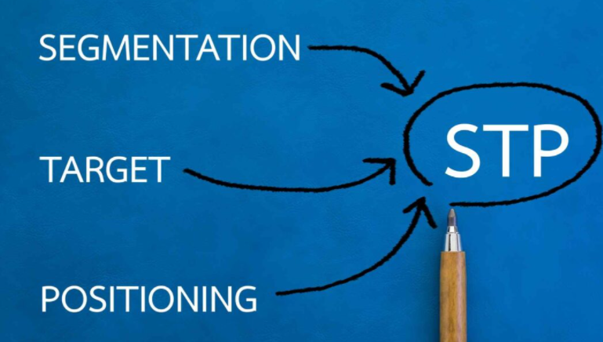
Figure 1: Segmentation, Targeting and Positioning of Apple
(Source: Doroshenko2017)

Analysis
The above discussion regarding Apple Inc. for the STP strategy associated with Segmentation, Targeting, and Positioning, the market of the USA pays more advantage to the company compared to the market of the UK. According to Gou et al. (2019), this is because this company generally belongs to the market of the USA and this provides an advantage to understand the target audience and the perception to provide the products regarding it.

PESTLE Analysis
Political
Factors | USA | UK
Political | USA works for promoting advocacy and democracy within the entire world which works for impact the development of electronic industry within this country. | UK is powerful centre regarding culture and finance and generated political uncertainties which are negative for providing advantage to Apple company to explore.
Economical | The GDP growth in this country is very high and increased by 4.0% and can provide Apple to gain high revenue (Bea.gov, 2021).  $68,310 is the GDP per capita of the US (Data.worldbank.org, 2021). | UK is the 6th largest of country regarding its nominal GDP growth increases by 1.43% from previous year 2020 (Statista.com, 2021).  $47,089 is the per capita income rate of the UK (Data.worldbank.org, 2021).
Social | The population of this country is very high which can works for increasing the sales.  99% is the literacy rate of the US (Data.worldbank.org, 2021). | The population in UK is multicultural and effective for business development.  The literacy rate of the UK is 99% (Data.worldbank.org, 2021).
Technological | USA is became leader regarding technology and science development.  Internet penetration rate of this country is 87.27% (Statista.com, 2021). | This technologically advanced company and provide the business new advantages.  Internet penetration rate of this country is 92.52% (Statista.com, 2021).
Legal | USA is having its own legal scheme and government structure. | UK is legal landscape and can fetch negative impact for business development.
Environmental | This country faces very extreme level of weather condition. | UK is having several of difficulties regarding weather but effectual for living and explore business.

Hofstede’s cultural dimension model
Power distance index (PDI)
In this dimension the power and equality perceives first as the organizational decision-making and hierarchy is essential to better do the business in USA and UK market.
Individualism vs. collectivism (IDV)
Privacy, time and challenging task are the main advantage for this company to grow the business within both the markets.
Uncertainty avoidance (UAI)
The motivational factors, egoism and money orientation concern is essential for Apple Company to effectively grow the market share. The overall population of these two nations are effective to develop long term strategies. The legal factors ensure the sustainability in the political situation. It helps to understand that business organisations can develop long term strategies for ensuring bigger profit.
Masculinity vs. femininity (MAS)
The effective decision-making and learning process and flexibility and risk-taking factors are present in this company very highly.
Long-term orientation vs. short-term orientation (LTO)
Virtues and obligations, right and values are the strong cultural dimension of this company to ensure business development within these two markets. The literacy rate of the UK and the USA is high as the percentage is 99%. The marketers of this organisation can provide a clear conception regarding the effectiveness of Apple products and it will be helpful to gain the loyalty of the target customers. The higher internet penetration rate ensures the application of social media marketing strategy as it is a cost saving approach for better efficiency.
Indulgence vs. restraint (IND)
Freedom to speech, optimism and personal happiness is essential to acquire talents and makes sure business development.

SWOT Analysis
Strengths
This company is having best of positive qualities and strategies regarding the development of business. According to Bruijl (2018), it is the company which works for leading the innovation of technology.
Weaknesses
Decreasing market share, high price of the products, patent infringements and the defect within products are some of the weaknesses of this company.
Opportunities
Launching of iTV, loyal employees, increasing within the market the several of services of communication can provide advantage for future development.
Threats
Rapid changes within technology, growth of android OS, competitors within the market of music and this pandemic situation decreases company’s sales.

Porter’s five forces
Competition in the Industry
The very high aggressiveness of the other firms and the very low differentiation of company’s products increase the strong force of competitors.
Potential of new entrants within the industry
This force power is moderate as the very high cost regarding the development of brand and the capacity of the new entrants in this industry is high.
Power of suppliers
This is nearly very weak for Apple Company as very high availability of the suppliers are present related with same industry.
Power of customers
The power of customers buying power is strong because of information of high buyer and low cost of switching.
Threat of substitute products
The products of this company is associate with high functionality and technology which works for weaken the threat of other products.
Product brand ding strategies of Apple
The apple company works for effectively use the branding strategies to promote the products in the market and also helps in developing the business. They are working on rethinking about the requirement of advertising before adverting about any product. On the other hand, the other strategies like avoid the several of wars of price keeping the approaches of marketing and products very simple.
Market Entry Methods
Licensing
This method of market entry allows Apple to effectively target the country like USA and UK by using the property. As per the opinion of Gou et al. (2019), the property are like trademarks, patents and production techniques which are needed to explore the business in new countries. This is also important as this requires very small investment and provides huge return.

Ansoff’s Matrix-
Product Development
The apple company ensures the core growth by the new product’s development on a regular basis and this has delivered positive outcomes for the company.
Market penetration
Apple Company engages with the strategy of market penetration by the effective kind of application of several marketing strategies.
Market Development
This company appeals for multinational technologies to local sentiment and culture as when ensure the development of several marketing strategies for entering within new markets.
Diversification
Diversification is involved in the new products development of Apple but also not attempting the diversification by the maker of iPhone that have provided very successful in the market.
Product Life cycle model
Apple Company has several of products that are having or associated with different stages related with the product life cycle. The company is recently introducing the amazing iPhone having new colour of red, and related with the introduction stage, sand this stage is generally characterized by slow growth and few sales. On the other hand, the company doesn’t requires to teach the customers about products as they are already gain the effective knowledge about products. The other iPhones are in maturity stage, and some of them are in decline stage and requires diversity.

7ps of marketing mix of Apple in the USA and UK
7ps of the marketing mix | USA | UK
Product | The products of Apple are divided into some the categories such as iPhone, Mac, iPad, Accessories and Home products, Wearable products. On the other hand, it also consists of the service categories such as AppleCare, Advertising, Cloud Services, Digital Content, and the payment services works for providing the company competitive advantage. As per the opinion of Busatto et al.(2018), the company’s products are best known for their high quality and durability, and also Apple works for upgrading the products within the periodical manner in the market USA. The products of this company are integrated with the most innovative kind of features and abilities and also come up within various colours and sizes which are attracted towards its users. | In the UK market, Apple is dealing with the development of products regarding the perception of customers to provide the services of the operating system and products. The effective products and services of this company are iPhone, iPod, iPad, iMac, Apple TV, Mac OS X, Watch OS, I Movie, Facetime, and others that provide the company advantage regarding increasing its sales and profit margin.
Price | The Apple company’s integrating pricing strategy is based on premium pricing, price skimming, geographical production, MAP (minimum advertising price. As per the opinion of Gonchar et al.(2019), the highest price, skimming strategy is setting the high price for new products, differing prices in the variance of places, and the MAP strategy does not allow their dealers and resellers to sell or advertising the products below a settled certain price.  This works for providing the company competitive advantage based on the market of USA. | The base rule of this company regarding its prices in the market of the UK differentiates the capacity of the entire storage regarding higher or high prices. On the other hand, the logic regarding the pricing strategy within the Apple company helps in running the overall course regarding the products successfully.
Place | The element regarding the Apple company’s marketing within the market of USA is associated with online stores, Apple stores, the third party carriers related with cellular networks, the force of direct sales. On the other hand, the wholesalers, retailers, and also the resellers who are value-added works for the delivery of the customized, and also solution regarding market-specific towards the customers. | As per the opinion of Al Amin and Islam (2017), in the market UK, the company usually deals with the place regarding the delivery of the products to the customers is Online platform, Apple exclusive stores as in which they are selling the products on its own to show or display the power of this brand.
Promotion | The promotional activities used by the Apple company helps in emphasizing its product’s quality and premium image in the market USA. According to Mohammadi et al. (2018), then the company uses Advertising, personal selling, public relations, and sales promotion to attract more customers and also uses the social media platform to connect with more customers in a very short time. This helps the company to increase its sales by about $90 billion regarding the buying surge in this pandemic situation in the year 2021(Theguardian.com, 2021). | The company in the market of UK is known for its elegant and smart promotion activities. According to Al-Fadly (2019), the major focus of this brand within its products to differentiate them from the customers by adopting the promotion strategies in advertising, using social media platforms, personal selling, sales promotion, and public relations for attracting customers.
People | The company within the market of USA for promoting its vision-related through by its important employees. The company mostly deals with a huge number of teams that are having a piece of perfect knowledge about the features or technology of the products to serve the customers. | The plan of protection regarding Apple care helps in extending the services towards the customers and also the company appoints Apple experts to works for managing the customers regarding the purchasing of products online and from the Apple stores.
Physical Evidence | The apple company massage for generating or creating its own effective culture and brand image regarding the features of technology and innovation to attract more customers and gain customer’s trust. | However, Zahid et al. (2020) stated that the company is successful in having the attractive logo and names of the products as they are not saying smartphones, its name is regarding iPhone which is attractive for the customers and works for increasing the customer’s loyalty level.
Process | The company’s effective activities are always related to match up with the trends and conditions of the market. As per the opinion of Doroshenko (2017), the company provides high importance regarding every aspect for the experiences of the customers and development of the business by managing the process. They are associated with providing standardized services, involvement of customers, and booking and delivery of the products within time. | The company provides both in online and stores the deliveries of the products are available. The company in recent years works for expanding the channels of distribution by managing the supply chain-related with providing the customer’s priority by taking the booking and paying off, they are delivering the products on time.

Figure 2: 7ps Marketing mix of Apple Inc.
(Source: Zahid et al. 2020)

Analysis
The above discussion is based on the Apple Company regarding its marketing mix of 7ps in both the countries USA and UK, the company based on the data shows that the marking mix provides a better advantage in the USA market for the development of business. According to Gou et al. (2019), the strategies and elements of Apple are better workings within the USA market by effective implementation of them.

Directional Development of Apple in the USA
The company Apple is a multinational company of America that works for its directional development and embarked on increasing the business by expanding the operations. According to Busatto et al. (2018), the company also implements several strategies regarding the development of products to manage the directional development efficiently.
Decisive investments
The company is becoming lucrative for the investment that helps in contemplates and scrutinizes its directional development and growth. The company works for formulating all the cons and pros before making any kind of big investments by improving its services and products regarding upgrading the technology within the existing products of it. According to Gonchar et al.(2019), in the market or country USA, the company focus on making heavy investments for the development and research of the products to catch the attraction of the customers and get a competitive advantage.
Growing inorganically by acquisitions and mergers
The company also works for acquisitions and mergers that are mostly made in view regarding the augment the overall offerings and performance-related with the target market. In the market of the USA broadening the entire market and acquire new technologies works for Apple to boost up the scalability and for investing more in on board intelligence to ensure directional development (Al Amin and Islam 2017). They also work for offering the technologies that are specialized in techniques of machine learning and recognition that ensure the company’s growth in this market.

Figure 3: Directional Development of Apple in the USA
(Source: Al Amin and Islam 2017)
Leveraging the technology for the development of products
The company also uses disruptive technology for the development of the products by launching the services of fitness, the machine learning that second-generation n is effective for the company to ensure the directional development. On the other hand, Mohammadi et al. (2018) stated that the new kind of entry-level product such as iPad works for offering 40% of boosting GPU and also explores the top-selling laptop of windows to penetrate the overall market of USA.
Geographic Expansion
The geographic expansion of Apple is generally included with sales within several continents, where the company can easily foster huge gains. According to Al-Fadly (2019), the company works for expanding the business in several of cloth tries like Greater China, Japan, Europe, the region of Asia pacific for the directional development. In the year 2020 April, Apple announced the expansion of the largest geographic extension ever. This helps the company to expand and penetrate more market share in the country USA regarding the expansion of Apple stores. This provides the company profit margin in the year 2021 of $23.6 billion more than $11.3 billion based on the same period within the last(Bbc.com, 2021).

Directional Development of Apple in the UK
Differentiation of Products
The Apple Company based in the country UK works for differentiating the products from the other companies to ensure for gaining competitive advantage. As per the opinion of Zahid et al. (2020), the unique designs, style, colours, structure, functions are helping the products to attract customers and also increase the purchase number of customers to provide the company directional development. On the other hand, the products are different from the other company’s products regarding their technological innovation and features which providence the customers a comfort zone to buy the products again and again.
Development of Product
The company also related with the development of the products based on periodical manner that provides the other advantage like huge market penetration and market share. According to Doroshenko (2017), the development of the products through innovation like changing the models of the existing products, include new features and technologies within the products works for ensuring the company’s directional development and emphasizes the sales and profit margin. The company also works for the development of the products regarding the perception of the users by the careful study related with further and initiated researches to properly understand the requirements and needs of the customers and make changes according to it.
Expansion in sustainability and services
The company is expanding its essential services buy including the stores of digital content, iCloud, streaming services, and Apple cloud in recent time to get more market share and sales. As per the opinion of Gou et al. (2019), the company is launching other services like Apple News, Apple TV, Apple Arcade, and Apple card to make a huge profit margin. On the other hand, they are also working for making the recycling robot that dissects and breaks down an iPhone. Liam also designed the reusable kind of parts as much as possible and also stored them to snake new manufacturing by them.
Thus, based on the overall discussion regarding the uses of specific strategies and approaches like STP, 7ps marketing mix and directional development strategy, this helps Apple company to understand the effectiveness of it to ensure development. According to Busatto et al.(2018), the segmentation, Targeting, and position of the company regarding both countries effectively ensure business development worldwide. It provides the company advantage to set the benchmark by choosing the right market regarding segmentation of it to the selling of the products in an efficient manner. Though in the USA the company is building up more segmentation, targeting market and positioning provides better advantages as this helps in increasing the company’s growth and revenue over the year.
However, Goncharet al. (2019) stated that the 7ps of marketing mix regarding the development and management of the essential elements provide the company more competitive advantage. But the company must also work for the elements of the process, people, and price to ensure more market penetration and profit margin. The discussion on the directional development of Apple based on both the countries also helps to understand the strategies which this adapts for expansion and development to ensure growth worldwide.

Marketing or Business performance measurements
Apple keeps its focus on its marketing strategies in the market of the United States of America and the United Kingdom by timely evaluation of its marketing. Marketing evaluation can be identified as several measures that help executives of an organisation to interpret, compare, and qualify performances of their organisation in the market. Assessing performances in the market requires marketing metrics (Shah, 2020). Apple uses a marketing matrix to assess its performances in markets of the United States of America and the United Kingdom.

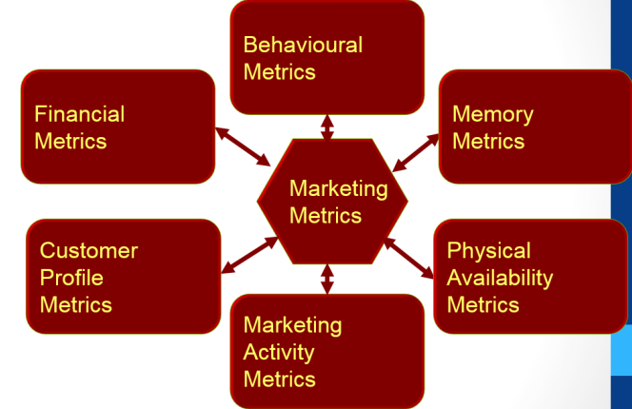
Figure 1: Key performance indicators
(Source: Shah, 2020)
Various methods are used by organisations to understand and evaluate key performance indicators (KPI) or metrics. All these are measured using behavioural metrics, memory metrics, physical ability metrics, marketing activity metrics, financial metrics, and customer profile metrics. Apple came out with a vehicle that accelerated its innovation, inventiveness, and intelligence helping its potential and target customers to get more attracted to its products. The communicative process of Apple is different from its competitors in the market (Kocienda, 2018). The organisation is clear about what they do or why they do so. Apple makes sure that people and the greatest minds within their organisation make the most of communication skills to convey their message to others; this process is known as the “Golden Circle”.
Studies show that all the organisations have knowledge about what they do. Very few have ideas about the way they do it. Rest very few of the organisations have an idea of the reason oh what they do. Apple falls under the section of very few organisations. There are various methods of marketing used by several companies for their business. Apple uses the new method of marketing that is the Golden Circle method of marketing (Straker and Nusem, 2019). This method includes three steps such as; employees of Apple have a clear idea that Apple challenges status by thinking differently from its competitors. Second, Apple comes up in the market with products that are user-friendly and beautifully designed. Third, Apple comes up with great electronic gadgets such as Apple watches, iPad, iPhones, and Apple Macbook. This process of marketing helps Apple to establish a central message for its users in markets of the United States of America and the United Kingdom.

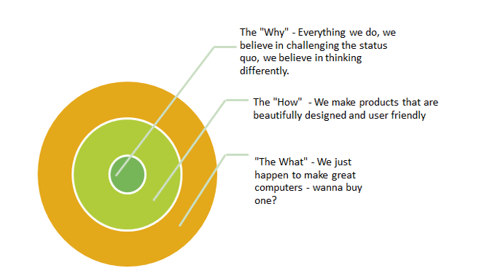
Figure 2: The Golden Circle
(Source: Kocienda 2018)
Being unique and innovative does not guarantee success every time. Apple thus follows the path of enchanting the technological visionaries and enthusiasts who can perform well as a carrier of the Apple banner in the global market. Apple focuses on every personal space that includes personalised impressions on the iPhone to provide iPads to elementary schools. The organisation has adequate reach to cross several points tripping the combination of Early Majorities and Early Adopters in the market. According to the studies of Sorri (2017), one can think of several innovative products that have failed to generate Early Majorities. The idea of Apple tends to flow from early adopters to customers.

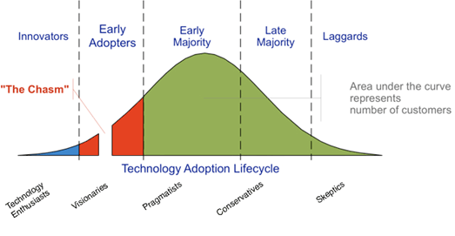
Figure 3: Adaptation circle of technologies
(Source: Sorri 2017)
Apple understands the needs of their customers and simultaneously comes with innovation in their products. Steve Jobs comes with a distinctive insight into the way people want to deal with technology. Apple spends most of its time observing the experiences of its potential and target customers on using their product and product of other organisations simultaneously. Apple put their customer experiences in design to understand the threats and opportunities faced by customers (Straker and Nusem, 2019). The organisation understands customer needs in an intuitive and streamlined way of product performances so they came up with a digital and entertainment hub for their customers. This initiative helped Apple to build compatibility with its customers.
The retail presence of Apple helped customers to gain an experience of aesthetic and easy use of Apple products. Stores helped customers to experience greater solutions than continuous product offers (Msaed et al. 2017). In an interview, Ron Johnson, former Apple store head said that stores are short, fun and it is something people want to talk about (Forbes.com, 2017). According to a case study, there are few things that made Apple so enormous in the global market. In 2007, Apple came up with the iPhone that created a revolution in the mobile phone market. 2007 witnessed a sale of 1.4 million iPhones in competition to Nokia and Blackberry (Bbc.com, 2021). In 2021, 41.3 million iPhones and about 56% of the revenue of Apple comes from selling iPhones (Bbc.com, 2021).
The services provided by Apple and its brand loyalty have a huge impact on its sales revenues. The services of Apple include Apple music or Apple iTunes, Apple Pay, the Apple Store, and iCloud (Soniya and Mohanraj, 2018). These make up the business of Apple by financially pushing the organisation to make up revenue that is fast growing. In 2021, market value of Apple hit 1.4 trillion and with a growth in revenue of 31% (Bbc.com, 2021). All these services provided by Apple helped in preserving brand loyalty for customers providing satisfaction. In the United States of America, the brand value of Apple to Coca-Cola is $57.3 billion (Bbc.com, 2021).
Therefore, it can be said that Apple keeps its focus on the major performing indicators such as behavioural metrics, memory metrics, physical ability metrics, marketing activity metrics, financial metrics, and customer profile metrics. There are several methods of marketing used by Apple for maintaining their value and place in the market such as the Golden Circle method of marketing. This method helps the organisation to answer several questions like Why, How, and What. Other than that, Apple put customer experiences to understand customer’s needs and experiences and come up with innovation accordingly. Retail stores helped customers to experience aesthetic and easy use of Apple products. Apple captured the electronic market in the 1990s with the introduction of the iMac. They launched iMac with bright colours rather than boring white or grey. This attracted several customers towards Apple and now they are dominating the market with 1.6 trillion values.

Effect in the market of the United States of America
The introduction of Apple in the markets of the United States of America helped in the employment of 2,000,000 across 50 states. There is a widespread number of job roles in the Apple organisation such as software and hardware engineers, retail, scientist, manufacturing, designer, construction, and customer support (Msaed et al. 2017). The percentage of Apple product users is increasing daily in the United States of America. In 2016 the percentage was 43.5 that were increased to 45.2 in 2019 (Statista.com, 2021). At present time there are 113 million iPhone users in the United States of America whereas 300 million people use smartphones.

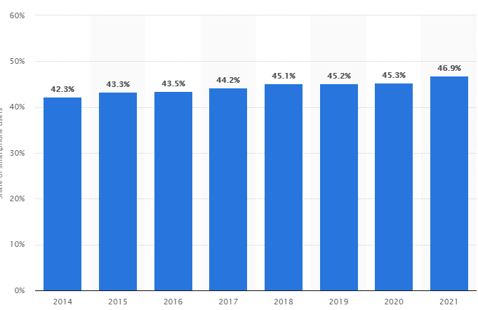
Figure 4: iPhone users in the united State of America
(Source: Statista.com, 2021)

Effect in the market of the United Kingdom
In the market of the United Kingdom, Apple has supported the economy by providing jobs to 1.7 million people. Apple has 4300 suppliers in Europe and developers of Apple in Europe earn nearly 20 billion Euros in sales of Apple stores globally (Apple.com, 2021). In 2020, 49.98% share of the mobile operating system market belonged to Apple iOS in the United Kingdom (Statista.com, 2021).
Apple targeted the customers like students, managers, professionals, and executives. Other than that 64% of Apple users are with a degree in College. In 2020, Apple held the top position in mobile devices in the United Kingdom. In 2019, the Apple watch was sold enormously in the market of the United Kingdom gaining an estimation of 14.3 million smartwatch sales. The market share of Apple in the United Kingdom can be estimated at 36.3% per year (Statista.com, 2021).

Conclusion
Therefore, it can be justified that the report focuses on understanding the market of Apple in the United States of America and the United Kingdom. In the case of market segmentation, Apple follows the concept of STP. It allows Apple to focus on the breaking of the base of the customers within smaller segments or groups and to develop the essential strategies of marketing. In the USA, Apple targets teenagers, business people, Adults, and University and college students. In the UK, Apple targets people concerned about design, style, and simplicity. In the USA Apple is positioned as the most luxurious brand whereas, in the UK, Apple is setting a benchmark regarding its positioning.
The marketing mixes of 7Ps help Apple to expand and increase its business in the USA. Other than that, Apple focuses on decisive investment, growth through acquisition and mergers, leveraging technologies, and expanding geographically in the market of the USA. Directional development also helped Apple to spread its business in the market of the USA. Apple keeps its focus on the major performing indicators with the help of Golden Circle marketing methods. The primary focus of Apple is its customers and their experiences thus they came up with Apple stores. Apple provided numerous jobs to the population of the USA and UK by contributing directly to their economies.

References
Akbar, F., Omar, A., Wadood, F. and Wan Yusoff, W.Z.B., (2017). Niche marketing strategy framework for SMEs: A conceptual framework. Available at SSRN 2999227.
Al Amin, M. and Islam, M., (2017). Factors leading to Market Segmentation of fashion house business based on customer behavior: Evidence from Bangladeshi Fashion Industry. International Journal of Business and Technopreneurship, 7(3), pp.251-272.
Al-Fadly, A., (2019).Investigating the Effect of Construction Companies’ Marketing Mix on the Experience of Customers in the Gulf Region.
Apple.com ., (2021) Apple job creation. https://www.apple.com/uk/job-creation/
Apple.com, (2021), Apple Reports First Quarter Results. Available at https://www.apple.com/in/newsroom/2021/01/apple-reports-first-quarter-results/ [Accessed on 11th July 2021]
Apple.com, (2021), Apple Reports Second Quarter Results. Available at https://www.apple.com/in/newsroom/2021/04/apple-reports-second-quarter-results/#:~:text=Cupertino%2C%20California%20April%2028%2C%202021,per%20diluted%20share%20of%20%241.40. [Accessed on 12th July 2021]
Apple.com, (2021), The Power of Apple. Available at https://www.apple.com/business/ [Accessed on 12th July 2021]
Bbc.com, (2021), Surge in iPhone sales sees Apple's profits double. Available at https://www.bbc.com/news/business-56920146 [Accessed on 13th July 2021]
Bbc.com., (2021). Five big things that have made apple. https://www.bbc.com/news/business-45044963
Bea.gov, (2021), Gross Domestic Product, 4th Quarter and Year 2020 (Advance Estimate). Available at https://www.bea.gov/news/2021/gross-domestic-product-4th-quarter-and-year-2020-advance-estimate [Accessed on 10th August 2021]
Bishop, C., Turner, A. and Read, P., (2018). Effects of inter-limb asymmetries on physical and sports performance: a systematic review. Journal of sports sciences, 36(10), pp.1135-1144.
Bruijl, G.H.T., (2018). The relevance of Porter's five forces in today's innovative and changing business environment. Available at SSRN 3192207.
Busatto, N., Farneti, B., Commisso, M., Bianconi, M., Iadarola, B., Zago, E., Ruperti, B., Spinelli, F., Zanella, A., Velasco, R. and Ferrarini, A., (2018). Apple fruit superficial scald resistance mediated by ethylene inhibition is associated with diverse metabolic processes. The Plant Journal, 93(2), pp.270-285.
Data.worldbank.org, (2021). GDP per capita. Available at: https://data.worldbank.org/indicator/NY.GDP.PCAP.CD?locations=GB [Accessed on 18.08.2021]
Data.worldbank.org, (2021). GDP per capita. Available at: https://data.worldbank.org/indicator/NY.GDP.PCAP.CD?locations=US [Accessed on 18.08.2021]
Data.worldbank.org, (2021). Literacy rate. Available at: https://data.worldbank.org/indicator/SE.ADT.LITR.ZS?locations=GB [Accessed on 18.08.2021]
Data.worldbank.org, (2021). Literacy rate. Available at: https://data.worldbank.org/indicator/SE.ADT.LITR.ZS [Accessed on 18.08.2021]
Doroshenko, T.N., (2017). Management capabilities of generative development of apple trees.International Journal of Green Pharmacy (IJGP), 11(03).
Forbes.com., (2017) Why Apple is a great marketer. https://www.forbes.com/sites/christinemoorman/2017/07/10/why-apple-is-a-great-marketer/?sh=69709bcc297d
Gonchar, V., Gorokhova, T. and Ponomarenko, A., (2019). Segmentation and positioning in the marketing practice of the company.
Gou, X., Zhang, W., Zhang, J., Zhang, J. and Zhang, J., (2019), April. Study on the Structure Design and Feasibility Analysis of Apple Inhaled Box Bags Based On Hailproof. In IOP Conference Series: Earth and Environmental Science (Vol. 252, No. 5, p. 052059). IOP Publishing.
https://www.theguardian.com/technology/2021/apr/28/apple-quarterly-earnings-covid-sales [Accessed on 9th July 2021]
Kocienda, K., (2018). Creative Selection: Inside Apple's Design Process During the Golden Age of Steve Jobs. Pan Macmillan.
Mohammadi, H., Saghaian, S. and Alizadeh, P., (2018). Prioritization of expanded marketing mix in different stages of the product life cycle: The case of food industry.
Msaed, C., Al-Kwifi, S.O. and Ahmed, Z.U., (2017). Building a comprehensive model to investigate factors behind switching intention of high-technology products. Journal of Product & Brand Management.
Shah, H., (2020). An exploratory study into organisation and innovation decline in successful companies: the case of Apple Inc (Doctoral dissertation, University of Groningen. Faculty of Economics and Business).
Soniya, D.K. and Mohanraj, M.G., (2018). A Study on Factors Affecting Brand Trust Apple I Phone. International Journal of Trend in Scientific Research and Development, 2(6), pp.1476-1486.
Sorri, K., (2017). Establishing a platform ecosystem: Case study on early adopters (Master's thesis).
Statista.com , (2021), United Kingdom: Real gross domestic product (GDP) growth rate from 2016 to 2026. Available at https://www.statista.com/statistics/263613/gross-domestic-product-gdp-growth-rate-in-the-united-kingdom/ [Accessed on 12th August 2021]
Statista.com, (2021) UK internet penetration: percentage of population using the internet in the United Kingdom from 2000 to 2020. Available at: https://www.statista.com/statistics/468663/uk-internet-penetration/ [Accessed on 18.08.2021]
Statista.com, (2021), Market share of Apple iOS in the United Kingdom (UK) from December 2011 to March 2021. Available at https://www.statista.com/statistics/271195/apple-ios-market-share-in-the-united-kingdom-uk/ [Accessed on 10th July 2021]
Statista.com, (2021). Percentage of population using the internet in the United States from 2000 to 2019. Available at: https://www.statista.com/statistics/209117/us-internet-penetration/ [Accessed on 18.08.2021]
Statista.com., (2021) Percentage of US population using smartphones. https://www.statista.com/statistics/236550/percentage-of-us-population-that-own-a-iphone-smartphone/
Statista.com., (2021). Apple iOs market share in UK. https://www.statista.com/statistics/271195/apple-ios-market-share-in-the-united-kingdom-uk/
Straker, K. and Nusem, E., (2019). Designing value propositions: An exploration and extension of Sinek’s ‘Golden Circle’model. Journal of Design, Business & Society, 5(1), pp.59-76.
Theguardian.com, (2021), Apple sales rise to $90bn amid Covid buying surge.Available at
Zahid, A., He, L., Zeng, L., Choi, D., Schupp, J. and Heinemann, P., (2020).Development of a robotic end-effector for apple tree pruning.Transactions of the ASABE, 63(4), pp.847-856.

