I have found the carousel of ‘Practice in Context’ particularly helpful – I have especially enjoyed those where lecturers have spoken about artists and thinkers that relate to what I’m mainly interested in. An example would be theorist Rosalind Krauss who writes about a sculptor in whom I’m particularly interested; Auguste Rodin. I recently attended an in-conversation at the RA with artist Phyllida Barlow, the contrast between Barlow and Rodin fascinates me. These two sculptors and the materials they’ve both used has made me question what is really classed as ‘sculpture’? Rodin was considered to have transformed sculpture into something that we call modern – but 102 years after his death, what we consider ‘sculpture’ is constantly evolving.

- Tactility

“[…] Making art from life is evolving as technology opens up new ways of creating and visualising artwork.” (Jonathan Yeo) Sculpture is mainly associated with materials such as clay, bronze and plaster which is known for its tactility. The responsiveness of clay whilst being worked on is given very little recognition – much more priority is given to the visual sense, or the outcome of a sculptural piece. Perceptual psychologist Rudolf Arnheim writes: "Seeing may [...] become an inhibitory factor when forced upon an individual who does not use his visual experiences for creative work." (Arnheim, 1969) Johnathan Yeo is an artist interested in self-portraits in history and has recently collaborated with Google to create a sculpture of himself using a software called Tilt Brush – this software allowed him to create the same gestural brushstrokes and marks that he would make in an expressive painting in a three-dimensional space and effectively create a painted sculpture. While Yeo enjoyed working with the technology, he struggled with some aspects and says: “I wasn’t looking at anything, I was cut off from reality, I couldn’t even see my own hands. The other problem was that even when I made something I liked, there was no way of exporting it – the software wasn’t designed to actually replicate something in the real world […] I was left perplexed about what to do with this technology.” (From Virtual to Reality with Jonathan Yeo, 2017)
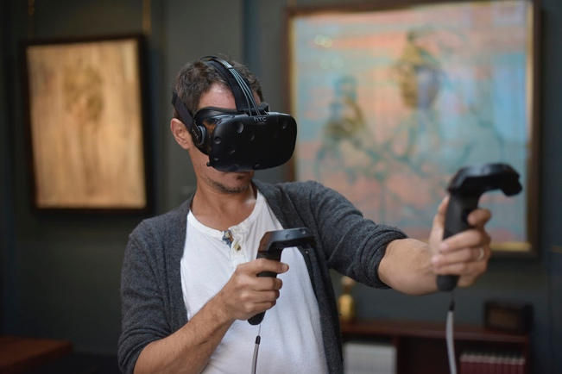

Yeo working on his sculpture via Google’s software, Tilt Brush. (Jonathan Yeo, 2017)

Whilst going through the process of creating a piece in clay, an artist is able to express what he or she feels – the artist is able to use sight but also touch. The observer is limited to just the visual sense while viewing a sculpture. Sculptor Auguste Rodin had the ability to stimulate these tactile sensations which only makes the act of observing his work feel far more complete. The evidence of touch in Rodin’s work is evident in many of his sculptures, including The Burghers of Calais. The amount of thought and time gone in to each of the six figures is apparent and the movement of Rodin’s fingers as he smeared, scooped and squashed the clay, adding extra lumps of clay where needed is clearly visible to the viewer and it is this personal touch that makes his sculptures so powerfully expressive to the modern eye – something that Yeo simply cannot achieve. In his book “The Language of Sculpture” William Tucker tries to show how a number of sculptors worked and the language that sculpture uses, he writes: “[…] it remains a surface, a skin. In Rodin, one senses the identity of external event with internal force: clay is felt as substance, not over the surface, but through ever cubic inch of volume” (Tucker, 1974)

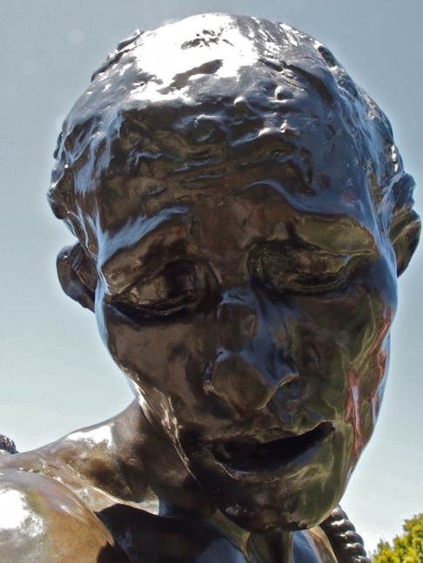

Auguste Rodin, The Burghers of Calais (Close up) 1889

This poses the question of whether this technology is something that artists would truly find valuable. Does Tilt Brush deserve an artist’s consideration? A lump of clay comes from the earth, something so simple can be transformed into something so complex - can something created with the aid of virtual reality be classed as a ‘sculpture?’ Art theorist and critic Rosalind Krauss published an essay in 1979 called ‘Sculpture in the Expanding Field’, Krauss writes about sculpture and what it had become towards the end of the twentieth century. Throughout the essay, Krauss questions what exactly the three-dimensional form of ‘sculpture’ really is. She writes: “[…] surprising things have come to be called sculpture.” (Rosalind Krauss, 1979 p.30) Krauss goes on to explain that the definition of sculpture and art as a whole had become more ‘elastic’ upon looking back at the previous century. The diversity of sculpture is constantly changing throughout history.

After several three-dimensional printed prototypes, Yeo casts his virtual reality sculpture in bronze. Whilst the outcome may be similar to that of the work of Rodin, does the end result still emanate the same sense of emotional quality? While Yeo’s sculpture marks a new approach to creating sculptures, his solid marks come across as almost impersonal and clinical in contrast to Rodin’s Nijinsky – the expressiveness, tension and shape truly represent the dynamics of the dancer’s flight and motion.

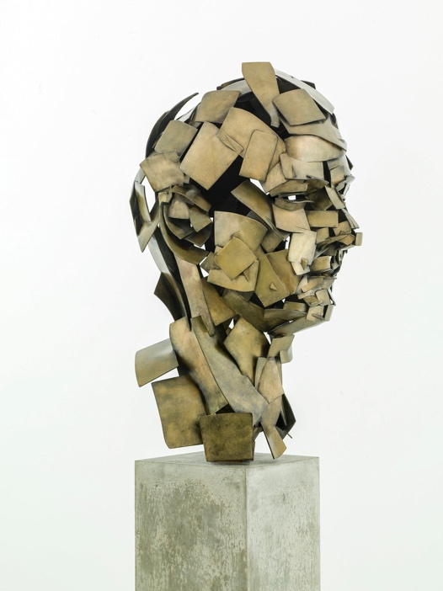
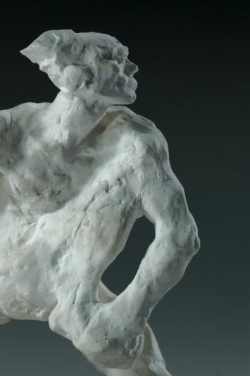

Yeo’s Homage to Paolozzi, 2017
Rodin’s Nijinsky, 1912

- Hierarchy

Today, artists use an incredibly wide range of materials. These range from the more traditional materials such as clay, bronze and marble, to materials that are slightly less traditional and even temporary such as flowers, wood, LEDs and many other textiles. ‘Sculpture’ is made in many ways, from a huge range of materials and methods. An example of diversifying materials would be artist and sculptor Barbara Hepworth, who used a variety of materials throughout the entirety of her career. Hepworth carved directly into stone and wood and this gave her an incredible amount of satisfaction as an artist. “I am basically and primarily a carver, and the properties of stone and wood and marble have obsessed me all my life.” (Currey, 2013)

It is clear that since the 20th Century, sculpture has not been confined to the traditional techniques of modelling and carving, or to the more traditional materials such as clay, stone, wood and metal. Sculptors such as Hepworth have experimented, and are able to use any material they believe will serve a purpose and help create a piece of art. Sculpture can simply no longer be identified by only traditional materials or techniques anymore, despite all these changes, there is mainly one thing which has remained consistent in sculpture – it is this that emanates as the perpetual concern of all sculptors: the creation of a form in the third dimension. Over the last four decades, artist Phyllida Barlow has created large sculptures and installations, she uses inexpensive materials such as scrim, cardboard, wood, fabric, polystyrene, cement and plaster. Her bold and striking work is predominantly focused on the experimentation with these everyday materials in order to create her bright three-dimensional sculptural forms.
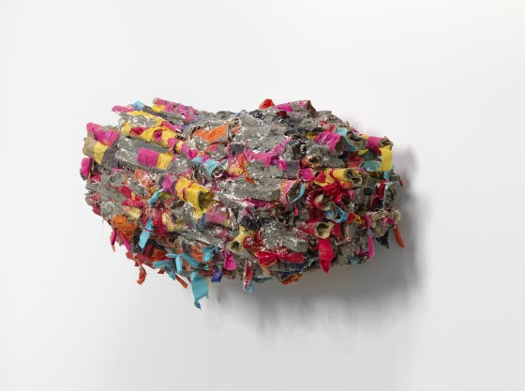

Phyllida Barlow, Untitled (2018)

Barlow’s textured and tactile sculptures appear almost unstable, this is a significant contrast of the permanence and stability of the more traditional and monumental sculptures of that of Auguste Rodin.

Barlow was particularly interested in the contemporary art movement Arte Povera, meaning ‘poor art.’ The movement’s hallmark was the experimentation of materials that went beyond the more traditional materials such as bronze, marble or clay. Instead, artist opted for rags, wood and twigs, paper and rope – this challenged the values of the more traditional art and its materials. Barlow says: “I’m not that interested in materials. I’m just interested in something that will do the job as efficiently and as expediently as possible. And that’s the minimum of technical interference between myself, my enjoyment of them and what the materials are – that is the most important thing.” (The Courtauld Institute of Art, 2017) In 1976, Barlow resurrected one of her works, Shedmash, leading her to the notion of the temporary. There is no bronze, no marble or steel – her work doesn’t necessarily resemble a typical sculpture and instead resembles a haphazardly placed mess. It is for this reason that nearly all the work she created throughout the entirety of her career was dismantled and then broken up.

So, is there a hierarchy of materials in the 21st Century or are artists and the public focusing more on the three-dimensional form rather monetary value of a material such as bronze? Are sculptures from the likes of Phyllida Barlow as respected as Rodin’s The Thinker? Poet and critic, Ezra Pound writes: “First, those which owe part of their quality as works of art to the material of which they are made and of which the material inspires the artist and is freely accepted by him and, second, those which owe nothing of their quality except by accident to their material and indeed, of which the material is even a hindrance to the free expression of the artist, is patronized rather than beloved by him.” (Ezra Pound, 1935)

- Scale

The notion of using whatever material is at hand is pivotal to Phyllida Barlow’s aesthetic. Barlow prefers to work with unglamorous and easily-accessible materials, she appears painfully aware and resistant to gravitation of creating something monumental or how a piece of work would look casted in bronze. She says: “For me, sculpture is problematic. You begin with an empty space and then you try and fill it, or negotiate it.” (Tate, 2013) Barlow pushes her work to its limits, destroying it and showing a complete lack of regard for the work itself and it is this sense of instability that sometimes intimidates – overrunning in the spaces its exhibited in. This is quite the contrast to Rodin’s The Burghers of Calais. Rodin was heavily criticised for not organising each of the six figures in a pyramid and not placing them on a plinth, which was the traditional practice towards the end of the 19th century. Rodin had pictured his piece on the ground “very low to enable the spectators to penetrate the heart of the subject, like the entombments in our churches, where the group is almost on ground level. In this way, the group becomes more familiar and plunges views deeper in the tragedy and sacrifice of the drama.” (Rodin Works, 2004)
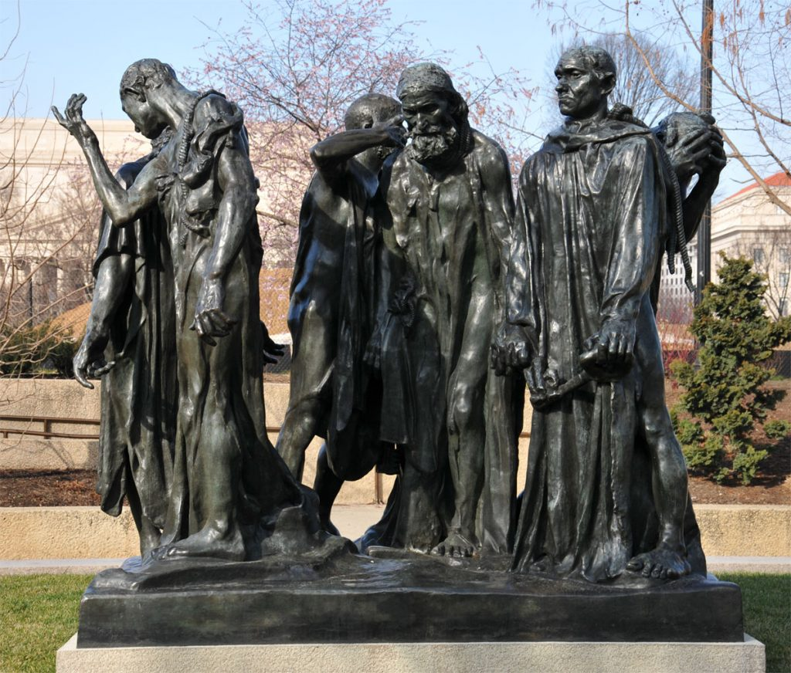

Rodin’s The Burghers of Calais, 1889

At Phyllida Barlow’s Cul-de-Sac at the RA, she has caused an obstruction: the viewer is left unable to look through into the second gallery space from a certain direction due to a colossal grey column that impedes the exit of the gallery - this gives the viewer a refreshed perspective of the work, after walking through the exhibition and approaching the end of the cul-de-sac, the viewer is forced to turn back around, dwelling on her large forms for the second time which is unsettling but also somewhat uplifting with vivid colours including green, red, yellow and orange. Untitled: Canvasracks fills the entire height of the gallery space, the combination of surging tarpaulin and banners protruding from concrete cylinders comes across as celebratory and confident. During an in-conversation with art critic and London correspondent for Artforum, Gilda Williams, Barlow describes her work as her “private world” (2019) she talks about seeing numerous elements of the exhibition complimenting each other and compared her Cul-de-Sac exhibition to her previous pieces and how the objects sit in the space almost in combat. Barlow now refers to the gallery space as a “protagonist” – equal to her work. (2019) Barlow’s use of the wall’s height and gallery space is a completely different approach compared to Rodin, who was far more modest when it came to using a space to compliment his work. The Burghers of Calais exists in several original casts along with many other copies – the original sculpture, created in 1889, was made to stand outside the townhall of Calais. Rodin went on to make another four casts, one of which now stands in Victoria Tower Gardens. Rodin visited London to supervise the placing of the sculpture and suggested that it should be placed right in front of the Houses of Parliament, however this idea was rejected, and the sculpture was placed behind the Palace of Westminster. Sir Nicholas said: “Victoria Tower Garden’s was not Rodin’s first choice. He would’ve preferred to place the work at ground level at the entrance to the House of Commons. My personal preference would be to site the group at the level Rodin wishes, but the Commons entrance is unfortunately now inaccessible to the general public.” (Independent, 2000)

Having taken everything into account, I have come to the conclusion that I am interested in how people perceive and experience sculpture; the phenomenology of sculpture. “Phenomenology is a diverse philosophical discourse united by an interest in the structures of subjective experience and the appearance of ‘phenomena’ to consciousness. Central to a number of key texts is the belief that the body is the site of perception and provides us with our ‘primary function’ of living and feeling the world.” (Tate, 2013) Having experienced Phyllida Barlow’s work in the flesh, my perception of what can be classed as a ‘sculpture’ has changed quite drastically, along with the different materials incorporated into artworks. I’ve admired Rodin for a long time, his use of clay and the manipulation of the surface has inspired me in my recent work. Having looked at two opposing artists that have both recently fuelled my own studies, the use of space and thought behind a space is riveting. How does the way a more traditional and perhaps more respected artist such as Auguste Rodin and his materials may influence, move or even strike a person compared to Phyllida Barlow, who’s far more methodical when it comes to materials and using gallery space? Taking everything into account, my chosen question is: Perceiving Through the Body: A Phenomenological Approach to Sculpture. Is There a Hierarchy and Does Our Experiences of Sculpture Differ Based on The Materials and Displaying of the Work?

Bibliography

Yeo, J. (2017) From Virtual to Reality. Available at: https://www.jonathanyeo.com/from-virtual-to-reality (Accessed 13th March 2019)

Yeo, J. (2017) From Virtual to Reality with Jonathan Yeo. Available at:
https://www.youtube.com/watch?v=xAl_o-_FKVg (Accessed 13th March 2019)

Yeo, J. (2017). [image] Available at: https://www.jonathanyeo.com/from-virtual-to-reality
(Accessed 13th March 2019)

Krauss, R. (1979) Sculpture in the Expanded Field. Available at: http://www.onedaysculpture.org.nz/assets/images/reading/Krauss.pdf
(Accessed 14th March 2019)

Fad Magazine (2019). Untitled. [image] Available at: https://fadmagazine.com/2018/12/20/phyllida-barlow-ra-cul-de-sac/ (Accessed 15 Apr. 2019)

Pound, E. Literary Essays of Ezra Pound (New York: New Directions Publishing, 1935)

Arnheim, R. (1969). Visual Thinking. Berkeley in Los Angeles: University of California Press.

Rodin Museum (n.d.). Nikinsky. [image] Available at: http://www.musee-rodin.fr/en/collections/sculptures/nijinski (Accessed 2 May 2019)

Yeo, J. (2017). Homage to Paolozzi. [image] Available at: https://www.jonathanyeo.com/from-virtual-to-reality (Accessed 2 May 2019)

Maddocks, F. (2013) In the studio with Phyllida Barlow RA. Available at: https://www.royalacademy.org.uk/article/in-the-studio-phyllida-barlow (Accessed 2 May 2019)

The Courtauld Institute of Art. (2017) INTERVIEW // Phyllida Barlow. Available at: https://courtauld.ac.uk/research/publications/immediations/immediations-online-2/immediations-2017-volume-4-number-2/phyllida-barlow (Accessed 3 May 2019)

Rodin Works. (2004) The Burghers of Calais. Available at: http://www.rodin-web.org/works/1884_burghers.htm (Accessed 3 May 2019)

Terrain Gallery (n.d) The Burghers of Calais. [Image] Available at: https://terraingallery.org/art-criticism/auguste-rodin/ (Accessed May 5 2019)

Tate. (2013) Figure and Landscape: Barbara Hepworth’s Phenomenology of Perception. Available at: https://www.tate.org.uk/research/publications/tate-papers/20/figure-and-landscape-barbara-hepworths-phenomenology-of-perception (Accessed May 6 2019)

Thomas, H. (2019) Phyllida Barlow in-conversation with Gilda Williams at the RA, 10th April 2019

Independent. (2000) Campaign to rescue Rodin’s unloved ‘Burghers of Calais.’ Available at: https://www.independent.co.uk/news/uk/this-britain/campaign-to-rescue-rodins-unloved-burghers-of-calais-707032.html (Accessed May 7 2019)

Stanford University. (n.d) The Burghers of Calais. [Image] Available at: http://bookhaven.stanford.edu/2013/08/the-burghers-of-calais-it-has-a-happy-ending-really-it-does/ (Accessed May 7 2019)

Tucker, W. (1974) The Language of Sculpture 1st Ed. Thames and Hudson Ltd.

