


An Evaluation and Comparative Analysis of a wide range of EVIDENCE using a COMMERCIAL MOBILE Forensic Tool (Cellbrite)

Ethan Hopkins
Dr. Nitheesh Kaliyamurthy

Project submitted as part of the requirements for the award of Course Name

April 2025

Declaration of Originality

I, Ethan Hopkins declare that I am the sole author of this Project; that all references cited have been consulted; that I have conducted all work of which this is a record, and that the finished work lies within the prescribed word limits.

This work has not previously been accepted as part of any other degree submission.

Signed : Ethan Hopkins

Date : 29/04/2025

FORM OF CONSENT

I, Ethan Hopkins hereby consent that my Project, submitted in candidature for the Computing (Cyber Security and Networking), if successful, may be made available for inter-library loan or photocopying (subject to the law of copyright), and that the title and abstract may be made available to outside organisations.

Signed : Ethan Hopkins

Date : 29/04/2025

Copyright Acknowledgement

I acknowledge that the copyright of this project report, and any product developed as part of the project, belong to University of Wales Trinity Saint David, Swansea.

ABSTRACT/SYNPOSIS
This project provides a complete evaluation and comparative analysis of commercial mobile forensic tools, with an emphasis on Cellebrite. The availability of smartphones in day-to-day life and the criminals using them has made mobile forensics a vital topic. Thus, the study endeavours to evaluate how successfully these tools can recover digital evidence, namely, deleted, fragmented, and encrypted data under realistic conditions.

This research investigates the strengths, limitations, legal considerations, and technological challenges associated with mobile forensic tools. The experimental component involved testing Cellebrite’s capabilities using synthetic and custom-created datasets across multiple Android and iOS devices. Effectiveness was assessed by evaluating the success of data recovery across various artifact types, including images, messages, call logs, and application data.

Results show that Cellebrite is exceptionally capable at recovering artifacts, extracting over 390,000, from physical extractions on supported devices such as the iPhone 11 and Pixel 7a, including deleted files and encrypted data. But its performance is significantly worse when conducting logical extractions or using devices with limited compatibility, such as the Samsung A13. In some cases’, messages and call logs were recoverable, but more frequently, app data (including phone books, photos and videos) and encrypted content remained inaccessible.

The project reveals the different extraction methods, device compatibility, and adaptability to standards of forensic tools. While Cellebrite remains a powerful tool, its commercial cost and dependency on device-specific support raise concerns. Open-source alternatives like Autopsy offer flexibility and transparency but struggle with encrypted or real-time data.

Overall, we find that no single tool covers forensic requirements completely. Future research should aim at hybrid frameworks of commercial robustness coupled with open-source flexibility, as well as enhance validation, scalability and ethical compliance in forensic investigations.

Table of Content

Copyright Acknowledgement 2
ABSTRACT/SYNPOSIS 3
Table of Content 4
1.1 ACKNOWLEDGEMENTS 7
Chapter 1 8
1.2 Introduction 8
1.3 Aim 10
1.4 Objectives 10
1.5 Structure Of The Project 11
Chapter 2 - RESEARCH & REVIEW OF LITERATURE 13
2.1.1 Introduction 13
2.1.2 Methodology 14
2.1.3 Scope & Objectives of the Review 16
2.1.4 Structure of the Literature Review 17
2.2.1 Digital Forensic Methodologies 18
2.2.2 Competitor Analysis: Commercial vs. Open-Source Tools 18
2.2.3 Related Work Analysis in Digital Forensic Tool Comparison 19
2.2.4 Conclusion 19
2.3.1 Functional Capabilities: Data Acquisition & Recovery 20
2.3.2 Accuracy, Speed, and Resource Efficiency 20
2.3.3 Comparative Performance in Mobile & Computer Forensics 21
2.3.4 Conclusion 22
2.4.1 Legal Admissibility of Digital Evidence 23
2.4.2 Encryption Bypass & Ethical Challenges 23
2.4.3 Regulatory Compliance & Privacy Concerns 24
2.4.4 The Role of Judicial Precedents in Forensic Tool Use 25
2.4.5 Conclusion 26
2.5.1 Digital Forensic Tools & Susceptibility to Counter-Forensic Techniques 26
2.5.2 Comparative Discussion: Literature on Command & Control, Privilege Escalation, and Data Exfiltration 26
2.5.3 Conclusion 28
2.6.1 Emerging Forensic Technologies 29
2.6.2 Challenges & Open Research Problems 30
2.6.3 Conclusion 31
2.7.1 Datasets 32
2.8.1 Summary of Key Findings 33
2.8.2 Implications for Researchers & Practitioners 33
2.8.3 Final Thoughts on Open-Source vs. Commercial Forensic Tools 34
2.8.4 Conclusion 35
Chapter 3 - RESEARCH METHODOLOGY 36
3.1 Research Philosophy 37
3.2 Research Approach 37
3.3 Research Strategy 37
3.4 Research Choices 38
3.5 Time Horizon 38
3.6 Data Collection 39
3.7 Ethical Considerations 39
3.8 Limitations of the Methodology 39
3.9 Contingency Plan 40
3.10 Conclusion 41
Chapter 4 - DESIGN & IMPLEMENTATION 42
4.1 INTRODUCTION 42
4.2 PROBLEM FORMULATION 42
4.3 DESIGN 42
4.3.1 Dataset Selection 43
4.3.2 Effectiveness Measurement 46
4.3.3 Environmental Setup 46
4.3.4 Risk Management and Contingency Plan 46
4.3.5 Ethical and Legal Considerations 46
4.4 IMPLEMENTATION – Phase 1 Cellebrite 47
4.5 OPTIONAL PHASE 2 – COMPARISON WITH OPEN-SOURCE TOOLS 51
4.6 CONCLUSION 51
Chapter 5 – Testing and Evaluation 52
5.1 Introduction 52
5.2 Experimental Process 52
5.3 Results 59
5.4 Evaluation and Critical Analysis 63
5.5 Limitations of the Experiment 65
5.6 Conclusion 67
Chapter 6 - CONCLUSIONS AND RECOMMENDATIONS 68
6.1 Summary 68
6.2 Conclusion 69
6.3 Recommendations for Further Research 71
Chapter 7 – Reflections 72
Objectives and Reflections 72
Additional Reflections 74
chapter 8 - REFERENCES 75
GLOSSARY 79

ACKNOWLEDGEMENTS
I would like to sincerely thank my supervisor, Dr. Nitheesh Murugan Kaliyamurthy, for their guidance, support, and valuable feedback throughout this dissertation. their time and effort have been greatly appreciated.

I would also like to extend my sincere thanks to my good friend, Daniel James, for his encouragement and support throughout the challenging stages of this project. His assistance and motivation were invaluable in helping me stay focused.

Chapter 1

Introduction
Forensics is the use of scientific techniques and methods used to investigate crimes and aid in the legal process, collecting evidence to establish facts that are admissible in a court of law. These rules also apply to digital forensics, utilising computer science to carve and extract data from all types of devices, including computers, mobile devices, networks and cloud systems, and can extract data such as saved files on various storage devices, location data, meta data, cache and deleted or fragmented data that could be linked to crime or help solve investigations of all kinds, such as missing persons. [1] Digital forensics has many uses outside the court of law, such as incident response, corporate misconduct and is also used around the world by intelligence agencies such as MI5 in order to investigate cyberespionage against the UK. [1] [2]
Mobile forensics is one of the many types of digital forensic sectors that focus on the extraction of evidence on mobile phones, where data is identified, analysed, collected, and preserved to be used in court in a legally admissible manner. [3] These tools use numerous techniques to gather data whilst keeping the data legally admissible. One technique is using hashing or hash functions. Hashing is where an input, such as a string of text is put through a hash function which creates a unique hash value based on that specific data. This allows comparison of the hash value before and after extracting which ensures that no data has not been tainted, therefore maintaining the integrity of the data. [4]
Data recovery is another important part of digital forensics and works based on how data is saved on storage devices. When a file is deleted, the pointers, or metadata that direct to the files are removed, but not the data that the file was composed of. The data remains on the drive until it is overwritten, which means it is possible to locate that data and recover it when using specialised tools. These are also used for corrupt and hidden data, which use techniques to piece together data that has been partially lost, along with algorithms to decrypt files. [5]
The use of mobile phones has grown exponentially in just the last 2 decades, with now over 80% of the population of US owning a smart phone [6] and is becoming more and more intertwined with our daily lives. Due to the usability and security that mobile phones offer, they are commonly used by criminals which makes mobile phones crucial for investigations as they almost always contain evidence of their users’ crimes [7], whether that be for planning drug deals, instigating attacks or scamming people online.
This project will explore how effective a commercially used mobile forensic tool kit is when compared to a free to use, open-source toolkit. This study will focus on how their recovery techniques stack up against modern phones and their advanced security measures, providing insights into their strengths, weaknesses, and areas for improvement.

Aim
The aim of this report is
To evaluate the effectiveness of a commercial mobile phone forensic tool comparing a wide range of evidence, benchmarking its performance in recovering digital evidences, including deleted, fragmented and encrypted data.

Objectives
The objectives are to:

- Conduct a systematic literature review by identifying and categorising peer-reviewed research on commercial and open-source mobile forensic tools.
- Develop and document a clear research methodology using the research onion framework, including systematic literature review and experimental design, completed by the milestone date.
- Formulate clear evaluation criteria and experiment design using synthetic mobile datasets (calls, messages, location data), with detailed documentation completed by the project midpoint.
- Conduct comparative analysis experiments with selected toolkits, measure against defined criteria, analyse outcomes, and complete final reporting by the project deadline.

Structure Of The Project
The project is composed of three key sections. Firstly, the academic foundation which involves a review of existing literature and past studies related to mobile forensic tools and methodologies, includes a study of commercial toolkits and open-source solutions, as well as the challenges shown by modern mobile phone security features. This groundwork will allow for an enhanced knowledge base and will help create the foundation required for the relative analysis for the core of this project.
The second part focuses on the design and implementation. This includes defining the research problem, creating a structured approach to test and compare many devices with a commercial toolkit, and outlining the methods used for forensic analysis of controlled mobile devices. Synthetic data will be planted onto test devices so that we can create realistic scenarios that are commonplace in forensic investigations, such as fragmented, deleted, and encrypted data. The software tools and hardware required for the project will also be detailed in this section.
Finally, in the third part of this project, the findings will be presented. This includes the results following the analysis of the forensic tool, bringing attention to their effectiveness, efficiency, and reliability in recovering mobile data. The results will be analysed to identify strengths, weaknesses, and any inconsistencies between the phones. The chapter will then conclude with a summary of the findings, conclusions, and propositions for future research and development in mobile forensics.

Chapter one delivers a background summary of the report, specifying the aim and emphasising the objectives necessary for a successful outcome.

Chapter two focuses on reviewing the research and literature that is being used throughout the project.

Chapter three details the research approach and design that will be used to conduct my own research.

Chapter four outlines the approach to the design and implementation of the experiment that will be conducted for this project.

Chapter five examines the results of the experiment, discussing in detail all aspects of the study and what the results mean for the outcome of this project.

Chapter six focuses upon concluding the paper, and recommendations for future work surrounding this area of research.

Chapter 2 - RESEARCH & REVIEW OF LITERATURE

Introduction to Digital Forensics & Forensic Toolkits

2.1.1 Introduction
There is an essential role for digital forensics in today’s world, with evolution of cybersecurity and the rise in cyber criminals, it is becoming a necessity in all sectors. It is used to aid criminal investigations and law enforcement by helping in the collection, preservation and analysis of all types of evidence related to some form of digital technology. This rise in cyber criminals, most of which use mobile phones to conduct their illegal activities, has led to the expansion of forensic tools with a priority on mobile forensics. These forensic toolkits have been indispensable for digital forensic teams and law enforcement, aiding in extractions, recovery, analysing and presenting digital information that can be used as evidence in legally admissible manners from every type of device that stores data, such as mobile phones, computers, cloud storage of IoT devices. [8]
There are a wide range of toolkits, each with their own unique strengths and weaknesses in different situations. A commercial toolkit such as Cellebrite is a popular choice for law enforcement agencies and police forces in the UK as it offers specialized decryption and data extraction capabilities. On the other side of the scale, we have the open-source options such as Autopsy and FTK Imager for example. These toolkits focus on certain parts of the extraction and recovery and in some cases are designed to be used in conjunction with other toolkits. These open-source tools are also cost-effective and extremely flexible due to its modular design, allowing the ability to modify the software to suit the needs of the investigation. [9]
This literature review will compare Cellebrite and Autopsy, focusing on the functional capabilities, efficiency, legal considerations and the future developments of each in digital forensics.

2.1.2 Methodology
To ensure a comprehensive and focused literature review, a structured search strategy was used to identify relevant research papers. The search was conducted using Boolean search queries that included key terms related to mobile forensics, digital evidence analysis, and forensic tools. The objective was to retrieve peer-reviewed studies, conference papers, and journal articles relevant to the comparison of Cellebrite (commercial) and Autopsy (open-source) forensic tools.
Keywords Used in Search

The search was built using the following query:

(("Mobile Forensics" OR "Mobile Device Forensics" OR "Smartphone Forensics" OR "Digital Forensics" OR "Forensic Tools") AND ("Tools" OR "Techniques" OR "Methodologies" OR "Frameworks" OR "Processes") AND ("Open-Source" OR "Commercial" OR "Cellebrite" OR "Autopsy" OR "The Sleuth Kit" OR "TSK") AND ("Data Acquisition" OR "Digital Evidence" OR "Analysis" OR "Artifacts" OR "User Data"))

This initial search yielded 206 results, including various sources ranging from broad forensic topics to niche areas in forensic methodologies.
Exclusion Criteria and Scope Refinement
Given the broad scope of the initial results, a filtering process was implemented to narrow down the selection to highly relevant, recent, and methodological papers.

The following filters were applied:
- Peer-reviewed journal articles and conference papers.
- Publications between 2020 and 2025.
The following inclusion criteria was implemented
- Studies comparing forensic tools or focusing on data acquisition, digital evidence analysis, and forensic methodologies.
- Research relevant to commercial tools (e.g., Cellebrite, Belkasoft) and open-source tools (e.g., Autopsy, FTK).
- Papers including the legal properties of a mobile forensic case
The following exclusion criteria were applied:
- Irrelevant Scope – Studies that focused on forensic tools unrelated to Cellebrite or Autopsy or covered general cybersecurity without forensic analysis.
- Educational Focus – Papers designed as teaching material or overviews rather than presenting original research or comparative studies.
- Lack of Tool-Specific Analysis – Studies that discussed forensic methodologies in general but did not evaluate specific tools.
- Limited Relevance to Recovery Challenges – Research that examined forensic processes but did not address data extraction, analysis, or evidence recovery.
- Narrow Technical Focus – Studies that explored a single forensic aspect, such as a single encryption technique, rather than holistic tool evaluation.
- Outdated or Redundant Studies – Research published before 2020 was removed to ensure current and relevant findings were prioritized.
Final Selection Process
After applying filters for peer-reviewed journals, conference papers, and publication date (2020-2025), the number of results was reduced to 80 papers. After analysing these the number of papers reduced further, by using the exclusion criteria, to allow only the most relevant papers to be used. This refinement left me with 30 papers, which allowed for a manageable workload while maintaining a high level of research quality and relevance.
The exclusion criteria helped ensure that only high-impact studies were included in the review. This filtering process was essential to keep the research focused and aligned with the objectives of the study, preventing the inclusion of overly broad or outdated materials.

Here is a table showing the number of results after each search criteria is implemented.
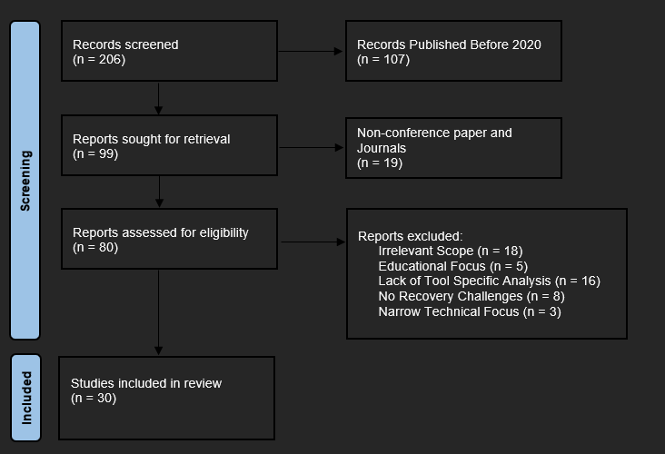

2.1.3 Scope & Objectives of the Review
This review aims to critically evaluate Cellebrite and Autopsy. This will be conducted by assessing the data acquisition capabilities, processing speed, legal possibilities and the accuracy of forensic evidence. This review will prioritise peer-reviewed publications, competitor analysis and related word to give a deeper and well-rounded understanding of digital forensics. [10]

This literature review will cover:
- The comparison of Cellebrite and Autopsy’s capabilities in data extraction, recovery and analysis.
- Evaluating the performance factors, such as speed of extraction, accuracy and number of data/artifacts found.
- The legal and ethical considerations when used in forensic investigations
- Current research gaps and the future trends of digital forensics

2.1.4 Structure of the Literature Review
This review is structured as follows:

- Part 2 will discuss digital forensic methodologies and provide a competitor analysis.
- Part 3 presents a performance-based comparison of Cellebrite and Autopsy.
- Part 4 aims to explore the legal and ethical implications of digital forensics.
- Part 5 examines forensic tool when they are faced with cyber threats and anti-forensic techniques.
- Part 6 discusses emerging trends in digital forensics.
- Part 7 shows the data sets that were sourced during the literature review to find potential data for extraction
- Part 8 summarizes key findings and potential research implications.

The Digital Forensic Landscape & Tool Comparisons

2.2.1 Digital Forensic Methodologies
The standardised investigation methods of digital forensics maintain both integrity of data and reliability and legal acceptability. The forensic procedures described in ISO/IEC 27037 and NIST guidelines include steps for identifying and acquiring evidence, and concluding with reports [11]. The established guidelines serve two important functions because they protect forensic data against contamination and ensure proper evidence handling through chain of custody management.
Forensic investigations currently experience expanding usage of automation technologies alongside machine learning and cloud forensic methods. Automation tools boost processing speed through less human work while artificial intelligence systems enable quick discovery of data abnormalities together with encrypted documents and patterns [12]. Cyber investigation methodologies need continuous development to match up with increasing cloud storage solutions and encrypted digital communication channels

2.2.2 Competitor Analysis: Commercial vs. Open-Source Tools
Legal institutions use commercial forensic tools such as Cellebrite, EnCase and Magnet Axiom to extract encrypted data which function through their proprietary decryption methods. Academic research and cybersecurity investigations suit the open-source tools Autopsy and The Sleuth Kit because of their focus on disk imaging together with log analysis and extensibility features [13].

A comparison of forensic software reveals:
- Cellebrite excels in mobile device forensics, particularly for extracting deleted messages, encrypted files, and application data.
- Autopsy is better suited for disk forensics and file system analysis, offering extensive support for Windows, Linux, and Mac file systems [14]. However, due to its modular design, it is possible to forensically analyse mobile phones.
- Magnet Axiom integrates AI-driven automation, helping investigators analyse large datasets more efficiently.
- XRY is widely used in Europe for mobile forensics, with capabilities very similar to Cellebrite.

2.2.3 Related Work Analysis in Digital Forensic Tool Comparison
A previous study evaluated how Autopsy executes disk forensics beside Cellebrite's exclusive mobile data retrieval features. Reverse engineering studies have discovered that Cellebrite devices achieve higher rates in recovering encrypted data than Autopsy tools despite Autopsy serving as an economical solution for forensic experts [13]. Research needs to address two ongoing problems with real-time validation of forensic evidence and AI-based assessment tools [15].

Critical Evaluation
The literature on digital forensic methodologies, such as ISO/IEC 27037 and NIST guidelines, provides clear and structured standards for evidence handling, enhancing reliability in forensic investigations. However, studies highlight significant issues in adapting these methodologies to modern technologies such as cloud storage and advanced encryption. They suggest that current standards fall behind technological advancements, potentially affecting evidence quality and usability. Therefore, future research should prioritize updating these methodologies to better integrate new technologies and ensure effectiveness across diverse forensic scenarios. [11]

2.2.4 Conclusion
Digital forensic tools vary in their functionality because commercial solutions effectively handle encrypted data while managing cases automatically, but open-source tools focus upon customization combined with lower costs. Research efforts should concentrate on building mixed forensic systems that unite commercial and open-source analytical tools to boost forensic operations and make processes more transparent.

Cellebrite vs. Autopsy – Functional & Performance Comparisons

2.3.1 Functional Capabilities: Data Acquisition & Recovery
These tools are particularly useful in digital forensic investigations that seek to acquire and recover data from several digital devices. Two distinct functional capabilities that are unique to their respective commercial and open-source forensic solutions, Cellebrite and Autopsy, dominate the space of the two options available. Cellebrite offers mobile phone forensics that excel at supporting physical, logical, file system and cloud extractions. The Universal Forensic Extraction Device (UFED) allows investigators access to locked and encrypted mobile devices and provides the capability to recover deleted SMS messages, call logs, multimedia content. Cellebrite is known to excel, especially when performing studies of device acquisition of Android and iOS devices despite of security barriers, encryption and password protection among others [16]. Unlike autopsy, which is mainly used for computer forensics – hard drive imaging, metadata analysis and file carving. The Sleuth Kit provides the integration of Autopsy with Windows, MacOS, and Linux file system forensics. Whereas Autopsy concentrates upon disk forensics and recovering deleted files including logs, timestamps and so forth from storage devices, including mobile devices when paired with the correct modules, Cellebrite specializes in mobile forensics, extracting several data types, such as deleted and encrypted data from mobile devices [17].

2.3.2 Accuracy, Speed, and Resource Efficiency
Each forensic tool’s efficiency is measured by how fast it would process through the data, how detailed it would be at retrieving data, and the number of artifacts found. Comparative research for Cellebrite and Autopsy time-based performance has been conducted on the forensic scenario under which they are given. Cellebrite’s proprietary algorithms significantly reduce the time necessary to extract data from mobile devices [18]. Cellebrite hardware accelerated processing is useful when a large quantity of encrypted or deleted data must be extracted. However, because it is commercial, the tool requires high performance computing and needs to be in constant use to sustain a real financial investment, which makes it less available to independent researchers [19]. However, Autopsy itself is a lightweight, modular tool that can be run off standard forensic workstations with no special hardware requirements. Although its ability to reconstruct a forensic timeline and file carving are rigorously accurate in disk forensics, the performance of spectral analysis in a mobile device data extraction operation falls behind that of Cellebrite. Autopsy takes longer to process if the files being analysed are fragmented or encrypted and research has shown that Autopsy takes longer if using SSDs with TRIM enabled data deletion [20].

2.3.3 Comparative Performance in Mobile & Computer Forensics
Cellebrite and Autopsy are both strong in specific forensic contexts; they are given differing specializations. Cellebrite’s Strengths: Data acquisition for mobile devices, both logical and physical extractions. Allows for superior handling of encrypted & deleted mobile data [19]. Forensic investigation automated reporting and case management and access to proprietary support and frequent updates to make forensic effectiveness improve. Autopsy’s Strengths: File system and disk image analysis for computer forensics. Ability to be open source in terms of changing and customizing the tool flexibility. It is more accessible to use and is associated with lower hardware and software resource requirements. Strong forensic timeline reconstruction capabilities for investigative workflows. However, research has also suggested performance trade-offs. While Cellebrite is considered as the preferred tool for extracting data from encrypted devices for mobile forensic investigation purposes, it fails to live up to the cost effectiveness and transparency of the open-source Autopsy [20]. However, while hard drives and removable media work well with Autopsy, it doesn’t have the mobile forensic need which would be required by law enforcement.

Critical Evaluation
The literature reviewed focus on distinct strengths and limitations of Cellebrite and Autopsy. Studies [20] clearly highlight Cellebrite’s superior capability in handling encrypted mobile data extraction efficiently and accurately, demonstrating its effectiveness for high-stakes investigations. However, other studies [18] provide a balanced perspective by illustrating Autopsy’s advantage as an open-source, cost-effective alternative, particularly for disk and file system analyses. Despite these strengths, both studies underline critical trade-offs: Cellebrite’s proprietary nature and higher cost limit its accessibility, whereas Autopsy’s limited encryption-handling capabilities restrict its effectiveness in mobile forensic scenarios. Thus, future research should explore hybrid approaches or enhanced encryption handling within open-source frameworks to bridge these performance gaps.

2.3.4 Conclusion
Cellebrite and Autopsy address different forensics use cases in that Cellebrite addresses mobile device investigations, very well and Autopsy is very cost effective for disk forensics. The selection of forensic tools will be decided by the investigative scenario, the budget constraints and / or the availability of proprietary software. Yet in the case of disk-based investigations, Autopsy’s flexibility, cost efficiency, and forensic imaging capabilities outweigh a predominantly costlier, less comprehensive mobile data extraction product like Cellebrite while providing a substantially faster and more comprehensive mobile data extraction service.

Digital Evidence Integrity & Legal Considerations

2.4.1 Legal Admissibility of Digital Evidence
To be legally admissible in the court, digital forensic tools must promote the collection of evidence in an admissible manner. To achieve this, compliance with forensics’ best practices by maintaining authenticity, integrity, and reliability of digital artifacts is required. ISO/IEC 27037 and NIST Special Publication 800-86 specify methods for evidence handling, chain of custody support, and evidence validation [11]. Third, forensic evidence must be legally recognized and thus be tamper proof, verifiable, and reproducible. Cellebrite and Autopsy also have hashing mechanisms like MD5 and SHA-256 checksums to prevent the data extracted to be tampered. The proprietary tools of Cellebrite generate automated case reports that are formatted for judicial review and thus simplify evidence submissions during a court process [20]. Open-source Autopsy allows individual reports to be generated by autopsy itself, but this is less than ideal from a forensic point of view, and only 'works' if forensic conditions are strictly adhered to [19]. The case in recent years demonstrates that the chain of custody protocols should be followed by the forensic tools to maintain the traceability of the digital evidence from the acquisition to the court room. While Cellebrite is accepted throughout the law enforcement and legal circles per studies, open source tools such as Autopsy can require extra steps to become admissible as much as Cellebrite.

2.4.2 Encryption Bypass & Ethical Challenges
The rapid expansion of electronic devices’ use of encryption poses a serious problem for various forensic investigators. Ethical debates have been made around Cellebrite’s proprietary decryption abilities that allow law enforcement to bypass security on locked smartphones. While such technology is useful for criminal investigations, its use in jurisdictions that have strict privacy protections regarding digital information [21] raises concerns regarding privacy and potential human right violations.
Cellebrite’s encryption bypassing techniques have been based on zero-day vulnerabilities and forensic exploits that have sparked criticism from privacy advocates. It is an ethical concern when the forensic tools are employed in countries where human rights protections are weak, and digital evidence are collected without timely oversight. A belief that forensic software has been used to target journalists and other political opponents and activists has been reported, [18] raising the issue of the proper balance between security and civil liberties. On the contrary, autopsy does not include built in decryption features, and thus, is not as controversial from an ethical perspective. Despite that, forensic investigators perform decryption on encrypted mobile data using external decryption tools which introduce risks for evidence corruption or data loss if not done correctly [22].

2.4.3 Regulatory Compliance & Privacy Concerns
There are a range of national and international data protection regulations that are applicable for digital forensic investigations to comply with. General Data Protection Regulation (GDPR) (EU) California Consumer Privacy Act (CCPA) (USA) Computer Fraud and Abuse Act (CFAA) (USA) Investigatory Powers Act (UK) [23] Cellebrite forensic tools have been controversial about cross border data transfer and have been criticised particularly when used by international criminal cases. Others deem Cellebrite's methods to be almost too invasive as some would say they violate data privacy laws of extracting sensitive personal data without explicit user consent [24]. As this solution is open source, there is no inherent enforcement in autonomy concerning compliance mechanisms and must be done manually by forensic practitioners that guarantee their data acquisition and storage practices are in line with legal and ethical standards. Thus, it renders compliance more investigator dependent, whereas Cellebrite adds built in compliance safeguards such as automated chain of custody documentation [25].

Data minimization is becoming a growing concern as a legal principle that requires forensic investigators to only collect the data needed for an investigation. Cellebrite’s tool harvests comprehensive device data but is viewed by critics as excessively comprehensive with most of the data collected beyond the scope of investigation, subjecting investigators to legal challenges. On the other hand, Autopsy offers greater control on how data is collected, thereby reducing such legal risks [26].

2.4.4 The Role of Judicial Precedents in Forensic Tool Use
Forensic tool usage is bound by judicial rulings. Most courts that have analysed Cellebrite forged forensics reports have found them to be admissible as primary digital evidence in multiple jurisdictions because their use is so widespread in the industry. However, Cellebrite’s proprietary decryption techniques have become the subject of tension regarding the transparency of such technologies, as defence attorneys assert there should be transparency to closed source forensic tools in digital investigations [23]. However, Autopsy as a forensic open-source tool is more transparent, but the court needs the admissible expert witness testimony to justify that it made forensic findings. They say the more open-source forensic tools tend to need more forensic validation and subject to cross examination during legal proceedings [27].

Critical Evaluation
The reviewed literature provides insights into the critical legal and ethical challenges associated with the usage of certain digital forensic tools. Some studies [19] highlight Cellebrite’s built-in compliance safeguards, stressing their practicality in maintaining legal admissibility and chain-of-custody standards. However, this source also critiques Cellebrite’s proprietary encryption bypass capabilities due to ethical concerns around privacy and transparency. On the other hand, few studies offer a nuanced discussion on the flexibility and transparency of Autopsy, noting its strengths in sticking to privacy regulations and ethical standards, although emphasizing its limitations in handling encrypted data [20]. Thus, future research should aim to develop balanced forensic tools or hybrid approaches that combine the strengths of commercial and open-source solutions, addressing current limitations in encryption management and ethical transparency.

2.4.5 Conclusion
Digital investigations are under debate regarding the legal and ethical implications of usage of forensic tools. Cellebrite offers efficiency, automation, compliance, but also privacy violations, cross border access, unethical deployment. In contrast, Autopsy is fully transparent, there is an investigator in control, but it requires additional verification necessary for courtroom admissibility. Future forensics should put standardised compliance features as a priority, having open-source tools capable to match commercial forensic software in legal validation. There are also additional judicial oversight developments that need to continue to evolve to strike a balance between data security and privacy preservation in the ever-growing data collection craze.

2.5.1 Digital Forensic Tools & Susceptibility to Counter-Forensic Techniques
Digital forensic tools such as Cellebrite and Autopsy are intended to extract and analyse data but are increasingly thwarted by counter forensic techniques that the adversary uses to avoid detection. Data hiding, encryption, encryption, obfuscation, anti-forensic malware, and steganography are among these techniques [28]. This advanced decryption technology is included in the proprietary technology of Cellebrite and supports the extraction of deleted and hidden data, as well as encrypted data from mobile devices. Adversaries have come up with file system tampering and artifact obfuscation to run forensic extraction tools idle [29]. According to research, Cellebrite fights against new encryption standards, i.e., Secure Enclave or quantum-resistant encryption technologies. Being an open-source tool, autopsy offers more transparency and greater flexibility, thereby allowing forensic experts to develop the custom modules to counter act an anti-forensic technique. Yet it is not as effective in real time counter forensic situations when working with data protection mechanisms for mobile devices [14].

2.5.2 Comparative Discussion: Literature on Command & Control, Privilege Escalation, and Data Exfiltration
Modern cyber threats often rely on command and control (C2) infrastructures to sustain unauthorized remote access, elevate privileges, and exfiltrate data without detection. The ability of forensic tools to detect such activities is crucial for effective incident reconstruction and evidence collection.
Cellebrite’s support for advanced mobile forensics includes memory capture and application-layer data extraction, which are vital for detecting traces of C2 communications and identifying unauthorized command executions. According to a study [17], tools with mobile memory analysis capabilities are increasingly essential as attackers shift toward ephemeral and encrypted channels. Similarly, [20] studies show that proprietary tools like Cellebrite can more effectively capture volatile memory and recover hidden or self-deleting malware used in privilege escalation attacks.
In contrast, Autopsy demonstrates strengths in log analysis and forensic timeline reconstruction, as noted in a study. [16]. These features allow investigators to identify suspicious behaviours such as login anomalies, timestamp tampering, or abnormal access sequences—common indicators of privilege escalation. [29] However, since Autopsy relies on post-event analysis and does not provide live monitoring capabilities, it struggles to capture real-time exfiltration over encrypted channels or covert tunnels. Some Studies [30] also emphasize this limitation, arguing that open-source solutions must evolve to handle modern anti-forensic strategies embedded in advanced persistent threats (APTs).
Together, these comparisons reinforce the notion that while Cellebrite is more suited for real-time detection and encrypted mobile environments, Autopsy’s strengths lie in static analysis, making it more effective in traditional disk and log-based investigations.

Critical Evaluation
The literature in Chapter 5 highlights how digital forensic tools are increasingly being challenged by evolving counter-forensic techniques. Tactics like data hiding and obfuscation that hinder effective analysis, emphasizing the need for advanced detection capabilities. [16]
Other studies [13] note that commercial tools such as Cellebrite have an edge in live memory analysis and real-time forensic automation, making them more effective against encrypted or self-deleting data. However, performance inconsistencies remain when tools face newer anti-forensic methods.
Meanwhile, it is highlighted that open-source tools like Autopsy, while adaptable and resource-efficient, struggle with real-time threats and are better suited for static disk forensics. [20]
Overall, neither tool type fully addresses advanced counter-forensics. Future work should aim to develop more adaptive and integrated forensic solutions to stay ahead of emerging threats.

2.5.3 Conclusion
Compared with digital forensic tools, adversarial techniques present an ongoing challenge to be countered by any new encryption handling, anti-forensic detection, and forensic automation. The literature highlights how digital forensic tools are increasingly challenged by evolving counter-forensic techniques. Tactics like data hiding and obfuscation that hinder effective analysis, emphasise the need for advanced detection capabilities. It is noted [13] that commercial tools such as Cellebrite have an edge in live memory analysis and real-time forensic automation, making them more effective against encrypted or self-deleting data. However, performance inconsistencies remain when tools face newer anti-forensic methods. Meanwhile, open-source tools like Autopsy, while adaptable and resource-efficient, struggle with real-time threats and are better suited for static disk forensics. Overall, neither tool type fully addresses advanced counter-forensics. Future work should aim to develop more adaptive and integrated forensic solutions to stay ahead of emerging threats.

Future Trends & Emerging Challenges in Digital Forensics

2.6.1 Emerging Forensic Technologies
The progress of technology has been very rapid, therefore continuous developments in digital forensic methodologies are required. Artificial Intelligence (AI), machine learning, blockchain, cloud forensic are some of the emerging technologies that are redefining the area of forensic investigations [31]. Artificial Intelligence & Machine Learning in Forensics The automated data analysis, anomaly detection and evidence correlation are being strengthened by AI-driven forensic tools. Machine learning algorithms can accurately pattern and identify the patterns in large datasets that can increase efficiency rate by malware detection, forensic timeline reconstruction and automated classification of evidence [32]. But there is always a quandary of how to make AI forensics outputs both interpretable and reliable, especially when AI forensics outputs are read to them since they must be admitted as evidence in courts of law [32]. Blockchain for Digital Evidence Integrity The immutability nature of blockchain is a very attractive aspect which is attracting the use of blockchain technology in digital forensics. Investigators can record evidence trails in tamper proof blockchain ledgers, where evidence trails and forensic logs are stored, and be assured that both the evidence collected, and the acquired forensic logs are of good faith only [8]. Studies show that in relation to chain of custody tracking applications, blockchain could greatly diminish evidence manipulation risks [8]. For scalability and integration with existing forensic systems however it remains a challenge [33]. Cloud-Based Forensics However, with growing use of cloud storage solutions, this increased adoption of forensic challenges which is especially data distributed across multiple servers and multiple jurisdictions. Cloud forensics must deal with problems of remote evidence acquisition, multiple tenants’ segregation of data and cross border legal concerns [22]. Live cloud forensics advances provide investigators with techniques to obtain volatile evidence in real time where they mitigate the risk of evidence loss during a dynamic cloud environment [22].

2.6.2 Challenges & Open Research Problems
Structurally, despite the technological advancements, there are still several challenges to the digital forensic investigations. Forensic tool validation, increase of encryption complexity, as well as restrictions of the forensic automation are key issues.
Forensic Tool Validation & Standardization
This poses a pressing challenge to ensuring the reliability of forensic tools as they often have disparate findings depending on the tool used. Lack of universal forensic validation framework gives a justification that there is absence of industry standard. [34] There are efforts to develop automated validation techniques that will validate forensic tool accuracy across multiple investigation scenarios [33]. Encryption & Privacy Challenges End to end encryption (E2EE) and quantum resistant cryptography present serious barriers for forensic investigation.
However, legal and ethical concerns around exploitation-based tactics of trying to bypass encryption remain [28]. However, to balance out data privacy regulations (Like GDPR, CCPA) there are restrictions in accessing lawful evidence to not infringe with individual rights [32]. Forensic Automation & Scalability Forcing digital evidence volumes to grow at such a rapid pace, automation of forensic approach must maintain to scale. Despite AI driven forensic workflows, case of false positives, bias on the AI decision-making and dependence on the automatic processes are [31]. Cloud forensics also call for real time processing capabilities which present advanced forensic computing [22].

Critical Evaluation
The literature examined in Chapter 6 reflects the ongoing evolution and associated challenges in digital forensic practices, particularly in the face of growing data complexity and scale. Studies [31] underscore the transformative role of artificial intelligence and machine learning in digital investigations, emphasising their potential to enhance real-time analysis and improve forensic automation. However, these advancements are not without their challenges. As highlighted, [33], ensuring the reliability and accuracy of forensic tools remains a significant hurdle, especially as tool outputs must be consistent and admissible in legal contexts. [36]
Additionally, the integration of emerging technologies like blockchain and advanced cloud forensics introduces both opportunity and complexity. Research [34] explores the technical feasibility and security benefits of these technologies but also reveals difficulties in standardizing their use across various platforms and legal jurisdictions. As cloud environments expand, cross-border data collection and volatility in evidence storage further complicate investigations [31].
A key gap identified across the reviewed studies is the lack of universal validation frameworks for forensic tools, particularly those dealing with encrypted or obfuscated data sources. This has been demonstrated in real-world tool testing, such as MOBILedit and related forensic suites [20], which, while effective in isolated functions, often struggle with interoperability and forensic rigor across different devices and formats. Similarly, studies [25] explore how data extraction from iOS platforms still presents inconsistencies due to OS-level restrictions and evolving encryption protocols. [37]
Moving forward, future research must prioritize the development of standardized, cross-compatible frameworks for forensic validation. These must be robust enough to support real-time, automated analysis, while being flexible enough to remain compliant with legal standards across international boundaries.

2.6.3 Conclusion
Digital forensics is undergoing a transformative shift driven by AI, blockchain, and cloud-based investigations. While these technologies enhance forensic capabilities, challenges such as encryption barriers, forensic tool validation, and legal compliance must be addressed. Future research should focus on developing standardized forensic frameworks, improving forensic automation reliability, and ensuring legal and ethical alignment with evolving data privacy regulations.

2.7.1 Datasets
Phone | OS | Image Size (GB) | Encrypted Data | Deleted Data | nonstock applications | Dataset  Type
iPhone SE | IOS 13.1.4 | 9.63 | Yes | Yes | 41 | Pre-made
iPhone 8 | IOS 15.3.1 | 16.65 | Yes | Yes | 54 | Pre-made
iPhone 11 | IOS 16.1.2 | 20.01 | Yes | Yes | 56 | Pre-made
iPhone 11 | IOS 17.3 | 22.12 | Yes | No | 55 | Pre-made
Pixel 5a | Android 13 | 19.83 | Unknown | Unknown | Unknown | Pre-made
Pixel 7a | Android 14 | 18.41 | Yes | Yes | 53 | Pre-made
Samsung  A13 | Android 14 | 47 | Yes | Yes | 56 | Self-made

This table shows all the datasets that have been sourced. All pre-made datasets have been sourced from The Binary Hick website [38] which contains a large catalogue of image files for many IOS and Android devices. These devices have been chosen due to their newer operating systems, which increase the relevance of the potential results. The self-made dataset has been provided by UWTSD, which has been modified with self-planted data to allow for direct comparison between the actual data and extracted data.

Conclusion & Research Implications

2.8.1 Summary of Key Findings
Through this literature review, Cellebrite and Autopsy have been compared functionally and evaluated, reviewing legal considerations, and forensic resilience. Key findings include Mobile forensics (especially in encrypted data extraction, deleted file recovery, cloud-based evidence acquisition) is Cellebrite’s game. However, its proprietary nature and high-cost limit accessibility for independent forensic practitioners and researchers. A robust open source controlled (disk imaging, timeline reconstruction, and metadata analysis) autopsy is provided by. However, unlike native encryption bypassing, it can be extended. Forensic tools still pose legal and ethical problems, especially privacy laws (GDPR, CCPA), data protection, and ethical forensic practices. On the one hand, there is non-disclosed methods of decryption of proprietary tools such as Cellebrite, while open-source tools require a rigorous forensic validation for court admissibility. The ever-changing sophistication of counter-forensic techniques such as data hiding, steganography and self-deleting malware presents the forensic investigator with challenges. Cellebrite is better at real-time forensic automation than is Autopsy; Autopsy can exceed at file system and disk-based investigations. AI, blockchain and cloud based forensic automation will unite to develop future forensic resolutions, including aiding in the real time forensic analysis, integrity of evidence as well as digital forensic scalability.

2.8.2 Implications for Researchers & Practitioners
Implications for Forensic researchers, law enforcement agencies, and cybersecurity professionals based on this study’s findings are significant. The forensic researchers are focusing in developing AI powered forensic automation for increasing investigative speed and accuracy and research on machine learning based anomaly detection and automated artifact classification is still required to be conducted on open-source forensic tools. When considering trade-offs between commercial and open-source forensic tools, law enforcement agencies need to determine whether these tools meet legal admissibility standards, meet forensic accuracy standards and the cost effectiveness of this tool in real world applications. Autopsy offers a more transparent and more extendable alternative, but Cellebrite is more appropriate for handling encrypted data and for mobile forensics.
Failing to meet the need and maintaining a contingency of working forensic professionals, cybersecurity professionals need to stay ahead of anti-forensic tactics from emerging threats and adapt their forensic resilience strategies accordingly. Real time forensic intelligence combined with AI based monitoring of forensic data can considerably improve incident response, as well as cyber threat attribution.

2.8.3 Final Thoughts on Open-Source vs. Commercial Forensic Tools
Today, commercial versus open-source forensic solution debate is still open ended, as closed source solutions have their own advantages and disadvantages as compared to open-source ones. Thanks to their validity in courts, call and forensic tools such as Cellebrite are regularly updated, very optimized, and of course indispensable for high stakes investigations. Nevertheless, disputes about proprietary control, high costs, and the ethical transparency of having others' eyes on your thoughts deny them widespread use. The autonomy, adaptability, and community driven development of access trends are enabled through open-source forensic tools like Autopsy, which however require manual forensic validation, legal admissibility assessment, and community improvement. Future Directions Future forensic research should explore: Automated Forensic Analysis – Developing automated forensic models that can self-learn to improve automated classification and anomaly detection of evidence (AI and Machine Learning). Decentralized, tamper proof forensic logs for Blockchain for Forensic Integrity. Integration of commercial and open-source forensic tools to maximize forensic accuracy, scalability and legal compliance.

2.8.4 Conclusion
Cellebrite and Autopsy are two different but complementary means to analyse digital forensic cases. Autopsy is an extensible, transparent, cost effective, and mobile forensic research and practitioners platform while Cellebrite offers leading edge mobile forensic solutions. There are various investigative needs, legal requirements and technological constraints that determine which of these tools is chosen. AI driven automation, blockchain based integrity verifications and improved forensic standardization will shape the future of digital forensics to bring forensic investigations to be effective and ethically sound.

Chapter 3 - RESEARCH METHODOLOGY
Introduction
This chapter outlines the methodology used to compare the performance of Cellebrite in a controlled forensic setting. It explains the research philosophy, approach, and strategy, detailing how a systematic literature review and experimental testing were combined. The chapter also describes the data collection methods, ethical considerations, and limitations of the study, providing a clear structure for how the investigation was conducted.
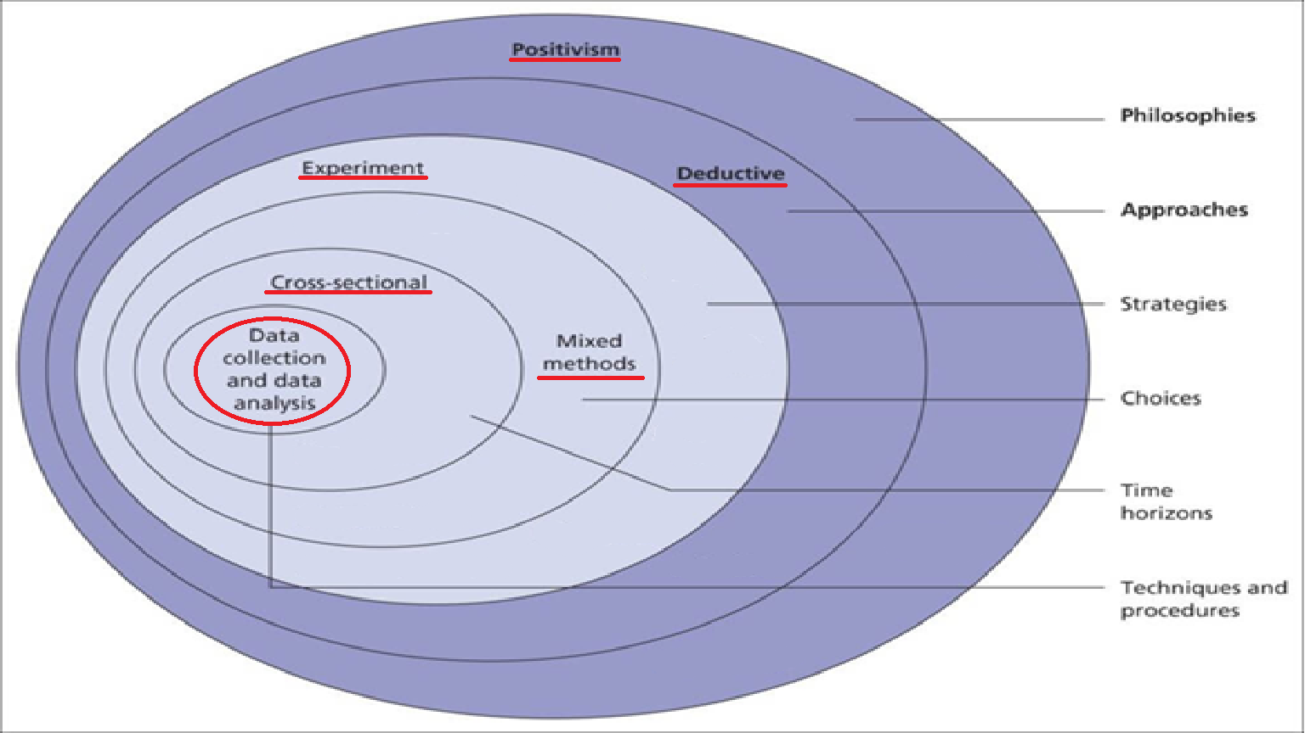 [Figure 1]
The research design for this section follows a research onion, which includes different layers to the methodology as shown here
[Figure 2][38]

3.1 Research Philosophy
This study follows the positivist research philosophy, which emphasizes objective, observable, and measurable data. Positivism aligns with the nature of digital forensic research, as the results must be replicable, quantifiable, and free from subjective bias. By comparing Cellebrite and Autopsy using structured experiments, the study ensures that forensic tool evaluations are conducted based on empirical evidence and standardized forensic methodologies.

3.2 Research Approach
The study adopts a deductive research approach, where forensic theories and best practices are used as a foundation to guide the comparative analysis. The research follows a structured framework that tests existing forensic models by evaluating Cellebrite and Autopsy under controlled conditions. This deductive approach ensures that the findings are aligned with forensic validation standards, making them reliable for practitioners and legal contexts.

3.3 Research Strategy
This study employs a systematic literature review (SLR) combined with an experimental comparative analysis. The SLR ensures that only relevant, high-quality academic sources are used to build a strong theoretical foundation, while the comparative analysis allows for empirical testing of forensic tools. The methodology follows these key steps:
- Systematic Literature Review – A structured search strategy was implemented to identify relevant research on forensic tools, applying predefined inclusion and exclusion criteria.
- Device Selection – A controlled dataset was created using a smartphone and a storage device (e.g., USB drive or hard disk) to simulate real-world forensic scenarios.
- Forensic Imaging – Both Cellebrite and Autopsy were used to extract data from identical sources.
- Performance Metrics – Data was compared based on:
  - Time required to complete forensic extraction.
  - Number of artifacts recovered (e.g., call logs, messages, app data, system logs, deleted files).
  - File system and metadata integrity.
  - Ease of usability and forensic reporting quality.
The SLR ensured a structured theoretical framework, while experiments provided quantifiable performance comparisons, forming a robust methodological approach.

3.4 Research Choices
This study employs a mixed-method approach, integrating:
- Quantitative Analysis – Numerical comparison of forensic tool performance (e.g., efficiency, number of artifacts recovered).
- Qualitative Analysis – Observations regarding forensic workflow usability, interface design, and reporting structure.
This combined method ensures a comprehensive assessment of Cellebrite from both a technical performance and user experience perspective.

3.5 Time Horizon
The research follows a cross-sectional study design, meaning data is collected at a single point in time rather than across multiple phases. This approach captures the current forensic capabilities of Cellebrite, making it relevant for contemporary forensic investigations.

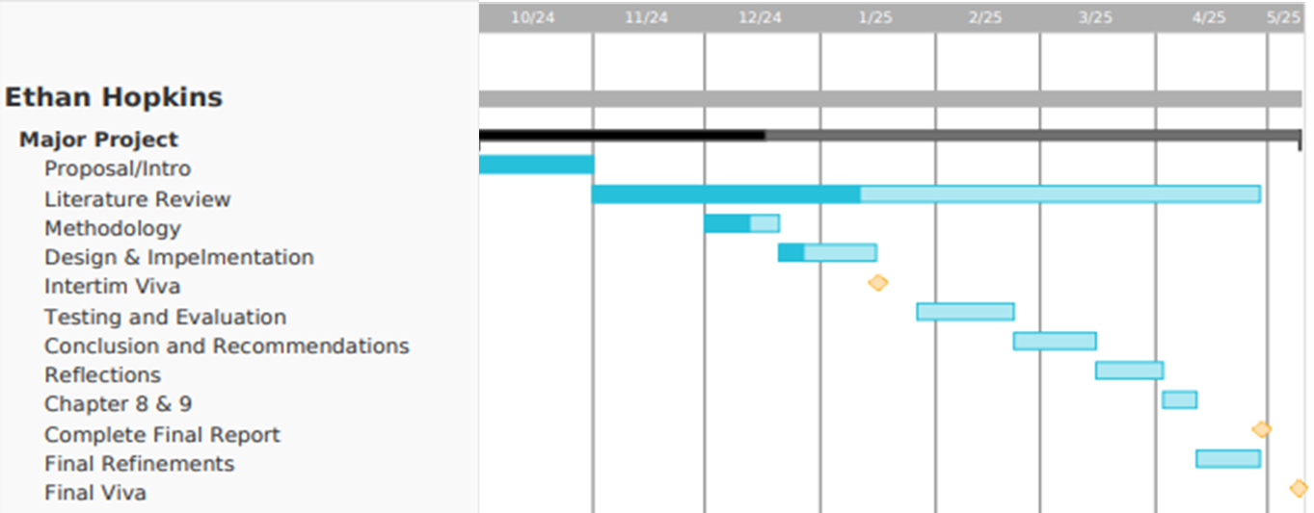
[Figure 3]

3.6 Data Collection
The data collection process follows a structured forensic testing framework, ensuring consistency and repeatability:
- Forensic Extraction Experiments – Controlled forensic extractions using Cellebrite.
- Performance Measurement – Logging of extraction times and total artifacts recovered.
- Comparison Tables & Documentation – Structured recording of results, including:
  - Data acquisition time.
  - Types and volume of data recovered.
  - Ease of forensic workflow execution.
  - Accuracy of forensic reports.

3.7 Ethical Considerations
This study follows strict ethical standards in digital forensics, ensuring:
- No real-world sensitive or private data is used.
- All forensic tests use pre-configured test environments.
- Compliance with GDPR, the Computer Misuse Act, and forensic best practices.
- Results are presented with full transparency and no bias toward any forensic tool.

3.8 Limitations of the Methodology
Potential limitations include:
- The study is limited to a single extraction per tool, meaning long-term tool performance trends are not evaluated.
- Only one commercial (Cellebrite) forensic tool will be tested, limiting comparisons with alternatives like Magnet Axiom or EnCase.
- Certain advanced forensic scenarios, such as cloud forensic extractions or deep memory analysis, may not be included due to software constraints.

3.9 Contingency Plan
- Data Collection and Experimental Issues
Risk: Technical issues could be faced during the data extraction, such as incompatibility, software issues or file corruption.
Plan: Back up all successful extractions. If any incompatibility issues are found with the tools, a different open-source toolkit will be used such as iLEAPP.

- Ethical and Regulatory Constraints
Risk: Ethical concerns surrounding the data being used and shown in the experiment report
Plan: To directly prevent the risks associated with ethical approval and compliance issues, purely synthetic data will be used.

- Tool Availability and Licensing Issues
Risk: Restricted access or unexpected licensing issues with Cellebrite, or open-source toolkits being abandoned or not updated
Plan: Alternative commercial forensic tools such as Magnet AXIOM or XRY will be utilized. Additionally, an expanded evaluation using Autopsy and other open-source solutions may be performed to maintain comparative analytical depth.

- Time Management and Resource Constraints
Risk: Unforeseen delays impacting the research timeline.
Plan: The scope of experimental testing will be reduced, prioritizing essential metrics such as extraction times and the number of artifacts recovered. The project timeline includes allocated buffer periods to allow flexible adjustments if required.

3.10 Conclusion
By integrating a systematic literature review, structured forensic testing, and mixed-method analysis, this methodology ensures a robust, objective, and replicable comparison of Cellebrite and Autopsy. The research onion framework strengthens the study’s rigor, ensuring that both theoretical and experimental findings are aligned with digital forensic best practices.

Chapter 4 - DESIGN & IMPLEMENTATION

4.1 INTRODUCTION
This chapter outlines the structured design and implementation processes focused primarily on evaluating the effectiveness of Cellebrite forensic software. The chapter is divided into two phases, with Phase 1 concentrating on the effectiveness assessment of Cellebrite using multiple datasets across different mobile platforms, and Phase 2 (optional) involving a comparative analysis using open-source forensic tools if time permits.

4.2 PROBLEM FORMULATION
The primary research aim is to evaluate the effectiveness of Cellebrite in extracting various forms of digital data from multiple mobile devices. This assessment will involve:
- Two pre-made online datasets, one each for iOS and Android.
- One custom dataset created on a physical device containing encrypted and deleted data

4.3 DESIGN
The experimental design involves clearly defined criteria for dataset selection and effectiveness measurement.

4.3.1 Dataset Selection
A total of three mobile devices will be chosen for analysis:
iOS Device Selection:
Phone | OS | Image Size (GB) | Encrypted Data | Deleted Data | nonstock applications
iPhone SE | IOS 13.1.4 | 9.63 | Yes | Yes | 41
iPhone 8 | IOS 15.3.1 | 16.65 | Yes | Yes | 54
iPhone 11 | IOS 16.1.2 | 20.01 | Yes | Yes | 56
iPhone 11 | IOS 17.3 | 22.12 | Yes | No | 55

Pre-made IOS dataset Selection
After considering these 4 options, the iPhone 11 running IOS 16.1.2 will be selected due to it being the newest IOS available that contains both encrypted and deleted data, as well as it having the most app installed. This will give the most insight into this experiment due to it having a wider variety of applications, different types of data, as well as giving us the most realistic results as the phone is running a more common operating system when compared against the older IOS 13 and IOS 15.

Android Device Selection:
Phone | OS | Image Size (GB) | Encrypted Data | Deleted Data | nonstock applications
Pixel 5a | Android 13 | 19.83 | Unknown | Unknown | Unknown
Pixel 7a | Android 14 | 18.41 | Yes | Yes | 53

Pre-made Android dataset Selection
The Pixel 7a will be selected to be used in this experiment due to it being the most recent of the two phones, running newer software granting us a more relevant outcome despite the smaller image size. As well as this, the phone is loaded with encrypted and deleted data whereas the pixel 5a is not clearly stated to have either.

This selection of phones with a premade dataset will grant a better understanding into the capabilities of Cellebrite, with both phones running recent operating systems with robust security systems, a realistic image size, and a variety of data types and applications.

Custom Dataset Device:
- Real-world phone setup explicitly for this research.
- Dataset includes deliberately placed encrypted and deleted data to assess Cellebrite’s capabilities comprehensively.

The phone is a Samsung A13 running Android 14 which has been provided by UWTSD. It contains a back log of data that has been designed for educational purposes. On top of this back log, self-made data has been added for the purpose of this experiment including deleted images and encrypted images with the purpose of giving this experiment a baseline figure when looking closer at the capabilities of extracting both data types.

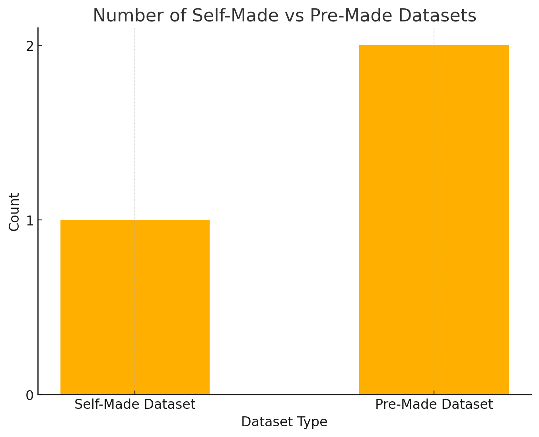
[Figure 4]
Here is the graph to show the number of selected devices per dataset type.

4.3.2 Effectiveness Measurement
Effectiveness will be quantified through comparative analysis:
- Extracted data versus actual dataset contents.
- Specific categories to be evaluated include:
  - Images
  - Call logs
  - Text messages
  - Application data
  - Deleted data recovery
  - Encrypted data handling
Effectiveness Calculation Example:
- If the dataset contains 100 images and Cellebrite extracts 90, the effectiveness for this category is 90%.
- Each data category's effectiveness will be separately calculated, analysed, and tabulated clearly for comparison across all devices.

4.3.3 Environmental Setup
Cellebrite Physical Analyzer v7.66 (latest stable version) will be utilized, configured for physical data extraction. with a second option of using a logical extraction if a physical extraction is not possible due to software limitations. The extraction will be conducted via direct physical connection to ensure maximum data recovery capability.

4.3.4 Risk Management and Contingency Plan
Potential risks identified include data corruption, extraction failures, and compatibility issues. Mitigation strategies include maintaining backup copies of datasets and using alternate compatible hardware if available

4.3.5 Ethical and Legal Considerations
The experiment strictly follows ethical guidelines, including GDPR compliance, ensuring all data is synthetic or educational, thereby preventing any violation of privacy standards or institutional policies.

4.4 IMPLEMENTATION – Phase 1 Cellebrite
This experiment will be conducted in a closed environment inside the UWTSD computer lab using UWTSD supplied computers, as well as the Cellebrite toolkit.

Below are screenshots showcasing the steps taken to prepare the experiment for each phone.
iPhone 11 Extraction set up
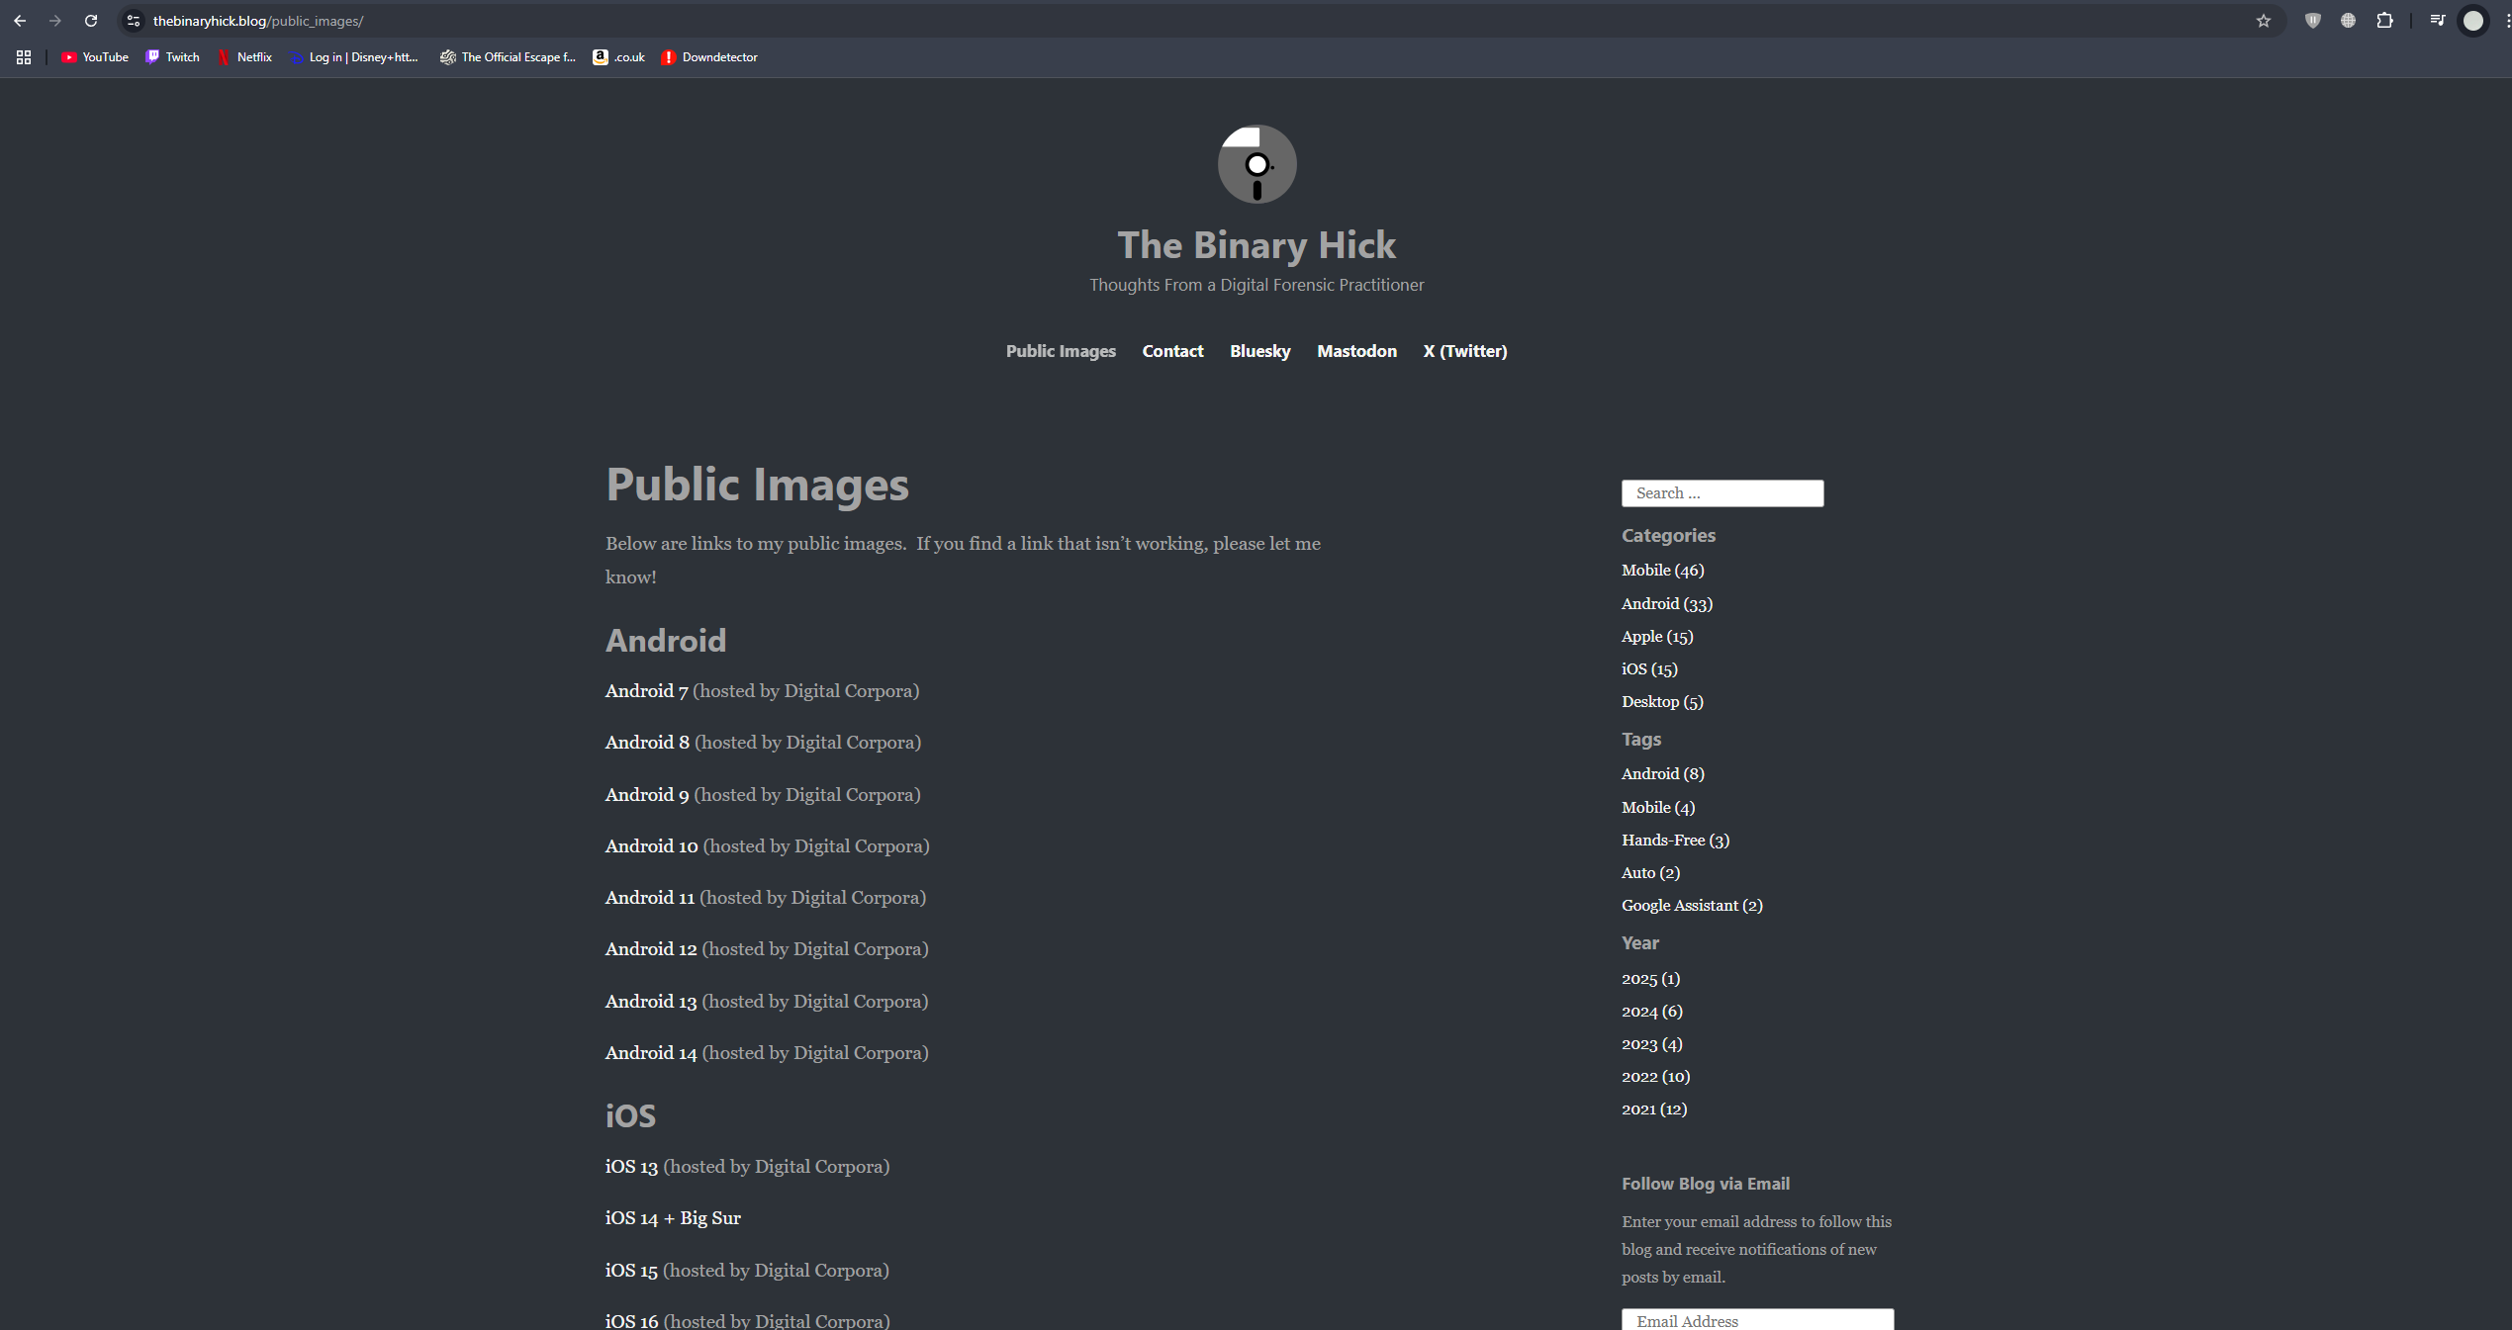
[Figure 5]
This image shows the website (The Binary Hick) where the iPhone 11 forensic image was sourced for use in the experiment. [40]

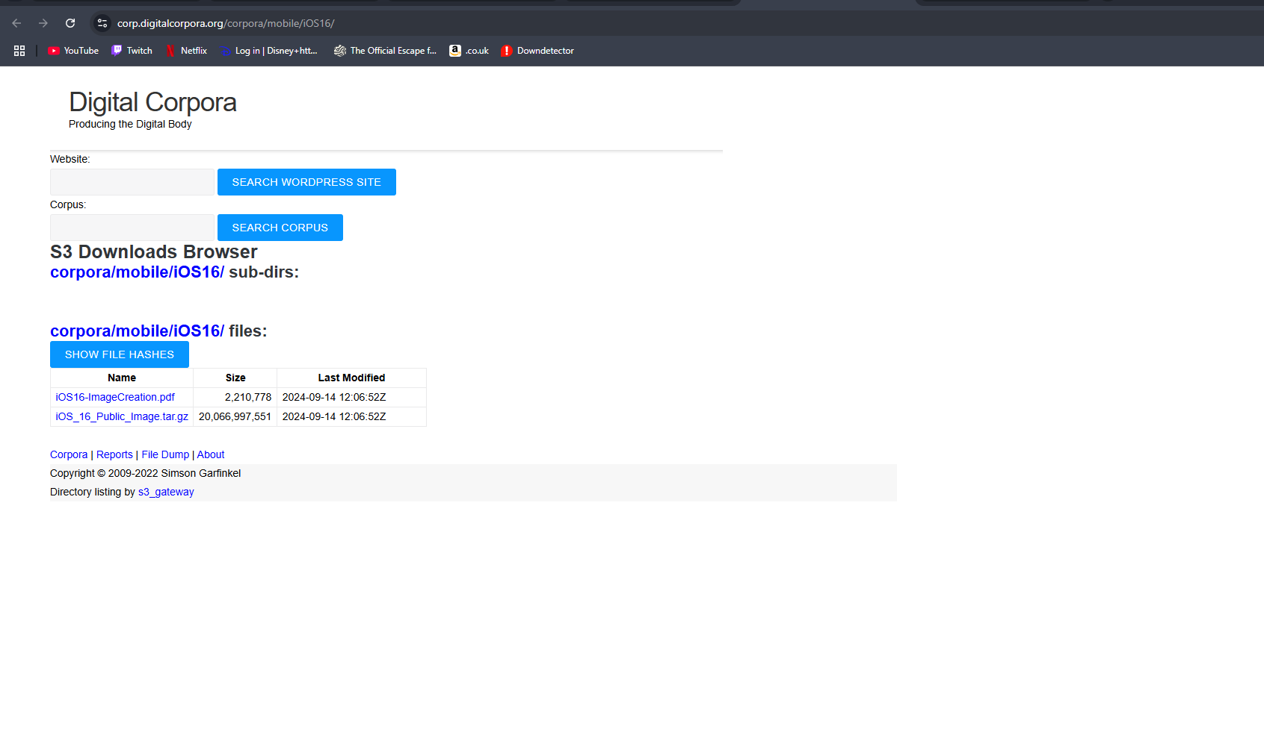[Figure 6]
Here is shown the download page for the iOS16 public image dataset from Digital Corpora. This dataset was used to create the pre-made data environment for the iPhone 11 forensic extraction during the experimental phase. [41]

Pixel 7a Extraction set up
[Figure 7]
This image shows the website (The Binary Hick) where the Pixel 7a forensic image was sourced for use in the experiment. [40]

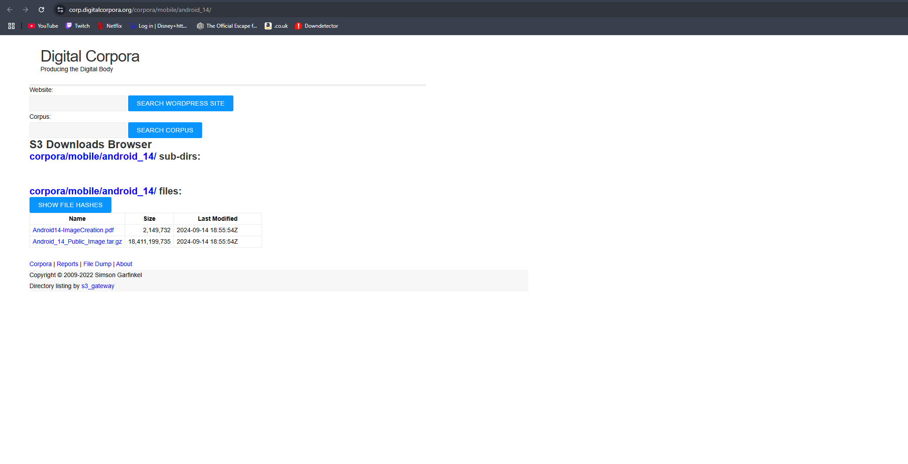[Figure 8]
This screenshot displays the Digital Corpora website where the Android 14 forensic image was downloaded for use in the experiment. [42]

Samsung A13 Extraction set up
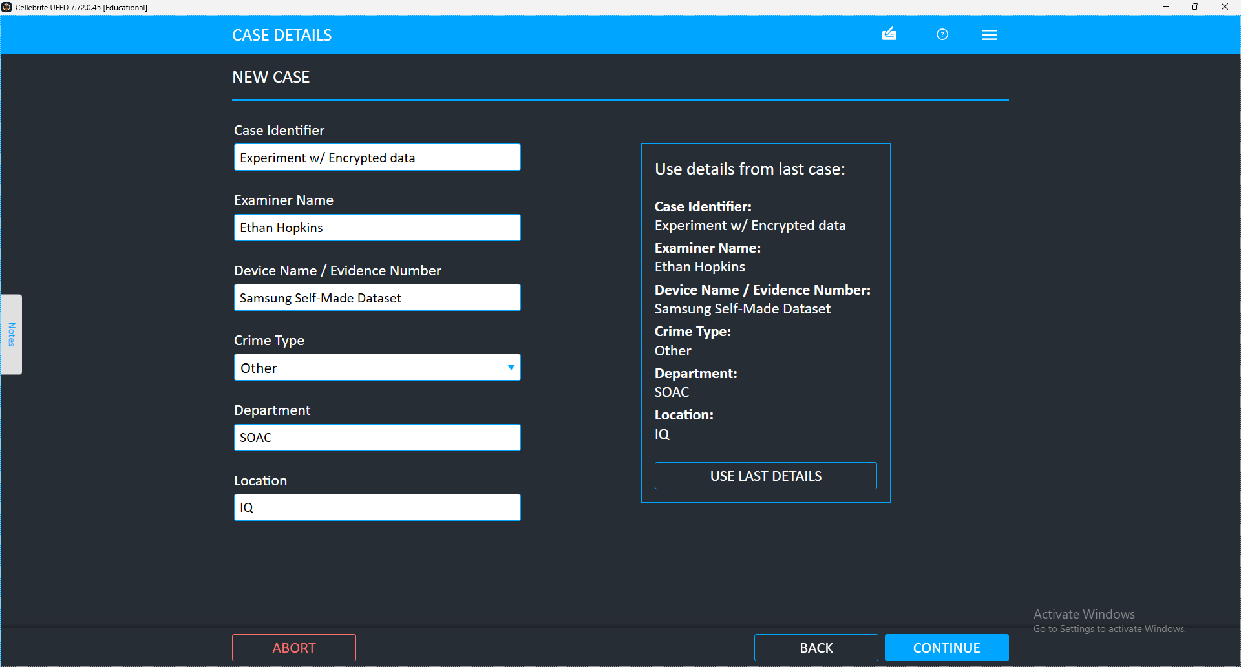[Figure 9]
A new case was created for the extraction of the A13.

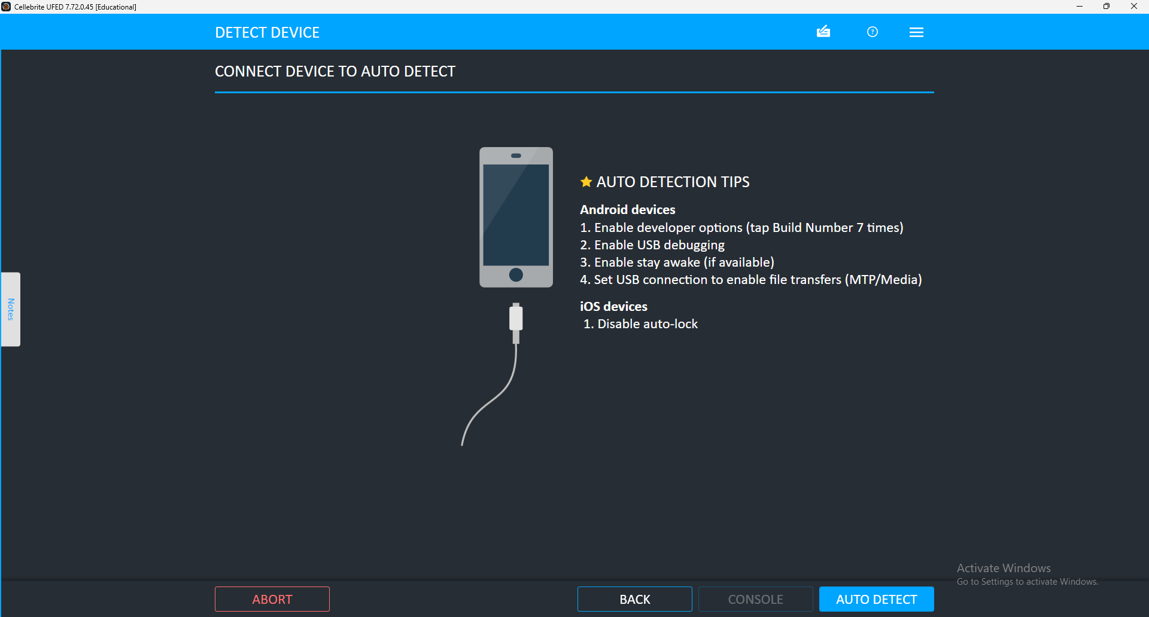
[Figure 10]
The auto detect feature from the Cellebrite software was used to detect the exact model of the phone.

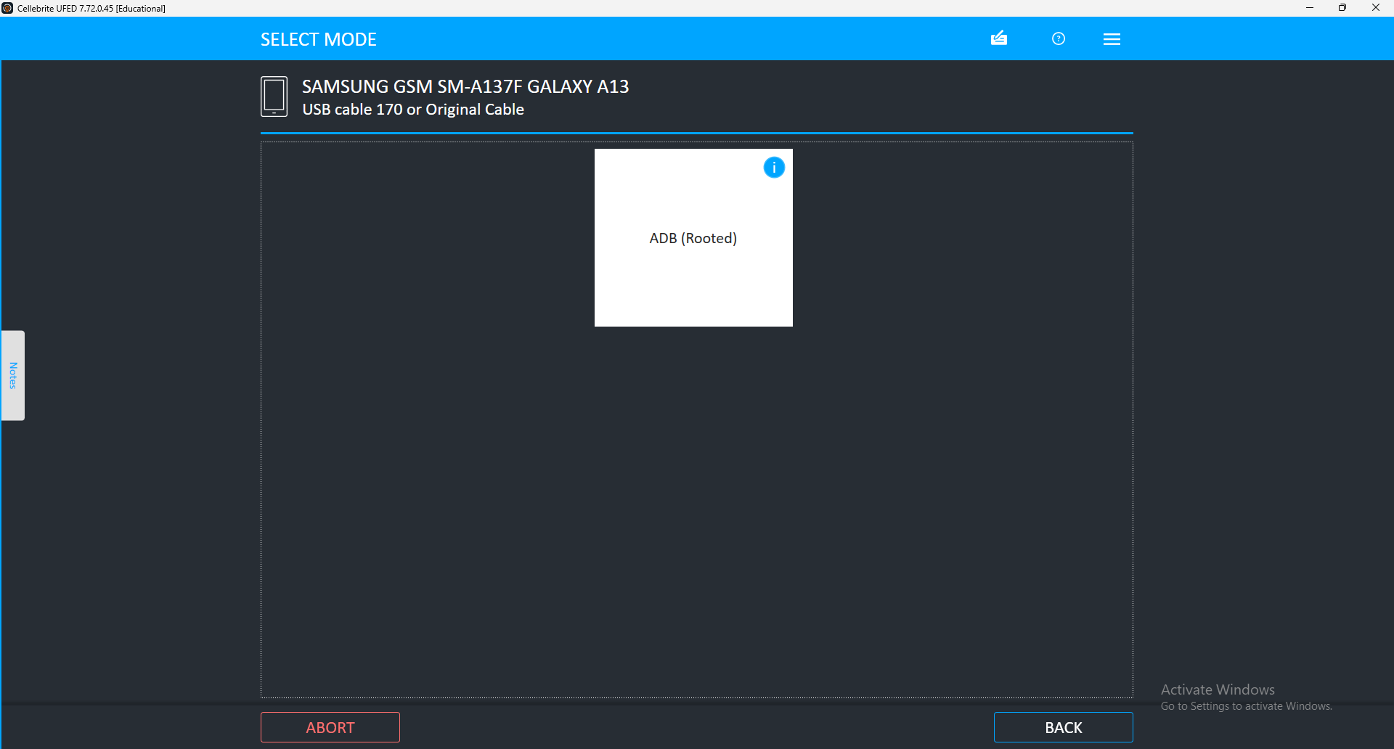
[Figure 11]
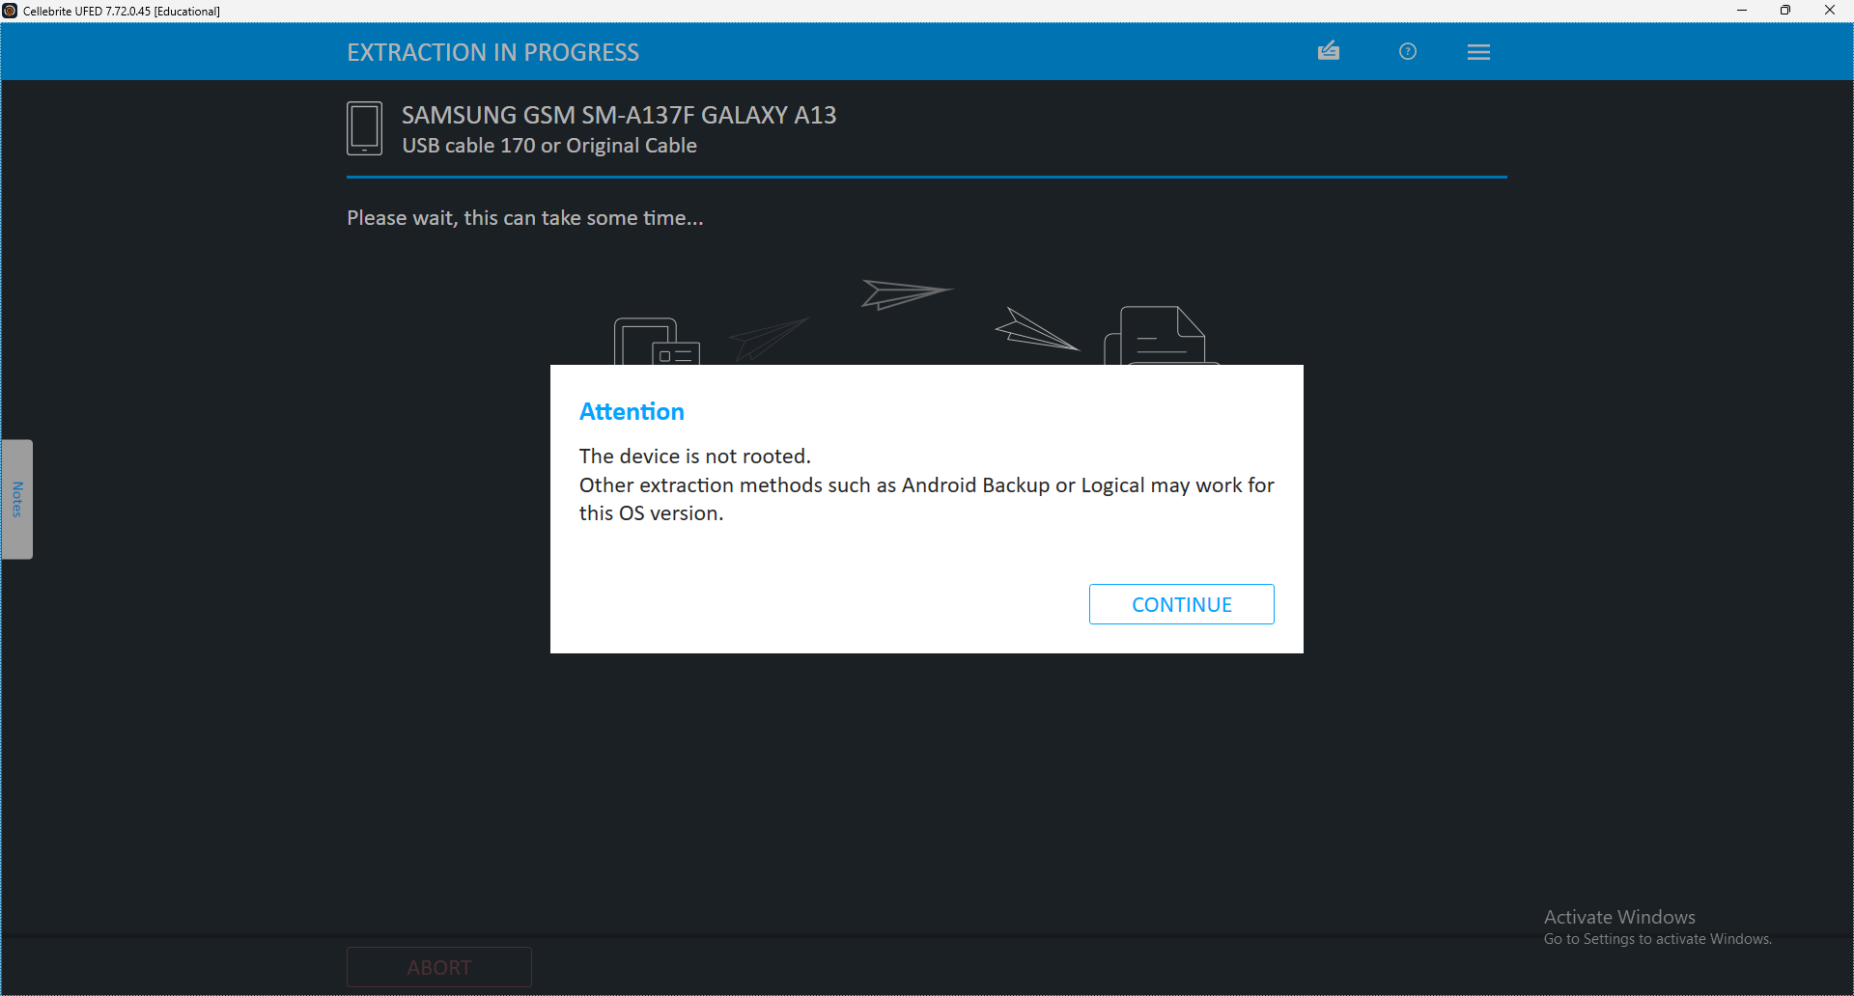
[Figure 12]
These two screenshots show that a physical extraction was attempted; however, the phone was not rooted. A rooted phone is crucial for physical extractions. This was not possible to work around as in this scenario, rooting the phone was not an option due to restrictions surrounding the phone being used, as it was supplied by UWTSD.
In this case, the Advanced Logical extraction type was selected, allowing the experiment to also cover different types of extractions and how they may differ. However, this means that a direct comparison between the self-made data sets and pre-made data sets will not be comparable.

Why must a phone be rooted?
A phone must often be rooted to perform a physical extraction because:
- Physical extraction aims to copy the entire memory of a device (including deleted data, hidden system areas, protected app data, etc.).
- Normal user permissions, including admin ones, do not allow access to everything stored on a phone, especially on Android devices.
- Rooting grants superuser access to the full file system — bypassing security restrictions that would otherwise block access to critical parts of memory (such as private app data, system folders, unallocated space where deleted files reside).
In short:
Rooting lifts the operating system's security controls, allowing forensic tools to access deeper memory layers that logical extractions or standard access cannot reach. [43]

4.5 OPTIONAL PHASE 2 – COMPARISON WITH OPEN-SOURCE TOOLS
If time allows, Phase 2 will involve repeating the dataset extraction processes using open-source forensic tools (e.g., Autopsy) to provide comparative analysis results. This phase will follow the same structured design and implementation approach outlined for Phase 1.

4.6 CONCLUSION
This chapter clearly describes the structured and systematic approach employed to evaluate the effectiveness of Cellebrite forensic software, ensuring transparency, reproducibility, and comprehensive analysis. The optional comparative analysis phase provides additional context and insight if feasible.

Chapter 5 – Testing and Evaluation

5.1 Introduction
This chapter will cover the experimental phase of the project, discussing how the experiment was carried out, with accompanying screenshots that were documented throughout the experimental process, As well as a complete overview of the results that were attained. Following this will be an evaluation of the results, including a critical analysis and any limitations that were noted.
It should be noted that both pre-made data sets were extracted by physical extraction, and the self-made data set tests were performed using logical extraction. This was due to limitations using the Cellebrite toolkit when testing the Samsung A13 during testing, however this will be used to an advantage to further compare Cellebrite when either extraction type is used.

5.2 Experimental Process
To begin this experiment, both pre-made data sets were downloaded, since these phones were not physically in hand, the steps of extracting the data from these phones not required. For the third phone, with the self-made data set, a Cellebrite toolkit was used to extract an image file of the phone, along with the Cellebrite software that is required. After connecting the Samsung A13 to the Cellebrite toolkit using the provided USB Type-C cable, the extraction process was initiated.

Samsung A13 Extraction Process
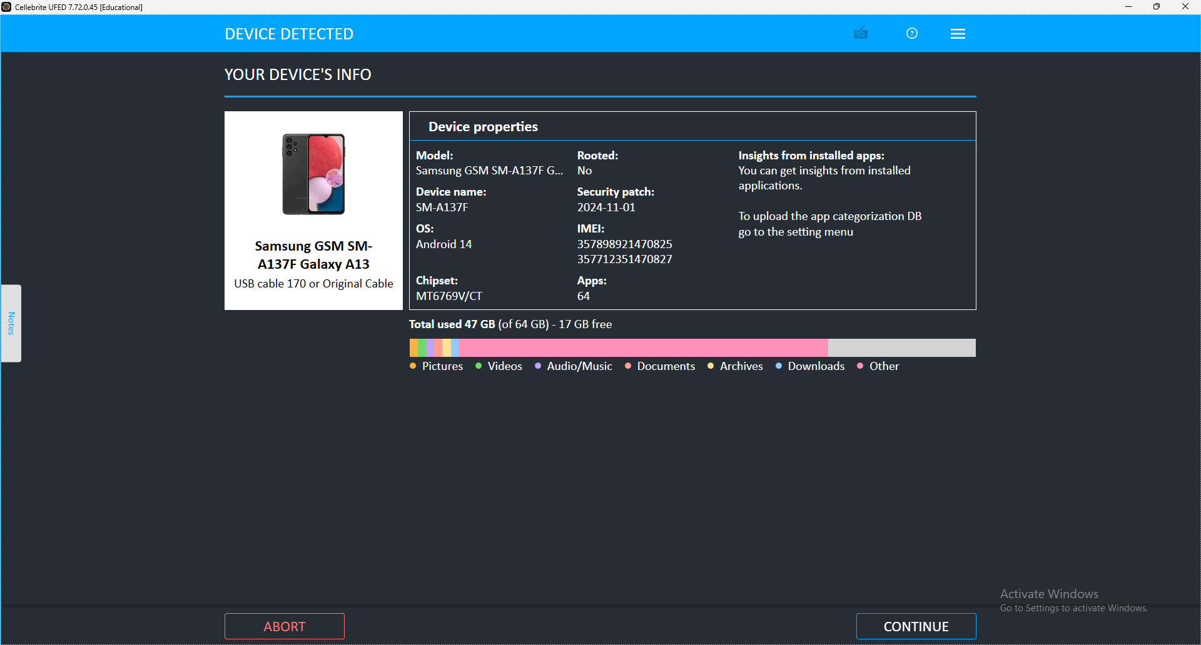[Figure 13]
After reloading the case, an attempt was made using the “Advanced Logical” extraction type.
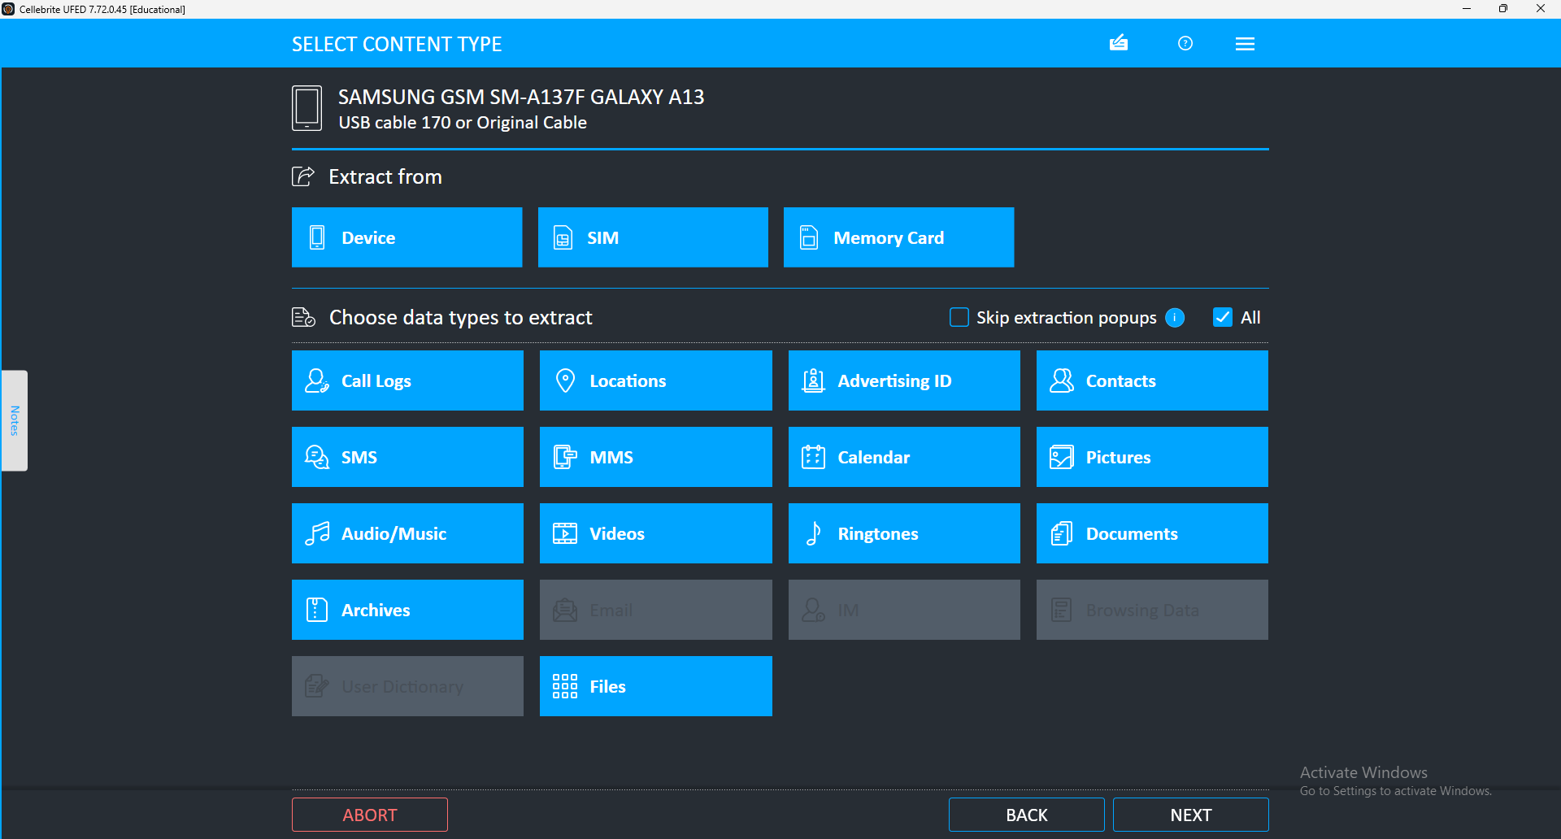[Figure 14]
All data types were selected to be extracted, to allow as much information as possible to be examined.
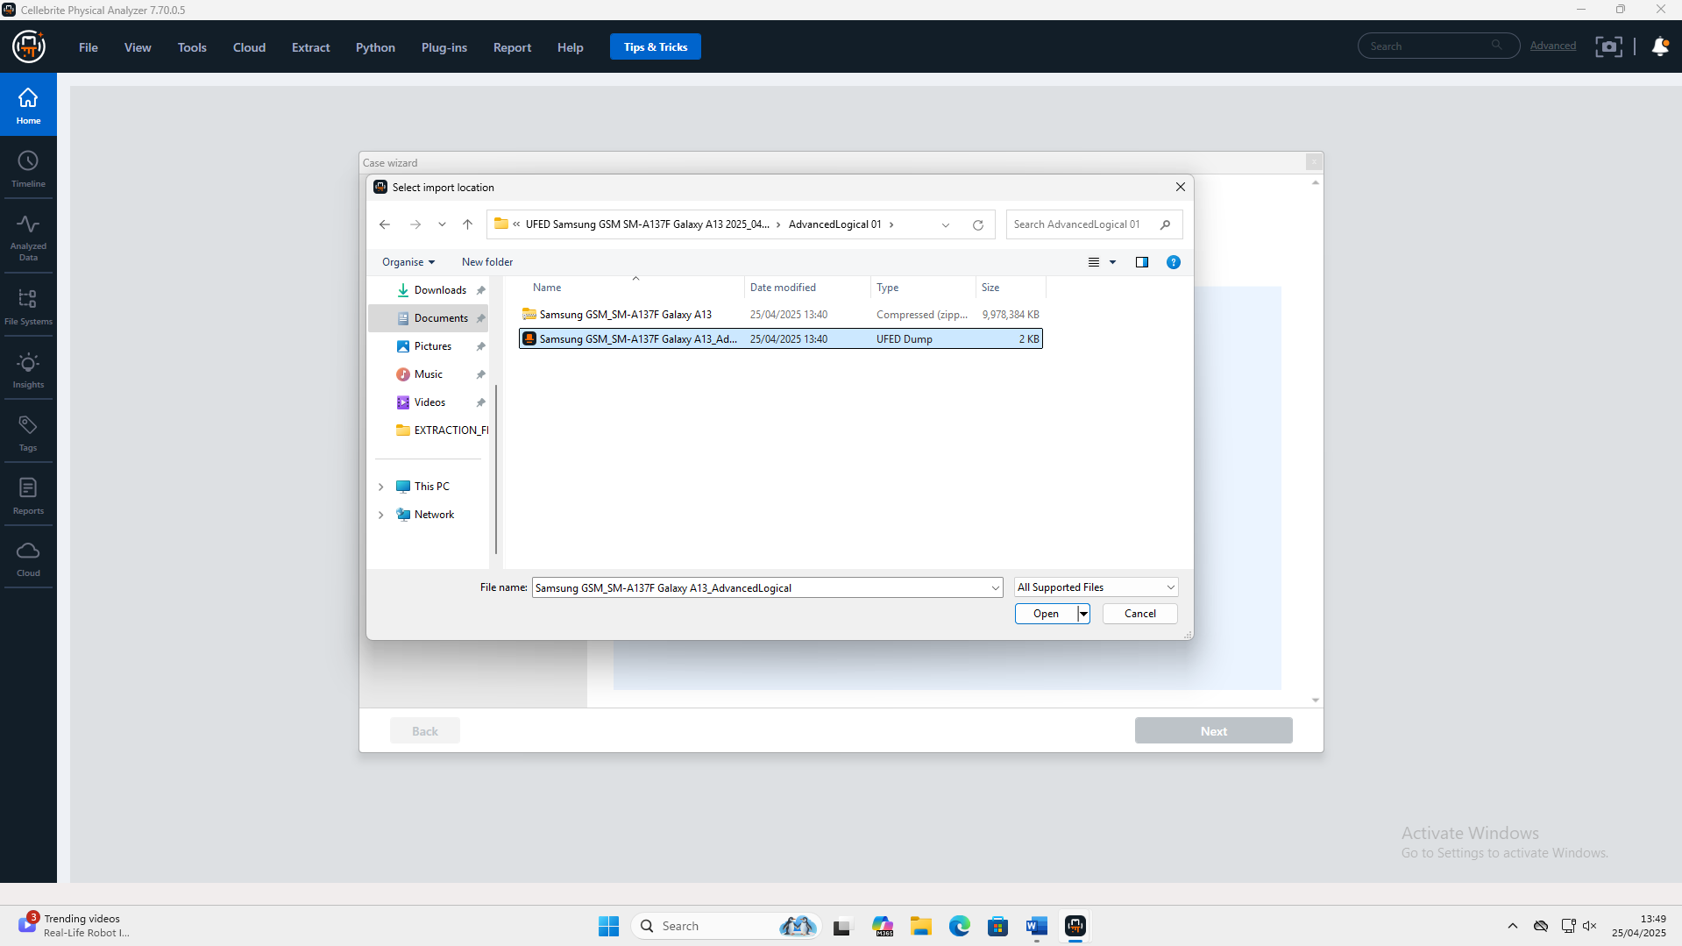
[Figure 15]
After the image created was complete, the Cellebrite Physical Analyser application was used to complete the extraction.
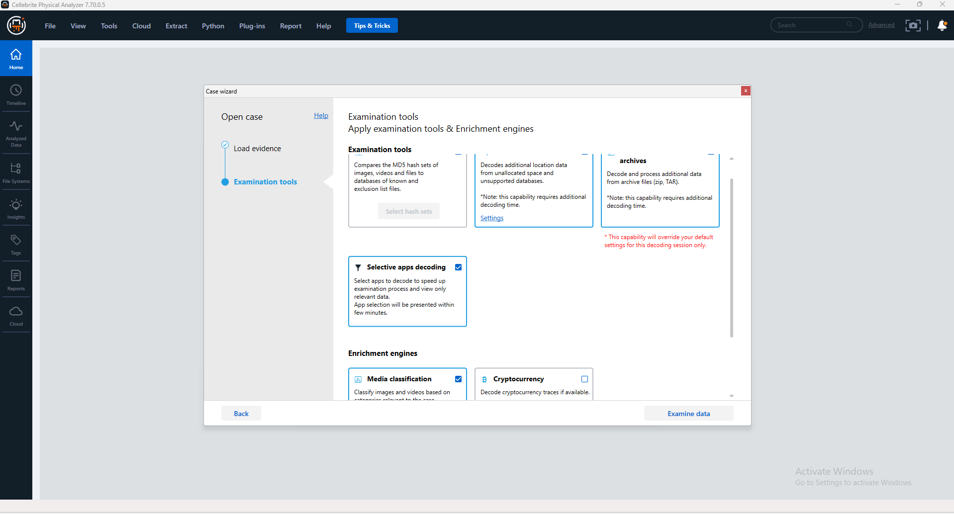
[Figure 16]
All data types were selected for the extraction.

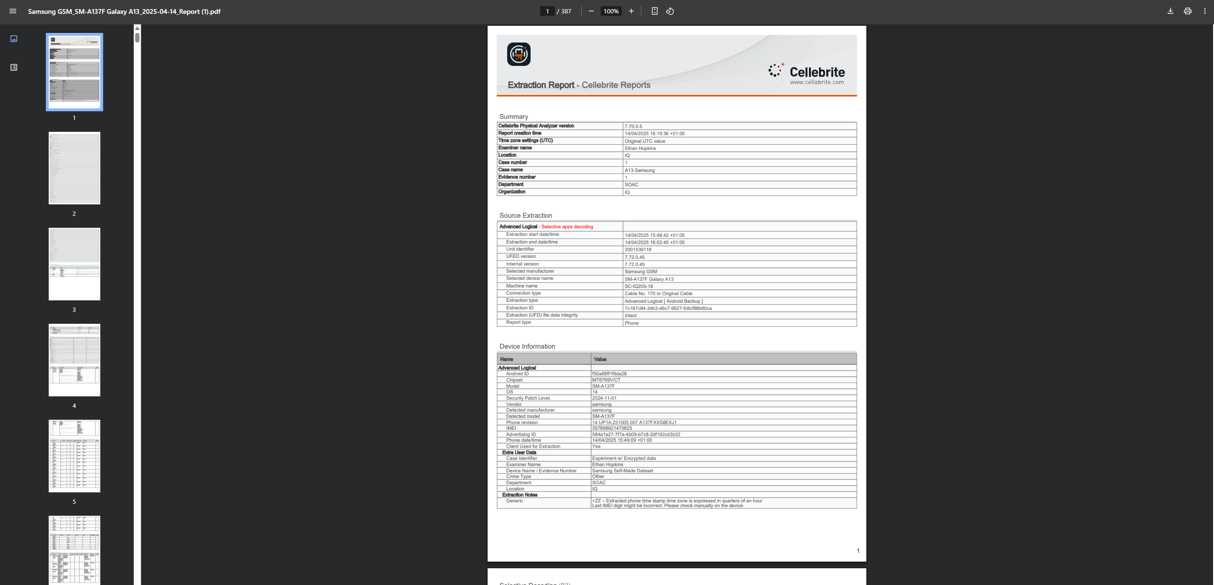
[Figure 17]
The final report for the A13, generated by Cellebrite Physical Analyzer, was used to document the results and compile all the tables presented in the experiment.

iPhone 11 Extraction Process
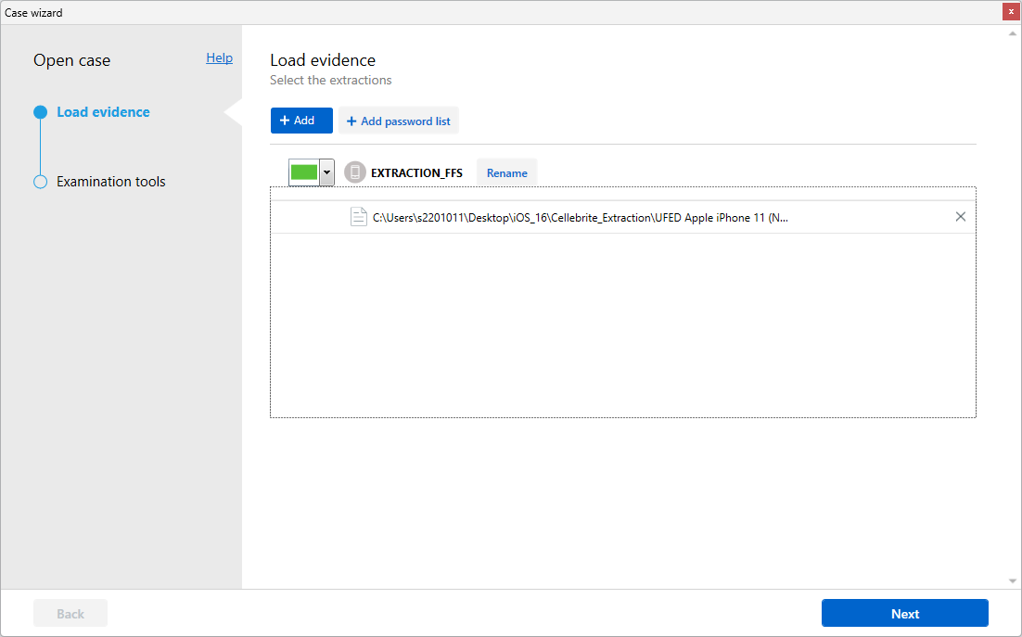
[Figure 18]
Selecting the file made by the Cellebrite UFED software for the iPhone 11.
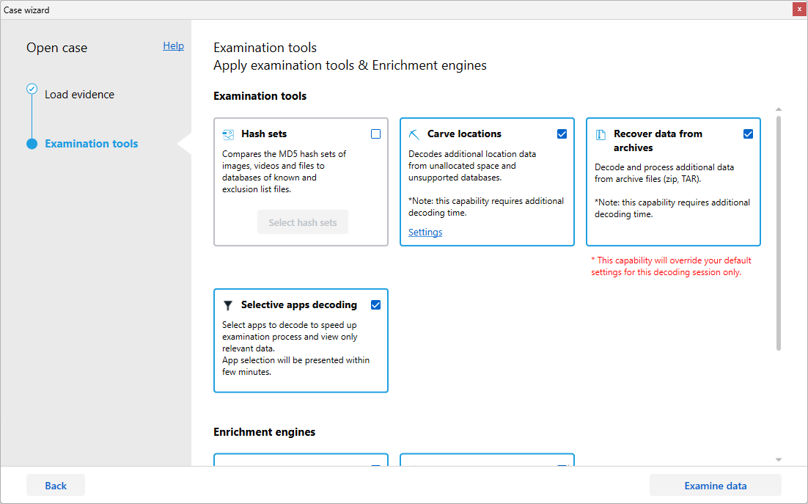
[Figure 19]
Selecting to include all data that is available on the iPhone 11.

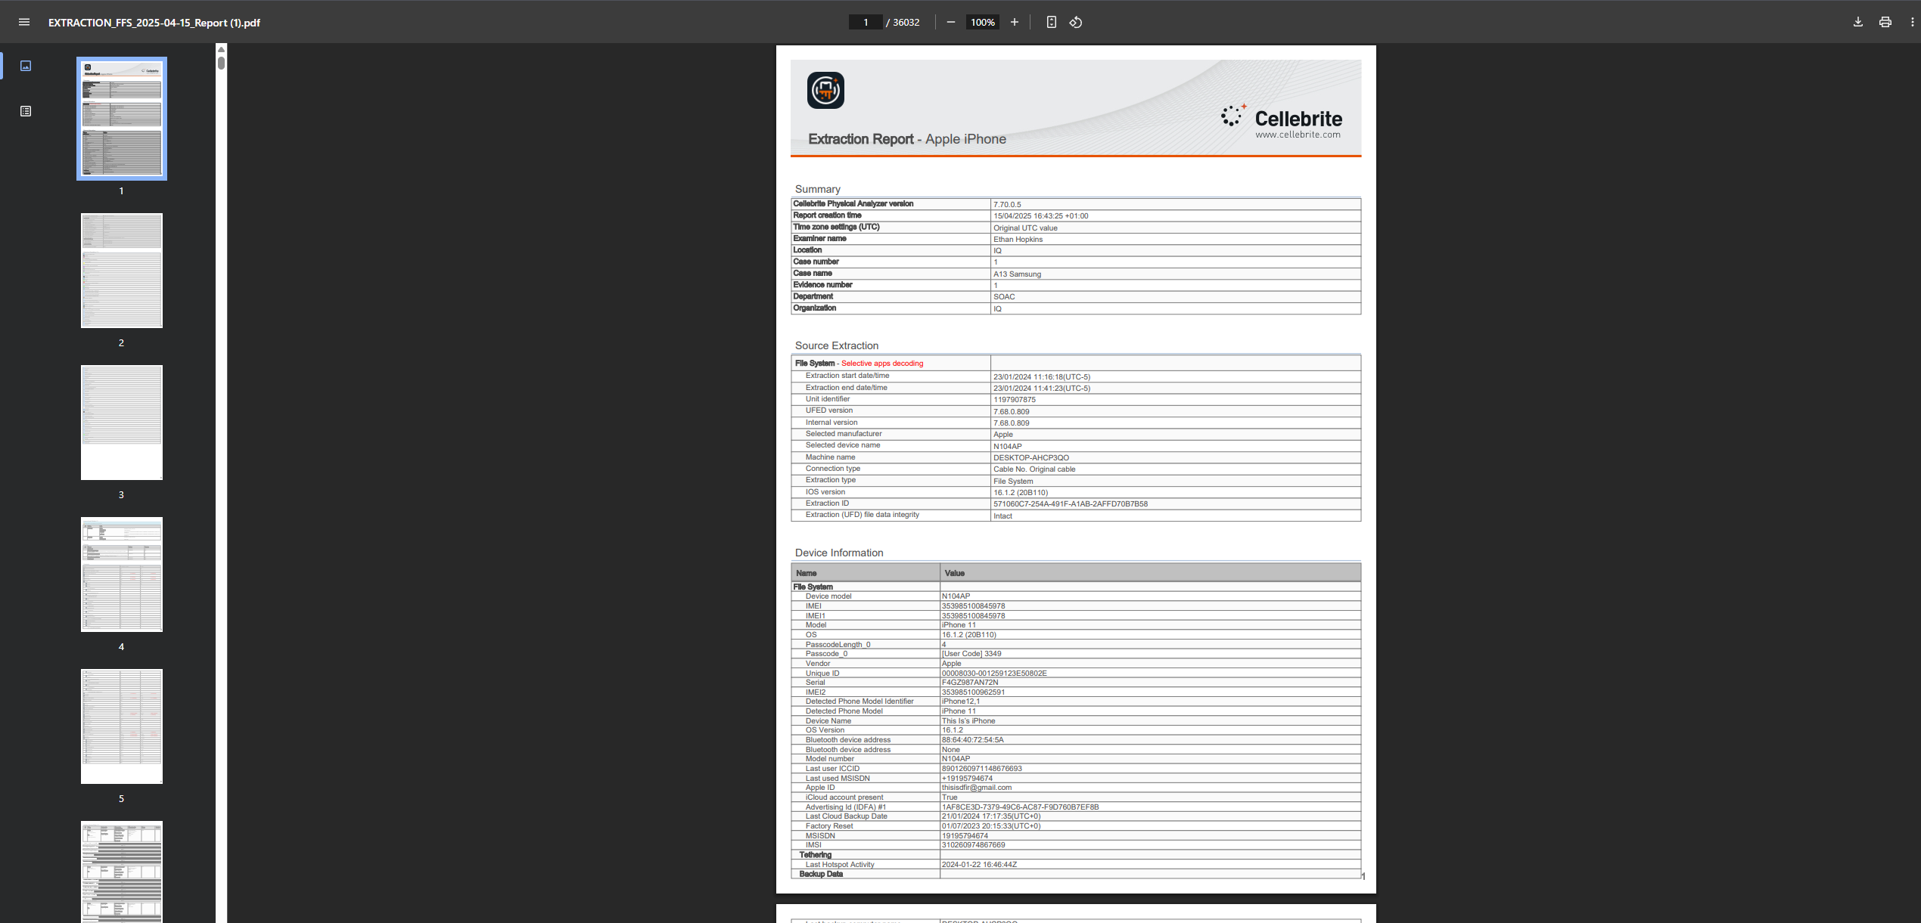[Figure 20]
The final report on the iPhone 11 created by Cellebrite Physical Analyser, which was used to record all the results and to create all the tables for the experiment.

Pixel 7a Extraction Process
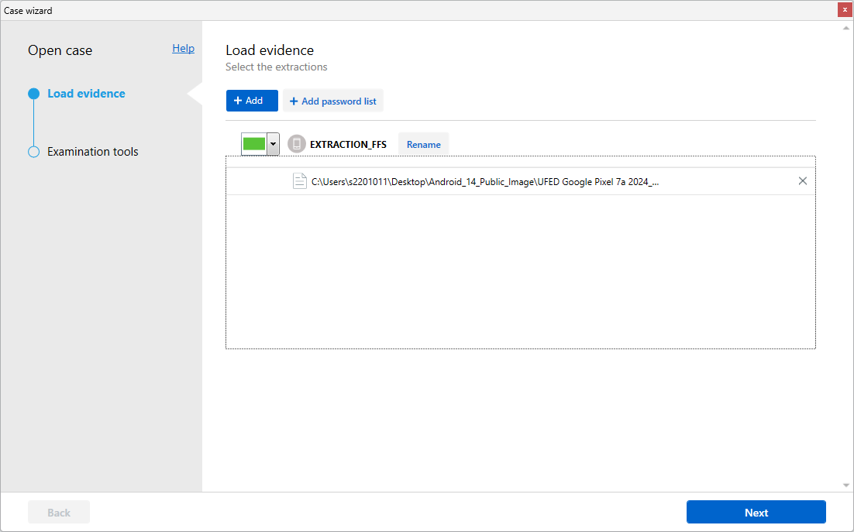
[Figure 21]
Selecting the file created by the Cellebrite UFED software for the Pixel 7a.

[Figure 22]
Selecting to include all data that is available on the Pixel 7a.
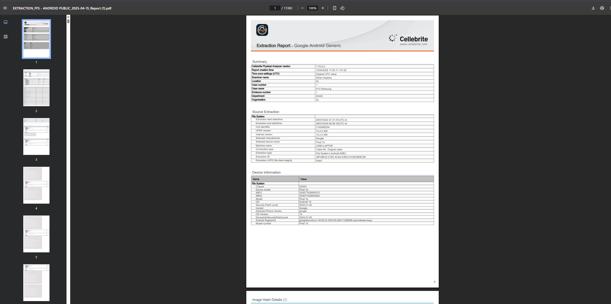[Figure 23]
The final report on the iPhone 11 created by Cellebrite Physical Analyser, which was used to record all the results and to create all of the tables for the experiment.

5.3 Results
Number of Non-Stock Applications Comparison
Device | Extraction Type | Non-Stock Apps Present | Non-stock Apps Extracted | Non-Stock Apps not Extracted | Extraction Rate (%) | Notes
Samsung A13 | Logical | 56 | 14 | 42 | 25% | No data from apps were extracted
Pixel 7a | Physical | 53 | 53 | 0 | 100% | All apps including data
iPhone 11 | Physical | 56 | 56 | 0 | 100% | All apps including data
This table above shows the number of non-stock applications that were installed on the device, and how many were extracted by Cellebrite. The reports do give access to see what applications have been installed and when they were installed, however that information is not being used to judge the effectiveness of Cellebrite unless specifically mentioned.
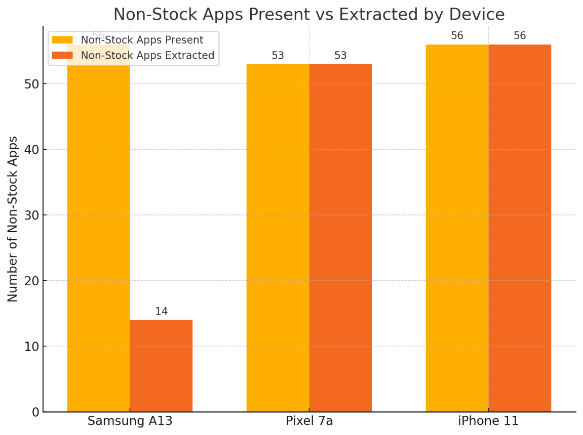
[Figure 24]
A graph to show how many apps were extracted compared to those available.
Number of Messages Comparison
Device | Extraction Type | Messages Present | Messages Extracted | Messages not Extracted | Extraction Rate (%) | Notes
Samsung A13 | Logical | 76 | 76 | 0 | 100% | All messages across multiple applications
Pixel 7a | Physical | N/A | N/A | N/A | N/A | Extraction unsuccessful for this data
iPhone 11 | Physical | 97 | 97 | 0 | 100% | All messages across multiple applications
This table shows the number of messages present on each device and how many were extracted by Cellebrite. Unfortunately, due to unknown limitations, the Pixel 7a extraction was unable to extract any messages. These results will not be considered when measuring the effectiveness as it is unclear if this was due to a fault with Cellebrite or the pre-made files.
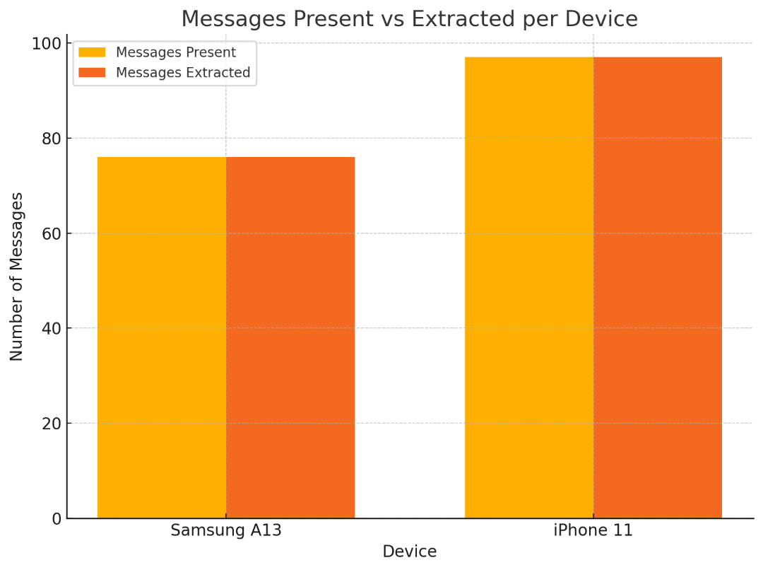
[Figure 25]

Graph showcasing the results from the previous table. Both achieved 100% extraction rates. Pixel 7a was not included due to lack of results in the experiment.

Number of Call Logs Comparison
Device | Extraction Type | Call Logs Present | Call Logs Extracted | Call logs not Extracted | Extraction Rate (%) | Notes
Samsung A13 | Logical | 17 | 17 | 0 | 100% | All data and details
Pixel 7a | Physical | N/A | N/A | N/A | N/A | Extraction unsuccessful for this data
iPhone 11 | Physical | 77 | 77 | 0 | 100% | All data and details

This Table shows the number of call logs located in each device, data on each contact was also available for each device, except the Pixel 7a, which had issues extracting the call logs much like the messages.
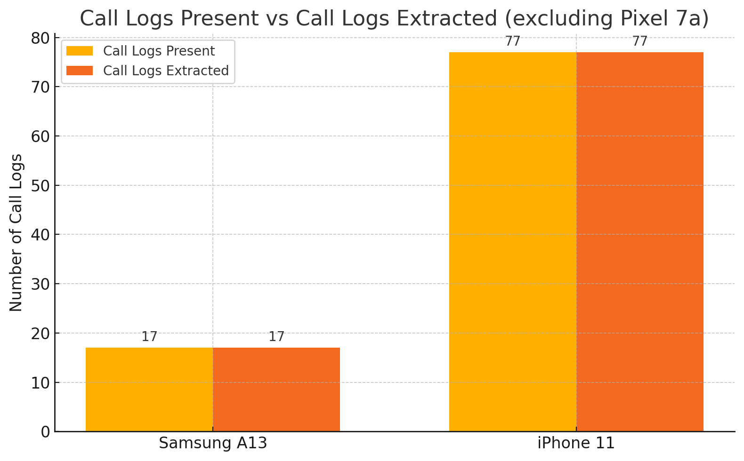[Figure 26]
Comparison of call log extraction success for the Samsung A13 and iPhone 11. Both devices achieved a 100% extraction rate, with all present call logs successfully recovered. The Pixel 7a was excluded due to extraction failure for this data type.

Number of Images Comparison
Device | Extraction Type | Images for Testing | Images Extracted | Images not Extracted | Extraction Rate (%) | Notes
Samsung A13 | Logical | 731 | 711 | 20 (Encrypted images) | 97.26% | 100% not including encrypted images
Pixel 7a | Physical | Unknown | 31585 | Unknown | Unknown | Includes a huge number of images, thumbnails, etc.
iPhone 11 | Physical | Unknown | 49722 | Unknown | Unknown | Includes a huge number of images, thumbnails, etc.
The table above shows the number of images found on each device, although the true number of images on the pre-made data sets was unknown, it clearly shows the difference between a physical and logical extraction as an unproportionate number of images were extracted despite the difference in image files between them
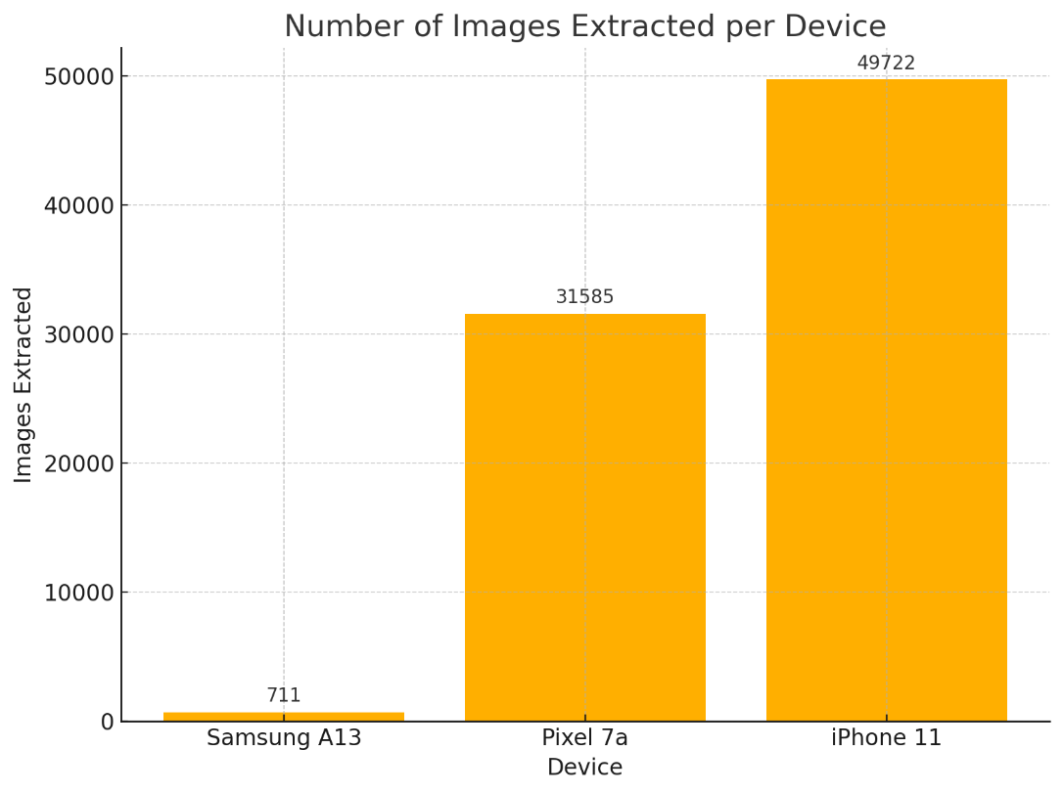[Figure 27]
This graph shows the results for the image extraction, which shows a dramatic difference between the number of images that can be extracted through physical extraction, when compared to logical extraction.

Brief Summary Comparison
Device | Extraction Type | Number of Artifacts Found | Number of Deleted Artifacts found | Categories of Artifacts | Time to Extract  (Mins) | Data Integrity
Samsung A13 | Logical | 6709 | 0 | 18 | 14:03 | Intact
Pixel 7a | Physical | 116449 | 0 | 20 | 71:29 | Intact
iPhone 11 | Physical | 392909 | 11279 | 40 | 25:05 | Intact

Here is a table showing the comparison of the main sections of the reports.

5.4 Evaluation and Critical Analysis
The results from the Cellebrite extractions reveal clear distinctions in effectiveness depending on the type of extraction performed, the device involved, and the category of data being retrieved. The critical analysis below interprets these findings considering the effectiveness percentages observed, relevant expectations set in Chapter 4, and comparisons with previous research.

Effectiveness Overview and Interpretation
In most physical extractions, Cellebrite performed exceptionally well, and particularly on the iPhone 11, 100% of apps, messages and call logs were extracted, over 49,000 images and over 11,000 deleted artifacts were extracted. However, this level of depth accurately depicts Cellebrite’s ability to extract in a deep level when physical access is available, in line with the Chapter 4 expectations and other studies that look at Cellebrite as one of the most comprehensive commercial mobile forensics tools.
Despite this, the tool was much less impressive during logical extraction on the Samsung A13. Only 25% of the non-stock applications were recovered in which app data of none were available. While majority of images had been retrieved along with call logs and messages, it was not able to retrieve encrypted images nor identify any deleted artifacts. These findings are consistent with the output predicted by the literature review, which propose that consistent with logical extractions, they have limited access to the data, particularly data from third party applications and deleted content However, in this case, the extraction rate for messages and call logs were still at 100% for the artifact type and therefore demonstrate that it still has a use case for certain artifact types in situations where physical extractions are not possible.

Interestingly, unlike the expectations or findings of the previous research, Cellebrite failed to extract the messages and call logs from the Pixel 7a even though a physical extraction was used. The retrieval rates obtained by physical extractions are expected to be generally higher as physical extractions have greater access to the file system. The Pixel 7a could suffer from a device specific (or OS level) security which might interfere with the Cellebrite parsers, preventing access to the data even when this device is acquired associated. Good forensic tools can be bad at compatibility with some Android builds, and encryption standards.
As for amount of image extraction, Cellebrite scored highly in terms of quantity when compared to other devices, with the premade datasets returning tens of thousands of media artifacts. The exact number of original images is not known for the pre-made sets, but since the tool can retrieve a lot of them, including thumbnails of the media and potential deleted media, it supports well both in file carving and low-level media recovery as mentioned in the digital forensics’ literature. The difference that separated was the recovery of deleted data. Except for that extracted using a physical method, no deleted artifacts were recovered from the iPhone 11. Neither the Pixel 7a nor the Samsung A13 showed deleted data at all, indicating that physical extraction alone will not suffice for recovered deleted artifacts, and that some other means is required. This hints once more at how critical device compatibility will be in helping Cellebrite’s deleted file parsing.

Benchmarking Against Expectations and Literature
Overall, this result aligns with the presumed assumption at the beginning of Chapter 4: Cellebrite rarely succeeds when devices are physically unavailable and little encryption is present but is very effective when these conditions do exist. This strongly supports previous literature evidence on the capabilities and limitations of the tool. In particular:
- It was confirmed that physical extraction is superior, especially with iOS, with almost total success for Cellebrite.
- The logs were much lower for third party apps and their extracted data.

Alignment and Deviation from Literature
More broadly, results are consistent with previous research: Cellebrite excels on physical extractions of supported devices, but is much less useful on encryption, certain Android versions, and logical extractions only. A notable deviation was the Pixel 7a physical extraction, which, rather than being a limitation of physical extraction itself, likely reflects either a flaw in Cellebrite’s current support for that device or version of Android. This highlights a potential research gap for future tool development or further testing across the huge range of Android devices.

5.5 Limitations of the Experiment
While this experiment provided valuable insights into the effectiveness of Cellebrite across different devices and extraction methods, several limitations were encountered that may have influenced the accuracy, reliability, and generalizability of the results.

Time Constraints
One of the most significant limitations was the time available to conduct the extractions and analyse the data. Due to strict time constraints, it was not possible to repeat the extraction of the Pixel 7a, which failed to recover key data such as messages and call logs. Without the opportunity to troubleshoot or reattempt the extraction, it remains unclear whether this failure was due to a technical error, user mistake, or an inherent limitation of Cellebrite with that device or OS version. As a result, this may introduce uncertainty into the overall comparison and affect the perceived reliability of the tool's performance in this case. This time constraint also led to the experiments being cut short and scaling the experiment back to not include the second phase where there would be a comparison between Cellebrite and an open-source toolkit, which would have given significantly more insight into how effective Cellebrite is as an expensive, commercial toolkit.

Tool Access and Site Limitations
Another constraint was the limited access to Cellebrite’s software and hardware, which had to be used on-site in the lab. This restricted flexibility in scheduling, limited trial-and-error testing, and prevented repeated extractions or adjustments to extraction techniques (e.g., switching from logical to physical). This limitation may have prevented more vigorous validation of results and hindered deeper troubleshooting of issues that showed themselves during the process.

Limited Datasets
The experiment was also limited by the number and variety of datasets used. With only three phones (one custom logical dataset and two pre-made physical datasets), the scope of the experiment was relatively narrow. The dataset used for the logical extraction was self-created, which introduced the benefit of knowing what data was present but may not reflect the complexity or diversity of a real-world forensic case. The limited sample size and variety of devices restrict the generalizability of the findings across other phone models, OS versions, or real-world investigation scenarios.

Lack of Documentation for Pre-Made Datasets
Further limitations involved the insufficient documentation provided for the pre-made datasets. While they included a wide range of data, there was no clear indication of exactly how many messages, images, or files were initially present on the devices, making it difficult to calculate precise extraction success rates in all categories. As a result, any data that was used in the comparisons had to be manually counted, for each individual piece of data. This introduced issues such as human error and could potentially affect the validity of the conclusions drawn about Cellebrite’s success rates for those datasets.

5.6 Conclusion
This chapter covered the experimental content of the project, to evaluate Cellebrite’s suitability on logical and physical extraction. There were three devices included in the tests: a self-made dataset with logical extraction, and two premade datasets extracted physically. On physical extractions, Cellebrite proved to be very good, especially on the iPhone 11, in which almost all data types, including deleted artifacts, were found. This aligns with expectations from Chapter 4 as well as according to existing literature that reinforce the tool’s strength in physical extractions.
Relatively speaking the logical extraction on the Samsung A13 yielded relatively poor results, with only limited app data recovered and not a single deleted or encrypted piece. Nevertheless, it still managed to deliver the messages and call logs. The Pixel 7a did not extract the data that were unexpected, perhaps because of software or compatibility issues.
Some limitations such as a time constraint, not being able to use all the tool, a given dataset sample only and no documentations for the premade datasets may have contributed to inaccurate results. The findings provide a sound basis for drawing conclusions on Cellebrite’s capabilities and can identify what additional improvements or further research are required.

Chapter 6 - CONCLUSIONS AND RECOMMENDATIONS

6.1 Summary
The purpose of this project was to test the effectiveness of the commercial mobile forensic toolkit Cellebrite based on which extraction methods yield the best results on each mobile device type. We conducted the study using Samsung A13, Pixel 7a smartphone and iPhone 11 smartphones: with both the self-created and pre configuration sets to simulate the actual forensic conditions.
The research started with a thorough look at mobile forensic tools capabilities as well as limitations; ethical considerations associated with digital forensics; problems encountered when faced with encryption or device variability. Criteria for evaluation and outcomes expected were put into place based on this review.
The research onion model was used to provide the methodology with a structured and reproducible approach to the experiment. As a result of constraints of the extraction tools, a logical extraction was performed on the Samsung A13 while physical extraction was performed on the Pixel 7a and iPhone 11. The methodology also provided for the same steps that are applied in data preparation, device handling, and extraction procedures so that no inconsistent steps were followed. Messages, images, application data, call logs, deleted or encrypted content among other things were being examined as key data types.
Chapter 5 details the experimental process and how dramatically Cellebrite’s effectiveness varies based on how dates are extracted, and which device is used to do so. When performed physically, often to the iPhone 11, a large amount of live and deleted artifacts was recovered with comprehensive results. However, robust logical recovery of basic data types occurred but application data and encrypted files were poorly recovered via logical extraction.
These findings were then evaluated and critically analysed, which aligned with what was expected in the report and how have been done before. From the conclusion, it was determined that Cellebrite is excellent under optimal circumstances (e.g., physical access and device compatibility), however, under less favourable situations (e.g., logical access only and non-supported Android systems), its performance can be greatly affected.
Additionally, the research pointed out a few of the limitations that were involved in time restrictions, access to tools, lack of data and lack of documentation. While these limitations exist, the project still provides useful insights regarding how useful Cellebrite really is in the real world, and it paves way for future forensic tool comparison and improvement.

6.2 Conclusion
The primary objective of the research was to analyse critically the effectiveness of Cellebrite, a commercially available mobile forensics toolkit, with physical and logical extraction techniques on different devices. The investigation analysed real then pre-configured datasets on three smartphones — Samsung A13, Pixel 7a and iPhone 11 and through this analysis, Cellebrite’s ability to retrieve various digital artifacts such as messages, call logs, images, application data among others and even recover deleted or encrypted content was assessed.
The motivation for this study was established in Chapter 1, as the mobile forensic tools are being used extensively in digital investigations, and encryption technologies and device diversity are continuously evolving. The research had sought to gain a more in depth understanding of how extraction methods had a bearing on the recovery of data and whether Cellebrite always works the same across different platforms.
In Chapter 2, the literature review was conducted on the status of mobile forensics as it exists now, revealing Cellebrite’s documented strengths and weaknesses. According to studies mentioned, its performance was strong in physical extractions, especially on iOS, though it had several limitations with logical extractions and Android devices that were supported. The research questions were determined by these findings and realistic expectations of the experimental outcomes were set.
Chapter 3 described the research design and methodology based on the research onion model to structure a systematic approach. To test hypotheses based on prior literature, a deductive strategy was used in considering them and experiments were carried out to resemble real world forensic conditions as far as possible. Clearly defined data types and measurements criteria were used, together with the steps to ensure that extractions were repeatable and consistent.
Chapter 4 dealt with the preparation of the dataset and the tools, namely a self-made controlled dataset as well as the analysis of premade forensic images. By this setup we were able to test a different range of conditions, from known data (ideal for validation) to more complex and real-world simulations.
Chapter 5 detailed the experimental process and results. Some important things were discovered, Cellebrite performs particularly well under ideal conditions (as you might well have expected) — i.e., physical extraction of supported devices like the iPhone 11 and nearly 390,000 artifacts, including 11,000 deleted files. Although logical extraction (on the Samsung A13) was much less successful, extracting most application data and missing any deleted artifacts, it didn’t perform very well. In the case of the Pixel 7a, we noticed an unexpected failure: even a physical extraction did not cause the phone to output any messages or call logs, and this is indicative of such a possibility, that some builds of Android may not play well with the Pixel 7a.
This is supported by the critical evaluation that effectiveness of Cellebrite is very conditioned from device compatibility and method of extraction. These conclusions were like previous research and highlighted well understood limitations of logical extractions, especially for apps not owned by the user and encrypted content. But equally, unexpected results, like the failure of the Pixel 7a, indicate that Cellebrite may need to stick to regular updates or support a greater range of devices to stay workable.
The problem was acknowledged to result in limitations such as time constraints, restricted tool access, and lack of detailed documentation could influence reliability of the result. However, the results are nevertheless meaningful as to Cellebrite’s strengths and weaknesses, and the necessity of selecting the appropriate extraction method for a specific forensic case.
In summary, this research demonstrates that forensic use of Cellebrite will depend on context but is still a powerful tool. Under logical-only conditions or when dealing with unsupportive platforms, its performance is severely diminished, being strongest during physical extractions against compatible devices. This work gives practitioners, tool developers and future researchers in the digital forensics’ domain a useful reference point.

6.3 Recommendations for Further Research
The research that has been conducted has many possibilities for further research. The following areas are particularly recommended:
- Wider Device Testing: Conduct further extractions using a broader range of Android and iOS devices to assess Cellebrite's compatibility and reliability across multiple versions and brands. There are many more datasets available through The Binary Hicks website, which was used as the primary source of pre-made data sets during this project.
- Cross-Tool Comparisons: Reintroduce a comparison with open-source tools such as Autopsy or MOBILedit, to provide insight into whether expensive commercial tools offer significant advantages in real-world usage.
- Extraction Method Testing: Perform both logical and physical extractions on the same devices to better understand the data gap between methods under controlled conditions.
- Focus on Encrypted and Deleted Data: Further explore Cellebrite’s capability in identifying and recovering encrypted or deleted content, particularly from Android platforms.
- Tool Updates and Parser Analysis: Investigate how Cellebrite updates affect parser accuracy and compatibility, especially considering inconsistent results like those observed on the Pixel 7a.
- Reconduct an examination using the pixel 7a to gather a usable dataset and compare again to the results found during this project.

Chapter 7 – Reflections

This research critiqued the effectiveness of the Cellebrite mobile forensic toolkit, in terms of data extraction and analysis of data from different devices using physical and logical extraction. The research aimed to probe the potential of Cellebrite in a context of realistic forensic and then measure how good Cellebrite would perform under a variety of conditions, such as those of different device type, operating system, encryption, and data type.

Objectives and Reflections
Below is a reflection on the process, challenges, and how they
were managed about the extent to which each objective was met.

Objective 1: Establish understanding of current mobile forensic techniques and identify Cellebrite’s role within the wider context of digital forensics.
Related Chapter(s): Chapter 2 – Literature Review
In investigating modern mobile forensics practices as well as commonly used tools in such investigations to determine the relative strengths and weaknesses, this aim was accomplished. It also looks at how Cellebrite fits into commercial forensic ecosystem and contrasting it to open-source offerings. Theoretical foundation for the experimental stage was research for extraction differences of logical and physical extraction. In Chapter 5’s critical evaluation of the findings from literature, the findings were also successfully used as a benchmark.

Objective 2: Design and implement a methodology for testing Cellebrite’s performance across devices and data types.
Related Chapter(s): Chapter 3 – Methodology; Chapter 4 – Experiment Design
A structured methodology compliant to the research onion model was conceived, and it was successfully completed in achieving the desired objective. The design was also real-world including access to data and tools and was systematic and repeatably. The methodology had to be altered slightly because of certain limitations of access they had to the Samsung A13 (logical extraction was used), but they were all well documented and justified. With regards to the aim, the experimental setup was overall robust and well aligned.
Objective 3: Collect and analyse experimental data using Cellebrite on various devices and datasets.
Related Chapter(s): Chapter 5 – Experiment and Results
This objective was largely met. Cellebrite’s toolkit was successful in collecting data from three devices and artifact types were analysed (applications, messages, call logs, images, etc., deleted data). Although the messages and call logs could not be extracted from the Pixel 7a, this nonetheless provided valuable insight into Cellebrite’s limitations. Self-made and pre-made datasets were included to supplement the analysis and broaden its scope. Manual counting and documenting of the expected data, where missing such as the premade datasets helped keep the integrity of the results.

Objective 4: Critically evaluate the effectiveness of Cellebrite and discuss strengths, weaknesses, and anomalies in performance.
Related Chapter(s): Chapter 5.4 – Evaluation and Critical Analysis
A breakdown of Cellebrite’s performance, now including different extraction types and devices fully met this objective. This evaluation was balanced in the success; that is exhibited with the toolkit in performing physical iOS extractions and the failing parts with logical extractions and some Android devices. The benchmarks showed that the analysis was both against literature expectations and realistic of Cellebrite’s practical strengths and weaknesses.

Additional Reflections
Meeting Objectives in practice
Each objective set out at the beginning of this project has been met to a considerable extent, with the structure of the report maintaining focus throughout.

Personal Development
Throughout this project, there was significant development of both technical and soft skills. It helped deepen my understanding of digital forensics, mobile device behaviour, and data analysis techniques. Soft skills such as time management, the documentation, and problem-solving under pressure were continually tested and improved. The project also strengthened my ability to critically analyse technical results in a real-world context.

Handling Setbacks and Adaptability
My adaptability was tested with things such as technical failures, insufficient access to Cellebrite, and time pressures. As mentioned, these setbacks necessitated flexibility in methodology regarding approach such as logical extraction if physical extraction was not possible. While the project has not been scoped to solve every issue in time, the ability to carry on, document what limitations cannot be solved first thus not crippling the resulting research, reflects maturity in research and resilience.

chapter 8 - REFERENCES

1] K. Patrick, W. G. Griswold, F. Raab, and S. S. Intille, ‘Health and the Mobile Phone’, Aug. 2008. doi: 10.1016/j.amepre.2008.05.001.
[2] J. E. R. McMillan, W. B. Glisson, and M. Bromby, ‘Investigating the increase in mobile phone evidence in criminal activities’, in Proceedings of the Annual Hawaii International Conference on System Sciences, 2013, pp. 4900–4909. doi: 10.1109/HICSS.2013.366.
[3] D. Sandhya, S. Daware, and V. M. Thakare, ‘Recent Trends in Computing’, IJCA, 2012. [Online]. Available: https://www.researchgate.net/publication/267986937
[4] Cellebrite, ‘ Cellebrite Provides Facts About its Business and Solutions’.
[5] D. Sandhya, S. Daware, and V. M. Thakare, ‘Recent Trends in Computing’, IJCA, 2012. [Online]. Available: https://www.researchgate.net/publication/267986937
[6] A. Pal, M. Maheswari, K. B. Jena, and G. K. Singh, ‘SIM Card Data Extraction in Digital Investigations: A UFED Cellebrite Approach’, International Journal of Medical Toxicology and Legal Medicine, vol. 27, no. 1, pp. 27–37, 2024, doi: 10.52710/ijmtlm.5.
[7] A. A. Alyas and V. Kumar, ‘Lawfully Data Collection Techniques in Mobile Forensic & Analysis Using Cellebrite Physical Analyzer’. [Online]. Available: https://ssrn.com/abstract=4483864
[8] K. Ghazinour, D. M. Vakharia, K. C. Kannaji, and R. Satyakumar, “A study on digital forensic tools,” 2017 IEEE International Conference on Power, Control, Signals and Instrumentation Engineering (ICPCSI), Sep. 2017, doi: https://doi.org/10.1109/icpcsi.2017.8392304.
[9] Himanshu, S. Bhatt, and G. Garg, “Comparative analysis of acquisition methods in digital forensics,” IEEE Xplore, Jul. 01, 2021. https://ieeexplore.ieee.org/stamp/stamp.jsp?tp=&arnumber=9514970
[10] Syeda Sundus Zehra and S. Qadir, “Forensic Data Analysis of Delivery and Transport Applications,” pp. 62–68, Dec. 2022, doi: https://doi.org/10.1109/iccws56285.2022.9998473.
‌ [11] K. Kent, S. Chevalier, T. Grance, and H. Dang, “Special Publication 800-86 Guide to Integrating Forensic Techniques into Incident Response Recommendations of the National Institute of Standards and Technology,” NIST, Aug. 2006. Available: https://nvlpubs.nist.gov/nistpubs/Legacy/SP/nistspecialpublication800-86.pdf
‌ [12] F. E. Salamh, M. M. Mirza, S. Hutchinson, Y. H. Yoon, and U. Karabiyik, “What’s on the Horizon? An In-Depth Forensic Analysis of Android and iOS Applications,” IEEE Access, vol. 9, pp. 99421–99454, 2021, doi: https://doi.org/10.1109/access.2021.3095562.
‌[13] M. Farnan, J. Pratt, A. David, and Masoud Shakiba, “Digital Forensic Tools: Comparison of Autopsy TSK and Forensic Explorer,” pp. 1–5, Jun. 2024, doi: https://doi.org/10.1109/iciteics61368.2024.10625076.
‌[14] F. Alief, Y. Suryanto, L. Rosselina, and T. Hermawan, “Analysis of Autopsy Mobile Forensic Tools against Unsent Messages on WhatsApp Messaging Application,” IEEE Xplore, Oct. 01, 2020. https://ieeexplore.ieee.org/document/9251876
‌[15] M. Raji, H. Wimmer, and R. J. Haddad, “Analyzing Data from an Android Smartphone while Comparing between Two Forensic Tools,” SoutheastCon 2018, Apr. 2018, doi: https://doi.org/10.1109/secon.2018.8478851.
‌ [16] H. H. Lwin, W. P. Aung, and K. K. Lin, “Comparative Analysis of Android Mobile Forensics Tools,” IEEE Xplore, Feb. 01, 2020. https://ieeexplore.ieee.org/abstract/document/9022838/
‌ [17] H. F. Tayeb and C. Varol, “Android Mobile Device Forensics: A Review,” 2019 7th International Symposium on Digital Forensics and Security (ISDFS), Jun. 2019, doi: https://doi.org/10.1109/isdfs.2019.8757493.
‌[17] Suleyman Muhammed Arikan and Özgür Yürekten, “Development and Maintenance of Mobile Forensic Investigation Software Modules,” Jun. 2021, doi: https://doi.org/10.1109/isdfs52919.2021.9486353.
‌ [18] T. B. Tajuddin and A. A. Manaf, “Forensic investigation and analysis on digital evidence discovery through physical acquisition on smartphone,” 2015 World Congress on Internet Security (WorldCIS), Oct. 2015, doi: https://doi.org/10.1109/worldcis.2015.7359429.
‌ [19] R. Padmanabhan, K. Lobo, M. Ghelani, D. Sujan, and M. Shirole, “Comparative analysis of commercial and open source mobile device forensic tools,” IEEE Xplore, Aug. 01, 2016. https://ieeexplore.ieee.org/abstract/document/7880238
‌ [20] A. A. Ababneh, Maha Abu Awwad, and M. H. Al-Saleh, “IMO forensics in Android and windows systems,” Aug. 2017, doi: https://doi.org/10.1109/iisa.2017.8316377.
‌ [21] F. E. Salamh, Umit Karabiyik, and M. K. Rogers, “Asynchronous Forensic Investigative Approach to Recover Deleted Data from Instant Messaging Applications,” Oct. 2020, doi: https://doi.org/10.1109/isncc49221.2020.9297227.
‌ [22] D. Simmons, “10 Countries with GDPR-like Data Privacy Laws,” insights.comforte.com, Jan. 13, 2022. https://insights.comforte.com/countries-with-gdpr-like-data-privacy-laws
[23] “Legal and Ethical Issues in Digital Investigations: What You Need to Know,” Cadosecurity.com, 2024. https://www.cadosecurity.com/wiki/legal-and-ethical-issues-in-digital-investigations-what-you-need-to-know?utm_source=chatgpt.com
‌[24] M. Jeyaseeli and C. Shanthi, “Comparison of Open Source Data Extraction Tools,” pp. 861–867, Dec. 2022, doi: https://doi.org/10.1109/smart55829.2022.10046697.
‌[25] Dhruv Suvarna, Mahesh KM, M. Gupta, Sonal Gabburi, Prasad Honnavalli, and Sapna VM, “The Development of a Digital Forensic Framework for Ease of Forensic Analysis,” vol. 6, pp. 1–5, Apr. 2024, doi: https://doi.org/10.1109/isdfs60797.2024.10527263.
‌[26] C. Easttom and W. Sanders, “On the Efficacy of Using Android Debugging Bridge for Android Device Forensics,” 2019 IEEE 10th Annual Ubiquitous Computing, Electronics & Mobile Communication Conference (UEMCON), Oct. 2019, doi: https://doi.org/10.1109/uemcon47517.2019.8992948.
‌[27] Muhammad Syihaab Al-Faaruuq and Dimas Febriyan Priambodo, “iOS Digital Evidence Comparison of Instant Messaging Apps,” Nov. 2022, doi: https://doi.org/10.1109/icsintesa56431.2022.10041620.
‌[28] S. S. Shimmi, Gokila Dorai, Umit Karabiyik, and S. Aggarwal, “Analysis of iOS SQLite Schema Evolution for Updating Forensic Data Extraction Tools,” Jun. 2020, doi: https://doi.org/10.1109/isdfs49300.2020.9116208.
‌[29] J. Mehta, Yash Bhadania, P. Shah, and P. Prajapati, “Comparative Study of Mobile Forensics Tools: Autopsy, Belkasoft X and Magnet Axiom,” pp. 1257–1263, Aug. 2024, doi: https://doi.org/10.1109/icesc60852.2024.10689971.
‌[30] D.-Y. Kao, Y.-T. Chao, F. Tsai, and C.-Y. Huang, “Digital Evidence Analytics Applied in Cybercrime Investigations,” 2018 IEEE Conference on Application, Information and Network Security (AINS), Nov. 2018, doi: https://doi.org/10.1109/ains.2018.8631403.
‌[31] S. Bandal and S. Rath, “Unveiling Digital Secrets: An Image Text Vision App for Enhanced Digital Forensics Investigations,” 2024 12th International Symposium on Digital Forensics and Security (ISDFS), pp. 1–6, Apr. 2024, doi: https://doi.org/10.1109/isdfs60797.2024.10527293.
‌[32] F. E. Salamh, Umit Karabiyik, and M. K. Rogers, “Asynchronous Forensic Investigative Approach to Recover Deleted Data from Instant Messaging Applications,” Oct. 2020, doi: https://doi.org/10.1109/isncc49221.2020.9297227.
‌[33] Himanshu, S. Bhatt, and G. Garg, “Comparative analysis of acquisition methods in digital forensics,” IEEE Xplore, Jul. 01, 2021. https://ieeexplore.ieee.org/stamp/stamp.jsp?tp=&arnumber=9514970
[34] S. C. Sathe and N. M. Dongre, “Data acquisition techniques in mobile forensics,” 2018 2nd International Conference on Inventive Systems and Control (ICISC), Jan. 2018, doi: https://doi.org/10.1109/icisc.2018.8399079.
[35] M.-R. Boueiz, “Importance of rooting in an Android data acquisition,” IEEE Xplore, Jun. 01, 2020. https://ieeexplore.ieee.org/abstract/document/9116445
‌[36] Serafettin Senturk, Talha Apaydin, and Hasan Yasar, “Image and File System Support Framework for a Digital Mobile Forensics Software,” Oct. 2020, doi: https://doi.org/10.1109/uyms50627.2020.9247055.
‌[37] D. Delija, D. Sudec, G. Sirovatka, and M. Žagar, “How to do a forensic analysis of Android 11 artifacts,” IEEE Xplore, May 01, 2022. https://ieeexplore.ieee.org/abstract/document/9803540 (accessed Sep. 02, 2022).
[38] 15writers, “Understanding the Research Onion,” 15 Writers, 2020. https://15writers.com/research-onion/
[39] B. Hick, “The Binary Hick,” The Binary Hick, Jan. 30, 2019. https://thebinaryhick.blog/ (accessed Apr. 28, 2025).
‌[40] “Public Images,” The Binary Hick, Aug. 26, 2021. https://thebinaryhick.blog/public_images/ (accessed Apr. 28, 2025).
‌[41] “Digital Corpora: corpora/mobile/iOS16/,” Digitalcorpora.org, 2024. https://corp.digitalcorpora.org/corpora/mobile/iOS16/ (accessed Apr. 28, 2025).
‌[42] Digital Corpora. https://corp.digitalcorpora.org/corpora/mobile/android_14/ (accessed Apr. 28, 2025).
‌[43] Privacy International, “A technical look at Phone Extraction,” Privacy International, Oct. 14, 2019. https://privacyinternational.org/long-read/3256/technical-look-phone-extraction

GLOSSARY
Autopsy – An open-source digital forensic platform based on The Sleuth Kit, used for hard drive, smartphone, and file system analysis.
C2 – Command and Control.
CCPA – California Consumer Privacy Act.
Cellebrite – A commercial digital forensics company that provides tools and software for mobile device data extraction.
EnCase – A commercial digital forensic tool for data acquisition and analysis.
GDPR – General Data Protection Regulation.
iOS – iPhone Operating System.
Magnet AXIOM – A commercial forensic software platform for analysing digital evidence.
MOBILedit – A mobile forensic extraction and analysis tool.
NIST – National Institute of Standards and Technology.
OS – Operating System.
SLR – Systematic Literature Review.
TSK – The Sleuth Kit.
UFED – Universal Forensic Extraction Device (Cellebrite’s device).
USB – Universal Serial Bus.
XRY – A mobile device forensic extraction software developed by MSAB.

