Assessment: 1
Module Name: Marketing Management
Student Name: Suraj kumar
Module number: LCMB7001
Subject: Marketing Management Assessment
Student Code: 2126818
Course Name: Masters of business Administration (General)
Lecturer Name: Tushara Balendran
Submission Date: 9th Sep 2022
Pages: 17

INDEX
1. Introduction……………………………………………………………………………….……1
2. Company’s Background………………………………………………………………….…….1
Communication:…………………………………………………………………..……………..1
* Definition of communication……………………………………………………………………………...…….1
* Communication Model……………………………………………………………….………...1
3. Integrated Marketing Communication………………………………………………….….…..2
4. New Promotion Strategies ………………………………………………………………. ……3
• Sources of promotion………………………………………………………………………...….4
5. Brand and brand Equity………………………………………………………………….….4
* Definition Of Brand Equity …………………………………………………………………….4
* Model and diagram……………………………………………………………………….…….5
* Advantages and disadvantage of Equity ( KELLER’s brand Equity Model)………..………….6
6. Customer Journey Stages and Diagram and Definition………………………………..…..7
7. Customer Touchpoints………………………………………………………………….…….8
* Pre-purchase……………………………………………………………………………….……8
* Purchase…………………………………………………………………………………………8
* After Purchase………………………………………………………………………………..…9
8. Customer Journey MAP diagram with the help of example of table………………………10
9. Total Engagement model:……………………………………………………………………10
10. Conclusion…………………………………………………………………………….…….12
11 References……………………………………………………………………………..……..13

Introduction
“The Group's portfolio incorporates more than 55 own brands like Debut, Maine New England, Red Herring, and Thomas Nash, as well as 25 Debenhams Designers brands. Roughly 70% of incomes are ascribed to organization marking. Debenhams likewise has in-store eateries, bistros, and a wedding gift administration. The firm currently has 51 overall establishment areas in 19 nations, include-ing Bahrain, Egypt, Indonesia, Malaysia, Saudi Arabia, and Turkey, and will presently lay out eight extra in Denmark. Debenhams likewise expands its client base by selling straightforwardly using its site. Debenhams is a public firm exchanging offers on the London Stock Exchange (LSE) (Strachan and Nemoto, 2011).
Background
“Debenhams Plc is a restricted risk business. Debenhams was established in 1778 as Flint and Clark and worked autonomously until its unfriendly obtaining by the Burton Group in the last part of the 1980s. Debenhams recovered its freedom in 1998 when it "demerged" from the Burton Group, which a while later changed its name to Arcadia Group plc. The essential activity of the Group is the offer of style pieces of clothing and adornments, beauty care products, and home things. It sells ladies', men's, homewares, wellbeing and excellence, frill, underwear, and youngsters' clothing. The Group works division shops as well as little store designs. (Strachan and Nemoto, 2011).”
Communication
The method involved with sending data starting with one individual then onto the next is known as communication. It is the demonstration of conveying thoughts, realities, sees, considerations, messages, or feelings to others inside and past the association, utilizing the channel to cultivate common comprehension and certainty (Cobley, 2008).
“Model of communication”
Fig 1
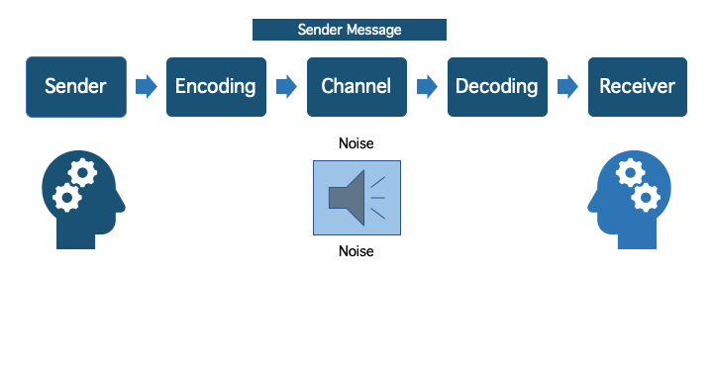
“Source: Communication Theory.com”
Integrated Communication Model
Integrated Communication Model (ICM) is a system that coordinates all showcasing correspondence strategies and guides them to the expected interest group. Since the entire showcasing blend is purposely used for the promoting effort, this technique accommodates the most impact on the objective segment.
In spite of the fact that ICM has turned into a well known jargon among professionals, its application among organizations is restricted, notwithstanding the way that they officially use IMC. This is on the grounds that most organizations simply utilize a couple of the promoting blend while beginning their showcasing plan.
This article is a contextual analysis of Debenhams' ICM in the United Kingdom. The article uses a portfolio way to deal with deciding the organization's degree of ICM reception. This show will start with a short history of the firm. The report then, at that point, gives an understanding of the organization's showcasing procedure utilizing a portfolio approach.
Fig 2
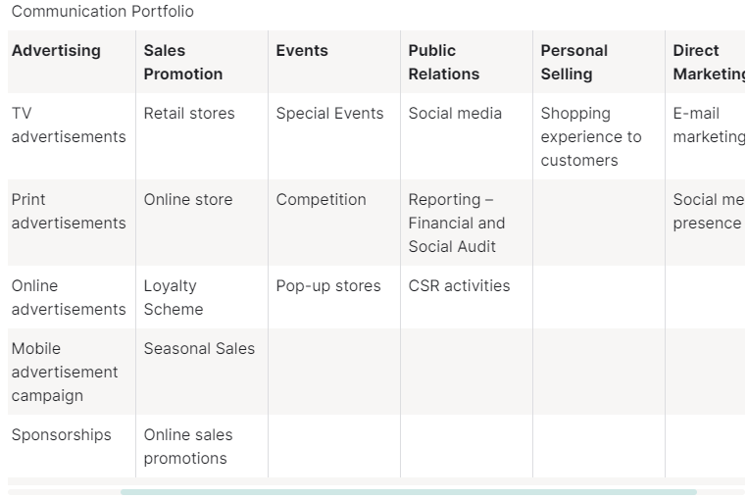
“Source: Ivypanda.com”

Promotion Strategies
- Online
Debenhams might target guests by giving update adverts that quick them to recall an item they saw on your site before. This might include offering alluring limits along with retargeting people who have a thing in their bin yet have not yet paid. These promoting help in expanding turnover, and a fruitful retargeting system might give a high ROI.
Debenhams can Work with influencers, for example, design bloggers and vloggers that have a following equivalent to the kind of clients you need to effectively focus on your objective market. Forces to be reckoned with are confided in voices among their following, and many will favor this arrangement to more customary advertising means like TV.
- Offline
Debenhams is able to do Live, individual showings and discussions put the purchaser and seller in close contact. As an outcome, they are among the best lower part of-the-channel innovations that anyone could hope to find.
Debenhams is equipped for Trade presentations might allow organizing opportunities with both possible purchasers and industry pioneers. Besides, these occasions might give extra disconnected promoting possibilities.
Fig 3

“Source: www.ivypanda.com”
Brand
In the present economy, when many labor and products are progressively becoming commoditized, a brand sticks out and draws consideration.
A brand resembles a living animal in that it has a character and character, as well as a name, culture, vision, feeling, and keenness. These are conceded by the brand's proprietor and should be explored consistently to keep up with the brand pertinent to the objective market to whom it intends to sell (Schreuer, 2000).
Brand Value
As indicated by Debenhams' latest financial year finishing August 2020, its web-based business accomplished unaudited online net incomes of about £400 million, an unaudited gross exchange esteem (i.e., whole deals including concession brands) of £1.524 billion, and an unaudited EBITDA of £12.7 million. This was a critical lessening from the organization's last documented accounts with Companies House in 2018, which revealed a gross conditional worth of £2.90 billion and an EBITDA of £157.3 million, as well as from its 2017 records, which detailed a gross value-based worth of £2.95 billion and an EBITDA of £217 million (Arvidsson, 2006).
Kellers brand equity model
Fig 3
* 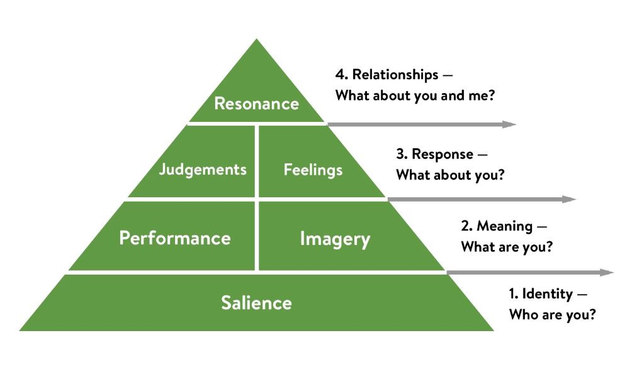
“Source:www.Medium.com”
Brand identity
Brand character alludes to how individuals see a brand and how they separate one brand from another. It is the means by which the brand lays down a good foundation for itself in the client's view. Building a brand character is a comparable thought (Vasileva and Vasileva, 2017) Mother Design revamped Debenhams' visual identity with the goal of giving the store's 200-year history a "contemporary and approachable spin." As part of a larger effort to "reclaim the joy of shopping," a new logo and slogan - "do a little of Debenhams" - have been devised. (2018 Design Week)
Brand Meaning
At the point when you meet a human individual and find out about them, you start to have different inquiries. What precisely do they do? Where are they utilized? How is everything turning out? Et cetera. Clients need to find out about organizations similarly that these requests emerge in the personalities of people (Vasileva and Vasileva, 2017). It as of now possesses names like Karen Millen, Coast, Warehouse, and Oasis, as well as Dorothy Perkins, Wallis, and Burton, which were beforehand important for Sir Philip Green's ancient Arcadia style realm (Guardian, 2021)
Brand Response
At the point when a buyer buys your merchandise, he creates assumptions regarding the brand and the exchange. Assuming that the client's assumptions are met, he is incredibly happy and has extraordinary feelings about the brand. In the event that the item surpasses assumptions, it delivers a ton of buzz and may change the client into a brand evangelist. Such positive communications impart "Sentiments" in customers (Vasileva and Vasileva, 2017) Debenhams' definitive objective, as indicated by Cristofoli, is to create brand liking and brand love. Cristofoli feels that when firms do things right on their reevaluation process, individuals feel a debt of gratitude, featuring how "blown away" the group was by the gathering to the Stevenage store's presentation last year (Marketingweek, 2018).
Brand resonance
This level is achieved by only a couple of brands. This is a level at which the brand has areas of strength for an and mental association with the client. If you were to ask me, I revere my MacBook and am reluctant to buy a Windows PC sooner rather than later. Truth be told, a few of my companions have bought the MacBook because of my suggestions (Vasileva and Vasileva, 2017) The branding is supplemented with an idea or more the-line promoting planned to be extraordinary and give Debenhams a place of separation in a serious business. The idea of eight inventive executions sees Debenhams take on an objective to feature the unashamed joy of shopping. It is lively, attitudinal, and pleased in its show (Ibbonline, 2018).
“Advantage and disadvantage”
Merits
- Improve item execution discernment
- Increase unwaveringness
- Companies might utilize this technique to procure influence while delivering new things
- Differentiate from rivalry
- When an opponent joins the market, piece of the pie might diminish.
Demerits
- In many models, this would be viewed as a deficiency of brand value. Notwithstanding, it very well may be contended that faithful clients are currently more significant, bringing about an increase in brand value.

The client excursion's five stages
Mindfulness (pre-deal)
The revelation step incorporates getting data through various advertising draws near, procuring data, doing explore, looking for clear message, and starting critical thinking. Your advertising will by and large demonstrate the entry point your shopper came from, whether it was business or individual - the message ought to suit the stage they're in (Norton and Pine, 2013).
Thought (pre-deal) (pre-deal)
Brand mindfulness, brand commonality, perceived history, and saw quality and administration may all swing an exchange to the more natural or favored brand. Increment memorability in this item class (Norton and Pine, 2013).
Buy (post-deal)
The decision has been taken, and the buy has been finished; this is the ideal opportunity for fast activity. There ought to be no hole between this period and starting contact. The client ought to be perceived. Begin your greeting and message machine to drive the excursion forward with an incredible encounter and the chance to move them into resulting stages (Norton and Pine, 2013).
Retention
Keep up with client bliss and "endorsement rating" by settling this issue - and expecting future deterrents you might help your client with (Norton and Pine, 2013).
Advocacy
On the off chance that you deal with different stages well, your customers will turn out to be endlessly fans will give the best showcasing you can get. Their impact on others' buy decisions ought to assist them with selling more. At this stage, suggestion and motivator are a stupendous method for advancing deals.
“Customer touch point”

Before purchase
Online advertisements
These are the advertisements that you see on different websites on the side, bottom, or top. They are also known as digital banner advertising. This is a useful touchpoint for driving traffic and leads to your website.
Social networking sites
You may contact thousands of individuals or prospective consumers using social media outlets such as Instagram, LinkedIn, Twitter, Facebook, and Pinterest, among others. You may target these folks with posts, hashtags, sponsored adverts, and so on, which is quite useful for client acquisition.
Referal
Word-of-mouth marketing or referrals are more successful than any promotional or marketing strategy.
During the purchasing process
Brochures
Product catalogues or brochures, whether online soft copies or physical copies, are an excellent method to exhibit your goods or services.
Reviews
The customer usually sees the review when buying on a website. There are several websites that allow users to publish product reviews; they may rate the product and provide precise information or comments about certain elements.
Post purchase
These customer feedback questionnaires, which are sent following a product purchase, assist to assess the consumer experience. What made the client experience so exceptional? If not, what might be done differently?
Many of your consumers will sign up to get emails from you about new items, special discounts, and so on.
Debenhams, a UK retail chain, is one retailer that has effectively utilized the force of computerized innovation. Notwithstanding its in excess of 60 unfamiliar locales, the business keeps up with north of 160 shops in the United Kingdom and the Republic of Ireland. It sells attire for everyone, as well as excellence, wellbeing, and family products (Vannucchi and Pantano, 2019).
Debenhams delivered its (free download) versatile shopping applications to focus on the organization's quick moving, time-crunched clients, and the outcomes were amazing. The UK business began with an iPhone application in October 2010, trailed by applications for Android and Nokia clients under a year after the fact. The Debenhams iPhone application was a gigantic achievement, with 360,000 downloads and near £1 million in deals in the initial five months! In the a half year after the presentation, deals on the retailer's site, Debenhams.com, became by a surprising 82.4%.
Debenhams has accumulated input from more than 230,000 of its clients over the earlier eighteen months by means of a shopper knowledge drive supported by client experience specialists Empathica (Norton and Pine, 2013).The bits of knowledge given by the Empathica innovation, which is utilized in every one of the 161 areas, have assisted Debenhams with getting a more prominent comprehension of what their shoppers esteem from their experience, as well as helping the retailer in driving in-store upgrades in light of certified client input.

The Customer's Journey
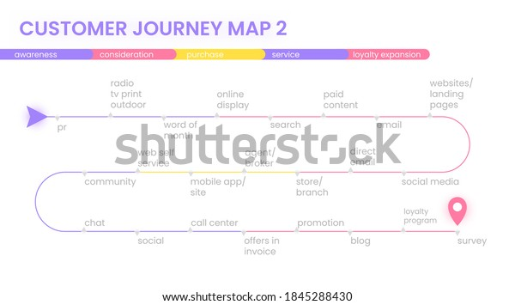

According to this map, in the first stage the Debenhams is the awareness stage. In which company introduce his product and services in the market. In the second stage, the customer go to the company official site. Then go to the store of the company and want to buy the product and service. The next stage is the customer finally purchase the things and after buying this the customer will give the
"The Engagement technique"
An engagement model is a set of guidelines that defines the relationship between the client and the development team. It includes the responsibilities, obligation, commitment, rules, tasks, and duration of the engagement. All of these are written down in a legally binding contract signed by both parties (Robert & Alpert, 2010).
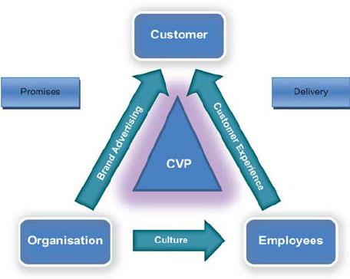
“Source: ResearchGate.com”

Debenhams requests to individuals, all things considered. It was as yet one of the main ten most visited style organizations on the high road as of not long ago. What's more, this wide allure will permit Boohoo to arrive at many new objective classes that it in any case proved unable.
In light of the Debenhams brand, there is presently the enticing capability of item expansion. In the event that you remember your latest visit to a Debenhams, you will undoubtedly review the few stories of design, yet in addition the shoes, sports merchandise, and homeware. Numerous people are probably not going to be keen on a Boohoo decorative liner or some games shorts. Be that as it may, with the Debenhams blemish on it, the entire arrangement checks out.
Then there's the cost lack of care presented by the Debenhams brand. It might have been a fruitcake of a firm eventually, yet it is a brand with monstrous client mindfulness and not inconsequential degrees of brand picture. Along these lines, clients might hope to pay something else for Debenhams stock at whatever point Boohoo returns for business on the web (MarketingWeek, 2021).
Conclusion
Debenhams has combined its showcasing channels through the organization's multi-channel advertising procedure. This technique has brought about the organization's monetary achievement (Debenhams, 2010). Debenhams' web-based shop expanded deals by 88.4 percent in 2010, mirroring the program's remarkable achievement (Debenhams, 2010).
Debenhams.com turned into the organization's greatest shop in 2010, and they laid out a web-based presence (Debenhams, 2010). This could never have been attainable without a coordinated promoting methodology that could blend on the web and in-store showcasing messages and convey it simultaneously. Therefore, Debenhams carried out an incorporated advertising methodology, which worked on its exhibition.
Keller's Brand Equity Model is astounding since it shows a brand which stage it has a place with and how it might progress. At last, it helps brands in creating brand value. The Brand value pyramid has a few levels, and getting starting with one stage then onto the next could require years.

Reference
Arvidsson, A., 2006. Brand value. Journal of Brand management, 13(3), pp.188-192.
Cobley, P., 2008. Communication: Definitions and concepts. The international encyclopedia of communication.
Dorsey Jr, J.T., 1957. A communication model for administration. Administrative Science Quarterly, pp.307-324.
https://economictimes.indiatimes.com/definition/brands
https://ivypanda.com/essays/integrated-marketing-communications/
https://socialsci.libretexts.org/Bookshelves/Communication/Introduction_to_Communication/Communicating_to_Connect__Interpersonal_Communication_for_Today_%28Usera%29/01%3A_Fundamentals_of_Interpersonal_Communication/1.02%3A_Basic_Process_Models_of_Communication
https://www.designweek.co.uk/issues/3-september-9-september-2018/debenhams-reveals-new branding-and-advertising campaign/#:~:text=Mother%20Design%20has%20redesigned%20Debenhams,reclaim%20the% 0joy%20of%20shopping%E2%80%9D.
https://www.marketingweek.com/debenhams-comes-out-fighting-with-new-brand-identity/
https://www.marketingweek.com/mark-ritson-boohoo-buying-debenhams-brand/
https://www.questionpro.com/blog/employee-engagement-strategies-best-practices/
https://www.researchgate.net/figure/The-total-engagement-model_fig2_49513186
https://www.shutterstock.com/image-vector/customer-journey-map-process-buying-decision-1706730172
https://www.theguardian.com/business/2021/jul/14/boohoo-sell-brands-debenhams-stores-middle-east
Norton, D.W. and Pine, B.J., 2013. Using the customer journey to road test and refine the business model. Strategy & Leadership.
Roberts, C., & Alpert, F. (2010). Total customer engagement: designing and aligning key strategic elements to achieve growth. Journal of Product & Brand Management.
Schreuer, R., 2000. To build brand equity, marketing alone is not enough. Strategy & Leadership.
Strachan, A. and Nemoto, K., 2011. Debenhams. International Private Equity, pp.617-640.
UKEssays. November 2018. The Organisational Challenges Faced By Debenhams Commerce Essay. [online]. Available from: https://www.ukessays.com/essays/commerce/the-organisational-challenges-faced-by-debenhams-commerce-essay.php?vref=1 [Accessed 24 August 2022].
Vannucci, V. and Pantano, E., 2019. Digital or human touchpoints? Insights from consumer-facing in-store services. Information Technology & People.
Vasileva, I.V. and Vasileva, T.N., 2017. Keller''s brand equity model. Modern Science, (6-1), pp.93-98.
Watson Jr, J.B., 2004. Engagement Model. Service-learning: History, theory, and issues, p.73.

