Student name: Syeda Sadaf Jabeen
Student ID number: 2310935
Module: Independent Project
Module code: BMHP6020
Lecturer name: Chloe Harries
Assignment Title: Element 2 - Academic Methods Poster

Methods and Search Strategy Academic Poster  Cultural competence and stigmatisation in UK mental health services: a secondary research review | S
01 Introduction and Research Aim  This poster summarises the methodology for a secondary research dissertation. The aim is to explore how cultural competence in UK health and social care can reduce stigmatisation and improve access, experience and outcomes for ethnic minority communities using mental health services. The focus is NHS talking therapies and inpatient care, where national evidence reports unequal access, experiences and outcomes (National Collaborating Centre for Mental Health, 2023; NHS England, 2025). | 02 Search Strategy  A search strategy is a planned and repeatable way of finding evidence using databases, keywords, limits and screening criteria (Booth, Sutton and Papaioannou, 2022; Siddaway, Wood and Hedges, 2019). Searches will combine terms such as: “cultural competence” OR “cultural safety”; stigma OR discrimination; “ethnic minority” OR Black OR Asian; and “mental health services” OR “NHS talking therapies” OR inpatient.
03 Searching for Information  Sources will include CINAHL, MEDLINE, PsycINFO, Google Scholar, and key UK websites such as NHS England, CQC and the NHS Race and Health Observatory. Titles and abstracts will be screened first, then full texts will be checked. Relevant evidence will be saved in Zotero and key details will be extracted into an Excel table, including author, year, setting, method, findings and limits (Care Quality Commission, 2023; NHS England, 2024). | 04 Picture / Graph / Visual Aid  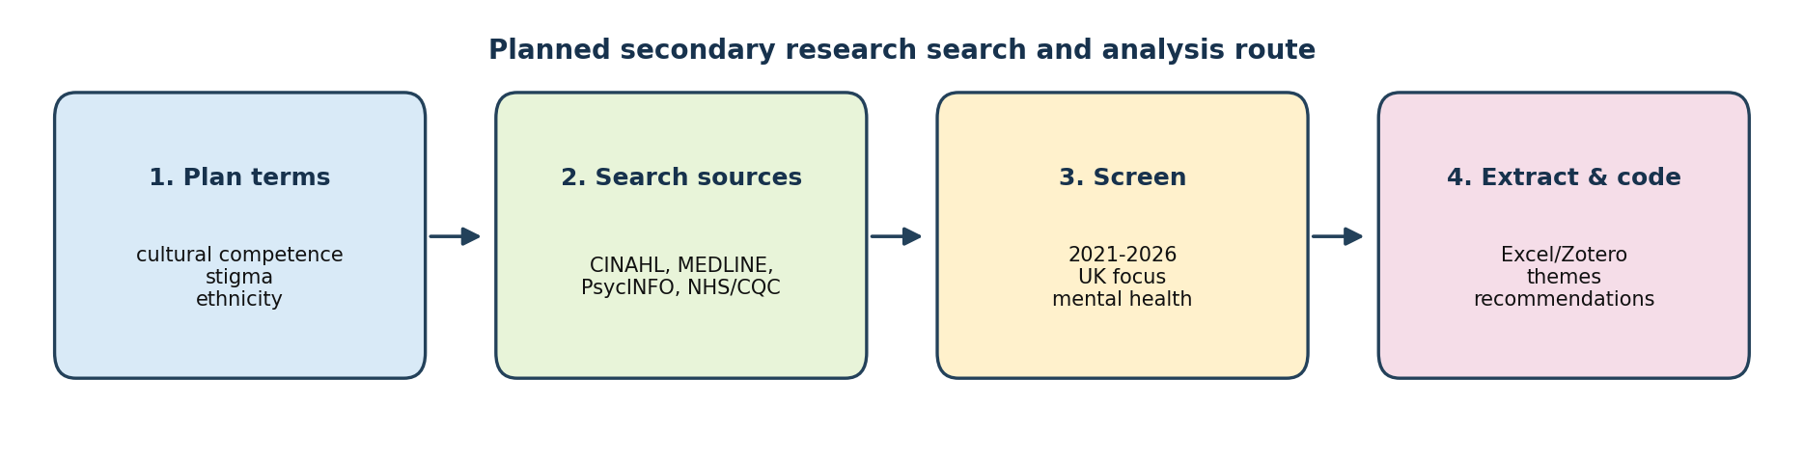  The diagram shows the planned route from search terms to final themes and practical recommendations.

Research Validation, Criteria, Ethics and References
05 Research Validation and Analysis  Validation means checking that evidence is credible, relevant and reliable. Peer-reviewed sources and national guidance will be compared and appraised using quality questions from CASP (2024). Findings will be analysed through thematic synthesis: repeated ideas will be coded, grouped into themes, then linked back to the research aim (Thomas and Harden, 2008; Braun and Clarke, 2022). | 06 Inclusion Criteria  • Published 2021-2026.  • UK-focused or clearly useful for UK practice.  • About cultural competence, cultural safety, stigma, ethnicity, inequality or mental health.  • Peer-reviewed studies, NHS/CQC reports, charity reports and guidance.  • Full text available online.
07 Exclusion Criteria  • Sources older than 2021 unless methodologically important.  • Non-UK studies with no clear link to UK services.  • Opinion pieces with weak evidence.  • Sources not focused on health/social care or mental health.  • Duplicates or inaccessible full texts. | 08 Ethical Considerations  The study uses public secondary data, so no new participants are recruited. Ethics will focus on accurate Harvard referencing, avoiding plagiarism, using respectful non-stigmatising language, protecting confidentiality where reports include sensitive examples, and reporting evidence fairly, including limits and gaps (Phillips, 2022; NHS England, 2025).
References
Booth, A., Sutton, A. and Papaioannou, D. (2022) Systematic approaches to a successful literature review. 3rd edn. London: SAGE.  Care Quality Commission (2023) The state of health care and adult social care in England 2022/23. Newcastle upon Tyne: Care Quality Commission. Available at: https://www.cqc.org.uk/publications/major-report/state-care/2022-2023 (Accessed: 2 February 2026).  National Collaborating Centre for Mental Health (2023) Ethnic inequalities in Improving Access to Psychological Therapies (IAPT): full report. London: NCCMH.  NHS England (2025) Culturally competent inpatient care. Available at: https://www.england.nhs.uk/long-read/culturally-competent-inpatient-care/ (Accessed: 2 February 2026).  Siddaway, A.P., Wood, A.M. and Hedges, L.V. (2019) 'How to do a systematic review: a best practice guide for conducting and reporting narrative reviews, meta-analyses, and meta-syntheses', Annual Review of Psychology, 70, pp. 747-770. | Braun, V. and Clarke, V. (2022) Thematic analysis: a practical guide. London: SAGE.  Critical Appraisal Skills Programme (CASP) (2024) CASP checklists. Available at: https://casp-uk.net/casp-tools-checklists/ (Accessed: 2 February 2026).  NHS England (2024) Annual report on NHS England's work on healthcare inequalities and the NHS Race and Health Observatory. Available at: https://www.england.nhs.uk/long-read/annual-report-on-nhs-englands-work-on-healthcare-inequalities-and-the-nhs-race-and-health-observatory-2/ (Accessed: 2 February 2026).  Phillips, J. (2022) Addressing health inequalities: developing a better understanding of physical health checks for people with severe mental illness from Black African and Caribbean communities. London: Race Equality Foundation.  Thomas, J. and Harden, A. (2008) 'Methods for the thematic synthesis of qualitative research in systematic reviews', BMC Medical Research Methodology, 8(45), pp. 1-10.

