

University of Wales Trinity Saint David
School of Engineering
Dispatch Process Automation Development
Manufacturing Design & Technology
ACMA 5002
Daniel Grelak
1901993

Contents Page

Contents Page 1
1. Introduction 2
2. Research 3
• Design For Manufacture (DFM) 3
• DFM Guidelines 3
• Design for Assembly (DFA) 4
• Quality Function Deployment (QFD) 4
3. Pre-Design Process 5
• Preliminary assumptions 5
• QFD 5
• Design Ideas 6
• Final Design Assumptions 8
4. Design Process 9
5. Design Appraisal 17
• List of parts and processes: 18
• Future proofing 18
6. Manufacturing 19
7. Further work 20
References 21

Introduction

Times of a close cooperation between the robots and humans are here. In more and more of industrial environments such partnership exists with a success, increasing manufacturing capabilities and possibilities. Good example of co-bot and human working together is CP Lab, modular Industry 4.0 learning system, simulating manufacturing processes.
In this project scenario CP Lab produces mobile phones, which then are delivered to dispatch station and are picked up by robot arm and moved. For the purpose of this process new gripper (end connector) must be designed and documented, with regard to appropriate design principles.
End effector is a peripheral device that attaches to a robot’s wrist allowing robot to interact with the task (Resources, 2020). In this project robot gripper must be able to surely grab the phones and safely move them to desired location. Handling of the mobile phone case is only possible on its sides, as the top cover might not be secured and could possibly be dropped if gripped wrong.
Final design should be suitable for manufacturing environment, therefore must be robust, durable and easy to service.
Next chapters contain research conducted, design process and its appraisal.

Research

First aspect of designing is to consider and research all necessary aspects of the part (application, environment, number of parts, assembly etc.) and use available tools accordingly. In this case robot gripper must be designed with few considerations in mind.

Design For Manufacture (DFM)

Design for Manufacture is a methodology used to optimize design process for ease of part implementation and to lower manufacturing costs from the beginning of the design process (TWI, 2020). Implementation of this process in early design stage is crucial for speed and high production rates. Most of the manufacturing costs are connected to design choices and having that in mind from Day 1 can significantly lower costs of manufacturing. Design process influence on final product oscillate around 70%, being only 5% of its production cost.

DFM Guidelines

There are few DFM guidelines that should be considered while designing a product.

- Reduce number of parts- lowering number of parts can help with lowering overall manufacturing costs. Less parts means less handling, storing, servicing etc.
- Simplify the design- making a part simple also lowers manufacturing costs and time.
- Making a modular design- modular design can help with more complicated parts, where there is no easy solution for designing it in one piece and keeping it easy and cheap to manufacture.
- Manufacturing process- should be kept in mind from the beginning of the design process, as it influences shape and functionality of the product. Factors like cost, product material and surface finish all depend on the chosen process and should be considered in early stages of design.

Design for Assembly (DFA)

Methodology used to simplify and optimize number of components to minimalize number of assembly operations required. (Fractory, 2019) Base principles of Design for Assembly include positioning of the parts, alignment, orientation and required tools to maximize easy of assembly. For each of parts in the assembly question can be asked to assess if there are necessary or they are non-essential and could be left out of the design.

Quality Function Deployment (QFD)

QFD is a method for translating customer requirements into technical requirements for each step of product development. (QualityOne, 2018) It is a tool to combine customer needs and requirements to design suitable solution. Advantage of QFD process is that it encourages proactive product development, which results in fewer design changes and shorter development time.

Pre-Design Process

Preliminary assumptions

This project required few assumptions to be made, before design process could be started, to accurately target expectations of the design. Assumptions are based on Project Description and Design Principles from the Research Chapter.

- Number of parts must be minimum, keeping in mind DFA and DFM guidelines.
- Must be simple and functional.
- Must be able to securely grab phone on its sides and move it.
- Gripper should be mechanically actuated.
- Must be appropriate for high-volume manufacturing.
- Must be able to withstand sustained use.

QFD

For better understanding of customers and technical requirements simple QFD has been performed (Figure 1). From gathered and evaluated data importance score of requirements can be compared to prioritize them while designing.

 | Quality Function Deployment
 | Project title: | Robot Gripper
 | 1: low, 5: high | Functional Requirements (How's)  → | Mechanically actuated | Gripping from the sides | Must fit robot arm | Robust | Easily changeable and serviceable
 | Customer importance rating | Customer Requirements - (What's)  ↓ |  |  |  |  |  | Weighted Score
1 | 5 | Must grab and move product | 8 | 9 | 9 | 6 | 2 | 170
2 | 5 | Must cooperate with CP Lab | 7 | 9 | 9 | 2 | 2 | 145
3 | 4 | Appropriate for high-volume manuf. | 1 | 3 | 1 | 9 | 9 | 92
4 | 4 | Able to withstand sustained use | 3 | 3 | 1 | 9 | 6 | 88
5 |  |  |  |  |  |  |  | 0
6 |  |  |  |  |  |  |  | 0
7 |  |  |  |  |  |  |  | 0
8 |  |  |  |  |  |  |  | 0
9 |  |  |  |  |  |  |  | 0
 |  | Technical importance score | 91 | 114 | 98 | 112 | 80 | 495
 |  | Importance % | 18% | 23% | 20% | 23% | 16% | 100%
 |  | Priorities rank | 4 | 1 | 3 | 2 | 5
 |  | Difficulty | 3 | 2 | 1 | 3 |  | 1: very easy, 5: very difficult
 |  | Cost and time | 3 | 2 | 1 | 3 |  | 1: low, 5: high
Figure 1 QFD for robot gripper

Design Ideas

Through the process of brainstorming possible design ideas were discovered, including possible implementation of requirements. Figure 2 picture draft that were used for final design. From the early stage od designing guidelines of DFA and DFA were considered, main design assumptions included minimal number of parts and simple manufacturing processes.

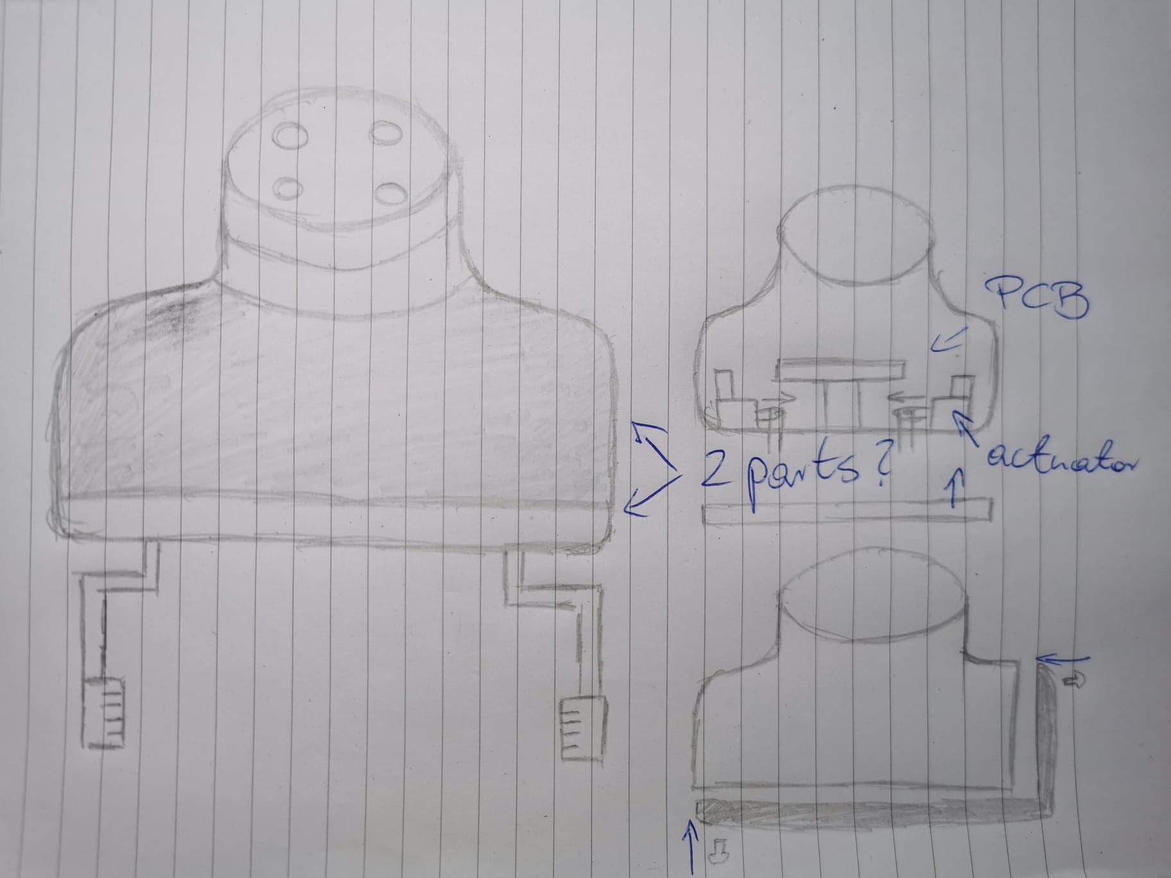

Figure 2 Design Idea

Idea of the draft was to grip phone by mechanically actuated grippers from both sides. Main concern was how to split main body to limit number of parts, screws etc. Possible solutions included bottom part being screwed to the Main Body or bottom part being inserted to Main Body from the side. After consideration it has been decided to move forward with parts connected from the side. Main Body being mainly a cover and connection to the robot arm, and Side Part which would include all the assembly parts. Idea was that it would minimize parts and enable development in the future, where Side Part could include different parts for different applications and be inserted into same Main Body. That solution also makes service of the gripper and exchange of parts easy, with good access to the gripper insides. Gripping will be performed by two grippers moving on rails and driven by two actuators. Space for PCB or microcontroller was also predicted.
In the subject of manufacturing processes, it has been preliminary decided that exterior parts of the gripper like Main Body and Side Part will be injection moulded, likely from ABS, which has lower shrinkage and other thermoplastics and moving parts like grippers will be CNC machined from some kind of alloy.
On this stage it has been decided that slight modification of dispatch CP Lab dispatch station will be required. In current state sides of the station are too high, leaving not enough space to safely garb the phone (Figure 3). Proposed solution leave enough space on both sides, that grippers will be able to grab the phone safely.

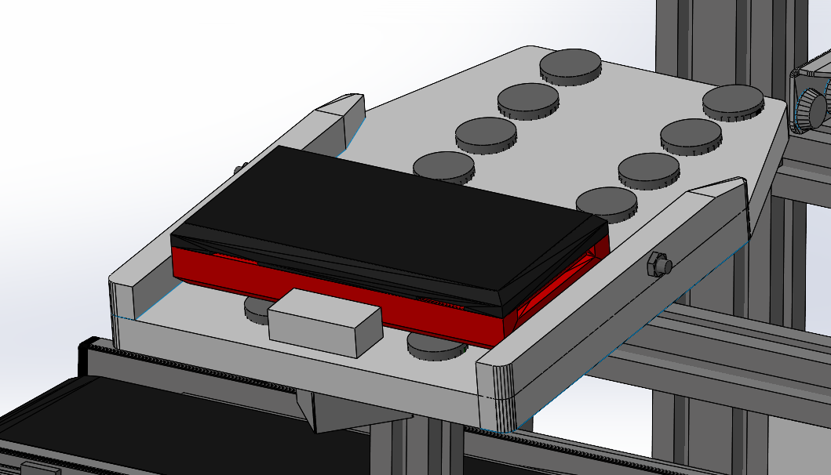
Figure 3 Phone on dispatch station.

Final Design Assumptions

- Design of a Body must be suitable for injection moulding manufacturing process, which allow easy and quick manufacture of large quantities.
- Body will split in two parts, where Main Body could be used with variety of different Bottom Parts for range of applications in the future.
- Bodies will be able to insert into each other to minimize number of screws.

Design Process

For convenience Design Process will be pictured by the list of steps carried out in the Process.

- Extrusion of Main Body shape.
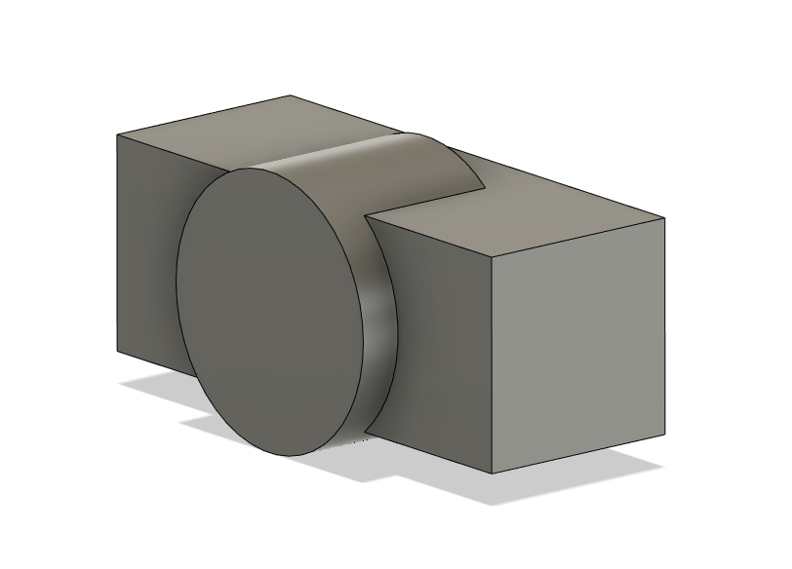
In the first step Extrude command has been used to shape a body from sketches of rectangle and circle, so it can fit contents and be able to connect to the Robot Arm (Figure 4). Main Body design leave enough space inside of the body so it can fit variety of components to future proof it. From

Figure 4 Step 1: Extrude commands.

- Fillet of the edges.
To dispose of all sharp edges Fillet command has been used in the next step. That feature ensures that all of the edges are smooth, which makes manufacturing process simpler and minimize risks of accidents and cuts. (Figure 5)

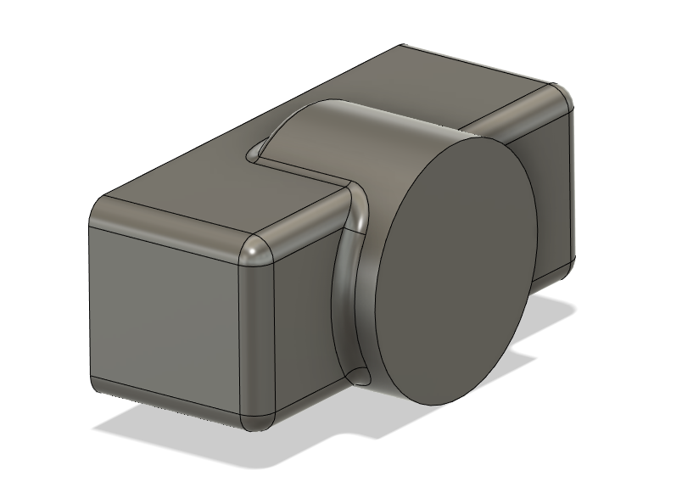

Figure 5 Step 2: Fillet command.

- Shell.
This feature removes material from interior of the body, which turns solid part to shell that is empty inside. Thickness of the walls is set to 5mm to ensure rigidness of the body. (Figure 6). Removal of unnecessary bottom face has been done by Extrude Cut feature.
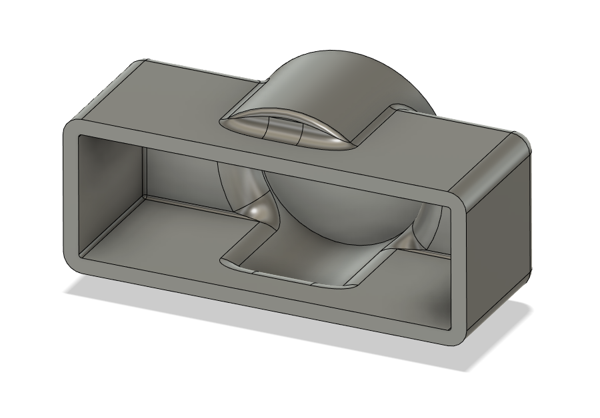

Figure 6 Step 3: Shell

- Split of the bodies.

In next step Split feature has been used to Split body in two parts. That can be done by constructing offset plane in required position and using Split command which cuts body in position of the plane. (Figure 7)
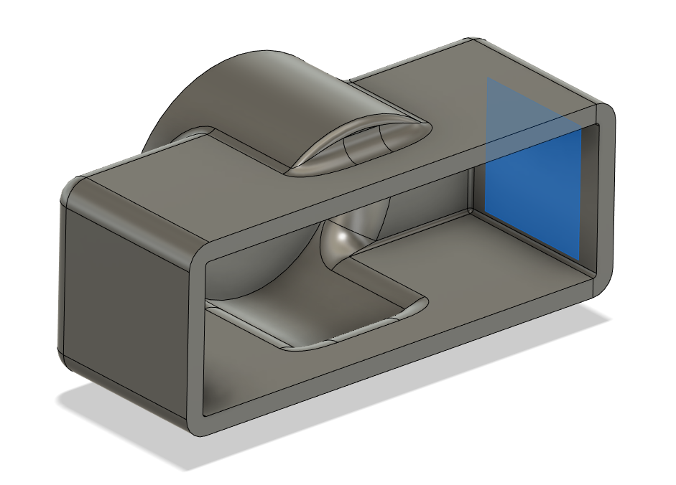

Figure 7 Step 4: Split of the body
Placement of the Split is crucial in the design. Two bodies must connect in the right place, so by implementation of further steps easy assembly of the bodies will be possible. After this step parts of the assembly are: Main Body and Bottom Part. Also, material for the Parts has been changed to ABS.

- Hole for screw.

To allow quick assembly of the parts one screw on the side is necessary. This can be done by Hole feature, which is simple way of making a tapered hole for variety of screws etc. of all standard sizes. Hole command in Fusion 360 also ‘remember’ last used size of the hole, making it simple to assure that all the screws in assembly are the same size. In this case M3 screw will be used. (Figure 8)

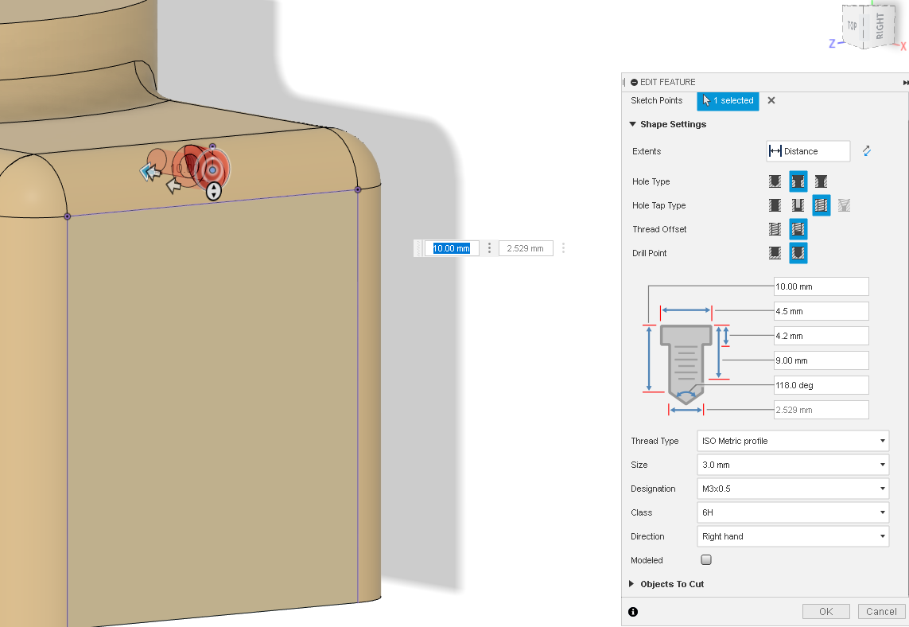

Figure 8 Step 5: Hole for a screw.

- Modelling bodies by Extrude and Cut Extrude commands.

By set of Extrude and Cut Extrude commands Bottom Part has been modelled to desired shape to fit with the cut in the Main Body (Figures 9 and 10). Design consider DFA methodology for simple assembly and to minimize number of screws. Step also includes Mirror feature for quicker process.

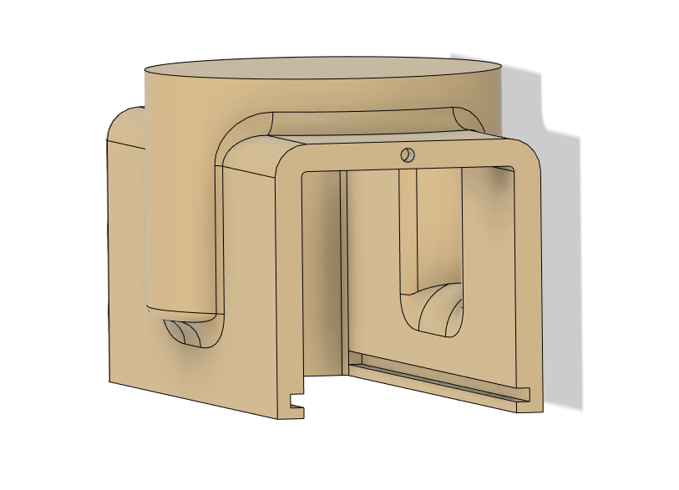
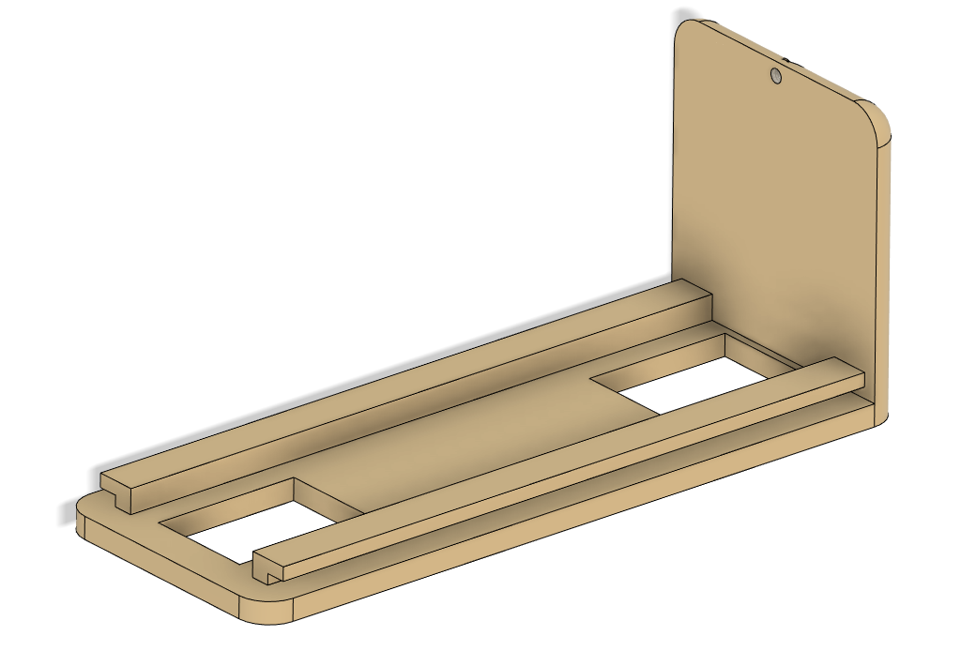

Figures 9 and 10 Step 6: Extrude and Cut Extrude commands to shape and connect parts.

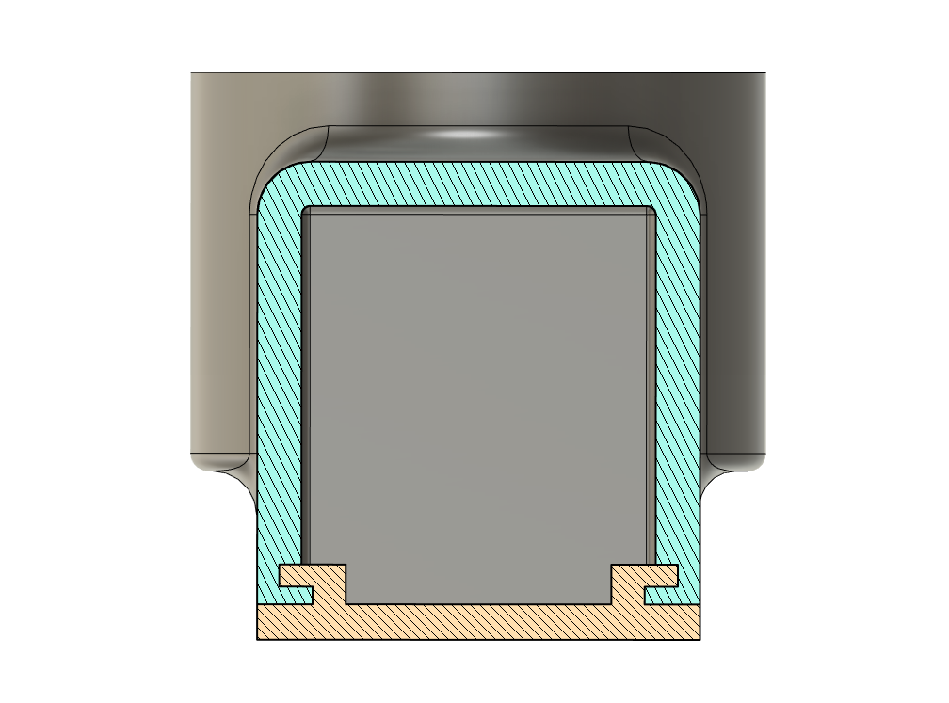
Figure 11 picture cross section view of the assembled parts. Design requires only single screw to connect both parts.

Figure 11 Cross section view of the assembly.

- Bottom Part modelling.

At this point focus was on modelling Bottom Part to the state where it will be possible to insert actuators and rails for grippers. Process consisted mainly of Extrude and Cut Extrude features. Design idea behind Bottom Part was to use set of two rails with two independent motors. Final shape of Bottom Part can be seen in Figure 12. Simple design allows secure attachment of stainless-steel threaded rods and cold rolled steel plate guides. (Figure 13) Guide parts are simply pressed in place without any additional components and rails fit through holes in Bottom Part. Project feature helped with placement of cut outs for guide rails, said feature projects existing geometry in opened sketch, greatly reducing design time. Thread on a rail can be achieved by Thread feature.

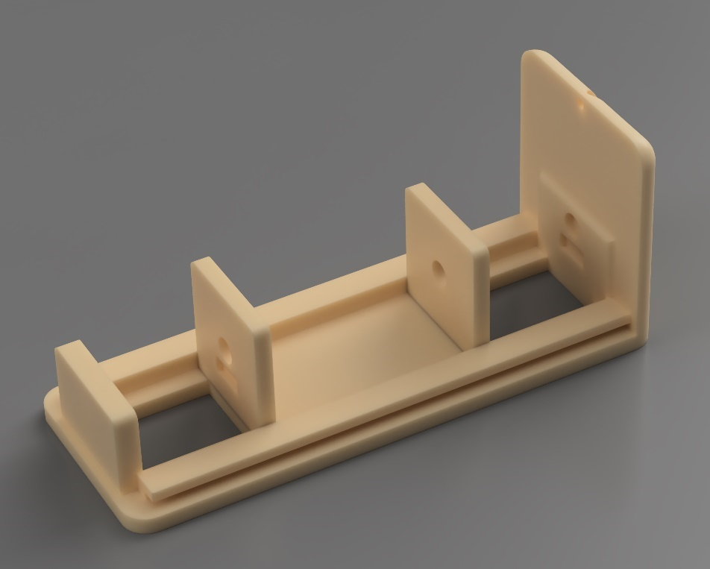

Figure 12 Bottom Part.

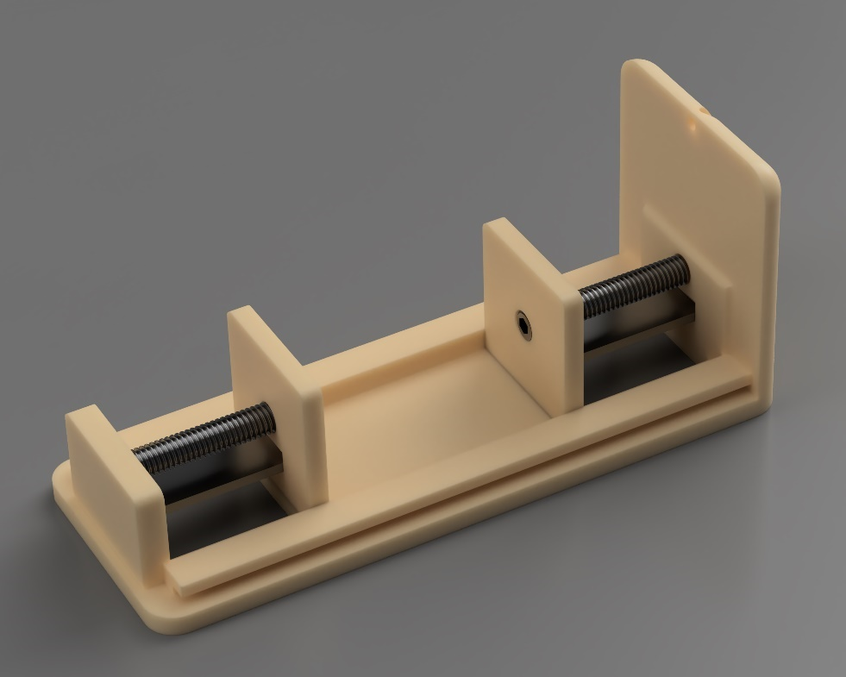

Figure 13 Bottom Part with rails and guides.

- Motors

Operation of grippers will depend on set of motors (Figure 14), they are positioned back-to-back in the Bottom Part assembly.
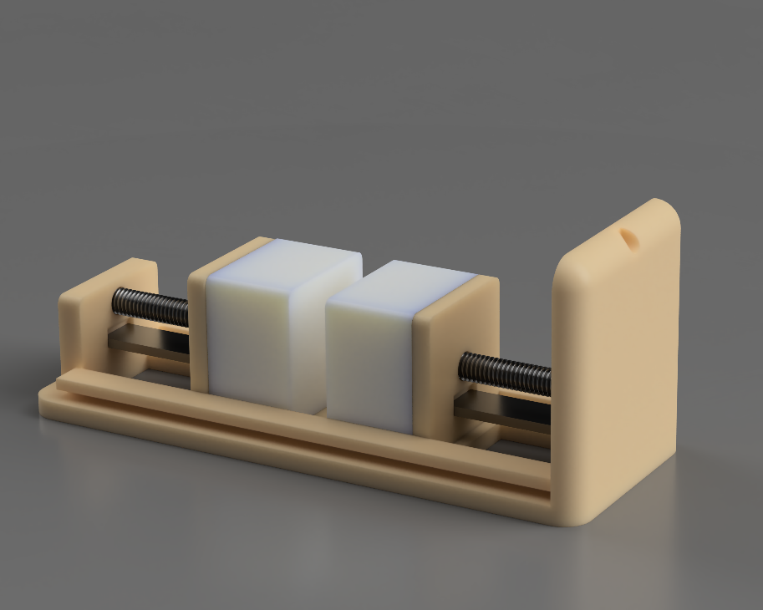

Figure 14 Bottom Part with motors.

- Grippers

To securely grab and move the phone set of steel die casted grippers is required. Grippers were design in as simple as possible way, with circular cut outs to reduce weight and to allow connecting attachments in the future (Figure 15). Set of geometry like said cut outs can be design by Rectangular Pattern feature which duplicates sketches curves in rows and columns. Body of grippers has been made of few Extruded sketches. All the edges are smoothed by Fillet command.

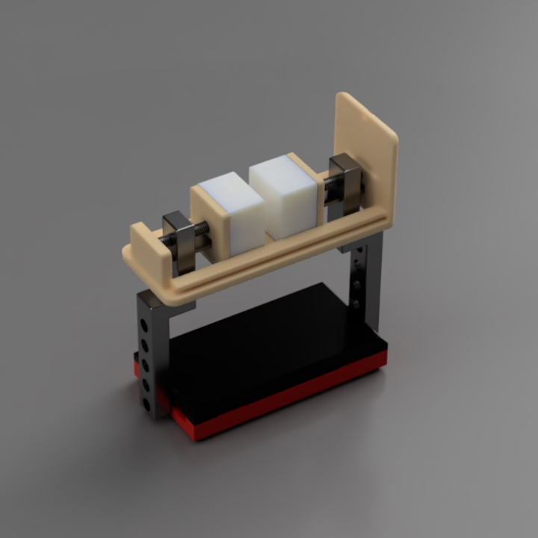

Figure 15 Bottom Part assembly with Grippers.

- Robot Arm connector
Connecting to robot arm will be possible by pressed die casted aluminium connector, modelled by simple Extrude and Extrude Cut features. Assembly of full End Connector is presented in Figure 16.

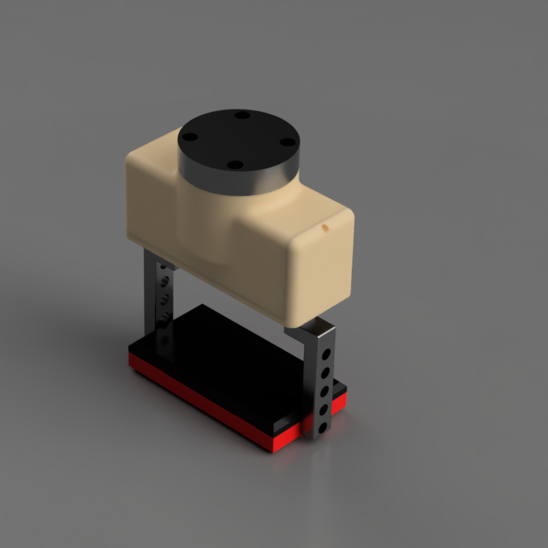

Figure 16 End Connector Assembly.

Design Appraisal

Presented design allows secure movement of phone from PC Lab Dispatch Station to required localization. Parts were design with regard to the DFA and DFM methodologies and their number is kept to the minimum number required for appropriate functionality. Full assembly consist of only 11 elements (Figure 17). Assembly will require 4 additional screws for connection to robot arm and on M3 screw to secure Main Body and Bottom Part.

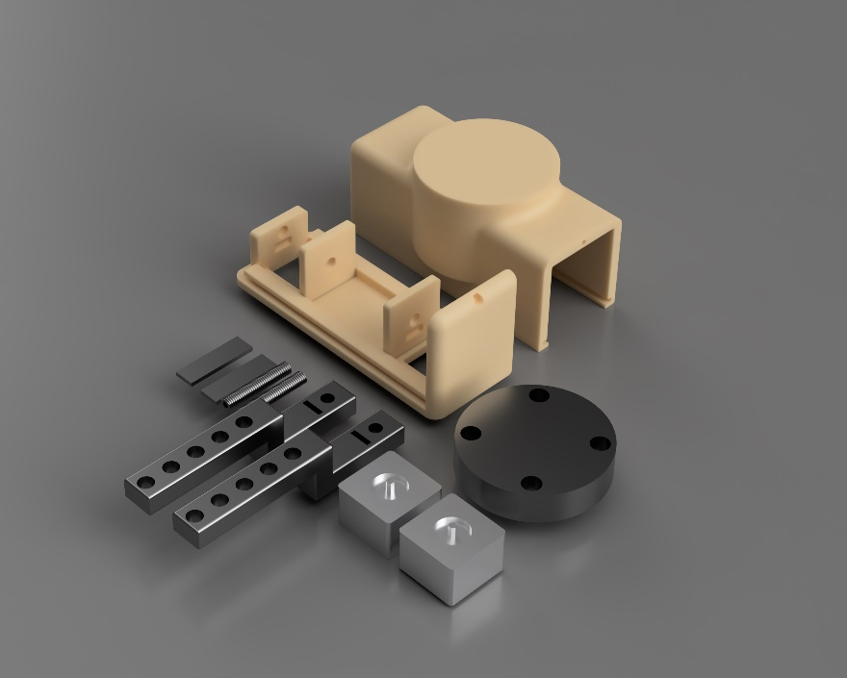

Figure 17 Parts of the assembly.

To predict behaviour of the End Connector in situation where it accidently hit an obstacle, which is possible in industrial environment, computer simulation has been prepared. Force of the hit to the side was set to 2000N, that is comparable to punch of the amateur boxer and is too high to occur in life, but results are satisfactory and confirm that End Connector rigidity is sufficient for its purpose. Results were converted to GIF file so they could be uploaded in Word document (Figure 18).

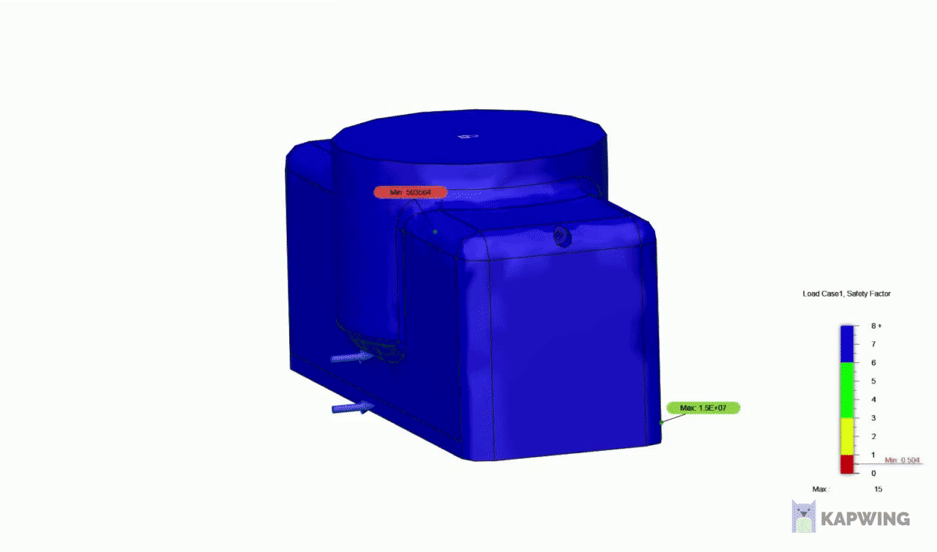
Figure 18 Simulation of hitting obstacle.

List of parts and processes:
- Main Body – Injection Moulding (ABS)
- Bottom Part – Injection Moulding (ABS)
- Motor x2
- Rod x2 – Hot rolled round bar, thread rolling (Stainless steel)
- Guide x2 – Cold Rolling (Stainless steel)
- Connector – Die Casting (Aluminium)
- Gripper x2 – Die Casting (Aluminium)

Future proofing

Design of the End Connector allow future modifications, where modified for purpose Bottom Part can fit Main Body. Main Body has enough volume to fit range of possible components. That solution can save time and budget in the future.

Manufacturing

Manufacturing methods are strictly connected to the design and in this project were considered from the earliest stages of the design process. Chosen methods are reasonably cheap and will be sufficient for the purpose of End Connector assembly. All chosen processes are a good choice for high volume manufacturing. These manufacturing processes are:

- Injection moulding – process suitable for producing parts in large quantities, initial costs are large, but this solution is appropriate for the project. (Rogers,2015). Advantages of the process are low scrap rate and consistent quality of the parts, where all parts are identical. Downside of this method is upfront costs and susceptibility to highlight design flaws.
- Die casting – process in which liquid metal is pressed into a mould under pressure (Stark,2019). This process is suitable for mass production because moulds are not destroyed in the process and can be used multiple times. Moulds are made from high quality and heat resistant steel grades.
- Cold rolling – process in which metal is passed through the set of rollers at temperatures below its crystallization temperature (Ulbrich,202). Metal is pressed to increase the yield strength and enhance hardness of material. Process is performed in room temperature and is suitable for high volume manufacturing.
- Hot rolling – process in which metal is heated above its recrystallization temperature to plastically deform it in the working or rolling operation (CorrosionPedia,2020). This process creates shaped to desired dimensions and material properties and keeps same volume of material.
- Thread rolling – process of metal forging that forms threads into the mirror image of a roller die. (CJWinter,2020) This process does not remove any metal from workpiece unlike metal grinding or cutting. Thread rolling process use steel dies to displace and mould metal.

Further work

This project focused on researching DFA and DFM methodologies, design preparation and design process of End Connector for Robot compatible with CP Lab environment. If more work would be performed in the future more focus could be pointed to CP Lab system, as this was not research in the project. Also, more work could be done into connection between the robot arm and End Connector, Gripper parts could be tested by computer simulation to test their behaviour under the loads and their service life. Another important factor that this report does not include is dies and moulds for manufacturing of the components that also could be prepared from cad files of the parts. Connection between parts inside of End Connector could also be developed to implement more DFA and DFM guidelines.

References

Fractory. 2019. Design for Assembly (DFA) Principles Explained | Fractory. [online] Available at: <https://fractory.com/design-for-assembly-dfa/> [Accessed 17 June 2022].
Quality-One | Quality and Reliability Consulting - Training - Facilitation. 2018. QFD | Quality Function Deployment | Quality-One. [online] Available at: <https://quality-one.com/qfd/> [Accessed 17 June 2022].
Resources, A., 2020. What is an End Effector and How Do You Use One?. [online] Automate. Available at: <https://www.automate.org/news/what-is-an-end-effector-and-how-do-you-use-one> [Accessed 17 June 2022].
Rogers, T., 2015. Everything You Need To Know About Injection Molding. [online] Creativemechanisms.com. Available at: <https://www.creativemechanisms.com/blog/everything-you-need-to-know-about-injection-molding> [Accessed 17 June 2022].
Stark, A., 2019. What is Die Casting? Development, Processes and Materials in Die Casting. [online] Spotlightmetal.com. Available at: <https://www.spotlightmetal.com/what-is-die-casting-development-processes-and-materials-in-die-casting-a-818604/https://www.spotlightmetal.com/what-is-die-casting-development-processes-and-materials-in-die-casting-a-818604/> [Accessed 17 June 2022].
Ulbrich. 2020. What is "Cold Rolling" Stainless Steel and Other Metals?. [online] Available at: <https://www.ulbrich.com/blog/what-is-cold-rolling-stainless-steel-and-other-metals/> [Accessed 17 June 2022].
Twi-global.com. 2020. What is Design for Manufacturing (DFM)?. [online] Available at: <https://www.twi-global.com/technical-knowledge/faqs/faq-what-is-design-for-manufacture-dfm> [Accessed 17 June 2022].
Corrosionpedia. 2020. What is Hot Rolling? - Definition from Corrosionpedia. [online] Available at: <https://www.corrosionpedia.com/definition/637/hot-rolling> [Accessed 17 June 2022].
Cjwinter.com. 2020. What is thread rolling?. [online] Available at: <https://www.cjwinter.com/blog/what-is-thread-rolling> [Accessed 17 June 2022].

