Appendix
- Probability of a Car Accident in Great Britain/UK
The number of serious or fatal road traffic accidents has generally fallen in the past few years. From 2012 to 2020, the number of people seriously injured in Great Britain dropped 33%, from 33,089 to 22,069. Over the same time period, the number of fatal accidents dropped 17%, from 1,754 to 1,460. Why the huge improvement? While drops in the years up until 2019 could be down to safer cars or drivers, in 2020 the remarkable improvement is simply down to people driving fewer miles due to the pandemic lockdown.
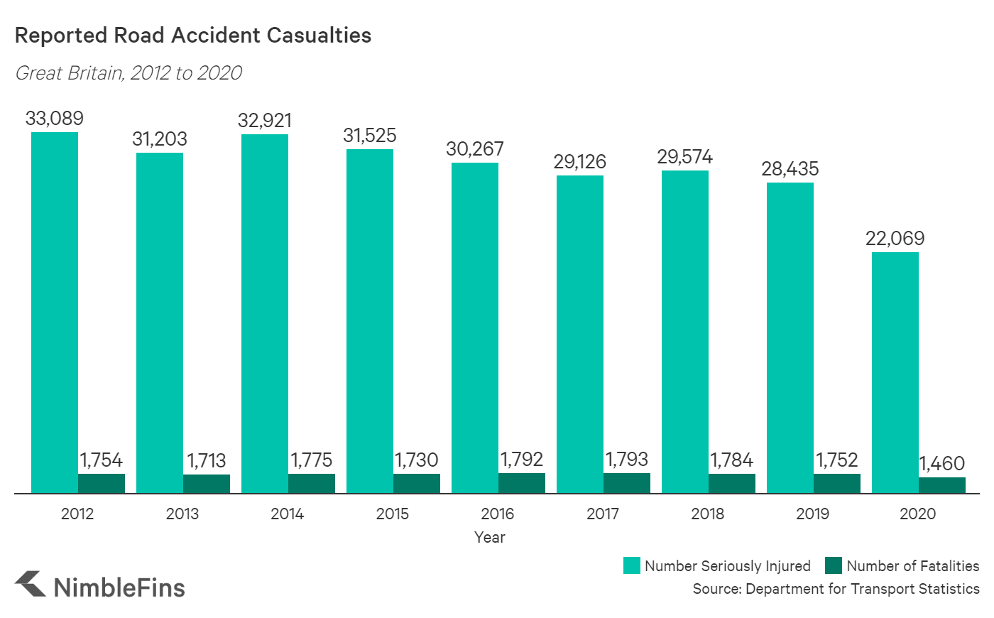
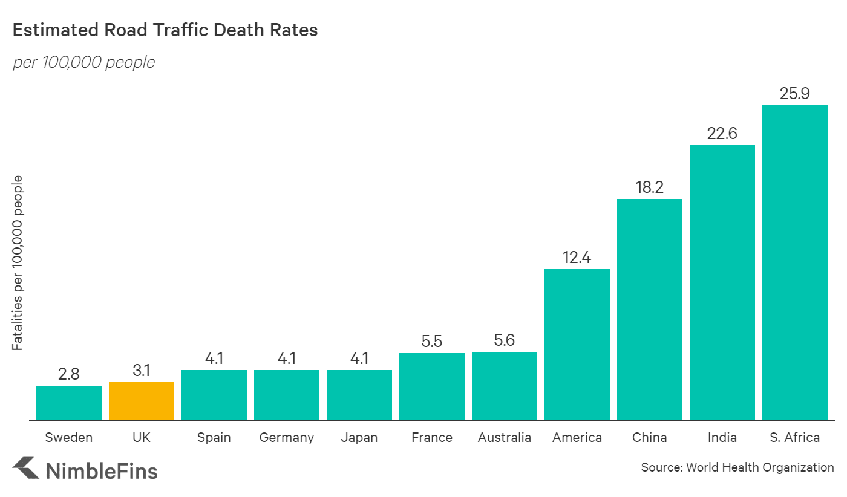

- The Data Protection Act
The Data Protection Act 2018 controls how your personal information is used by organisations, businesses or the government.
The Data Protection Act 2018 is the UK’s implementation of the General Data Protection Regulation (GDPR).
Everyone responsible for using personal data has to follow strict rules called ‘data protection principles’. They must make sure the information is:
used fairly, lawfully and transparently
used for specified, explicit purposes
used in a way that is adequate, relevant and limited to only what is necessary
accurate and, where necessary, kept up to date
kept for no longer than is necessary
handled in a way that ensures appropriate security, including protection against unlawful or unauthorised processing, access, loss, destruction or damage
There is stronger legal protection for more sensitive information, such as:
race
ethnic background
political opinions
religious beliefs
trade union membership
genetics
biometrics (where used for identification)
health
sex life or orientation
There are separate safeguards for personal data relating to criminal convictions and offences.
Your rights
Under the Data Protection Act 2018, you have the right to find out what information the government and other organisations store about you. These include the right to:
be informed about how your data is being used
access personal data
have incorrect data updated
have data erased
stop or restrict the processing of your data
data portability (allowing you to get and reuse your data for different services)
object to how your data is processed in certain circumstances
You also have rights when an organisation is using your personal data for:
automated decision-making processes (without human involvement)
profiling, for example to predict your behaviour or interests

- 2.2 Departments, Subfunctions, and Activities We used the outcome of the mapping process to identify and allocate each subfunction to one or more of the four functions. The aggregation of related subfunctions resulted from an affinity grouping process. Each group of subfunctions was given a descriptive name that was then used to identify and label candidate organizational departments. Table 3 lists the departments, subfunctions, and activities for the Protect/Shield function. Table 4, Table 5, and Table 6 contain similar information for the remaining three functions.
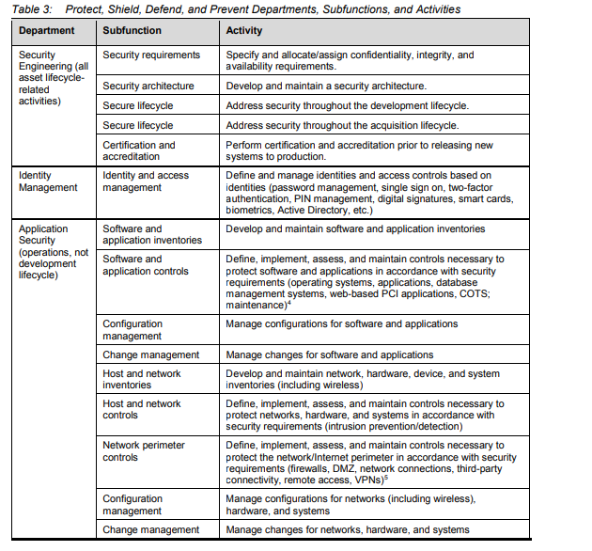

- Windows comprise of a number of components and their security resistance is linked to how these components perform as a whole system. Consequently, when specifying the level of protection required of the window, it should relate to the whole system, not just the glass. When identifying glazing, there are various types of glass to select from, each of which has different properties:
- Annealed/float glass – traditional window glass which forms sharp glass shards when broken. It is not recommended for use in any security solution.
- Toughened glass, also known as tempered glass – the production process produces glass that is approximately five times stronger than annealed glass. It will break into small chunks instead of glass shards.
- Heat strengthened glass – this is similar to toughened glass but is only twice the strength of annealed glass.
- Laminated glass sandwiches – an interlayer between layers of glass designed to hold together when the glass shatters.
- Polycarbonate – significantly stronger and lighter than glass and hard to break.
Laminated glass is the preferred option for most security applications. Care should be taken to ensure that the correct type of laminate is specified and used. It is also important to ensure that the rest of the glazing system, e.g. support structure and fixings, are specified and installed correctly.
Anti-shatter film, fitted alongside bomb blast net curtains may be used in conjunction with any of the types of glazing. Additional measures such as bars and grilles may also be incorporated to provide enhanced security. Thought should be given to whether these are placed inside or outside the glazing. Obscuration measures can be used to mitigate both the threat of ballistic attacks and unauthorised observation. In the case of ballistic attacks, such measures will prevent aimed shots but may not stop un-aimed fire. The construction details of glazing therefore needs to be considered to determine whether they will withstand bullets from the selected threats.

