

Master of Business Administration
Student Name: Ali Akbar Rafsan
Student Number: 2433800
Module Code: LCMB7003
Assessment: Individual report
Course Name: Strategic Management
Lecturer: Amare Desta
Word Count: 5288
Submission Deadline: 22nd December 2025

Table of Contents
Executive Summary 1
PART 1: Organisation and Target Market Selection of Pret A Manger 2
1.1 Introduction of Pret A Manger Company 2
1.2 Reason why the Target Market is chosen: United Arab Emirates (UAE) 3
1.3 Strategy Justification of Market Choice 4
1.4 Secondary Data Availability 5
PART 2: Comprehensive Strategic Analysis of UAE Expansion for Pret A Manger 6
2.1 PESTLE Analysis of the UAE Market 6
2.2 Porters Five forces Analysis 9
2.3 VRIO Analysis of Pret A Manger 11
2.4 Value Chain Analysis by Porter 12
2.5 Porters Diamond Analysis (UAE Foodservice Sector). 14
2.6 Critical Analysis of Strategic Tools (Limitation) 15
Part 3: Strategy Development and Formulation (Pret A Manger - UAE Expansion) 15
3.1 Strategic Objective 16
3.2 McKinsey 7S Framework Application 16
3.3 Porters generic strategy: 18
3.4 Market Entry Strategy 19
3.5 Ansoff Matrix Application 20
3.6 Corporate-Level Strategy 21
3.7 Using Secondary Data: Pret’s Last 5-Year Trends (2019–2023) 22
3.8 S.A.F.E. Framework Evaluation 22
PART 4: Performance Evaluation Framework (Pret A Manger - UAE Expansion) 24
4.1 Balanced Scorecard for Pret A Manger UAE 24
4.2 Swiftness to Triple Bottom Line (TBL). 27
4.3 Why the Balanced Scorecard is appropriate at Pret 27
Conclusion 28
References 29

Contents of Figure
Figure 1: PESTLE Analysis 6
Figure 2: Porters Five forces Analysis 11
Figure 3: VRIO Analysis 12
Figure 4: Value Chain Analysis by Porter 13
Figure 5: Porters Diamond Analysis 14
Figure 6: McKinsey 7S Framework 16
Figure 7: Ansoff Matrix 20
Figure 8: S.A.F.E. Framework 22

Executive Summary
This report offers a strategic analysis about international expansion and a strategic plan of an entry of the business into the United Arab Emirates (UAE) and presents a case of a premium fresh-food and coffee chain called Pret A Manger that is based in Britain. The UAE is being characterised as a high-potential market that is stimulated by economic development, high rates of tourism inflows, a multicultural expatriate market, and rising demand rates to high-quality quick-service food concepts. Pret offers fresh food that is cooked on-site, natural ingredients, ethically sourced, and can be served fast are fundamental characteristics of its business model that are in line with consumer trends in Dubai and Abu Dhabi. An in-depth PESTLE analysis reveals the political stability of the UAE coupled with the business-friendly environment, favourable business indicators, high level of digital adoption and favourable regulatory environment regarding international franchising. According to Porters Five Forces, there is a high competition level but also an evident opportunity in the niche of premium fresh-food. The VRIO, Value Chain and Porters Diamond analysis proves that the in-store kitchen capabilities of Pret and its global brand strength will create a sustainable competitive advantage when transferred to UAE conditions.
Based on the McKinsey 7S model, the analysis of the report found that Pret was not prepared in terms of its organisations and that it was required to introduce systematic franchising collaborations, supply-chain re-arrangements, and training of local teams. The Generic Strategy developed by Porter is the differentiation strategy and the Ansoff strategy proves that the UAE expansion is a Market Development strategy that should localise the products, especially with the halal requirement and regional menu. The best mode of entry to use is a master franchise entry mode to capitalise on the knowledge of the local market and minimise operational risk. Lastly, a customised Balanced Scorecard is created to assess strategic performance within the financial performance, customer satisfaction, operational excellence, and organisational development. The important performance indicators are revenue growth, customer satisfaction rating, supplier trustworthiness, employee training, and the green measure. In general, the decision to expand Pret A Manger to the UAE is a strategic, financially viable, and operationally viable opportunity with high growth potential based on a well-thought-out digitally-enabled, culturally-adaptive, and market-entry strategy.

PART 1: Organisation and Target Market Selection of Pret A Manger
Expansion of international business involves a thorough consideration of the organisation and the target market to be sure that the strategic choices to be made are based on the feasibility, competitiveness and long-term development (Grant, 2022). This section is about Pret A Manger, a chain of British sandwich and coffee stores that are well known worldwide and its future prospects of entering the United Arab Emirates (UAE). By concentrating on fresh and ethically-sourced food, the speed of delivery, and its location in urban areas, Pret A Manger has created a solid brand image (Pret A Manger, 2024). The reason why the UAE is chosen as the target market is that it is highly urbanised with a high economic growth and demand in the western style of quick-service restaurants (IMARC Group, 2023; Oxford Business Group, 2023). The accessibility of plausible secondary data in company reports, industry analysis, and market intelligence sources is also taken into consideration in this part, and will assist in a sound evaluation of the international expansion strategy of Pret (Euromonitor, 2023; Statista, 2024).

1.1 Introduction of Pret A Manger Company
Pret A Manger (often referred to as Pret) is a British global chain of sandwich and coffee shops with its headquarters in London created in 1986. The company identifies itself as a supplier of natural, fresh, ready to eat food prepared on-site kitchens, sandwiches, wraps, salads, hot food, snacks and coffee prepared by the barista. Over the last 10 years, Pret has grown and currently has over 650 branches worldwide in the UK, US, Europe and Asia (Pret A Manger, 2024).
There are four pillars of the business model of the company:
- Fresh food prepared daily
- Sustainable and ethical sourcing.
- Speed and convenience
- High-end city sites that target the busy workers.
Pret has recorded good recovery and international expansion following the pandemic. In 2023, the company reported record revenues of PS792 million, which was partly due to international expansion, addition of new franchise partners, and innovation of digital-based products (Pret A Manger Annual Report, 2023). Pret has also expressed a long-term vision of expanding into new markets with high potential in the world by franchising and strategic alliances (World Coffee Portal, 2023).
Considering it has a powerful brand image, effective global operating model, and renewed focus on international expansion, Pret A Manger is a viable organisation to study expansion strategy under an international context.

1.2 Reason why the Target Market is chosen: United Arab Emirates (UAE)
United Arab Emirates (UAE) is chosen as the target market in expansion because of the high economic growth, urbanisation, a wide expatriate population and rising fast-food culture and cafes. One of the fastest-growing foodservice markets in the Middle East, UAE has been backed by growing disposable incomes, high working-age population, and the growing demand of Western-style quick-service formats (IMARC Group, 2023).
1.2.1 Market Attractiveness
UAE foodservice market is estimated at a value of over USD 20billion, and it is growing owing to tourism, hospitality development, and international retail development (Statista, 2024).
The QSR (quick-service restaurant) market is estimated to increase at a CAGR of 5-6% in the coming five years due to the demand of high quality fast food and ready-to-eat food items (IMARC Group, 2023).
The cities of Dubai and Abu Dhabi, in particular, have high pedestrian traffic, concentrated business areas, and a high number of office employees, which perfectly fit into the target profile of Pret (Oxford Business Group, 2023).
These trends imply that the food-to-go and coffee-focused business model by Pret will find a rich market in UAE.

1.3 Strategy Justification of Market Choice
When the company is planning to enter the international market, it is important to evaluate the attractiveness of the market and how it fits the business model (Grant, 2022). The focus on quality food, rapid service, and ethical sourcing offered by Pret A Manger is in place to the urban population with high disposable incomes and time-constrained; these characteristics feature much of the population across the UAE (UAE Government Portal, 2023; Pret A Manger Annual Report, 2023). The UAE market is also having opportunities because of the relative lack of direct competition in the high-end fresh-sandwich cafes, the country encourages foreign investment, and the tourism industry is experiencing growth (Euromonitor, 2023; Dubai Chamber of Commerce, 2024; UAE Ministry of Economy, 2024). This section assesses the degree to which these factors support the choice of the UAE as a strategic market to grow internationally by Pret.
Fit with the Business Model of Pret:
The model of fresh food, fast service that Pret is employing would be suitable to the high-income and time-crunched, urban professionals of the UAE. The high number of expatriates (88 percent of the UAE residents) knows Western food concepts and wants international cafe brands (UAE Government Portal, 2023). This decreases the cultural barrier of entry.
Sustainability-oriented branding by Pret is another factor that appeals to the growing interest in the UAE on ESG activities and ethical consumerism among young professionals.
Advantages of Competitive Landscape:
The market in the UAE is not overcrowded with specialised brands of sandwich-shops. The mainstream competitors are Starbucks, Costa Coffee and local cafe chains, but there is not much direct competition in the niche of high-end fresh-sandwich cafes that Pret is located in (Euromonitor, 2023). This provides a strategic position to differentiate Pret with its unique kitchen-fresh value proposition.

The business environment is favourable:
The UAE government has promoted foreign investment and global franchising by imposing low taxation, free economic zones, and simplification of business regulation (Dubai Chamber of Commerce, 2024).
At the same time, the tourism policy of the country, which seeks to attract 25 million tourists every year by 2025, also contributes to an increased number of customers acquiring international foodservice solutions (UAE Ministry of Economy, 2024).
These combine to put the UAE in a strategically appealing location to grow Pret.

1.4 Secondary Data Availability
High-quality secondary data is essential to take effective decisions in the international business strategy (Grant, 2022). Pret A Manger has a large amount of publicly available information, such as annual reports, sustainability reports, and financial statements (Pret A Manger, 2024). Simultaneously, the UAE foodservice and retail industry is also highly covered in terms of industry analyses, market reports, and business media (IMARC Group, 2023; Statista, 2024; Oxford Business Group, 2023). The high number of valid secondary sources makes it possible to analyse the prospects of Pret to expand into the UAE with the help of the relevant, up-to-date and credible data. In this section, the accessibility and usefulness of such data in the study is described. Pret A Manger is a good company to use in secondary data collection because:
- The company has annual reports, sustainability reports, and financial statements.
- IMARC, Statista, Euromonitor, MarketLine, Oxford Business Group and business media like Financial Times are only some of the sources that extensively analyse the UAE foodservice industry.
- Cafes, QSRs, and F&B retail industry and market data are common and current in UAE.
- The international expansion strategy of Pret is frequently discussed in executive interviews and news storeys.

PART 2: Comprehensive Strategic Analysis of UAE Expansion for Pret A Manger
To expand Pret A Manger to the UAE, one will need a systematic approach to the external and internal business environment analysis to guarantee the sustainable growth and competitive edge. This section applies the proven models of analysis, namely, PESTLE, Porters Five Forces, VRIO, Value Chain, and Porters Diamond, to assess the macro-environmental, industry, and organisational elements that affect the potential entry of Pret (Grant, 2022; Johnson et al., 2020). This section will give a thorough evaluation of the opportunities, challenges, and strategic implications of Pret in the foodservice industry in the UAE by assessing political, economic, social, technological, legal, and environmental factors, as well as competitive forces, resources, capabilities, and value creation processes. The important limitations of these tools are also highlighted to provide the analysis with the context of the dynamic international environment (Barney, 2020; Porter, 1990).

2.1 PESTLE Analysis of the UAE Market
The PESTLE framework helps assess macro-environmental influences relevant to Pret A Manger’s international expansion.
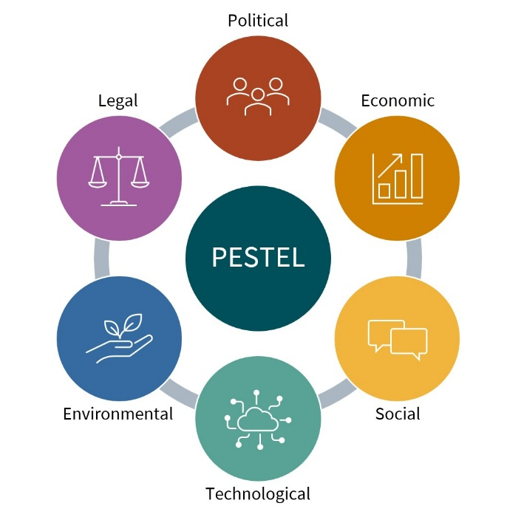
Figure 1: PESTLE Analysis
(Source: AKISConnect)
2.1.1 Political Factors
The UAE offers a politically stable, pro-business environment characterised by strong governance, efficient public administration, and favourable foreign investment policies (World Bank, 2024). Government initiatives such as the UAE Economic Vision 2031 emphasise diversification away from oil into hospitality, tourism, and services, creating opportunities for international food brands (UAE Ministry of Economy, 2024).
The UAE’s extensive free zones allow 100% foreign ownership and simplified regulatory procedures, which can support Pret’s entry either through franchising or joint-venture models (Dubai FDI, 2024). Political neutrality and strong diplomatic relations with Western countries enhance international trade and supply-chain reliability, which is essential for Pret’s daily fresh-food logistics.
Risk consideration: Regulations on food imports, halal certification, and labour compliance must be closely managed to avoid operational disruption.
2.1.2 Economic Factors
The UAE is a high-income economy with a 2024 GDP per capita exceeding USD 47,000 (IMF, 2024). Economic diversification, tourism, and retail growth contribute to a strong consumer services sector. The foodservice market is valued at USD 23–25 billion, with the QSR and café category growing at a CAGR of around 5–7% (Statista, 2024; IMARC Group, 2023).
Urban centres like Dubai and Abu Dhabi host large business districts where consumers demand quick, high-quality food options—aligning directly with Pret’s core proposition. Additionally, Dubai International Airport remains one of the world’s busiest hubs, increasing demand for international food brands among tourists.
Risk consideration: High rental costs and inflation in food imports can pressure profit margins.

2.1.3 Social Factors
The UAE has a multicultural society, with expatriates comprising approximately 88% of the population (UAE Government Portal, 2024). This cosmopolitan consumer base is already familiar with Western café chains such as Starbucks, Costa Coffee, and PAUL, reducing cultural barriers for Pret.
Lifestyle trends include increasing health consciousness, demand for fresh food, and preference for premium convenience-based dining (Euromonitor, 2023). Pret’s focus on natural ingredients, sustainability, and fresh daily production aligns well with these trends.
Risk consideration: Menu localisation is necessary due to halal requirements and preferences for certain flavours.
2.1.4 Technological Factors
The UAE is one of the world’s most digitally advanced markets, with 99% internet penetration and strong adoption of food-delivery platforms such as Talabat, Deliveroo, and Careem Food (Hootsuite, 2024). Integration with such digital ecosystems supports Pret’s omnichannel strategy—including online ordering, loyalty apps, subscriptions, and digital payments.
Technological infrastructure in logistics and cold-chain systems supports daily fresh-food supply, although high operational standards are required.
Risk consideration: Cybersecurity and digital-privacy compliance must be ensured, particularly for subscription programs.
2.1.5 Legal Factors
UAE foodservice operators must comply with strict requirements for halal certification, food hygiene, labour laws, and municipality permits (Dubai Municipality, 2024). Pret must adapt recipes and sourcing to ensure halal compliance.
Franchising laws have recently been modernised, improving transparency and reducing legal complexity for foreign brands entering the market (UAE Ministry of Justice, 2024).
Risk consideration: Non-compliance with halal or food safety regulations could lead to fines or licence suspension.
2.1.6 Environmental Factors
The UAE is committed to sustainability, launching the UAE Net Zero 2050 Strategy, which encourages businesses to reduce waste and carbon footprint (UAE Environment Agency, 2024). Pret’s existing sustainability initiatives—such as reusable cups, organic coffee, and food waste reduction programs—align strongly with this national agenda.
However, the UAE’s desert climate increases environmental and logistical challenges: imported ingredients and refrigeration requirements raise carbon footprint and operating costs.

2.2 Porters Five forces Analysis
2.2.1 Threat of new entrants - moderate
The UAE cafe/QSR market can be easily entered thanks to the franchise-friendly legislation and business incentives (Dubai FDI, 2024). But, the cost of capital, especially of prime sites, brand-development costs and the logistics of fresh-food restrict new entrants. The brand of Pret, which is well-established in the world, makes it less vulnerable, but niche players might appear.
2.2.2 Supplier Power- Moderate to High
The UAE is a country that depends on food imports, as there is less domestic farming (FAO, 2024). This generates concentration of suppliers and price sensitivity to international prices. Supplier relations are important to Pret since it depends on fresh items that are available daily. The strategic partnership and long-term contracts will be necessary to ensure the quality and minimise the supply-chain risk.
2.2.3 Buyer Power- Buyers- High
Dubai and Abu Dhabi consumers have numerous choices in the cafe / fast-casual area. The sensitivity of price ranges is high, nevertheless, the customers demand quality products, quick service, and good atmosphere. Pret needs to differentiate through freshness, sustainability and consistency of services.
2.2.4 Threat of Substitutes: High
Consumers may replace the offerings of Pret with:
- Local bakeries
- International QSR chains
- Home-cooked meals
- Convenience-store food
- Cafe chains with food menus
It is thus necessary to differentiate by using the kitchen-fresh positioning.
2.2.5 Competitive Rivalry: High
Major competitors include:
- Starbucks
- Costa Coffee
- Tim Hortons
- PAUL
- Caribou Coffee
- Local artisanal cafes
The premium location offers high competitive rates because it is saturated leading to competitive pressure, and location strategy is essential.

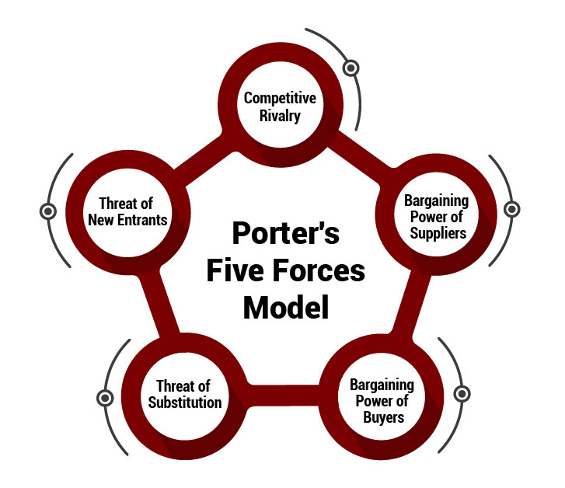
Figure 2: Porters Five forces Analysis
(Source: The Strategy Institute)

2.3 VRIO Analysis of Pret A Manger
Pret’s fresh-food kitchen model is its most distinctive capability, offering a competitive advantage in UAE where many cafés rely on central kitchens.
Resource | Valuable | Rare | Inimitable | Organisation Support | Competitive Implication
Daily in-store fresh food preparation | Yes | Yes | Yes (logistically complex) | Yes | Sustainable competitive advantage
Strong global brand reputation | Yes | Moderate | Yes (brand equity) | Yes | Differentiate disadvantage
Ethical sourcing & sustainability commitments | Yes | Moderate | No | Yes | Temporary competitive advantage
Fast-service operational culture | Yes | No | No | Yes | Competitive parity
Digital ecosystem (subscription, app) | Yes | Moderate | No | Yes | Temporary advantage

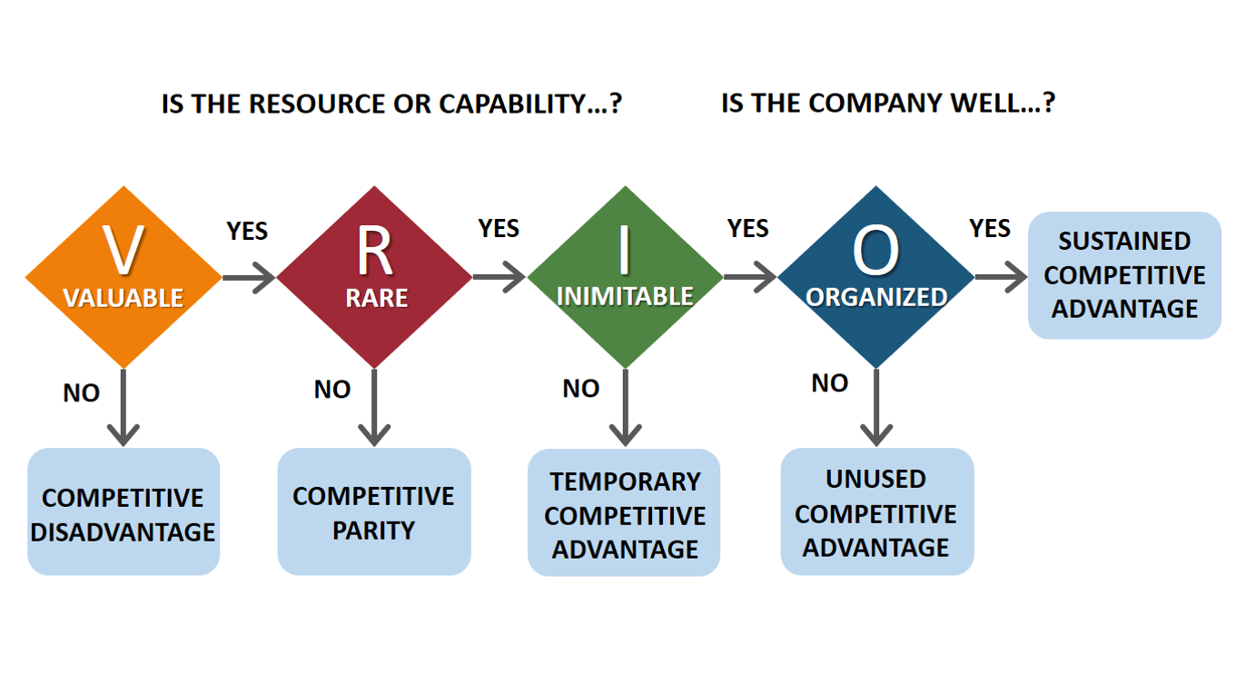
Figure 3: VRIO Analysis
(Source: Business-to-you)

2.4 Value Chain Analysis by Porter
Primary Activities
Inbound logistics: Dependence on imported ingredients; needs to create distribution centres in the UAE.
Operations: Fresh food that is made daily in on-site kitchens- drives quality but will raise training and labour needs.
Outbound logistics: Low due to direct-to-customer retail model.
Marketing & sales: Good online marketing; the brand storey (freshness, natural ingredients) of Pret helps make a difference.
Service: Quick, courteous service is a must; customer loyalty programmes help keep them.

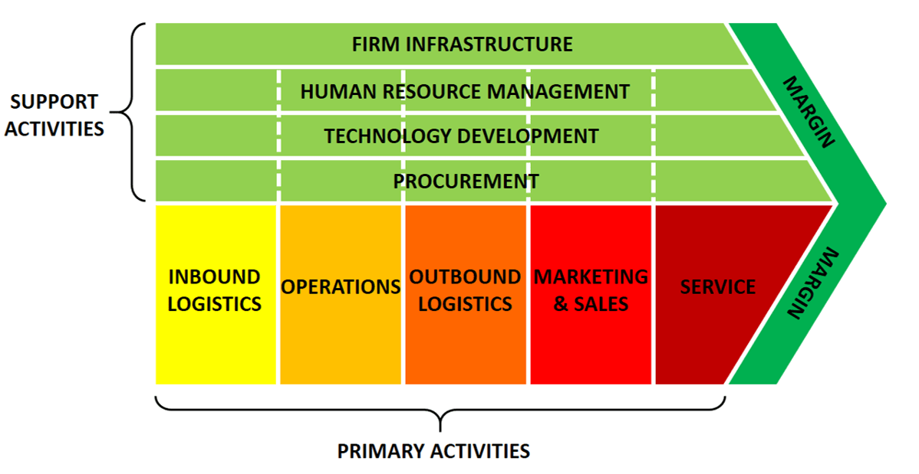
Figure 4: Value Chain Analysis by Porter
(Source: Business-to-you)
Support Activities
Procurement: Should have halal certified suppliers.
Technology: Mobile application, payment systems, and connexion with food delivery applications.
HR: labour market highly dependent on expatriate staffs in the UAE--needs training and retention programmes.
Infrastructure: High pedestrian retail units were required.
The value chain of Pret is in line with the capabilities of UAE, yet one of the primary challenges is the complexity of supply chains.

2.5 Porters Diamond Analysis (UAE Foodservice Sector).
Factor Conditions
- Well-developed infrastructure, international logistics, new ICT infrastructure.
- Low domestic agriculture - high levels of importation.
- Skilled hospitality labour force (primarily expatriates)
Demand Conditions
- Great demands on quality, freshness, and high-grade cafe experiences.
- High number of expatriates used to Pret-style products.
- Increase in health conscious customers.
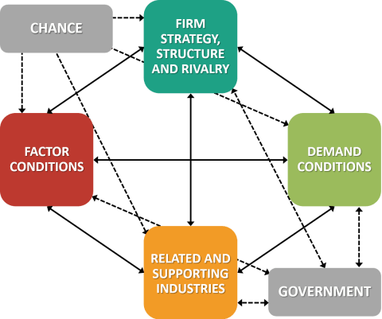
Figure 5: Porters Diamond Analysis
(Source: Business-to-you)
Related and Supporting Industries:
- Good logistics, packaging, cold-chain suppliers.
- Fast growing food delivery services.
- Under tourism and hospitality ecosystem increases demand.

Firm Strategy, Structure, and Rivalry
- Extreme rivalry with international cafes.
- There must be high brand visibility and innovation.
Franchising is typical--appropriate in the Pret entry mode.

2.6 Critical Analysis of Strategic Tools (Limitation)
As helpful as the tools listed above are, they have their flaws:
PESTLE is overly simplistic on its complex macro trends and lacks impact quantification (Johnson et al., 2020). With digital disruption and globalisation blurring the boundaries of industries, Porters Five Forces is not the right model in highly dynamic markets such as UAE (Grant, 2022). So VRIO is based on the premise of consistent internal strengths, but the ability of Pret could decline under international conditions (Barney, 2020).
The decentralised fresh-kitchen model used by Pret is a challenge to value chain analysis as it may work differently in the UAE. Diamond Model puts more emphasis on national competitiveness as opposed to strategic choices of individual firms (Porter, 1990). It is then a combination of tools that offer a more solid analysis.

Part 3: Strategy Development and Formulation (Pret A Manger - UAE Expansion)
Based on the examination of the UAE market and the internal strengths of Pret A Manger, this section is dedicated to the creation and the design of the strategies that will lead to effective market entry and successful growth. It analyses business level, corporate level, and operational strategies to match the strength of the business with the market opportunities of Pret. The models of strategic frameworks used to analyse organisational fit, competitive positioning, and strategic feasibility include the McKinsey 7S model, the Generic Strategies described by Porter, the Ansoff Matrix, and the S.A.F.E. evaluation (Ansoff, 1957; Porter, 1985; Grant, 2022). The focus is on market penetration, product localisation, premium positioning, digital integration, and entry through franchises, so that Pret can capitalise on its global brand and operational experience and comply with the regulatory and cultural demands in the UAE (Pret A Manger Annual Report, 2023; Dubai Municipality, 2024; World Coffee Portal, 2023).

3.1 Strategic Objective
Pret A Manger seeks to launch the United Arab Emirates (UAE) as a long-term internationalisation initiative. The main goal is to make Pret one of the premier high-end brands of fresh-food, fast-service, in Dubai and Abu Dhabi, in three years, and reach sustainability in terms of making a profit through the franchise or a master-franchise type of partnership.
The plan is based on market penetration, menu localisation, premium positioning and operational adaptation to exploit the unique competencies of Pret coupled with responding to market dynamics in the UAE.

3.2 McKinsey 7S Framework Application
The McKinsey 7S tool will be used to evaluate organisational fit and strategic alignment to the expansion of Pret into the UAE.
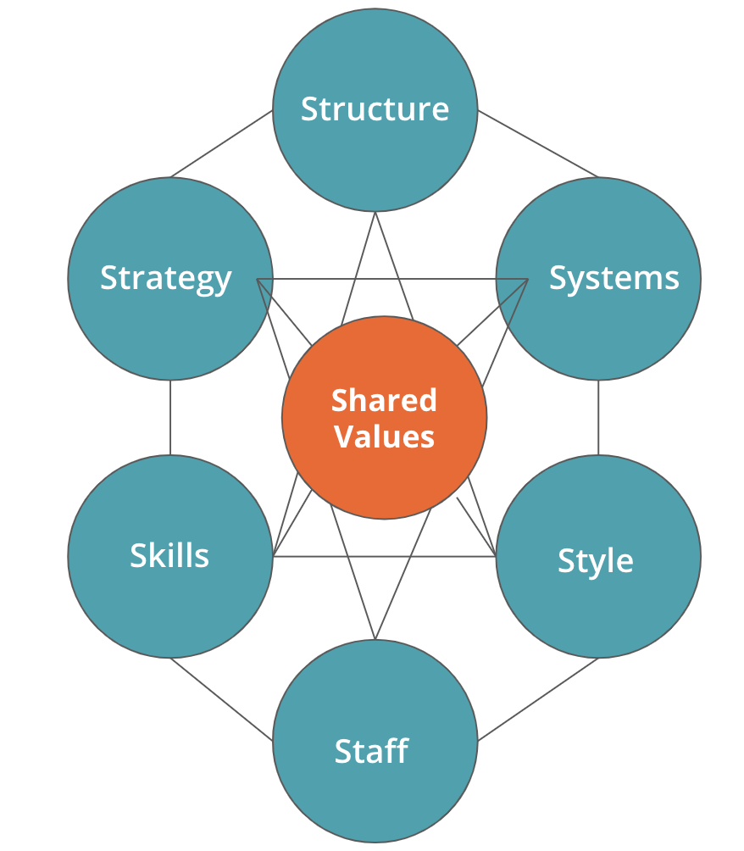
Figure 6: McKinsey 7S Framework
(Source: CFI)

3.2.1 Strategy
The expansion plan by Pret will focus on:
- Franchising / master franchise entry into UAE, minimising capitals risk.
- Premium positioning through daily preparation, natural and sustainable.
- Trying to target the areas of high pedestrian traffic and railways.
- Delivering through digital platforms, loyalty, and subscriptions.
This goes with the global growth orientation of Pret (Pret A Manger Annual Report, 2023).
3.2.2 Structure
Pret is currently a decentralised store operations company that maintains a centralised headquarters in London. To expand into UAE, it will need:
- A local franchisee.
- Local supply-chain management departments.
- Special quality-checking and training departments.
A hub and spoke system provides consistency in operations.
3.2.3 Systems
Pret relies on:
- Daily kitchen product systems.
- Health and safety systems
- Electronic point of sale and rewards programmes.
- Monitoring supplier-quality.
These systems need to be adjusted to the halal regulations of UAE, laws concerning labour, and digital-payment ecosystems (Dubai Municipality, 2024).

3.2.4 Shared Values
The values of Pret include freshness, natural food, ethical sourcing, which concurs with the UAE consumer trends in the direction of healthy food and sustainability (Euromonitor, 2023). These values create brand resonance.
3.2.5 Skills
The internal strengths of Pret include:
- Experience in preparing fresh-foods.
- Barista training
- Customer service culture
The transfer of skills will demand investment in the development of the staff since UAE has an expatriate labour market.
3.2.6 Staff
The UAE foodservice industry is highly dependent on foreign employees. Pret must:
- Train multicultural teams
- Provide competitive remuneration.
- Offer good onboarding of fresh-food preparation standards.
3.2.7 Style
Pret has a leadership style that is people based, collaborative. This culture should be reflected in the UAE franchise management in order to achieve consistency in services and brand authenticity.

3.3 Porters generic strategy:
Differentiation Strategy
Pret ought to seek a differentiation policy, founded on:
- Preparation in-store kitchen daily (uncommon in UAE cafes)
- Natural, healthy, and quality ingredients.
Sustainability and ethical sourcing
- Product freshness and speed of service.
- Strong brand storytelling
Differentiation goes along with high-end urban consumer markets in Dubai and Abu Dhabi (Porter, 1985).

3.4 Market Entry Strategy
Since the UAE is a franchise-friendly country and Pret has international operational experience, the proposed mode of entry is:
Master Franchise Partnership:
Advantages
- Lower capital investment
- Faster scale-up
- Takes advantage of local partner knowledge of market.
- It becomes easier to comply with the halal and regulatory requirements.
- Reduces supply-chain risk
Appropriate Local Partners May include
- Alshaya Group
- Americana Group
They already have Starbucks, Costa Coffee, Shake Shack, and other companies, which proves that they are experienced in the premium F&B franchising.

3.5 Ansoff Matrix Application
Strategy | Relevance to Pret UAE Expansion
Market Penetration | Using Pret’s existing menu & brand to capture UAE urban professionals.
Market Development | Main strategy: introducing Pret’s current products to a new geographical market (UAE).
Product Development | Halal-compliant recipes, local flavours, exclusive Middle Eastern sandwiches & salads.
Diversification | Not recommended initially due to risk and operational complexity.

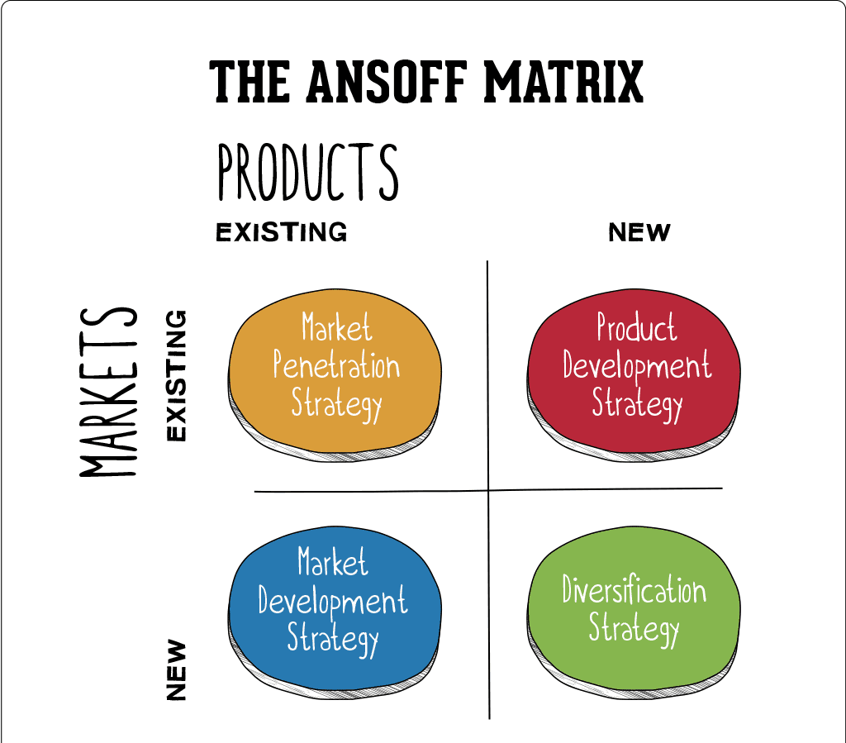
Figure 7: Ansoff Matrix
(Source: Smartinsights)
The UAE expansion is more of a Market Development strategy with the aspect of Product Development. This section presents the UAE business-level strategy. Pret should target to establish presence in Dubai and Abu Dhabi, it should target:
Premium Urban Location Strategy:
- Business districts (DIFC, Downtown Dubai, Abu Dhabi Corniche)
- Big transport centres (Dubai Metro, Dubai International Airport)
- Malls (Dubai Mall, Mall of the Emirates).
Menu Localisation:
- 100 per cent halal certified products.
- Middle Eastern-themed products (e.g. chicken shawarma wraps, zaatar pastries).
- Cracker expansions of vegetarian and vegan.
- Cold drinks during hot weather.
The Digital Strategy of Omnichannel:
- Merger with Talabat, Deliveroo, Careem Food.
- Pret app launch on subscription model.
- Digital loyalty program
Customer Experience Strategy:
- Fast service
- Early morning opening times
- Special corporate catering services.

3.6 Corporate-Level Strategy
Pret has a corporate strategy that stresses on international growth via partnership models. For UAE:
- Strategic Priorities
- Geographical diversification
- Franchise-led internationalisation.
- Develop high quality brand image in the Middle East.
- Enhance supply-chain resilience.
- Sustainability integration
This is in line with the global direction of Pret (World Coffee Portal, 2023).

3.7 Using Secondary Data: Pret’s Last 5-Year Trends (2019–2023)
(Summarised from Pret Annual Reports & industry sources)
Year | Revenue Trend | Key Insight
2019 | Strong pre-COVID sales | Record global growth
2020 | Severe decline | COVID impact, store closures
2021 | Gradual recovery | Digital adoption accelerates
2022 | Significant rebound | Subscription model success
2023 | £792m (record revenue) | Led by strong international sales + franchising
The growing trend is a sign of the willingness by Pret to go global.

3.8 S.A.F.E. Framework Evaluation
The S.A.F.E model measures the feasibility and effectiveness of strategies.
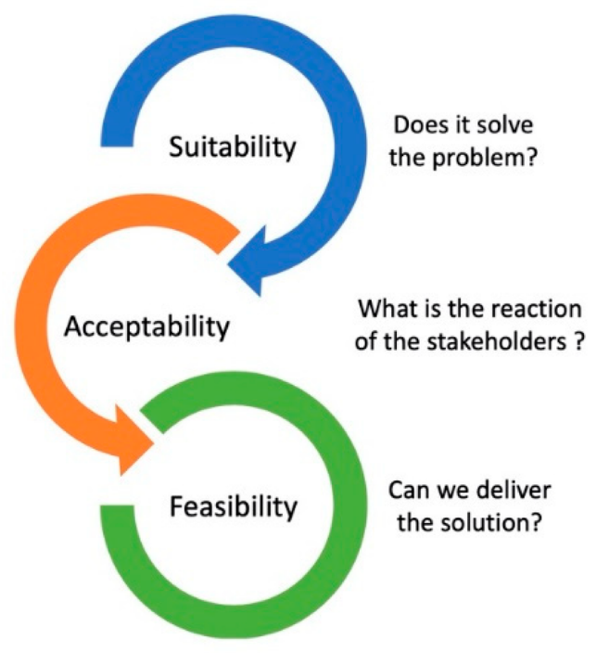
Figure 8: S.A.F.E. Framework
(Source: Researchgate)
3.8.1 Suitability
The economy, expatriate population, cafe culture and the demand of fresh premium food have a lot of compatibility with the strategic capabilities of Pret in the UAE. Local consumer behaviour is appropriate for differentiation in terms of freshness and sustainability.
3.8.2 Acceptability
The stakeholders, such as the shareholders of Pret, franchise partners, and customers will be willing to support UAE expansion because of:
- Attractive market growth
- Franchising model minimising risk.
- Strong brand appeal
In terms of economics, the premium pricing is possible because of the high-income consumers in UAE. Risks (competition, supply-chain), are tolerable.
3.8.3 Feasibility
The growth is possible because:
- Pret already has experience in franchising.
- The developed infrastructure of F&B in UAE.
- Access to skilled labour.
- Good supply-chain systems.
But feasibility means high halal compliance and alignment with the local partners.
3.8.4 Evaluation
In general, the expansion of Pret into UAE will rate well in terms of all SAFE criteria. There is high potential to succeed because of strategic fit, capability alignment, and market attractiveness.

PART 4: Performance Evaluation Framework (Pret A Manger - UAE Expansion)
A Balanced Scorecard (BSC) is embraced to ensure that the expansion of Pret A Manger in the UAE market is effectively tracked and in line with strategic goals. The BSC was created by Kaplan and Norton (1996) and helps organisations to assess four types of performance, namely, Financial, Customer, Internal Business Processes, and Learning and Growth. This multi-dimensional strategy suits Pret since it provides a balance in terms of profitability, operational excellence, service quality, and organisational capability particularly in a new international market.

4.1 Balanced Scorecard for Pret A Manger UAE
4.1.1 Financial Perspective
This perspective measures Pret’s financial performance in the UAE market, reflecting profitability and revenue growth.
Objectives | KPIs | Targets (Years 1–3) | Justification
Achieve revenue growth through premium positioning | Annual UAE revenue | AED 25m by Year 1; AED 60m by Year 3 | Growing UAE QSR market and premium consumer base supports revenue growth (IMARC, 2023).
Improve operating margin | Operating profit margin | 10% by Year 3 | Reflects improved scale, supply-chain efficiency, and franchising model benefits.
Ensure return on investment | ROI from UAE operations | 15% by Year 3 | UAE offers high footfall and strong demand for premium food outlets (Statista, 2024).
Explanation:
The franchising model reduces capital expenditure, enabling Pret to achieve profitability faster while maintaining premium pricing.

4.1.2 Customer Perspective
This dimension evaluates Pret’s ability to attract and retain customers in the competitive UAE café/QSR sector.
Objectives | KPIs | Targets | Justification
Build strong brand awareness | Brand awareness index | 30% recognition by Year 2 | UAE consumers are receptive to international brands (Euromonitor, 2023).
Enhance customer satisfaction | Customer satisfaction score (CSAT) | ≥ 85% | Premium service quality is essential to differentiation.
Increase customer loyalty | Subscription sign-ups (Pret coffee subscription) | 20,000 subscribers by Year 3 | UAE’s digital adoption supports subscription models.
Grow digital/online sales | Percentage of online orders | 25% of total orders | Strong food-delivery ecosystem in UAE (Hootsuite, 2024).
Explanation:
Pret’s subscription model, already successful in the UK, aligns well with UAE’s digitally active population and strengthens repeat purchases.
4.1.3 Internal Business Process Perspective
This focuses on operational excellence, supply-chain efficiency, and service delivery.
Objectives | KPIs | Targets | Justification
Ensure consistent quality of fresh food | Daily quality audit score | 95% compliance | Pret’s brand relies on fresh daily production.
Improve order fulfilment speed | Average service time | 90 seconds per customer | Fast service is core to Pret’s competitive advantage.
Achieve full halal compliance | Halal certification audits | 100% compliance | Mandatory for UAE market operations.
Strengthen supply-chain reliability | On-time supplier deliveries | ≥ 98% | Fresh food model requires precise deliveries.
Explanation:
Operational KPIs reflect the complexity of Pret’s “on-site kitchen” model, requiring strong supplier coordination and internal process discipline.

4.1.4 Learning & Growth Perspective
This examines Pret’s capacity to build capabilities, attract skilled employees, and embed organisational culture.
Objectives | KPIs | Targets | Justification
Build a skilled, well-trained workforce | Employee training hours | 40 hours per staff per quarter | Expatriate labour market demands strong training.
Improve employee retention | Annual staff turnover rate | < 25% | UAE hospitality sector has high turnover; improving retention protects service quality.
Strengthen organisational culture alignment | Employee engagement score | ≥ 80% | Pret’s service culture requires strong team cohesion.
Develop leadership capability in UAE | Number of certified Pret managers | 50 by Year 3 | Ensures standardisation and quality control.
Explanation:
Learning and growth KPIs ensure Pret maintains its service culture and operational skills within the UAE’s multicultural labour environment.

4.2 Swiftness to Triple Bottom Line (TBL).
(Secondary framework (only optional), based on the preferences of the assignment)
The Triple Bottom Line (People, Planet, Profit) is helpful in long-term performance evaluation as Pret A Manger already has good sustainability commitments.
People
- Local employment creation
- Ethical labour practices
- Employee education and health care initiatives.
Planet
- Food waste minimization (donation to UAE Food Bank)
- Sustainable packaging (biodegradable products)
- Knowledgeable energy friendly kitchen operation.
Profit
- Long-term profitability
- Franchised stores expansion.
- Strengthening brand equity
This is in line with the environmental engagements of UAE in Net Zero 2050 ( UAE Environment Agency, 2024).

4.3 Why the Balanced Scorecard is appropriate at Pret
The BSC will help Pret in its expansion in UAE since:
It maintains a balance between financial and operational and customer-oriented actions. It converts strategy into action which can be measured and this helps in having clear expectations with franchise partners. It minimises the chances of failure of the strategy as it guarantees coherence among people, processes, and systems (Kaplan and Norton, 1996). It is in service of the long-term sustainability and foreign expansion objectives of Pret.

Conclusion
As shown in this report, the company expansion of Pret A Manger to the United Arab Emirates is a strategically sound and high potential growth opportunity. The successful economic environment of UAE, growing foodservice market, and popularity of high-quality fresh-food ideas are quite aligned with the differentiated value offering of Pret. The macro-environmental analysis supports that the UAE has a stable political environment, digital infrastructure and franchise-friendly regulatory framework, which makes the market attractive to international brands. Through strategic analysis, it is clear that Pret has some specific strengths, specifically its daily fresh-food preparation model and its good global brand equity which can provide sustainable competitive advantage in a market where coffee chains are the major competitors, but not the specialised fresh-sandwich type. Nonetheless, to succeed in the UAE, they will need to adapt, particularly in halal compliance, supply-chain structure, and employee training.
The proposed master franchise entry mode with the assistance of differentiated positioning and menu localisation is less risky and allows swift market entry. The proposed Balanced Scorecard offers a systematic system of monitoring to assess financial performance, customer engagement, operational efficiency and organisational learning. To sum up, Pret A Manger has every opportunity to succeed in the UAE market in the long-term by building on its main strengths, engaging reputable partners on the local market, and implementing an effective strategy supported by strong performance indicators. Through proper localisation and operational discipline, the UAE expansion will be a major milestone in the course of global expansion with Pret.

References
Ansoff, H.I. (1957) ‘Strategies for diversification’, Harvard Business Review, 35(5), pp. 113–124. Available at: https://hbr.org (Accessed: 1 December 2025).
Barney, J.B. (2020) Gaining and sustaining competitive advantage. 6th edn. Pearson.
Dubai Chamber of Commerce (2024) UAE Market Outlook 2024. Dubai: DCC. Available at: https://www.dubaichamber.com (Accessed: 1 December 2025).
Dubai FDI (2024) Investment Opportunities in Dubai. Government of Dubai. Available at: https://www.dubaifdi.gov.ae (Accessed: 1 December 2025).
Dubai Municipality (2024) Food Safety Guidelines. Government of Dubai. Available at: https://www.dm.gov.ae (Accessed: 1 December 2025).
Euromonitor (2023) Cafés and Bars in the United Arab Emirates. Euromonitor International. Available at: https://www.euromonitor.com (Accessed: 1 December 2025).
Euromonitor (2023) Consumer Foodservice in the UAE. Euromonitor International. Available at: https://www.euromonitor.com (Accessed: 1 December 2025).
FAO (2024) Food Security and Imports in GCC Countries. Rome: Food and Agriculture Organization. Available at: https://www.fao.org (Accessed: 1 December 2025).
Grant, R. (2022) Contemporary Strategy Analysis. 11th edn. Wiley.
Hootsuite (2024) Digital 2024 UAE Report. Available at: https://www.hootsuite.com/resources/digital-report-uae (Accessed: 1 December 2025).
IMARC Group (2023) GCC Fast Food Market Report 2023–2028. IMARC. Available at: https://www.imarcgroup.com (Accessed: 1 December 2025).
IMF (2024) UAE Economic Outlook. International Monetary Fund. Available at: https://www.imf.org (Accessed: 1 December 2025).
Johnson, G., Whittington, R. and Scholes, K. (2020) Exploring Corporate Strategy. 12th edn. Pearson.
Kaplan, R. and Norton, D. (1996) The Balanced Scorecard: Translating Strategy into Action. Harvard Business School Press.
Oxford Business Group (2023) The Report: UAE 2023. London: OBG. Available at: https://oxfordbusinessgroup.com (Accessed: 1 December 2025).
Porter, M.E. (1985) Competitive Advantage: Creating and Sustaining Superior Performance. New York: Free Press.
Porter, M.E. (1990) The Competitive Advantage of Nations. New York: Free Press.
Pret A Manger (2023) Annual Report and Accounts 2023. London: Pret A Manger. Available at: https://www.pret.co.uk (Accessed: 1 December 2025).
Pret A Manger (2024) Company Overview. Available at: https://www.pret.co.uk (Accessed: 1 December 2025).
Statista (2024) UAE Foodservice Market Overview. Statista. Available at: https://www.statista.com (Accessed: 1 December 2025).
UAE Environment Agency (2024) UAE Net Zero 2050 Strategy. Abu Dhabi Government. Available at: https://www.ead.gov.ae (Accessed: 1 December 2025).
UAE Government Portal (2023) Population and Labour Market Statistics. Available at: https://u.ae/en (Accessed: 2 December 2025).
UAE Ministry of Economy (2024) UAE Economic Vision 2031. Government of UAE. Available at: https://www.economy.gov.ae (Accessed: 1 December 2025).
UAE Ministry of Justice (2024) Franchising Regulations Overview. UAE Government. Available at: https://www.moj.gov.ae (Accessed: 1 December 2025).
World Bank (2024) UAE Governance Indicators. World Bank. Available at: https://www.worldbank.org (Accessed: 1 December 2025).
World Coffee Portal (2023) ‘Pret A Manger accelerates international expansion’. Available at: https://www.worldcoffeeportal.com (Accessed: 1 December 2025).

