Student name: Sofia Sacalus
Student code: 1907696
Programme name: BSc Health and Social Care
Module name: Living with Care: The Older Person
Module code: BMHP6009_BIRM
Assignment title: Individual Poster
Lecturer: Joanne Davies

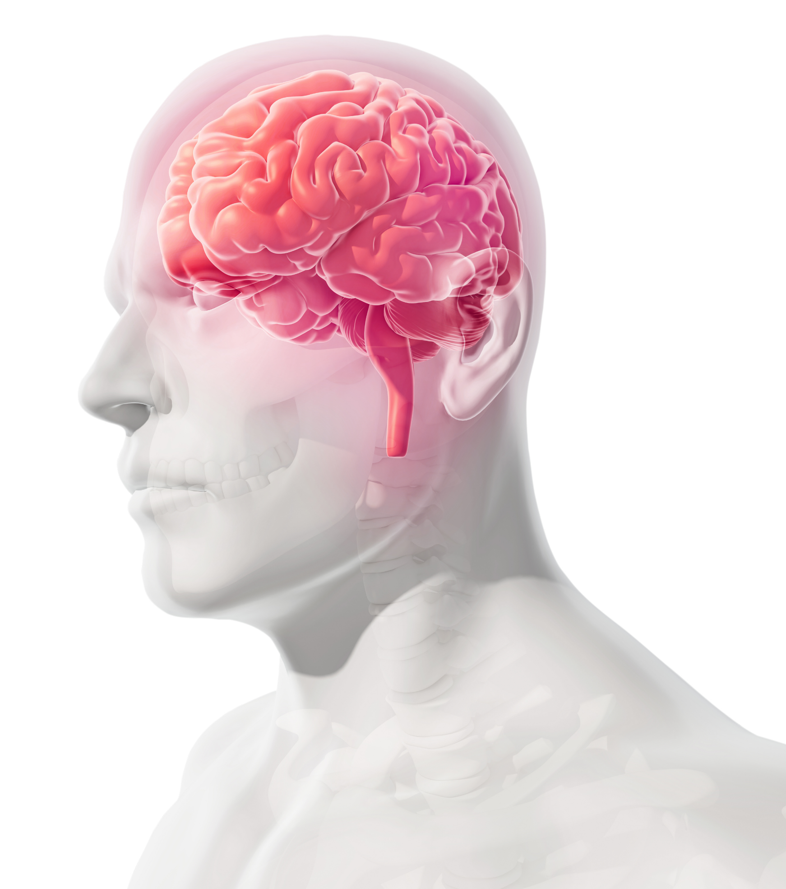
Understanding Dementia

Alzheimer's disease is a type of progressive brain disorder that affects people abilities to think and communicate. It can also stop their brain cells from working properly. (Dementia UK, 2021)

Types of Dementia
Vascular Dementia A person with vascular dementia has various cognitive changes that can affect different parts of their brains. For instance, they might have trouble remembering certain details. The usual symptoms of vascular dementia can start gradually or can manifest suddenly. They can also progress over time and can be compared to the symptoms of Alzheimer's disease. (National Institute on Aging, 2021)
Lewy Body Dementia Aside from memory loss, individuals with this condition might also experience visual hallucinations and sleep disturbances. They can also experience slowness and slurred speech. Mixed dementia is a type of cognitive impairment that can result from the effects of both Alzheimer's disease and vascular dementia. (AllRemedies - Natural Home Remedies For Better Health, 2018)
Signs of dementia Different people with different types of dementia have different symptoms. In most cases, these symptoms will appear some time before a person is diagnosed.
- memory loss
- difficulty concentrating
- finding it hard to carry out familiar daily tasks, such as getting confused over the correct change when shopping
- struggling to follow a conversation or find the right word
- being confused about time and place
- mood changes
- memory problems, such as regularly forgetting recent events, names and faces
- asking questions repetitively
- increasing difficulties with tasks and activities that require organisation and planning
- becoming confused in unfamiliar environments
- difficulty finding the right words
- difficulty with numbers and/or handling money in shops
- becoming more withdrawn or anxious(NHS Choices, 2019)

What can I do If someone who I love have dementia?
- Contact the GP
- Share your support for those living with Alzheimer's disease by joining a local organization or making a donation.
- Ask them to join in on a walk or participate in other leisure activities. Encourage them to get outside and enjoy life.
- Being with someone with dementia can be challenging. Being able to offer support and friendship can help ease the transition.
- Learn about Alzheimer's disease. It can affect you and your family. (Malchiodi, 2013)
Intervention
Psychosocial intervention is a type of treatment that is designed to help people suffering from Alzheimer's disease.A behavioral-oriented therapy is commonly used for people with hard-to-control behaviors. These treatment methods involve changing the environment that influences these actions.A cognitive-oriented therapy focuses on developing skills and reducing cognitive deficits.Experiencing pleasurable activities can also be part of a stimulation-oriented therapy program.
- Having relationship-focused interventions can help people with a dementia-and-their caregivers to renew and improve their relationships. It can help them regain their old sense of security and comfort, and it can help them to feel like they're being cared for.
- Was discovered a project known as Remembering yesterday and caring today, which was started by Pam Schweitzer. It involves the dyadic relationship between a caregiver and a loved one. (White, 2019)

If you suspect someome from your family of dementia do not hesitate to contact your GP for a test.
Dementia UK Helpline: 08008886678
helpline@dementiauk.org

References
Adams, T. and Gardiner, P. (2005). Communication and interaction within dementia care triads. Dementia, 4(2), pp.185–205.
Browne, C.J. and Shlosberg, E. (2006). Attachment theory, ageing and dementia: A review of the literature. Aging & Mental Health, 10(2), pp.134–142.
All Remedies - Natural Home Remedies For Better Health. (2018). List Of 17 Common Types Of Dementia And Early Symptoms. [online] Available at: https://allremedies.com/types-of-dementia/#:~:text=List%20Of%20Types%20Of%20Dementia%20%E2%80%93%20The%20Common (Accessed 10 Feb. 2022).
Chertkow, H., Feldman, H.H., Jacova, C. and Massoud, F. (2013). ‘Definitions of dementia and predementia states in Alzheimer’s disease and vascular cognitive impairment: consensus from the Canadian conference on diagnosis of dementia. Alzheimer’s Research & Therapy’, [online] 5(Suppl 1), p.S2. Available at: https://alzres.biomedcentral.com/articles/10.1186/alzrt198.
Dementia UK (2021). What is dementia? [online] Dementia UK. Available at: https://www.dementiauk.org/about-dementia/dementia-information/what-is-dementia/.
Dementia.com. (2010). DEMENTIA. [online] Available at: https://www.dementia.com/treatment.html.( Accessed 10 Feb. 2022).
Duron, E. and Hanon, O. (2008). Vascular risk factors, cognitve decline, and dementia. Vascular Health and Risk Management, [online] 4(2), pp.363–381. Available at: https://www.ncbi.nlm.nih.gov/pmc/articles/PMC2496986/.
Ince, P.G., Perry, E.K. and Morris, Chris.M. (2006). Dementia with Lewy Bodies. A Distinct Non-Alzheimer Dementia Syndrome? Brain Pathology, 8(2), pp.299–324.
Kitwood, T. and Bredin, K. (1992). Towards a Theory of Dementia Care: Personhood and Well-being. Ageing and Society, 12(03), pp.269–287.
Malchiodi, C.A. (2013). Art therapy and health care. New York: Guilford Press.
Melinda (2020). Dementia Symptoms, Types, and Causes - HelpGuide.org. [online] https://www.helpguide.org. Available at: https://www.helpguide.org/articles/alzheimers-dementia-aging/living-with-dementia.htm#:~:text=Common%20dementia%20signs%20and%20symptoms%20include%3A%20Memory%20loss. [Accessed 19 Nov. 2021].
MIND (2010). Equality Act 2010 | Mind, the mental health charity - help for mental health problems. [online] Mind.org.uk. Available at: https://www.mind.org.uk/information-support/legal-rights/disability-discrimination/equality-act-2010/.
National Institute on Aging. (2021). Vascular Dementia: Causes, Symptoms, and Treatments. [online] Available at: https://www.nia.nih.gov/health/vascular-dementia.
NHS Choices (2019). Can dementia be prevented? - Dementia guide. [online] NHS. Available at: https://www.nhs.uk/conditions/dementia/dementia-prevention/.
NHS Choices (2019). Symptoms of Dementia - Dementia Guide. [online] NHS. Available at: https://www.nhs.uk/conditions/dementia/symptoms/.
NICE (2018). About this guideline | Dementia: assessment, management and support for people living with dementia and their carers | Guidance | NICE. [online] Nice.org.uk. Available at: https://www.nice.org.uk/guidance/ng97/chapter/About-this-guideline.
Smits, L.L., van Harten, A.C., Pijnenburg, Y.A.L., Koedam, E.L.G.E., Bouwman, F.H., Sistermans, N., Reuling, I.E.W., Prins, N.D., Lemstra, A.W., Scheltens, P. and van der Flier, W.M. (2014). Trajectories of cognitive decline in different types of dementia. Psychological Medicine, 45(5), pp.1051–1059.
Yaffe, K. (2005). Research and Care of Patients With Dementia. The American Journal of Geriatric Psychiatry, 13(11), pp.921–925.

