How are the Falklands still threatened by Argentina?
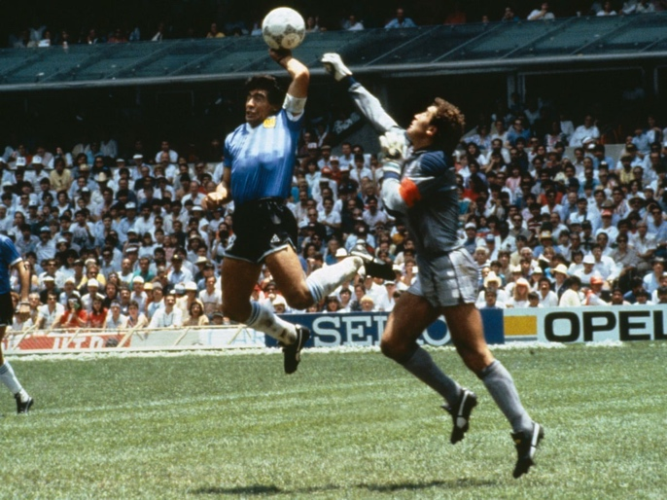
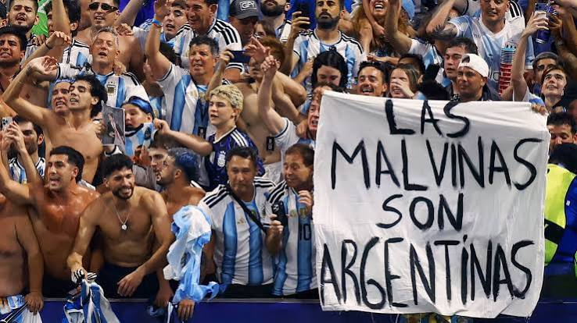
The Falklands, small and quaint, yet capable of causing decades of disputes spanning over 40 years. Located almost 300 miles to the east of Argentina, the Falklands are divided into two islands, the east island and the west island with a population of under 4000. Yet despite its small population, it is responsible for one of the longest disputes in British politics with a war that lead to the death of 907 people in 1982. Since then, the debate of self-determination and ownership have regularly been raised by Argentina.
Thomas, B (1986)

Recently, the debate has re-emerged following Argentina’s football team holding up a banner reading ‘Las Malvinas son Argentinas’ (The Falklands are Argentinian), allowing the debate to spread to the younger generation via social media. Football has long played a role in increasing tensions over the Falklands, such as Diego Maradonna’s ‘Hand of God’ which he dedicated to those who were killed in the 1982 war. According to figures published in an article by the independent, google searches of the Falklands increased by ‘2,400 percent after
Ellis, P (2026).
Argentina’s semi-finals with England’ where
the banner was shown which became ‘the
largest increase in search interest since the
platform began tracking data.’

An article by the Guardian highlights the returning tensions due to the Sea Lion oil project and President Javier Milei’s frustration towards the UN whilst the UK continues to support the island’s right to self-determination. Additionally, the issues surrounding the safety of the Falklands has been explored in many media outlets, notably in the Mail on Sunday who question the defence operations of Britain. The scope of coverage underlines the severity and scale of the issue. It raises the question as to whether politicians can learn from history or whether they are destined to repeat it.

A crucial aspect of the article is the threat of an Argentinian invasion which is heightened by Javier Milei’s aggressive and in intimidating comments made to the UN, where he believes that “members decided to look the other way regarding the situation of the Malvinas Islands.” Milei continuously draws our attention to the failure of the UN, stating that they have ‘masqueraded’ themselves as a political body who aim to maintain international peace. He describes them as ‘parasites’ implying that they’re infesting world peace with their selfish and avaricious behaviour. One could argue that Milei is justifying his anger and perhaps his future actions by saying that the UN has essentially failed to play an active role in the Falklands crises. This is significant as it increases national attention surrounding the dispute. His anger demonstrates that they don’t simply aim to have the physical territory but that the Falklands are a part of their national identity, highlighting how the historical argument over sovereignty continues to influence relations more that 40 years after the war.

Defence is key element of the debate surrounding the Falklands which is only partially mentioned in the Guardian article, however, dominates the Mail on Sunday. The confidence and certainty of Andy Burnham in the Guardian article who is certain that the UK ‘will defend the right of the Falkland Islanders to self-determination and to remain British,’ severely contrasts with the unnerving words of the Mail on Sunday who remain certain that the UK’s weak defence system will ‘leave the island vulnerable to attack.’ Burnham’s claims of ‘self-determination’ are reiterated in the Guardian article who specify that ‘99.8% of Falklanders voted to remain British in a 2013 referendum.’ Nevertheless, Milei argues that self determination shouldn’t apply to the Falklands as they were ‘implanted by the occupying power.’ The disagreement complicates resolutions as Britain and Argentina not only disagree over who owns the land but have contradicting opinions over who should determine the island’s future. These have direct political and social repercussions on the islanders who are in the centre of a battle that they have no voice in. The dispute therefore continues to have consequences more than 40 years after the war. Furthermore, the Mail on Sunday states that by withdrawing crucial defence equipment such as an ‘RAF A330 voyager tanker aircraft,’ the UK was clearly indicating ‘to Argentina that the Falklands is not a defence priority’ which is ‘exactly what happened in 1981 and a year later, they invaded.’ This is significant as it not only implies that the UK is in no position to successfully challenge Argentina by means of force but also that politicians are failing to learn from their previous mistakes.

Additionally, the Guardian article draws our attention to the economic effects of the crises, particularly the impact of oil sanctions. Tensions have been heightened over Milei’s claims that the Sea Lion project is ‘an unlawful act’ despite their initial ‘unilateral’ stance. The Sea Lion project is an oil discovery located 220km off the coast of the Falklands with the first oil expected in March 2028 and set to last over 30 years. Although there are economic benefits for the UK and the Falklands, Argentina has introduced ‘sanctions against more than 60 companies and people linked to the oil drilling project’ implying that the Falklands are being exploited for their natural resources. One could infer that if the Falklands were to have some of the revenues, then an Argentinian takeover would be harder. The issue surrounding oil has a wider political impact, bringing the United States directly into the Falklands debate. It was reported in the Mail on Sunday that the US might change their position on the conflict following Milei’s ‘threatened sanctions on oil firms working near the British territory.’ This has a severe impact as it makes the sovereignty dispute economically important.

The Falklands story demonstrates how historical events can remain relevant decades after the original dispute. Despite the 1982 war ending over 40 years ago, the underlying sovereignty dispute has not been resolved and has been exacerbated by recent oil explorations and high media attention because of the 2026 football World Cup. This demonstrates how historical claims continue to influence international relations, national identity, and the lives of the Falklanders.

Bibliography

Boffey, D. (2026) 'Milei threatens at UN that Argentina will take ‘matters into our own hands’ on Falklands,' The Guardian, 24 September. https://www.theguardian.com/uk-news/2026/sep/23/argentina-president-attacks-un-over-inaction-on-falkland-islands-sovereignty.

Debre, I. (2026) 'How Argentina’s World Cup banner has reignited Falklands dispute for new generation,' The Independent, 31 July. https://www.independent.co.uk/sport/football/falklands-war-banner-argentina-england-world-cup-b3025160.html.

'Falklands ‘vulnerable to attack’ after key RAF aircraft is withdrawn' (2026) The Mail on Sunday, p. 4. 27 September.

Navitas Petroleum (2026) Sea Lion - Navitas Petroleum. https://www.navitaspet.com/project/sea-lion/.

Territories, F. of the B.O. (2026) Sea Lion: The oil field shaping the future of the Falklands. https://fotbot.org/sea-lion-the-oil-field-shaping-the-future-of-the-falklands.

Images

Ellis, P (2026) Argentina players hold a banner reading ‘Las Malvinas son Argentinas’ after winning the 2026 World Cup semi-finals against England. The Guardian, 15 July https://www.theguardian.com/football/2026/jul/15/malvinas-is-argentinian-world-cup-holders-celebrate-win-over-england-with-banner.

Thomas, B (1986) Diego Maradonna scoring the “Hand of God” goal against England. 22 June. https://www.theguardian.com/football/blog/2014/apr/08/world-cup-moments-maradona-hand-god.

