

LOCATION: Swansea | LLEOLIAD: abertawe
LEVEL 7 | LEFEL 7
EXAMINATION PERIOD | CYFNOD ARHOLIADAU
MAY 2021 | MAI 2021

MODULE CODE: ACCA7029
COD Y MODWL: ACCA7029
ENTERPRISE CORE NETWORKING
TIME: 3 HOURS

Name : Ezzulddin Alakkar

Student ID : 2010845

Date & Time :

This is an individual practical test, held under examination conditions. You will be assigned three Switches and three Routers; you should configure these devices based on the given specifications.

This paper is marked out of 100.

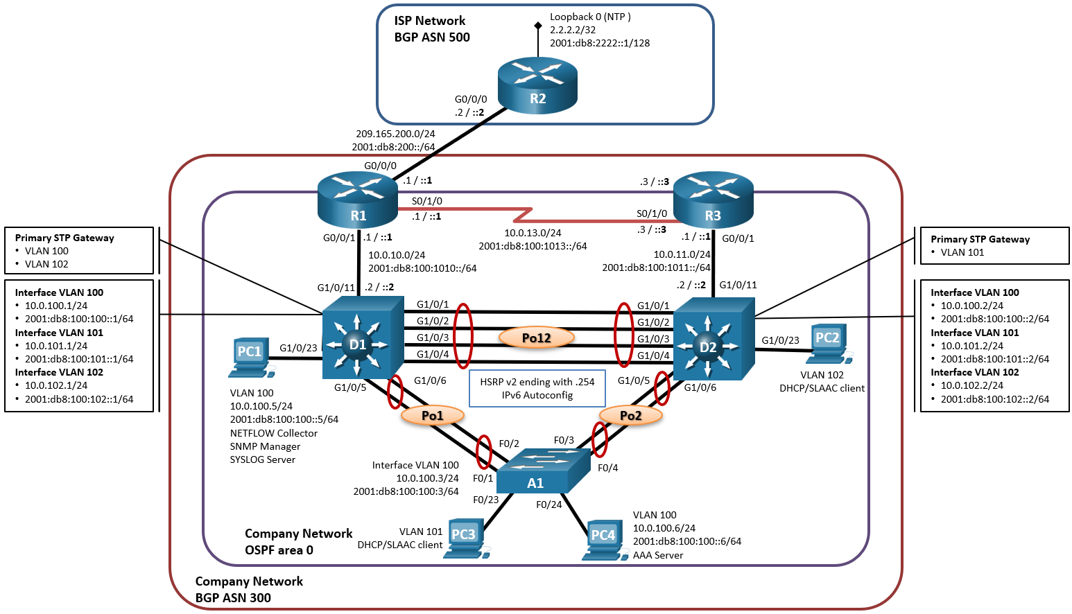
Topology

Addressing Table
Device | Interface | IPv4 Address | IPv6 Address | IPv6 Link-Local
R1 | G0/0/0 | 209.165.200.225/27 | 2001:db8:200::1/64 | fe80::1:1
R1 | G0/0/1 | 10.0.10.1/24 | 2001:db8:100:1010::1/64 | fe80::1:2
R1 | S0/1/0 | 10.0.13.1/24 | 2001:db8:100:1013::1/64 | fe80::1:3
R2 | G0/0/0 | 209.165.200.226/27 | 2001:db8:200::2/64 | fe80::2:1
R2 | Loopback0 | 2.2.2.2/32 | 2001:db8:2222::1/128 | fe80::2:3
R3 | G0/0/1 | 10.0.11.1/24 | 2001:db8:100:1011::1/64 | fe80::3:2
R3 | S0/1/0 | 10.0.13.3/24 | 2001:db8:100:1013::3/64 | fe80::3:3
D1 | G1/0/11 | 10.0.10.2/24 | 2001:db8:100:1010::2/64 | fe80::d1:1
D1 | VLAN 100 | 10.0.100.1/24 | 2001:db8:100:100::1/64 | fe80::d1:2
D1 | VLAN 101 | 10.0.101.1/24 | 2001:db8:100:101::1/64 | fe80::d1:3
D1 | VLAN 102 | 10.0.102.1/24 | 2001:db8:100:102::1/64 | fe80::d1:4
D2 | G1/0/11 | 10.0.11.2/24 | 2001:db8:100:1011::2/64 | fe80::d2:1
D2 | VLAN 100 | 10.0.100.2/24 | 2001:db8:100:100::2/64 | fe80::d2:2
D2 | VLAN 101 | 10.0.101.2/24 | 2001:db8:100:101::2/64 | fe80::d2:3
D2 | VLAN 102 | 10.0.102.2/24 | 2001:db8:100:102::2/64 | fe80::d2:4
A1 | VLAN 100 | 10.0.100.3/23 | 2001:db8:100:100::3/64 | fe80::a1:1
PC1 | NIC | 10.0.100.5/24 | 2001:db8:100:100::5/64 | EUI-64
PC2 | NIC | DHCP | SLAAC | EUI-64
PC3 | NIC | DHCP | SLAAC | EUI-64
PC4 | NIC | 10.0.100.6/24 | 2001:db8:100:100::6/64 | EUI-64

Task 1: - Topology Creation and Basic Configuration (10 marks)
Using Packet Tracer software create the topology shown above and complete all tasks below.
- Configure hostnames on each device.
- Disable DNS lookup on all routers
- Enable ipv6 unicast routing
- Configure all devices with IP address shown in the above tables and network topology.A1 conf#ipv6 address 2001:db8:100:100::3/64
- Ipv6 address fe80::a1:1 link-local

Task 2: - Device Configuration (80 marks)
- On the “Company Network” (i.e., R1, R3, D1, and D2), configure single-area OSPFv2 in area 0. Use OSPF Process ID 4.

  - Assign the following router-IDs. R1: 0.0.4.1, R3: 0.0.4.3, D1: 0.0.4.131, D2: 0.0.4.132
  - On R1, R3, D1, and D2, advertise all directly connected networks / VLANs in Area 0. On R1, do not advertise the R1 – R2 network.
  - On R1, propagate a default route. Note that the default route will be provided by BGP.
  - Disable OSPFv2 advertisements on: D1: All interfaces except G1/0/11. D2: All interfaces except G1/0/11.

- On the “Company Network” (i.e., R1, R3, D1, and D2), configure classic single-area OSPFv3 in area 0. Use OSPF Process ID 6

  - Assign the following router-IDs. R1: 0.0.6.1, R3: 0.0.6.3, D1: 0.0.6.131, D2: 0.0.6.132.
  - On R1, R3, D1, and D2, advertise all directly connected networks / VLANs in Area 0. On R1, do not advertise the R1 – R2 network.
  - On R1, propagate a default route. Note that the default route will be provided by BGP.
  - Disable OSPFv3 advertisements on: D1: All interfaces except G1/0/11. D2: All interfaces except G1/0/11.

- On R1 in the “ISP Network”, configure MP-BGP.
  - Configure R1 in BGP ASN 300 and use the router-id 1.1.1.1.
  - Configure an IPv4 and IPv6 neighbor relationship with R2 in ASN 500.
neighbor 2001:db8:200::2/64 remote-as 500
  - In IPv4 address family:
    - Disable the IPv6 neighbor relationship.no bgp default ipv6-unicast
    - Enable the IPv4 neighbor relationship.bgp default ipv4-unicast
    - Advertise the 10.0.0.0/8 network. Network 10.0.0.0 mask 255.0.0.0 activate
  - In IPv6 address family
    - Disable the IPv4 neighbor relationship. No bgp default ipv4-unicast
    - Enable the IPv6 neighbor relationship.bgp default ipv6-unicast
    - Advertise the 2001:db8:100::/48 network. Network 2001:db8:100::/48activate
  - Configure two static summary routes to interface Null 0:
    - A summary IPv4 route for 10.0.0.0/8. Aggregate-address 10.0.0.0 255.0.0.0 summary-only
    - A summary IPv6 route for 2001:db8:100::/48. Aggregate-address 2001:db8:100::/48 summary-only

- R2 in the “ISP Network”, configure MP-BGP.
  - Configure R2 in BGP ASN 500 and use the router-id 2.2.2.2.
  - Configure and enable an IPv4 and IPv6 neighbor relationship with R1 in ASN 300
neighbor 2001:db8:200::1/64 remote-as 300

  - In IPv4 address family: address-family ipv4
Network 2.2.2.2 mask 255.255.255.255 activate
    - The Loopback 0 IPv4 network (/32).
    - The default route 0.0.0.0/0. Ip route 0.0.0.0 0.0.0.0 int g0/0
  - In IPv6 address family
    - The Loopback 0 IPv0 network (/128). Network 2001:db8:2222::1/128 avctivate
    - The default route (::/0). Ip route ::/0 int g0/0
  - Configure two static summary routes to interface Loopback 0:
    - An IPv4 default static route. Aggregate-address 0.0.0.0 0.0.0.0 summary-only
    - An IPv6 default static route. Aggregate-address ::/0 summar-only

- On all switches configure VLANs as shown in the table:

VLAN number | Name | Network
100 | Management | 10.0.100.0/24
101 | UserGroupA | 10.0.101.0/24
102 | UserGroupB | 10.0.102.0/24
999 | NATIVE

- Set D1 and D2 as DHCP server for VLANs 101 and 102. Exclude 10.0.x.1 to 109 and 141 to 254 on both LANs.

- On all switches, configure IEEE 802.1Q trunk interfaces on interconnecting switch links.

- On all switches, change the Native VLAN on trunk links.

- On all switches, enable the Rapid Spanning-Tree Protocol.

- On D1 and D2, configure the appropriate RSTP root bridges based on the information in the topology diagram. D1 and D2 must provide backup in case of root bridge failure.

- On all switches, configure an LACP EtherChannel as shown in the topology.
- On D1, configure HSRP version 2.
- D1 is the primary router for VLANs 100 and 102; therefore, their priority will also be changed to 150.
  - Configure IPv4 HSRP group 104 for VLAN 100, assign virtual IP address 10.0.100.254, group priority 150 and enable preemption
  - Configure IPv4 HSRP group 114 for VLAN 101, assign virtual IP address 10.0.101.254 and enable preemption
  - Configure IPv4 HSRP group 124 for VLAN 102, assign virtual IP address 10.0.102.254, group priority 150 and enable preemption
  - Configure IPv6 HSRP group 106 for VLAN 100, assign virtual IP address ipv6 autoconfig, group priority 150 and enable preemption
  - Configure IPv6 HSRP group 116 for VLAN 101, assign virtual IP address ipv6 autoconfig and enable preemption
  - Configure IPv6 HSRP group 126 for VLAN 102, assign virtual IP address ipv6 autoconfig, group priority 150 and enable preemption
- On D2, configure HSRP version 2.
- D2 is the primary router for VLANs 101; therefore, their priority will also be changed to 150.
  - Configure IPv4 HSRP group 104 for VLAN 100, assign virtual IP address 10.0.100.254 and enable preemption
  - Configure IPv4 HSRP group 114 for VLAN 101, assign virtual IP address 10.0.101.254, group priority 150 and enable preemption
  - Configure IPv4 HSRP group 124 for VLAN 102, assign virtual IP address 10.0.102.254 and enable preemption
  - Configure IPv6 HSRP group 106 for VLAN 100, assign virtual IP address ipv6 autoconfig and enable preemption
  - Configure IPv6 HSRP group 116 for VLAN 101, assign virtual IP address ipv6 autoconfig, group priority 150 and enable preemption
  - Configure IPv6 HSRP group 126 for VLAN 102, assign virtual IP address ipv6 autoconfig and enable preemption
- On all devices, set the local clock to the current UTC time.
- Configure R2 as NTP master at stratum level 3.
- Configure NTP as follows: R1 must synchronise with R2. R3, D1, and A1 to synchronize time with R1. D2 to synchronize time with R3.

- On all switches, configure host access ports connecting to PC1, PC2, PC3, and PC4.

- Configure PortFast and BPDU Guard on the interfaces connected to PCs. Shutdown all unused ports.
- Enable port security on ports connected to end devices. Set the maximum so that only one device can access the Fast Ethernet ports.
- Secure the ports so that the MAC address of a device is dynamically learned and added to the running configuration. Set the violation mode so that the Fast Ethernet ports are not disabled when a violation occurs, but a notification of the security violation is generated and packets from the unknown source are dropped.

Task3: Network connectivity
Using ping command, verify end-to-end connectivity:
From PC-A, ping PC-B & PC-C. Is it successful? ___yes/no_____
From PC-A, ping default gateway. Is it successful? ___yes/no_____
From PC-B, ping 172.27.0.1. Is it successful? ___yes/no_____
From PC-A, ping 209.165.200.225. Is it successful? ___yes/no_____

Verify HSRP is working as expected
Issue the shutdown command on R1 G0/1, and then re-issue the following commands to verify that HSRP is working as expected:
From PC-B, ping 172.27.0.1. Ping should not be successful ___yes/no___
From PC-B, ping default gateway. Is it successful? ___yes/no_____
From PC-B, ping 209.165.200.225. Is it successful? ___yes/no_____

Submission Requirement
The packet tracer file should be saved as “studentname_id” and uploaded onto Moodle. In addition to packet tracer file, you must also submit

- This document with Task 3 completed

All documentation for your solution should be submitted electronically on Moodle.
It is your responsibility that you submit all the outputs and files correctly.

