Rhys Hughes (2116435)
07/01/24 ACCA6024
aSSIGNMENT 1 & 2: cLOUD bASED wEB sERVICES

Table of Contents
Table of Contents 1
1.0 Introduction 2
2.0 User Requirements 4
2.1 Data requirements 4
2.2 website requirements 4
3.0 Design 4
3.1 Basic layout 5
3.2 Edit mode 5
3.3 Create new book 5
3.4 Filtering 5
4.0 Testing 5
4.1 Testing tables 6
References 12
Figures 12

1.0 Introduction
This report will detail the creation of a cloud based web service that uses Ajax and a REST API to create a dynamic webpage. The organisation selected is a bookstore called magic quill Books. To this end the user requirements such as the data and design requirements are defined. The JavaScript is also tested to ensure that it works and meets the organisation’s needs.

2.0 User Requirements

2.1 Data requirements
For this case 8 pieces of data were chosen to identify and describe the individual books. These are the Unique Identifier called “Id” which is used as the identifier in the database, the “Name” of the book which is a text string, the “Description” which is a short description of the contents, also a text string, the release date “ReleaseDate” which is stored in a date format, ISBN which is numeric, Genre, and Audience which are both text. These were chosen to have a variation in data types. On the HTML side the name is a text input, the description is a textarea, the release date is a date input, the ISBN is a number input, and the genre and audience are dropdown selections.

2.2 website requirements
The website requirements are designed to get as much information to the user as possible and to have the ability to create (POST), edit (PATCH), delete, and filter the different books. It is also designed around one dynamic page. Also, for the website to be more responsive such as with resizing and for quicker design times, Bootstrap will be used.

3.0 Design

3.1 Basic layout
The basic webpage layout can be seen in Figure 1. The header is at the top with the buttons to access the Bootstrap Offcanvas filter and create pages. In the middle is the table containing the books with an edit button on the side. This table is dynamically created by getting the information from the database. It automatically creates new rows for each of the books.

3.2 Edit mode
It was decided to have per record editing. Clicking on the edit mode changes that specific books table row to allow for editing. This can be seen in figure 2. Input boxes replace the book information, and the information is automatically inserted into them. It also replaces the edit button with three different ones. The first is a SAVE button which patches the data into the database. The second is the discard button, this discards any changes by reloading the table, the final one is the delete button which deletes the record from the database.

3.3 Create new book
The create offcanvas modal can be seen in FIgure 3. The modal is opened by clicking the create button in the header. In the modal, all the data required can be inputted. Once inputted it automatically refreshes the table to show the new input data.

3.4 Filtering
The filtering modal can be accessed by clicking the filter button in the header which can be seen in figure 4. Here it allows the user to select how they want to filter and a reset filter option. It was decided against going for multiple option filters and instead having per type filtering.

4.0 Testing
Various information is required for software testing. The primary information required is the project’s name, a detailed description of what is being tested and the test itself [1]. The other information required are the specific features tested and the criteria for success. The testing document that will be used contains the test title, feature description, test description, expected results, and test results, success or failure (checkbox).

4.1 Testing tables

Test title: | Page load displays table
Feature description | LoadBooks() gets the books from the database and creates a table containing them all
Test description | Refresh the page and see whether the table loads
Expected results | Table loads with book data
Test results | Table loads with book data | Success? | ✓

Test title: | Edit mode toggles on correctly
Feature description | The edit button on the table enables the toggle mode that takes the data from the books and sets them as the default for the inputs.
Test description | Edit button gets clicked
Expected results | Edit button gets clicked and the information from the row is inserted into the input fields
Test results | Edit button gets clicked and the information from the row is inserted into the input fields | Success? | ✓

Test title: | Edit mode discard
Feature description | If discard is clicked the table is reloaded and edit mode is exited.
Test description | Once in edit mode the discard button is clicked, the table should reload.
Expected results | Discard button is clicked and any data in the input fields should not be sent to the database and exit mode is exited as the whole table reloads.
Test results | Discard button is clicked and any data in the input fields should not be sent to the database and exit mode is exited as the whole table reloads. | Success? | ✓

Test title: | Edit mode save
Feature description | In edit mode clicking the save button patches the data in the input fields to the database
Test description | Edit mode is enabled, data is inputted into the input fields, the save button is pressed and the database gets updated with the new information.
Expected results | The information in the input fields is Patched to the database and then the table reloads showing the new data
Test results | The information in the input fields is Patched to the database and then the table reloads showing the new data | Success? | ✓

Test title: | Edit mode delete
Feature description | The delete button deletes that book from the database
Test description | When in edit mode the delete button is pressed causing the database to delete the book.
Expected results | The delete button is pressed and the book is removed from the database and then the table is refreshed showing that it’s gone
Test results | The delete button is pressed and the book is removed from the database and then the table is refreshed showing that it’s gone | Success? | ✓

Test title: | Create book name check success
Feature description | Input test on the book name input (assuming all other input fields also pass their tests)
Test description | Something is inputted into the name
Expected results | This information is sent to the database and the table is refreshed to show this information
Test results | This information is sent to the database and the table is refreshed to show this information | Success? | ✓

Test title: | Create book description check
Feature description | Input test on the book description input (assuming all other input fields also pass their tests)
Test description | Something is inputted into the description
Expected results | This information is sent to the database and the table is refreshed to show this information
Test results | This information is sent to the database and the table is refreshed to show this information | Success? | ✓

Test title: | Create book release date check
Feature description | Input test on the book release date input (assuming all other input fields also pass their tests)
Test description | Something is inputted into the release date
Expected results | This information is sent to the database and the table is refreshed to show this information
Test results | This information is sent to the database and the table is refreshed to show this information | Success? | ✓

Test title: | Create book ISBN check
Feature description | Input test on the book ISBN input (assuming all other input fields also pass their tests)
Test description | Something is inputted into the ISBN
Expected results | This information is sent to the database and the table is refreshed to show this information
Test results | This information is sent to the database and the table is refreshed to show this information | Success? | ✓

Test title: | Create book Genre check fail
Feature description | Input test on the book Genre input
Test description | Current selection is please Select should cause error
Expected results | Alert requesting the user select a Genre, information is not sent to the database
Test results | Alert requesting the user select a Genre, information is not sent to the database | Success? | ✓

Test title: | Create book Genre check success
Feature description | Input test on the book Genre input (assuming all other input fields also pass their tests)
Test description | Something is inputted into the Genre
Expected results | This information is sent to the database and the table is refreshed to show this information
Test results | This information is sent to the database and the table is refreshed to show this information | Success? | ✓

Test title: | Create book Audience check fail
Feature description | Input test on the book Audience input
Test description | Current selection is please Select should cause error
Expected results | Alert requesting the user select a Audience, information is not sent to the database
Test results | Alert requesting the user select a Audience, information is not sent to the database | Success? | ✓

Test title: | Create book Audience check success
Feature description | Input test on the book Audience input (assuming all other input fields also pass their tests)
Test description | Something is inputted into the Audience
Expected results | This information is sent to the database and the table is refreshed to show this information
Test results | This information is sent to the database and the table is refreshed to show this information | Success? | ✓

Test title: | Filter book Name check fail
Feature description | Input test on the filter Name input
Test description | Input is blank and the filter by Name button is pressed
Expected results | Alert requesting the user input a Name, no filter is applied
Test results | Alert requesting the user select a Name, no filter is applied | Success? | ✓

Test title: | Filter book Name check pass
Feature description | Input test on the filter Name input
Test description | Input contains something and the filter by Name button is pressed
Expected results | The table is filtered by the input
Test results | The table is filtered by the input | Success? | ✓

Test title: | Filter book description check fail
Feature description | Input test on the filter description input
Test description | Input is blank and the filter by description button is pressed
Expected results | Alert requesting the user input a Name, no filter is applied
Test results | Alert requesting the user input a description, no filter is applied | Success? | ✓

Test title: | Filter book description check pass
Feature description | Input test on the filter description input
Test description | Input contains something and the filter by description button is pressed
Expected results | The table is filtered by the input
Test results | The table is filtered by the input | Success? | ✓

Test title: | filter book Genre check fail
Feature description | Input test on the filter Genre input
Test description | Current selection is please Select should cause error
Expected results | Alert requesting the user select a Genre, no filter is applied
Test results | Alert requesting the user select a Genre, no filter is applied | Success? | ✓

Test title: | Filter book Genre check success
Feature description | Input test on the filter Genre input
Test description | Something is inputted into the Genre
Expected results | The table is filtered by the input
Test results | The table is filtered by the input | Success? | ✓

Test title: | filter book Audience check fail
Feature description | Input test on the filter Audience input
Test description | Current selection is please Select should cause error
Expected results | Alert requesting the user select an Audience, no filter is applied
Test results | Alert requesting the user select ab Audience, no filter is applied | Success? | ✓

Test title: | Filter book Audience check success
Feature description | Input test on the filter Audience input
Test description | Something is inputted into the Audience
Expected results | The table is filtered by the input
Test results | The table is filtered by the input | Success? | ✓

Test title: | Filter reset
Feature description | Filter reset button refreshes the table
Test description | A filter is applied then the filter reset is pressed
Expected results | The table is reset without any filters after the button is pressed
Test results | The table is reset without any filters after the button is pressed | Success? | ✓

5.0 Conclusion
In conclusion the webpage achieves the organisations' goal of a dynamic webpage that uses AJAX and a REST API. Improvements to the solution would be with the filtering. The filtering is done client side after getting all the data, a more efficient and correct way of doing this would be using AJAX and AXIOS to make a custom request to the database that uses SQL to filter the data before sending it to the client.

6.0 References

[1] | Y. Zaremba, “What Makes a Good QA Documentation (and How to Apply It to Your Own),” IEEE Computer Society, 19 October 2022. [Online]. Available: https://www.computer.org/publications/tech-news/build-your-career/applications-of-good-qa-documentation. [Accessed 7 January 2024].

7.0 Figures
Figure 1: Basic webpage design
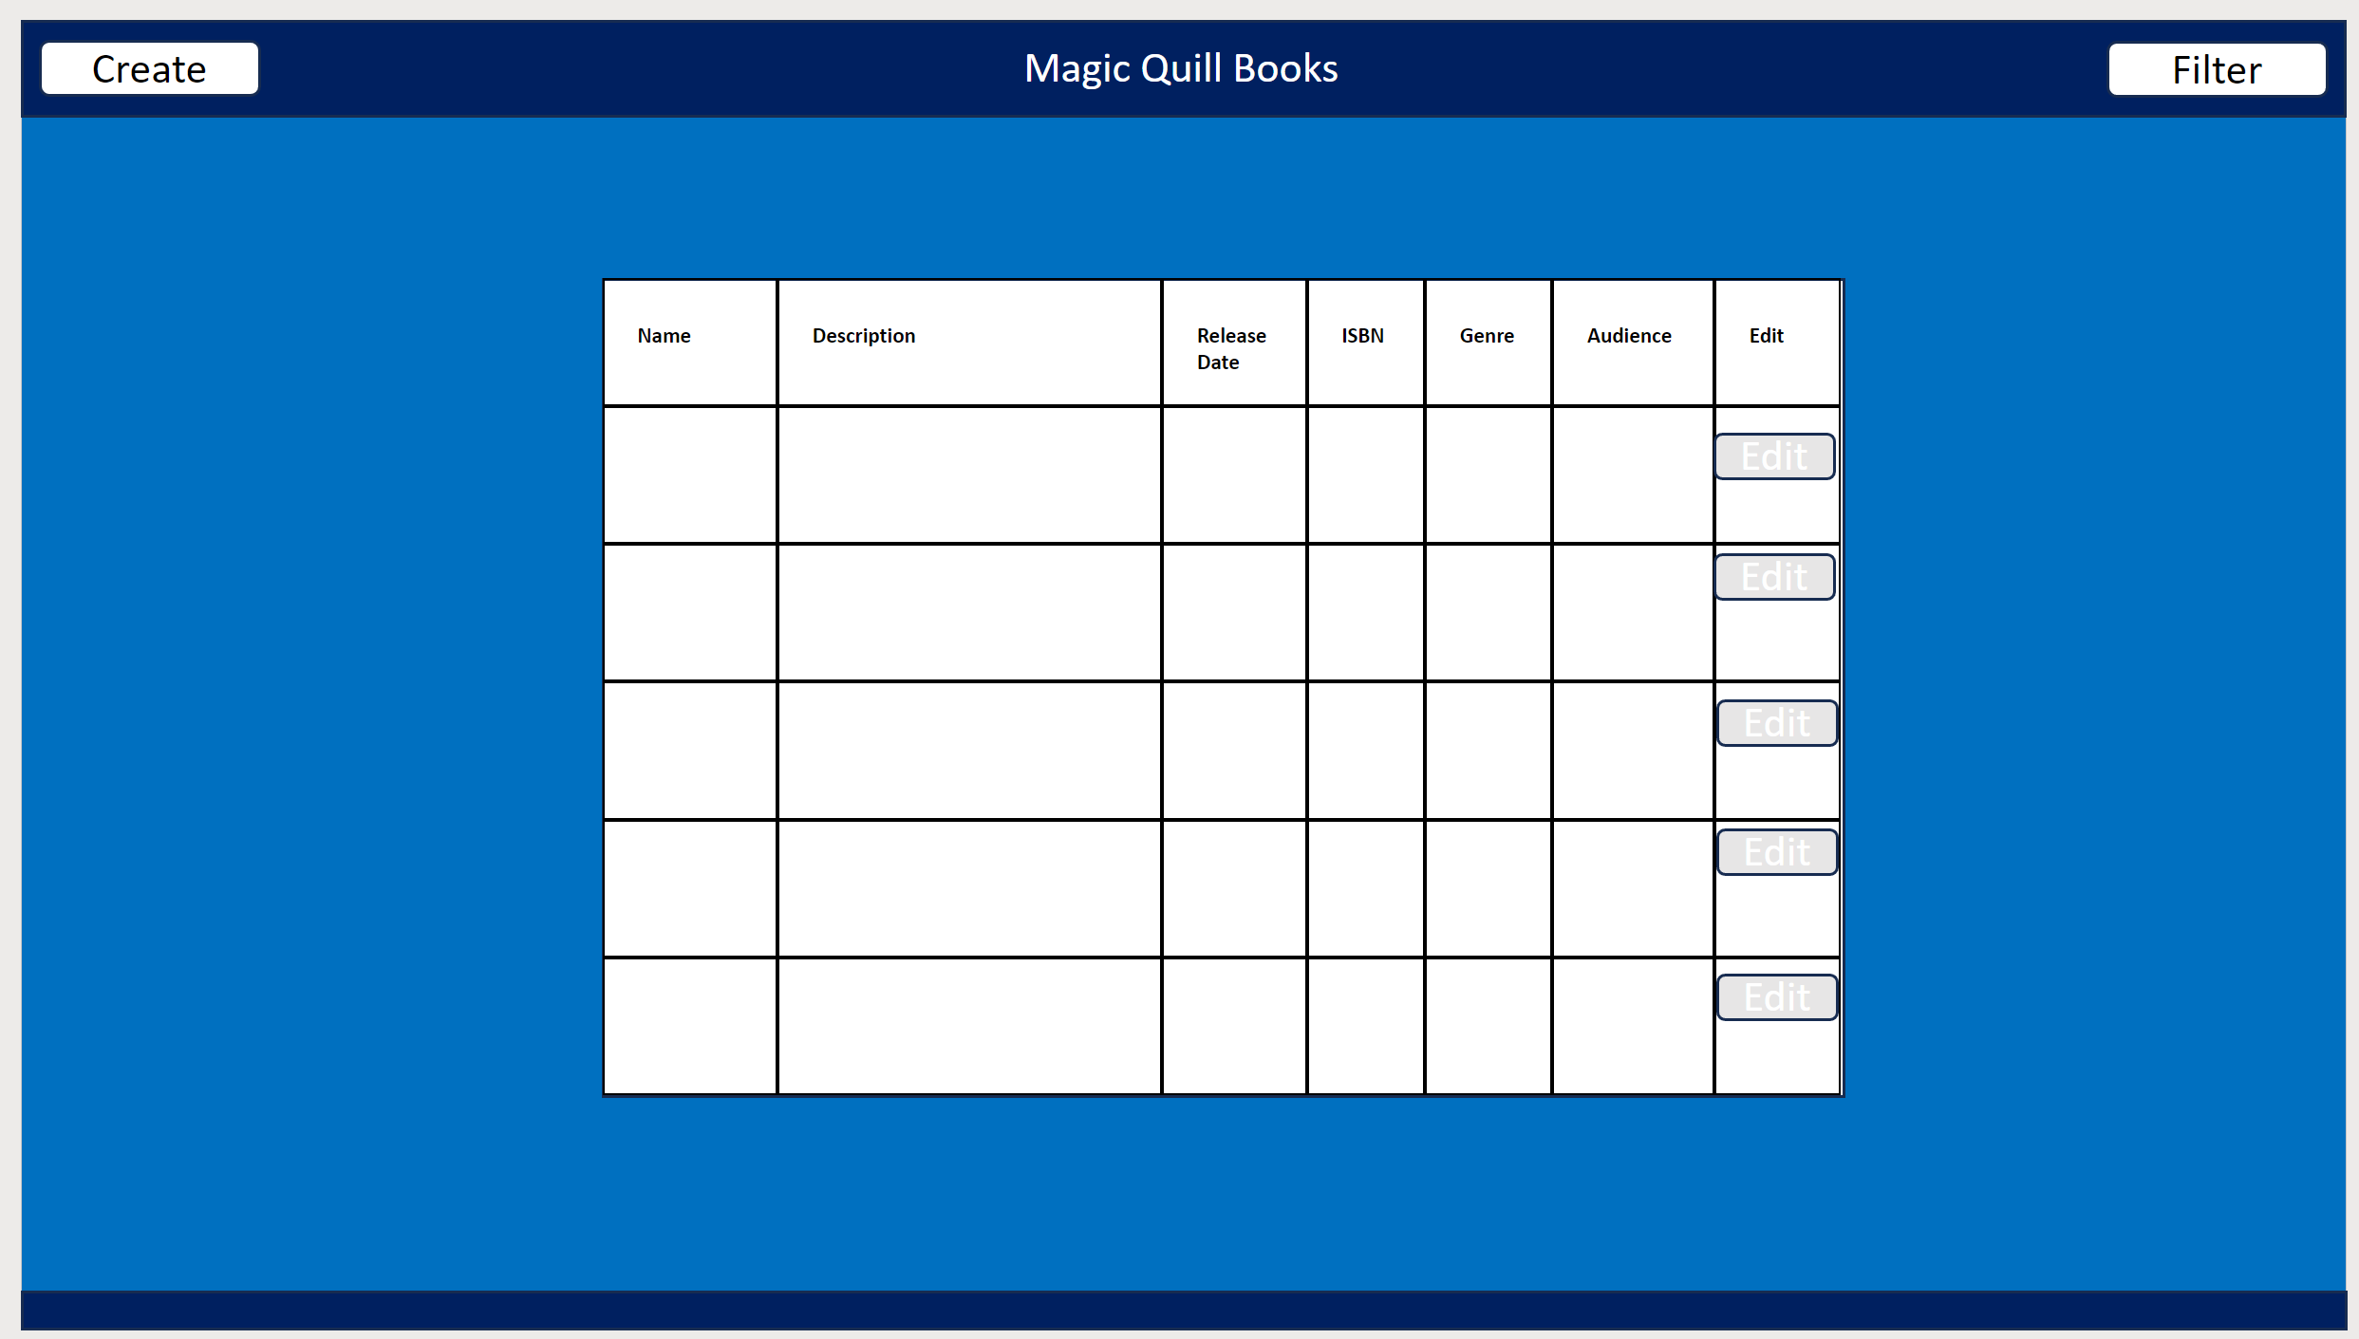

Figure 2: After clicking edit
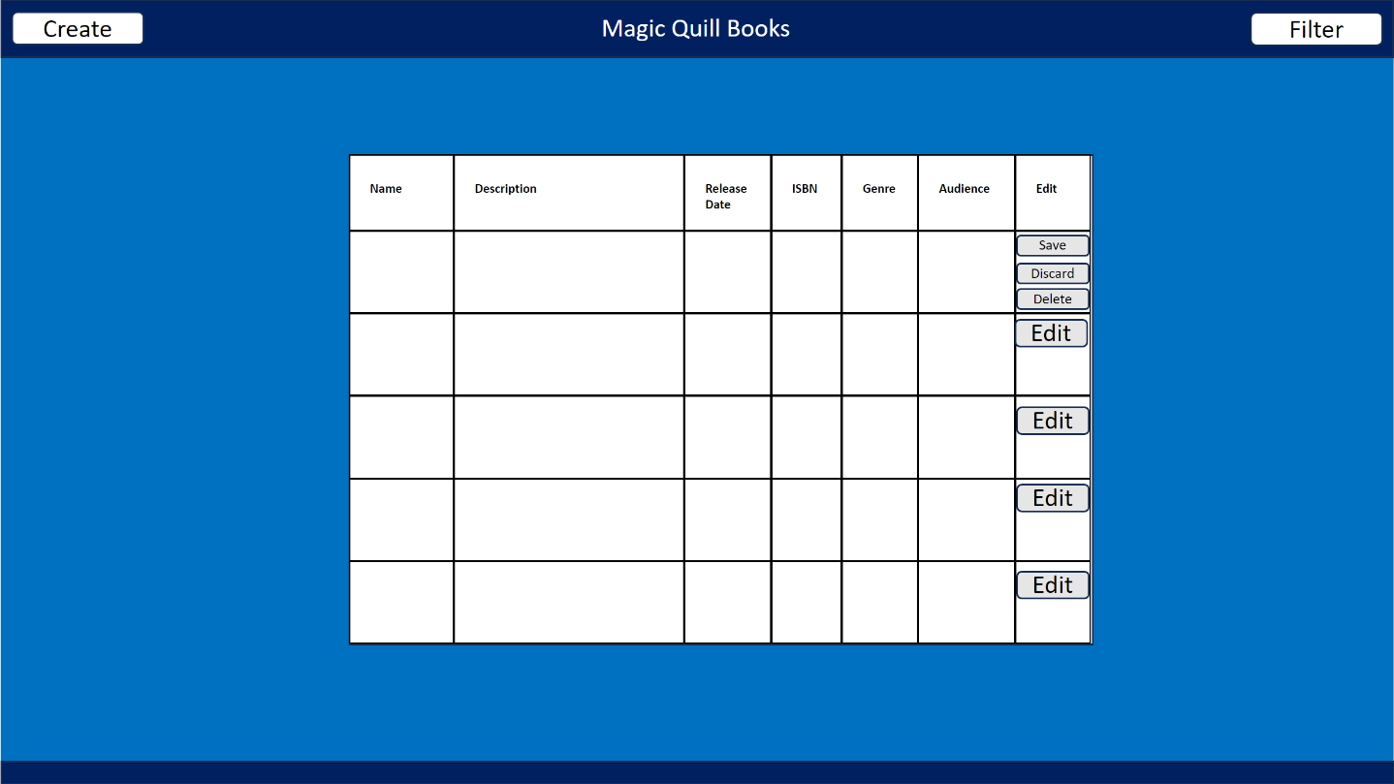

Figure 3: Create offcanvas
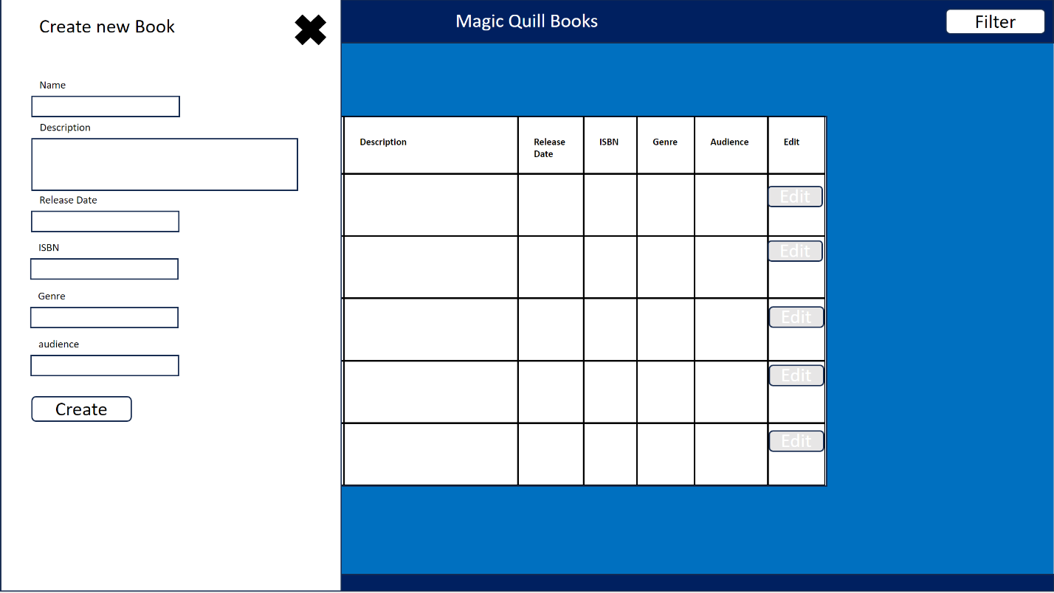

Figure 4: Filter offcanvas


