
APPENDIX GA36b

LEVEL 5 ASSESSMENT SPECIFICATION

Student name: | Finlay Broadhead | Student ID number: | 1902747
Programme: | Outdoor Adventure Education/ Adventure Filmmaking
Module: | Sustainable Journeys
Module code: | BMOE5004 | Contribution to Overall Module Assessment (%): | 50%
Lecturer: | Graham Harvey | Internal Verifier: | Denise Leonard
Assignment Title: | Expedition proposal | Word count (or equivalent): | 10 minute
Submission deadline: | 30th April 2021 at 3.00pm | Return date of provisional marks & written feedback: | 31st May 2021
Submission method: | All written assessments, where practical and possible, must be submitted via Turnitin unless otherwise instructed by the Lecturer. (Please DO NOT put this assessment specification into Turnitin or it will match many similarities with other students’ submissions.)  Alternative submission method (if applicable):  Late submission of the assessment will result in a late penalty mark. Penalties for late submission: Up to one week late, maximum mark of 40%. Over one week late, 0%. Only the Extenuating Circumstances Panel may approve a change to submission dates.
Academic honesty / referencing: | Academic honesty is required. In the main body of your submission you must give credit to authors on whose research and ideas your work is based. Append to your submission a reference list that indicates the books, articles, etc. that you have used, cited or quoted in order to complete this assessment.

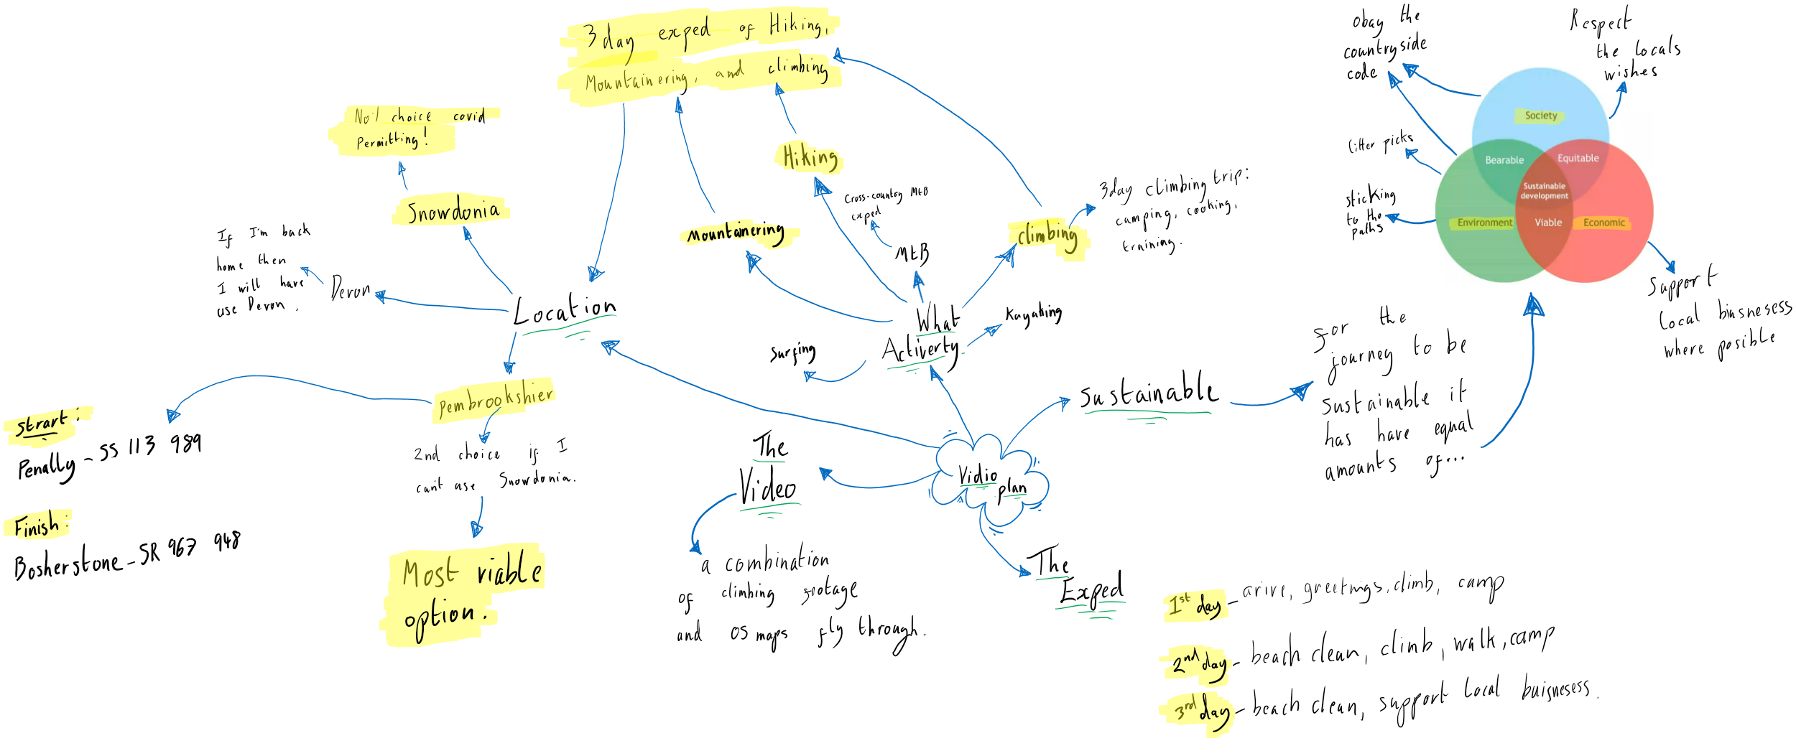
Mind Map:

Script:

Opening worded screen

“would you rather be there listening to this… or here listening to this? It must be a no brainer!”

“Hi, I’m Finlay Broadhead a second year, Outdoor Adventure Education student at the University of Wales Trinity Saint David. I am here to tell you why you should come and join me on my Pembrokeshire coastal walk.”

Why we are doing it:
“The journey will begin in Penally just outside on Tenby taking the Pembrokeshire coast path all the way to Bosherstone. It is an amazing stretch of coastline teaming with wildlife, and home to some of Wales’ best climbs. The aim is to have a fun adventure walking climbing and for some people to lead legs of the walk to build confidence and leadership skills. But it is also to participate in a large litter pick along the coastline, allowing us to raise awareness of the effects that litter is having on our oceans. Allowing us to look at the environment and be one with it, protect it not ‘conquer’ it. Only 9% of plastic can be recycled and studies suggest that at the moment over 13 million metric tones of plastic leaks into our oceans every year and that is set to rise to 30 million metric tones by 2040 (National Geographic, 2020). Microplastics impact reefs by:
1) Direct physical and mechanical damage
2) The introduction of pathogenic agents ‘hitchhiking’ on the plastics that are extremely harmful to wildlife
3) ‘Overtopping’ phototrophic animals preventing light from reaching tissue and creating low oxygen levels in the water
4) Direct ingestion and gut blockage
5) Entanglement and entrapment to all wildlife
(UN,2020)
We are suffocating our planet. We cannot and should not let this happen. So, join me on our own pilgrimage of plastic awareness.

But of course this is also about having fun and enjoying the environment we are here to protect. We will be walking, enjoying the amazing views and seeing wildlife not so commonly seen; climbing and abseiling down cliffs and into coves that you wouldn’t normally be able to see; and at the end of each day we will be camping under the stars.”

Kit:
“The Kit you will need is:”
On screen
- Sleeping bag
- Tent or bivvi bag
- Suitable sized rucksack
- Stove and gas
- Cutlery
- 3 days’ worth of food, I recommend boil in the bags for dinner.
- 2 litters of water min, there will be stations to fill up.
- Suitable clothing
- Warm layers
- Waterproofs
- Suitable footwear
- Personal first aid kit
- Any personal climbing gear you may want to bring.
- Litter picking equipment if you have it

Journey:
“The adventure itself will begin on the 18th of June in Penally at 10:00 am and will finish on the 20th in Bosherstone.
Our meeting point will be just off the A4139 along the Penally Training Camp road. After the initial meet and greet, we will set of to our first spot of the day, known as Fisherman’s point. This is where we will have our first climb of the weekend. It is an amazing Slab wall that is perfect for a fun and safe first climb. Where people can either top rope or ghost led to practice their gear placement. All whilst observing Fulmars, Oyster Caters and Turns flying above you and seals swimming bellow you!

After this we will carry on along the coast path towards Lydstep, where we can have a look at differ Rock formations and old disused quarries. This also gives us a chance to look at the foot fall in different areas of the coast and how damaging it can be to area. This could kick start some discussions about different land management techniques, such as a honeypot sight or sacrificial spots to reduce the people wandering everywhere. It is also the spot for our next climbs. After Lydstep we will be stopping at Church Doors for a short lunch break. Moving on to our final stop for the night, near Manorbier Bay. Where hopefully there will be an amazing sunset and some great star gazing…This is where we will be bivving out and setting up camp as discreetly as we can. It is important that we pitch up late and leave early! To avoid upsetting others trying to enjoy the coastline.

The second day we will have an early start with breakfast on the Manorbier Bay beach and have a beach clean where we can pick up anything that should not be there. After this we will move on towards Eastmoor Cliff where we will be spending most of the morning climbing. After this we will move on towards Fresh water east where we will have a quick beach comb and stop for some lunch. Moving onto our next camp at Greenala Point, a beautiful spot above the sea. Again, it is important that we pitch up late and leave early to avoid upsetting other walkers.

The last day, another early morning with the reward of a cooked breakfast in Stackpole Café, supporting the local business. After our hearty breakfast we will move on to the last section of our adventure, past Barafudel Bay towards Stackpole Head and round to Mowingword to have a look at the amazing coastal features there. Finally, up to our final leg of the journey towards Bosherstones lily ponds, and to the car park.

For those who want to stay for a well-deserved drink at the local pub, do so. Only to support the local businesses of course!”

Route cards & maps:
https://uowtsd-my.sharepoint.com/:b:/g/personal/1902747_student_uwtsd_ac_uk/EXbleS4AtydBiHxVSa5wHd8BeyIT4bMknKGlJvsvUXqXkQ?e=sMu7xL

Video link:
https://www.youtube.com/watch?v=z7PaX5OvUC1

