  Component One:  What are the key skills required when working in the housekeeping team? 750 words (+/- 10%)  Contribution to Overall Module Assessment: 25% | Student No: | 2127642
 | Module Title: | Operating Hotel Facilities
 | Module Code: | BMIH4006
 | Lecturer: | Lawrence Blake
Student Journal
Within the hospitality industry, the guestroom takes the position of the main creation of a hotel since it adds to over 50% of the total trades that make the profit percentage from the room sales. Guests may stay in these rooms for pleasures, conveniences or even for necessity. All hotels and other lodging establishments ought to make an effort to provide their customers with a comfortable, lovely, welcoming, and fairly priced atmosphere. The most potent message in the hotel industry is one of cleanliness. A guest's reaction upon entering a spotless, tidy, and well designed room cannot be matched by any level of service, friendliness, or splendor (Casado, 2012). Both management and customers agree that keeping the hotel clean and in outstanding condition is crucial for charging a fair rate and attracting repeat business.
In reading various literature on the hospitality industry, housekeeping is a crucial aspect of the hospitality industry, and it plays a significant role in maintaining the quality of service and customer satisfaction. I noted that housekeeping team is responsible for ensuring that the guest rooms, public areas, and back-of-the-house areas are clean, well-maintained, and safe for guests and staff. Thus, working in the housekeeping team requires a specific set of skills, which are essential for the effective and efficient execution of housekeeping duties.
One of the most crucial skills required when working in the housekeeping team is attention to detail. Housekeeping staff needs to be meticulous in their cleaning and maintenance duties to ensure that everything is spotless and free of dirt and debris. Attention to detail is also essential when checking for maintenance issues and reporting them promptly to the maintenance team to prevent further damage (Slack et al, 2010). During my time working in the hospitality industry, I learned that attention to detail is not just about cleaning the room but also about creating a welcoming atmosphere. For example, when cleaning a guest room, it is essential to ensure that the furniture and fixtures are arranged correctly, and the amenities are appropriately placed. A simple mistake such as placing the coffee cups in the wrong position can negatively impact the guest's experience and perception of the hotel's cleanliness and attention to detail.
Another critical skill required is time management. I noted that housekeeping staff often has a limited time frame to clean and prepare guest rooms before the next guests arrive. Therefore, time management is crucial to ensure that everything is completed on time without compromising on the quality of service (Jones, 2007). I my experience, I have seen how time management can affect the quality of service and the guest experience. During the peak season, when the hotel is fully booked, the housekeeping team has to work quickly and efficiently to prepare the rooms for the next guests. It can be challenging to balance the quality of service with the limited time frame, and the housekeeping staff has to prioritize their tasks to ensure that the guests' rooms are cleaned and prepared on time.
The knowledge presented above can be applied in the hospitality industry in various ways to improve the quality of service and the guest experience. For instance, knowledge of the principles of customer service can be applied in dealing with guests to ensure their needs are met and that they have a pleasant experience. Knowledge of hygiene and cleanliness standards can be applied in housekeeping to ensure that the guest rooms and the hotel's public areas are clean and well-maintained.
The theoretical knowledge of management and leadership can be applied in managing staff and ensuring that they work efficiently and effectively. This knowledge can be applied in creating schedules, delegating tasks, and ensuring that staff are trained in the necessary skills. The same can be seen in the kitchen department of the hotel industry, knowledge of nutrition and food safety can be applied in creating menus that cater to guests' dietary requirements and ensuring that food is prepared and served safely. Furthermore, the knowledge of marketing can be applied in promoting the hotel and its services to potential guests. This can be done through advertising, social media, and other marketing channels. Knowledge of finance and accounting can be applied in managing the hotel's finances, ensuring that expenses are kept under control, and that revenue is maximized.
What I learned through my experience is that the hospitality industry is all about providing a high level of service to guests. Knowledge about the industry can help achieve this by providing a basis for understanding the principles of customer service, hygiene, cleanliness, management, leadership, nutrition, food safety, marketing, finance, and accounting. By applying this knowledge in practice, hotels and other businesses in the industry can ensure that their guests have a pleasant and satisfying experience.

Bibliography
Casado, M, 2012. Housekeeping Management. London: Wiley.
Jones, T.J., 2007. Professional management of housekeeping operations. John Wiley & Sons.
Slack, N., Chambers, S. and Johnston, R., 2010. Operations management. Pearson education.

Word Count

Component Two:
Contribution to Overall Module Assessment: 25%
In this scenario – You have just been promoted to team leader for a floor within the hotel. A guest complains that on their arrival, their room had not been properly cleaned. Create an action plan and answer the following questions.

Problem | Why did it happen? | What are you going to do? | How will you prevent this from happening in the future? | What measures would you introduce to improve team effectiveness?
As a new team leader for a floor within a hotel, it is essential to handle complaints from guests with care and professionalism. In this scenario, a guest has complained that their room was not properly cleaned upon arrival. Thus, this issue must be addressed promptly to ensure the guest's satisfaction and prevent similar problems in the future.  Action Plan  1. Apologize to the guest and offer to have their room cleaned immediately.  2. Ask the guest if there is anything else that can be done to make their stay more comfortable.  3. Notify the housekeeping staff to prioritize cleaning the guest's room and ensure that it meets the hotel's standards.  4. Conduct an investigation to determine why the room was not cleaned properly, including reviewing the cleaning checklist, inspecting the work done by the housekeeping staff, and interviewing staff involved in the cleaning process.  5. Take appropriate corrective action, including retraining staff, revising cleaning procedures, or making any necessary repairs or improvements to equipment or facilities.  6. Follow up with the guest to ensure that their concerns have been addressed and that they are satisfied with the resolution. | The reasons why the room was not properly cleaned could be varied. It could be due to a lapse in the cleaning process, insufficient staff, inadequate training, or a lack of appropriate cleaning supplies or equipment. | As a team leader, I will immediately take action to address the guest's complaint and ensure that their room is cleaned to their satisfaction. I will also conduct an investigation to determine the root cause of the problem and take corrective action accordingly. | ? To prevent such incidents from happening in the future, I will take the following measures:  1. Provide additional training to housekeeping staff on the hotel's cleaning standards and procedures, emphasizing the importance of attention to detail and thoroughness.  2. Conduct regular inspections of rooms to ensure that they are cleaned to the hotel's standards.  3. Improve communication among the housekeeping staff, front desk staff, and management to ensure that any issues are addressed promptly.  4. Regularly review and update cleaning checklists and procedures to ensure that they are up to date and effective. | To improve team effectiveness, I would introduce the following measures:  1. Regularly communicate with team members to provide feedback and offer opportunities for growth and development.  2. Provide ongoing training and support to help team members improve their skills and knowledge.  3. Foster a positive and supportive work environment that encourages teamwork, collaboration, and open communication.  4. Recognize and reward team members for their hard work and contributions to the hotel's success.

Component Three:
Contribution to Overall Module Assessment: 50%
Your task is to create and prepare a presentation following the detailed scenario provided below.

As the floor housekeeping manager and given the recent guest complaints you need to put together a basic training presentation for your colleagues within the housekeeping team to get the best out of them, ensure that brand standard is being achieved and that Health and Safety procedures are also being followed.

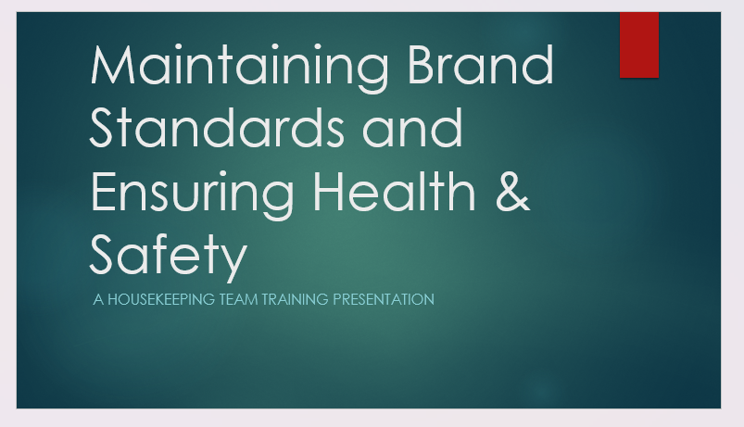

Training Notes:
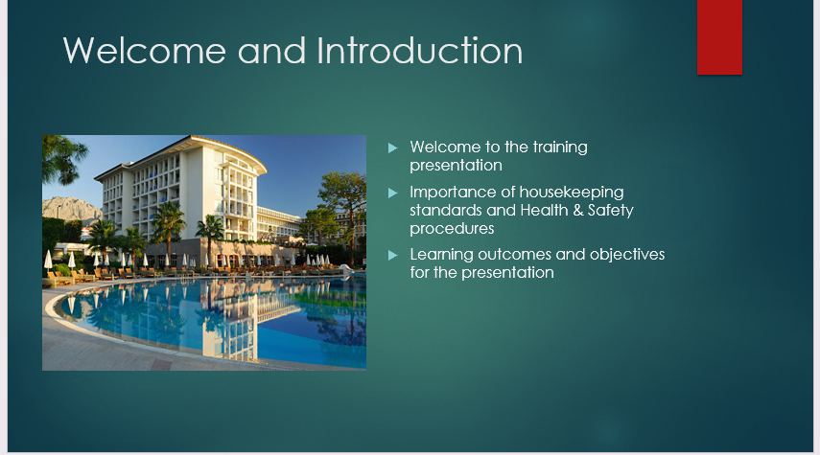

Training Notes:
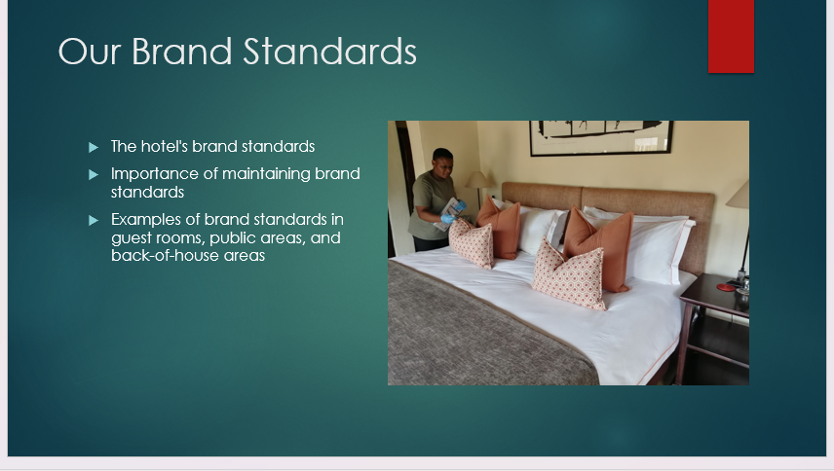

Training Notes:
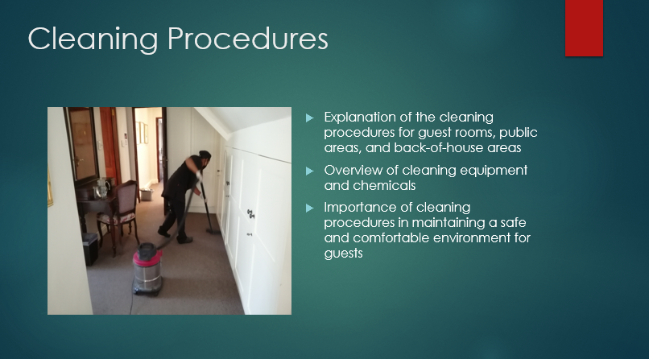

Training Notes:
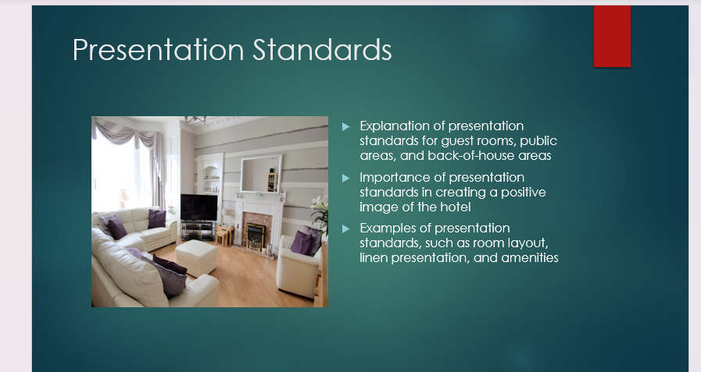

Training Notes:

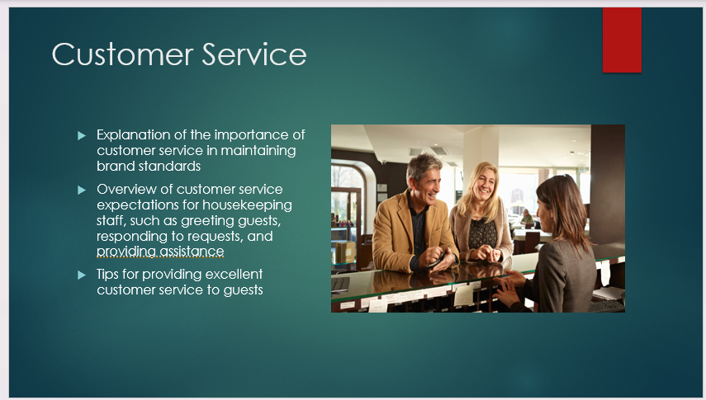

Training Notes:
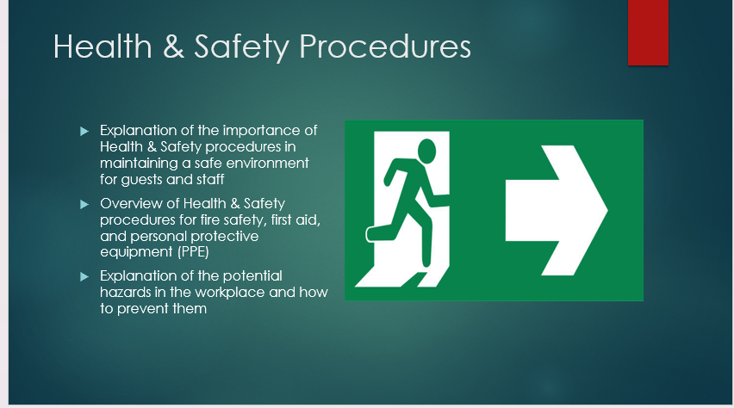

Training Notes:
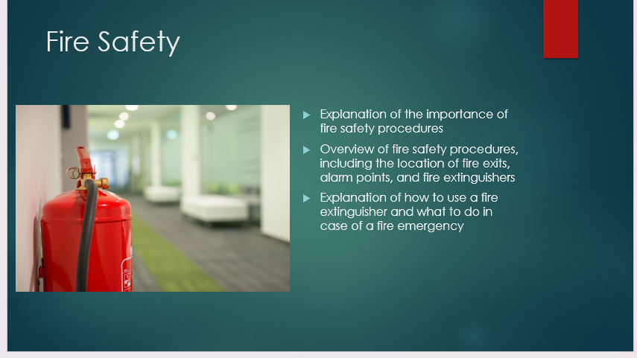

Training Notes:
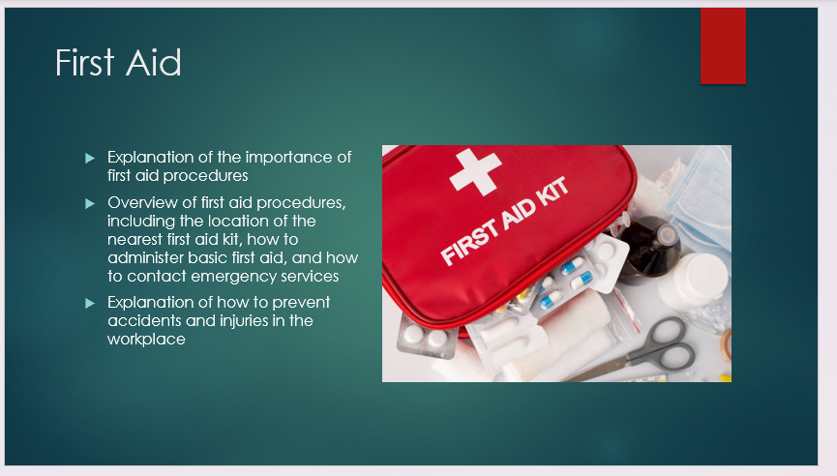

Training Notes:
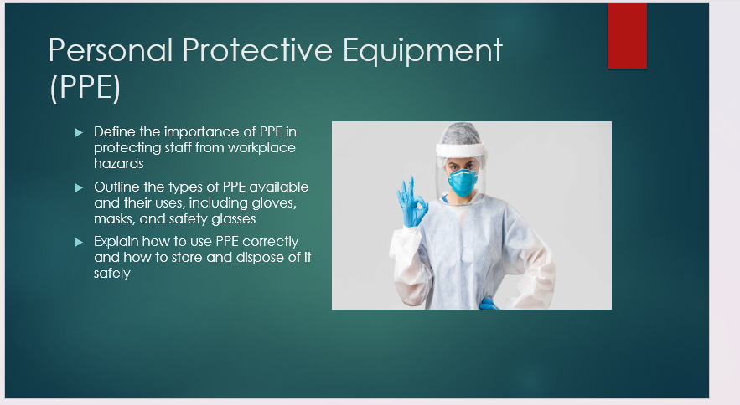

Training Notes:

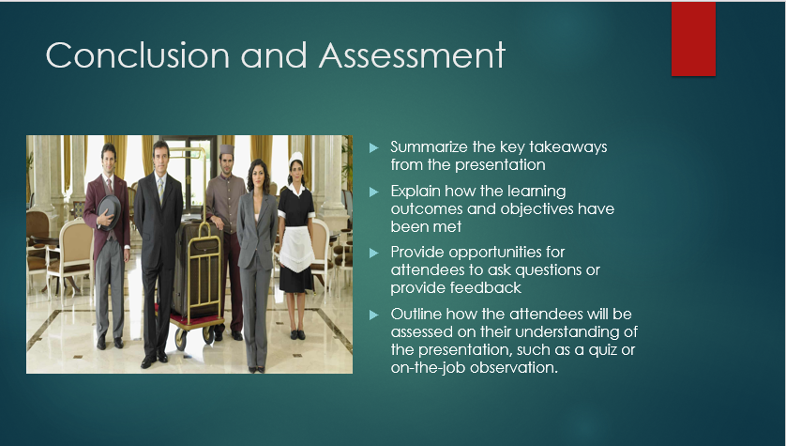

References
Casado, M, 2012. Housekeeping Management. London: Wiley.
Jones, T.J., 2007. Professional management of housekeeping operations. John Wiley & Sons.
Slack, N., Chambers, S. and Johnston, R., 2010. Operations management. Pearson education.

