

Joining CIOB

July 17

Build FX Co.
Authored by: Luke Nicholas



Why I want to join CIOB
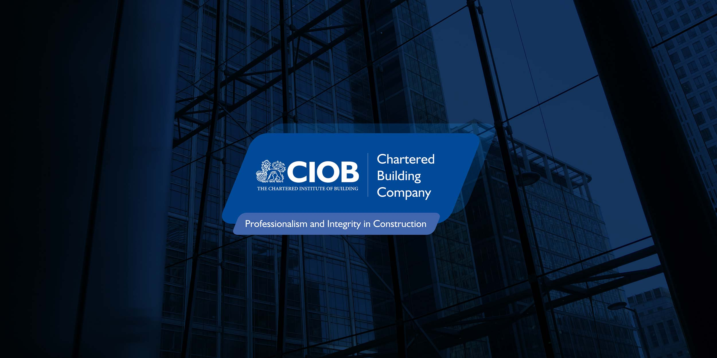

And why I chose CIOB
Executive Summary
I am writing this report based on what I feel is indeed beneficial to you, myself and the company. This is for me to register as an individual through a professional body.
The Chartered institute of building.

Main Researched Topic
Having investigated various professional bodies, I feel the CIOB are most suitable for not only my needs, but the needs for the business and the direction and future of the business within the built environment.

As an institute, they have been practicing the improvement of construction and building for the benefit of society since 1854. (CIOB, 2022)
As a company they have a structure in place in which you can increase your rank as you further your own personal development.
This is recognized at an international level.
They offer various membership levels in which must be earned through both academic and practical levels. Which opens benefits with both engagement with other professionals but allows for a level of improvement and facilities inaccessible without this type of forum.

They were granted a royal chartership in 1980. As stated by the CIOB (2022).
With such gravitas, there is also a strong code of conduct to adhere to, as with any professional affiliation program.

This ethos can be applied across the board with all avenues of the business. Most of all the most important. Health and Safety. CIOB does a lot for health and safety and their ability to deliver various courses both practically, and online is an asset for any practicing construction business. The HSE reports in 2019 that there was 79,000 people recorded with work related ill health and 30 fatalities. (HSE,2019). This is an alarming figure and feel we can do more to improve it. Which requires training and understanding.

Being in the construction industry doesn’t matter which profession you are in, doesn’t mean you’re a health and safety professional. Which is why the various webinars and qualifications you are treated to with various discounts as a member allows training for all levels of staff within the business. (CIOB academy 2022) Not only for the senior staff, but to allow the workforce to have the correct information from the management.

The governments promise and commitment to furthering the sustainability and future of the construction industry within the built environment all comes down to the people who are doing it. Such as ourselves. The industry as a whole need more passionate and higher skilled people in all sectors. This requires further training, study and commitments. Which in turn requires the workplace itself to be far more inviting than it currently is. (Construction Sector Deal, 2021) Over the last decade there has been a significant shift in health and safety, but there will always be room for improvement, and this is extremely relevant for smaller firms like ours. As the CIOB academy offers an almost infinite catalogue of courses and webinars for such topics and discounts of all relevant and up to date textbooks which will then always be available for yourself and new staff.

What is even more inviting is that the CIOB and its policies and goals are aligned with that of the CITB. Who can obviously offer grants for training and further our health and safety proposals. And with the CIOB it can hold more merit for me to be involved if I am a chartered member within their ranks. The CIOB has various training on the CITB and how to apply for their various models of training on offer and the CIOB and CITB have such similar aims for the industry going forward. (CIOB academy, 2020)

CIOB as an institution has such rich history within construction and their milestone calendar since it’s inauguration. From registering as an educational charity in 1970, collaborating with the UK government to launch their Trustmark. (Leading the cultural shift, 2021, p8 – p9). These are just snippets of the diversifying shift this institute has created worldwide for the industry.

As a lifelong sufferer of mental health, to know they partnered with Anxiety UK in 2020 makes it an even more personal connection to know they are on the forefront of such inclusion and in 2021 they have appointed a lead for the EDI (Equality, Diversity and inclusion).

As all aspect of health and safety remain paramount within this industry, being it one of the most dangerous careers to choose. Mental health is often forgotten about. The inclusivity that the CIOB bring for every level of your workforce can be paramount to a company. And I feel I could champion such ethos at every level if I am to a CIOB member. “26% of construction industry professionals”, considered taking their own lives in 2019. (Rees-Evans,2020, p.17)

These short comings of mental health within the industry could have a detrimental effect upon both the financial security of the industry but also the very future of construction and the housing infrastructure for every generation. The lack of available training, understanding and still being very stigmatized. Especially among certain generations and even more so gender biased with a male dominant environment. The lack of empathy and more macho bravado even among the females in this industry only fuels this stigma to not share any feelings of doubt or anxiety. I have experienced this firsthand on more than one occasion. Over 90% of the manual labour workforce reported moderate to extreme levels of stress due to mistrust and lack of communication from management. (Rees- Evans, 2020, p.23)

The considerate constructors scheme is something we have always committed to when operating a site that is longer than three months of work. Which shows our commitment to safety, for both us and the local community but also shows our commitment to the community.
CIOB are one of the founders of the considerate constructors scheme. (Considerate constructors scheme,2022) This scheme opens the construction project and company to the public in a positive way allowing engagement between the locals and the company but also to help with any shortcomings on our part.
Being part of the very elite that founded such a safety conscious and priceless commodity for our industry must show value not only to me but throughout the business.

The impact the climate has upon the industry currently is leading to a strong hold from the government forcing stricter rulings on equipment usage and forcing net zero from an environmental stance. Not that this is a bad thing by any means, but to almost expect it overnight and adhere to it so dramatically can have staggering financial effects which I know would have been overlooked. Especially for smaller businesses like ours.
As the CIOB is a licensed body for the society for the environment (SocEnv) for chartered environmentalist (CEnv) as shown on their website. (CIOB,2022).

This environmental commitment gives us the benefit of all their practices and new ways of working, both with their distribution contacts but also the new and innovative technologies that can be implemented. To be able to make the pledge to net zero, (SocEnv, 2022). This is a huge commitment and for any size business not seen as a financially viable one yet. But with CIOB and the SocEnv, this is entirely possible.

Pledge to net zero has its own hurdles and is set to be achieved by 2050. This has a whole host of its own difficulties and sets a president within any company but specifically a construction company. I don’t believe we are able to join such a pledge yet due to our infancy without any large affiliation among these establishments like CIOB or CITB etc. Which I feel makes it difficult to make such steps without having the support and facilities they offer to change the attitude and way of thinking of the staff and even yourself before such commitments can take place. Being the environmental industries global commitment, tackling greenhouse gases (pledge to net zero,2022) but also securing a future proof method for how to move forward with increasing prices from suppliers, and fuel companies.

Conclusion

The pressure to find stable financial and safe work practices within the construction and built environment industry is proving to be more difficult every day. For us to succeed and stay successful we must adapt to an ever-changing landscape and with the CIOB, I feel is a first step towards this goal. BIM (Building information modelling) is still the future of construction projects, specifically still only on larger scale, but when any collaborative working is required, BIM can be incomparable to past working practices. And CIOB as a partner of BIM plus allows for this to be an opportunity to further educate us on the path to the future of construction and how it is to be shared and taught through possible apprentices or to the older, less computer minded individuals.

This has been sweeping the industry at an international level (CIOB,2016) and we need to catch up on this way of thinking before it becomes the only practice on our opportunities and tenders of construction. This will require supply chains to adopt such systems, which even now, seems to be still an issue with modernisation of systems within the UK but CIOB and BIM plus are striving to create better systems to allow BIM integration to be far less complicated and scarier than it seems.

Name: Luke Nicholas
Job role and responsibilities: Construction and Contracts Manager
Review of learning needs |  |  | Development plan
Reference | In what area do I need to improve my performance? | What do I need to learn in order to achieve this? | What will I do to achieve this? | What are the likely resources and support that I will need? | How will I evaluate a successful outcome?
Enforcing Site safety | To maintain and improve my standards. | Best practices involved from the start of a project through to the end. | Further training, for myself and implement consistency across all sites. | The chartered institute of builders, the health and safety executive and the considerate constructors scheme. | Workforce engagement, site safety records and incident reports and any accident reports.
Public speaking | Speaking to large groups of people | Practicing to small groups and individuals whom I don’t feel comfortable with. | Gain confidence, practice and be less critical of myself. | Support from my manager/director. And support from the other site managers and peers. | Engaging meaningful conversations with those I’ve conducted and ask for feedback.
Self confidence | Self-belief and battling my anxiety with people and self-deprecation. | Self and peer evaluation. Looking for support with anxiety UK and CIOB. | Possible CBT sessions and group sessions and practice. | Anxiety UK offer resources through their membership scheme which allows for group led support. | With the intention of possibly championing the group led sessions within the anxiety UK group.
Mental Health awareness | Being a long-term sufferer, I want to help others and myself at the same time. | Open door policy with all peers and employees under my supervision. | Open lines of communication with an emphasis on how everyone is and mindful of moods. | Anxiety UK are a great resource, as are the NHS and charity MIND. I will also be my own resource having been involved in various processes over my lifetime. | Removing the stigma and bravado of the construction industry, even if it has to be one person or one site at a time.
Being less Critical of myself | Due to my mental health, I am overly critical of myself to the point of self-sabotage. | Confer with my peers and once completed a task, not to redo it for the sake of me not feeling adequate. | Stop setting my standards beyond the timeframe usually available. | A support group to instill some form of confidence of self-worth and achievement in not over criticising myself and restarting large bodies of work for no good reason. | Setting myself goals and targets with required written tasks with only one restart allowed. No matter what and only if I do not pass a certain completion percentage.
Further development to achieve MCIOB and eventually FCIOB | If I do achieve the status of joining CIOB I would love to work towards MCIOB or FCIOB status. | I need to achieve the equivalent of a degree initially and then pass the membership and work towards the FCIOB. | Further improve my CPD through the CIOB academy and through my studies and everyday work. | CIOB, and their academy. Possibly HSE guidance and anyone with the experience and knowledge of construction and the built environment. | When I have achieved the status, I set out to achieve and working towards being FCIOB.
Maintain a high health and safety standard. | Possibly work towards a NEBOSH certification in construction. | If I am in a position financially, I feel this would be highly beneficial for my career. | Maintain my high standards of study and CPD and possibly save up for the exam. | NEBOSH and CIOB offer various training materials and to speak to peers who have completed or work in the industry. | When I have achieved the status of passing the NEBOSH exam.

Reference List; -

- BIM Plus (2022) Explainers.
Available at: https://www.bimplus.co.uk/category/explainers/
(Accessed: 10th July 2022)

- Chartered Institute of Building (2022) About us.
Available at: https://d8.ciob.org/about
(Accessed: 7th July 2022)

- Chartered Institute of Building (2022)
Available at: https://d8.ciob.org/
(Accessed: 12th July 2022)

- Chartered Institute of Building Academy (2022)
Available at: https://www.ciobacademy.org/about/
(Accessed: 13th July 2022)

- The Digital opportunity, (2016) CIOB, Our Blogs,
[Blog], 13th July
Available at: https://www.ciob.org/blog/digital-opportunity
(Accessed: 14th July 2022)

- Construction Sector Deal, (2019) Policy Paper,
(22nd July)
Available at: https://www.gov.uk/government/publications/construction-sector-deal/construction-sector-deal
(Accessed: 17th July 2022)

- Considerate Constructors Scheme, (2022) About us,
Available at: https://www.ccscheme.org.uk/ccs-ltd/what-is-the-ccs2/
(Accessed: 14th July 2022)

- Chartered Institute of Building Academy, (2020) Funding the Construction Industry, CITB. Available at: https://www.ciobacademy.org/product/funding-for-the-construction-industry/
(Accessed: 16th July 2022)

- Rees-Evans, D. (2020)
Anxiety UK
[CIOB Report]
Available at: https://www.anxietyuk.org.uk/wp-content/uploads/2020/05/CIOB-Understanding-Mental-Health-in-the-Built-Environment-Report.pdf
(Accessed: 14th July 2022)

- Health and Safety Executives, (2019)
Construction statistics in Great Britain.
Available at: https://moodle.uwtsd.ac.uk/pluginfile.php/336746/mod_resource/content/0/construction%20Statistics.pdf
(Accessed: 10th July 2022)

- Pledge to net Zero, (2022)
About us,
Available at: https://www.pledgetonetzero.org/case-studies-energy-institute
(Accessed: 11th July 2022)

- Society for the environment, (2022)
Pledge to net zero.
Available at: https://socenv.org.uk/pledge-to-net-zero/
(Accessed: 17th July 2022)

